Study of the Biological Activity of Compounds Isolated from
Lawsonia inermis

M.J. Mohammed O.M. Ramadhan
Dept. of Biology, College of Education Dept. of Chemistry, College of Education
University of Mosul University of Mosul
R.M. Hamoshy
Dept. of Essential Sciences, College of Veterinary
University of Mosul

(NJC)

(Received on 3 /7 /2005) (Accepted for publication on 4 / 3 /2006)

Abstract
This research work was aimed to separate some compounds that have a biological activity from Lawsonia inermis leaves. The plant leaves were obtained from southern part of Iraq-Basrah-Al-Faw as a semidry. The biological activity was examined on both Gram positive and negative bacteria. Pseudomonas aeruginosa, Escherichia Coli, Proteus mirabilis, Salmonella typhi, Klebsiella pneumoniae, Bacillus subtilis and Staphylococcus aureus.
The study involve extraction of some tanny materials employing ethanol. Ethanolic extract was fractioned over silica gel column (80-120) mesh. Fractions isolated were eluated by chloroform, acetone and finally ethanol. The separated fractions were further analyzed by IR, TLC plate and chemical tests.
The results revealed the chloroform extract contains mainly
p-hydroxy benzoic acid, and the acetone extract contains mainly caffeic acid while the ethanolic fractions contains tannic acid. The chemical structure of each analyzed compounds was concluded from comparison with that reported in the literature.
Application of p-hydroxy benzoic acid to both Gram positive and negative bacteria indicated that all types of bacteria were affected with some difference except Pseudomonas aeruginosa. Caffeic acid fluctuated on the bacteria Salmonella typhi, Escherichia Coli, Bacillus subtilis and Staphylococcus aureus but not on Pseudomonas aeruginosa, Proteus mirabilis, Klebsilla pneumonia.
However, extract include tannic acid showed agreed effect on all types of bacteria under study when it compared to effect of extract include p-hydroxy benzoic acid, caffeic acid and the control (Gentamycin and Tetracycline).
الخلاصة
يهدف البحث الى فصل بعض المكونات ذات الفعالية البايولوجية من اوراق نبات الحنة Lawsonia inermis الذي تم الحصول عليه من مدينة الفاو-محافظة البصرة على بعض الجراثيم السالبة والموجبة لصبغة كرام (Pseudomonas aeruginosa ، Escherichia Coli ، Proteus mirabilis ، Salmonella typhi ، Klebsiella pneumonia ، Bacillus subtilis ، Staphylococcus aureus) . تضمنت الدراسة استخلاص المواد الفعالة والدابغة بواسطة الايثانول ثم تجزئة المستخلص بواسطة عمود من هلام السليكا والغسل التدريجي بوساطة ثلاثة مذيبات هي الكلوروفورم، الاسيتون والايثانول. وتم فحص الاجزاء المفصولة للتعرف على المكونات عن طريق اطياف (IR) والكشوفات الكيميائية الكلاسيكية اضافة الى حساب (Rf) للمكونات ومقارنتها بما هو متوفر في الادبيات لهذه المركبات. واتضح من الدراسة ان حامض بارا-هيدروكسي البنزويك كان له تاثير تثبيطي متفاوت على الجراثيم المستخدمة قيد الدراسة ما عدا جرثومة Pseudomonas aeruginosa . واظهر حامض الكافيك تاثير تثبيطي متفاوت على الجراثيم Escherichia coli ، Salmonella typhi ، Bacillus subtilis و Staphylococcus aureus فيما لم يظهر أي تاثير على الجراثيم Pseudomonas aeruginosa ، Proteus mirabilis و Klebsiella pneumoniae . واظهر حامض التانيك تاثيرا تثبيطيا واضحا على جميع انواع الجراثيم المستخدمة قيد الدراسة مقارنة مع عينات السيطرة (Tetracycline, Gentamycin)

Introduction
Medical plants were considered as one of the main strategic source for the manufacturing of drugs. Active ingradients obtained from plants were greatly different from the synthetic drugs. Moreover, side effects caused by synthetic drugs are more than that caused by drugs extracted from medical plants⁽¹⁾. Scientific research study the importance of the plants kingdom that is considered as the main source for the natural organic compounds that have certain biological activities toward the microorganisms⁽²⁾.
Plants extracts are gaining popularity as, ingredient in cosmetic formulations. These extracts contain natural molecules derived directly from plant that are currently important constituents of many medical prescription. The reasons for using plant extract in industrial products and especially; drugs cosmetic formulation may be due to thermal stability, acceptable color, fragrant odor and transparency in the application⁽³⁾. Additionally, plant extract and essential oils can be used either in its concentrated form or diluted and mixed with another materials in industrial products⁽⁴⁾. Active components obtained from plants are mainly organic in nature present in the form of alkaloids, flavones, phenols, aldehydes, ketones, essential oil... etc. These components were not manufactured till now because the catalysts of their synthesis were found as secondary metabolism in plants which and no laboratory methods to synthesize them are available now⁽⁵⁾.
Henna (Lowsonia innermis) contains certain type of essential oil rich in α-β unsaturated ionone (α-β unsaturated ketone), which is fragrant fatty ketones. Henna paste is used in skin decoration at pH=5.5 by adding weak acids such as, boric, oxalic and sometime acetic acid⁽¹⁾. Analysis of the chemical composition of Henna leaves indicate the presence of orange 6 (2-hyroxy-l,4-naphthaquinone). Henna extract contains orange derivatives, 1,2-dihydroxy coumarine, xanthones, flavones, flavanoids, gallic acid, steroids, tannic acid and light essential oils rich in phenols. Henna contains lawsone, mannite which is strong plant coloring pigments in addition to gel type material⁽⁶⁾, tannine derivative, resineous and finally oils⁽⁷⁾.
Effect of aqueous extract of Henna and variation of the used concentration to find the effective concentration on a certain type of bacteria that are living in the urinary track and vessels was studied by Bhuranes⁽⁸⁾. Leaves are used as a remedy in skin diseases in the form of paste, where Henna is used the treatment of boil burn, bruises, and skin inflammation. Leaves in the form of paste have been used externally to relief headache and removal of sowlow in burning feet. Decoction of the leaves is used as gargle in sore throat⁽⁹⁾. Many researchers use Henna plant leaves as aqueous extraction to relief body pain and skin infections⁽¹⁰⁾. In this research we aimed to investigate the effect of ethanolic extract of Henna leave, obtained from south of Iraq in Basrah governorate, and the fractions obtained from silica gel column by gradient elution using various solvents. These fractions were further analysed by chemical methods, IR and thin layer chromatography, which were used to investigate the structure of these compounds.

Experimental
1. Bacterial Culture:
In this study two types of Gram positive bacteria are used, they are: Staphylococcus aureus which was obtained from the department of Biology/College of Education/Mosul University and Bacillus subtilis which was obtained from department of Biology/College of Education/Mosul University
Another types of Gram negative included five different types they were: Pseudomonas aeruginosa, Esherichia coli, Klebsiella pneumoniae and Proteus mirabilis which were obtained from Veterinary College/Mosul university, while Salmonella typhi was obtained from department of Biology/ College of Science/Mosul University.

2. Plant Classification:
Lawsonia inermis (Henna) leaves was a crop of 2003, obtained as a semi-dry leaves from Al-Basrah-Faw City in the southern part of Iraq. The sample was dried at room temperature for two weeks and further at 50-60 °C for 48 hr, till constant weight was obtained. The sample was crushed and sieved to acceptable particle size of 120 mesh, (standard sieves was used). The sample was kept sealed till were used⁽¹¹⁾.

3. Extraction of Active Biologically Ingradient from Lawsonia inermis:
10 gm of dried Lawsonia inermis exactly weighed was mixed with 200 ml of ethanol. The mixture was stirred mechanically for 48 hrs. The mixture was allowed to settle for 12 hrs., filtered through Buchner flask and the solid remained washed with absolute ethanol. The solvent was removed by rotary evaporator. The residual materials which were dark black in color was weighed to a constant weight⁽¹²⁾.

4. Checking of the Ethanolic Extract:
Ethanolic extract was checked by dissolving a small amount in 20 ml of 10% NaOH. The appearance of orange red color indicate the success of the extraction and the presence of the dyes, alkaloids and other active ingradients⁽¹³⁾.

5. Chromatographic Fractionation of Lawsonia inermis Ethanolic Extract:
2gm of Lawsonia inermis ethanolic extract (dry) was transferred quantitatively to chromatographic column (1.1 × 50 cm), containing 40 gm of previously activated silica gel (80-120 mesh) at 300 °C for 3 hr. The column was prepacked through wetting method. The column was eluted with acetone, chloroform, ethanol and finally water. Elution of each fraction was continued till the observed spot and layer was removed from the column and the eluant returned it's original color and refractive index. The fractions obtained were further recoved by removing the solvents by rotary evaporator. The fraction obtained was used in this study⁽¹⁴⁾.

6. Choosing the Effective Concentration:
The choice of effective concentration was carried by preparing stock solution of the extract in dimethyl sulfoxide (DMSO) (1:5, W:V) 200 mg/ml and then diluted it to 100, 50 25, 12.5 mg/ml to be applied in the study⁽¹⁵⁾.

7. Functional group analysis of ethanolic extract of Lawsonia inermis fractions
The total ethanolic extract and the fractions obtained from the silica gel column by gradient elution were studied using IR, using liquid film and solid KBr disc using Infrared spectrophotometer model Tensor 27 Bruker Co., Germany⁽¹⁶⁾.

8. Inhibiting Activity Test:
Leven et al.⁽¹⁷⁾ method that depended on Vandepitte et al.⁽¹⁸⁾ method was followed to performance this test.
Nutrient agar was incubated by using single colony of the seven types of bacteria aforesaid each alone, then the media was incubated at 37 °C for 18-24 hrs., the microbial suspension was diluted by normal saline solution by comparison with standard test tube (Macferland No. 1), it contain 10⁸ cell/cm³ from the microbial suspension then spread on agar media surface by using glass spreader, the dishes were incubated for 30 minutes until the absorption complete. Then the disks were prepared from filter paper (Whatman No.1) (diameter = 6mm), then saturated by different concentrations of isolated material from plant under test⁽¹⁹⁾. The disks were fixed by sterilized tong and incubated at 37 °C for 18-24 hrs. and finally the inhibiting regions were measured and compared with standard antibiotics as positive control sample.

Results and Discussion
Henna contains a natural reddish brown dye made from the leaves and roots of the migantte tree. Lawsonia inermis is a known asthmagen. Henna is also referred to as natural orange-6. Henna is found in many industrial cosmetic products.
In our study we aimed to investigate the antibacterial effect of ethanolic extract of Lowsonia inermis and their chromatographic fractions. The fractions were studied using infrared spectroscopy which indicate the presence of a certain functional groups belongs to acid, alkaloids, phenols and some waxy materials in chloroform fraction. These absorption peaks are given Table (1).

Table (1): Absorption peaks of some Lawsonia inermis fractions from silica gel column of the ethanolic extract
Fraction | IR ν (cm⁻¹) | Expected compounds
Ethanolic/ silica gel column
Chloroform extract  Figure (1) | 3381, 2980, 2360, 1617, 1419, 1077, 791 | p-hydroxy benzoic acid
Acetone extract  Figure (2) | 3446, 3050, 2926, 2855, 2360, 1684, 1653, 1635, 1457, 1375, 1251, 1074, 793 | caffeic acid
Ethanol extract  Figure (3) | 3421, 29502, 2925, 2900, 2360, 1699, 1684, 1653, 1558, 1457, 1072, 775 | tannic acid

The fractions were tested on seven types of Gram positive and negative bacteria using the pellet method and measuring the diameter of the effect of ethanolic extract. Henna leaves was conducted in a ratio of 1/40 (mg/ml) at room temperature. Ethanol was removed by rotary evaporator temperature. Residual materials remained were further fractionated over prepacked silica gel column (1.1 × 50 cm). The column was eluated with, chloroform, acetone and finally ethanol. The fractions were recoved by removal of the solvent to constant weight. Stock solution of each fraction was prepared and diluted by DMSO to (200, 100, 50, 25, 12.5) mg/ml.
Application of chloroform extract to the above mentioned bacterias indicate that when 200 mg/ml was employed if it was noticed in comparison to the synthetic antibiotics. Infrared spectra of the fraction indicated the presence of low molecular weight hydroxy acid of the type; p-hydroxy benzoic, gallic and caffeic acids. It is expected that such compounds act either by changing the (pH) of the media and/or enter the microorganism through the cell membrane. Application of chloroform eluate from silica gel column after removal of the solvent indicated fluctuated effect.
The IR spectrum of the first fraction indicated the presence of OH 3381 Broad, 2980 CH stretching), COO⁻, 2360 aromatic ring character 1617, 1419 and 791), Therefore may say that this fraction was of the type carboxyl, alkyl, phenols of many isomers.
Looking at the infrared spectrum of the extract from the second column of the silica gel and comparing the results of R_{f} from literature with that of R_{f} for isolated compounds and authentic ones also applying the chemical tests for functional groups in the isolated system, we found the following:
- The chloroform eluted fraction isolated from the silica gel column from the ethanol fraction of the first column gave:
- +ve test for carboxylic acid/iodide-iodate test.
- +ve test for monophenol/FeCl₃ solution.
- Retention factor (R_{f}) over silica gel sheet using ethyl acetate-benzene (9:14) as given in literature gave R_{f} anthetic 0.8 R_{f} isolated (0.78).
- So the expected structure⁽²⁰⁾ is:

p-Hydroxy benzoic acid

- Acetone eluted fraction isolated from the second silica gel column gave:
- +ve test for carboxylate, phenols and olefenic double bond and aromatic monocyclic.
- R_{f} of the compounds isolated from the column and the authentic compound using silica gel sheet and the solvent system from the literature (benzene-ethanol-water); 80-4-16 gave; R_{f} authentic 0.79 R_{f} isolate (0.81).
- So the expected structure⁽²⁰⁾ is:

Caffeic acid

3. Ethanol eluted isolated from the second silica gel column gave:
a. Positive test for carboxylic acid, aromatic ring and polyphenols.
b. Retention factor (R_{f}) of authentic and isolated compound over silica gel using the solvent system from literature (ethyl acetate-benzene) (9:14) R_{f} authentic 0.40 R_{f} isolated 0.42.
c. So the expected structure⁽²⁰⁾ is:

Tannic acid
Chloroform extract showed different inhibiting effect on bacteria, higher effect was showed on Prot. mirabilis, and equal inhibiting effect was found on K. pneumoniae, B. subtilis, so showed inhibiting effect best than antibiotics. The extract showed less inhibiting effect on S. typhi compared with standard antibiotics, and finally did not show any effect on Ps. aeruginosa.
Acetone extract showed different inhibiting effect on bacteria. The best effect was showed on S. typhi, it showed inhibiting effect on E. coli, B. subtilis and Staph. aureus greater than antibiotics, it did not show any effect on Ps. aeruginosa, Prot. mirabilis and Kleb. pneumonae.
Ethanol extract showed different inhibiting effect on bacteria, the best inhibiting effect was showed on Ps. aeruginosa, it showed equal inhibiting effect on E. coli and Staph. aureus, it showed effect on Prot. mirabilis and K. pneumonae greater than antibiotics. It showed equal effect on B. subtilis compared with antibiotics, and finally it showed inhibiting effect on S. typhi less than antibiotic (Tetracycline).
From the above results conclude the extracts of Lawsonia inermis leaves have a high inhibiting effect on bacteria growth and it is clear that the ethanolic extract effect was greater than chloroform and acetone extracts (ethanol > chloroform > acetone).
Henna plant contains many of biological active compounds. It was used in a wide field in folk medicine treatment, recently it has been used it in drug industry especially as antibiotics⁽²¹⁾.
Tannins are known compounds found in Henna plant, that have a high inhibiting effect towards bacteria⁽²²⁾, especially the compound called (Lawson), this name taken from plant’s name Lawsonia inermis⁽²³⁾.

Table (2): Inhibiting activity (expressed as inhabiting diameter mm) of chloroform extract include p-hydroxy benzoic acid separated from Henna leaves
Conc.  mg/ml | Ps. aeruginosa | E. coli | Prot. mirabilis | S. typhi | Kleb. pneumonia | B. subtilis | Staph. aureus
200 | - | 18 | 20 | 15 | 19 | 19 | 18
100 | - | 16 | 17 | 12 | 14 | 15 | 14
50 | - | 10 | 15 | 9 | 10 | 12 | 12
25 | - | 8 | 10 | - | 7 | 9 | 12
12.5 | - | - | 7 | - | - | - | -
Table (3): Inhibiting activity (expressed as inhabiting diameter mm) of acetone extract include caffeic acid was separated from Henna leaves
Conc.  mg/ml | Ps. aeruginosa | E. coli | Prot. mirabilis | S. typhi | Kleb. pneumonia | B. subtilis | Staph. aureus
200 | - | 20 | - | 22 | - | 18 | 17
100 | - | 17 | - | 17 | - | 13 | 14
50 | - | 15 | - | 12 | - | 10 | 11
25 | - | 10 | - | 10 | - | - | -
12.5 | - | 7 | - | - | - | - | -
Table (4): Inhibiting activity (expressed as inhabiting diameter mm) of ethanolic extract include tannic acid was separated from Henna leaves
Conc.  mg/ml | Ps. aeruginosa | E. coli | Prot. mirabilis | S. typhi | Kleb. pneumonia | B. subtilis | Staph. aureus
200 | 23 | 22 | 20 | 16 | 16 | 17 | 22
100 | 18 | 19 | 17 | 10 | 12 | 15 | 17
50 | 15 | 13 | 13 | 9 | 10 | 12 | 12
25 | 12 | 10 | 11 | 7 | 7 | 9 | 10
12.5 | 9 | 7 | 9 | - | - | - | -
Table (5): Inhibiting activity (expressed as inhabiting diameter mm) of phenolic acids isolated from Henna leaves chloroform, acetone and ethanol extracts at 200 mg/cm³ in comparison with the Tetracycline and Gentamycin
Extracts | Ps. aeruginosa | E. coli | Prot. mirabilis | S. typhi | Kleb. pneumonia | B. subtilis | Staph. aureus
p-Hydroxy benzoic | - | 18 | 20 | 15 | 19 | 19 | 18
Caffeic | - | 20 | - | 22 | - | 18 | 17
Tannic | 23 | 22 | 20 | 16 | 16 | 17 | 22
Genramycin 10 mg/disc | 12 | 15 | 15 | 14 | 9 | - | 14
Tetracycline  30 mg/disc | 14 | 17 | 17 | 18 | 14 | 17 | 16
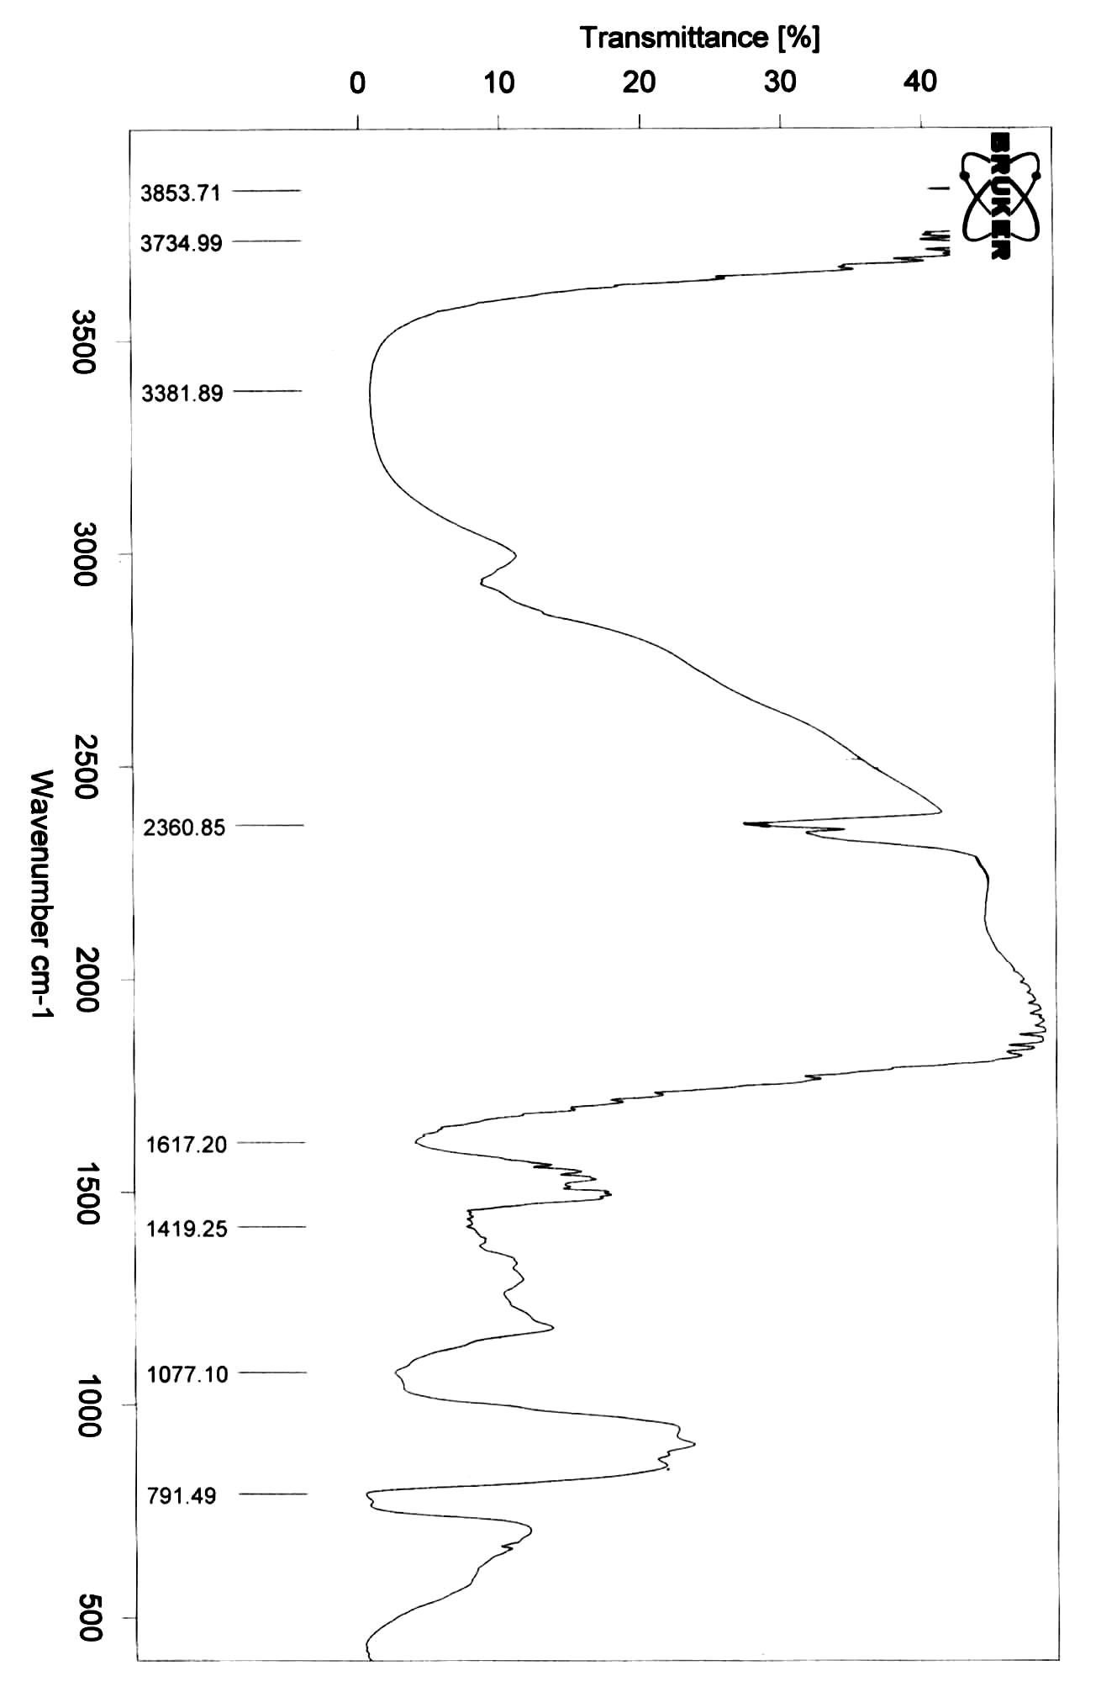
Figure (1): IR spectrum of chloroform extract from the second silica gel column
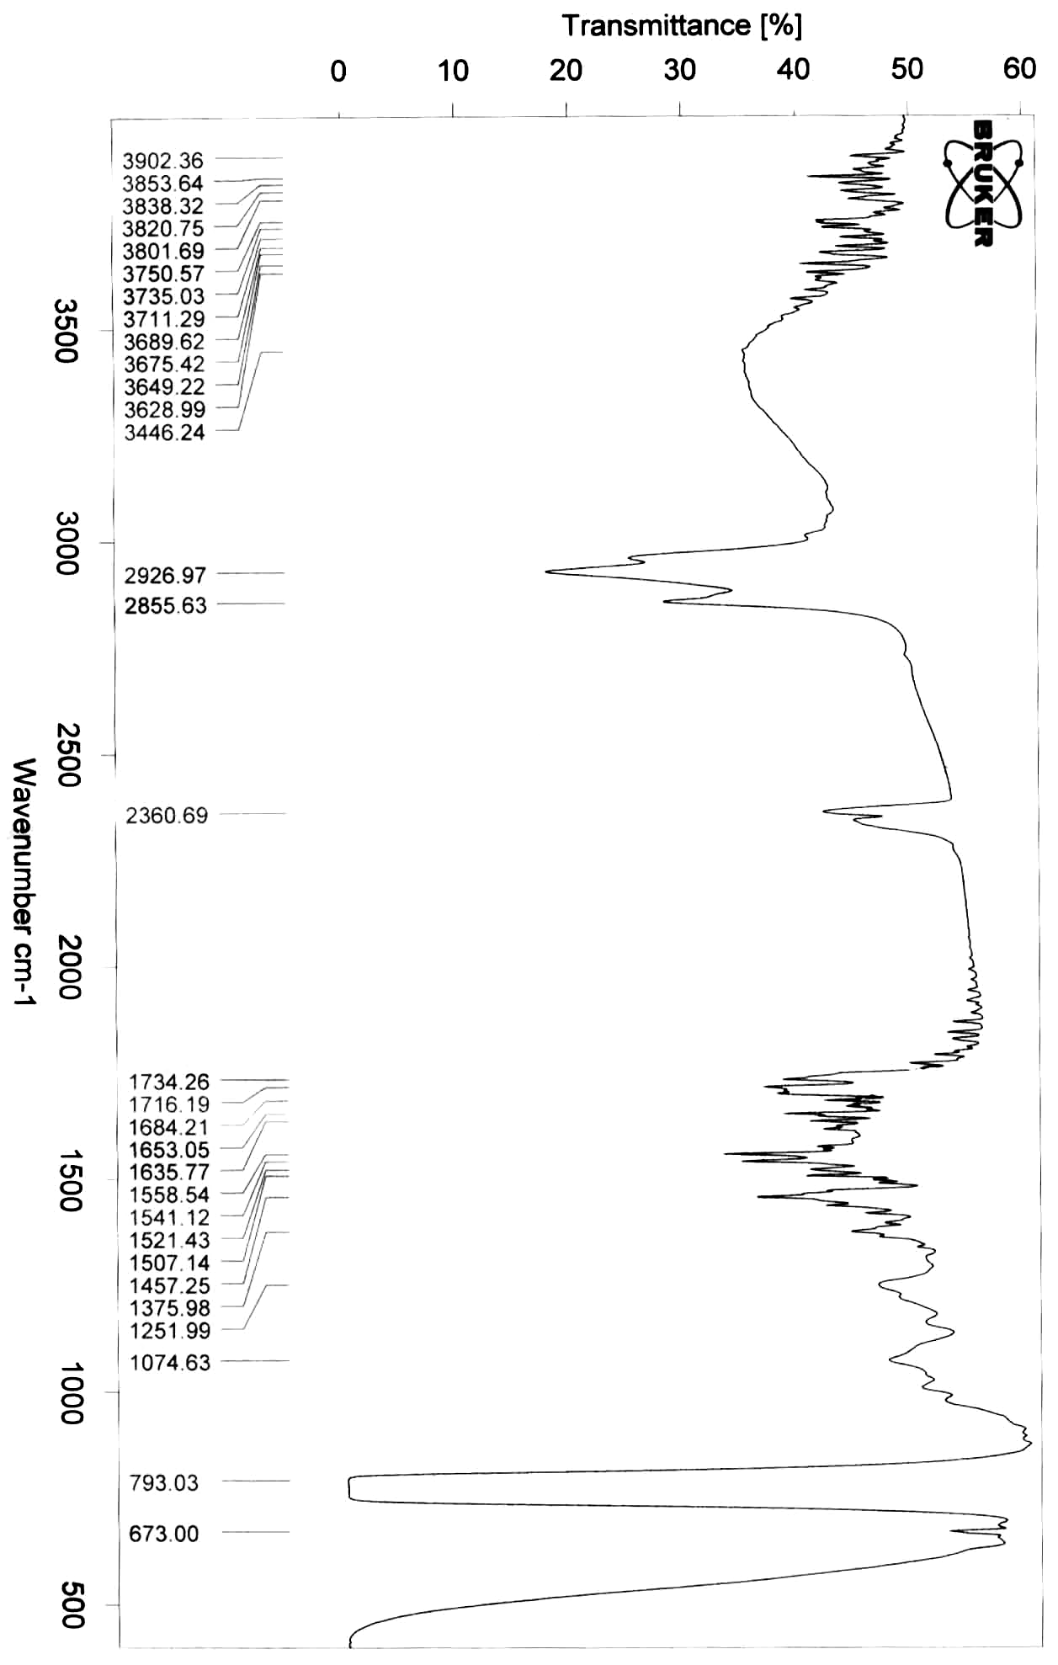
Figure (2): IR spectrum of acetone extract from the second silica gel column
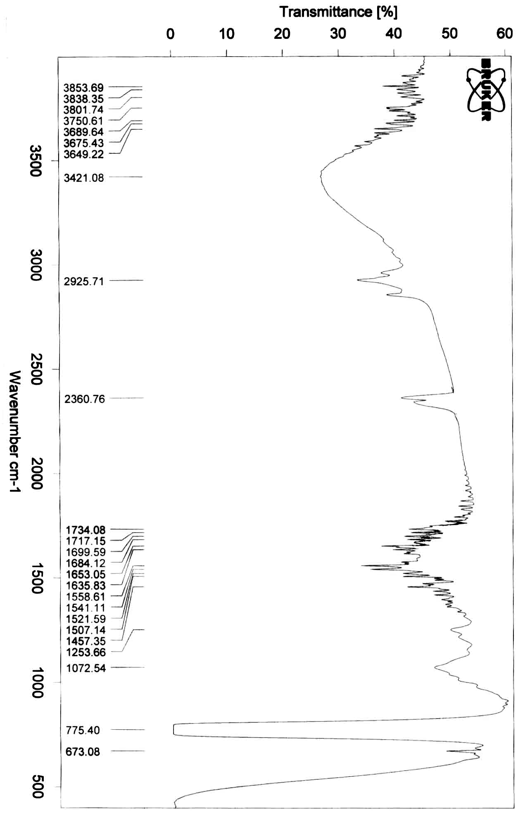
Figure (3): IR spectrum of ethanol extract from the second silica gel column

References
- قطب، ف. ط.، النباتات الطبية، زراعتها ومكوناتها، 1981، دار المريخ للنشر، الرياض.
- Grand, A., J. Ethnopharmacol, 1989, 25, 315.
- Majiid, S.; M. Katayoun and E. Madjid, Proceeding of ICNP, 2002, 153.
- Blumen, M., American Potential Council, 2004, Herpclip T.M.
- Cowan, M.M., American Society for Microbiology, 1999, 12, 564.
- Alowodi, S.E., African Journal of Biotechnology, 2003, 2, 317.
- James, S., JSDC, 2000, 116, 193.
- Bhuranes, W., J. Indian Pharm., 2002, 34, 260.
- Ali, B.H.; Bashir, A.K. and Tanira, M.O., Anti inflammatory antipyretic, analgesic effect of L. inermis in rats. Desert and Marine Environmental Research Center. UAE University, Al-Ain, 1992.
- Dahanukar, S.A. and Kulkarni, R.A., Indian J. Pharm., 2000, 32, 81, 118.
- Baily, L. H., (1977), “Manual of cultivated plant”, 15th ed., Macmillan Publishing Co., NewYork, USA.
- Grand, A; Woudergem, P.A.; Verpartes, R. and Passet, J.L., J. of Ethnopharmacol, 1988, 22, 25.
- Shriner, R.L.; Fuso, R.C. and Curtin, D.Y., 1964, The Systematic Identification of organic compounds. 5th ed., John Wiley and Sons, Inc., NewYork.
- Gidding, J.C.; Graushka, E.; Killer, R.A. and Hazes, J., 1975, “Advanced in chromatography”, Marcel Deleker Inc., NewYork.
- Riose, J.L.; Recio, M.C., and Villar, A., J. Ethnopharmacol, 1987, 12, 139.
- Silverstein, R.M.; Bassler, G.C. and Morrill, T.C., 1981, “Spectrophotometric Identification of Organic Compounds”, 4th ed., John Wiley and Sons, USA.
- Leven, M.; Vandenberghe, D.A.; Metens, F.; Vlietinck, A. and Lammens, E.; Planta. Medica, 1997, 36, 311.
- Vendepitte, J.; Engback, K.; Piote, P. and Heuk, C., Basic Laboratory Procedures in Clinical Bacteriology, 1991, World Health Organization, Geneva.
- Todar, J. Med. Microbiol., 2002, 1.
- Harborne J.B., Phytochemical Method, 1973, University of Reading.
- Medicinal Plants of India, Vol.2, New Delhi: Review of ICMR: 1987, p.140.
- Ballal, M.; Srujan, D.; Bhat, K.K. and Shirwaikar, A., Indian J. pharmacol, 2001, 33, 392.
- Pandy, D.K., Indian Drugs, 1982, 19, 451.

