Synthesis And Oxidation Reactions of Some
Diacetylene Compounds

M.S. Al-Ajely
Chemistry Department,College of Education , Mosul University
Mosul - Iraq

(NJC)

(Received on 12 /10 /2005) (Accepted for publication on 4 / 3 /2006)

Abstract
Some diacetylene compounds were prepared using the well known coupling procedures. These compounds were used as model compounds for polydiacetylenes. They subjected to oxidation with various oxidizing agents. Reaction with performic acid gave the corresponding glycol or ketonic compounds.
الخلاصة
يتضمن البحث تحضيربعض المركبات ثنائية الاستلين وذلك باستخدام طرق الاقتران المعروفة حيث تعتبر هذه المركبات كنموذج (Model) للبوليمرات ثنائية الاستلين التي من خلالها يمكن التعرف على طبيعة التفاعلات التي تعانيها هذه البوليمرات . اجريت تفاعلات الاكسدة لهذه المركبا ت النموذجية باستخدام عدة انواع من عوامل الاكسدة ووجد بان حامض فوق الفورميك (Performic acid) يحول هذه المركبات الىالكلايكولات والكيتونات المقابلة

Introduction
The coupling of terminal acetylenes to form diacetylenes has been known for a considerable period . One of the first method was oxidative Glaser coupling¹ which involve two steps . In later works these two reactions were carried out in situ with many different diacetylenes^{2,3} being produced. Eglinlon and Galbrith in 1950 proposed anew coupling method involving oxidative coupling by cupric salt in pyridine ⁴. Again , there are many examples of this procedure ^{5,6,7} . However, the method which has proved most popular for the coupling of diacetylenes is the Hay reaction ⁸ . The synthesis of unsymmetrical diacetylenes can be carried out using cadiot - chodkiewicz method ^{9,10,11}. The method which was found most versatile for the formation of carbon-carbon single bonds is the palladium or nickel catalyzed cross coupling achieved by the early 1980th¹². Negishi ¹³ in 1984 reported a two steps process leading to conjugated diynes in particular terminal diynes. In this work new enyne compounds (model for polydiacetylenes) were prepared and subjected to
various oxidizing agents. The oxidation product introduced preduction aid for the polydiacetylenes behaviors when they subjected to the same oxidation conditions which will be studied in next work .
Experimental
All organometallic reactions were carried out under an atmosphere of dry nitrogen using standard schlenks techniques . Solvents used were dried under reflux and freshy distilled under a dry nitrogen atmosphere. Drying agents were : Na/benzophenone .
Infrared spectra were recorded on Perkin Elmer 580 and 1600 instruments calibrated against polystyrene , ¹NMR spectra were recorded on jeol PX 60 (60 MHz) . Hitachi R-24 (60 MHz), Bruker WP80 (80 MHz). Bruker WP200 (200. 13 MHz) spectrometers. ¹³C NMR were recorded on a Burker WP200 (50. 323 MHz) spectrometer. Chemical shifts were reported with respect to an external tetramethylsilane reference, (positive shifts were to low field).
UV-spectra were recorded using Shimadzu UV-240 spectrophotometer .
¹H and ¹³C NMR spectra were measured at Heriot–Watt University, Edinburg U.K.
Trimethylsilylacetylene was prepared using the well established procedure ^{14,15} . Tetrakis (triphenylphosphine) palladium (0) [Pd(pph₃)₄] was prepared according to the well known procedure ¹⁶, penylacetylene was prepared following the published procedure ¹⁷, diiodoethylene was prepared by bubbling acetylene in ethanolic iodine solution ¹⁸.
Preparation of Dichloro[l, 3-Bis(diphenylphosphino) propane ] Nickel(II), (NiCl₂dppp):
1,3-Bis(diphenylphosphino) propane (1 g, 2.43 mmol) was placed in ethanol (15 ml) under nitrogen and the mixture refluxed until all the solid had dissolved . NiCl₂ 6H₂O (0.58g, 2.44 mmol) was then dissolved in hot ethanol (15 ml) (again under an atmosphere of nitrogen), and added to the phosphine solution . The combined solutions were refluxed (under nitrogen) for 50 min. After cooling to 0 °C (ice-bath) . The precipitated product was collected and washed with hot ethanol (10 ml) followed by dry ether (10 ml) , to leave 1.1 g (80%) of a dark red solid. The product was used without further purification
The Synthesis of di (enyne) Model Compounds
Preparation of trans 1, 6-Bis(trimethylsilyl) hexa-1, 5-diyne-3-ene(4):
In a procedure similar to that previously reported⁽¹⁹⁾ a solution of trimethylsilyl acetylene (10.08g, 0.102 mmol) in THF (100 ml) was cooled to -78 °C (liq. N₂). To this was added 37 ml (0.107 mol) of a 2.9M solution of ethyl magnesium bromide in ether. A thick white suspension was formed on warming to room temperature over 2 h. The reaction mixture was then cooled to -78 °C (liq. N₂) , whereupon trans 1,2 dichloroethylene (3.94 ml, 0.0406 mol) was added along with [ NiCl₂ (dppp)] , (0.748g, 0.0014 mol). The mixture was slowly warmed to room temperature , with the colour changing to yellow and finally to dark red/ brown colour . After stirring for 12 h the reaction was quenched by the addition of a saturated solution of ammonium chloride (150 ml). The organic phase was separated from the aqueous phase and washed with brine (2x50 ml) and water (2x50 ml). After drying over anhydrous sodium sulphate, the solvent was evaporated under reduced pressure, yielding a yellow solid in a brown oil . The product was dissolved in 40-60 petroleum ether and chromatographed on a column of silica gel . The collected fractions yielded a yellow / white solid in a yellow oil. Recrystallization of the product from methanol yielded 6.23 g, (66%) of a yellow solid ⁽⁴⁾ . Further purification was effected by sublimation to yield white solid mp 74-76 °C .

Synthesis of trans l-chloro4-phenyl-l-buten-3-yne²⁰(1):
To a stirred solution of phenylacetylene (1 g, 9.7 mmol) in dry benzene (75 ml) under nitrogen was added anhydrous n-butylamine (4.8 ml, 48.5 mmol) followed by trans 1,2-dichloroethylene (1.9g, 1.5 ml, 19.4 mmol). To this solution was added copper (I) iodide (0.277g, 1.5 mmol) followed by tetrakis (triphenylphosphine) palladium (0) (0.5g, 0.49 mmol). After stirring for 20 h the mixture was washed with brine (2 x 50) and then dried over anhydrous sodium sulphate . This was followed by the removal of the solvent under reduced pressure , and purification of the residue by column chromatography on silica gel (hexane) to yield 0.8g (51%) of a pale yellow oil(1).
Synthesis of l-phenyl-6-trimethylsilylhexa-l, 5-diyne-3-ene (2):
A solution of trimethylsilylacetylene (0.75g, 7.54 mmol) in dry THF (15 ml) was cooled to -78 °C (liq. N₂). To this was slowly added ethyl magnesium bromide in ether. The thick white suspension was then allowed to warm to room temperature over period of 2 h, and then the mixture was gently refluxed under an atmosphere of nitrogen for 1 h. After cooling to -78 °C , trans l-chloro-4-phenyl-l-buten-3-yne (1) (1g, 6.11 mmol) and NiCl₂ (dppp) (0.056 g, 0.1 mmol) were added to the reaction mixture in sequence , with stirring . The mixture was slowly allowed to warm to room temperature and stirring was continued for 12 h. The reaction was quenched by pouring the mixture into saturated ammonium chloride solution (150 ml) . The organic phase was separated from the aqueous phase , and washed with water (20 ml) and brine (20 ml), followed by drying over anhydrous sodium sulphate . The remaining solvent was removed under vacuum and the residue purified by column chromatography on silica gel (petroleum ether 60/80) to yield 1.1 g (65%) of a pale yellow oil (2).
Analysis ; calculated for C₁₅H₁₆Si : C, 80.36 : H, 7.14%
found :C. 80.5 : H, 7.3%
Desilyation of l-phenyl-6-trimethylsilyl hexa-1, 5-diyn-3-ene²¹ (3):
A mixture of lithium hydroxide (0.25g, 10.45 mmol), l-phenyl-6- trimethylsilyl hexa-1, 5-diyne-3-ene (2) (0.4g, 178 mmol), THF (5 ml) and water (0.25 ml) were stirred at room temperature for 2 h. The organic and aqueous being washed with pentane (3x5 ml) . The combined organic extracts were dried over anhydrous potassium carbonate , and then filtered through celite, washing with further pentane (10 ml) . Removal of the solvent yielded a clear oil (3), unstable at room temperature
Synthesis of trans 1, 6-diphenyl hexa-1, 5-diyne-3-ene²² (6)
A mixture of phenylethynyl copper (I) (3.4 g, 0.02 mol) and trans-1,2-diiodoethylene (2.69 0,01 mol) were stirred in dry pyridine (50ml) under an atmosphere of nitrogen for 2 h , and the mixture was gently heated to 90-100 °C , then the yellow solid was rapidly dissolved to give a red solution which after 2 h had turned black. This solution was poured into a mixture of ice-concentrated hydrochloric acid (1:1) , the solid formed was filtered off and washed with water . The filterate and washing were combined and extracted with ether (3x50 ml) , the extracts were dried over anhydrous magnesium sulphate . the solvent was evaporated under reduced pressure yielding a brown solid which on recrystallization from light petroleum (60-80 °C) yielded trans-l,6-diphenyl hexa-l,5-diyne-3-ene (2.2g) m.p 113-114°C.

Synthesis of 1, 4-diphenyl-l, 3-butadiyne (8):
The preparation of the title compoimd was done using cupric acetate pyridine system⁴ , Cuprous derivative of phenylacetylene was prepared by treatment of phenyl acetylene (10 ml) with saturated solution of cuprous iodide in ammonium hydroxide in a (250 ml) flask, stoppered and shaken vigorously for 30 min , the yellow precipitate was then filtered off, washed with water and dried at room temperature .
The cuprous acetylide was dissolved in pyridine (60 ml) . This solution was added to a hot solution of cupric acetate (2 g) in hot pyridine (60 ml). The resulting green solution was heated for 20 min at 90 °C . The reaction mixture was poured into a mixture of ice concentrated HC1 1:1 and filtered , washed with water . The filtrate and washings were combined and extracted with ether (3x50 ml) , then followed by drying over anhydrous magnesium sulphate . The product was dried under vacuum. The resulting brown solid (80%) was recrystallized from ethanol gave 1, 4-diphenyl-l, 3-butadiyne m.p 84-86 °C
Reduction of 1, 4-diphenyl-l, 3-butadiyne with LAH ²³ :
Lithium Aluminum Hydride (LAH) , 0.8g and 1, 4-di-phenyl-l,3-butadiyne (4g) in 1 : 1 molar ratio were dissolved in dry and degased THF 100 ml) in 250 ml. round bottomed flask . The contents of the flask were flushed again with nitrogen. The reaction mixture was heated at 50 °C for 24 h. After cooling water (60 ml) was added and the mixture was left overnight in ice-bath. The precipitated product was then filtered and washed with n-hexane.
Crystallization from methanol yielded (0.63 g, 7%) of yellow crystals m.p 94-95 °C . of compound(9).
The reaction of two moles of phenyl acetylene with one mole of trans 1, 2-dichloro ethylene was also achieved . So phenyl acetylene (6.6 ml, n-butyl amine (23.4 ml) , 1, 2-dichloro ethylene (3.6 ml), cuprous iodide (1.35g) and Tetrakis triphenylphosphine Pd (0.243g) were dissolved in dry and degased toluene (100 ml) . The reaction mixture then stirred for 16 h at room temperature , the solution was evaporated under reduced pressure . The residue was extracted with ether and dried on anhydrous magnesium sulphate. The solution was then evaporated yielded a brown solid in dark oil, it was crystallized from ethanol a yellow crystals of compound (6), 80% yield, m.p 84 °C .
Attempted reaction of model compound with various oxidizing agents:
Reaction of trans-1, 6-diphenyl hexa-1, 5-diyne-3-ene with (UHP)²⁴ :
Urea hydrogen peroxide (UHP) was prepared according to the method reported previously ²⁵ . Acetic anhydride (4.089) was added dropwise to stirred mixture of UHP (7.69); disodium hydrogen phosphate (20 g), compound. (6), (0.95g) in dichloromethane (100 ml) at 0 °C . The mixture was allowed to warm to room temperature and stirring was continued for 10 h, saturated solution of sodium hydrogen carbonate was added to neutralize the acid . The aqueous layer was then extracted with dichloro methane . The combined organic layers were washed with water, dried over anhydrous magnesium sulphate and evaporated after confirming the absence of peroxide to afford the starting material, compound (6), it was confirmed from m.p , IR and NMR spectra.
Reaction of 1, 6-bis(Trimethylsilyl) hexa-1, 5-diyne-3-ene with (UHP):
Again the treatment of compound (4) with UHP according to the previously mentioned procedure was unsuccessful and the starting material was recovered
Reaction of compound (4) with (MCPBA):
Metachloroperbenzoic acid (MCPBA) has been freshly prepared according to the well known procedure ²⁶. The strength of this per acid was determined by iodometric titration. The oxidation was carried out according to a previously published procedure²⁷ . Compound (4), (1 g) and MCPBA (0.86 g) were dissolved in dichloromethane (200 ml). The reaction mixture was stirred for 24 h , then filtered and washed with 5% sodium carbonate , dried organic layer was separated , the aqueous layer was washed with further dichloromethane (50 ml) , the dichlorometane fractions were combined, dried on anhydrous magnesium sulphate . the solvent was evaporated under vacuum , the residue was crystallized from ether/methanol giving white crystals of compound (4).
Reaction of 1, 4-diphenyl-l, 3-butadiyne with performic acid²⁸ :
To a mixture of compound (8) , (1 g) and 98% formic acid (20 ml), 30% hydrogen peroxide (8.6 ml) was added . The reaction mixture was then heated to 40°C with continuous stirring for 24 h . The temperature was allowed to rise to 80 °C and the stirring continued for 4 h. The reaction mixture was then cooled and the unreacted material was filtered and the filtrate was treated with sodium carbonate and extracted with ether (3x20 ml) , dried over anhydrous magnesium sulphate . The final solution was left for 3 h, gave yellowish white crystals of compounds (10) 10% yield, mp 118-120 °C.
Analysis : Calculated for C₁₆H₁₀O₂ : C, 82.03 : H , 4.30 .
Found : C 82.0 : H, 4.30%
Reaction of Trans-l,6-diphenyIhexa-l,5-diyne-3-ene with performic acid :
The above reaction was carried out in 1 : 1 molar ratio , but the reaction. was too slow. A mixture of compound (6), (0,456g) and excess of performic acid hydrogen peroxide 5ml, and formic acid 20 ml were stirred at 70 ºC for 3 days . The reaction mixture was then cooled to room temperature and water (20 ml) was added . The brown powder was filtered and crystallized from ether to give yellow crystals of compound (7) (13% yield) m.p. 130 °C.

Analysis : Calculated for C₁₈H₁₄O₂ : C, 82.42 : H, 5.38%
Found : C 82.40 : H, 5.4%
Reaction of trans-1, 6-Bis (trimethylsilyl) hexa-1,5-diyne-3-ene with performic acid (5):
In a procedure similar to that previously mentioned , trans-1, 6- Bis(trimethylsilyl) hexa-1, 5-diyne-3-ene (4) , (1 g) and performic acid (hydrogen peroxide 5 ml and formic acid 20 ml), working up as before . The final mixture was treated with ether (100 ml) and washed with 5% sodium carbonate solution 10 ml. The organic phase was separated from the aqueous phase . After drying over anhydrous sodium sulphate , the solvent was evaporated under reduced pressure , yielding yellow solid product, crystallization from minimum amount of ether gave 10% yield of white crystals (5) m.p. 95 °C.
Analysis ; Calculated for C₁₂H₂₂Si₂O₂: C, 72.68 : H, 11.18%
Found : C, 72.66 : H, 11.21%

Results and Discussion
The models were synthesized by established metalmediate Grignard reaction. 1, 6-Bis (Trimethylsilyl) hexa-l,5-diyne-3-ene, l-phenyl-6-Bis(Trimethylsilyl) hexa-l,5-diyne-3-ene, 1-phenyl hexa-1, 5-diyne-3-ene and 1, 4-diphenyl-l-ene-3-yne were prepared in E-form (listed in the experimental part). Compound (4) (Scheme 1) and compound (6), (Scheme 2) , were prepared according to previously published procedure^{20,22,29}. Their IR and NMR spectral data were detailed in Table (1,2). The asymmetrically substituted diyne (2) (Scheme 1), was prepared by NiCl₂ (dppp) promoted coupling of trimethylsilylacetylene magnesium bromide ¹⁹ , the spectral data are detailed in Table (1,2).
Desilyation reaction of compound (1) was effected by lithium in aqueous tetrahydrofuran²¹ to give the new compound (3) which was stable at -5 °C in n-pentane solution . The spectral data listed in Table (1,2) confirm its structure . This compound could be transformed with ethylmagnesium bromide into Grignard reagent then coupled separately with E, l-Chloro-4-phenyl-l-butene -3-yne and E, 1, 2-2dichloro ethene to give triyne diene and tetrayne triene as extended model compounds .
Compound (9) (Scheme 2) has been previously synthesized³⁰ by the reaction of phenylacetylene with catalytic amount of chlorotris triphenylphosphine) rhodium (I) as a mixture of head-to head and head- to-tail dimerization afforded 2,4-diphenyl-but-l-ene-3-yne as side product 14% whilst compound (9) formed 20% yield . In this work compound (9) was prepared as stereospecific product using previously reported procedure²³ by treatment of compound (8) with lithium Aluminum hydride (LiA1H₄) the spectral data listed in Table (1, 2) was in good agreement with previous finding²⁷.

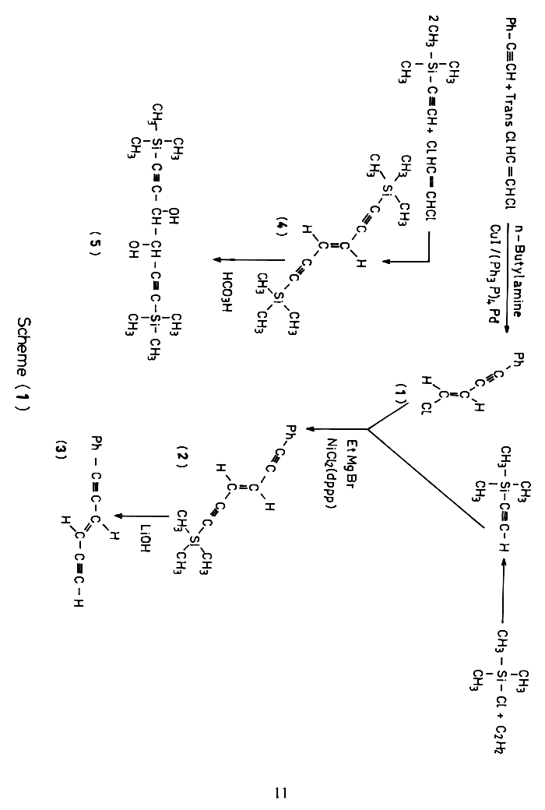
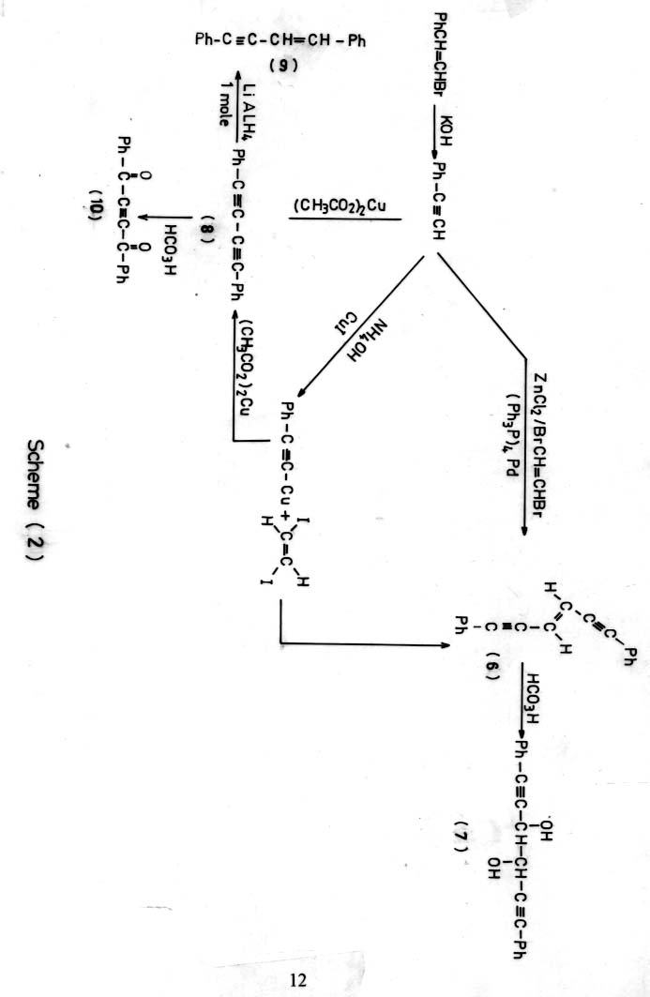
Table (1) IR. absorption spectral data of starting materials and the model compounds together with model reaction products.
Com. No. | m.p.  ºC | Yield  % | Solvent | ν cm⁻¹ absorption bands
H-C≡C-Si(CH₃) | 57 | 30 | Neat | 2040 (C≡C)
IHC=CHI | 73 | 63 | Nujol | 1620 (w)
HC≡C-ph | 141 |  | Neat | 2990 (s, , C-H stretch), 2220 (s, C≡CH), 1600, 1500 (ph)
4 | 74-76 | 66 | Nujol | 3030 (w), 2960 (m), 2895 (w, C-H), 2080 (s), 2030 (s, 2C≡C, 1640 (w), 1620 (C=C), 1450 (m), 1405(m), 1340 (w), 1250 (s), 1245 (s), 1165(m).
1 | -- | 51 | Neat | 3070 (s), 3035 (m) for (C-H), 2210 (m, C≡C), 1580 (m)
2 | -- | 55 | Neat | 3080 (w), 3060 (w), 3030 (m), 2960 (s), 2920 (s), 2900 (m) for C-H, 2020 (s, C≡C), 1600 (m), 1485 (ph), 1440 (m), 1290 (m)
5 | 95 | 10 | Nujol | 3300 (b, OH), 2995, 2890 (s, C-H), 2100 (w, C≡C), 1750 (m), 1600, 1500 (w) for ph, 1110 b (C-O)
6 | 113-114 | 64 | Nujol | 3010 (s, C-H), 2150, 2100 (w) for  (C≡C), 1650 (m), 1600s, 1500 (S, ph)
7 | 130 | 13 | Nujol | 3330 (b, OH), 2980 (s, C-H), 2100 (W, C≡C), 1600, 1500 (s, ph), 1200 (s, C-O).
8 | 84-86 | 80 | Nujol | 2955 (s, C-H Ar), 2200 (w, C≡C), 1600, 1500 (s, ph)
9 | 94-95 | 7 | Nujol | 2985 (s, C-H), 2220 (w, C≡C), 1640 (w, C=C), 1600, 1500 (s, ph)
10 | 118-120 | 10 | Nujol | 2990, 2980 (s, C-H), 2100 (w), 1700 (s, C=O), 1600, 1500 (w, ph)

Table (2) ¹³CNMR spectral data of starting materials and the model compounds together with model reaction products.
Com. No. | HNMR,³CNMR (solvent) | ppm JHz
H-C≡C-Si(CH₃) | ¹H (60 MHz) | 2.17 (s, 1H, C≡CH), 0.15 (s, 9H, Si(CH₃)₃
IHC=CHI | ¹H (60 MHz) (CDCl₃) | 6.3 (s, HC=CH)
HC≡C-ph | ¹H (60 MHz) (CDCl₃) | 7.1 (m,ph), 2.3 (s, C≡CH)
4 | ¹H (200 MHz) (CDCl₃) | 5.99 (s, 2H, C=CH), 0.17 (s, 18H, Si(CH₃)₃
4 | ¹³C (50 MHz) (CDCl₃) | 121.73 (C=C), 102.94, 100.16 (C≡C), 0.24 Si(CH₃)
1 | ¹H (80 MHz) (CDCl₃) | 7.30 (m, 5H, ph), 6.55 (d, 1H, JAB=13, C=CH, 6.09 (d, 1HJAB=13.6, C=CH)
2 | ¹H (20 MHz) (CDCl₃) | 7.44 (m, 2H, ph), 7.32 (m, 3H, ph), 6.24 (d, 1H, JAB=16.08, C=CH), 6.07 (d, H, JAB= 16.08, C=CH)
2 | ¹³C (50 MHz) (CDCl₃) | 131.61, 128.61, 128.33, 122.6 (ph), 121.88, 120.53 (C=C), 103.24, 100.47, 94.97, 87.74 (C=C), 0.22 Si(CH₃)₃
3 | ¹H (200 MHz) (CDCl₃) | 7.44 (m, 2H), 7.33 (m, 3H), 6.31 (A component of ABX system, 1H, JAB= 16.11, JAX= 0.52, C=CH), 6.04 (B component of ABX system, 1H, JAB= 16.10, JBX= 2.35, C=CH), 3.205 (dd, 1H, JHA= 2.35, JBX= 0.58, C=CH)
3 | ¹³C (50 MHz) (CDCl₃) | 131.61, 128.71, 128.35, 122.65 (ph), 122.90, 119.50 (C=CH), 95.03, 87.31, 81.94 (C≡C), 82.35 (C≡CH)
5 | ¹H (200 MHz) (CDCl₃) | 6.2, 6.3 (d, 2H), 6.4 b (OH), 0.16 Si(CH₃)₃
6 | ¹H (200 MHz) (CDCl₃) | 7.4 (m, ph), 6.3 (s, olefinic protons)
7 | ¹H (200 MHz) (CDCl₃) | 7.4 (m, ph protons), 6.4, 6.5 (d, 2H), 4.7 (b, OH)
8 | ¹H (60 MHz) (CDCl₃) | 7.2 (m, ph)
9 | ¹H (200 MHz) (CDCl₃) | 7.4 (m, ph), 6.3 (q, AB system)
9 | ¹³C (50 MHz) (CDCl₃) | 137.36, 141.25 (olefinic carbons),  132.80, 131.5, 129.23, 128.95,  128.6, 128.6, 128.35, 127.53,  126.38, 121.68, 108 (phenyl ring carbons), 95.00, 87.80 (acetylenic carbons)

Reaction of model compound with various oxidizing agents
It was established²⁵ that U.H.P alone in combination with anhydrides has been shown to serve as a valuble alternative to anhydrous hydrogen peroxide . The use of this reagent was ineffective at oxidation of trails 1, 6 -Bis (trimethyl silyi) hexa-1, 5-diyne-3-ene (4) (Scheme 1) . We have also examined the reactivity of compound (4) toward MCPBA as oxidizing agent with the goal of preparing the epoxide but it was ineffective at epoxidation of the above compound . It is also worthnoting that compound (4) showed great stability toward sulphuric acid, where a sample stirred with dil H₂SO₄ for 24 h and showed no sign of reaction . This behavior indicate that C=C was extra stabilized by its conjugation to the carbon-carbon triple bond. The results of negative respond of trans , Bis(Trimethyl silyi) hexa-1, 5-diyne-3-ene toward the above oxidizing agent confirmed by m.p. IR and U.V of the final product . The U.V spectrum of the compound showed identical bands max 28.73
(ε 4.08xl0⁴), 271.2 nm (s 3.6xl0⁴) dm³mol⁻¹cm⁻¹ with the product, which gives evidence that the conjugated system was not disrupted.
There was similar speculation concerning compound (6) (Scheme 2). This compound showed negative respond toward U.H.P and MCPBA, this behaviour was also con firmed by m.p., IR and U.V measurements of the products .
The U.V-spectrum gave identical bands λ_{max} 332.2 (ε = 9520), λ_{max} 276 nm with starting material (no disruption of the conjugated system), which also means the stability of C=C by conjugation to adjacent carbon-carbon triple bonds . The more stronger oxidizing agent which have to be tried is trifluoroperacetic acid. The unavailability of 90% hydrogen peroxide to prepare the above peracid so performic acid was used instead as oxidizing agent. It was established that trifluoroperacetic acid could oxidize diphenyl acetylene to benzil²⁸, 1,4-diphenyl-l,3-butadiyne (8) scheme (2) was treated with performic acid and showed that the C≡C could be oxidized to give dibenzoyl acetylene (10, 10%) which was confirmed from C.H.N analysis and the IR spectral data , Table (1).
The above results encouraged us to use this reagent for oxidation of the model compound which contain C=C , more susceptible for oxidation than C≡C bond.
Reaction of Trans-1,6-Bis (Trimethylsilyl) hexa-1, 5-diyne 3-ene with performic acid (5)
It has been established ²⁸ that treatment of the olefmic compound with performic acid results in the formation of epoxide intermediate , then the acid attacks one of the oxirane ring carbons giving the corresponding threo glycol, so compound (5) was prepared according to the previously mentioned procedure ²⁸ (listed in the experimental part). The IR spectrum of the above compound shows that the acetylenic bonds in the free model transformed into single absorption band ν 2100 cm⁻¹ which means that carbon-carbon double bond was transformed into single symmetric bond and that the free rotation of the two acetylenic moieties about this single bond resulted in giving only the above absorption band , accompanied by -OH stretching absorption at ν 3300 cm⁻¹ , and it is reasonable to conclude that similar epoxidation and opening of the epoxy intermediate to diol occurs to compound (7) . This conclusion is supported by the ¹HNMR Table (2) which shows that the two protons resonating at slightly lower field region (higher frequency) as double signal δ 6.2, 6.3 ppm accompanied by broad signal resonating at S 6.4 ppm assignable to the hydroxy protons.

It is important to mention here that the coupling procedures used in our investigation are used for coupling diacetylene monomers to obtain polydiacetylenes for different optical ^{31,32} and medical³³⁻³⁷ applications in which the model compounds will give significant imagination toward polydiacetylenes behaviors for their susceptible applications..

References
- G. Glaser, Ber., 2 422 (1969); Ann., 137, 154 (1870).
- W. Chodiwicz, Ann, 1957, 2, 819.
- G. Eglinton and McCare, Adv.Org. Chem., 1963, 4, 225.
- G. Eglinton and A.R. Galbrith, J. Chem. Soc., 1959, 889.
- C. Plancketta, N. Ran. A. Huck and R.C. Schultz Makromol Chem. Rapid Commun., 1982, 3, 249.
- T. Abraham, E.J. Soloski and C.L. Benner, J. Polym. Sci., 1989, 27, 4305.
- W. Chodiwicz. Compt-Rend, 1957, 245, 325.
- A.S. Hag, J. Org. Chem., 1962, 27, 3320.
- Chodkiewicz, W., Ann. Chim, 1957, 2, 819.
- Chodkiewicz, W., and P. Cadiot, Bull Chem. France, 1958, 298.
- Chodkiewicz, W., J.S. Alhuwalia, P. Cadiot and A. Willemart, Compt. rend, 1957, 243, 322.
- M. Bertault, L. Tauper, J. Canceill and A. Collet., Macromol. Chem. Rapid Commun, 1987, 8, 443.
- E. Negishi, N. Okukodo, S.F. Lovich and F. luo., J. Org. Chem., 1984, 49, 2629.
- K.P.C. Volhardt and L.S. Winn, Tetrahedron lett, 1985, 26, 709.
- W. Edward Lindsell, Peter N. Prston and Peter J. Tomb, J. Organometalic Chemistry, 1992, 439, 201.
- P. Fitton and J.E. McKeon, Chem. Commun., 1968, 4.
- C. Campbell. Org. Synthesis, 1950, 30, 72: Coil, 4.
- Keiser. Ann. Chem., 1899, 12, 265: Chem abst., 1947, 2697a.
- J.A. Wolker, S.P. Bitler and F. Wadi, J. Org. Chem, 1984, 49, 4733.
- Andrew S, Kend C.A, Smith, J. Org. Chem., 1988, 53, 2655.
- SJ. Danishefsky, D.S. Yamashita and N.B. Manto, Tetrahedron Lett., 1984, 26, 709.
- B.J. Coe. P.L. Marsh and C.R. Tatlow, J. Chem. Soc. Perkin Trans, 1972, 1, 639.
- E.F. Magoon and L.H. Slaugh, Tetrahedron, 1967, 23, 4509.
- M.S. Copper, H. Heaney, A.J. Newbold and W.R. Sanderson, Tetrahedron Lett.,1990, 533.
- C.Lu.E. Wttughes, P.A. Giguore, J. Am.Chem. Soc., 1941, 63, 1507.
- "Organanicum. Practical Hand book of Org. Chemistry" Edited by PA.OngleyP.44 (1973).
- J.K. Crandall, W.Wconver, J.B. Kominand, W.H.Machleder, J.Org.Chem., 1974, 39, 1723.
- D.C. Klenmfelter and P.V. R. Schleyer, J. Am. Chem. Soc., 1961, 83, 2329.
- Adrino Carpita and Renzio Rossi, Tetrahedron Lett, 1986, 27, 4351.
- J. Ohshita, K. Furumori, A. Matsuguchi and M. Ishikawa, J. Org. Chem., 1990, 55, 3277.
- SUNG-HO jin, SUNG–HYUN HIM TEONG–SOON GAL J. polymer Sci .Part A ,Polymer Chem ., 2001, 39, 4025.
- SUNG-HO HN ,JUGNGF JIN, SEONG- BAE MOON, HYUNG-HONC LEE, TEONG-SOON GAL, J. Polymer Sci. part A, Polymer Chem., 2002, 40,958.
- D. Charych, Q. Cheng, A. Reiche G. Kuzienko, Chemistry and Biology, 1996, 3,113.
- W.E Liudseel ,C. murry, P.N. Preston and T. A. J .Woodman, Tetrahedron, 2000, 56, 1233.
- P.T. Hennios, M.H.C. Sautuua and R.D Correia , J. Braz .Chem. Soc., 2001, 12(l), 64.
- T. Sheynis , J. Sykora , A-Benda , S. Kolushera ,M. Hof and R. Jeliuk, Eur.J. Biochem ., 2003, 270 ,4478.
- Jie – Chen and Amir Berman, Nanotechnology, 2004, 15, 5303.

.

