

Iraqi National Journal of Chemistry
Journal homepage: http://iqnjc.com/Default.aspx

Determination of the Concentration Level of Homocystiene in The Serum of Patients With Myocardial and Type II Diabetes in Salahaddin Province

¹Nadia Ahmed Saleh Aljbarah, ²Omeed Majeed Al-Muhandis, ²Amjed Abbawi Saleh Aljebouri,
¹Tikrit University, Chemistry Department, Salahaddin, Iraq ²Kirkuk University, Chemistry Department, Kirkuk, Iraq
omeed27@gmail.com
Amjed_ch86@yahoo.com
nadia78@yahoo.com

ABSTRACT

Clinical studies predict an increase in the mortality rate among patients with heart disease and diabetes in the world by 2020 because of the symptoms of high blood pressure that leads to aggravation of the cardiovascular disease. Any rise in the level of amino acid in the blood directly contributes to high blood pressure and symptoms of diabetes that are considered a significant exacerbation of the causes of cardiovascular disease. Controversy still holds about the direct and indirect relationship between amino acids and cardiovascular disease (heart attack) and type II diabetes. Therefore, our study included verification of the relationship between amino acid concentration and the symptoms of heart attacks and diabetes type II.
Our research was based on a study of 50 cases of patients of both sexes who suffer from heart disease and Type II diabetes, in addition to 25 healthy persons of 25-45 years of age as a group control. Cases were randomly adopted from outpatient clinics in Tikrit Teaching Hospital. Reliable measurements of amino acid levels in the blood serum of people with stroke, heart attack and diabetes were done by using Eliza technique. They were compared with the approved standard controls. A sharp increase in the concentrations of homocysteine, triglycerides and cholesterol has been observed at the level of statistical significance (p ˂ 0.01) in patients who suffer from stroke, heart disease and diabetes type II compared with the healthy group. Whereas, a different relationship has been observed with folic acid and vitamin B₁₂. The concentration of folic acid at the level of statistical significance (p ˂ 0.01) and the concentration of vitamin B₁₂ at the level of statistical significance (p ˂ 0.05) have decreased in patients with stroke, heart disease, diabetes type II compared with the healthy group.

Keywords: homocysteine, cardiovascular, diabetes

Introduction:
Homocysteine (Hcy) ​​is a natural amino acid contains sulfur, a 2-amino-4-mercabtobutanic acid in a free form or linked structure (but not in proteins). It plays important roles in metabolic processes in mammals⁽¹⁾. The natural metabolism of Hcy requires the provision of enough amounts of folate and vitamin B₁₂ and lesser amounts of vitamin B₆ and riboflavin. The levels of these vitamins is inversely proportional to the distribution of Hcy levels⁽²⁾. For this, we find folate with vitamin B₆ and B₁₂ are commonly used to treat high Hcy ​​levels through dietary supplements containing these vitamins⁽³⁾. Homocysteine plays a major role in the destruction of body arteries more than the effects of smoking or obesity or cholesterol and it is discharged in two ways. The first way, Hcy is converted into methionine by a reaction that depends on the presence of folate, vitamin B₁₂ and methionine synthase enzyme. The other way is to get rid of the excess homocysteine by conversion into cysteine by a reaction that depends on the presence of vitamin B₆ and cysteine beta synthase enzyme⁽⁴⁾.
Diabetes is a chronic disease characterized by excessive sugar in blood due to multiple factors, environmental or genetic. This disease occurs due to the lack of effective insulin or it results in part due to partial or total lack of insulin or exhibition of resistance to insulin by the muscles and liver⁽⁵⁾. These factors lead to the high level of sugar or glucose in blood. The disturbed action of insulin leads unbalanced metabolic operations of carbohydrates, fats and proteins with the emergence of various symptoms, such as thirst, and increased urination (Polyuria), with an apparent formation of ketone structures⁽ ⁶⁾. Diabetes Mellitus can be classified as two types^{(7,8)}. Type I, insulin-dependent diabetes. This type of diabetes affects the age group of newborn to 25 years of age, as well as its appearance sometimes in the elderly^{(9.10)}, with an estimated incidence of (5-10%)⁽¹¹⁾. This type of insulin dependent diabetes occurs due to lack (wholly or partly) of insulin hormone, which is secreted by the beta pancreatic cells⁽¹²⁾. Type II diabetes is insulin independent that affects people who are older than thirty years of age. It is therefore, called Adult-Onset diabetes, with an estimated incidence of about (90. 95%). Type II diabetes is distinguished from Type I, first by its insulin resistance. This type usually occurs in obese people as a result of a defect in their target tissues, where insulin hormone actually works (insulin receptor, or post-receptors)^{(13,14,15)}.
High levels of Hcy ​​in blood plasma increases the tendency for blood clotting excessively and can therefore form clots inside arteries. These clots will decrease blood flow, which leads to a lack of blood supply to the heart muscle resulting into a heart attack. Therefore, the damaging risk of high levels of Hcy is several times higher than the other risks of blood pressure, high cholesterol, smoking, diabetes⁽¹⁶⁾. High levels of Hcy ​​is a strong evidence of the likelihood of death due to Atherosclerosis, which directly occurs through the formation of toxic effects. Cellular Lining inside the veins get crushed causing inflammation of the veins, as well as causing acceleration of oxidation of low density lipid proteins⁽¹⁷⁾. Concerning folic acid (Petroyl glutamic acid) cannot be created in mammal's body, but is obtained from food^{(18.19)}. This vitamin was isolated for the first time in 1941 from spinach leaves, and was prepared in laboratory in 1946. In 1998, the Food and Drug Administration in the United States made improvements to flour and grain by adding folic acid at a proportion of 0.14% that contribute to increasing the level of acid in the body⁽²⁰⁾.
Methods and Materials
Collection And Preparation of Blood Samples
(50) Blood samples were collected from sick people at Tikrit Teaching Hospital with diabetes type II and heart attack within age range between (25-45 years) of both sexes. Information about patients' treatment before and after entering the hospital were obtained from their Case Sheets. On the other hand, information for the Control Group were obtained from samples taken from healthy people at the same Hospital. Sample collection was performed by taking blood (5ml) from arm veins of both the patients and healthy people using plastic disposable syringes. Blood samples were kept in plastic tubes with appropriate lids treated with anti-clotting agent (EDTA). Blood serum was directly separated from blood by centrifuge at speed of (4000 rpm) for a period ranging ⁽¹²⁻¹⁵⁾ minutes. The samples were kept a freezer at (-20C˚).
Determination of Homocysteine ​​Level in Serum
Hcy ​​levels were estimated using the ELISA technique through the use of Hcy enzyme, which ​​is considered as an immune enzyme and is used to estimate Hcy ​​in the blood⁽²¹⁾.
Determination of Folic Acid and Vitamin B₁₂ Levels in Serum
Folic acid and vitamin B₁₂ in the blood serum were measured by using the ultra-sensitive ELISA technique (by R & D, Minneapolis, MN system) with CVs of 10.3%, 6.1% and 4.1%, respectively⁽²²⁾.
Determination of Cholesterol Level in Serum
The estimation of the concentration level of cholesterol was done using several test kits manufactured the French Company (Biolabo). This method relies on the basis of converting cholesterol and cholesterol esters to the pink dye (Quinoneimine)⁽²³⁾.
Determination of Triglycerides Level in Serum
Estimation of the concentration level of triglycerides was performed using several test kits, which are manufactured by the French company (Biolabo). The triglycerides are decomposed into fatty acid and cholesterol by the lipase enzyme (EC 3.1.1.3). The produced cholesterol is phosphatized by adenosine triphosphate (ATP) and glycerol kinase enzyme to glycerol-3-phosphate. This is oxidized by glycerol-3-phosphate oxidase enzyme to dihydroxyacetone phosphate and hydrogen peroxide. Through the peroxidase enzyme and 4-amino antipyrene a pink color compound of Quinone emine was formed, which matches the color intensity of TG concentration in serum⁽²⁴⁾.
Results and Discussion
In this study, statistical analysis was performed using statistical analysis program (SPSS12) that included the results of statistical values ​​for each of the Hcy, triglycerides, cholesterol, folic acid, vitamin B₁₂ in the blood serum of (25) healthy people who aged (25-45 years) of both sexes. Whereas, blood serum samples of patient people with heart attacks and diabetes type II were divided into three groups. The first group included⁽²⁰⁾ patients with stroke and heart attack. The second group included (15) patients with cardiovascular stroke and diabetes type II. The third group included (15) patients with diabetes type II. The levels of each of the cholesterol and triglyceride were measured using the spectral test kit method, which was supplied by Biolab Inc. Measurements of the levels of each of the Hcy, vitamin B₁₂ and folic acid were also performed for the blood serum of both the control group and the group of patients with heart attack and diabetes type II by using the ELISA technique. The results prescribed in table (1) show a high increase in the effectiveness of each of the triglyceride, Hcy ​​and cholesterol at the level of statistical significance (P˂0.01). Table (1) also depict a noticeable decrease in the effectiveness of folic acid at the level of statistical significance (P˂0.01) with a significant decrease in the effectiveness of vitamin B₁₂ at the level of statistical significance (P˂0.05).
Parameter | Control  mean±SD  N=25 | Infarction  myocardial  mean±SD  N=20 | myo±DM  mean±SD  N=15 | DM Typ2  mean±SD  N=15 | P-value
Hcy (mmol/L) | 8.61±2.91 | 15.63±4.53 | 10.67±3.11 | 9.08±3.11 | 0.001
Triglyceride (mmol/L) | 2.83±0.23 | 2.04±0.211 | 3.81±0.57 | 2.01±0.19 | 0.01
Cholesterol (mmol/L) | 4.35±1.00 | 4.36±1.11 | 4.56±1.20 | 5.08±1.30 | 0.01
Folic acid (mg/ml) | 10.32±3.00 | 6.51±2.01 | 7.89±2.81 | 8.68±2.44 | 0.001
B₁₂(Pg/ml) | 298.53±165.20 | 280.06±15.32 | 275.11±143.99 | 211.3±139.32 |  | 0.014
Table (1): Measurements of average values of the biochemical variations upon the effect of various factors
Determination of Homocysteine ​​in Blood Serum
The estimation of Hcy ​​in blood serum is shown in Table 1 and Figure 1. It is evident that there is a significant increase in the level of Hcy ​​in people with stroke, heart disease and type II diabetes compared to that in healthy people at the level of statistical significance (P˂0.01). The average concentration level of Hcy in the blood of healthy people (2.01 ± 8.61 μmol/L), while its level in patients with heart attacks is (4.5 ± 15.63μmol/L) and the level in patients with diabetes type II and heart attack is (10.67 ± 3.11 μmol/L) and the level in patients with diabetes Type II (9.08 ± 3.00 μmol/L). The increase of the level of Hcy in people with stroke and heart attack, Figure (1), is just above its level in people with Type II diabetes. The level of Hcy ​​in people with cardiac stroke only is the higher than in people with both of the heart disease and type II diabetes together. Through data collected from patients elucidated that the reason for the high level of Hcy ​​in the blood is due to other diseases, kidney for example, that are associated with heart attack and diabetes type II. These results were in line with the study carried out by Imge et.al.²⁵ The level of Hcy increases with age where is an increased possibility of heart attack occurrence, as of myocardial infarction caused by high levels of Hcy, which leads to injury and scratch that form thrombus⁽²⁶⁾. As the accumulation of platelets restricts blood flow, it leads to rupture of the fibrous cover and composition of heart attack and brain stroke⁽²⁷⁾. The high concentration of Hcy ​​associated with diabetes type II, compared with patients without diabetes, is considered an indication of deteriorating cardiovascular disease⁽²⁸⁾. In individuals with cardiovascular disease and diabetes type II, the high Hcy ​​levels of more than (14μmol/L) represents a danger for their lives⁽²⁹⁾.

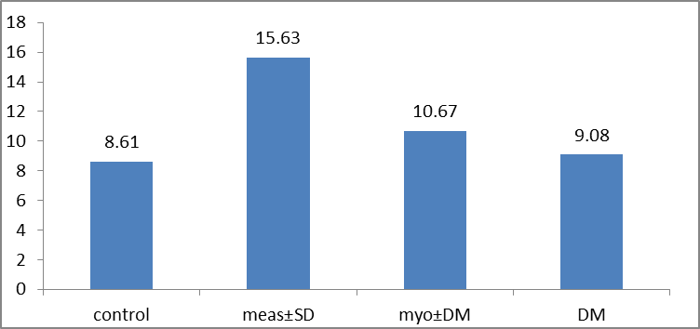
Homocysteine (μ mol/L)
Figure 1. Shows the level of Homocysteine in the blood serum
Measurements of Triglyceride Level in Blood Serum
Table 1 and Figure 1 indicate a significant increase in the level of triglyceride in people with stroke, heart attack and diabetes type II compared with healthy people at the level of statistical significance (P˂0.01). The average level of triglyceride in the blood of healthy people is (2.83 ± 0.23 μmol/L), while in patients with heart attacks is (2.04 ± 0.21 μmol/L) and in patients with both diseases the heart attack and diabetes type II is (3.81 ± 0.57 mmol/L) and the level in patients with diabetes Type II is (2.01 ± 0.19 mmol/L).
Figure (2) indicates a high level of triglyceride in people with both of heart attack and diabetes type II together compared to its level in people with Type II diabetes only, and it is also higher than its level in people with only cardiac stroke. The high level of triglyceride may be attributed to several metabolic factors such as abnormal fat oxidation process as in the liberalization of energy on the form of ATP in spite of the presence of high level of glucose in the blood⁽³⁰⁾. Researchers noted that high triglycerides in blood may play an important role in the development of heart disease in patients with high blood pressure and diabetes⁽³¹⁾. There are many evidences that confirm the existence of a relationship between the levels of Hcy and high blood lipid (triglyceride) in the serum of patients with cardiac stroke that is higher than that in the control group. Similar results obtained by Marcil⁽³²⁾ confirms this pattern of relationship.
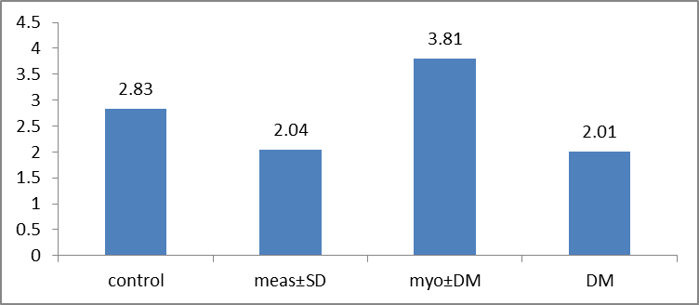
Figure 2. Shows the level of triglycerides in the blood serum
Measurements of Cholesterol Level in Blood Serum
The levels of cholesterol in blood serum are shown in Table 1 and Figure 3. At the level of statistical significance (P˂0.01), a significant increase is found in the level of cholesterol in patients with heart attack and diabetes type II compared to that in the healthy people. Figure (3) shows that the average concentration of cholesterol in the blood serum of healthy people is (4.35 ± 1.00 mmol/L), while in patients with heart attacks is (4.36 ± 1.11 mmol/L) and in patients with diabetes type II and heart attacks is (4.56 ± 1.20 mmol/L) and in patients with type II diabetes is (5.08 ± 1.30 mmol/L).
It is evident that the concentration of cholesterol in people with only diabetes type II is above its level in people with both of heart attack and diabetes type II together, and it is higher than that in people with heart attack only. These findings are consistent with what the researcher found that a large proportion of the mobile cholesterol LDL-Ch as a result of Glycation process in diabetic patients that leads to high sugar level in blood⁽³³⁾. The findings agree with the researchers that the higher cholesterol level than normal when developing diabetes and heart attack⁽³⁴⁾. There are many evidences that confirm the existence of a relationship between the levels of Hcy and high blood lipids (total cholesterol) in the serum of patients with cardiac stroke higher than the level in the control group. Similar results have been recorded by Marcil⁽³²⁾.
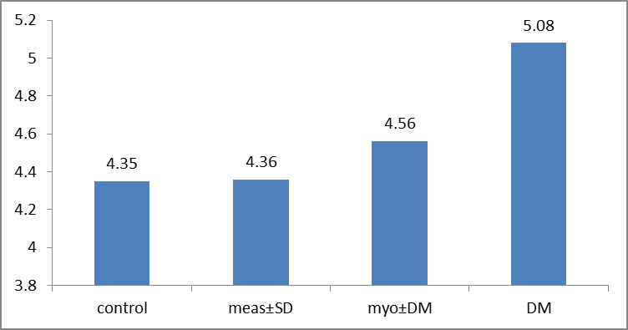
Figure 3. Represents the level of cholesterol in blood serum

Measurements of Folic Acid in Blood Serum
Estimation of the level of folic acid in the blood serum is shown in Table 1 and Fig. (4). It has been found that there is a decrease in the level of folic acid in people with heart attack and Type II diabetes compared to that in healthy persons at the level of statistical significance (P˂0.01). The average concentration of folic acid in the serum of healthy persons is (10.32 ± 3.00 mg/ml), while its average in patients with heart attack is (6.51 ± 2.01 mg/ml) and its average in patients with both of diabetes Type II and heart attack is (7.89 ± 2.81 mg/ml) and its average in patients with diabetes Type II (8.68 ± 2.44 mg/ml). Figure (4) shows a decrease in the level of folic acid in people with heart attack is just above its level in people with diabetes Type II, and the level of folic acid in people with heart attack is less than its level in people with both, heart attack and diabetes type II together. This finding of low level of folic acid is in consistence with the studies conducted in institutes of Research and Development that stress that the lack of folic acid causes a rise in the level of Hcy ​​in the blood^{(35,36)}.
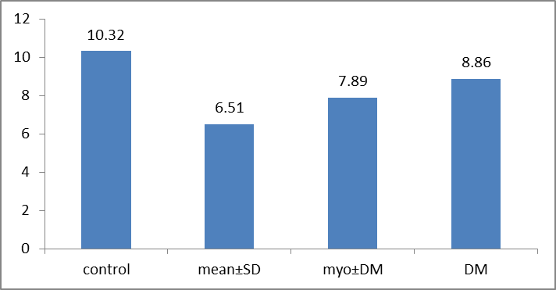
Figure 4. Shows folic acid levels in blood serum
Measurement of Vitamin B₁₂ in Blood Serum
In this study, estimation of the level of vitamin B₁₂ in the blood serum is carried out and as shown in Table 1 and Fig. (5). It has been found that there is a decrease in the level of vitamin B₁₂ in people with heart attack and diabetes type II compared with that in healthy persons at the level of statistical significance (P˂0.01 ) where the average concentration of vitamin B₁₂ in the blood serum of healthy persons is (20.165 ± 53.298 Pg/ml), while its average in patients with heart attack is (32.158 ± 06.280 Pg/ml) and its average in patients with both of diabetes type II and heart attacks together is (7.89 ± 11.275 Pg/ml) and its average in patients with Type II diabetes is (211.3 ± 143.99 Pg/ml). Figure (5) depicts a decrease in the level of vitamin B₁₂ in people with cardiac stroke and just above its level in people with Type II diabetes, and its level in people with cardiac stroke only is lower than its level in people with both of heart attack and diabetes type II together. The low level of vitamin B₁₂ is in consistence with the study conducted in the institutes of Research and Development, which confirm that the acid deficiency causes a rise in the level of Hcy ​​in the blood^{(35,36)}.
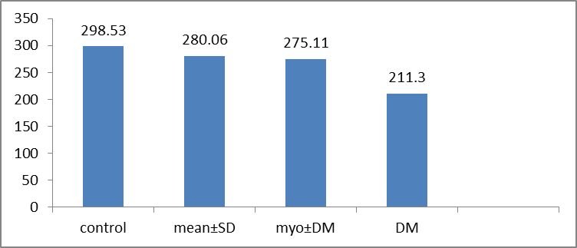
Figure 5. Shows vitamin B₁₂ levels in blood serum

تقدير تركيز الهوموسستين في مصل الدم للمرضى المصابين بالجلطة القلبية ومرض السكري النوع الثاني في محافظة صلاح الدين
د.اوميد مجيد المهندس ^{1} (مدرس) , امجد عباوي صالح الجبوري¹ (مدرس مساعد), د.نادية احمد صالح الجبارة² (مدرس)
¹جامعة كركوك، قسم الكيمياء، العراق – كركوك, ²جامعة تكريت ،قسم الكيمياء ، العراق– صلاح الدين
الملخص
تتوقع الدراسات السريرية ازدياداً في نسبة الوفيات لدى مرضى القلب والسكري في العالم بحلول عام 2020 بسبب ارتفاع مرض ضغط الدم المؤدي إلى تفاقم أمراض القلب والأوعية الدموية. إن أي ارتفاع في مستوى الحامض الأميني في الدم يسهم بشكل مباشر في ارتفاع ضغط الدم وأعراض مرض السكري التي قد تكون أحد الأسباب الهامة لاستفحال الأمراض القلبية الوعائية. لا يزال الجدل حاصل حول العلاقة المباشرة وغير المباشرة بين الحامض الأميني والأمراض القلبية الوعائية (الجلطة القلبية) ومرض السكري النوع الثاني. لذلك شملت دراستنا على التحقق من علاقة تراكيز الحامض الأميني مع أمراض الجلطة القلبية والسكري النوع الثاني.
استند بحثنا على دراسة 50 حالة من المرضى الذين يعانون الأمراض القلبية والسكري النوع الثاني، إضافة الى 25 من الأصحاء الذين لا يعانون كمجموعة سيطرة تتراوح اعمارهم بين 25-45 سنه. تم تبني الحالات بشكل عشوائي ومن كلا الجنسين من العيادات الخارجية لمستشفى تكريت التعليمي. واعتماد مستوى الحامض الأميني المُقاس في مصل الدم بواسطة تقنية Eliza للمصابين بالجلطة القلبية ومرض السكري ومقارنتها مع الضوابط المعتمدة. فقد لوحظ هناك ارتفاع حاد في تراكيز الهوموسستين وثلاثي الكليسريدات والكولسترول عند مستوى دلالة (p ˂ 0.01) لدى المرضى الذين يعانون من جلطة القلب والسكري النوع الثاني مقارنة مع مجموعة الأصحاء. وكما لوحظ انخفاض تركيز حامض الفوليك عند مستوى دلالة إحصائية (p ˂ 0.01) وانخفاض فيتامين B₁₂ عند مستوى دلالة (p ˂ 0.05) لدى مرضى جلطة القلب والسكري النوع الثاني مقارنة مع مجموعة الاصحاء.

الكلمات الدالة: الهوموسستين، الجلطةالقلبية، مرض السكري.

Determination of the level Homocystiene Concentration the Serum of Patients with myocardial and Type II Diabetes in Salahaddin Province
¹Omeed Majeed Hamid Al-Muhandis ,¹Amjed Abbawi Saleh Aljebouri ,²Nadia Ahmed Saleh Aljbarah
¹Kirkuk University, Chemistry Department, Kirkuk, Iraq ²Tikrit University, Chemistry Department, Salahaddin, Iraq
ABSTRACT
Clinical studies predict an increase in the mortality rate among patients with heart disease and diabetes in the world by 2020 because of the symptoms of high blood pressure that leads to aggravation of the cardiovascular disease. Any rise in the level of amino acid in the blood directly contributes to high blood pressure and symptoms of diabetes that are considered a significant exacerbation of the causes of cardiovascular disease. Controversy still holds about the direct and indirect relationship between amino acids and cardiovascular disease (heart attack) and type II diabetes. Therefore, our study included verification of the relationship between amino acid concentration and the symptoms of heart attacks and diabetes type II.

References

1. Scholze A, Rinder C, Beige J, et al.(2004); 109:369-374.
2. He K, Merchant A, Rimm EB. et.al fliate ,Vitamin B6,and B12 Intakes in Relation to Risk of Stroke Among Men Stroke 2009; 35(1):169-174.
3. Herrmann W, Schorr H, Obeid R, Geisel J. Vitamin B12 Status Particularly Holotrans Cobalamin II and Methylmaionic Acid Concentrations, and Hyper H omocystinemia in Vegirtarians. Am J Clin Nutr. 2003;78(1):131-136 .
4. Mizrahi EH, et al. Plasma total Homocysteine levels dietary vitamin B and folate intake in AD and healthy qhin Jnutr health Aging .2008;7(3):160-165.
5. Sayed Hadedy (2004). "Public pathological chemistry." Second edition, SHUAA Publishing Syrian and science-Halb.s 54
6. Hernandez-galici E., Aguilar-contreras A., Aguilar-Santamaria L. , Roman-Ramos R., Chavez-Miranda A. A. Garcia-Yega L. M. , Flores-Saenz J. L. and Alarcon-Aguilar F. J. (2002). "Studies on Hypoglycemic Activity of Mexican Medicinal Plants". Proc. West. Pharmacol. Soc.
7. Burtis,C.A, Ashwood,E.R, Tietz, (1996)."fundamentals of Clin.chem.",4th ed. , PP: 308-312 W.B. Saundrs Co; Philadephia.
8. National Diabetes Data Group, (1979). "Diabetes". 28:1039.
9. Zilva j.F. ,pannal,P, R. (1984). "Hyperglycaemia and Diabetes Mellitus" clinical chemistry in Diagnosis and Treatment".4th Edition.p.204.
10. Foster D.W. (1980). "The Diabetes Mellitus in Harrisons Principles of Internal Medicines". (Eds. Isselbasher, K.J.;Adams,R.D.;Braunwald,e.; Petersdorf ,R.G.and Wilson,J.D.).McGraw-Hill International Book Company ,Paris , New Delhi, Singapore, etc.p.1741.
11. World Health Organization (2002)." Laboratory Diagnosis and Monitoring of Diabetes Mellitus " . WHO .p.6.
12. Borth Wick , L . (1982). "Diabetes Mellitus". 151,26-29.
13. Al-Saabaa, Samir (2008), "diabetes patient information," Saad Pharmaceutical Industries, p. 5
14. Fernandez M. A. , Kim K. J. , Yakar S. , Dupont J., Hernandez-Sanchez C., Castle A. L., Filmore J. , Shulman G. I. and Le Roith1 D. (2001). "Functional Inactivation of the IGF-I and insulin receptors in skeletal muscle causes type2diabetes". GENES& DEVELOPMENT 15:1926.
15. Turtle J. R. and Obaid M. (2004)." Type 2 Diabetes: an epidemic in the making" ADF Health., (5): P29.
16. Bonna KH, Hjolstad I. ueland Pm .at .el Homocysteine lowering and cardiovascular events after acute myocardiak infarction N Engl Jmed 2006:354: 1578-88.
17.Toole JF,malinow MR chambless LE ,et .al Lowering Homocysteine in patients with ischemic stroke to prevent recurrent stroke myocardial infarction, and death the vitamin Intervention for stroke prevent on (VISP)randomized controlled trial JAMA 2009; 291:565-75.
18. Suh JR, Herbig AK, Stover PJ. (2001). "New perspectives on folate catabolism". Annu Rev Nutr.;21:255-282.
19. Al-Falih, Khawla Ahmed (2007). "Introduction to biochemistry." National Library for Printing and Publishing, second edition, the University of Mosul, pp.185-186-182.
20. Jacques PF, Selhub J, Bostom AG, Wilson PW, Rosenberg IH. (1999). "The effect of folic acid fortification on plasma folate and total homocysteine concentrations". N Engl J Med.;340:1449-1454.
21. Frantezen F,Faaren AL,Alfheim I,Nordhe:Ak.An enzyme conversion immunoassay for determining total homocysteine in plasma or serum. Clin chem 1998;44:311-316.
22. Chen j,Giovannucci E,E, Kelsey K,al.A methylenetetrahydrofolate reductase polymorphism and the risk of colorectal cancer. Cancer Res 1996;56:4862-4.
23. Manal A. Hamed., Pol. J. Food Nutr. Sci,( 2006) ; 15/56, 2: 339–348.17
24. Fontes J.P., Goncalves M., and Riberio U.G., Rev.Port., Cardiol, (1999);18(2) :1129.
25 .Imge ,B., Asli U., and Isil,Turk.J.Med.sci.39(4),513-517,(2009).
26. Bjelland I, Tell GS, Vollset SE, Refsum H, Ueland PM. Folate, vitamin B12, homocysteine, and the MTHFR 677C→T polymorphism in anxiety and depression.
27. Almeida OP, Flicker L, Lautenschlager NT, Leedman P, Vasikaran S, van Bockxmeer FM. Contribution of the MTHFR gene to the causal pathway for depression, anxiety and cognitive impairment in later life. Neurobiol Aging 2005; 26: 251-257.
28. Wotherspoon F, Laight DW, Turner C, Meeking DR, Allard SE, Munday LJ, et al. The effect of oral folic acid upon plasma homocysteine, endothelial function and oxidative stress in patients with type 1 diabetes and microalbuminuria. Int J Clin Pract 2008; 62: 569-574.
29. Belcastro V, Gaetano G, Italiano D, Oteri G, Caccamo D, Pisani LR, et al. Antiepileptic drugs and MTHFR polymorphisms influence hyper-homocysteinemia recurrence in epileptic patients. Epilepsia 2007; 48: 1990-1994.
30. Betteridge, D.J,Eur.J.Clin Invest(1999).29,supple.21,12-18.
31. Rafai,J and Nader ,N@’’Am.Asso .Clin.Chem.’’(1997),6:32-34.
32.Stea TH, Mansoor MA, Wandel M, Uglem S, Frolich W. Changes in predictors and status of homocysteine in young male adults after a dietary intervention with vegetables, fruits and bread. Eur J Nutr 2008; 47: 201-209.
33. Coni,E.Benedetto,M.Pasquale,R.Maslla.D.Modesti,R.,Matte,EA.’protective effect of oleu ropein .an olive,oil biophenols , on low density lipo protein oxidizbliity in rabbits ‘’lipids.(2000),35(1)54-54.
34.Vander,A.,Sherman,J.and Lucan,D.’’Humanphysiology’’ 7ed Mcgrawhill-NY(1998);601-616.
35. Recommendations for the use of folic acid to reduce the number of cases of spina bifida and other neural tube defects. MMWR Recomm Rep. (1992).;41:1-7.
36. Lowering blood homocysteine with folic acid-based supplements: meta-analysis of randomised trials. Indian Heart J. (2000);52:S59-S64.

