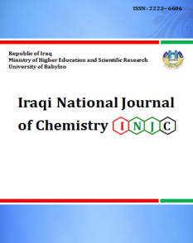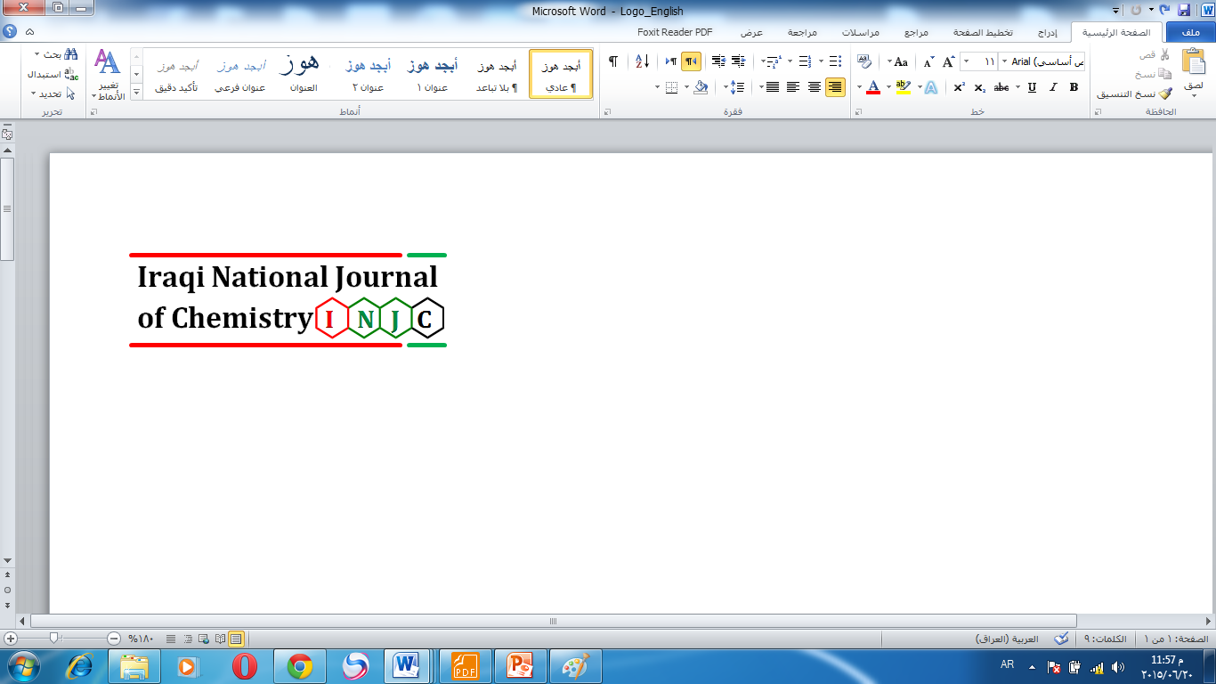

**Iraqi National Journal of Chemistry**

**Journal homepage: http://iqnjc.com/Default.aspx**

**Preparation and identification of new Chalcone- Azo ligand (SACAI) and its complexes.**

***Saad M Mahdi***

Department of Chemistry, College of Science, Babylon University, Babylon -Iraq. saadalhsany@gmail.com.

Keywords: - Chalcone - Azo , Azo compounds, amino chalcone, transition metal complexes.

**Abstract: -** A new organic ligand (Chalcone-azo ligand), *(2E)-1-(4-((4,5-diphenyl-1H-imidazol-2-yl)diazenyl)phenyl)-3-(2-hydroxyphenyl) prop-2-en-1-one* (SACAI) with its divalent (Co, Ni and Cu) complexes were synthesized. The azo-derivative was prepared via the preparation of amino chalcone first, then diazoating of this amine and coupling with (4, 5-diphenylimidazole) component.

Three transition metal ion complexes were prepared from this legend, after the determination of (M: L) ratio beyond the ultraviolet-visible studies of the (ligand-ion) mixtures. The M: L ratios for all complexes were (1:2).

The amino-chalcone, new ligand (SACAI) and its complexes were identified with the available techniques such (Mass spectroscopy for the ligand, elementary analysis, Atomic Absorption, UV-Visible spectroscopy, F.T.I.R spectroscopy), electrical molar conductivity and Magnetic susceptibility for the solid complexes. From the results obtained, we can suggest the non-ionic octahedral geometry for all complexes. The new ligand acting as a bidentate chelating ligand that coordinating from the N3 imidazole atom and the far azo heterocyclic ring nitrogen atom.

**تحضير و تشخيص ليكاند آزو-جالكون الجديد مع بعض معقداته**

**سعد مدلول مهدي**

**قسم الكيمياء /كلية العلوم/ جامعة بابل**

**الخلاصة:**

تم في هذه البحث تحضير ليكاند عضوي جديد لمركب الازو-جالكون *(2E)-1-(4-((4,5-diphenyl-1H-imidazol-2-yl)diazenyl)phenyl)-3-(2-hydroxyphenyl) prop-2-en-1-one* ( SACAI) وثلاث من معقداته لعناصر (الكوبلت والنيكل والنحاس) ثنائية الشحنة . حيث تم تحضير مركب الجالكون الاميني (SAC) اولا ومن ثم ازواج ملح الديازونيوم للامــين مع قاعـدة الازواج (4,5-Diphenyl imidazole) في وسط قاعدي كحولي بدرجة الصفر المئوي.

حضرت المعقدات الصلبة الثلاث بعد تثبيت الظروف من التركيز الامثل والطول الموجي ، وحساب النسبة المولية اللازمة لتحضير تلك المعقدات بعد دراسة اطياف الاشعة (الفوق بنفسجية – المرئية) ، وكانت النسبة المولية الملائمة للتحضير هي (1:2,M:L) .

شخص الجالكون الاميني ( SAC) والليكاند الجديد (SACAI) ومعقداته بالتقنيات الممكنة كطيف الكتلة لليكاند الجديد وتقنيات ( التحليل العناصري الدقيق ومطيافية الاشعة الفوق بنفسجية – الحمراء ومطيافية الاشعة تحت الحمراء وطيف الانبعاث الذري) اضافة لاستخدام التقنيات اللاخرى ( كالتوصيلية المولارية والحساسية المغناطيسية ) للمعقدات الصلبة ، واثبتت خلاصة النتائج ومحصلتها امتلاك المعقدات جميعها الصفة اللاايونية والشكل الهندسي ثماني السطوح خلال ارتباط الليكاند ثنائي المخلب من ناحية نتروجين الاميدازول N3 وذرة نتروجين الازو البعيدة عن الحلقة الغير متجانسة بالايون المركزي للمعقدات.

**Introduction:**

The importance's of organic compounds lie in the type of constituent groups, though how utilized them in most manufacturing industries1.  
Azo compounds and their derivatives can regard one of them; due to they're entry in many manufacturers as (paints2, dyes3, pesticides4, food colorants5 and in lubricant oil improvements6), as well as in the chemistry fields as a precursor for many organic compounds and the important organic chelating compounds, that have the ability of coordinating with a huge number of elements for trace amount determination in different samples7.   
Azo compounds have a biological activity toward the microbial8; recent studies (Congo red and Evans blue) had been studied as an HIV inhibitor of viral replication, that believing in the bonding between the azo group and the protease & reverse transcriptase 9. Chalcone the precursor of flavonoids10, pyrazoline11 and other compounds, chalcones indeed their conjugation importantly, it acts as a non-azo dyes12 compound and its one of the most important compounds that enter as drug source13, in pharma logical activities as (antitumor14, anticancer15 and radical scavenger16).  
However, when the two components were meeting in one compound, we will see a dearth of sources, due to a lot of research working with this side17, 18.  This activated us to work hard in this field.

**Experimental**

The entire chemicals used in this work were of analytical reagent grade from (Fluke, BDH and Sigma), 4, 5-dipheny imidazole was a laboratory synthesized with a high grade of purification.



Schem1.General steps in SACAN preparation.

- Mass Spectra was taken with MSD Direct Probe using Acq Method low energy. M, Metal analysis was performed by Shimadzu 6800AA (Flame Atomic Absorption Spectrophotometer. Elemental analysis (C.H.N) of compounds was carried out by (Micro Analytical unit, 1108 CHN Elemental analyzer), UV-Visible study and electronic spectra were recorded on a Shimadzu (UV-Visible 1650) spectrophotometer using a quartz cell. FTIR Spectra were recorded by Shimadzu FTIR8400 test scan series using the KBr disc in the wave number range (4000-400cm-1), magnetic susceptibility measurement was determined by Faraday's method using Magnetic Susceptibility Balance Model – M.S.B Auto. The molar conductivity was measured at room temperature in two solvents (ethanol and dimethyl formamide) in 1x10-3M ligand concentration using (Info lab terminal). Melting points were determined using Saturates digital SPM30.

Synthesis of the amino chalcone19:

Amino chalcone *(E)-1-(4-aminophenyl)-3-(2-hydroxyphenyl)prop-2-en-1-one* SAC) was prepared via reaction of ( p-aminoacetophenone,0.01mole ,1.35gm) and ( salicyaldehyde,0.01mole, 1.22 gm = 1.06ml) in absolute ethanol (30ml), then stirring and cooling at 5C˚, within 30min. Dropping of (3M KOH) solution to the reaction component with stirring till the solution began more thickening, with continuing the stirring for 24hrs. Decant this thickened solution in iced bath and neutralized with dil. HCl, the yellow precipitant appear, filter and wash with deionized water several times to remove the trace of acid and salt formed, then air drying the precipitant, recrystallize the product with hot ethanol.

Synthesis of the Chalcone- azo (SACAI):

The Chalcone- azo was prepared according to Shibata method20, the ligand *((E)-1-(4-((Z)-(4,5-diphenyl-1H-imidazol-2-yl)diazenyl)phenyl)-3-(2-hydroxyphenyl)prop-2-en-1-one* SACAI) was synthesized by preparation of diazonium salt of the amino-chalcone (SAC) by dissolving (5mmole,1.195gm ) of this amine in an acidic mixture ( 8ml conc. HCl + 15ml D.W) and cooling in 0C˚ water bath, then (5mmole, 0.35gm NaNO2 in 10ml D.W ) solution was added carefully to the ammine with stirring at the same temperature, within 15min the diazonium salt was formed. The coupling component (4,5-diphenyl imidazole) was prepared by dissolving (5mmole, 1.1 gm) in alkaline alcoholic solution (2M NaOH). Then transferred in the ice cold bath, the daizonium salt was added dropwise to the coupling component with stirring at 0C˚, a reddish-orange color was formed, complete the process until the end of daizonium solution, then neutralization of the pH value to complete the precipitation of the azo compound, the precipitant was filtered washed many times to remove the salt traces then drying and recrystallized with a hot ethanolic solution. A deep reddish-orange powder was collected.

Synthesis of the complexes

All the divalent transition metal element (Co, Ni and Cu) complexes were prepared with the same procedure, that:

In 100 ml rounded bottom flask 10 mmole of (SACAI) was dissolved in 40 ml absolute ethanol and refluxed with 5mmole of metal chloride (that dissolved in the minimum amount of absolute ethanol); they refluxed for 1hr. With stirring, then the solvent reduced to the quarter in hot water bath, then the hot solution, transferred to crash ice bath, the colored precipitant was developed, then collected, dried and recrystallized with hot ethanol.

Table.1 Physical characteristic of the ligands and its complexes

|  |  |  |  |  |
| --- | --- | --- | --- | --- |
| Compound | M.Wt g/mol | Color | m.p C˚ | Yield |
| SAC | 239.09 | Yellow | 116-118 | 77% |
| SACAI | 470.17 | Red-orange | 120-122 | 72% |
| [Co(sacai)2Cl2] | 1069.22 | Deep brawn | 149-151 | 75% |
| [Ni(sacai)2Cl2] | 1068.22 | Maroon | 151-153 | 70% |
| [Cu(sacai)2Cl2] | 1075.49 | Deep violet | 172-174 | 78% |

Table.2 Elementary analysis for SACAI and its complexes

|  |  |  |  |  |
| --- | --- | --- | --- | --- |
| Compound | **C** % calculated  (Found) | **H** % calculated  (Found) | **N** % calculated  (Found) | **M** % calculated  (Found) |
| SAC | 75.30  (75.39) | 5.48  (5.50) | 5.85  (5.90) | -------- |
| SACAI | 76.58  (76.62) | 4.71  (4.74) | 11.91  (11.98) | -------- |
| [Co(sacai)2Cl2] | 67.29  (67.36) | 4.14  (4.17) | 10.46  (10.48) | 5.50  (5.58) |
| [Ni(sacai)2Cl2] | 67.31  (67.41) | 4.14  (4.16) | 10.47  (10.51) | 5.48  (5.55) |
| [Cu(sacai)2Cl2] | 67.01  (67.13) | 4.12  (4.15) | 10.42  (10.51) | 5.91  (5.98) |

**Results:-**

Because of the scientific novelty in the entrance of this subject, we found it necessary to go into these fields to prepare new organic legends that were many important functional groups approved the board outlook in the vital area and the others like (medical, pharmaceutical and industrial).

In this work a new chalcone- azo was synthesized by two steps:

Firstly the amino chalcone (SAC) was synthesized by the Cleasien – Schmidt condensation of the p-amino acetophenone with salicyladehyde in 10% alkaline alcoholic media to form the amino chalcone (SAC), the TLC (petroleum: ethyl acetate 4:1) with *Rf* = 0.28 indicate the completion of the reaction.

The certainty of chalcone preparation can be enhanced with the FTIR spectral data, which the appearance of the functional group of the compound in their regions gives us confidence to the formation; the main bands are:

-The hydroxyl group of the salicyaldehyde gives str. band at 3396 cm-1, while the primary amine gives two adjacent str. bands at 3332 & 3226 cm-1 respectively.

-The appearance of the chalcone bands clearly at (1647cm-1 & 1514 cm-1) related to the carbonyl and methylene groups21, as shown in the following figure 1. :

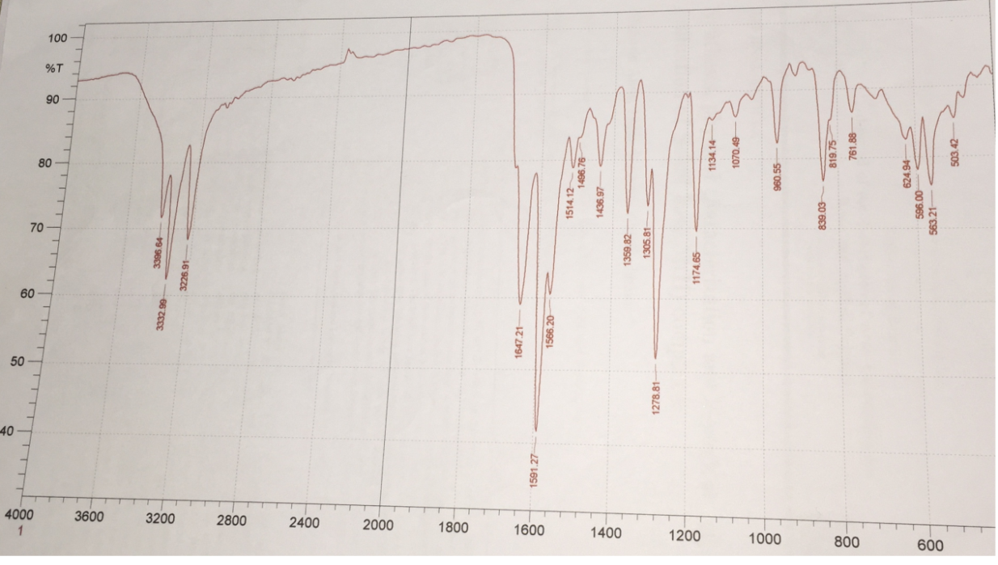

Fig. 1 FTIR Spectra for (SAC).

* The second step of the process, including the preparation of the azo compound (SACAI)as a brand new organic compound by the reaction of the diazonium salt of the amino chalcone (SAC) with the coupling component (4,5-diphenyl imidazole).

The brand new azo (SACAI), was identified with (CHN,FTIR and Mass spectroscopy ) to ensure the compound formation, the approaching of the found elementary(CHN) data to the theoretical calculated, with the assistance of the FTIR spectral data helps with reliability of preparation (as shown below):

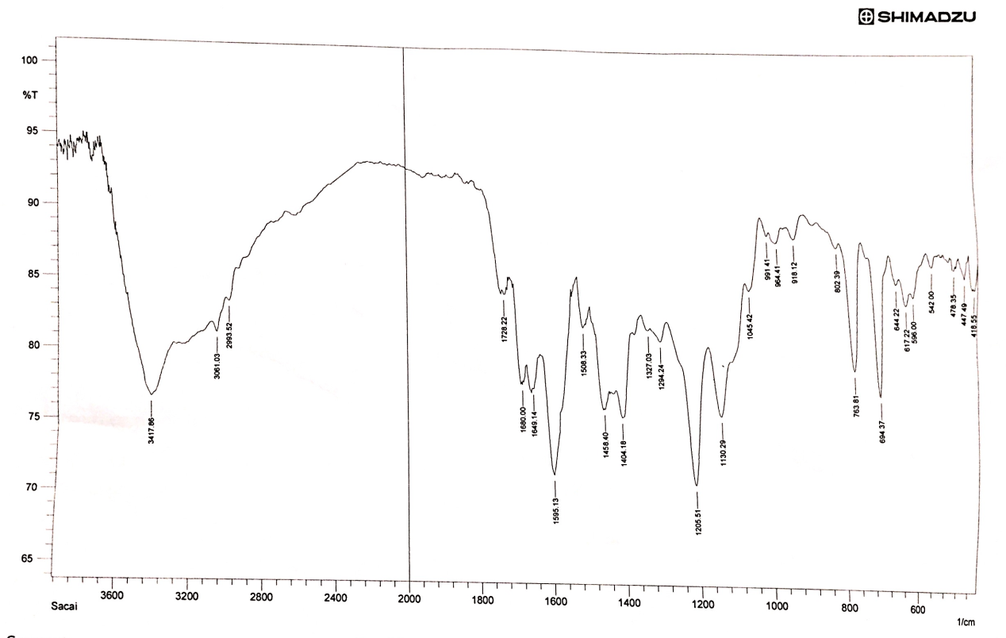

Fig. 2 FTIR Spectra for (SACAI)

The disappearance of the amine bands and the appearance of the azo group (N=N) band in the 1452cm-1 region22, the remaining of the other bands within the limit, i.e. that the formation of this azo, while the chalconic hydroxyl group was combined with the (N-H) imidazole group in the (3417cm-1) region, this will be shown with the ligand complexes, too.

**Mass spectroscopy**, is the analytical tools that used for compound identification, by their ability to sorts ions based on their mass (weight), one of the mass spectrum usage to determine the masses of the particles and of molecules, and to elucidate the chemical structure of the molecules23.

The mass fragmentation of (SACAI) gives clearly the site of the mother ion band at (470.1*m/e*), this agreed with the molecular mass of (SACAI), other fragments of this azo compound was included within the following figure (as the 4,5-diphenyl imidazole fragment (220*m/e)*).

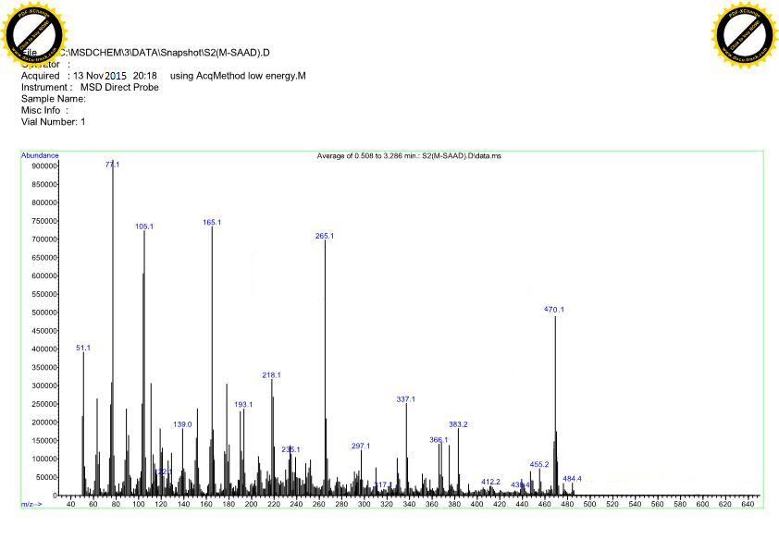

Fig.3 SACAI Mass Spectra

The new ligand (SACAI) was soluble in many solvents such (ethanol, methanol, DMF, DMSO, Acetone, chloroform, carbon tetrachloride, and acetonitrile) while its insoluble in water.

**UV-Visible spectroscopy**:-

A wide range of concentration will be done in this study to determine the optimal concentration for the ligand, and their divalent transition metal ion complexes (Co2+, Ni2+ and Cu2+), the concentration range (10-3-10-4M) gives out of range results, deep and condense colors that excluded from the study, while within(10-5 M) ranges, gives clear solutions obey (beer-lambert law).

(SACAI) give an observable λmax at (424nm) this related to the charge transfer via azo group, while the second absorption band to the (π-π*) transition, a red shifting and vivid color observed when these ions aqueous solutions were mixed with the alcoholic ligand solution, due to the coordination between the ions and ligand24  take place, as shown:

SACAI 424nm



Co SACAI 480nm







Cu SACAI 492nm

Ni SACAI 482nm

Fig. 4 SACAI UV-Visible spectroscopic data

The UV-Visible study utilized to determine the no. of a mole used in the preparation of the complexes, by using the mole ratio method 25, its suitable and easy method for soluble complex determination 26.

From the results obtained, the mole ratio (M: L) was (1:2) for the three (SACAI) complexes. This will be shown in fig. below.

Fig.4 Mole ratio curves for SACAI Complexes.

The mole ratio results deduced the stability of the complexes, by using the relation  , where As= the absorbance at the mole ratio, Am = the absorbance with a ligand component increment. α= dissociation constant. , for (1:2) ratio, β= stability constant and c = the concentration of the two components (ligand &metal ion) in the study.

Table.3 complexes stability data

|  |  |  |  |  |  |
| --- | --- | --- | --- | --- | --- |
| Metal ion Complex | Am | As | α | β | Logβ |
| [Co(sacai)2Cl2] | 0.742 | 0.732 | 0.052 | 2.09X1011 | 11.32 |
| [Ni(sacai)2Cl2] | 0.740 | 0.732 | 0.108 | 5.43X1011 | 11.73 |
| [Cu(sacai)2Cl2] | 0.759 | 0.755 | 0.0052 | 7.18X1012 | 12.85 |

These results agreed with Irving-Williams Series27 that the [stability](https://en.wikipedia.org/wiki/Stability_constants_of_complexes) of complexes formed by [divalent](https://en.wikipedia.org/wiki/Divalent) first-row [transition metal](https://en.wikipedia.org/wiki/Transition_metal) ions generally increases across the period to a maximum stability of copper:

Mn (II) < Fe (II) < Co (II) < Ni (II) < Cu (II) > Zn(II).

The solid (SACAI) complexes were synthesized, according to their mole ratio results, and then identified with the elementary analyzer to determine their (CHN) component and atomic absorption to the metal percent in complex.

Their FTIR spectral data showed changes in two functional groups (the azo group N=N and the imidazole azomethine group C=N) by their shifting in their values due to coordination with these ions, and remaining the other groups within their limits. This will indicated that they were not participated in coordination), the M-Cl band doesn't appear due to the limitation of KBr disk working within 400cm-1 while this band appear within 300 cm-1  region28, and this well illustrated in the following table:

Table.4 FTIR data for (SACAI) Complexes.

|  |  |  |  |  |  |
| --- | --- | --- | --- | --- | --- |
| **Compound.** | **ν(N-H)** | **ν(C-H)** | **ν(C=N) imd** | **ν(N=N)** | **M-N28** |
| SACAI | 3417 | 3061 | 1595 | 1458 | ------ |
| [Co(sacai)2Cl] | 3417 | 3061 | 1598 | 1442 | 453 |
| [Ni(sacai)2Cl] | 3417 | 3061 | 1598 | 1450 | 449 |
| [Cu(sacai)2Cl] | 3417 | 3059 | 1585 | 1448 | 443 |

*all values measured in cm-1.

And observed in the following figures:

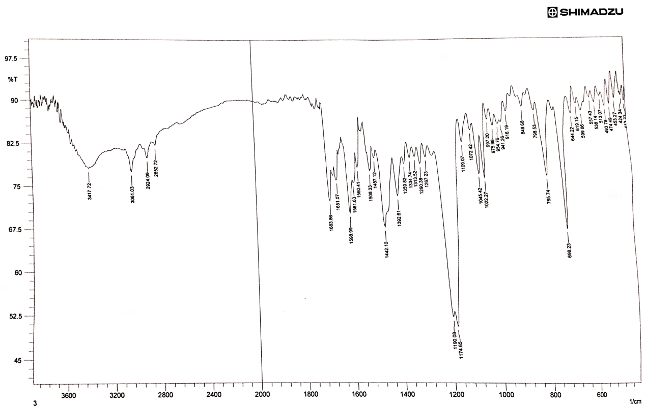

Fig.7 CoSACAI FTIR Spectra

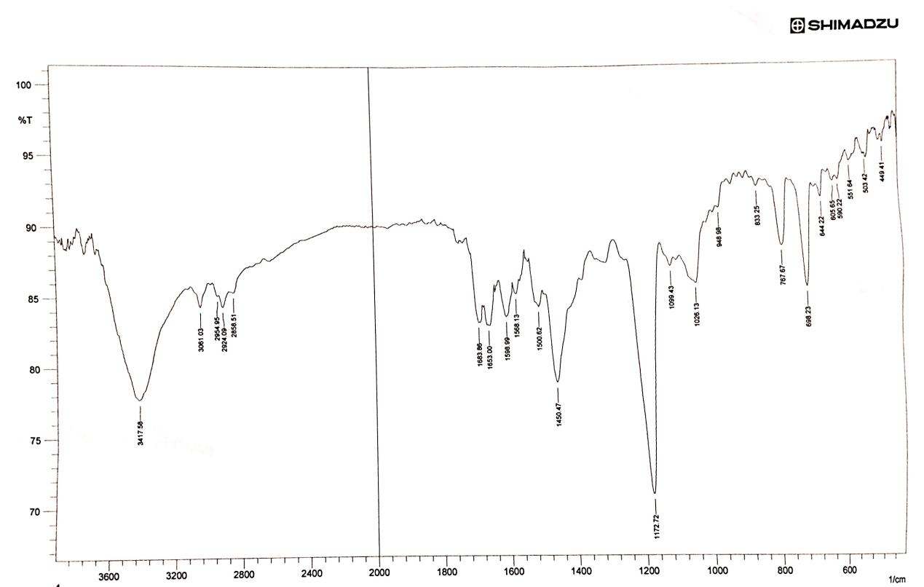

Fig.8 NiSACIA FTIR Spectra

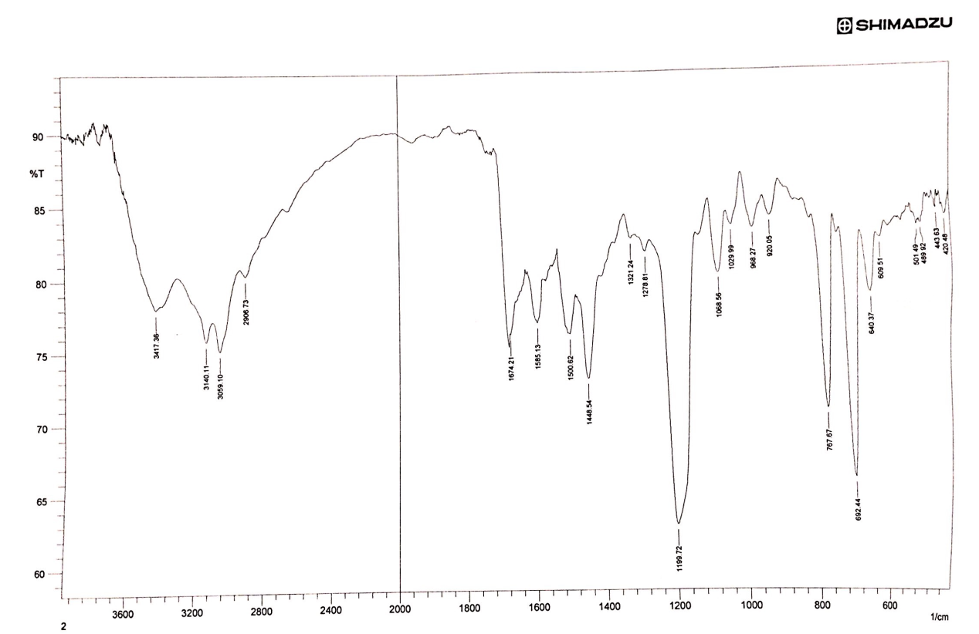Fig. 9 CuSACAI FTIR Spectra

**Electrical molar conductivity:**-

Complex ionic formula can know by the electrical molar conductivity for them29, that the number of electrolyte species proportion with the conductivity30, and approach to zero value in non-electrolyte solutions.

All complexes have a non-ionic character due to the depression of their conductivity values in two solvent (ethanol and dimethyl formamide).

Table.5 conductivity values of the (SACAI) Complexes.

|  |  |  |
| --- | --- | --- |
| Metal ion Complex | Conductivity in ethanol | Conductivity in DMF |
| [Co(sacai)2Cl2] | 13 | 15 |
| [Ni(sacai)2Cl2] | 19 | 22 |
| [Cu(sacai)2Cl2] | 22 | 25 |

Magnetic & electronic properties:-

Magnetic susceptibility data act as a complementary part to suggest the complexes geometry (in particular for TME΄s) 31, via the study influence of the partially filled outer orbitales, magnetic data supplied us with the electronic contribution and the metal oxidation state, that the number of odd electron(s) for the metal play a role which either complex in the high - spin state or low.32

* The cobalt complex has a 4.15 B.M value; this indicates with the abundance of three odd electrons of octahedral cobalt complexes 33, the increment value returned to the orbital contribution.
* While the nickel complex gives a 3.02 B. M, this will agree with octahedral nickel complexes that have two odd electrons34.
* Copper susceptibility value was 1.89 B.M; this was tuned with the odd electron octahedral copper complexes as in literature35

The electronic spectral data shown in the following table:

Table.6 electronic spectral data for (SACAI) Complexes

|  |  |  |
| --- | --- | --- |
| Complex | Transition type | Transition value in Cm-1 |
| [Co(sacai)2Cl2] | 4T1g(F) --------- 4T1g(P)  4T1g(F) --------- 4A2g (F)  4T1g(F)  --------- 4T2g(F) | 18761  16949  9175 |
| [Ni(sacai)2Cl2] | 3A2g (F) -------- 3T1g(P)  3A2g (F) --------- 4T1g(F)  3A2g (F) ---------- 4T2g(F) | 21928  14662  7444 |
| [Cu(sacai)2Cl2] | 2Eg ---------- 2T2g | 14597 |

These data agree with the literature octahedral complexes of the transition metal elements 32.

From the study associative data, the (CHN, Mass spectra, FTIR) and the enhancement of (UV-Visible) to determine the ratio of solid complexation, Indeed to the (conductivity, magnetic and electronic spectra), give an evidence to suggest the octahedral geometry for all the three complexes for the new ligand (SACAI), acting as a bidentate chelating ligand by the imidazole N3 atom and the far azo nitrogen atom.



Scheme2. Suggested complexes Geometry

***References***

1. Chenier, Philip J. *"Survey of Industrial Chemistry",*2nd revised edition. New York: Wiley-VCH Publishers. (1992)

2. Smith. T. P., Malcomber, D.W., and Almasry. M. A. **US Patent** .5.166.326, (1992).

3. M. Komel, F. Galil, L. Abdel Wahab and A. Osman ***J. für parktische***

***Chemie,***313;1101, (1972).

4.H. Kumar and R.P. Chaudhary, **Arch.Appl.Sci.Res.**2 (5); 407, (2010).

5. S. Carmen:"Food colorants (chemical and functional properties)". CRC Press, 2008.

6. G.G. Chigarenko, A. PoromarRenko, A.S. Burlov, A.G. Chigarenko ,I.S. Vasilcheenko , A.I. Urerev , D.A. Garnoviskii , A.D. Garnoviskii , **J.Fract.& Wear.**28 (4); 377, (2007).  
  
7. Z. Marczenko, "*Spectrophotometric determination of elements*" 2nd Ed. Ellis Harwood Ltd.,England, (1986).

8. H. Z. Shams, R. M. Mohareb, M. H. Helal and A. M. El-Sayed. *molecules****, 16,***6271.2011.

9***.*** A.F.Warder, **Int J Chem Sci App**, 3, 356, (2012).

10. R.M. Rohini, K. Dive and S. Devi. **Der pharma Chemica**.7 (1), 77, (2015).

11. E. H. Farouq and M. K. Samad, ***E-journal of chemistry***, **9 (3): 1613,** 2012.

12.B. Sharma, S. C. Agrawal and K. C. Gupta. internat. J of Chemical Research, **1** (1), 2010.

13. R. M. Gutierrez, R. M. Ramirez and J. V. Sauceda, ***Afr. J.Pharm. Pharmacol***.**9** (8): 237,2015.

14. YR Prasad; PR Kumar; CA Deepti; MV Ramana, **E-Journal of Chemistry**. 3(13), 236,2006.

15.S.K. Kumar; E. Hager; C. Pettit; H Gurulingappa; NE Davidson and S.R Khan, ***J. Med . Chem*,** 46, 2813. 2003.

16. J.M Yun; M.H.Kweon; H. Kwon; J.K. Hwang and H. Mukhtar, ***Carcinogenesis* .**, **27**(7), 1454, 2006

17. B. S. Dawane, S. S. Chobe, G. G. Manadawad and

B.M.Shaikh,**orbital electr.j.chem.Campo Grande,** 4(1);7, (2012).

18. H. A. Deshpande. H. N. Chopde, C. P. Pandhurnckar and R. **J. Parta,**

**Chem. Sci. Trans,** 2 (2); 621, (2013).

19. R Ajendra Prasad, A. Srinivasa Rao and R. Rambabu , **Asian**

**J of Chemistry**, 21 (2): 907, (2009).

20. S. Shibata, M. Furukawa and R. Nakashima; **Anal. Chem.**

**Acta.**, 81; 131, (1976).

21. A. M. Asiri; **JKAU**, 12; 69, **(2000).**

22. L.J. Bellamy; "the infrared spectra of complex molecules ", 2nd Ed. Vol 2. Chapman & Hill 1980.

23. J.D. Watson & O.D. Sparkman; "Introduction to mass spectrometry", 4th ed. John Wiley &Sons Ltd. 2007.

24. B. K. Reddy, J. R. Kumar, K.J. Reddy and A.V. Reddy, **Anal.Sci.**19 ; 423, (2003).

25. J. H. Yoe and A. L. Jones; **Ind. Eng. Chem., Anal.Ed**, 16; 11, ( 1944).

26. G.W. Ewing “Instrumental Methods of chemical analysis” 5th ed. Mc Graw– Hill (1985).

27. [H. Irving](http://pubs.rsc.org/en/results?searchtext=Author%3AH.%20Irving) and [R. J. Williams](http://pubs.rsc.org/en/results?searchtext=Author%3AR.%20J.%20P.%20Williams), ***J. Chem. Soc*.**, 1953, 3192.

28. K. Nakamoto;" Infrared and Raman Spectra of Inorganic and Coordination compounds". 6th Ed, John Wiley& Sons, Inc. Publication. 2009.

29. D. A. Skooge, “Fundamentals Analytical Chemistry”, 5th. Ed. , New York, 87, 24,411 **1988**.

30. Ursula E. Spichiger-Keller;" Chemical Sensors and Biosensors for Medical and biological applications ", Wiley-VCH, 2008.

31. R. Jeans and E. Moore; " Metal ligand bonding ", Royal Society of chemistry ". 1st published, 2004.

32. Lever ABP, ”Inorganic Electronic Spectroscopy” 2nd Ed, Elsevier, **1984**.

33.B. Singh, R. N. Sing and R. C. Aggarwal; **Polyhedron**, 4; 401,

(1985).

34.K.Bizilij,S.G.Hardin,B.F.Hoskings,P.J.Oliver, R.T.Edward and

G. Winter, **Aust. J. Chem**, 39;1035, (1986).

35.J. Kotz, P. Treichel, J. Townsend and D. Treichel "Chemistry

&chemical reactivity " 9th Ed. Cengage learning, USA, 887, (2015).

Some abbreviations mentioned in this research:

**SAC**: salicyldehyde aminoacetophenone chalcone.

**SACAI**: salicyldehyde aminoacetophenone chalcone AZO 4,5-Diphenyl imidazole.

The novelty of this work according to REAXYS.

