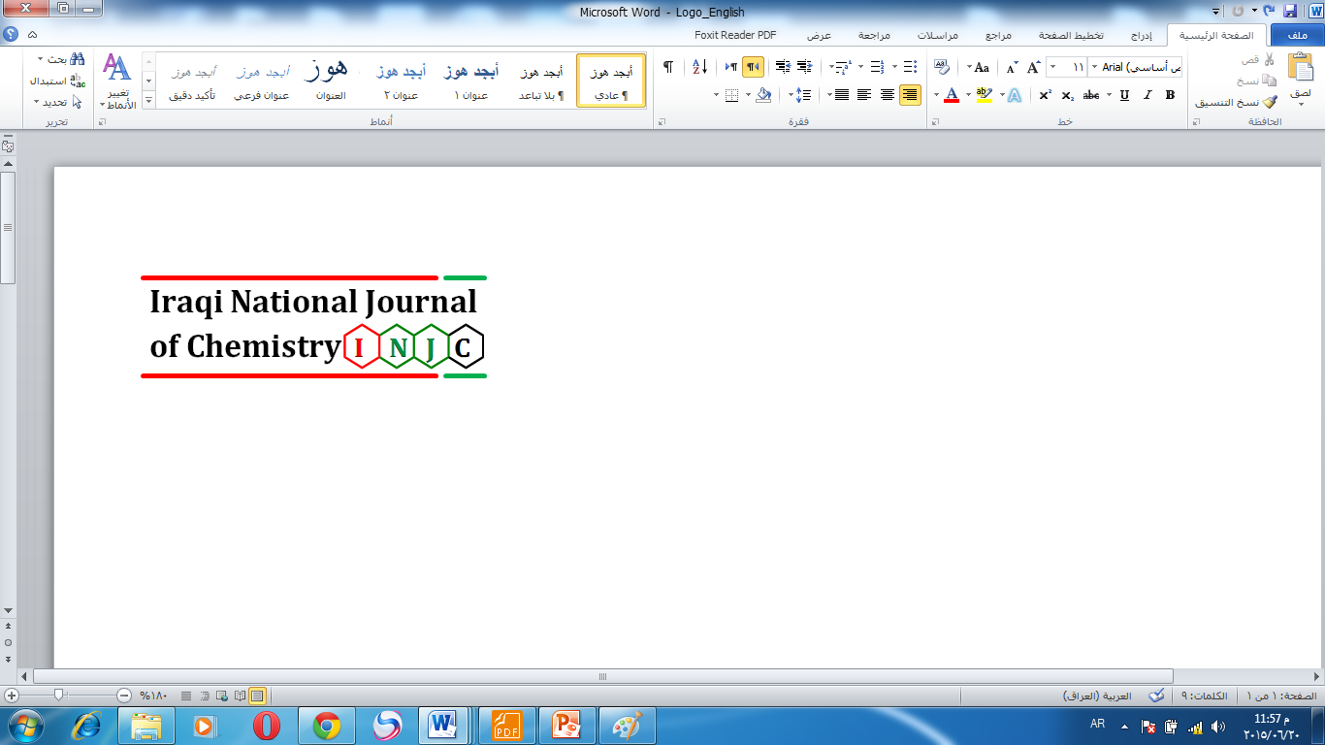
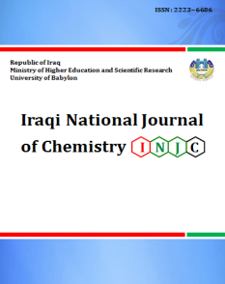
Iraqi National Journal of Chemistry
Journal homepage: http://iqnjc.com/Default.aspx

Volume: 15 Issue: 4 Year: 2015

Editorial Board:
Editor in Chief:  Prof. Dr. Falah H. Hussein (Iraq)  Editorial Secretary:  Asst. Prof. Dr. Mahmoud H. Hadwan (Iraq)  Editorial Directory:  Asst. Prof. Dr. Asim A. Balakit (Iraq)  Editors:  Prof. Dr. Hathama R. Hasan (Iraq)  Prof. Dr. Taghreed H. Al-Noor (Iraq)  Prof. Dr. Omar H. Al-Obaidi (Iraq)  Prof. Dr. Hassan .Al shamsi (Iraq)  Prof. Dr. Marwan M. Al Sharook (Iraq)  Prof. Dr. Ashour H. Dawood (Iraq)  Prof. Dr. Hadi S. Al-Lami (Iraq)  Prof. Dr. Shirwan O. Baban (Iraq)  Prof. Dr. Abbas M. Bashi  Asst. Prof. Dr. Abdulsamie H. Alta’ee (Iraq)  Asst. Prof. Dr. Abbas J. Lafta  Asst. Prof. Dr. Ayad F. Alkaim (Iraq)  Asst. Prof. Dr. Muhsen A. Al-Ibadi (Iraq) | Advisory Board:  Prof. Dr. Dawn Verdugo (United States)  Prof. Dr. Ram K.Agarwal (India)  Prof. Dr. SuvardhanKanchi (South Africa)  Prof. Dr. Gamal A. El-Hiti (Saudi Arabia)  Prof. Dr. TaghreedHashim Al-Noor ( Iraq)  Prof. Dr. Adel Ali Ismail (Egypt)  Prof. Dr. Najim A. Al-Masoudi(Germany)  Prof. Dr. Muhsen Al-Jouhry (Yemen)  Prof. Dr. D. V. Prabhu (India)  Prof. Dr. Mufeed J. Ewadh (Iraq)  Asst. Prof.Dr. AjazHussain (Pakistan)  Prof. Dr. Hedef D. Ibrahim El-Yassin (Iraq)  Prof. Dr. Ammar H .Al-Dujaili (Jordan)  Dr. Umar Farid (United Kingdom)  Dr. Helmi Hussain (Canada)  Dr. Yassin N. AlObaidi (United States)  Dr. Kadum J. Msayib (United Kingdom)

Contact Us
You can contact with the cadre of the Iraqi national journal of chemistry.
admin@iqnjc.com
Contents:
No. | Title | Page
1 | Synthesis of hetero cyclic compounds pyrazole and pyridiazine from  3-Methylbutane Hydrazide Derivatives with evaluating of its  biological activity  Hala Shakyier Lihimes | 294
2 | Determination of the Concentration Level of Homocystiene in The  Serum of Patients With Myocardial and Type II Diabetes in  Salahaddin Province  Nadia Ahmed Saleh Aljbarah,  Omeed Majeed Al-Muhandis,  Amjed Abbawi Saleh Aljebouri, | 307
3 | Assess the relationship between insulin fasting levels and healthy obesity in adults in the province of Babylon, Iraq  Amera Kamal Mohamed  and Alaa Jawad Hassan | 318
4 | Preparation and identification of new Chalcone- Azo ligand (SACAI) and its complexes.  Saad M Mahdi | 329

