Synthesis and Spectrophotometric Study of 4- (6- Nitro-2-
benzothiazolylazo) Resorcinol as an Analytical Reagent
for the Determination of Zinc.

Mohammed K. Khlool , Kasim H. Kadhim, and Abbas N. Al-Sharefy
Dept. of Chemistry , College of Science , University of Babylon
Babylon-Iraq

(NJC)

(Received on 18/ 1 /2005) (Accepted for publication on 11/ 10 /2005)

Abstract
4-( 6-Nitro-2-benzothiazolyl azo )resorcinol (6-Nitro BTAR) has been synthesized , and used as a reagent for the spectrophotometric determination of micrograms of zinc ions. This method sensitive, selective and rapid for reaction between Zn²⁺ and (6-Nitro BTAR), to form a brown complex having a molar ratio of 1:2 (Zn - 6-Nitro BTAR) at pH 6. The molar absorptivity of the complex is (5846 .7 L.mol⁻¹.cm⁻¹) at λ_{max} 462.5 nm .Beer’s law is obeyed in the range of 0.2 –2.5 μg.ml⁻¹ and the stability constant was found to be 1x10⁸ L².mole²⁻.
The relative standard deviation, recovery and relative error values of method were found to be R.S.D% = 1.6, Re % = 98.84,and Erel % = -1.16. The most important interference were due to Hg²⁺,Cd²⁺,CrO₄²⁻, Ag⁺, Ni²⁺ and Co²⁺ , and suitable masking agents were used. The method was applied successfully for the determination of zinc in clay of shaat Al-Hilla.
الخلاصة
حضر الكاشف العضوي 4- ( 6 – نايترو – بنزوثيازوليل ازو ) ريزورسينول واستخدم في تقدير كميات مايكرو غرامية من ايون الزنك II بطريقة تحليلية طبقية سهلة وسريعة وحساسة. المعقد المتكون ( البني اللون) من تفاعل الكاشف مع ايون الزنك II عند pH = 6 بنسبة 1:2 من الايون الفلزي الى الكاشف عند الطول الموجي 462.5nmومعامل الامتصاص المولاري 5846.7 لتر. مول ^{–1} .سم⁻¹ حيث كانت التراكيز التي تطاوع قانون بير مساوية الى (0.2-3 ) مايكرو غرام زنك II / مليلتر , وبلغت قيمة ثابت الاستقرارية1x10 لتر² .مول⁻² , وحدد دقة وضبط الطريقة التحليلية المتبعة بأستخدام محلول قياسي من ايون الزنك فكانت قيمة R.S.D % , Re % , Erel % هي 1.6 , 98.84 , 1.16 على التوالي. كذلك تم دراسة تأثير ايونات Hg²⁺,Cd²⁺,CrO₄²⁻, Ag⁺, Ni²⁺,Co²⁺ على التوالي والتي تتداخل عند تفاعل الكاشف BTAR مع ايون الزنك II وتم حجب تاثيرها باستخدام عوامل حجب قياسية , طبقت الطريقة التحليلية لتقدير الزنك في طين شط الحلة.

Introduction
The determination of trace – or ultra trace amounts of zinc becomes more and more important in different fields such as environmental, biological, and material sciences ⁽¹⁾. Zinc are essential elements for animals, and of ten exist in food, drink and grains ⁽²⁾.
Many method used to determination Zn²⁺ ions, for example separation, preconcetration or by inductively coupled plasma atomic emission spectroscopy (Icp–AES)⁽³⁾. Another example simultaneous determination of Zn in cow liver by differential pulse polarograply ⁽⁴⁾ .
Also spectrophotomctric determination of zinc by using the reagent 2- (3,5– dibromo –2 – pyridylazo)–5-diethyl amino phenol ⁽⁵⁾ . beer’s law was obeyed for up to 0.36 μg.ml⁻¹ molar absorptivity 12,000 , the ratio of zinc to regent was 1:2.
Mohmmod et al⁽⁶⁾ used 1-(2-benzothiozolylazo)-3-(4-hydroxy dibenzo furan) for defrmination of zine at λ_{max} 603 nm , optimam ph (4.8) and molar absorptivity 10820 L.mole^{–1}.cm ^{–1}. Hnilickova et al⁽⁷⁾ used thiazolylazo resoreinol for determinetion of zinc at λ_{max} 510 nm, at optimum ph (4.8) and molar absorpitivity 32000 .
In this work , the reagent of (6-Nitro BTAR) which prepared by Azhar ⁽⁸⁾ is reprepared and used for the determination of zinc in aqueous solution and clay of shaat Al-Hilla. This study include found a sensitive and selective reagent for the spectrophotometer determination of zn²⁺ at room temperature .

Experimental
Apparatus
Absorption spectra were recorded with cintra5-GBc scientific Equipment, while absorption measurement were obtained with pye unicam uv. Visible sp8–100 double–beem length spectrophotometer both with matched 1 cm quartz cells. pH of the solution was measured using a philips Pw 9421 PH meter ( PH + 0.001 ).

FTIR spectra
FTIR spectra were recorded with FTIR – 8000 sehimadzu, single beam , both laser by KBr disks .
- Atomic absorption spectrophotometer 5000 , perkin – Elmer , U.S.A
Reagents
- All chemical were used of analytical – reagent grade unless stated other wise .
- All solution were prepared with de – ionized water .
Perperation of Reagent ⁽⁹⁾
Dissolve ( 3.45gm of para nitro aniline and 3.8gm thiocyanate amounium) in 70 ml glical acetic acid , after that add drop by drop from burette (1.2 ml Br₂ + 15 ml glical acetic acid) with keep temp. 10ْ C.
After 15 min add alkaline solution to precipitate the thiazole compound. Take 1.95 gm of thiazole and dissolve in 50 ml glacial acetic acid then add (5ml conc. Hcl + 25 water to this solution . After that add drop by drop from burette a solution (0.69 gm NaNO₂ + 5 ml H₂O)with stirring at 10ْ C to form dizonium salt , then add (1.1 gm resorcinol + 50 ml ethanol) to dizanium salt to form the 4-(6- Nitro-2- benzothiazolylazo) resorcinol (6-Nitro BTAR).
Standard Zinc Solution
A solution of Zinc²⁺ 1000 ppm was prepared by dissolving (0.208)gm of Zncl₂ in 100 ml of distilled water, working solution were prepared freshly by appropriate dilution of the stock solution.
6- Nitro BTAR Solution
A solution of 1× 10⁻³ M were prepared by dissolve 0.079gm in 250ml ethanol.
Procedure
Add 3 ml of reagent (BTAR) to 1 ml from solution containing ≤ 3 mg. ml⁻¹ of Zn²⁺ in 10 ml calibrated flask and the solution was diluted to the mark with water after adjusted the pH at 7. Measure the absorbance of the resultant solution after 5– 0 min. at λmax 462.5 nm at 25 ْ C against blank solution prepared under the same conditions.

Results and Discussion
FTIR Spectra of Reagent
The FTIR spectra of reagent Fig.(1) appeared absorption band of (1-11) at 3454.3 cm⁻¹ refer to hydroxy group of resorcinol , absorption band of r ( C- H) at 2947.0 cm⁻¹ refer to (C-H) of aromatic ring, absorption band of r (C-H) at 1649.0 cm⁻¹ , absorption band of r( C = C ) thiazol ring at 1494.7 cm⁻¹, absorption band of r(N=N) at 1529.4 cm⁻¹ , and absorption band at 1328.9 cm⁻¹ refer to ( NO₂)^{(10,11)}.
FTIR Spectra of complex
The FTIR spectra of complex Fig. (2) appeared absorption band at 3300-2089.8 cm⁻¹refer to (OH) found in para position of resorcinol or found H₂O in the complex.

Absorption band appeared at 1647.1 cm⁻¹ refer to ( C=N) of thiazole ring different from this band in reagent because it spilted to lower vibrational that mean coordinated with matel from nitrogen thiazol ring.
In addituin absorption band spilted in 1529.4 cm⁻¹ refer to (N = N) , and that mean coordinate with matel from nitrogen azo group. In this complex appeared a new band at 553.5 cm⁻¹ refer to ( M-O ).
Properties of 6- Nitro BTAR:
6- Nitro BTAR orange color and stable in ethanol , but at pH ≥ 8.5 its solution being deep red where this situation may be interpretated as the following equilibrium :

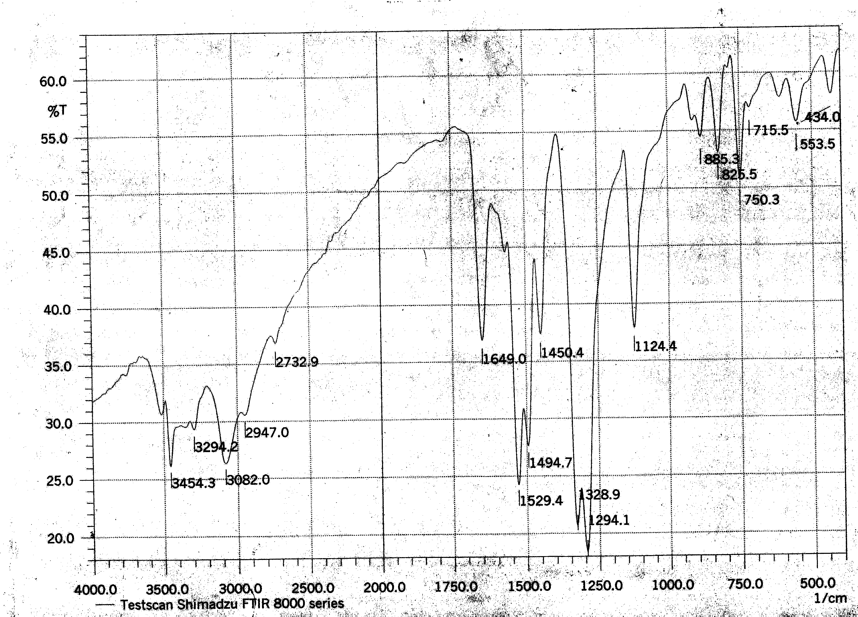

Fig.(1) FTIR spectra of reagent.

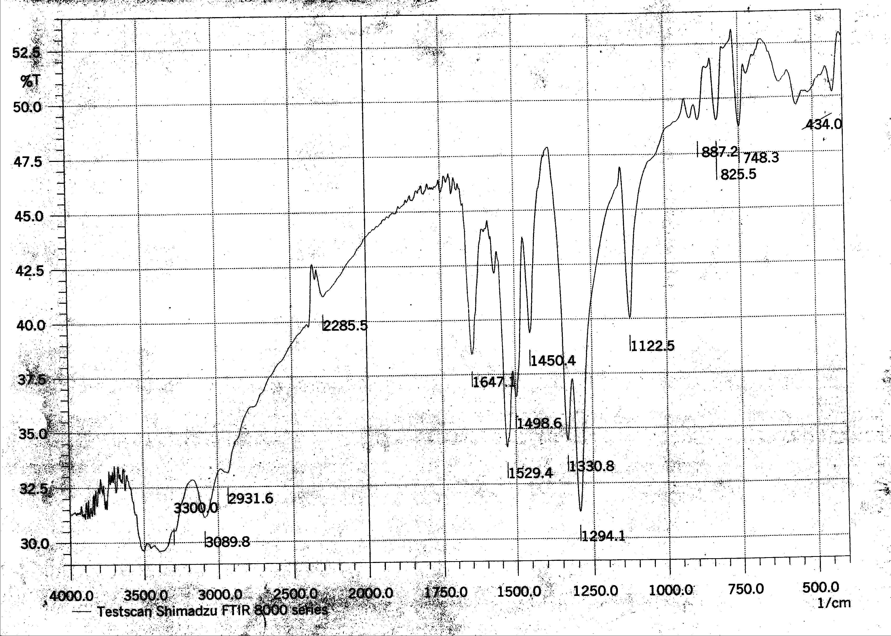

Fig.(2) FTIR spectra of complex.

Study of the Zinc²⁺ – 6 Nitro BTAR complex:
Absorption spectra :
UV- visible absorption spectra of solutions containing the reagent and its Zinc complex are shown in Fig.(3). The free Zinc showed an absorption maximum at 231 nm, reagent have 414 nm, and the complex at 462.5 nm.

200 300 400 500 600 700 800
2

1.5

1

0.5

0
Wavelength(nm)
Abs
Metal
Reagent
Complex
a
c
b

Fig.(3) Absorption spectra of ( a) Zn , (b) 6- Nitro BTAR, (c) Zn- BTAR complex. at pH= 6.

Effect of Reagent concentration:
When the amount of reagent added to an aliquot of solution containing 1 mg of Zn²⁺ was varied from (0.5-4.0) ml, the maximum absorbance was observed on the addition of 3 ml of BTAR at pH= 6.
Effect of pH:
The influence pH was studies over the rang 2-9.5 , adjusted by means of dilute Hcl and NaOH solution , Fig.(4) shows the relation ship between absorbance and pH, where the maximum absorbance obtained in the range of pH ( 5.5- 8) . At pH > 8 a decreases in absorbance because the precipitation of Zinc complex, and also before pH < 5.5 a decrease in absorbance may be due to form a zolium cationresult from the reaction between hydrogen ion and long pair of electron found a nitrogen atom in thiazole ring.

pH control
Fig.(4) Effect of pH on the absorbance of Zinc complex, Zn²⁺1 μg.ml⁻¹.

Effect of time and temperature:-
The stability of the absorbance of the complex was studies from 1 to 10 min ( intervals 1 min) till 24 h. (Fig.5) . The maximum absorbance was reached at the 10 min . The absorbance after this optimal time was, almost stable until 24 hrs.
The effect of temp. on the absorbance of the Zn-6- Nitro BTAR complex was studied. The study was performed at temp. between 10ºc and 60ºc ( Fig. 6)

Fig.(5): Effect of time on the absorbance of Zinc complex Zn²⁺1 μg.ml⁻¹.
Fig.(6)Effect of temp on the absorbance of Zinc complex Zn²⁺1 μg.ml⁻¹.

The maximum absorption was obtained when the temp. was varied between 20Cº and 40cº , at temp. higher than 40 cº the absorbance gradually decreased with increasing temp. until it reaches 60cº , wich may be due to dissociation of the complex.

Determination of Stiocheiometry constant ⁽¹²⁾
The composition of the complex was studied by Job's method (Fig.7,8). Both methods indicated that the ratio of metal iow to ligand molecules was 1:2 at pH 5.5-8. The formation constant , calculated by applied procedure, was found to be 1 x 10⁸ L². mole⁻².

Fig.(7): Job plots (BTAR) = [ Zn⁺²]=1x10⁻³, pH=5.5-8.

Fig.(8): Mole- ratio plots (BTAR)= [ Zn⁺²]=1x10⁻³, pH=5.5-8.

Analytical characteristics:
Linearity range:-
Linear calibration graph through the origin was obtained and showed that the complex obegd Beer's law over the range (0.2-3) μg/ml of Zn²⁺. The average molar absorpivily was found to be 5846.7 L².mole⁻¹.cm⁻¹ and the saudell's sensitivity was 0.0011 μg.cm⁻² and the correlation coefficient (r) was 0.9984. The high value of ( r ) indicate the good linearity and correspondence to Beer's law.

Precision and accuracy
The relative standard deviation, evaluated for seven independent of 3 μg/ml of Zn²⁺ was 1.6%, and the recovery and relative error for the complex solution containing (1.5) ppm of Zinc are 98.84, - 1.16% respectively. This result show that this method is highly precise.
Interferences:
The effect of the ions (Hg²⁺, Cd²⁺, Ag⁺,CrO₄²⁻,Ni²⁺,Co²⁺) which form complex with the reagent 6- nitro BTAR during its reaction with Zn²⁺were studied. On the other hand, suitable masking agents were examined for eliminating the effect of the interfering six ions as shown in Table (1).

Table 1: Effect of Masking reagents on the absorbance of Zinc complex

Zn²⁺/ ppm | Masking agent (2) ml,[0.01]M | Abs
3 | - | 0.234
3 | Citric acid | 0.242
3 | Tartaric acid | 0.235
3 | Ascorbic acid | 0.361
3 | Oxalic acid | 0.276
3 | 5-sulphosalcylis acid | 0.082
3 | 1,10 phenoanthrolin | 0.143
3 | NaF | 0.197

For this table allowstered the citric acid, tartaric acid, and oxalic acid not effect on the absorbance, therefore making a mixture of this reagent and calculate the absorbance of the zinc.

Analytical Application:
To check the applicability of this method , sample of clay of sheet AL-Hilla was analysed according to the method which is described below⁽¹³⁾ . A sufficient amount of wet clay was dried at 105cº for 48h. One gram of the dried and powderd clay was weighted accurately. This weight, largely, dissolved in conc. HNO₃ (20-30ml) , after that little deionized water added and the solution was filtered using whatman⁻¹ filter paper. The filtered solution was then diluted to the mark in volumetric flask.
The result obtained from the proposed method was compared with those given by atomic absorption spec. (ASS) ( Standard addition method).
The conc. of Zn⁺² analyzed by proposed method was found be 132 μg.gm⁻¹ of dried clay and that AAS was found to be 124 μg.gm⁻¹ of dried clay.
The good agreements of the results obtained by the tow method indicates applicability of the proposed method for the determination of Zn⁺² in samples of different matrixes.

References
1. K.Lee, M.Oshima and S.Motomizo , Anal. Sci., 2004, 20, 1432.
2. H.W. Goo, Y.Chang,H. and Q. Song Ye,J. Korean Chem. Soc., 2001, 22,6.
3.S.L.C. Ferreira and H.C. Dossantos, J. Braz.Chem. Soc., 1998, 9, 525.
4- G. Somer, G.Guliyera, and O.Sendil, Can.J. Chem., 2003, 81,931.
5- Z.Y. Wang, Anal . Abs., 1989, 51,5.
6-A.A. Mohammod, A.A. Al- Kadhumi and N.A.Fakhri, J. of College of Educ., 1990, 2,2.
7- H.R. Hovind, Review Analyst, 1975, 100,1196.
8- A.A. Qhali, M.Sc.Thesis , Uneversity of Babylon ,(2003).
9- R.Q. Brewster and F.B.Dains, J.Ger. Chem. Soc., 1936, 58, 1364.
10- L. Hejazi, et al.,Talanta, 2004, 62,185.
11-T.Nakai,I.Fuoiwara, and S. Tagashira, Anal. Sci., 2004, 20,235.
12- W.C. Vosburgh and G.R. Cooper, J.Am. Chem. Soc., 1941, 63,347.
13- M.M.S. Al- Tace, Ph.D.thesis , Babylon University, 1999.

