Spectrophotometric Determination of Methyl dopa by
Reaction with Tyramine and Potassium metaperiodate.

Mohammed.J.Hussan, Muneer.A.Al-Da'amy and Anas.M.Al-Abachi
Chemistry Department,College of Science,Baghdad University
Baghdad-Iraq

(NJC)

(Received on 20 / 2 /2005) (Accepted for publication on 28 / 9 /2005)

Abstract
A batch and flow injection (FI) spectrophotometric methods have been developed for the determination of methyl dopa in aqueous solution and in pharmaceutical tablets preparation. The methods are based on the reaction of methyl dopa with tyramine in the presence of potassium metaperiodate as oxidizing agent. The water soluble orange colour produced was measured at λmax 481 nm.linearity was observed from 0.5-20 and from 1-50 μg ml⁻¹ methyl dopa with quantification limits of 0.20 and 0.43 μg⁻ ml⁻¹ methyl dopa by batch and FI procedure respectively. The effect of chemical and physical parameters have been carefully considered and the proposed procedures were successfully applied to the determination of methyl dopa in tablet pharmaceutical formulation.
الخلاصة
تم تطوير طريقتين تقليديه وحقن جرياني طيفيه لتعين المثيل دوبا في المحاليل المائيه والأقراص الدوائيه. تعتمد على تفاعل المثيل دوبا مع التايرمين وميتا بيريودات البوتاسيوم كعامل مؤكسد في الوسط المتعادل. تم قياس الناتج البرتقالي اللون الذائب في الماء عند طول موجي 481 نانوميتر. وكانت الخطيه بين 0.5 -20 و 1- 50 مايكروغرام مل⁻¹ وحد كشف 0.2 و 0.43 مايكروغرام مل⁻¹ مثيل دوبا لكل من الطريقه التقليديه وطريقة الحقن الجرياني على التوالي. تم دراسة العوامل الفيزيائية والكيميائيه التي تؤثر على الطريقتين وتم تطبيق الطريقتين بنجاح في تعين المثيل دوبا في الأقراص الدوائيه.

Introduction
Methyl dopa [3-(3,4-dihydroxy phenyl) 2-methyl L-alanine] is one of the catechol amine drugs that was discovered in 1960 and was used as hypotensive agents(1) in 1970. The pharmaceutical preparations containing this drug (Aldomate) is available for many years and several analytical procedures have been proposed for their control .These include spectrophotometric(2),chromatographic(3),potentiometric(4), and flow injection(5).

Oxidative coupling organic reactions seems to be one of the most popular spectrophotometric methods for the determination of several drugs such as sulphonamids (6),paracetamol (7), phenylephrine HCL (8), methyl dopa (9) and folic acid (10).
In the present paper ,an automated procedure is proposed for the spectrophotometric determination of methyl dopa by reaction with tyramine in the presence of potassium metaperiodate in neutral medium.The reaction can be carried out in batch and in FIA and in this paper the two approaches are compared.The reaction products have been spectrophotometrically measured at 481 nm.

Experimental
Apparatus
All spectral and absorbance measurements were carried out on a Shimadzu uv-visible 260 digital double beam recording spectrophotometer using 1cm silica cells . In FIA ,a flow cell with 50 μl internal volume and 1cm path length was used for the absorbance measurements. A two-channel manifold (Fig.1) was employed for the FIA spectrophotometric determination of methyl dopa drug. A peristaltic pump (Ismatec, Labortechnik – Analytik, CH – 8152, Glatbrugg – Zurrich- Switzerland) was used to transport the carries solutions. (Rheodyne-USA) injection valve was employed to provide appropriate injection volumes of standard solutions and samples. Flexible vinyl tubing of 0.5 mm internal diameter was used for the peristaltic pump. Reaction coil (RC) was of Teflon with internal diameter of 0.5 mm.
Channel A was used to transport tyramine solution and channel B to transport potassium meta periodate solution. The sample was injected into the stream of the mixture of tyramine with potassium metaperiodate solution, through the injection valve. Solutions were propelled by peristaltic pump with individual flow rate of 1.5 ml min.⁻¹. The absorbance was measured at 481 nm.

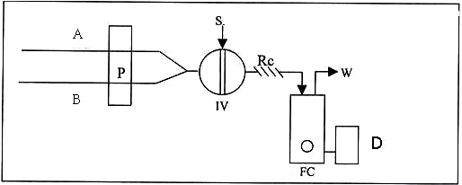
Fig (1).Manifold employed for FIA-Spectrophotometric determination of Catecholamine drugs with P-toluidine and Sodium periodate where: W. IV. Injection valve, Rc.Reaction Coil, S. Sample, P.Peristaltic pump, FC.Flow cell, D.Detector Waste.

Reagents
All chemicals were of analytical reagent grade unless otherwise stated. Pure methyl dopa and aldomate tablets were obtained from the state company for drug industries (SDI).

Solutions
Freshly prepared aqueous solution of the pure drug (100 μg ml⁻¹) of methyl dopa, (protected from sun light) was used as the standard solution for analytical purposes. Aqueous solutions of 0.1M and 0.1M potassium meta periodate were used. More dilute solutions were prepared by suitable dilutions.
Procedure for the batch method.
In to aseries of 25ml calibrated flask,transfer increasing volumes of methyl dopa solution (50 μgml‾¹).Add 2.5ml of 5*10‾³M of potassium metaperiodate solution,followed by 2 ml of 1*10⁻² M of tyramine solution .Dilute the solution to the mark with distilled water and allow the reaction mixture to stand for 15 min at room temperature.Measure the absorbance at 481nm against a reagent blank prepared in the same way but containing no methyl dopa. The colour of the formed dye is stable for about 120 min.For the optimization of conditions and in all subsequent experiments, a solution of 10 μgml‾¹ methyl dopa was used and the final volume was 25ml.

Procedure for the FIA method.
Samples containing different concentrations of methyl dopa drug were prepared by simple dilution with distilled water of the stock solution (100 μg ml⁻¹). The FIA spectrophotometric measurements were carried out using the manifold shown in Fig.1, employing 1 mM of tyramine and 5 mM potassium metaperiodate with a flow rate of 0.75 ml min⁻¹ in each channel .100 µl of samples and standard solutions were injected and the absorbance of the resulting dye product was measured at 481 nm.
Optimizations of conditions were carried out on 20 μg ml⁻¹ of methyl dopa.

Pharmaceutical preparation:
Tablets

Ten tablets of metyl dopa were weighed and finally powdered using a mortar. A weighed amount of the powder equivalent to 100 mg of the pure methyl dopa was dissolved in hot water, cooled and made up to 100 ml with distilled water. The resulting solution was filtered off and was treated as described under recommended procedure.

Result and Discussion
Batch spectrophotometric determination:
When a diluted aqueous solution of methyl dopa was mixed with tyramine and potassium metaperiodate in neutral medium, an intense orange colour forms immediately and become stable after 15 min.The colour has a maximum absorption at λmax 481 nm. Fig.2 shows the spectra of the orange colour formed and of the reagent blank.

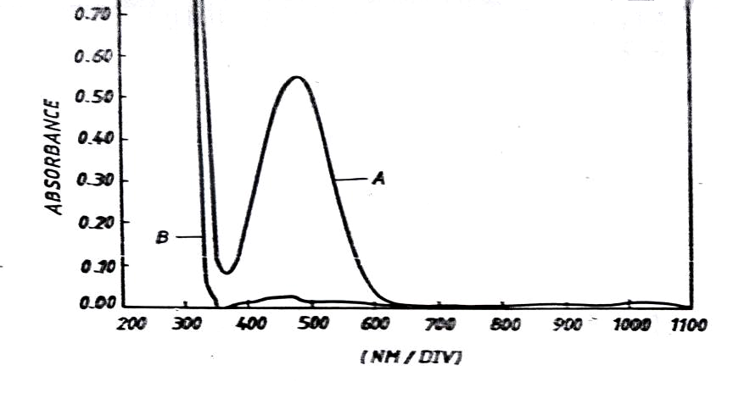
Fig.2 :Absorption spectra of A (20 μg ml⁻¹) of metyl dopa treated as described under procedure and measured against reagent blank and B the reagent blank measured against distilled water.

The best experimental conditions for the determination of methyl dopa were established for tyramine (from 0.0001 to 0.01 M) and potassium metaperiodate (from 0.0001 to 0.008 M) by altering one variable at a time and studying the absorbance at 481 nm as a function of time. The obtained results show that 0.0008 M of tyramine and 0.0005 M of potassium metaperiodate are the concentrations that can give a higher absorption intensity at 481 nm for 250 μg of methyl dopa in afinal volume of 25 ml ( i-e 10 μg ml⁻¹).
The development of the colour of methyl dopa from a mixture containing 10 μg ml⁻¹ in 0.0008 M tyramine and 0.0005 M potassium metaperiodate gave evidence that the colour develops during the first 15 min. and remains stable for more than 120 min.
The effect of temperature on the colour intensity of the dye was studied. In practice, high absorbance was obtained when the colour was developed at room temperature (25 C⁰) than when the calibrated flasks were placed in an ice-bath at (0 C⁰) or in a water bath at ( 60 C⁰).
The stoichiometry of the reaction was investigated using molar ratio method (11). The results obtained (Fig.3) show a 1:1 drug to tyramine product was formed at 481 nm.The formation of the dye may probably occur as follows:

Fig.3 Study of the mole ratio of the reaction between methyl dopa and tyramine
The regression equation obtained, from a series of methyl dopa standards, and the analytical figures of merit of this procedure are summarized in Table 1 in which are also summarized the main performance of the flow procedure developed for methyl dopa determination in order to make an effective comparison between the two approaches.
Table.1 Analytical features of the procedures developed for the determination of methyl dopa
Parameter | Batch procedure | FI procedure
Regression equation  Linear range (μg ml⁻¹)  Correlation coefficient  Limit of detection (s/n=3) μg ml⁻¹  Reproducibility % for 10 μg ml⁻¹  Recovery,% for 10 μg ml⁻¹  Through-put (hr‾¹) | Y=0.0159x-0.0011  0.5-20  0.9991  0.20  1.40  98.66 | Y=0.0051x+0.0127  1-50  0.9980  0.43  0.86  100.94  120

FI Spectrophotometric determination:
The batch method for determination of methyl dopa was adopted as a basis to develop F1 procedure , using the manifold indicated in Fig.1.The absorbance intensity of the coloured product at 481 nm has been improved by studying the effect of the different FI parameters on the reaction between methyl dopa and tyramine in the presence of potassium metaperiodate such as tyramine concentration (from 0.0001-0.01M) , potassium metaperiodate (from 0.0001-0.05M), flow rates of reagents (from 0.15-2.5 ml/min.in each channel ) , length of the reaction coil (from 25 -125 cm) and injection volume (from 50-250 μL) . The results obtained showed that a concentration of 0.001M and 0.005M were optimum for tyramine and potassium metaperiodate respectively . A flow rate of 0.75ml/min. in each channel , a reaction coil of length of 50cm and an injection volume of 100 μL were the best conditions which provided the highest absorbance at 481nm with the lowest blank value .
A standard calibration line , obtained for a series of methyl dopa standards and the main analytical figures of merit of the developed procedure are indicated in Table 1 .
The increase in the temperature of the reaction coil does not increase the absorbance at 481nm and caused a degradation of the coloured product and low sensitivity and stability of the reaction products.
Analytical application :
The developed methodology is very adequate for the determination of methyl dopa in aqueous solution and in pharmaceutical preparation samples at a concentration level of traces (p.p.m.) and without requiring any previous separation step nor a temperature or pH control . Moreover the proposed procedures are very economical when compared to other methods such as those based on the use of HPLC.
In comparison of the batch with FI procedure , the later is more convenient than the former method because of its speed (sample through-put of 120 injection/hr.) and wider linear range of the calibration graph (Table1) .
The precision of the method was evaluated by analyzing pure sample of methyl dopa and a good recovery was obtained (Table1). Finally the proposed method was applied successfully to the analysis of some tablets containing methyl dopa . The results in Table2 are in accordance with those obtained by the official method.

Table.2 Application of the proposed methods to the determination of methyl dopa in tablets.
Drug sample | Batch method  Recovery*,% RSD*,% | FI method  Recovery*,% RSD*,% | Official method  Recovery, %
Aldomate  250 mg (SDI)  Aldomate  250 mg (ASIA) | 98.66 0.92  101.34 1.80 | 101.50 0.72  100.57 0.74 | 98.30  98.02
* For five determinations.

References
- Meyers,F.H.,Jawetz,E. and Goldfien, A.,"Review of Medical pharmacology"
2 nd Ed,Blackwell Scietific publications ,Califorinia 1970
2. Salem, F.B., Anal.Lett.,1985, 18, 1063.
3. Rona, K.,Ary,K.,Gachlyiand ,B., and Kalbovich ,I., J. of Chromato., 1996, 125, 730.
4. Badawy,S.S.,Issa, Y.M., and Tageldin, A.S., Electro analysis, 1996, 8, 1060
5. Berzas, J.J., Lemus,, J.M. and Buitrago, P., Anal.Lett., 1997, 30, 1109.
6. Abachi, M.Q., Farid, Y.Y and Hamza. M.J., National Journal of Chemistry, 2002, 8, 520.
7. Abachi, M.Q.,Al-Abachi, R.S., National Journal of Chemistry, 2002, 8, 527
8. Al-Abachi, M.Q., Hussan M.J. and Mustafa M.A., National Journal of Chemistry, 2003, 9, 79.
9. El-Kommos, E.M. Mohamed F.A. and Khedr, S.A, J.Assoc.off.Anal.Chem., 1990, 73, 516
10. Ghabsha, T.S., Al-Sabha, T.N. and Saleem, M.S., J.Techn. Res., 1994, 49
11. Hargis, L.G, Analatical chemistry, 1988, Prentice-Hall Inc., New Jersey

