The Influence of pH and Temperature on Tautomerism of Imines Derived from 2-hydroxy -1- napthaldehyde .

A.S.P.Azzouz , A.A. Rahman and A.G.Taki

Chemistry department , College of Education University of Mosul

Mosul, IRAQ

(NJC)

(Received on 23/ 5 /2005) (Accepted for publication on 11/10 /2005)

Key words : Tautomerism and isomerization reactions , UV study , thermodynamic of tautomerism , thermodynamic of isomerization , Schiff base , oxime .

Abstract
The tautomerism reactions of one oxime molecule and seven Schiff bases derived from 2- hydroxy-1- napthaldehyde with an appropriate aliphatic and aromatic amines were studied .
The study is mainly concerned with the tautomerism reactions of the above mentioned imines . This requires the measurements of UV absorption spectra of imines 2-9 under the influence of different pH values in the range 4-10 and different temperatures. This is accomplished by the evaluation of equilibrium constants K1 and K2 for the tautomerism and isomerization reactions respectively and for imines 3-7
The remaining imines 2,8 and 9 undergo a tautomerism reaction only . The result shows that the extent of keto and enol forms in these imines are altered by the variation of both , pH and temperature .
The processes of tautomerism and isomerization reactions are proved by the evaluation of thermodynamic parameters which were measured in ethanol and 1,2- dichloroethane . The ΔH values calculated for both reactions indicate an exothermic reactions type.Also these reactions being either spontaneous or nonspontaneous as confirmed from the sign and value of ΔG estimated .Finally the calculated negative entropies values ΔS , support these reactions stated above and are accompanied by loss of keto entropy .Finally , a suitable explaination for the last behavior is given and discussed .
الخلاصة
الدراسة تشمل توتومرية واحد من الاوكزيمات وسبعة قواعد شيف المشتقة من
2-hydroxyl-1-napthylaldehyde ومن الأمينات المناسبة .
تركزت الدراسة على تفاعلات التوتومرية للأيمينات الواردة اعلاه . ذلك يتطلب قياسات اطياف الاشعة فوق البفسجية للأيمينات بالارقام 2-9 وتحت تأثير دوال حامضية( pH) مختلفة محصوربين 4-10 وبدرجات حرارية مختلفة . يصاحب ذلك استخراج ثوابت التوازن K₁ و K₂لتفاعلي التوتومرية والايزومرية على الترتيب وللأيمينات بالارقام 3-7 .أما اللأيمينات بالارقام 2,8,9 فأن تفاعلاتها تشمل التوتومرية فقط. كما بينت النتائج ان نسب توافر شكلي الكيتو والاينول في الأيمينات هي متغيرة واعتماداً عاى الدالة الحامضية ودرجة الحرارة اثناء القياس .
إن عمليتي التوتومرية والايزومرية الواردتين اعلاه , قد تم اثباتهما بعد استخراج المتغيرات الثرموديناميكية والمقاسة في مذيبي الكحول و 1,2-DCE . أما قيم ∆H المحسوبة للتفاعلين فقد أكدتا أنها باعثة للحرارة وبطبيعة تلقائية او غير تلقائية واعتماداً على اشارة ∆G وأخيراً فأن القيم السالبة للمتغير ∆S قد اكدتا التفاعلين اعلاه . كما عالج البحث الحالة الاخيرة وقدم التفسير والمناقشة اللازمين لها .

Introduction
Schiff bases derived from sulphadrugs and salicyaldehyde had been found to be good fungicides¹ , bactericides^{2,3} as well as chelating agents^{4,5} . This encourage some workers to increase experimentation in the chemistry of imines , particularly by measuring their U.V⁶ , IR⁷ , NMR⁸ and mass spectra^{6,9} , beside others kinetic^{10,11},
thermodynamic¹¹ and association^{12,13} physical properties .
The keto-enol equilibria for varieties of Schiff bases¹⁴⁻¹⁶ derived from β–ketones , o- hydroxyacetophenones , and o-hydroxyacetonapthones had been studied by p.m.r . Later , a number of Schiff bases¹⁷ were synthesized from methylamine containing N¹⁵ with the same previous ketones . The p.m.r spectra of these adducts confirm the previous assignments of structures, and the temperature dependence of the spectra , yields information on tautomeric equilibria .
In another study¹⁸ , the spectra of anils derived from napthaldehyde were altered by solvent polarity . These little informations lead us to increase expermentation in the field of tautomeric equilibria in these compounds .
Recently and in our previons paper¹⁹ we have confirmed the structures of eight imines derived from 2- hydroxy-1-napthaldehyde with an appropiate aliphatic and aromatic amines .The structures are identified by using U.V, IR and wet-dry melting points. The study proves the existence of imines in the hydrogen bonding forms , beside their capability of tautomerised keto and enol form.
The present investigation is an extension of the previous study. It deals with the effect of pH and temperature on enol keto equilibria in Schiff bases derived from 2-hydroxy-1-napthaldehyde and various amines. The study is accomplished by measuring the thermodynamic parameters of tautomerism reaction , namely theΔ H, ΔGand ΔS in these imines as given and discussed .

Experimental
Materials and methods
All chemicals used throughout this work are of Fluka origin.
Preparation of imines :
All imines 2-9 under study, have been prepared and identified by physical methods, namely UV, IR and wet-dry melting points are cited in our previous communication.

Experimental factors affecting the tautomerism of imines

- Effect of base
0.5 ×10⁻⁴ M of imines 2-9 are prepared in aqueous and 0.084 N NaOH media, followed by measuring their UV spectra in these media and against blank solvent .

- Effect of pH
At the begining , five buffer soluions of pH values 4,6,7,8 and 10 are prepared.

Then after 10⁻⁴ M of stock imines 2-9 are prepared in these buffer solutions . The effect of pH on the tautomerism process in imines stated is followed by measuring the electronic spectrum of each at different pH values against the same buffer solution . The equilibrium constant (K) value for the tautomerism reaction enol keto is evaluated from an equation K= A_{kteo} / A_{enol} , where A _{enol} = Absorbance of enol ,
A _{keto} = Absorbance of keto.
In the meantime , the two equilibrium constants values for any imine showing two keto bands in the UV spectrum and at longer wavelengths if compared with enol are calculated . In other words, for those reactions exhibiting two tautomerism reactions of a type:
trans -keto enol cis -keto
K₁ = A_{cis-keto} / A_{enol} , K₂ = A_{trans –keto} / A_{enol} , where ,
A_{cis – keto =} Absorbance of cis keto and A_{trans – keto =} Absorbance of trans keto .

3 – Effect of temperature
The influence of temperature on the tautomerism reaction in imines 2-9 is followed by measuring the UV spectrum of each 10⁻⁴ M imine in ethanol and 1,2-di- chloroethane(1,2-DCE)at a range of temperatures between 15-55 C⁰ .The thermodynamic parameters of tautomerism process are evaluated by standard
method ¹³.

Instrumentation
The UV absorption spectra were measured using UV – 160 visible Shimadzu having a computerized recording spectrophotometer . A temperature control during measurement was acheived by using a thermostat of the type Julabo Paratherm PT 40 PS. A matched silica cells of dimensions 1× 1× 3 cm³ are used . The pH is measured by using a digital pH meter of a type pw 9421 ( philips ) . The pH meter is calibrated by using a buffer solutions of pH values 4 and 9 .

Results and discussion
Initially to study the tautomerism in Schiff bases derived from 2-hydroxy-1- naptaldehyde , two preliminary experiments are performed by measuring the UV absorption spectra of imines 2-9 firstly in water and secondly in 0.084N sodium hydroxide as in Fig.1 . These show the existence zwitter ion formation and the high ratio of keto / enol in imines 2-9 in media stated respectively. The wavelengths of intermediates in the tautomerism reaction are observed to be of order of : zwitter ion>keto>enol . These are in agreement with other previous study on Schiff bases derived from salicylaldehyde²². These studies ensure the tautomerism reactions in imines under study, and encourage the authors to deal with the following factors which may affect the tautomerism reaction:-

- Effect of pH
Generally the tautomerism reactions can be taken place by using either acid or base catalyst. Accordingly, the effect of pH in the range 4-10 on tautomerism reaction in imines 2-9 is studied by measuring their UV spectra and the following results are collected
.
2- Hydroxy-1-napthaldoxime ( 2 )
Two absorption bands are appeared in the pH ranges 4-10, the first one is a shoulder with smaller intensity and lies at longer wavelength . The second one is a real band with higher intensity and absorbs at shorter wavelength. The former absorption is converted to a real band with higher intensity at pH 10. This indicates the tautomerism reaction of such compound at pH indicated , as in Fig.2. It is in agreement²⁴ with earlier study on carbonyl compounds .
2-Hydroxy-1-napthylideneaniline ( 3 )
In the range of pH 4-7 a nitrilium ion -CH-N⁺H- appeared at longer wavelength .Its intensity is increased by decreasing pH value . Other bands at relatively shorter wavelength with respect to the first are also assigned for keto and enol forms . The wavelengths of UV absorptions of such compounds are observed to be in order of²⁵⁻²⁶ :
nitrilium ion >keto>enol .
Also at basic condition i.e pH range (8-10 ), a disappearance of nitrilium ion band followed by an increase ratio of relative concentrations of keto/ enol forms , with a bathochromic shift of the keto²⁷⁻²⁸ band by increasing pH are observed .
2-Hydroxy-1-napthylidene –o-hydroxyaniline ( 4 )
A weak nitrilium ion bands are observed at pH 4-7 , attributed to its weak stability . This is due to the weak basicity of nitrogen atom of azomethine as approved in our previous communication¹⁹ by two folds inter and intramolecular hydrogen bondings. At higher pH value, the nitrilium ion band is disppeared and the keto and enol bands are retained in the spectrum as before. A blue shift in the wavelength of enol as accompanied by decreasing its absorbance by increasing pH value is also observed . This comes in agreement with Masuod et.al²⁶ finding for picolines and quinolines oximes, these authors concluded that the bands at shorter wavelengths are referred to the intramolecular hydrogen bonding of the oximes studied and represent the enol in compounds 2-9 i.e the enol bands are blue shifted by increasing pH.
2- Hydroxy-1-napthylidene m& p-hydroxyaniline ( 5,6 )
These compounds show the appearance of a nitrilium ion bands at relatively higher wavelengths in the pH range 4-7. These bands disappeared at pH range 8-10 and accompanied by a relative increase of a keto form by increasing pH . In the meantime , an inverse observation is happenening to the enol form .
2- Hydroxy-1-napthylidene o- & m-phenylenediamine ( 7,8 )
These molecules show a nitrilium ion bands at pH range 4-7 and their quick disappearance at higher pH . This will followed by a red shift and an increase of absorbance of keto form followed by a blue shift and relative decrease of enol form by increasing pH value , confirming the tautomerism process in these molecules.

2-Hydroxy-1-napthlidene –p-phenylenediamine ( 9 )
This shows a shoulder at longer wavelength and two clear bands for keto and
enol forms at the UV spectrum as in Fig.2. At a pH range 8-10 the shoulder is converted to a real band which supports the tautomerism²⁴ process in this compound. nitrilium ion band is completely absent at pH range 4-6.

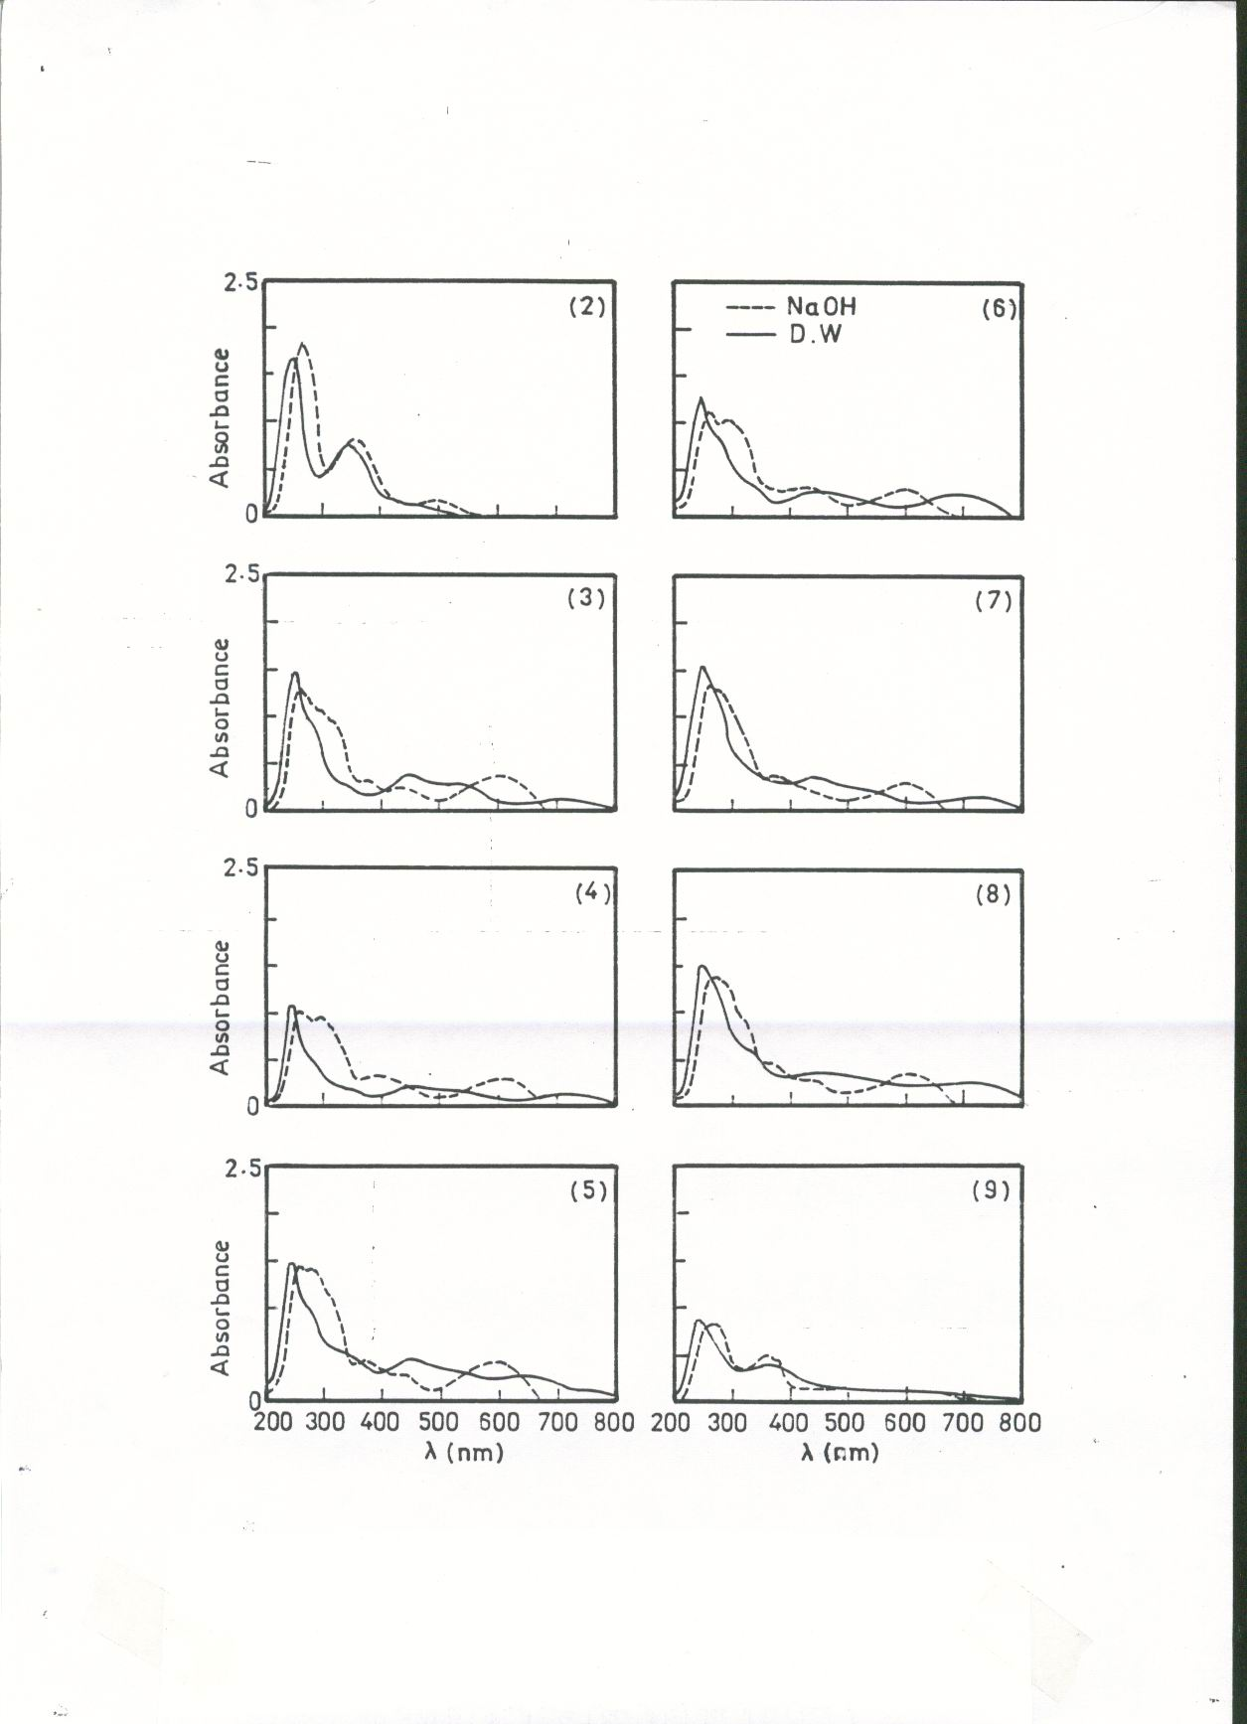

Fig . 1 Absorption spectra for imines 2-9 in aqueous and 0.084N NaOH media .

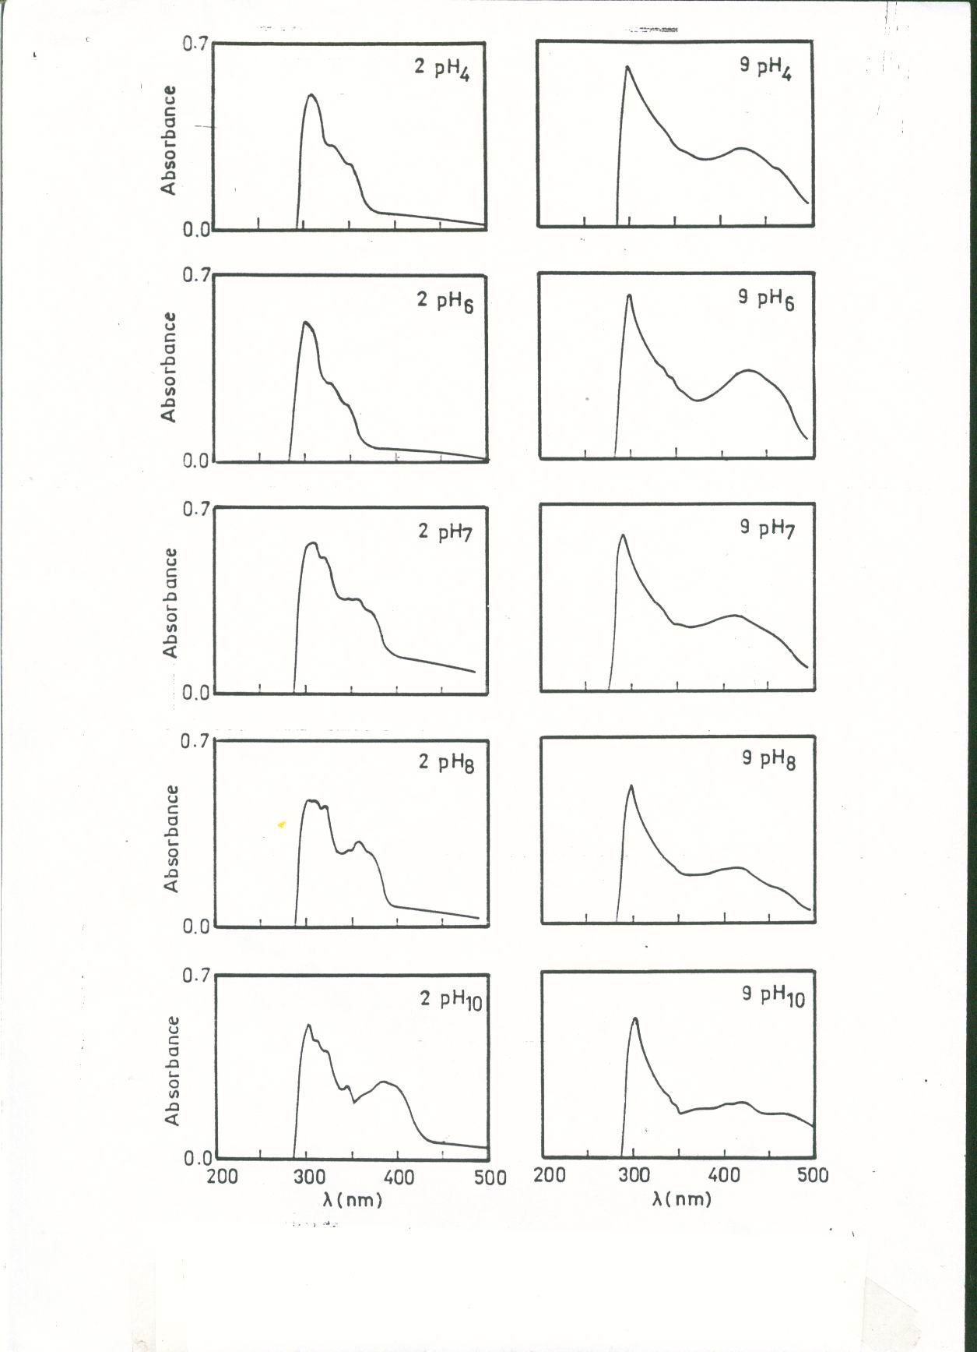

Fig . 2 Absorption spectra for imines 2 and 9 at pH range 4-10

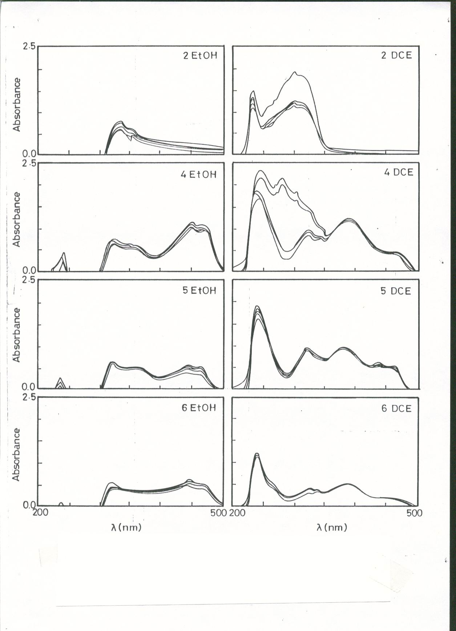

Fig.3 Absorption spectra for imines 2,4,5 and 6 in ethanol and DCE at a temperature range 15-55 C˚

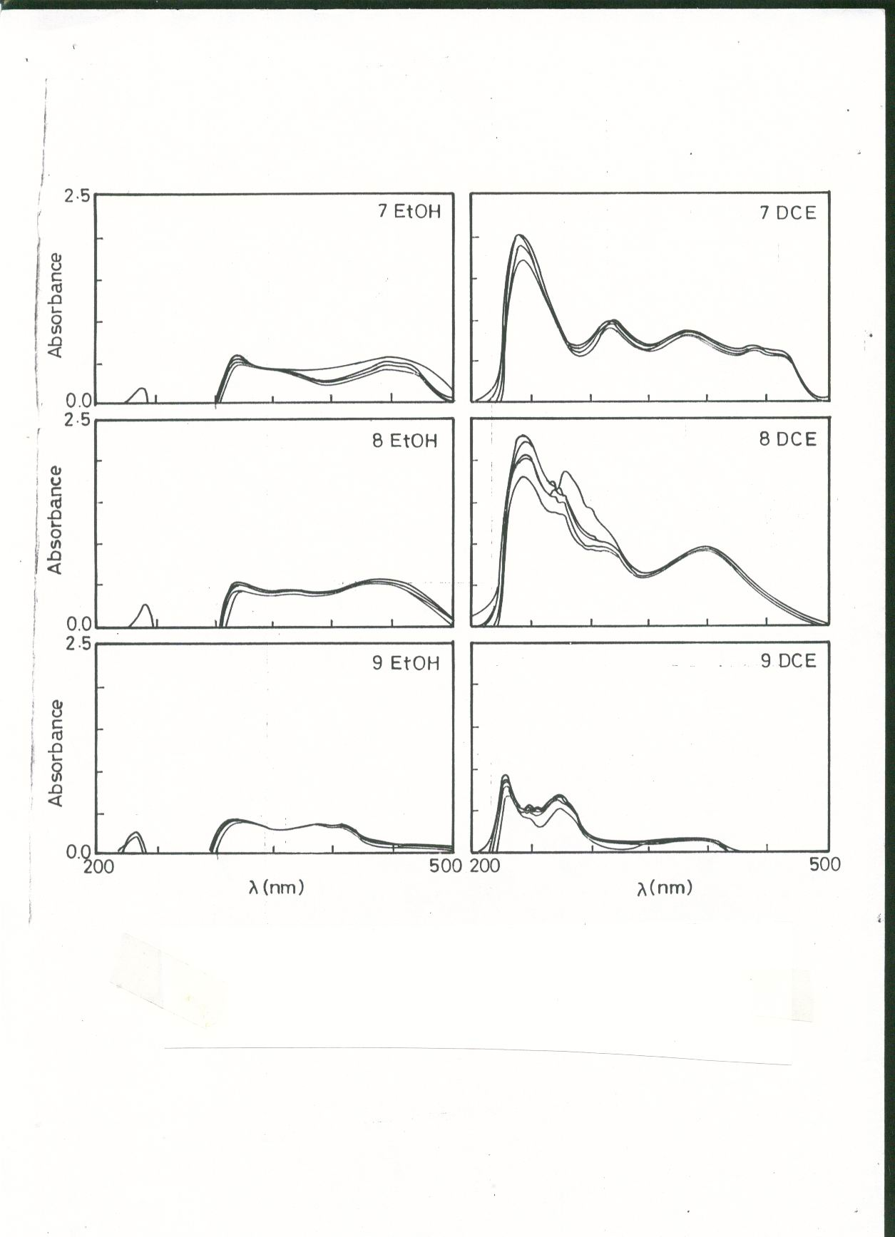

Fig.4 Absorption spectra for imines 7,8 and 9 in ethanol and DCE at a temperature range 15-55 C˚

B - Effect of temperature
Several workers have been observed clear influence of tautomeric equilibria^{21,31,32} for a number of organic compounds by changing the temperature. In this study , the tautomerism process in compounds 2-9 was achieved by measuring the UV spectra at a range of temperatures ( 288-328 ) k in ethanol and 1,2-dichloroethane ( DCE ) as in Fig.3-4 . In ethanol solvent, compounds (2) , (6,8 ,9) , (5,7)and (4) show two, four, five and six bands respectively with different relative intensities. Meanwhile in DCE solvent, compounds(2,8 ,9) and(4,7) show four and five bands respectively .
The phenomena of tautomerism reaction as expected in this work can be interpreted by the following equilibria :

This tautomeric reaction is in agreement with a previous tautomeric studies and occurs on substituted Schiff¹⁷ bases and anils³⁰ as a first step. It is accompanied by a second isomerism reaction³²⁻³⁵. In other words the processes of tautomerism and isomerism reactions are taken place in consecutive reactions.
Some studies^{30,41} had confirmed that the trans and cis keto bands appeared at longer wavelength if compared with enol form. So the longer wavelength bands in Fig. 2 and 3 are referred to the geometrical isomers¹⁸ trans-keto and cis-keto respectively. Surely, this will facilitate the evaluation of equilibrium constants K₁ and K₂ for the compounds which contain two adjacent bands at longer wavelength from the relations : K₁₌ A_{cis-keto} / A_{enol} , K₂ ₌ A_{trans-keto} / A_{enol}
And the thermodynamics of above reaction . Other compounds which show only one band for the keto form , facilitate the evaluation of only one equilibrium constant K=A_{keto} / A_{enol} .
The thermodynamic of tautomerism means the change in ΔG, ΔH and ΔS accompanied by the transformation of enol to the keto form , in addition to the physical meaning of any one of these thermodynamic parameters. Table ( 1 ) shows the results of vant Hoff plots in ethanol and DCE solvents. It gives the values of slope, intercept, correlation coefficient and standard errors . The first two values are used in the evaluation¹³ of enthalpy of tautomerization reactions in imines 2-9 under study . Meanwhile , Tabel ( 2 ) illustrates the values of ΔH,ΔG and ΔS for each imines at a temperature range ( 288 –328 ) K.
The ΔH values for all imines shown in Tabel ( 2 ) have a negative sign . Their values represent the enthalpy required to convert enol imines to their corresponding keto analogues and are exothermic reactions . These results come in agreement with the thermodynamic of tautomerism^{32,36-40} of several compounds . The last is a clear confirmation of the tautomerism reaction outlined above and assisting an improvement of the enthalpy difference between the trans keto and cis- keto tautomers in a range of values of ( 50-2500 ) J . mole⁻¹ for imines studied . Moreover , the last range mentioned is due to the different substituents positions in the imines , which is regarded as one of the effective factor influencing the tautomerism as well as the isomerism processes . Tabel ( 2 ) shows that the low Δ H values are for K₂ equilibrium constants in ethanol and DCE solvents . This can be explained by stability⁴² of trans – keto as compared with cis keto .

Table 1 Names and structures of prepared imines .
No. of compound | Compounds | Color | m.p. C⁰ | Structure
1 | 2 -Hydroxy-1-naphthaldehyde | yellow | 83-85
2 | 2-Hydroxy-1-naphthaldoxime | white | 138-140
3 | 2-Hydroxy-1-naphthylidene- aniline | yellow | 102-104
4 | 2-Hydroxy-1-naphthylidene -o- hydroxyaniline | faint brown | 274-276
5 | 2-Hydroxy-1-naphthylidene -m- hydroxyaniline | yellow | 260-262
6 | 2-Hydroxy-1-naphthylidene -p- hydroxyaniline | dark brown | 230-232
7 | 2-Hydroxy-1-naphthylidene -o- phenylenediamine | dark brown | 160-162
8 | 2-Hydroxy-1-naphthylidene -m- phenylenediamine | reddish brown | 168-170
9 | 2-Hydroxy-1-napthylidene-p-phenylidenediamine | brown | 268-270

Table 2 Thermodynamic data collected for imines 2-9 in ethanol and DCE solvents.
No. of Compound | Solvent | Temp.  Kº | ln K | ΔH Jmol⁻ | ΔG Jmol⁻ | ΔS J.mol⁻deg⁻
2 | EtOH | 288 | -0.196 | -3086.2001 | +469.3086 | -12.3455
2 | EtOH | 298 | -0.222 | -3128.9430 | +550.0209
2 | EtOH | 308 | -0.283 | -3077.7376 | +724.6814
2 | EtOH | 318 | -0.310 | -3106.2802 | +819.5941
2 | EtOH | 328 | -0.352 | -3089.4283 | +959.9011
2 | EtOH |  |  | -3097.7178 | +704.7012 | -12.3455
2 | DCE | 288 | +0.283 | -8370.5080 | -677.6242 | -26.7114
2 | DCE | 298 | +0.152 | -8336.5887 | -376.5909
2 | DCE | 308 | +0.052 | -8360.2688 | -133.1570
2 | DCE | 318 | -0.062 | -8330.3070 | +163.9188
2 | DCE | 328 | -0.148 | -8357.7450 | +403.5948
2 | DCE |  |  | -8351.0835 | -123.9717 | -26.7114
3 | EtOH  K1 | 288 | -0.420 | -4083.6821 | +1005.6614 | -17.6713
3 | EtOH  K1 | 298 | -0.479 | -4079.2999 | +1186.7569
3 | EtOH  K1 | 308 | -0.494 | -4177.7785 | +1264.9917
3 | EtOH  K1 | 318 | -0.581 | -4083.4055 | +1536.0780
3 | EtOH  K1 | 328 | -0.632 | -4072.7379 | +1723.4589
3 | EtOH  K1 |  |  | -4099.3804 | +1343.3893 | -17.6713
3 | EtOH  K2 | 288 | -0.455 | -4037.6635 | +1089.4665 | -17.8025
3 | EtOH  K2 | 298 | -0.515 | -4029.2058 | +1275.9495
3 | EtOH  K2 | 308 | -0.575 | -4010.7713 | +1472.4094
3 | EtOH  K2 | 318 | -.610 | -4048.4564 | +1612.7497
3 | EtOH  K2 | 328 | -0.667 | -4020.3278 | +1818.9036
3 | EtOH  K2 |  |  | -4029.2846 | +1453.8957 | -17.8025
3 | DCE  K₁ | 288 |  |  |  | -13.0138
3 | DCE  K₁ | 298 | -0.603 | -2384.1650 | +1493.9759
3 | DCE  K₁ | 308 | -0.634 | -2384.7884 | +1623.4914
3 | DCE  K₁ | 318 | -0.663 | -2385.5449 | +1752.8738
3 | DCE  K₁ | 328 | -0.692 | -2381.4793 | +1887.0784
 |  |  |  | -2383.9944 | +1689.3548 | -13.0138
3 | DCE  K₂ | 288 |  |  |  | -14.2294
3 | DCE  K₂ | 298 | -0.662 | -2600.2316 | +1640.1526
3 | DCE  K₂ | 308 | -0.695 | -2602.9842 | +1779.6948
3 | DCE  K₂ | 318 | -0.727 | -2602.8934 | +1922.0804
3 | DCE  K₂ | 328 | -0.759 | -2597.4816 | +2069.7869
3 | DCE  K₂ |  |  | -2600.8975 | +1852.9286 | -14.2294
4 | EtOH  K₁ | 288 | +0.725 | -1239.9733 | -1735.9632 | +1.7221
4 | EtOH  K₁ | 298 | +0.713 | -1253.2971 | -1766.5088
4 | EtOH  K₁ | 308 | +0.692 | -1241.5791 | -1772.0127
4 | EtOH  K₁ | 318 | +0.682 | -1255.4515 | -1803.1070
4 | EtOH  K₁ | 328 | +0.660 | -1234.9373 | -1799.8147
4 | EtOH  K₁ |  |  | -1245.0476 | -1775.4812 | +1.7221
4 | EtOH  K₂ | 288 | +0.675 | -1693.2824 | -1616.2416 | -0.2675
4 | EtOH  K₂ | 298 | +0.653 | -1697.5703 | -1617.8545
4 | EtOH  K₂ | 308 | +0.625 | -1682.8358 | -1600.4450
4 | EtOH  K₂ | 318 | +0.609 | -1695.1717 | -1610.1508
4 | EtOH  K₂ | 328 | +0.588 | -1691.2122 | -1603.4712
4 | EtOH  K₂ |  |  | -1692.0144 | -1609.6236 | -0.2675
4 | DCE  K₁ | 288 | -0.837 | -2241.0662 | +2004.1395 | -14.7403
4 | DCE  K₁ | 298 | -0.853 | -2279.3298 | +2113.3689
4 | DCE  K₁ | 308 | -0.891 | -2258.4173 | +2281.5943
4 | DCE  K₁ | 318 | -0.921 | -2252.4270 | +2434.9876
4 | DCE  K₁ | 328 | -0.949 | -2246.9023 | +2587.9154
4 | DCE  K₁ |  |  | -2255.6104 | +2284.4010 | -14.7403
4 | DCE  K₂ | 288 | -1.005 | -3303.9233 | 2406.4041 | -19.8275
4 | DCE  K₂ | 298 | -1.052 | -3302.1970 | +2606.4057
4 | DCE  K₂ | 308 | -1.041 | -3441.1768 | +2665.7011
4 | DCE  K₂ | 318 | -1.141 | -3288.5181 | +3016.6351
4 | DCE  K₂ | 328 | -1.177 | -3293.7589 | +3209.6695
4 | DCE  K₂ |  |  | -3325.9146 | +2780.9630 | -19.8275
5 | EtOH  K₁ | 288 | +0.172 | -6266.2043 | -411.8423 | -20.3276
5 | EtOH  K₁ | 298 | +0.090 | -6280.6199 | -222.9814
5 | EtOH  K₁ | 308 | 0 | -6260.9149 | 0
5 | EtOH  K₁ | 318 | -0.065 | -6292.3410 | +171.8503
5 | EtOH  K₁ | 328 | -0.155 | -6244.7841 | +422.6837
5 | EtOH  K₁ |  |  | -6268.9724 | -8.0594 | -20.3276
5 | KtOH  K₂ | 288 | +0.040 | -2968.5686 | -95.7772 | -9.9750
5 | KtOH  K₂ | 298 | 0 | -2972.5413 | 0
5 | KtOH  K₂ | 308 | -0.042 | -2964.7411 | +107.5499
5 | KtOH  K₂ | 318 | -0.073 | -2979.0395 | +193.0011
5 | KtOH  K₂ | 328 | -0.115 | -2958.1863 | +313.6040
5 | KtOH  K₂ |  |  | -2968.6152 | +103.6755 | -9.9750
5 | DCE  K₁ | 288 | -0.450 | -2728.7445 | +1077.4944 | -13.2160
5 | DCE  K₁ | 298 | -0.489 | -2726.8677 | +1211.5327
5 | DCE  K₁ | 308 | -0.528 | -2718.5056 | +1352.0559
5 | DCE  K₁ | 318 | -0.560 | -2722.1655 | +1480.5571
5 | DCE  K₁ | 328 | -0.590 | -2725.9584 | +1608.9252
5 | DCE  K₁ |  |  | -2724.4448 | +1346.1130 | -13.2160
5 | DCE  K₂ | 288 | -0.545 | -3233.8791 | +1304.9654 | -15.7598
5 | DCE  K₂ | 298 | -0.588 | -3239.6310 | +1456.8123
5 | DCE  K₂ | 308 | -0.634 | -3230.5507 | +1623.4914
5 | DCE  K₂ | 318 | -0.673 | -3327.5071 | +1684.1337
5 | DCE  K₂ | 328 | -0.711 | -3230.3483 | +1938.8913
5 | DCE  K₂ |  |  | -3252.3832 | +1601.6588 | -15.7598
6 | EtOH  K₁ | 288 | +0.394 | -2157.5245 | -943.4062 | -4.2156
6 | EtOH  K₁ | 298 | +0.356 | -2138.2908 | -882.0156
6 | EtOH  K₁ | 308 | +0.326 | -2133.2241 | -834.7921
6 | EtOH  K₁ | 318 | +0.301 | -2136.3883 | -795.7994
6 | EtOH  K₁ | 328 | +0.276 | -2135.3956 | -752.6497
6 | EtOH  K₁ |  |  | -2140.1646 | -841.7326 | -4.2156
6 | EtOH  K₂ | 288 | +0.252 | -3106.1122 | -603.3968 | -8.6900
6 | EtOH  K₂ | 298 | +0.222 | -3139.6362 | -550.0209
6 | EtOH  K₂ | 308 | +0.174 | -3122.0789 | -445.5638
6 | EtOH  K₂ | 318 | +0.148 | -3154.7050 | -391.2900
6 | EtOH  K₂ | 328 | +0.101 | -3125.7409 | -275.4261
6 | EtOH  K₂ |  |  | -3129.6544 | -453.1395 | -8.6900
6 | DCE  K₁ | 288 | -1.041 | -622.8995 | +2492.6037 | -10.8177
6 | DCE  K₁ | 298 | -1.049 | -624.7073 | +2598.9730
6 | DCE  K₁ | 308 | -1.060 | -617.5028 | +2714.3547
6 | DCE  K₁ | 318 | -1.067 | -619.0447 | +2820.9900
6 | DCE  K₁ | 328 | -1.072 | -624.8765 | +2923.3354
6 | DCE  K₁ |  |  | -621.8061 | +2710.0512 | -10.8177
6 | DCE  K₂ | 288 | -1.195 | -2209.9457 | +2861.3462 | 17.6086
6 | DCE  K₂ | 298 | -1.224 | -2214.8304 | +3032.5481
6 | DCE  K₂ | 308 | -1.250 | -2222.5750 | +3200.8900
6 | DCE  K₂ | 318 | -1.280 | -2215.4210 | +3384.1305
6 | DCE  K₂ | 328 | -1.310 | -2203.2786 | +3572.3595
6 | DCE  K₂ |  |  | -2213.2100 | +3210.2548 | 17.6086
7 | EtOH  K₁ | 288 | +0.255 | -3946.3614 | -610.5801 | -11.5825
7 | EtOH  K₁ | 298 | +0.190 | -3922.3457 | -470.7386
7 | EtOH  K₁ | 308 | +0.146 | -3941.2967 | -373.8639
7 | EtOH  K₁ | 318 | +0.080 | -3894.7666 | -211.5081
7 | EtOH  K₁ | 328 | +0.027 | -3872.7130 | -73.6287
7 | EtOH  K₁ |  |  | -3915.4964 | -348.0638 | -11.5825
7 | EtOH  K₂ | 288 | +0.238 | -1889.8006 | -569.8748 | -4.5830
7 | EtOH  K₂ | 298 | +0.140 | -1712.6166 | -346.8600
7 | EtOH  K₂ | 308 | +0.115 | -1706.0692 | -294.4818
7 | EtOH  K₂ | 318 | +0.095 | -1708.5840 | -251.1659
7 | EtOH  K₂ | 328 | +0.076 | -1710.5002 | -207.2513
7 | EtOH  K₂ |  |  | -1709.4425 | -274.9397 | -4.5830
7 | DCE  K₁ | 288 | -0.218 | -1313.3148 | +521.9861 | -6.3725
7 | DCE  K₁ | 298 | -0.238 | -1309.3645 | +589.6621
7 | DCE  K₁ | 308 | -0.254 | -1312.3316 | +650.4208
7 | DCE  K₁ | 318 | -0.271 | -1309.9942 | +716.4838
7 | DCE  K₁ | 328 | -0.286 | -1310.2841 | +779.9197
 |  |  |  | -1311.0578 | +651.6945 | -6.3725
7 | DCE  K₂ | 288 | -0.314 | 1535.9610 | +751.8516 | -7.9437
7 | DCE  K₂ | 298 | -0.335 | -1537.2640 | +829.9866
7 | DCE  K₂ | 308 | -0.369 | -1501.7858 | +944.9027
7 | DCE  K₂ | 318 | -0.375 | -1534.6820 | +991.4445
7 | DCE  K₂ | 328 | -0.393 | -1533.8566 | +1071.7078
7 | DCE  K₂ |  |  | -1528.7098 | +917.9786 | -7.9437
8 | EtOH | 288 | +0.255 | -1766.2551 | -610.5801 | -4.0127
8 | EtOH | 298 | +0.225 | -1753.2562 | -557.4537
8 | EtOH | 308 | +0.208 | -1768.5582 | -532.6280
8 | EtOH | 318 | +0.182 | -1757.2388 | -481.1810
8 | EtOH | 328 | +0.163 | -1760.6851 | -444.4996
8 | EtOH |  |  | -1761.1986 | -525.2684 | -4.0127
8 | DCE | 288 | +0.045 | -3622.7995 | -107.7494 | -12.2050
8 | DCE | 298 | +0.043 | -3743.6360 | -106.5355
8 | DCE | 308 | -0.005 | -3746.3472 | +12.8035
8 | DCE | 318 | -0.050 | -3749.0085 | +132.1926
8 | DCE | 328 | -0.097 | -3738.7332 | +264.5182
8 | DCE |  |  | -3720.1046 | +39.0458 | -12.2050
9 | EtOH |  | -0.093 | -1311.5980 | +230.4141 | -5.33
9 | EtOH |  | -0.079 | -1391.8256 | +195.7281
9 | EtOH |  | -0.052 | -1507.6704 | +133.1570
9 | EtOH |  | -0.028 | -1620.0731 | +74.0278
9 | EtOH |  | -0.004 | -1736.4666 | +10.9079
9 | EtOH |  |  | -1513.5267 | +128.8469 | -5.33
9 | DCE |  | -0.210 | -2414.1860 | +502.8307 | -10.12
9 | DCE |  | -0.160 | -2621.9805 | +396.4115
9 | DCE |  | -0.118 | -2817.4233 | +302.1640
9 | DCE |  | -0.064 | -3051.6661 | +169.2065
9 | DCE |  | -0.038 | -3218.5323 | +103.6256
9 | DCE |  |  | -2824.7394 | +294.8476 | -10.12

Table 3 vant Hoff data plots for imines 2-9

No. of compound | Solvent | Constant | Slope | Correlation Coffiecent. | S.E.
2 | EtOH | -1.484907 | 373.247297 | 0.9784 | 0.009358
2 | DCE | -3.212822 | 1006.22602 | 0.9979 | 0.007890
3 | EtOH | -2.125491 | 491.535777 | 0.9999 | 0.000946
3 | EtOH | -2.141272 | 485.490059 | 0.9952 | 0.005688
3 | DCE | -1.565299 | 287.329251 | 0.9999 | 0.000338
3 | DCE | -1.711508 | 313.471506 | 0.9996 | 0.000827
4 | EtOH | 0.207143 | 150.01744 | 0.9775 | 0.003843
4 | EtOH | -0.032175 | 203.871643 | 0.9951 | 0.002414
4 | DCE | -1.772949 | 271.782351 | 0.9768 | 0.007068
4 | DCE | -2.384836 | 400.749913 | 0.8356 | 0.029389
5 | EtOH | -2.44499 | 755.354029 | 0.9977 | 0.007057
5 | EtOH | -1.19978 | 357.690966 | 0.9977 | 0.002916
5 | DCE | -1.589621 | 328.269969 | 0.9990 | 0.001746
5 | DCE | -1.895583 | 389.58842 | 0.9993 | 0.001710
6 | EtOH | -0.507059 | 257.418747 | 0.9992 | 0.000940
6 | EtOH | -1.045223 | 377.90862 | 0.9846 | 0.006297
6 | DCE | -1.301145 | 74.921521 | 0.9855 | 0.001536
6 | DCE | -2.117952 | 266.67248 | 0.9952 | 0.003132
7 | EtOH | -1.393141 | 470.055807 | 0.9698 | 0.013981
7 | EtOH | -0.551248 | 206.029204 | 0.9973 | 0.001427
7 | DCE | -0.766487 | 157.970003 | 0.9993 | 0.000687
7 | DCE | -0.955472 | 184.991274 | 0.9996 | 0.000684
8 | EtOH | -0.482651 | 212.207883 | 0.9936 | 0.002881
8 | DCE | -1.46801 | 451.295337 | 0.9996 | 0.002145
9 | EtOH | -0.64077 | 213.04500 | 0.9922 | 0.005200
9 | DCE | -1.21825 | 414.40600 | 0.9965 | 0.00668

The tautomerism process of compounds (2,8 ,9) is happen only between enol and keto form owing to the appearance of one keto band in the UV spectrum , hence the possibility of cis-trans isomerism reaction in such systems is completely forbidden . All ΔG values are evaluated in polar ethanol and in moderate less polar DCE solvents . The sign and magnitude values of ΔG are depends on the structures of imines , temperature and the solvents used . These findings are in agreement with theortical aspect and it is in agreement with our expectations .
Conclusions
1- when UV spectra of imines 2-9 are measured in water and dilute NaOH the sequence of absorption^{18,21,30} species as obtained is :
zwitter ion >trans.keto>cis-keto>enol
2- Imines 3-7show K₁ and K₂ equilibrium constant for a two consecutive reactions , namely the tautomerism and isomerization reaction . where as other imines2,8 and 9show only the K₁ equilibrium constant for tautomerism reactions only .
3- The sign of enthalpies ΔH of tautomerism and isomerization reactions in imines 2-9 as in Tabel ( 2 ) are all negative. This means that such reactions are exothermic. The enthalpies of tautomerism and isomerization reactions are calculated from K₁ and K₂ equilibrium constants respectively. Their values depend on the structure of imine, temperature and solvent polarity.
4- The calculated ΔG values from the two equilibrium constants K₁ and K₂ are for the tautomerism and isomerization reaction respectively :
The signs of ΔG being either positive or negative, which means that the reaction is nonspontaneous or spontaneous respectively.TheΔG values illustrated inTabel 2 being either positive or negative. Hence it is easy to interpert their values and signs in terms of different chemical structures of imines and temperatures. The polarity of solvent may contribute to a less extent in this point. These finding comes in a good agreement¹³ with the thermodynamic of interaction of Schiff base benzil mono benzyli- deneaniline at various temperatures.
5- The ∆S = S₂ - S₁ , S₂ and S₁ represent the entropy of keto and enol forms respectively . The negative signs of all ∆S values listed in Tabel(2) means a greater order of trans-keto or cis-keto when compared with enol form . This is happen by considering the following possibilities : -
- The increase in the association property of keto form in any imines by hydrogen bonding^{13,36}
- Solute – Solvent interaction or a dipole¹³ interaction between donor –acceptor species , especially when polar ethanol solvent is used . This assumption is agreed⁴³ with the inverse relationship between equilibrium constant value and the inverse of absolute temperature The smaller negative experimental entropy change (∆S) value as founded in Tabel (2) favour the first possibility as strongly proved in our recent communication¹⁹ of the molecules under study , while the larger ∆S predominate the dual possibilites .

References
- N.R. Sengupta , Indian J. Chem., 1966, 29, 33.
- A. Berger, Medicinal Chemistry,( 1960 ) , Interscience, NewYork .
- S. Goel and K. Lai, Asian J. Chem., 1990, 2, 271
- K.K. Narang and J.K. Gupta, J. Inorg. Nucl. Chem., 1976, 38, 589.
- K. Lai, Indian J. Chim, 1981, 20A, 853.
- A.A. Saeed, A.W.Sultan, S.A.Selman and N.A.Abood, Can.J.Spectrosc., 1983, 28, 142.
- A.A.Saeed , N.A.Abood, N.A.Al-Mosoudi : and G.T.Matti, Can. J.Spectrosc., 1985, 30, 142.
- Ed. S.Patai:, The Chemistry of Carbon Nitrogen Double Bond, John Wiley, New York , 1970, 149-180.
- A.S.P. Azzouz , Spectrosc. Lett., 1995, 28, 1 .
- A.S.P. Azzouz, K.A.Abdullah and Kh. I.Niemi, Microchem. J, 1991, 43, 45.
- A.S.P.Azzouz and S.S,Othman , J.Edu .Sci, 2001, 48, 32.
- A.S.P.Azzouz and S.M.Saleh, J.Edu.Sci., 2000, 46, 51,
- A.S.P.Azzouz,Z., Phys.Chem., 2002, 216, 1053.
- G.Dudek and R.H.Holm, J.Am.Chem.Soc., 1962, 84, 2691
- G.Dudek, J.Am.Chem.Soc., 1963, 85, 694.
- G.Dudek and G.Volpp, J.Am.Chem., 1963, 85, 2697.
- G.Dudek and E.P.Dudek, J.Am.Chem.Soc., 1964, 1964, 86, 2483.
- M.D.Cohen,T .Hirshberg and G.M.J.Schmidt , J.Chem.Soc., 1964, 2060.
- A.S.PAzzouz,A.AA.Rahman and A.G.Taki, J.Edu.Sci, 2003, Accepted.
- A.Findlay and J.A.Kitchener,Practical Physical chemistry, (1963), Longman, London, P.268
- S.F.Mason, J.Chem.Soc., 1957 , 5010.
- K.K.Chatterjee and B.E.Douglas, Spectrochimica Acta, 1965, 21, 1625.
- K.S.Tewari, S.N.Mehrotra and N.K.Vishnoi, “Text Book of Organic Chemistry” PVT, Newdelhi, (1980), P.271-75.
- Ed. J.Zabicky, The Chemistry of Carbonyl Group,Vol.2 Interscience, London, (1970 ).
- A.B.N.AL- Dabbagh, M.Sc Thesis, Mosul University , (1999).
- M.S. Masoud , G.B. Mohammad, A.M.Hindawey and T.M. Abdel-Fattah, Mutah J.Res. and Stud., 1991, 6, 2.
- D.G. Anderson and G.W. Mark , J.Am. Chem., Soc., 1965, 87, 1433.
- K.Nakamoto and A.E. Martell , J.Am. Chem. Soc., 1959, 81, 5857.
- G.O.Dudek and E.P.Dudek , J.Am. Chem. Soc., 1966, 88, 2407.
- R.S. Becker and W.F.Richey , J.Am. Chem. Soc., 1967, 89, 1298.
- K.I. AL- Niemi, ph. D Thesis ( 1999) , Mosul university .
- J.G.Dawber and M.M. Crane, J. Chem. Edu., 1967, 44,150.
- L.M.N.Saleem and O.Omer, Iraqi J.Sci., 1989, 30, 9.
- G.M.Wyman, Chem. Rev., 1955, 55, 625.
- L.M.N.Saleem and A.S.Authman, Spectro. 1992, Lett.,25, 799.
- G.Allen and R.A.Dwek, J. Chem. Soc., 1966, (B), 161.
- R. Roussel, M.O. de Guerrero, P.Spegt and J.C. Galine, Hetrocyclic Chem., 1982, 19, 785 .
- EJ.Drexler and K.W.Field, J. Chem. Edu., 1976, 53, 392.
- J.Powling and H.J.Bernstein , J.Am. Chem. Soc., 1951, 73, 4353.
- L.Burdett and M.T.Rogers, J.Phys . Chem., 1966, 70, 939.
- See ref. 8 , P. 50 , 61 , 65 .
- A.S.P. Azzouz, E.A.AL – Hyali and S.M.Khalil, J.Edu. Sci., 2000, 42, 22.
- M.Ladd, Introduction to physical chemistry, 3rd . ed., Cambridge(1998).

