Synthesis and Structural Studies on Nickel, Palladium and Rhenium Complexes of Potassium (1,1-Dicarboethoxy-2,2- dithioethene)

Mohamad Jaber Al-Jeboori,* Jalil A. Ugal and Moneer Kadhim

Department of Chemistry, College of Education, Ibn Al-Haitham, University of Baghdad, P.O. 4150, Adhamiyah, Baghdad, Iraq.
*e-mail:mohamadaljeboori@yahoo.com

(NJC)

(Received on 19/4/2005) (Accepted for publication on 12/11/2005)

Abstract
Diethylmalonate was reacted with carbon disulfide and potassium hydroxide in dioxane to give the bidentate ligand L {when L = potassium (1,1-dicarboethoxy-2,2-dithioethene}.
The reaction of the ligand with some metal ions (Ni^{II}, Pd^{II} and Re^{V}) in methanol under nitrogen with (2: 1) ligand: metal ratio resulted in a stable anionic complexes of the general formula: K₂[M(L)₂], K[ReO(L)₂], (where: M = Ni^{II}, Pd^{II}, L=1,1-dicarboethoxy-2,2-dithioethene).

All compounds have been characterised by some spectroscopic methods (I.R, U.V-vis, HPLC, atomic absorption) microanalysis and conductivity measurements. These studies showed that, the geometry around Ni and Pd is square planar, while Re complex adopted square pyramid geometry
الخلاصة
تضمن البحث تحضير الليكاند Potassium (1,1-dicarboethoxy-2,2-dithioethene) وذلك من مفاعلة ثنائي اثيل مالونيت مع ثنائي كبريتيد الكاربون وهيدروكسيد البوتاسيوم باستخدام الدايوكسان مذيباً. تم مفاعلة الليكاند مع بعض أيونات العناصر (Ni^{II}, Pd^{II}, Re^{V}) باستخدام الميثانول وسطاً للتفاعل وبنسبة (2: 1) ليكاند: فلز. حيث تم الحصول على سلسلة من المعقدات ذات الصيغة العامة: K₂[M(L)₂] , K[ReO(L)₂]
حيث: M= Ni^{II} , Pd^{II}
شخصت جميع المركبات المحضرة بالطرق الطيفية التالية (الاشعة تحت الحمراء، والاشعة فوق البنفسجية- المرئية و HPLC والامتصاص الذري)، وكذلك تم تشخيص المركبات بوساطة التحليل الكمي الدقيق للعناصر مع التوصيلية المولارية الكهربائية.
من النتائج اعلاه فأن الشكل الفراغي المقترح لمعقدات النيكل والبلاديوم هو مربع مستو بينما يتخذ معقد الرينيوم شكل هرم مربع القاعدة.

Introduction
Thiols compounds with some metals are playing role in the biological systems as enzymes responsible of hydrogenations.⁽¹⁾ Metal thiolate complexes are also potential precursors for metal sulphides and recently the exploration of the thiolate chemistry of platinum group metals as an alternative to thermal methods for synthesis of metal sulphides are reported.⁽²⁾ Certain 1,1 ethylenedithiolato metal complexes with electron-withdrawing substituents display interesting photophysical properties.⁽³⁾ Indeed, the increasing attention paid now a days to these species arises from their solvateochromic behaviour and room-temperature luminescence in solution, and their status as excellent candidates for applications as photocatalysts in light-to-chemical-energy conversion processes.^{(4,5)} In addition, the use of 1,1-ethylenedithiolate ligands may facilitate the syntheses of clusters or stabilize unusually high oxidation states.⁽⁶⁻⁹⁾ Most 1,1-ethylenedithiolato metal complexes are mononuclear, ^{(4,5,10)} although some homopolynuclear complexes with bridging or chelating 1,1-ethylenedithiolato ligands are reported.^{(11,12)} Rhenium complexes with thiols are very important as radiopharmaceuticals in nuclear medicine. We reported the synthesis and molecular structure of some novel Re(V)-oxo complexes with some dithiolate ligands.⁽¹³⁾ In this paper we report the synthesis and spectral studies on Ni^{II}, Pd^{II} and Re^{V} complexes of potassium (1,1 dicarboethoxy-2,2-dithioethene).

Experimental
Reagents were purchased from Fluka, Hopking & Williams & Riedel-Deltaen chemical Co. and used as received without further purification. The I.R spectra were recorder as (KBr disc) using a Pye-Unicam SP3-300. UV-Vis. Spectra were recorder in DMF using shimadzu-160A spectrophotometer. Molar conductivity measurements were recorder on Philips PW 9526 in different solvents on conc. 1 x10⁻³M. (C.H.N) analysis recorded on Perkin-Elemer B-20 at the University of Mosul, and atomic absorption were recorded on Pye-Unicam spectrophotometer. HPLC chromatograms of the complexes were obtained by using HPLC type Shimadzu LC-6A (Koyota-Japan), on (ODC-C₁₈) column; with an isocratic system and flow rate 1 cm³ with a mixture of (H₂O-MeCN) (65-35%) elution and UV (254nm) detection. [ReO₂(Py)₂]Cl was prepared by literature method. ⁽¹⁴⁾

Synthesis of ligand (L)
This ligand was prepared by method reported by Jensen and Henriksen⁽¹⁵⁾ as follows:
Pulverized potassium hydroxide (1.34 g, 2.4 x10⁻²mole) was suspended in dioxane (10mL), and a solution of diethyl malonate (1.88 mL, 1.2x10⁻² mole) and carbon disulfide (0.72 mL, 1.2 x10⁻² mole) in dioxame (10 mL) was added with stirring and cooling to maintain temperature a round (15ºC). After the addition, the suspension was stirred for another 20 minutes and then diluted with (250 mL) of ether. The yellow precipitate was filtered off, washed with dioxane- ether mixture with (1:1) ratio and dried in vacuum over NaOH and P₂O₅. Yield 3.5g (93%), m.p (90-92)ºC.
Synthesis of K₂[Ni{(EtOCO)₂ C=CS₂}₂]
(0.62 gm, 2x10⁻³ mole) of (L) was dissolved in (10 mL) MeOH, and a solution of NiCl₂. 6H₂O (0.25g, 1x10⁻³mole) in (10 mL) MeOH was added slowly to the mixture with stirring under nitrogen. The colour of the solution became red-brown, and the mixture was allowed to reflux for (60) min. The reaction was cooled to room temperature and filtered off. The solution was concentrated under vacuum to about half, and a red- brown precipitate was formed upon addition of Et₂O (15 mL). This was collected by filtration, washed with Et₂O (3 mL) and dried under vacuum to give 0.35 g (58%) of the complex. m.p. (300-302)ºC (dec).
Synthesis of K₂[Pd{(EtOCO)₂C=CS₂}₂]
(0.1g, 0.56 x 10⁻³ mole) of PdCl₂ with (10 ml) MeOH was heated under reflux for (30) min. The reaction mixture was filtered off. The filtrate was added dropwise under nitrogen atmosphere with stirring to a flask charged with (0.34 g, 1.12 x 10⁻³ mole) of (L) in (10 mL) MeOH. The reaction mixture was allowed to reflux for (60) min under nitrogen atmosphere, during this time, the colour of mixture became red-brown. The mixture was cooled to room temperature and filtered off. The solution concentrated to half, filtered off, and a red-brown precipitate was formed after addition of Et₂O (10 mL), this was collected by filtration and dried under vacuum, yield 0.16 g, (44%), m.p. dec. (256-258)ºC.
Synthesis of K[ReO{(EtOCO)₂ C=CS₂}₂]
(0.2 g, 0.35 x 10⁻³ mole) of [ReO₂(Py)₄]Cl in (10 mL) MeOH was added slowly with stirring under nitrogen to a mixture of (L) (0.27 g, 0.7 x 10⁻³ mole) in (15 mL) MeOH. The mixture was refluxed for (60) min during which time the colour of the mixture became red –brown. The solution was cooled to room temperature and filtered off, and concentrated under vacuum to about half, and a red- brown precipitate was formed upon addition of Et₂O (5 mL). The compound was dried under vacuum to give (0.1 g), (41%). m.p. >(330)ºC.
Results and Discussion
Synthesis of ligand
The ligand (L) was prepared according to the general method shown in Scheme 1. The (I.R) spectrum of the ligand (L) Fig. (2a), shows double bands at (1680 and 1615)cm⁻¹ assigned to ν (C=O) of the ester groups indicating that the two esters groups are non equivalent. A weak band at (1540)cm⁻¹ is assigned to ν (C=C), while the double bands at (1060 and 950)cm⁻¹ are corresponding to υ(C-S)⁽¹⁵⁾.
The (U.V-Vis) spectrum of the ligand Fig. (3a) showed absorption peaks at (250 nm)(39920 cm⁻¹)(ε_{max}=141 molar.cm⁻¹) and (342 nm)(29197cm⁻¹) )(ε_{max}=1922 molar. cm⁻¹) which assigned to (π-π*) and (n-π*) transitions respectively.

Scheme (1) The Synthesis route of the ligand

Synthesis of complexes
The reaction of (L) with (MCl₂) where (M = Ni, Pd) and [ReO₂(Py)₄]Cl was carried out in MeOH under reflux. The complexes are stable in the solid state and in solution.
The analytical and physical data Table (1) and spectral data Table (2) and Table (3) are compatible with the suggested structures Fig (1).

Figure (1) The Proposed structures of complexes

Table (1) Analytical and Physical data of the ligand and its complexes
Complexes formulation | Colour | m.pºc | Yield% | Found, (calcd.)%
 |  |  |  | C | H | N | Metal
K[(EtOCO)₂C=CS)₂] | Yellow | 90-92 | 93
K₂[Ni(EtOCO)₂C=CS)₂] | Red-Brown | 300-302 (dec.) | 58 | (31.73) 31.55 | (3.32) 3.44 |  | (9.69) 9.15
K₂[Pd(EtOCo)₂C=CS)₂] | Red- Brown | 256-258 (dec.) | 44 | (29.41)  29.27 | (3.08)  3.12 |  | (16.29) 15.75
K[ReO(EtOCO)₂C=CS)₂] | Red- Brown | Over 330 | 41 | (27.06)  27.42 | (2.83)  2.67
(Calcd.) : Calculated (dec.): decomposed

Table (2) I.R spectral data of the ligand and its complexes
Formula | υ (C=O) | υ (C=C) | δCH₃ | υ (C-O) | υ (C-S) | Additional peaks
K₂ [(EtOCO)₂C=CS₂] | 1680b  1615b | 1540w | 1440 | 1245s | 1060m  950m | -
K₂[Ni{(EtOCO)₂C=CS₂}₂] | 1720m  1675w | 1570ms | 1430b | 1270st | 1050st  965s | -
K₂[Pd{(EtOCO)₂C=CS₂}₂] | 1680m  1615m | 1565w | Over lap  1480,1400 b | 1120s | 1050s  960s | -
K[ReO{(EtOCO)₂C=CS₂}₂] | 1710w  1640m | 1560w | 1460w | 1130 | 645s | υ (Re=O)930st  υ (Re-S)345w  330w
b = broad, w = weak, vw = very weak, m = medium, s = sharp, st = strong

The (I.R) spectral data of the complexes are presented in Table (2). In general the (I.R) spectra of the complexes showed two bands at (1720, 1675) cm⁻¹ and (1710, 1640)cm⁻¹ which assigned to ν(C=O)⁽¹⁶⁾ stretching of (Ni and Re) complexes respectively (bar Pd complex the band remained at same wave number). These bands are shifted to higher wave number in comparison with that in the free ligand as a result of complexation. In addition the spectrum of rhenium complex showed a very strong band at 930 cm⁻¹ which assigned to ν(Re=O), while the double bands at (345, 330)cm⁻¹ are due to ν(Re-S)^{(17,18)}.

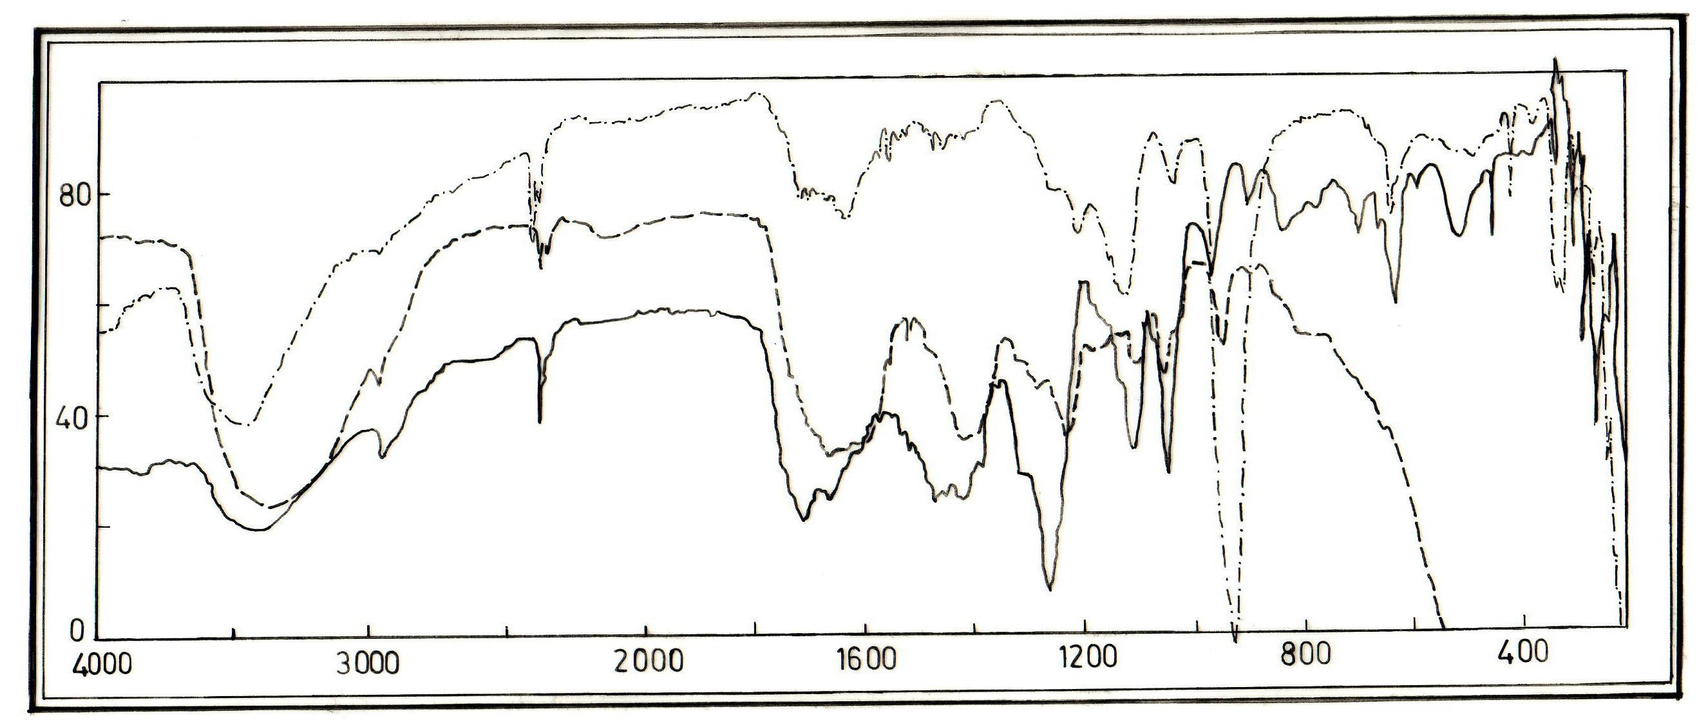

Figure(2) The (I.R) Spectra of:
(a) ( ) The ligand (L) (b) ( ) The complex K₂ [Ni(L)₂]
(C) ( ) The complex K[ReO(L)₂]

The molar conductance’s of the complexes in (DMF) in the (61-198 Ω⁻¹cm².mol⁻¹) range Table (3) indicating their electrolytic nature with (1: 1) and (2: 1) ratio for (Re and Ni, Pd) complexes respectively.⁽¹⁹⁾

Table (3): Electronic spectral data, HPLC and conductance measurement of ligand and its complexes
Compound | λ nm | ε_{max} molar⁻¹ cm⁻¹ | Assignment | HPLC | A_{m}(Ω⁻¹.cm².  mole⁻¹) | Medium | Ratio
K[(EtOCo)₂C=CS₂] | 250.5 | 141 | π-π*
K[(EtOCo)₂C=CS₂] | 342.5 | 1922 | n-π*
K₂[Ni(EtOCO)₂C=CS₂}₂] | 246.5 | 263 | Ligand field | 0.99 | 198 | DMF | 2:1
K₂[Ni(EtOCO)₂C=CS₂}₂] | 346 | 1120 | Ligand field
K₂[Ni(EtOCO)₂C=CS₂}₂] | 428 | 315 | ¹b₂g→¹b₁g
K₂[Pd(EtOCO)₂C=CS₂}₂] | 244 | 2480 | Ligand field | 1.33 | 195 | DMF | 2:1
K₂[Pd(EtOCO)₂C=CS₂}₂] | 332 | 10040 | C.T
K₂[Pd(EtOCO)₂C=CS₂}₂] | 365 | 8880 | C.T
K[ReO(EtOCO)₂C=CS₂}₂] | 288 | 1359 | Ligand field |  | 61 | DMF | 1:1
K[ReO(EtOCO)₂C=CS₂}₂] | 350 | 1030 | C.T |  | 61 | DMF | 1:1
K[ReO(EtOCO)₂C=CS₂}₂] | 420 | 590 | ¹e→¹a₁ |  | 61 | DMF | 1:1

The (U.V- Vis) spectra of the complexes displayed absorptions at (244-346) nm assigned to the ligand field and charge transfer. In the K₂[Ni(L)₂] Fig. (3b), the band at (428) nm is attributed to (d-d) electronic transition type (¹b₂g → ¹b₁g). While the bands at (332, 365)nm in the spectrum of K₂[Pd(L)₂] assigned to (C.T)^{(20,21)},Fig (3c). These results suggesting a square planar geometry about (Ni and Pd)⁽²²⁾.
In the (U.V-vis) spectrum of K[ReO(L)₂] the two bands at (350 and 420)nm are assigned to (C.T) and (d-d) electronic transitions type (¹e →¹a₁) respectively, suggestion a square pyramid geometry about Re.⁽²³⁾

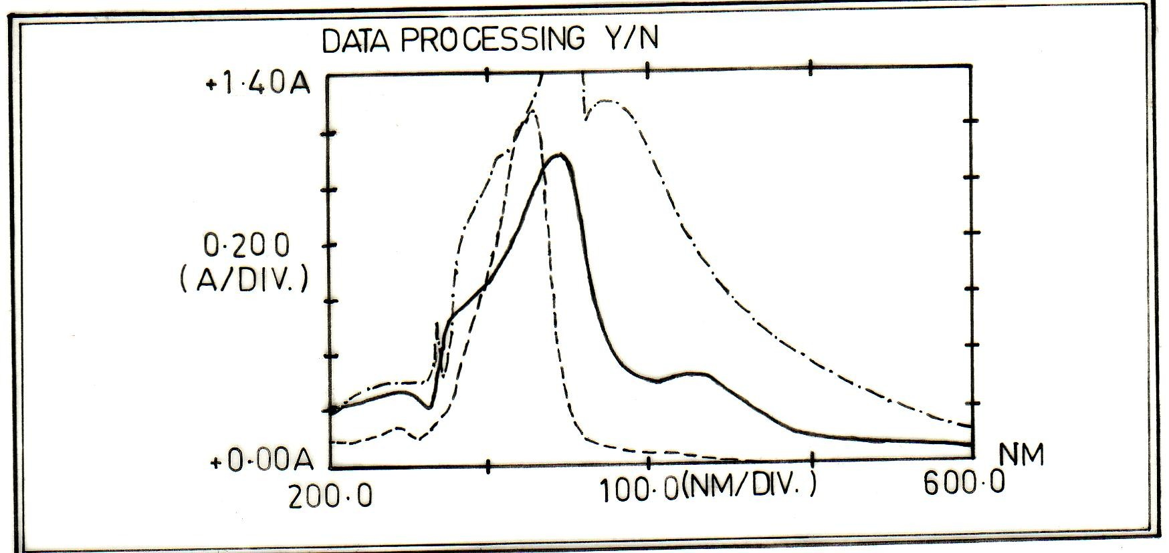

Figure(3) The (I.R) Spectra of:
(a) ( ) The ligand (L) (b)( ) The complex K₂ [Ni(L)₂]
(C) ( ) The complex K₂[Pd(L)₂]

The HPLC results of the complexes are presented in Table (3). Figs (4a and 4b) exhibit the chromatograms of (Ni and Pd) complexes which shows one signal at (Rt =0.99 min and 1.33 min) respectively, indicating the purity of the complexes and appear as a single species in solution.

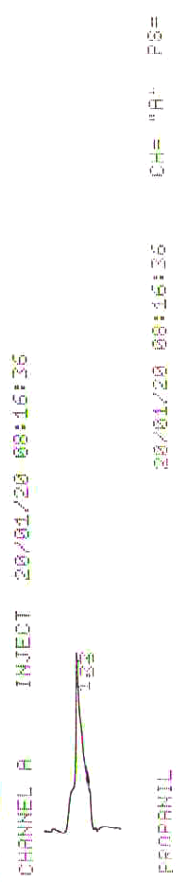

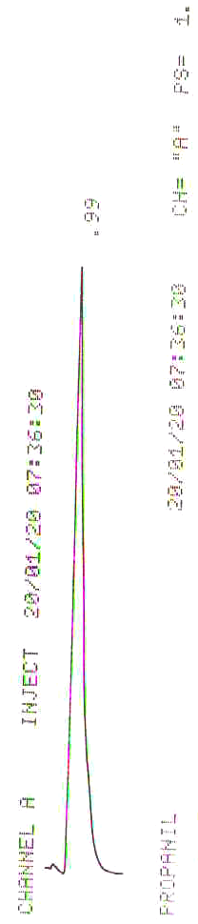

a
b

Figure (4) the HPLC chromatograms for:
(a) the complex K₂[Ni(L)₂] (b) the complex K₂[Pd(L)₂]

References
- F. Osterloh, W. Saak and S. Poh, J. Am. Chem. Soc., 1997, 119, 5648.
- J. R. Dilworth, P. Arnold, D. Morales, Y-Lok Wong and Y. Zheng, Modern Coordination Chemistry, 2002, 217-230.
- K. Mohanalingam, M. Nethaji, P. K. Das, J. Mol. Struct., 1996, 378, 177.
- J. A. Zuleta, M. S. Burberry, R. Eisenberg, Coord. Chem. Rev., 1990, 97, 47.
- J. M. Bevilacqua, R. Eisenberg, Inorg. Chem,. 1994, 33, 1886.
- M. C. Hong, W. P. Su, R. Cao, F. L. Jiang, H. O. Liu, J. X. Lu, Inorg. Chim. Act., 1998, 274, 229.
- P. J. M. Birker, G. C. Verschoor, J. Chem. Soc., Chem.Commun. 1981, 322.
- H. Dietrich, W. Storck, G. Manecke, J. Chem. Soc., Chem. Commun.,1982, 1036.
- D. Coucouvanis, F. J. Hollander, M. L. Caffery, Inorg. Chem., 1976, 15, 1853.
- J. A. Zuleta, J. M. Bevilacqua, D. M. Proserpio, P. D. Harvey, R. J. Eisenberg, J. Am. Chem. Soc., 1992, 31, 2396.
- J. P. Fackler, R. J. Staples, Z. Assefa, J. Chem. Soc., Chem. Commun., 1994, 431.
- B- S. Kang, Z-N. Chen, C.-Y. Su, Z. Lin, T.-B. Wen, Polyhedron, 1998, 17, 2497.
- M. J. Al-Jeboori, J. R. Dilworth and W. Hiller, Inorg.Chem.Acta., 1999, 285, 70.
- M.S. Ram and J.T Hupp, Inorg. Chem., 1991, 30,130.
- K. A. Jensen and L. Henriksen, Acta Chemica Scandina., 1968, 22, 1107.
- Nakamoto K., “Infrared Spectra of Inorganic and Coordination Compounds” 4th. Ed., J. Wiely and Sons, New York, (1996).
- U. Abram, In J. A. Mc Cleverty and T.J. Meyer, “Comprehensive Coordination Chemistry II” Ed: Elsevier, (2004), P.271.
- M. J. Abram, Inorganic Chimica Acta., 1990, 171, 132.
- Geary W. J., Coord. Rev., 7, 81 (1971).
- G. P. Smth and M.Blander, "Molten Salt Chemistry", Inter Science, NewYork, (1964), P.427.
- H. B.Gray and C.J.Ballhusene, J.Am.Chem.Soc., 1963, 85, 265.
- B.G.werden,E.Billig & H. B. Gray, Inorg.Chem., 1966, Vol.5, No.1, 2012.
- A. T. Numan, Ph.D. Thesis, Baghdad University, (2002).

