Synthesis of Prodrug Ciprofloxacin Procain Male amide Polymer

Firyal Mohammed Ali
Almustansiriya University, College of ScienceDepartment Of Chemistry,
mob.07801884131, E-mail: Abood121996@yahoo.com
Firas Aziz Rahi
Almustansiriya University, College of Pharmacy Department Of Pharmaceutics
mob07809124655, E-mail: mt_iraq@yahoo.com
Ahmed Yaseen
Baghdad College of Pharmacy
mob 07702679938, E-mail: ahmedpharma2009@gmail.com

(NJC)
(Received on 17/9 /2014) (Accepted for publication 23/12/2014)

Abstract
In this research, two new drugs were bonded through amide attachment using Maleic acid as aspacer binder ,produced di prodrug such as Procain and Ciprofloxacin. SinceProcain has localanesthetic action.and Ciprofloxacin as antibacterial drug was reacted with Maleicanhydride and free Procain oil produced amide attachment, the N-ProcainMaleamic acid (1) was converted to its acyl chloride by using thionyl chloride (2) then reacted with ciprofloxacin to obtain amide bond as a new prodrug (3), then polymerized free radically to obtain prodrug polymer(4) which was studied by controlled drug release in different pH values at 37C˚ ,to improve their characteristic and to minimize the side effect of the drug to be broad spectrum activity as atherapeutic material.This mutual prodrug was used with another biological active drug instead of single action. The prepared prodrug polymer(4) was characterized by FTIR , ¹H-NMR ,and UV spectroscopies ,the physical properties were determined was measured .The good results were obtained as sustained release of ciprofloxacin with broad spectrum antibioticbiological assay were conducted for prepared prodrug polymer using. The prepared prodrug showed high biological activity against E.coli, staphylococcus aureus and pseudomonas acuroginosoma.The prepared prodrug appear high biological activity, compared with standard Gentamycin.
Keywords: Maleamic acid, Ciprofloxacin, Procaine, prodrug
الخلاصة
الخلاصة في هذا البحث ربط نوعان من الأدوية من خلال المجموعة الامايدية باستعمال حامض الماليئك كرابط جسري بين الدوائين مثل البروكائين والسبروفلوكساسين كمضاد حيوي والذي تفاعل مع حامض الماليئك اللامائي ومع البروكائين كعامل مخدر موضعي
حيث تم تفاعل حامض الماليئك اللامائي مع زيت البروكائين منتجا ارتباطا اميدي حيث تكون ن –بروكائين مالياميك اسد (1) والذي حول الىكلوريد الحامض باستعمال الثايونيلكلورايد(2). بعدها فوعل مع السبروفلوكساسين للحصول على اصره اميديه كمركب دوائي (3). بعدها تمت بلمرته بطريقه الجذور الحرة للحصول على بوليمر دوائي (4) والذي درست له طرق التحلل الدوائي المحكم بدوال حامضيه مختلفة بدرجه 37 م ,وذلك لتحسين صفاته ولتقليل الاثار الجانبية للدواء ليتمكن من العمل بطيف واسع من الفعالية كماده علاجيه .هذا المركب له فعالية بايولوجيه اضافيه بدلا عن التاثير الدوائي الاحادي .شخص البوليمر الدوائي المحضر (4) بواسطه مطياف الأشعة تحت الحمراء والأشعة الفوق البنفسجية ,وعينت الصفات الفيزيائية وقيست اللزوجة الجوهرية , وحصل على نتائج جيده لسرع التحرر الدوائي البطيء لتجنب التأثيرات الجانبية للسبروفلوكساسين كمضاد حيوي واسع الطيف .قيست الفعالية البايولوجيه للدواء المحمل للأنواع البكتيرية مثل الكائنات الحية الدقيقة مثل القولونية، المكورات العنقودية الذهبية. وظهر تفعالية بايلوجيه عالية بمقارنتها مع الجنتماسين القياسي .
الكلمات المفتاحية: حامض الماليئك. سبروفلوكساسين. بروكائين.مقدمات دوائية

Introduction
Maleic acid or cis-butenedioic acid is an organic compound that is a dicarboxylic acid, a molecule with two carboxyl groups. Its chemical formula is HO₂CHC=CHCO₂H. Maleic acid is the cis-isomer of butenedioic acid, whereas fumaric acid is the trans-isomer. It is mainly used as a precursor to fumaric acid, and relative to its parent maleic anhydride, maleic acid has few applications. In industry, maleic acid is derived by hydrolysis of maleic anhydride, the latter being produced by oxidation of benzene or butane. ^{[1]} Maleic acid is an industrial raw material for the production of glyoxylic acid by ozonolysis. ^{[2]} Maleic acid may be used to form acid addition salts with drugs to make them more stable,.

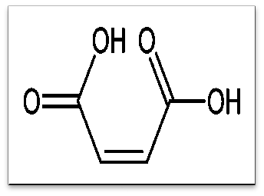

Ciprofloxacin hydrochloride, ^{[3, 4, 5]} a fluoroquinolone, is the monohydrochloride monohydrate salt of 1-cyclopropyl-6-fluoro-1, 4-dihydro-4-oxo-7-(1-piperazinyl)-3-quinolinecarboxylic acid. It is a faintly yellowish to light yellow crystalline substance with a molecular weight of 385.8. Its empirical formula is C₁₇H₁₈FN₃O₃•HCl•H₂Oand its chemical structure is asthis work aimed to synthesis of ciprofloxacinprodrug through amide bonds to obtain the new prodrug with controlled sustained drug release of a mutual drugs which have the two biological action in the same time^{[6-10]} .

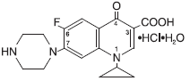
CiprofloxacinHydrochloride ^{[11, 12]}

Experimental work
Materials and Instruments
Maleic anhydride waspurchased from BDH, Ciprofloxacin and Procain were purchased from Aldrich, and DMF was obtained from Merck. All chemical materialswere used without further purification.
FTIR spectra were recorded by a4300 ShimatzuSpectrophotometer.UV-VIS.Spectra were recorded by Shimatzu.¹H NMR spectra were recorded on Shimadzu Spectrophotometer in DMSO-d⁶. Melting point were determined on Callen Kamp MF.B-600 melting point apparatus.
Ascending TLC was run on silica gel F254, pre-coated aluminum sheets. The final products and their intermediates were detected by irradiation with UV light by using the UV light detector (254). The Chromatograms were eluted by Dichloromethane solvent
Synthesis of N-procaine Maleamic acid (1)^{[13-15]}
(2.12gm, 0.02 mole) of maleic anhydride was dissolve in 10ml of methylene chloride , and (2.98 gm, 0.02mole) of Procain oil was added with stirring about 1 hr. The white precipitate was filtered off, washing with ether. The white prodrug wasrecrystallized, the yield of the product was 82%, m.p =239-240 °C.
Synthesis of N-ProcainMaleamic acid chloride (2) with Ciprofloxacin (3)
The prepared compound (2) as acid chloride derivative (2.9 gm, 0.003mol) was dissolved in (10 ml) of dioxane (1gm, 0.003mol)of ciprofloxacin was added in the presence of triethylamine (1ml).The mixture was stirred for about 2 hr. at 50°C, the solvent was distilled off under vacuum.The yellow product was obtained, washed with ether for several times, and dried at room temperature. The yield was 65%, m.p =52-55 °C. RF=0.61 in dichloromethane.
Synthesis of N-Procain Male amide Ciprofloxacin amide
( 1.42gm , 0.007mole )of prepared N-ProcainMaleamic acid chloride was dissolved in 5ml of DMF , ( 1ml) ofThionyl chloride was added drop wise with a vigorous stirring at 0 °C, the mixture heated at 50°C for 3 hr. ,distilled of and the mixture was concentrated under vacuum ,then the yellow product was obtained with 80 yield %, m.p = 200 °C.
Polymerization of prodrug monomer (3) to polymer (4)
In a screw capped polymerization bottle 1 gm of monomer (3) was dissolved in 10 ml of DMF ,(0.05%) of the monomer weight of dibenzonyl peroxide was addedas an initiator , then the bottle was flashed with nitrogen for 10 min. inside a gloves box and firmly stopped , the solution was maintained at 90°C .The mixture was concentrated under vacuum , the viscous yellow polymer was obtained , washed with ether and dried , the yield was 70%.
Controlled release study
A 100mg of modified polymer was kept in acylinder containing of 100ml of buffer solution at 37 C˚ without stirring .the sample was periodicallywithdrawn andanalyzed byUV.Spectrophotometer at suitable (271nm and 210 nm) for every prepared sample to determine the amount of the released of ciprofloxacin from prodrug, directly from the software built for many times using different pH values.
Result and Discussion
In this work, the new prodrug polymer was prepared according to the following steps:-
- Ring opening of maleic anhydride by Procain as amino drug, which introduced in a nucleophilic attack on carbonyl group of Maleic anhydride producing compound (1).
- Conversion of prepared compound(1) to its corresponding acyl chloride(2) by using Thionyl chloride
- Substitution of compound (2) with ciprofloxacin through amide attachment
- Polymerization of compound (3) free radically by using dibenzoyl peroxide as an initiator

Scheme (1)

Antibacterial assay
The inhibitory effect was done for prepared Cipro chitosan prodrug in the growth medium at concentration mg/ml of nutrient agar in petri dishes. The agar was inoculating the bacteria plugged out front old culture of E.coli, staphylococcus and pseudomonas aecuroginosa,on nutrient agar the plate incubated at(37C˚) and the colony was estimated by measuring perpendicular diameter of colony, compared with Gentamycin, the analysis of variance to show the statistical significance of the data as shown in Table(2),it appeared high biological activity, it inhibit the growth of gram negative bacteria with high effective of used as antibacterial medicine, alsoit is suggested to play as an important role in antimicrobial activity, with high successfully control with more development as a new derivative. with two different activities.
The certificate ofanalysis explain the data below:-

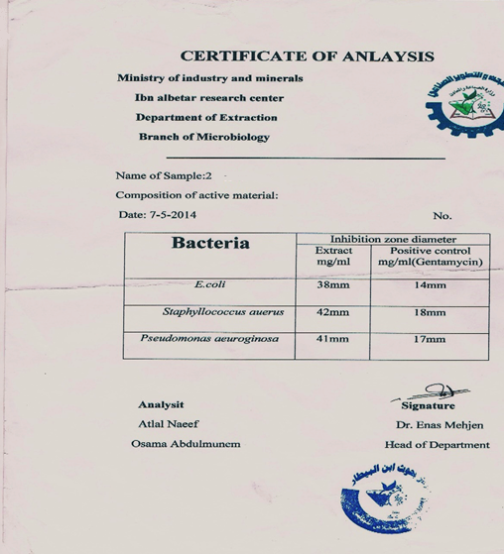
Biological assay forCiprofloxacinProcainMaleamideprodrug polymer (4)
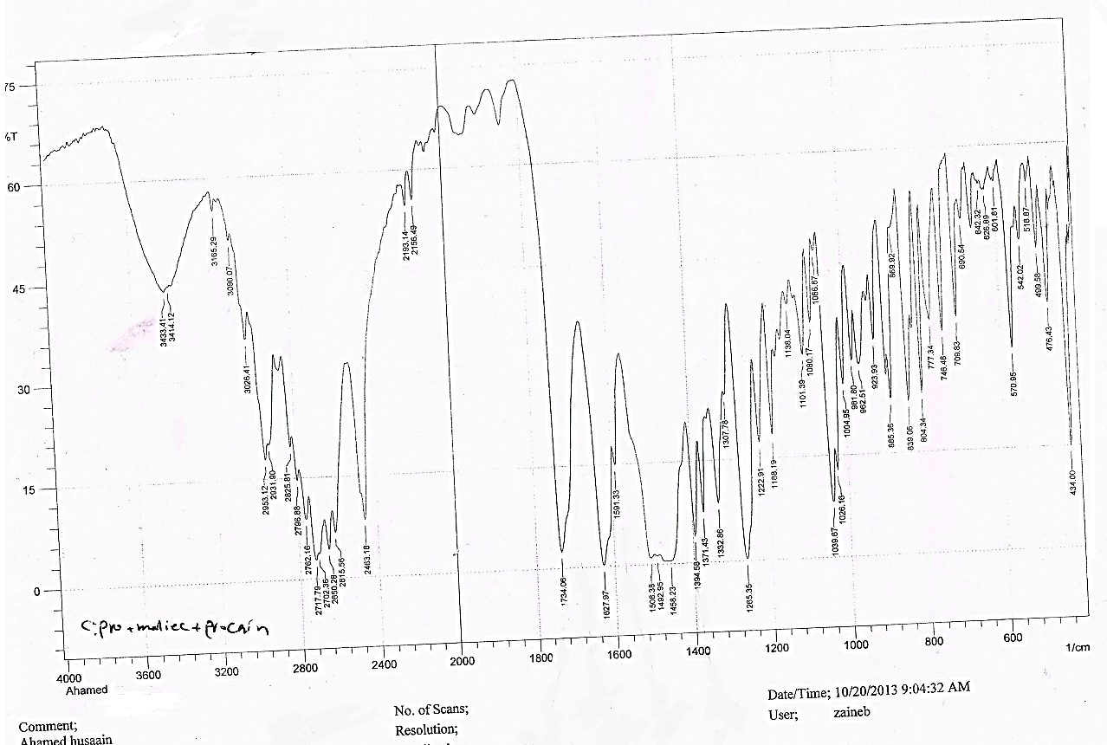
Fig.(1) FTIR spectrum of prodrug polymer

FTIR spectrum, Fig(1)showed the main absorption of formation of amide group at 3200cm⁻¹due to stretching NH amide of Procain amide ,and at 1651 cm⁻¹ of C=O amide ,and the other 1618 cm⁻¹ due to the C=O Ciprofloxacin and the other carbonyl group of N-Ciprofloxacin amide was appeared at 1623cm⁻¹ ,the band at 1714 cm⁻¹ indicated the presence of C-N, The band at 1600 cm⁻¹ was observed for C=C aromatic ring in Ciprofloxacin and Procain.

¹H-NMR Spectrum, Fig (2) showed the main signals as shown in the structure below:-

Fig (2) ¹H-NMR Signal

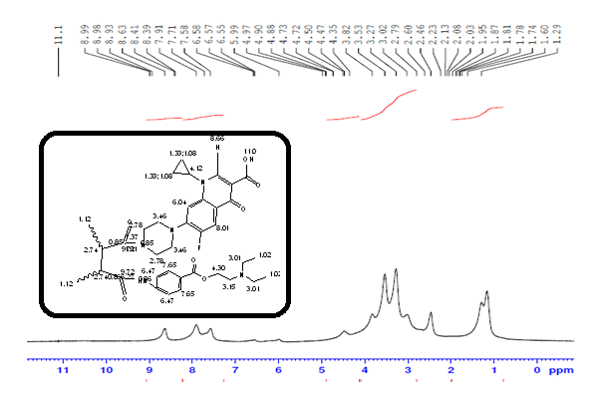
¹HNMR Spectrum of polymer (4)

Fig (3) Controlled drug release of polymer (4)

References
1- Kurt Lohbeck, Herbert Haferkorn, Werner Fuhrmann and Norbert Fedtke "Maleic and Fumaric Acids" in Ullmann's Encyclopedia of Industrial Chemistry, Wiley-VCH, Weinheim, 2000
2- KwesiAmoa. Journal of Chemical Education. 2007, 84 (12): 1948.
3-Ciprofloxacin. In clinical pharmacology Gold Standard/ Elsevier (2008Nov22).
4- “Cipro Labeling Revision 04/06/2009 Supplement 073". US Food and Drug Administration. 6 April 2009. Retrieved 8 September 2009
5- Montagnac R, Briat C, Schillinger F, Sartelet H, BirembautP,Daudon M. 2005. Fluor quinolone induced acute renal failure. General review about a case report with crystalluria due to Ciprofloxacin. NephrolTher 2005 ;( 10): p 44–51.
6-D Bhosle, S Bharambe, N Gairola, Suneela S Dhaneshwar. Mutual prodrug concept: Fundamentals and applications. Indian Journal of Pharmaceutical Science. 2006; 68(3): 286-294
7- Yasser Fakri Mustafa .Synthesis and in vitro kinetic study of new mutual prodrug for colon cancer associated with constipation. Tikrit Journal of Pharmaceutical Sciences. 2012; 8(1),35.
8-Patil S.J., P.J. Shirote. Prodrug approach: an effective solution to effective solution effective solution to overcome side effects. International Journal of Medical and Pharmaceutical Sciences, 2011; 1 (7).
6-European Directorate for the Quality of Medicines & Health-Care. 2008. European Pharmacopoeia, 6th edition. Strasbourg,France: Council of Europe
7-Pharmacopoeia of India, Ministry of Health and Family Welfare, 2007 ;( 2). 938.
8- MarcinSobczak. Synthesis and characterization of polyester conjugates of Ciprofloxacin. European Journal of Medicinal Chemistry. 2010; 45(9): 3844–3849.
9- Jian Bo Xiao1, Chun Sheng Yang2, Fen Lian Ren1, Xin Yu Jiang1 and Ming Xu3, 4. Rapid determination of Ciprofloxacin lactate in drugs by the Rayleigh light scattering technique. Measurement Science and Technology. 2007; 18(3).
10- Yusuf M. Al-Hiari *, InasSaleh Al-Mazari, Ashok K. Shakya †, Rula M. Darwish and Rana Abu-Dahab. Synthesis and Antibacterial Properties of New8-Nitrofluoroquinolone Derivatives. Molecules, 2007.
11- Sandhya A. Maratha, Rupesh Kumar, ParthasarathiAjitkumar, ValakunjaNagaraja and DipshikhaChakravortty. Curcumin reduces the antimicrobial activity of ciprofloxacin againstSalmonellaTyphimurium and Salmonella Typhi. Journal of Antimicrobial Chemotherapy Advance Access published October ,2012, 15.
12- Getu Kahsay1 and Awot G/Egziabher2. Quality Assessment of the Commonly Prescribed Antimicrobial Drug, Ciprofloxacin Tablets, Marketed in Tigray, Ethiopia. Ethiopian Drug Administration and Control Authority. 2010; 2 (1): 93-107
13-Takahiro Suzuki,Toruezure,To Yoshi Yamagishi,HirakataDomen, Masaruishida, Walter Schmid . Stimulatory Effect of Procaine on the Growth of Several Microalgae and Cyanobacteria. Journal of Pharmacy and Pharmacology., 2000; 52(2): 243–251.
14-Natasha L. Kuchembuck, MS; Patrick T. Callahan, DVM, MS; Keith D. Zyrtec, PhD. David A. Pitman, BS; Kirsten Wegner, DVM; Cynthia A. Cole, DVM, PhD. Plasma concentration and local anesthetic activity of procaine hydrochloride following subcutaneous administration to horses. 2007; 86(5).
15-Sinnott CJ Cogs well LP, Johnson A, et al. On the mechanism by, which epinephrine potentiates lidocaine’s peripheral nerve block? Anesthesiology 2003; (98):181–188
16- Seifen AB, Ferrari AA, Seifen EE, Thompson DS, Chapman J. Pharmacokinetics of intravenous Procaine infusion in humans. AnesthAnalg. 1979 Sep-Oct; 58(5): 382-6.

