**Synthesis of Novel Heterocyclic Compounds via Schiff bases**

Huda A. Hassan1 , Ruwaidah S. Saeed2 , Dheefaf F. Hassan3

***Dept. of Chemistry/Ibn-AL-Haithem, Faculty of Education for pure Scince***

***Baghdad University.***

1 [dr.m1967@yahoo.com](mailto:dr.m1967@yahoo.com), 2 ruwaidah [samir@yahoo.com](mailto:samir@yahoo.com), [3dh73falah@yahoo.com](mailto:3dh73falah@yahoo.com)

**(NJC)**

**(Received on 20/10 /2014) (Accepted for publication 16/12/2014)**

**Abstract**

In the present study a series of some four-,five-and seven-membered heterocyclic compounds have been synthesized by the reaetion of Schiff bases (1a,b) with chloroacetyl chloride, sodium azide, thioglycolic acid or various anhydrides to give azetidinone (2a,b), tetrazole (3a,b), thiazolidinone (4a,b) and 1,3-oxazepine derivatives (5-8a,b) respectively.

Schiff bases (1a,b)were prepared from the reaction of p-toluidine with aromatic aldehydes. All synthesized compounds were characterized by physical properties and spectral data.

**Key words:-** Azetidinone, Tetrazole, Thiazolidinone, 1,3-Oxazepine .

**الخلاصة**

حضر في هذا البحث بعض من مركبات حلقية غير متجانسة حاوية على حلقة رباعية وخماسية وسباعية من مفاعلة قواعد شف (1a,b) مع كلورواسيتايل كلورايد أو ثايوكلايكولك اسيد أو انهدريدات متنوعة للحصول على مشتقات ازيتيدينون (2a,b) وتيترازول (3a,b) وثايوزوليدينون (4a,b) و3,1-اوكسازبين (5-8a,b ) على التوالي .

حضرت قواعد شف (1a,b) من تفاعل بارا- تولويدين مع الديهايدات اروماتية , شخصت جميع المركبات المحضرة بالطرق الفيزيائية والطيفية .

الكلمات المفتاحية :- الازيتيدينون, التترازول, الثايوزولدينون, 3,1 - اوكسازبين .

**Introduction**

Heterocyclic compounds consisting of four -, five- and seven- membered rings have gaiven more importance in the recent decades for industrial and medicinal reasons. Azetidinone derivatives are one of these compounds , they represent an important class of four –membered cyclic amides, commonly known as β-lactam, due to their antibacterial [1-4], antifungal [2-4], antitubercular [3-4], antianthelminic [5] and enzymetic activity [6], furthermore they found to inhibit cholesterol absorption [7]. Five membered hetercyclics like tetrazole and thiazolidinone derivatives have gained increasing according to their industrial and biological properties. Tetrazole, for example, is well known to have antibacterial, anti-inflammatory [8-10] and fungicide [11] activities. They also have been examined for reducing uric acid [12] , Moreover , tetrazole derivatives are used to prepare epoxy resin which is a raw material of printed circuit boards [13]. On the other hand thiazolidinone are obriousely important because of their wide use in medicaments as antihyperglycemic [14] , antitumor growth [15,16] , antifungal [17] , anticonvulsant [18] and inhipitor for CDC7 protein kinase agents [19]. Finally, 1,3-oxazepine ring which constitutes a class of nitrogen and oxygen containing seven-membered heterocyclics have been investigated for their antibacterial activity [20-21] and some of those derivatives show liquid crystalilline properties [22], while others are used as photo stabilizing additives for pmma films [23].

**Materials and Methods**

All chemicals were supplied from Merck, Fluka and Sigma - Aldrich chemicals Co. and used as received . Melting points were determind in open caoillary tubes on adigital Gallen –Kamp MFB-595 . FTIR spectra were taken on a 8400s Shimadzu spectrophotometer, using samples in KBr disks. 1HNMR spectra were carried out by company : Bruker , model: ultra shield 300 MHz , origin : Switzerland and are reported in ppm(δ), DMSO was used as a solvent with TMS as an internal standard.



1a R =4-N( CH3)2 , 1b R=4- OH

**Scheme (1)**



1a R =4-N( CH3)2 , 1b R=4- OH

**Scheme (2)**

**Synthesis Methods**

**Preparation of of Schiff bases (1a,b) :-**

Amixture of p-toluidine (0.01mol) and 4-*N,N*-dimethyl benzaldehyde or 4-hydroxybenzaldehyde (0.01mol) were stirred under reflux in absolute ethanol(10 mL) in the presence of few drops of glacial acetic acid for 4hrs . The solvent was evaporated under vacuum and the residue crystallized from ethanol, The solids obtained were filtered ,washed and recrystallized from chloroform, (80% and 72%) , m.p = 111-113 0C and 194-1960C , respectively.

**Synthesis of 3-chloro-2-azetidinone derivatives (2a,b) :-**

Chloroacetyl chloride (0.01mol.) in 10mL of dioxan cooled at (0-5) Co , to this , triethylamine (0.01mol.) in(10mL) dioxane was added , and Schiff bases (0.01mol.) in 10mL of dioxane was slowly added and refluxed in water bath for 12hrs . After the reaction had been completed- (detectad by TLC) , the reaction mixture was poured into ice-cold water to give solid precipitate , which was filtered and dried , recrystallized by benzene:ether(50:50).

**Synthesis of tetrazol derivatives (3a,b) :-**

Sodium azide (0.01mol) was added to a stirring solution of Schiff bases (1a,b) (0.01mol) in DMF (15mL) , the mixture was refluxed for 4hrs, then it was allowed to cool and the precipitate was filtered , washed with water and recrysallized from petroleum ether.

**Synthesis of thiazolidin-4-one derivatives (4a,b) :-**

Amixture of Schiff bases (1a,b) (0.01mol) and thioglycolic acid (0.01mol) were stirred under reflux in dry benzene for 8hrs. The solvent was evaporated and the reaction mixture was neutralized with sodium bicarbonate solution , the product was filtered off and recrystallized from chloroform .

**Synthesis of 1,3-oxazepine derivatives (5-8a,b) :-**

Amixture of equimolar amounts (0.01mol) of Schiff bases (1a,b) and different acid anhydrides in dry benzene (0.01mol) were reflux for 6hrs. The solvent, resulting crystalline solid, was removed and recrystallized from ethanol .All physical properties of compounds were reported in table (1). All spectral data were reported in table (2).

**Results and Discussion:-**

The Schiff bases (1a,b) were synthesized by refluxing equemolare amount of p-toluidine with aromatic aldehydes 4-*N,N*-dimethylbenzaldehyde and 4-hydroxybenzaldehyde in dry benzene with some drops of glacial acetic acid (GAA). These Schiff bases were namely *N*-(4-*N,N*-dimethylaminobenzylidene)-4-methylaniline and *N*-(4-hydroxyaminobenzylidene) -2-methylaniline, respectively.

Schiff bases (1a,b) were identified by their melting points and FTIR spectroscopy. FTIR absorption spectra showed the disappearance of absorption bands due to NH2 and C=O groups of the starting meterials together with appearance of new absorption band in the region (1616-1636) cm-1 which is assigned to azomethine group ( C=N stretching).

The Schiff bases compounds (1a,b) were treated with chloroacetyl chloride followed by the addition of triethyl amine under reflux in water bath to yield the corresponding azetidinone derivatives (2a,b) , respectively.

The structure of the azetidinone derivatives( 2a,b) were identified by their melting point, FTIR and 1HNMR spectroscopy. The FT-IR spectra of compounds (2a,b) showed the appearance of the characteristic absorption band in region (1655-1660) cm-1  due to stretching vibration of carbonyl group of azetidine ring. Also the FT-IR spectrum of compound (2b), (Figure 1), showed the suggested band for olefinic (C-H), (C=C) aromatic . All the spectral data for these compounds are listed in (Table 2).

The 1HNMR spectrum of compound (2a), (Figure 2), (in DMSO as a solvent) shows the following signals: The signal at δ 2.33ppm for protons of methyl group, CH proton in azetidione ring appeared as a signal at δ 3.40 ppm, and signal at δ 2.72ppm for six protons for N-(CH3)2. Furthermore, δ 6.98-8.62 ppm are for aromatic ring protons.

Tetrazole derivatives (3a,b) were obtained by addition of reaction of Schiff bases(1a,b) with sodium azide in dry dimethylformamid (DMF). These compounds were identified by their melting points , FTIR and 1HNMR spectroscopy. The FTIR spectra (Table 2), showed the disappearance of absorption stretching band of imine group with appearance of new absorption stretching band in the region around 1511cm-1 which are assigned to N=N stretching. 1HNMR spectrum of compound (3a)(in DMSO as a solvent), showed many signals( eight aromatic protons) appeared in the region δ 7.02-7.94 ppm and two sharp signals at δ 1.93ppm and δ 3.81ppm could be attributed to protons of -CH3 group and six protons of N-(CH3)2 groups, respectively.

The thiazolidine-4-one derivatives (4a,b) were synthesized by refluxing equimolar amounts from the imine compounds with thioglycolic acid in dry benzene .The FT-IR spectra for compound (4a) showed the appearance of the characteristic absorption bands in the region (1605-1730) cm-1 due to stretching vibration of carbonyl group of thiazolidinone ring. Also the FT-IR spectrum showed the suggested band for olefinic (C-H) , (C=C) aromatic. All the spectral data for these compounds in table (2). The1H-NMR spectrum for compound (4a) showed the following characteristic chemical shifts , (DMSO)ppm: the aromatic ring protons of compound (4a) appeared as multiplet at δ (6.8-7.8)ppm , singlet signal at δ 2.9 ppm due to CH3 proton , signal at δ 8.4 ppm due to the C-H proton in thiazolidinone as singlet and protons of CH2 of thiazolidinone appeared at δ 3.35 ppm . The singlet signal at δ 3.07 ppm is for proton of (CH3)2N group. It’s well known that 1,3-oxazepine-4,7-dione is a seven-member ring containing nitrogen, oxygen and two carbonyl groups. In previous work, a series of 1,3-oxazepine derivatives 5-8(a,b) was prepared from substituted imines1(a,b) with different anhydrides: pyromellitic dianhydride, naphthalic, phthalic, maleic anhydride throughout concerted reaction of the type (2+5) cyclization reaction. The structures of the prepared compounds were determined on the basis of their FT-IR ,1H-NMR .

The characteristic FTIR absorption bands of these compounds, Figure (3) for compound (7a), were confirmed from the disappearance of band due to C=N of schiff base and other peaks characterized of cyclic anhydride of the starting materials together; Besides this, the appearance of band at (1749 – 1710) cm-1 for carbonyl groupsin oxazepine ring. C-H aliphatic band in the region ( 2983 -2845)cm-1 and bands around (1280 and 1103 cm-1) belong to asymmetric and symmetric (C-O-C) band. All the spectral data of FTIR for other compounds are listed in Table (2). The 1HNMR spectrum of compound (7b), Figure (4) (in DMSO), also showed a signal at δ2.49ppm that could be attributed to protons of -CH3 group and singlet signal that could be attributed to the proton of N-CH absorbedat δ 7.13 ppm. Furthermore, the aromatic ring protons appear at the range (δ 6.90-8.48) ppm, and a singlet at 10.36ppm could be attributed to the proton of -OH group.

**Table(1)The physical properties of synthesized compounds**

|  |  |  |  |  |  |
| --- | --- | --- | --- | --- | --- |
| Comp. No. | Nomenclature | Molecular  Formula | M.P. °C | Yield% | Color |
| 2a | 3-chloro-1- ( 4 – dimethyl aminophenyl) - 4 -(4-methylphenyl) azetidine-2-one | C18H18N2OCl | 158-160 | 78 | Yellowish  Brown |
| 2b | 3-chloro-1- (4–hydroxyphenyl) -4-(4-methyl phenyl) azetidine-2-one | C16H13NO2Cl | 180-182 | 72 | Yellow |
| 3a | N- (4–dimethylaminophenyl) - 1 -(4-methylphenyl)-1H- tetrazole-5-yl | C16H17N5 | 148-150 | 70 | White |
| 3b | N- (4–hydroxyphenyl) - 1 -(4-methylphenyl)-1H- tetrazole-5-yl | C14H12N4O | 200-202 | 68 | Pale yellow |
| 4a | N- (4–dimethylaminophenyl) - 1 -(4-methylphenyl) thiazolidine-4-one | C18H20N2OS | 121-123 | 66 | Yellow |
| 4b | N- (4–hydroxyphenyl) - 1 -(4-methylphenyl) thiazolidine-4-one | C16H15NO2S | 132-135 | 68 | Bright Brown |
| 5a | Benzene1,2,4,5-{2- (4–dimethylaminophenyl) - 1 –tolyl -2,3- dihydro [1,3]-oxazepine-4,7-diones} | C26H20N2O6 | 239-240 | 76 | Dark yellow |
| 5b | Benzene1,2,4,5-{2- (4–hydroxyphenyl) - 1 –tolyl -2,3- dihydro [1,3]-oxazepine-4,7-diones} | C24H15NO7 | 222-224 | 80 | Orange |
| 6a | 2- (4–dimethylaminophenyl) - 1 –tolyl-2,3- dihydrobenz- [1,2e][1,3]-oxazepine-4,7-diones | C28H24N2O3 | 166-168 | 74 | Yellowish  Brown |
| 6b | 2- (4–hydroxyphenyl) - 1 –tolyl-2,3- dihydrobenz- [1,2e][1,3]-oxazepine-4,7-diones | C26H19NO4 | 205-207 | 70 | Pale  Brown |
| 7a | 2- (4–dimethylaminophenyl) - 1 –tolyl-2,3- dihydro naphtha- [2,3e][1,3]-oxazepine-4,7-diones | C24H22N2O3 | 160-162 | 72 | Dark yellow |
| 7b | 2- (4–hydroxyphenyl) - 1 –tolyl-2,3- dihydro naphtha- [2,3e][1,3]-oxazepine-4,7-diones | C22H17NO4 | 250-252 | 77 | Pale orange |
| 8a | 2- (4–dimethylaminophenyl) - 1 –tolyl-2,3- dihydro- [1,3]-oxazepine-4,7-diones | C20H20N2O3 | 183-185 | 72 | Off-white |
| 8b | 2- (4–hydroxyphenyl) - 1 –tolyl-2,3- dihydro- [1,3]-oxazepine-4,7-diones | C18H15NO4 | 148-150 | 70 | Brown |

**Table(2) Charcterrisitic FTIR absorption band of compounds 2-8(a,b) (cm-1)**

|  |  |  |  |  |  |
| --- | --- | --- | --- | --- | --- |
| Comp. No. | Ѵ(C-H) aromatic | Ѵ(C-H)  Aliphatic | Ѵ (C=O | Ѵ (C=C)  aromatic | Others |
| 2a | 3028 | 2918-2730 | 1671 | 1604 | C-Cl:838 |
| 2b | 3027 | 2917-2734 | 1657 | 1603 | C-Cl:837  OH:3320 |
| 3a | 3026 | 2909-2793 | - | 1606 | N=N:1515 |
| 3b | 3028 | 2918-2795 | - | 1602 | N=N:1511  OH:3249 |
| 4a | 3039 | 2924-2733 | 1719 | 1602 | - |
| 4b | 3045 | 2920-2698 | 1730 | 1598 | OH:3340 |
| 5a | 3032 | 2942-2867 | 1699 | 1602 |  |
| 5b | 3041 | 2974-2789 | 1715 | 1608 | OH:3398 |
| 6a | 3098 | 2922-2735 | 1700 | 1601 | - |
| 6b | 3078 | 2960-2725 | 1701 | 1595 | OH:3286 |
| 7a | 3085 | 2995-2730 | 1745 | 1604 | - |
| 7b | 3044 | 2920-2733 | 1735 | 1606 | OH:3345 |
| 8a | 3080 | 2996-2880 | 1742 | 1604 | - |
| 8b | 3079 | 2958-2715 | 1659 | 1602 | OH:3356 |

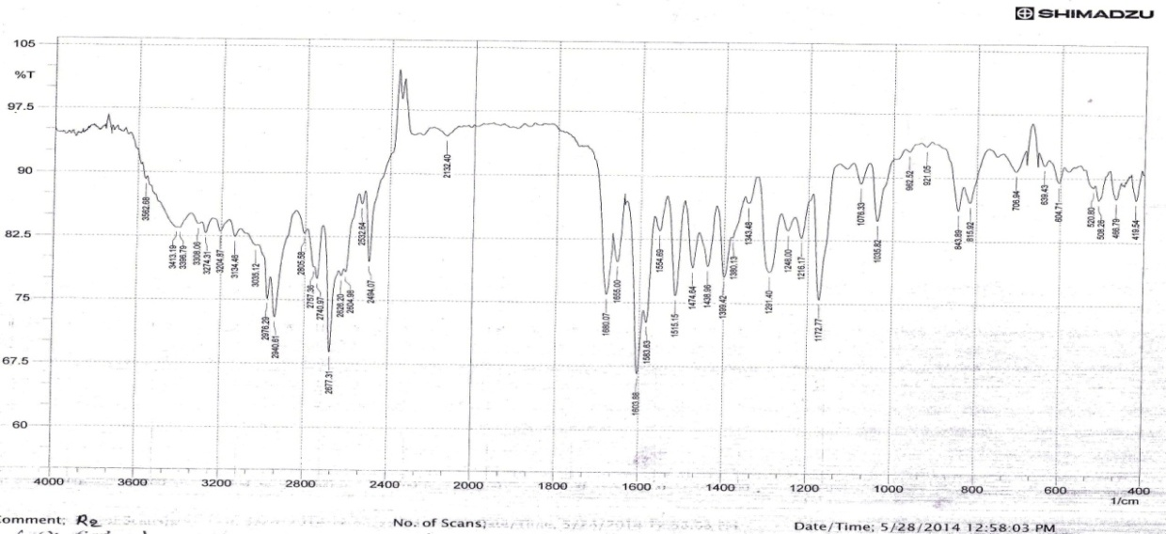

**Figure (1): FTIR spectrum of compound (2b)**

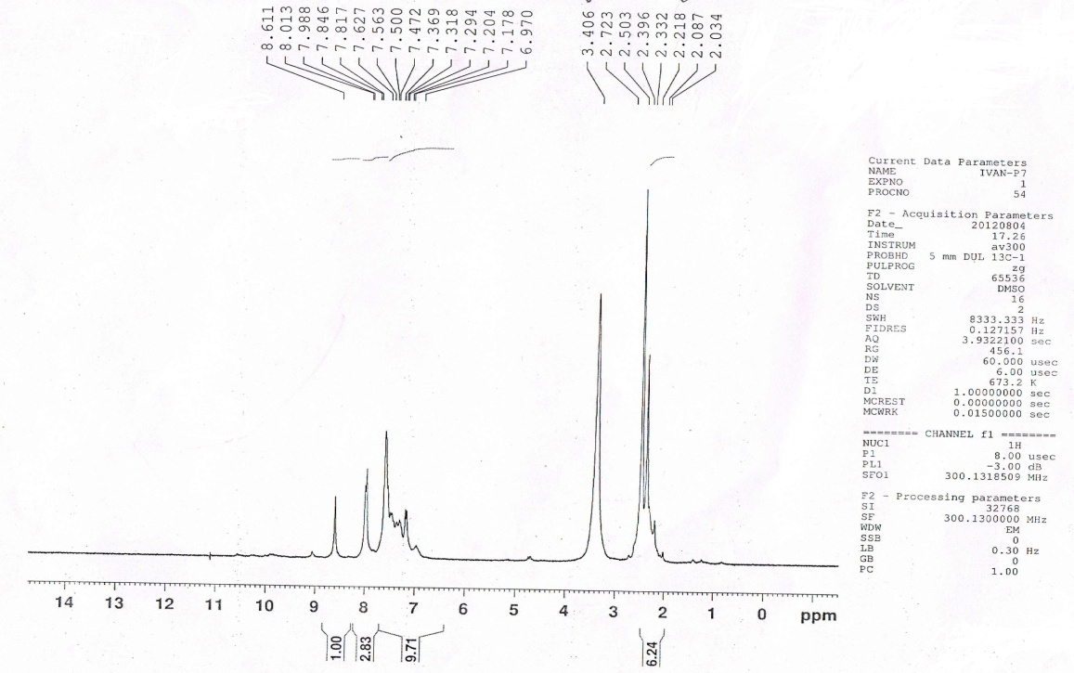

**Figure (2):1HNMR spectrum of compound( 2a)**

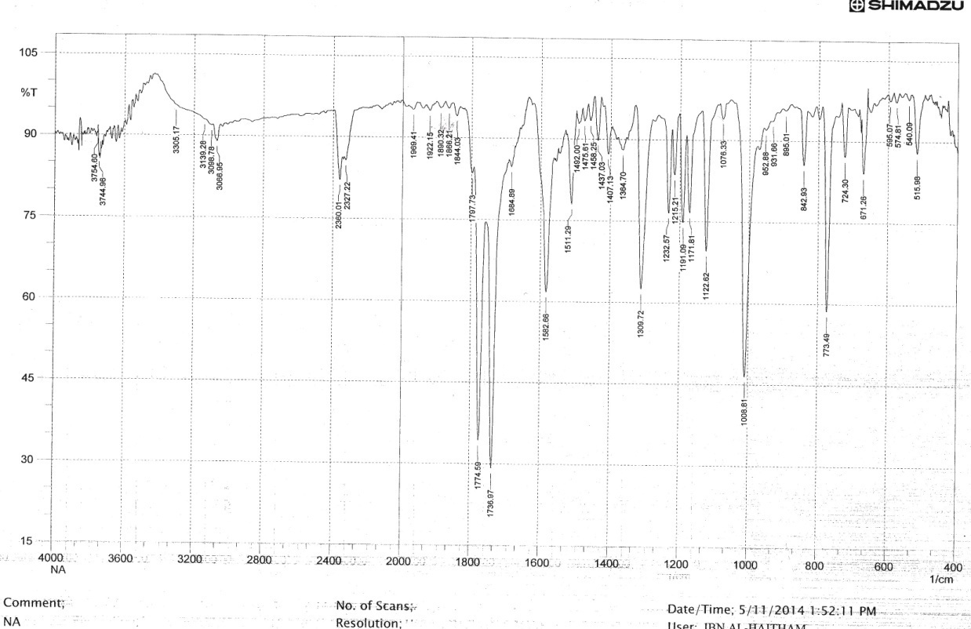

**Figure (3): FTIR spectrum of compound (7a)**

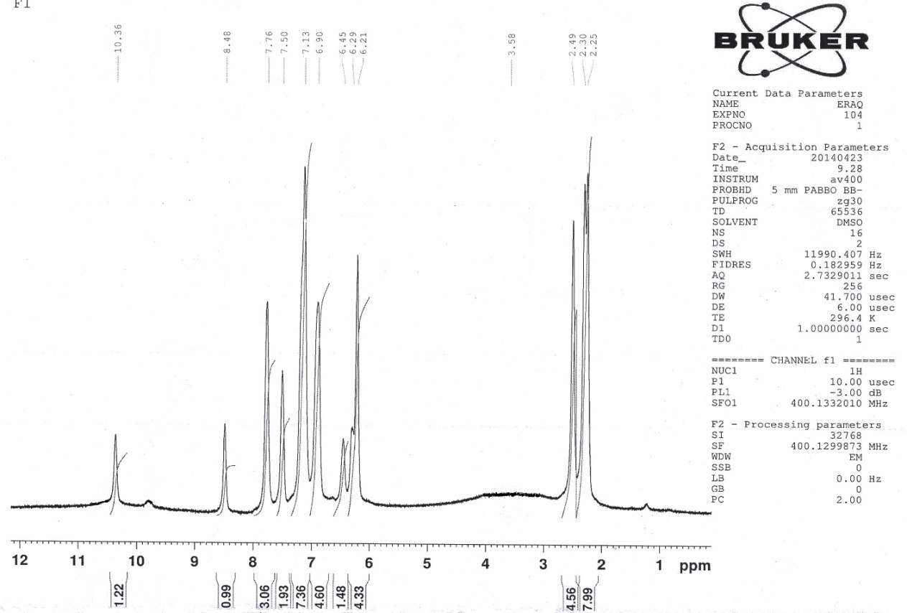

**Figure (4):1HNMR spectrum of compound( 7b)**

**References**

1-Shaw Kat A. Abdel mohsen and Mohammed S. Abaddy, Interna -tional  ***Journal of Pharmacy and Pharmaceutical Sciences***, 2014, **6**, issue5.

2-Neeta Rajput , A. k.Sikarwar and A.Dubey, http: ***heteroletters . org***. , 2013, **3(2)**, 191-196.

3-P.Samadhiya , R.Sharma , S.K.Srivastava and S.D.Srivastava ***Quim. Nova,*** 2012, **35(5),** 914-919.

4-R. Sharma , P. Samadhiqa , S. D. Srivastava and S. K. Srivastava " Synthesis and biological activity of 2-oxo-azetidine derivatives of phenothiazine", Org. Commun. 4:2, 2012.

5-S. B. Sathe , S. S. Saner and Md. Rageeb Md. Usman, ***Journal of Pharmaceutical and Scientific innovation***, 2012,  **1(2)** , March, 43-46 .

6- Hua Bai , Xuyang Zhav and Xiaoyiexu, " Azetidinone compounds and medical use there of ", US Patent , 8, 623 , 855 B2, 2014.

7- Y. Wang , Haiqian , W. Huang , H. Zhang and J. Zhou , ***Letters in Drug Design and Discovery***, 2011, **8** , 500-505.

8-M. Maria Dorathi Anu , M. Jayanthi , S. Damoclar Kumar S. Raja and S. V. Thirunavukkarasu, ***Inter national Journal of chem.. Tech. Research*** , 2013, **5(4)** , 1982-1990.

9- S. N. Rao , T. Ravisankar , J. Latha and K. S. Babu , ***Der Pharma chemical*** , 2012, **4(3)** , 1093-1103.

10- P. B. Mohite, R. B. Pandhave and S. G.Khamage, ***Analele Universitatiidin Bucuvesti-chimie (serienoua)***, 2011, **zoro, 02,** 107-113 .

11- Christian Beier , Jurgen Benting , Isabelle Christian and Pierre –Yres Coqueron , ***US patent*** 8, 2013, **557,** 849B2.

12- James Dennen O, Neil , Shahinil Sharma and Ramacham dran Aruchadran , "Tetrazole Compounds For Reducing Uric acid " , US Patent 0206653 AI ,2011.

13-Young Kwan , Sung Nam CHO , Jun Young KIM and Tae Hoon KIM , "Alkyl Sulfonated Tetrazole Compound , Preparing method thereof , and epoxy resin containing the same , and substrate produced there from " , US Patent 0209760 A1 , 2013 . 14- M. R. Bhosle , J. R. Mali and R. H. Mane ***Bioorganic and medicinal chemistry letters*** , 2014, **24** , issue12 , 2651-2654 .

15- Jing Wu, Lihix Yu , Feifei Yong and Jingiie Li , ***European Journal of chemistry*** , 2014, **80** , 340-351.

16- Mohamed A. Abdelgawad , Amany Belal and Osman M. Ahmed , ***Journal of chemical and Pharma ceutical Research*** ,2013,  **5(2)** , 318-327 .

17- C.Kant Belwal and K. A. Joshi , ***International J.of chem.Tech. Research,*** 2012, **4(4)**, 1758-1764 .

18- V. Velmurugan , N. Leelavathi , S. Kalvikkarasi and S. Priya Shanmuga , ***International Journal of chem.Tech. Research*** , 2012, **4(1)** , 01-04.

19-Takayuki Irie , Massaki Sawa , Sayuri Ito and Chika Tanaka ,  ***US Patent 8***, 2012, **119**, 812 B2.

20-Muna S. AL-Rawi , Huda A. Hassen , Dheefaf F. Hassan and Rana M. Abdullah, ***International Journal for Science and Technology*** , 2013, **8(2)** , 48-54.

21-A. W. Naser and Aseel F. Abdulla , ***Journal of chemical and pharmaceutical Research*** , 2014,  **6(5)** , 872-879.

22-A. AL-dujaili , Nisreen H. Karam and Jumbad H. Tomma , ***Journal of International Academic Research for Multidisplinary*** , 2013, **1** , Issue 11 , 184-190 .

23-Ayad Hameed , ***Journal of AL-Nahrain University*** , 2012, **15(4)**, 47-59 .