Spectrophotometric determination of Vanadium using new analytical reagent 7-(6-bromo-2-benzothiazolylazo)-8-hydroxyquinoline

Kasim Hassan Kadhim , Zainab Hadi Hameed
College of Science, University of Babylon
Arnawty1964@yahoo.com
zainabanalyst@gmail.com

(NJC)
(Received on 22/10 /2014) (Accepted for publication 13/11/2014)

Abstract
A new thiazolylazo reagent, 7-(6-bromo-2-benzothiazolylazo)-8-hydroxyquinoline (7-(6-BrBTA8HQ)), was synthesized by di azo coupling of (2-amino-6-bromobenzothiazol derivative) with 8-hydroxy quinoline, and used for the spectrophotometric determination of vanadium (V). This method was simple, rapid, sensitive, and selective for reaction between vanadium and 7-(6-BrBTA8HQ) to form a dark orange complex with a molar ratio (1:2).The molar absorptivity of the complex was (1.9737*10³L. mol_.cm_) at λ max 634 nm. Beer's law obeyed in the range of (1-14)ppm of vanadium,and the stability constant was equal to (0.1088*10¹⁰ L². Mol²⁻). The relative standard deviation,recovery, and relative error were equal to (0.631%,98%,2%) respectively. The ions ( Cr²⁺ ,Mn²⁺ , Cu²⁺ ,Cd²⁺ ,Fe²⁺ ,Ni²⁺ ,Co²⁺ ,Hg²⁺ ) were interferences when the reagent react with vanadium ,and can be eliminated approximately using suitable masking agent.
Keywords: 7-(6-bromo-2-benzothiazolylazo)-8-hydroxy quinoline, vanadium, spectrophotometry
الخلاصة
تم تحضيرالكاشفالعضويالجديد7-(6-برومو-2-بنزوثيازوليل ازو)-8-هيدروكسي كوينولين من ازدواج ( مشتق 2-امينو-6-برومو بنزو ثيازول) مع 8-هيدروكسي كوينولين. استخدم هذا الكاشف في التقدير الطيفي لأيون الفناديوم الخماسي بطريقة بسيطة وسريعة وحساسة وانتقائيةليكون معقد ذو لون برتقالي غامق بنسبة (1:2) من الايون الفلزي الى الكاشف، وكان معامل الامتصاص المولاري للمعقد ( 1.9737*10³ لتر. مول⁻¹.سم⁻¹) عند الطول الموجي 634 نانومتر. وكانت التراكيز التي تطاوع قانون بير ضمن المدى (1-14ppm)، وبلغت قيمة ثابت الاستقرارية (0.1088*10¹⁰ لتر².مول⁻²). وتم تحديد دقة وضبط الطريقة التحليلة المتبعة من خلال حساب قيم R.S.D% ،Re%، Rrel.% والتي تساوي 0.631%، 98%، 2% على التوالي. وتم دراسة تأثير الايونات Cr²⁺ ,Mn²⁺ , Cu²⁺ ,Cd²⁺ ,Fe²⁺ ,Ni²⁺ ,Co²⁺ ,Hg²⁺ )) التي تتفاعل عند تفاعل الكاشف (7-(6-BrBTA8HQ) مع ايون الفناديوم وتم حجب تأثيرها بأستخدام عوامل حجب مناسبة.
الكلمات المفتاحية:7-(6-برومو--2بنزوثيازوليل ازو)- -8هيدروكسي كوينولين، الفناديوم، المطيافية الجزيئية

Introduction
Vanadium is one of transition element with the atomic number 23. It has aatomic weight of 50.94.It has six oxidation states(-1, 0, +‏2,+ ‏3,+ ‏4, and+‏5) of which +‏3,+ ‏4, and +5 are the most common^{(1,2)}.It is widely distributed in nature and the average level of vanadium in the earth’s crust is normally 100–150 ppm. Most of Vanadium compounds comes as the products in the extraction of other elements such as iron, phosphorus, and uranium ⁽³⁾. The most important methods, which are used, for determination of vanadium are atomic absorption⁽⁴⁾, inductivity coupled plasma –mass spectrometry (ICP-MS)⁽⁵⁾, flow injection analysis (FIA)⁽⁶⁾and spectrophotometry⁽⁷⁾, which is one of essentially analysis technique based on formation colored complexes with organic and inorganic compounds.In this work, a new heterocyclic azo dye reagent (7-(6-BrBTA8HQ)has been synthesized, and used for the spectrophotometric determination ofvanadium (V), this method is simple, sensitive, selective, and rapid. Different organic reagent are used to formation of color complexes with vanadium, shown in table (1):

ref. | ε L.mol ⁻¹.cm-1 | Linearity  ppm | λ  max  (nm) | Organic Reagent  Used | No.
Yogendu Sharma 981 ⁽⁸⁾ | 2.5*10⁴ | 0.04-1.5 | 495 | p-Sulphobenzeneazo-4-(2,3-dihydroxy-5 chloropyridine) | 1
Abdullah, et al 1985⁽⁹⁾ | 12.1 *10³ | 0.5-5 | 410 | Thiophene-2-hydrazide | 2
N.feng, et al 1994 ⁽¹⁰⁾ | 1.53*10⁴ | 0.05-0.6 | 415 | 1-(3-methoxysalicylidene-amino)-8-hydroxy-3,6-naphthalene disulfonic acid | 3
C. Bing ,et al 1999 ⁽¹¹⁾ | 5.4*10⁴ | 0.1-2 | 593 | 2-(5-nitro-2-pyridylazo)-5 [N-n-propyl-N-(3-sulfopropyl)amino]phenol | 4
Qiufen, et al 2004⁽¹²⁾ | 1.23*10⁵ | 0.01-0.6 | 590 | 2-(2-Quinolylazo)-5-Diethylaminophenol | 5
Racheva, et al 2008⁽¹³⁾ | 3.1 *10⁴ | >1.7 | 390 | 4-nitrocatechol-tetrazolium | 6
J.CHRISTINE,et al 2009 ⁽¹⁴⁾ | 10.22*10² | >20.38 | 450 | 2-Hydroxy-4-n propoxy-5 bromoacetophenone oxime | 7
Kadyan,et al 2012⁽¹⁵⁾ | 2.55*10⁴ | >2.4 | 590 | 1-(2-quinolylazo)-2,4,5-trihydroxybenzene | 8
Yadav, et al 2014⁽¹⁶⁾ | 3.89*10⁴ | 1-5 | 380 | Acetophenone 2’, 4’- dihydroxysemicarbazone | 9

This reagent (7-(6-BrBTA8HQ) was prepared by Azhar and reprepared in this research and used to determination of vanadium (V)⁽¹⁷⁾.

Experimental
Apparatus
A-FTIR spectrais recorded as KBr discs using FTIR 8400 S Shimadzu in therange of 4000-200 cm-1.
B- UV-1650 Shimadzu spectrophotometerwas used to obtain electronic spectra.
C-Sensitive balance Sartorius.
D-pH meter WTWisused to adjusted and measured pH of solutions.

Reagents
All chemicals were used of analytical grade − reagent unless otherwise stated.All solutions were prepared using distilled water.

Synthesis of 2-Amino 6- BromoBenzothiazol (2-ABrBT)

2-ABrBT is prepared by a typical procedure (direct thiocyanogenation)⁽¹⁸⁾ ,it is described as follows:-p-bromo aniline(1.7203 gm) and ammonium thiocyanate (1.5224 gm) weredissolved in (70ml) glacial acetic acid cooled in ice and stirred mechanically, while a solution of bromine (1.5 ml) in (50 ml) glacial acetic acid was slowly added drop by drop.External cooling was applied throughout the reaction to keep the temperature below 10°C and the stirring was continued for (2 hour) after all the bromine had beenadded. The product was obtained by pouring in distilled water (D.W), an amount of cold NaOH solution was added to separate the precipitate and filtering then washing with D.W, and recrystallization with ethanol obtained a purified yellow solid.

Synthesis of the new reagent 7-(6-bromo-2-benzothiazolyl azo) 8-hydroxyquinoline7-(6-BrBTA8HQ):

The synthesis of 7-(6-BrBTA8HQ) was accomplished according to general procedure described elsewhere ^{(19),} with some modification. A 2-amino-6-bromobenzothiazole (2-ABrBT) (2.2909g) was dissolved in (25 mL) of distilled water and (5 mL) of concentrated hydrochloric acid and diazotized below 5ºC with (0.75 g) of sodium nitrite. The resulting diazonium chloride solution was addeddropwise with cooling to solution of (1.4516 g) of 8-Hydroxyquinoline dissolved in 50 mL of alkaline ethanol and the mixture kept in the refrigerator overnight. The mixture was then neutralized with Sodium hydroxide .The solid product was filtered off, washed with cold water, crystallized twice from hot ethanol to give a dark red Crystals of compound.

Standard stock solution of reagent (10⁻³M):
The reagent was prepared by dissolving (0.0385 gm) in ethanol and completed to 100 ml ethanol to prepare solution 10⁻³ M.

Standard solution of Vanadium (100 ppm):
A solution of vanadium 100 ppm was prepared by dissolving 0.0118 gm of NH₄VO₃ by adding of 0.2 M of NaOH and 6M H₂SO₄ and diluting the solution to volume 100ml of distilled water, working solutions were prepared freshly by appropriate dilution of the stock solution.

7-(6-BrBTA8HQ) solution (5*10⁻⁴ M):
25 ml of (10⁻³ M) 7-(6-BrBTA8HQ) was transferring into a 50 ml calibrated flask and diluted up to the mark with absolute ethanol to prepare (5*10⁻⁴ M).

General procedure:

Into a 5ml standard flask , transferring 1ml of solution containing (1-14) ppm of vanadium (V) and 2ml of 5× 10⁻⁴ M 7-(6-BrBTA8HQ) solution ,diluting to the mark with ethanol, mixing them well and after 5 min measuring the absorbance of solution at 634 nm in a 1 cm quartz cells against a reagent blank prepared in the same condition.

Results and discussion:
FTIR spectrum of reagent and complex:
The FTIR spectrum of reagent in fig. (1) shows the absorption band at (3431cm⁻) due to (O-H) group in 8-hydroxyquinoline ring. Absorption band at (3161cm⁻) refers to (C-H) of aromatic ring, absorption band at (1645 cm⁻) refers to (C=N) group, absorption band at (1546 cm⁻) refers to (C=C) group, absorption band at (1404 cm⁻) and (1305 cm⁻) refers to (N=N) and (C-N) group respectively. Absorption band for (C-O) and (C-S) at (1118, 1016cm⁻) respectively. Absorption bands at (742,799,925 cm⁻) refers to (Ar-H) and absorption band at (642cm⁻) for (C-Br)⁽²⁰⁾.

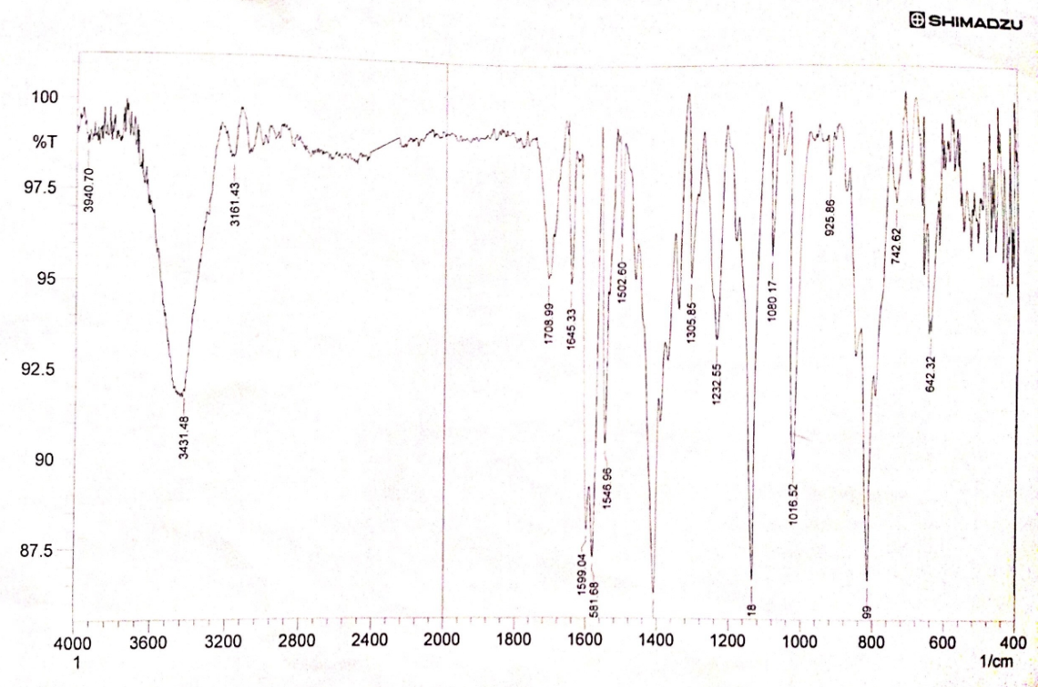
Fig. (1) FTIR Spectrum of the reagent

The FTIR spectrum of complex Fig. (2) shows absorption band at (3300-3900) Cm⁻¹which refers to H2O found in the complex. Absorption band for C=N of thiazole ring appeared at 1645 Cm⁻¹ which differ from bands in the reagent spectrum this difference is due to coordination metal ion with nitrogen ring. The coordination of metal ion with nitrogen of azo group gives an absorption band at 1581 Cm⁻¹ that also differs from band in the reagent. Anew band appears in this spectrum at (400-1000) Cm⁻¹ which refers to metal-oxygen bond (M-O).

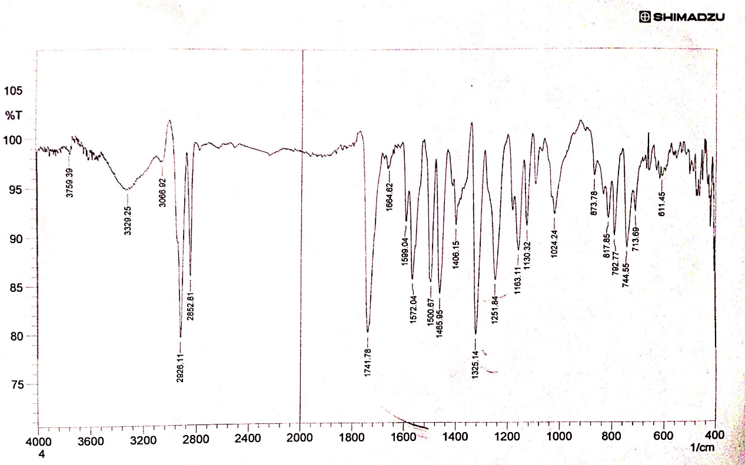
Fig. (2) FTIR Spectrum of the complex

NMR Spectra of reagent:
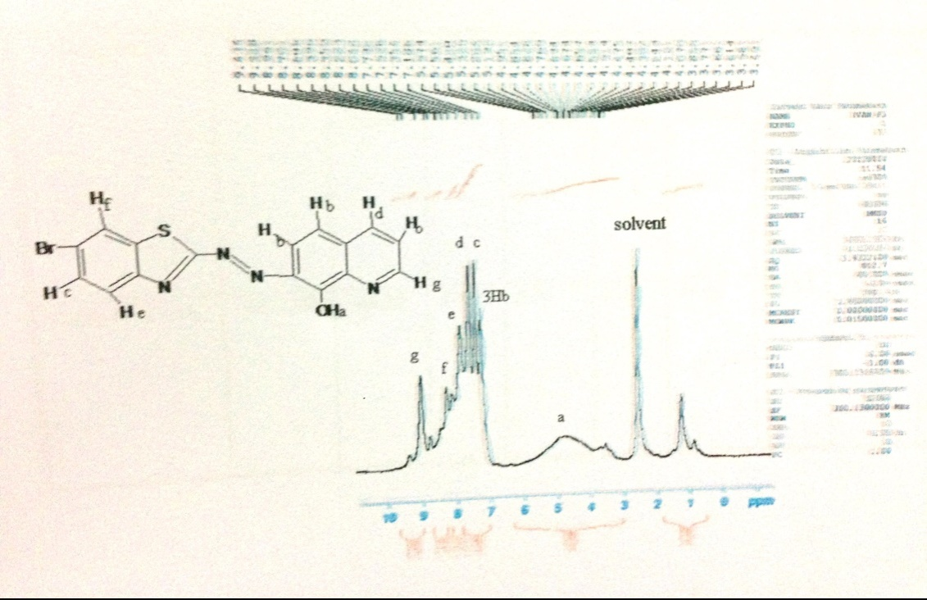
Fig.(3): The NMR spectra of 7-(6-BrBTA8HQ) in DMSO-d6

The 1H NMR spectrum (DMSO-d6, 400 MHz) of 7-(6-BrBTA8HQ) showed chemical shifts atδ4.89 (m, OH), 7.20(s,3H, pyridyl, phenoyl), 7.30(s, H, pyridyl),7.40 (s, H, pyridyl), 7.80-8.20 (m,2H, pyridyl) 8.99(s, H, pyridyl).
Physical and chemical properties of 7-(6-BrBTA8HQ):

7-(6-BrBTA8HQ) is reddish-orange powder which is slightly soluble in water, it is soluble in organic solvents, such as, CCl4, DMSO, acetone, DMF, ethanol.The reagent appears as orange color in acidic medium and violet in basic medium, absorption spectra of the reagent at different pH values are as follows in fig. (4):

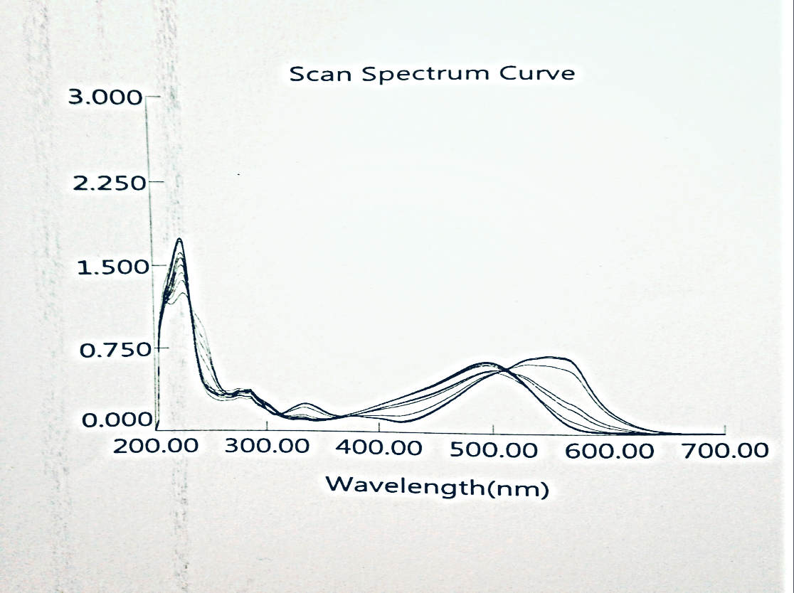
Fig. (4):-Absorption spectra of the reagent at different pH values

This figure shows two isosbestic points the first at 370nm and the second at 512nm.

Absorption spectrum of free reagent and complex:

The absorption spectra of the reagent in the ethanol solvent and the complex [V-7-(6-BrBTA8HQ)]are shown in figure (5):

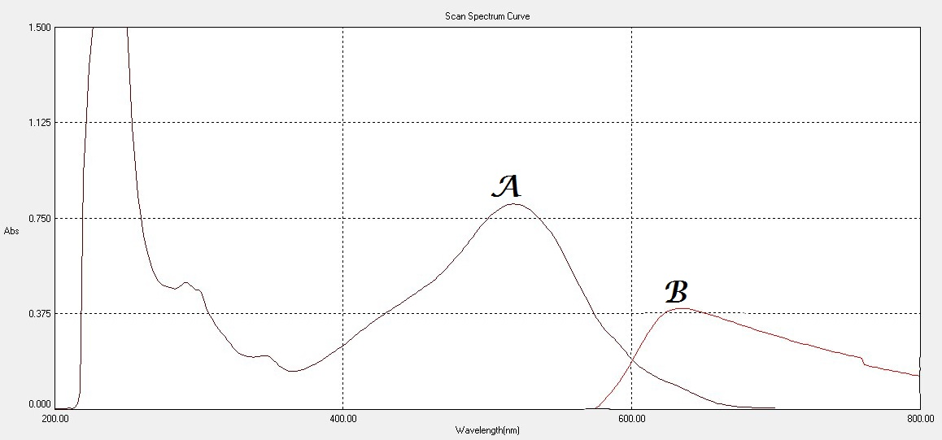
Fig. (5):-Absorption spectra of A: 7-(6-BrBTA8HQ)reagent
B: V-7-(6-BrBTA8HQ) complex at pH=7

The electronic spectrum of the reagent shows three characteristic bands, the two bands at (226,268) nm are due to the (π -π*) transition of the phenolic ring, while the third band at (518)nm is due to the (n- π*) transition of the nonbonding electron pairs of the nitrogen atom. The complex of V(V) with this reagent appears the peak at 634nm, this indicates the reaction happened between V and the reagent 7-(6-BrBTA8HQ).
Absorption spectra show that the λ max of absorption of reagent is apparent at 518 nm,while for V complex at 634 nm, this new λ max means the red shift in λ max of complex.

Effect of reagent concentration:

Keeping a constant concentration (20 ppm) of V(V) solution,the effect of reagent concentration (5 x10⁻⁴ M) on absorbance of the complex was studied by varying the volume of reagent (1-3)ml ,it was obtained that the complex formation was complete and absorbance was maximum when the amount exceeds 3ml.

The effect of pH:
The absorbance of the V-complex depends on the pH of the solution,the influence of pH was studied over the range (2-10) adjusted by addition of dil. NaOH(0.01M) and dil. HCl(0.01M), the optimum pH range was obtained between (7-8) of complex. Fig.(6,7)shows the relationship between absorbance of complex and pH, At pH <7 a decrease in absorbance may be due to form azoliumcation result from the reaction between hydrogen ion and the ion pair of electron on the nitrogen atom for thiazol ring . In addition, when pH >8 a decrease in absorbance was observed due to formation of vanadium hydroxide.

Fig. (6):-Effect of pH on the absorbance of vanadium complex
▲ pH complex without addition buffer solution
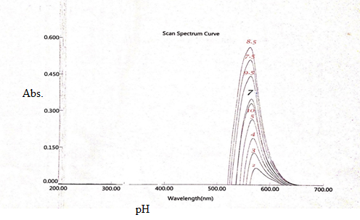
Fig. (7) Effect of pH on the absorbance of vanadium complex

The stability of the complex at different times and different temperatures:

The absorbance of the complex reaches a maximum value within 5 min and remains stable for 24 hour.
The absorbance of the complex was studied in the range (10-60) C⁰, the maximum and constant absorbance were obtained in the range (22-40)C⁰ ,it was decrease in the temperature more than 40C⁰ because the complex will be dissociated or evaporated in these temperatures.

Composition of complex and stability constant:

The complex composition was determined by job's and mole-ratio methods [fig (8,9)], both methods indicated that the complex has a molar ratio of (1:2) (M: L) at pH 7, and the stability constant (Kstab.) and (α) of complex was found to be (10.88 x10⁸ L.mol-1) and (0.0942) respectively by using the following equations ⁽²¹⁾:

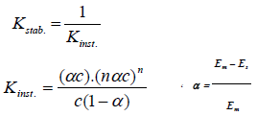
………… (1)

………… (2)
Where:
α=degree of dissociation.
c =total concentration of the complex=5x10⁻⁴,
n =mole ratio = 2.
Em= absorbance of a solution containing reagent two times excess than the amount of vanadium.
Es= absorbance of a solution containing a stoichiometric amounts [reagent] = [vanadium] = 5x10 ⁻⁴.

Fig. (8) Continuous variation method for V complex at optimum conditions

Fig (9) molar ratio method for V complex at optimum conditions

Analytical characteristics:
The calibration curvemade as described in the experimental procedure and good correlation coefficient was found .fig. (10), the some analytical parameters for this Spectrophotometric determination of V (V) using this reagent summarized in table (2) ⁽²²⁾:

Fig.(10):Calibration curve of VComplex

Table (2): Analytical characteristics of the proposed procedure
(N=No. of determination)

Analytical parameter | Value
Molar absorptivity ε,L.mol⁻.cm- | 1.8156*10³
Sandell's sensitivityµgm.Cm⁻² . | 0.0356
Correlation coefficient( R) | 0.9932
Detection Limit(D.L), ppm | 0.1893
Linear dynamic range, ppm | (1-14)
Standard deviation(S.D) , for (4ppm) | 0.0024
Relative Standard Deviation (R.S.D %), (N=7) | 0.631 %
Percent Relative error (E rel.%) for (4ppm) | 2%
Percent Recovery (Re %) | 98%
These results indicate that this method is highly accurate and suitable for the determination of V (v) spectrophotometrically.

Interferences:
The ions (Cu, Cd, Fe, Ni, Co, Hg) were formed the complexes with the reagent 7-(6-BrBTA8HQ) during its reaction with vanadium, the effect of these ions are studied,as in table (3).

Table (3): Effect of foreign ions on the determination of V (V) and suitable
Masking agents.
V  ppm | Foreign  ion  50ppm | Error%  Before addition masking agent | Masking agent  (1 )ml,[0.1 ]M | Error%  After addition masking agent
10 | Cu | -72.3 | Oxalic acid | 0.0
10 | Cd | -52.2 | Oxalic acid | 0.5
10 | Fe | 31 | Tartaric acid | 0.6
10 | Hg | -16 | Tartaric acid | 0.3
10 | Co | -19.7 | Ascorbic acid | 0.1
10 | Ni | -92.5 | Ascorbic acid | 0.2

Conclusion:In this work,7-(6-BrBTA8HQ) was synthesized and the color reaction of 7-(6-BrBTA8HQ) with vanadium was firstly studied. 7-(6-BrBTA8HQ)isone of the sensitive and selective spectrophotometric reagents for vanadium. The molar absorptivity reaches to 1.8156*10³ L mol^{–1} cm^{–1}. Most foreign ions do not interfere with vanadium when masked with oxalic acid, tartaric acid, and ascorbic acid.
Because the7-(6-BrBTA8HQ) can rapidly react with vanadium(V) at room temperature, this method can determine vanadium spectrophotometrically without heating or extraction. It is a sensitive, selective, rapid, and convenience method for vanadium.
References:
- B. Gummow, "Vanadium: environmental pollution and health effects " (2011) ,pp. 628-636.
- S.B.Etcheverry ,E.G.Ferrer, A.C.Gonzaez-Baro ,B.S. Parajon-Costa ,and P.A.M Williams, J. Arg. Chem.Soc., 2009, 97(1), 127-150.
- C.DebbieCrans, J.JasonSmee, E. Gaidamauskas, and L.Yang , Chem. Rev., 2004, 104, 849-902.
- K.G.Fernandes ,A.R.A.Nogueira ,J.A.Gomes and A.Nobrega , J.Braz.Chem.Soc. , 2004, 15(5), 676-681.
- A.L.Molinero and J.R.Castillo, J.Anal.Lett., 1998, 31(5) , 903-911.
- H.Karami ,M.f.Mousavi and M.Shamsipur , Anal. Chem.Acta , 2003, 481(2), 213-219.
- K.Gavazov ,V.Lekova and G.Patronov ,J.Acta Chem.Slov., 2006, 53, 506-511.
- Yogendu Sharma , AnalyticaChimicaActa, 1981, 233–235.
- K. A. Abdullah, A. G. M. Al-Daher and W. A. Bashir, Anal., 1985, 110, 409-410.
- N.C.Feng, B. Xu, Z. Bai, Y. Fang, Talanta. (1994), p.1841.
- C. Bing , Q. Zhang, H. Minami, and S. Inoue, J. of Chromatographic Science, 1999.
- Q. Hu, X. Wu, G. Yang, Z. Huang, and J. Yin , S. Afr., J. Chem., 2004, 57, 15–18.
- P. Racheva, K. Gavazov, V. Lekova and A. Dimitrov, Univ. of Plovdiv “PaissiiHilendarski”-Bulgaria, Scientific works. Chemistry, (2008).
- J. CHRISTINE, and A.NairE, Journal of Chemistry, 2009, 303-307.
- P. Kadyan, D. Singh, S. Verma and Poonam, Der PharmaChemica, 2012, 1577-1581.
- D. K. Yadav, R.S. Lokhande, S.M. Pitale, S.P. Janwadkar, P.S. Navarkar and P.K. Rana, World J. of Anal. Chem., 2014, 10-14.
- A.A. Ghali, Ph.DThesis, University of Baghdad, (2013).
- J.K.Malik, F.V.Manvi,,B.K. Nanjwade ,and S,Singh, Drug.Inven.Today, 2009, 1, 32.
- R.D. Patel, M.P. Patel, and R.G. Patel, indian j. of chem., 2005.
- M.G.A. Korn, A.C. Ferreira ,L.S.G.Teixeira, A.C.S. Costa, J.Braz.Chem.Soc., 1999, 10, 46-50.
- W.C. Vosburgh, and G. R. Cooper, J. Am. Chem. Soc., 1941, 437, 63.
- D.A.Skoog,''Principle of Instrumental Analysis''3rd ed.,SaunderGolden Publishing, (1985), P.22.

