Spectrophotometric determination of Procaine Hydrochloride in Bulk and Pharmaceutical by Diazotization-Coupling Reaction

Marwa Saad Mohammed , Kassim Hassan Kadim
Chemistry Department ,College of Scince, Babylon University,Babylon ,Iraq

(NJC)
(Received on 14/10 /2014) (Accepted for publication 23/11/2014)

Abstract
Asimple,rapid,sensitive,selective,and accurate spectrophotometric method for the determination of microgram amounts of procaine Hydrochloride drug in pure form and in pharmaceutical preparations.The method is based on diazotization of primary amine group of (PRO-HCl) with sodium nitrite and hydrochloric acid followed by coupling with 1,3-phenylenediamine in aqueous mildly acidic medium to form a stable orang azo dye, showed absorption at 454 nm. Beer’s law is obeyed over concentration range of(0.015-7.000)µg.m L⁻¹ with molar absorptivity of (6.906× 10⁴ ) L.mol⁻¹.cm⁻¹ and Sandell’s sensitivity of (0.004).µ.cm⁻².The method does not needed to temperature control or to solvent extraction. The optimum conditions for all colour development are described and the proposed method has been successfully applied for the determination of procaine Hydrochloride in bulk drug and pharmaceutical preparation vials with very good recoveries. The common excipients and additives did not interfere in this method.
Keyswords:-Procaine hydrochloride, Spectrophotometric,Diazotization-coupling,1,3-phenylenediamine,Pharmaceutical preparations.
الخلاصة
تم وصف طريقة طيفية سهله وسريعة وحساسة وانتقائية ودقيقة لتقدير كميات مايكرو غرامية من دواء الهيدروكلورايدبروكائين في حالته النقية وفي مستحضراته الصيدلانية .تعتمد الطريقة على تفاعل الأزوتة والازدواج لمجموعة الامين الاولي الهيدوكلورايدبروكائين مع1,3-فنيلين داي امين مع نتريت الصوديوم وحامض الهيدروكلوريك في وسط حامضي لتكوين صبغة برتقالية ذائبه في الماء و مستقرة ،والتي تعطي امتصاصيه عظمى عند454 نانوميتر .وجد ان قانون بير ينطبق ضمن مدى التركيز(0.015-.0007)مايكروغرام.مل⁻¹من الهيدروكلورايدبروكائين وان الامتصاصية المولارية (6.906× 10⁴)لتر .مول⁻¹.سم⁻¹ ودلالة ساندل للحساسية (0.004) مايكروغرام.سم⁻² .الطريقة لا تحتاج الى السيطرة على درجات الحرارة او الاستخلاص بالمذيب .وتم دراسة الظروف المثلى لتكوين المركب الملون وطبقت الطريقة المقترحة بنجاح لتقدير الهيروكلورايدبروكائين في حالته النقية او في مستحضراته الصيدلانية ( حقن) وباسترداد مئوي جيد كما وجد ان لايوجدتأثير للمضافات الدوائية في الطريقة المقترحة.
الكلمات الدلالية: الهيدروكلورايد بروكائين ،التقدير الطيفي ،الاقتران والأزوتة ،1,3-فنيلين داي امين،المستحضرات الصيدلانية.

Introduction
Procaine hydrochloride PRO-HCl is a white or almost white, crystalline powder or colourless crystals , very soluble in water, soluble in alcohol which has melting point of 154 C˚to 158 C˚ .Its chemical name 2-(diethylamino)ethyl 4-aminobenzoate hydrochloride(1):

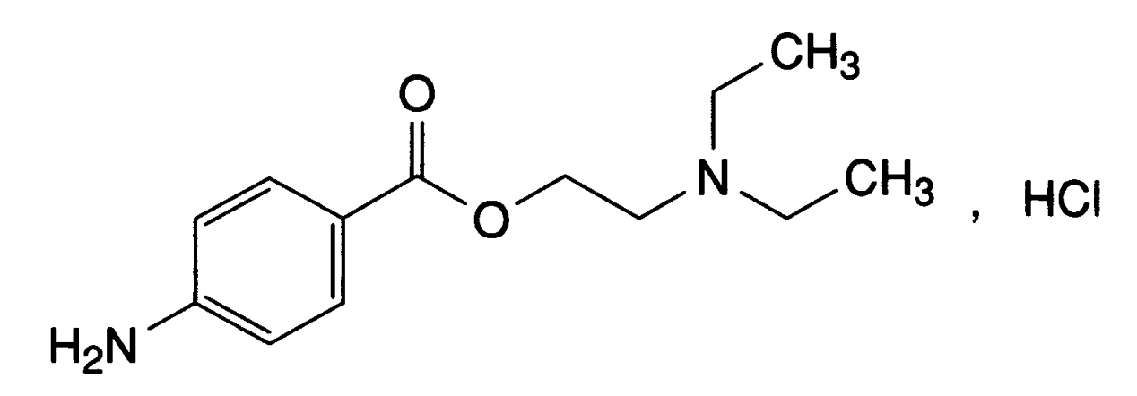
Fig (1): Chemical structure of procaine hydrochloride

It is used as alocal anaesthetic(2).Several methods have been reported for the determination of PRO-HCl,these methods involved involve chromatographic (3-6),electrochemical by using voltammetry method(7),Cyclic voltommetry(8),Stripping pulse differential adsorptive voltammetry(9) and potentiometric titration(10).For oral solution recommended spectrophotometric method based on Diazo-coupling with( 4-amino-5-hydroxynaphthalene -2,7-disulfonic acid) (11)and diazo –coupling with(2,5-dimethoxyaniline)(12), Charge-transfer by usingmetol reagent(13),Schiff base withp-dimethylaminocinnamaldehyde to form a sehiff base (14).Various analytical methods have been developed for the determination of this drug.These methods also include flow injection analysis (15-18) and flouresene methods(19,20).The aim of present work is to develop simple ,sensitive ,and selective spectrophotometric for the determination of PRO-HClmethod based on diazotization –coupling reaction with the reagent 1,3-phenylenediamine for the determination of PRO-HCl in bulk as well as pharmaceutical formulations.

Experimental
Apparatus
-All spectral and absorbance measurements were carried out on adigital double-beam UV-Visible 160 spectrophotometer with quarts cell of 1 cm path length .
-Sencetive balance)Sartorius,Balance Bp3015-Germany)
-Water bath( Water bath ,Cooling–Heating,memert ).
Material and Reagents
1- Reagents
All chemicals used were of analytical reagent grade purity. Standard reference procaine Hydrochloride was obtained from (State Company for Drug Industries and Medical Appliance, Sigma-Germany).

2-Solutions
All aqueous solution where prepared using deionized water . PRO-HCl standard aqueous solution 250 ppm.Sodium nitrite(BDH) aqueous solution 0.01 M .Hydrochloric acid (BDH) aqueous solution 1M . Sulfamic acid (BDH) aqueous solution 0.2 M . reagent 1,3- phenylenediamine (BDH) 0.01 M prepared using absolute ethanol (GCC).Dosage form aqueous solutions 100 ppm .
3-Recommended Procedure and Calibration Graph
Transfer increasing volumes of working PRO-HCl solution ,covering the range( 0.015-7.000) µg.mL⁻¹. Added of 0.2 M (1)MHClin to increament volume of working PRO-HCl solution and the mixtures are shaken , into a series of 25 mL volumetric flasks .Then 1mLof 0.01 M sodium nitrite solution is added and the mixtures are allowed to stand for 2 minutes .Then 1.5 mL of 0.2 M sulphamic acid solution is added and the mixtures allowed to stand for 2 minutes . After that 3 mL of 0.01 M (1,3- phenylenediamine) was added and the volumes were completed to the mark with deionized water. After 12 minutes measure the absorbance against a reagent blank , prepared in the same manner but containing no PRO-HCl at 454 nm using 1 cm cells.
4-Procedure for dosage forms
Injection:The contents of five vials were weighed.Aportion of the powder equivalent to 10 mg of the drug was weighed and dissolved in deoinized water then filtered and transferred in to 100 mL volumetricflask and completed to the mark with the same solvent .
Results and Discussion
Spectral characteristics
Absorption spectrum of the orange azo product with maximum absorption at 454 nm is shown in Fig .2.The reagent blank has practically negligible absorption at this wavelength. Hence, all measurements were made at this wavelength reagent blank.

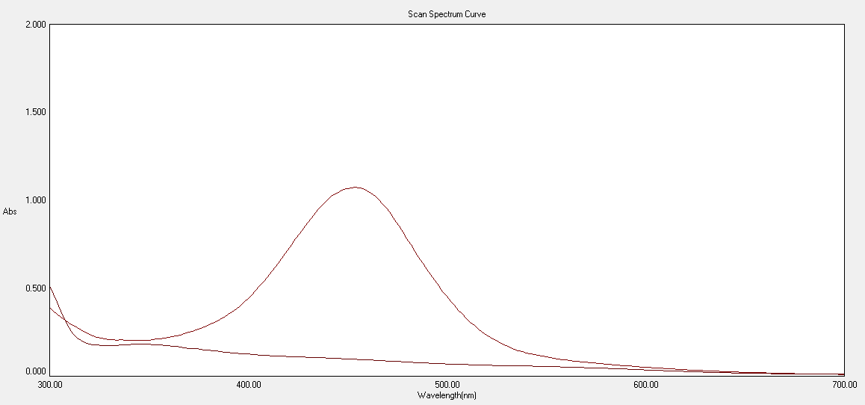
A
B
Fig(2):Absorption spectra of

A:(5ppm) of PRO-HCl treated as described under procedure and measured aginst1,3- phenylenediaminereagent blank.
B:the reagent blank measured against Ethanol.
Study of the optimum reaction conditions : The effects of various parameters on the optical properties of the azo dye have been studied and the reaction conditions are optimized
1-Effect of acid:Different amounts (0.05-3.00 ml of 1M)of different acids (have been examined .A 0.2 mL of 1M HCl to give the best results) the results are given in Table(1).

Table(1):Effect of volume of 1MHCl
Vol/HCl | Abs
0.05 | 0.559
0.10 | 0.699
0.20 | 0.813
0.25 | 0.798
0.30 | 0.769
0.50 | 0.689
1.00 | 0.652
2.00 | 0.674
2.50 | 0.659
3.00 | 0.658

2-Effect of Sodium Nitrite Concentration and Time: The effect of sodium nitrite concentration was tested by using different volumes (0.1-3.0 mL) of 0.01 M NaNO₂ solution was required with 2 minute reaction time to obtain a maximum absorbance .Table(2),Table(3)

Table(2):Effect of volume of 0.01 M sodium Nitrite.
Vol /NaNo₂ | Abs
0.1 | 0.625
0.2 | 0.683
0.5 | 0.787
1.0 | 0.855
1.5 | 0.810
2.0 | 0.823
3.0 | 0.820

Table(3):Effect of Time
Time/mint | Abs
1.0 | 1.063
2.0 | 1.079
3.0 | 1.067
5.0 | 1.072
7.0 | 1.066
10.0 | 1.069
14.0 | 1.073
16.0 | 1.071

3-Effect of Sulfamic acid Concentration and Time:The excess of nitrous acid is removed by the addition of sulfamic acid solution . The effect of its concentration was tested by using different volumes (0.1-4.0 mL) of 0.2 M sulfamic acid solution was required with 2 minute reaction time to obtain a maximum absorbance.
4- Effect of Reagent 1,3-phenylendiamine Concentration:The effect of reagent concentration was tested by using different volumes (0.1-5.0 mL) of 0.01 M of 1,3-phenylendiamine is sufficient for production of maximum and reproducible colourintensity.Fig(3)

Figure(3):Effect of 1,3-phenylendiamine Concentration

5-Effect of Time: The effect of time on the formation of the azo product was investigated by allowing the reaction to proceed for varying times. The results showed that the azo-dye reached maximum absorbance after 12 minutes .Table (4)

Table(4): Effect of Time
Time/mint | Abs
1.0 | 1.062
2.0 | 1.066
3.0 | 1.069
5.0 | 1.078
10.0 | 1.080
12.0 | 1.082
15.0 | 1.082
18.0 | 1.081
20.0 | 1.080
25.0 | 1.079
30.0 | 1.081
35.0 | 1.082
40.0 | 1.080
45.0 | 1.081
50.0 | 1.080
60.0 | 1.081

6-Effect of Temperature: The effect of temperature on the absorption was investigated at different temperatures (1-80 C˚). The results revealed that the absorbance relatively stable in the temperature rang (1-30 C˚). At higher temperatures, the absorbance value decreased , which was probably due to the dissociation of azo-dye.

Calibration Curve and Sensitivity (21)
Under the proposed experimental condition linear relation between the absorbance and the concentration of PRO-HCl was observed over the concentration range (0.015-7.000)µg.mL⁻¹ ,standard calibration curves for PRO-HCl were constructed Fig4 ,and different parameters of the analytical performance of the proposed method are summarized in Table 5

Figure ( 4 ) Calibration graph for PRO-HCl determination using 1,3- phenylenediamine as coupling reagent

Table(5):Analytical features of the procedure developed for the determination of PRO-HCl

Parameter | Proposed Method
Regression equation | Y= 0.2532 X+ 0.0099
Slope | 0.2532
Correlation coefficient | 0.9993
Linear Range (µg.mL⁻¹) | 0.015-7.000
Molar absorptivity (L.mol⁻¹.cm⁻¹) | 6.906 × 10⁴
Limit of detection (LOD) (µg.mL⁻¹) | 0.011
Limit of quantication (LOQ) (µg.mL⁻¹) | 0.037
Sandellʼssensitivity,S(µg. cm⁻²) | 0.004

Accuracy and Precision
To determine the accuracy and precision of the calibration graph, PRO-HCl was determind at three different concentration . The results shown in Table (6) indicate a satisfactory precision and accuracy.

Table(6):Accuracy and precision of proposed method
NO. | Conc. Of PRO-HCl µg per 25 mL |  | Error%* | Recovery* | R.S.D%*
NO. | present | found | Error%* | Recovery* | R.S.D%*
1 | 0.40 | 0.403 | +0.75 | 100.75 | 0.432
2 | 2.00 | 1.99 | -0.50 | 99.50 | 0.841
3 | 3.00 | 3.05 | +1.60 | 101.60 | 0.762
*Average for five determinations

Nature of product and reaction mechanism
To establish the composition (ratio of PRO-HCl to diazotized 1,3-phenylenediamine of the orange azo dye formed) ,Job’s method of continuous variations and mole-ratio method have been used. The resulting data reveal that the dye has been formed by the reaction of the PRO-HCl with 1,3- phenylenediamine reagent in a ratio of 1:1, Figure (5 and6),indicating a mono azo dye with probably of the following Schem:

Figure(5) :Mole ratio plot

Figure(6):Continuous Variation plot

Effect of interferences
In order to assess the possible analytical applications of the present proposed method, the interfering effects of excipients at various levels on the determination of 4 µg.mL⁻¹ of PRO-HCl. For this study, solution contained (PRO-HCl) and each one of the interference was taken separately in concentrations ten-times greater than that of (PRO-HCl) and were analyzed under the same procedure in the Calibration curve.Level of interference was considered to be acceptable if the error was not higher than2±% relative to the expected .Interference effect from some other drugs are present with PRO-HClwhich was studied in pharmaceutical preparations .Constant amount from PRO-HCl was taken where the final concentration of drug (4)ppm with avariable amount of interference drugs (at same concentration of studied drug),the result was given no interference with PRO-HClTable (6)

Table (6):Effect 0f excipients on the determination of 4 µg.mL⁻¹ of PRO-HCl

Excipint Conc.40 µg.Ml⁻¹ | Conc.of PRO-HCl  µg.ml⁻¹(found) | E%* | Rec%*
Tween 80 | 3.97 | -0.75 | 99.25
Benzylpenicillin(BEP) | 3.95 | -1.25 | 98.75
PRO-HCl:BEP
0.4:0.1 | 3.93 | -1.75 | 98.25
0.4:0.2 | 4.01 | +0.25 | 100.25
0.4:0.4 | 4.04 | +1.00 | 101.00
0.4:0.6 | 3.97 | -0.75 | 99.25
0.4:0.8 | 4.02 | +0.50 | 100.50

*Average for five determinations

Application of the method
The proposed method was applied to analysis of different dosage forms containing PRO-HCl in order to evaluate the analytical usefulness of the spectrophotometric method.Good results with good recoveries and reproducibilityʼs obtained basedon fivedeterminatons for three different concentrations of each pharmaceutical preparation Table (7).

Table(7):Application of the proposed method to the determination of PRO-HCl in some dosage forms.
Drug | Pharmaceutical preparation | Conc.µg.ml⁻¹ |  | E%* | Rec.%* | SD%*
Drug | Pharmaceutical preparation | Present | found | E%* | Rec.%* | SD%*
PRO-HCl | Devapen Injection | 2 | 1.97 | -1.50 | 98.50 | 0.0026
PRO-HCl | Devapen Injection | 4 | 4.04 | +1.00 | 101.00 | 0.0026
PRO-HCl | Devapen Injection | 6 | 5.96 | -0.60 | 99.33 | 0.0026
PRO-HCl | PENICAINE Injection | 2 | 2.01 | +0.50 | 100.50 | 0.0015
PRO-HCl | PENICAINE Injection | 4 | 3.99 | -0.25 | 99.75 | 0.0017
PRO-HCl | PENICAINE Injection | 6 | 5.98 | -0.30 | 99.70 | 0.0026
PRO-HCl | Procaine Penicillin for Injection 1MEGA | 2 | 1.99 | -0.50 | 99.50 | 0.0052
PRO-HCl | Procaine Penicillin for Injection 1MEGA | 4 | 4.03 | +0.70 | 100.70 | 0.0015
PRO-HCl | Procaine Penicillin for Injection 1MEGA | 6 | 6.02 | +0.30 | 100.30 | 0.0078
PRO-HCl | Procaine Penicillin for Injection 0.4 MEGA | 2 | 1.98 | -1.00 | 99.00 | 0.0043
PRO-HCl | Procaine Penicillin for Injection 0.4 MEGA | 4 | 3.97 | -0.75 | 99.25 | 0.0036
PRO-HCl | Procaine Penicillin for Injection 0.4 MEGA | 6 | 6.04 | +0.60 | 100.66 | 0.0017

*Average for five determinations

F and T-test, show that there is no signicant difference in accuracy between the proposed method and the officialBritish Pharmacopoeia (Bp) method Table (8).

Table(8):Application of the proposed and official methods to the determination of PRO-HCl in pure and some dosage forms.
PRO-HCl
Pharmaceutical preparation | Proposed method |  | Standard method(1)
Pharmaceutical preparation | Rec% | SD% | Rec%
Procaine HCl Pure | 100.60 | 0.0028 | 100.80
PENICAINE Injection | 99.98 | 0.0026 | 99.89
Procaine Penicillin for Injection 1MEGA | 100.16 | 0.0019 | 100.36
Procaine Penicillin for Injection 0.4 MEGA | 99.41 | 0.0048 | 99.20
Devapen Injection | 99.61 | 0.0032 | 101.70
SUM | 499.76 |  | 501.95
Mean | 99.952 |  | 100.39
STANDARD deviation | 0.00306
Unpaired t test =(0.626 ) F test=( 4.070 )

Comparison of Methods
Table (9): Comparison and characteristics of the different spectrophotometric methods were used for the determination of PRO-HCl
Reagent | Colour reaction | ^{λ}_{max/nm} | Linear rang/ µg.mL⁻¹ | Molar Absorptivity | Ref
4-amino-5-hydroxynapthalene-2,7-disulfonic acid | Diazo-coupling | 530 | 0.100-7.000 | - | 11
2,5-dimethoxyaniline | Diazo-coupling | 482 | (0.200-8.000) | 5.28×10⁴ | 12
Metol | Charge-transfer | 510 | 3.000-80.000 | 4.94×10³ | 13
P-dimethylaminocinnamaldehyde | Schiff base | 547 | 0.100-7.000 | - | 14
PromathazineHCl | Oxidative-coupling | 610 | 0.400-18.000 | 1.71×10⁴ | 22
3-methylbenzothiazolin-2-one | Oxidative-coupling | 575 | 50.000-400.000 | 0.6×10³ | 23
p-dimethylaminobenzalhyde | Schiff base | 455 | 15.000-0.2.000 | 3.46×10⁴ | 24
1,2-naphthoquinone-4-sulfonic | Replace reaction | 484 | 0.300-100.000 | 5.22×10³ | 25
H₂O₂ | Oxidation reduction | 550 | 0.040-1.130 | - | 26
p-Benzoquinone | Charge-transfer | 525 | 5.000-90.000 | 2.42×10³ | 27
1,3-phynelendiamine | Diazo-coupling | 454 | 0.015-7.000 | 6.906×10⁴ | This work
.

Conclusion
A simple ,rapid, precise and sensitive spectrophotometric method has been developed for the determination of trace amounts of procaine hydrochloride in aqueous solution reaction with 1,3-phenylenediamine based on its diazotized coupling reaction ,also the method does not resort to temperature control or to solvent extraction.
Reference
1-“British Pharmacopoeia” 2009,vol.I and II , Her Majestys Stationary Office, London.
2-The Extra Pharmacopedia and Pharmaceutical Press,London,1977,p.877.
3-O.Atay,and F.Oztop,Anal.Lett., 1997, 30(3)., 565.
4-A.Ghassempour,S.S.H.Davarani,M.Noroozi,and M.Shamsipur,Talanta, 2005, 65,1038.
5-M.L.Storms,and J.T.Stewart, J.Pharm.Biomed.Anal. 2002, 30, 49.
6-S.M.Shuang,and M .M. F. Choi , J .ofChromatography, 2001, 919(2), 321.

7-A. Liu, J. Wang, W. Chen, X. Xia, Y. Chen, and X. Lin, J SolidState Electrochem,2012, (16),1343.
8-M Wei, Y. Zhou, J. Zhi, D. Fu, Y. Einaga, A.Fujishima,X.Wang,andZ.Gu,Electroanalysis, 20(2), 137.
9-N.Li,J.Duan,and G.Chen,Anal.Sci., 2003, 19,1587.
10-C.Y.Wang ,X .Y .Hu ,G. D. Jin ,and Z .Z. Leng, J.Pharm.Biomed.Anal., 2002, 30, 131.
11-N.D.Dinesh,P.Nagaraja,and K .S .Rangappa , Indian J .Pharmaceutical Sci., 2002, 64(5), 485.
12-A.A..J.Kassam,Ph.D Thesis,University of Babylon University,(2013).
13-H.Hadi,Um-Salama Science Journal,2008, 5(1),137.
14-H.S.I.Tanx and D .Shelton ,J. PharmaceuticalSci., 1974, 63(6).
15-M.Q.Al-Abachi,W.A.Al-Uzri,and H .S .Al-Ward, J. Baghdad for Sci., 2012, 9(3), 521.
16-H.Pasekova,and M.Polaasek,Talanta, 2000, 52, 67.
17-N.Li,Y.Chi, J. Wang, J. Duan ,and G. Chen, Luminescence, 2003, (18),125.
18-X.Chen,X.Song,and J .WANG, Anal BioanalChem, 2006, 385,737.
19-S. Carretero, C. Cruces-Blanco, S. F. Peinado,R.El Bergmiand,A.F.GutieArrez, J.Pharm.Biomed.Anal., 1999, 21, 969.
20-F .G. Sanchez, A.L. R .Rubio, C. Cruces Blanco ,M .H .Lopez, J. C. M .Gomez and C .Carnero ,Anal. Chim.Acta, 1988, 205,139.
21-S.K.Menon , B . R. Mistry , K . V. Joshi, P . G. Sutariya, and R. V. Patel, SpectrochimicaActaPart A, 2012, 94, 235.
22-M.J.Hamzah,M.Q.Al-Abach,M.A.Al-Daamy, and Y .Y. Farid, J . KerbalaUniversity, 2009, 7(1), 236.
23-M.E.El-Kommos,and K.M.Emara, Analyst, 1987, 112, 1253.
24-L.D.Liu,Y.Liu,H.Y.Wang,Y.Sun,Li Ma, and B.Tang,Talanta, 2000, 52, 991.
25-L. X. Xu, Y. X. Shen, H. Y. Wang, J. G. Jiang,and Y. Xiao, SpectrochimicaActa PartA, 2003, 59,3103.
26-Y.Chen,F.Tian,and M.Song, J.Anal.Chem., 2009, 64(4),366.
27-A. S. Amin, and A. M. El-Diamond, Anal.Sci., 2003, 91,1457.

