Uricase Isolated from Seeds of Leek (Allium ampeloprasum), Celery (Apium graveolens) and Arugula (Eruca sativa)

Luay Abed Al-Helaly Fatma A. Mohammad
luayhelaly@yahoo.com fatimaa.m@yahoo.com
Department of Chemistry, College of Science, Mosul University, Iraq

(NJC)
(Received on 5/6 /2014) (Accepted for publication 15/9 /2014)

Abstract
This research included isolation of uricase from the seeds of leek (Allium ampeloprasum ), celery(Apium graveolens) and arugula(Eruca sativa). Studied the factors effecting its activity and determination of its molecular weight. One proteinous peak had been isolated by gel filtration (using sephadex )G-100)) from the proteinous supernatant obtained using ammonium sulfate saturation(70%). The apparent molecular weight of the isolated enzymes using gel filtration chromatography were (59600+ 209) Dalton for leek, (59430+ 221) Dalton for celery and (59800+ 190) Dalton for arugula .
The results also showed that the optimum conditions for the activity of uricase isolated from seeds of leek, celery and arugula obtained at (100 µg/ml) of enzymes concentration using (100, 100 and 120 mmol/l) of uric acid as a substrate, with borate buffer solution at pH (7.0, 7.0, 6.5 ) for (15) minutes at (40, 40 and 35 °C) respectively. Using Line Weaver–Burk plot, the values of maximum velocity (V_{max}) and Michaelis constant (K_{m}) were from to be (33.3 µmol/ min) and (83.3 mmol/l) for leek, (40 µmol/ min) and (285.7 mmol/l) for celery while (27 µmol/ min) and (166.6 mmol/l) respectively for arugula.
When using 100 mM chemical compounds for mercuric chloride(HgCl₂), ferrous chloride (FeCl₂) and ethylene diamine tetra acetic acid (EDTA) showed decreased the activity of the enzyme, but calcium chloride (CaCl₂), manganese sulphate (MnSO₄), magnesium sulphate (MgSO₄) and potassium chloride (KCl) increased the activity .

Keywords: Isolation, Uricase, Leek, Celery, Arugula .
الخلاصة
تم عزل إنزيم اليوريكيز من بذور الكراث (Allium ampeloprasum) والكرافس (Apium graveolens) والجرجير (Eruca sativa) ثم درست بعض العوامل المؤثرة على فعالية الإنزيم فضلا عن تحديد وزنه الجزيئي. حيث تم فصل قمة بروتينية واحدة بتقنية الترشيح الهلامي سيفادكس نوع G-100 للراسب البروتيني الناتج من عملية الترسيب بكبريتات الامونيوم (70%). بعدها قدر الوزن الجزيئي للإنزيم باستخدام تقنية الترشيح الهلامي التي كانت بحدود 59600 + 209 دالتون للكراث و59430 + 221 دالتون للكرافس و59800 + 190 دالتون للجرجير.
أشارت النتائج أيضا إن الظروف المثلى لقياس فعالية الإنزيم المنقاة من بذور الكراث والكرافس والجرجير على التوالي: عند تركيز الإنزيم 100 مايكروغرام/مل باستخدام حامض اليوريك كمادة اساس عند تراكيز 100، 100 و120 ملي مول/لتر بوجود محلول بورات المنظم عند أس هيدروجيني 7.0، 7.0، 6.5 وزمن التفاعل 15 دقيقة ودرجة حرارة 40، 40 و35°م على التوالي. واستخدمت رسومات لاين ويفر– برك لحساب قيمة السرعة القصوى (V_{max}) وثابت مكيلس (K_{m}) وكانت مساوية لـ 33.3 مايكرومول/دقيقة و83.3 ملي مول/لتر للكراث و40 مايكرومول/دقيقة و285.7 ملي مول/لتر للكرافس، بينما 27 مايكرومول/دقيقة و166.6 ملي مول/لتر على التوالي للجرجير.
لوحظ عند استخدام 100 ملي مول لكل من المركبات الكيميائية كلوريد الزئبقيك(HgCl₂) وكلوريد الحديدوز(FeCl₂) واثيلين ثنائي الامين رباعي حامض الخليك (EDTA) انها تعمل على خفض فعالية الإنزيم ولكن كلوريد الكالسيوم (CaCl₂) وكبريتات المنغنيز (MnSO₄) وكبريتات المغنيسيوم (MgSO₄) وكلوريد البوتاسيوم (KCl) عملت على زيادة فعالية الإنزيم .

الكلمات الدالة: عزل، اليوريكيز، الكراث، الكرافس، الجرجير. ـ

Introduction
Uricase (urate oxidase, EC 1.7.3.3, UC) is an enzyme in the purine degradation pathway that catalyzes the oxidative breakdown of uric acid to allantoin. This enzyme is found in mammals⁽¹⁾, plants⁽²⁾, fungi , yeasts⁽³⁾ and bacteria⁽⁴⁾. All mammals produce uricase, except humans and certain primates ⁽⁵⁾. Indeed, during evolution, uricase was inactivated in humans primarily due to missense and frame-shift mutations in the gene encoding this enzyme⁽⁶⁾ .
When increase of urate precipitates in soft tissues in the form of sodium urate crystals and absence of urate-lowering treatment, these urate deposits accumulate, causing the clinical symptoms of gout (flares, tophi, and urate arthropathy). Elevated serum uric acid concentration has been associated with, a significantly increased cardiovascular risk ⁽⁷⁾, idiopathic calcium urate nephrolithiasis⁽⁸⁾, and renal failure⁽⁹⁾. A high level of uric acid was related to leukemia in children⁽¹⁰⁾.
Uricase is useful for enzymatic determination of urate in clinical analysis by coupling with 4-aminoantipyrine-peroxidase system⁽¹¹⁾. Urate oxidase can be also used as protein drug to overcome severe disorders induced by uric acid accumulation⁽¹²⁾. Immobilized UC can be used as a uric acid biosensor ⁽¹³⁾. It is also used as an additive in commercial formulations of hair coloring agents⁽¹⁴⁾.
In patients with gout, the bulk of uric acid crystallized in joints and soft tissues is much greater than its circulating amount. Conventional urate-lowering agents such as xanthine oxidase inhibitors (allopurinol, febuxostat) or uricosuric agents (probenecid, benzbromarone)⁽¹⁵⁾ (Fig. 1) induce very slow reduction in uric acid deposits.

Figure 1: Mechanism of action of urate-lowering agents⁽¹⁵⁾.

Leek (Allium ampeloprasum) used for the treatment of constipation, asthma, hemoptysis, goat, obesity, hemorrhoids, headache and as a diuretic, emmenagouge and aphrodisiac⁽¹⁶⁾. Celery (Apium graveolens) containing powerful healing factor and active component in response to investigations by researchers seeking to explain some of the medicinal used as antibacterial, anti-inflammatory, condiment, carminative, diuretic and for treatment of bronchitis, asthma, rheumatism, arthritis, urinary calculi, constipation as well as liver and spleen disorders⁽¹⁷⁾. Arugula (Eruca sativa) is used as a diuretic, stimulant, and in the treatment of stomach disorders and scurvy⁽¹⁸⁾. The seeds and tender leaves are known in Arabian countries to increase sexual desire and are considered to be an aphrodisiac. It is also used as a carminative and to alleviate abdominal discomfort and improve digestion. It has been reported that the ethanolic extract of seed possesses potent antioxidant and renal protective and diuretic activities^{(19, 20)} .
The aim of this research is to provide a detailed study of involving isolation and purification of UC from leek (Allium ampeloprasum), celery (Apium graveolens) and arugula (Eruca sativa) using biochemical techniques and study the factors effecting the activity of enzyme and determination of its molecular weight.

Materials and Methods

Assay the activity of uricase
Uricase activity was measured according to the procedure described by Adamek et al. ⁽²¹⁾. To 2 ml of a solution containing uric acid (10 µg per ml of borate buffer 0.2 M, pH 8.5), 0.8 ml of water and 0.1 ml of crude enzyme at 25 °C were added. After 10 min, 0.2 ml of 0.1 M potassium cyanide solution was added to the mixture to stop the enzyme reaction. In the reference sample, the solution of potassium cyanide was added to the mixture before the addition of the crude enzyme. The absorbance of both samples was measured at 293 nm. The difference between absorbance of the sample and reference is equivalent to the decrease in uric acid during the enzyme reaction. One unit of UC enzyme was equal to the amount of enzyme which converts 1 μmol of uric acid to allantoin per min under optimum conditions.

Purification steps of uricase from seeds of leek, celery and arugula
The method given here has yielded an enzyme preparation acceptable for three types of vegetables seeds. All steps were performed at 4 ºC unless stated otherwise.

Step I: Collection of leek (Allium ampeloprasum ), celery(Apium graveolens) and arugula(Eruca sativa)
The seeds of leek (Allium ampeloprasum), celery (Apium graveolens) and arugula (Eruca sativa) were collected from locality market in Mosul city and it was classification in Mosul university/College of science/ Biology department. Seeds for each vegetable weighting 50 g were grinded in an electrical blender into a fine powder and mixing in a cold mortar with distilled water. The plant material was frozen in liquid nitrogen three times and stored at -20° C or directly used for the determination. The samples were centrifuged at 13,000 X g for 15 min at 2–5°C. The supernatants were used in protein⁽²²⁾ and enzyme assays⁽²¹⁾.
Step II: Ammonium sulfate fractionation
A supernatant was obtained from the seeds of (Leek, celery and arugula) and protein was precipitated using 70% ammonium sulfate (NH₄)₂SO₄ saturation (Protein salting out)^{(23, 24)}. Solid (NH₄)₂SO₄ was added slowly to the supernatant with gentle stirring on ice bath until the required saturation of ammonium sulphate was reached after which the mixture was allowed to stand at 4ºC overnight^{(25, 26)} .
Step III: Cooling ultracentrifuge separation
Each suspension from step II was centrifuged at 9,000 Xg for (45) min at -4°C. The protein in precipitate and supernatant were determined using the modified Lowry method⁽²²⁾, uricase activity was determined in each fraction⁽²¹⁾.
Step IV: Gel filtration chromatography using Sephadex G-100
The sephadex gel G-100 supplied as a powder was suspended in adequate distilled water so that when it was stirred incorporated air bubbles that escape rapidly to the surface. It was then allowed to swell for 3 hours at 90 ºC in a complete swelling ⁽²⁴⁾.
In the present study, the columns dimension was 2.0×117 cm which contained a gel sephadex height of (114) cm. The exclusion limit for sephadex G-100 is (150000) Dalton ⁽²⁴⁾. Depending on the volume of this column which was 358 ml, it was packed with a slurry of the gel in water .
A concentrated sample (4) ml of the protein precipitate (10 mg/ml) (by freeze-dryer technique), which was obtained in (Step III), was applied on the top of a bed sephadex G-100, followed by distilled water⁽²⁶⁾.
The elution of the protein materials was carried out at a flow rate (48)ml/ hour with a definite time (5) min. was used distilled water as eluant. The fractions collected using a fraction collector apparatus which was worked on minute system. The protein compounds in each fraction collected were detected by following the absorbance at wave length (280) nm using UV/Visible Spectrophotometer. The peaks was combined separately from the plot of an absorbance versus elution volumes with determined of UC in each fraction⁽²¹⁾.
Step V: Freeze-dryer (Lyophilization) technique
The enzyme fraction which was obtained from gel filtration was dried using Lyophilization technique to obtain a powder or a concentrated protein. The enzyme was kepted in a deep freeze at -20ºC in a tight sample tube to be used for the further investigations.

Results and Discussion
Enzyme purification
Many sources of UC are available, but commercial production may be hampered by low productivity and difficulties in protein purification for clinical applications^{(27, 28)}, isolation of uricase from seeds of leek (Allium ampeloprasum ), celery (Apium graveolens) and arugula (Eruca sativa), are good source for the enzyme. The results (Table 1, 2 and 3) are show increase folds of purification when UC was precipitate by ammonium sulphate 70%, agreement with those of Saeed who found that uricase enzyme was purified from P. aeruginosa using ammonium sulphate (70% saturation) ⁽²⁵⁾ and agreement with those of Mabrouk et al.⁽²⁹⁾ who found that G. Guoguricase enzyme was purified using ammonium sulphate (70% saturation). Supernatant was neglected for the time, because of their low activity.

Table 1: Partial purification steps of uricase from the leek (Allium ampeloprasum).
Purification stage | Volume taken (ml) | Protein conc. (mg/ml) | Total Protein (mg) | Total activity (U*) | Specific  activity  (U/mg protein) | Folds of Purification | Recovery %
Extraction crude | 170 | 2.87 | 487.9 | 27.608 | 0.057 | 1 | 100
Precipitate by (NH₄)₂SO₄(70%) | 127 | 1.38 | 175.26 | 23.39 | 0.133 | 2 | 84.7
Supernatant | 45 | 0.89 | 40.05 | 1.4 | 0.034 | 1 | 5.1
Sephadex G-100 (Fractions) Peak A | 80 | 0.173 | 13.84 | 19.0 | 1.37 | 24 | 68.8
U*: Unit of UC enzyme was equal to the amount of enzyme which converts one μmol of uric acid to allantoin per min under optimum conditions.

Table 2: Partial purification steps of uricase from the celery (Apium graveolens) .
Purification stage | Volume taken (ml) | Protein conc. (mg/ml) | Total Protein (mg) | Total activity (U*) | Specific  activity  (U/mg protein) | Folds of Purification | Recovery %
Extraction crude | 200 | 2.31 | 462 | 15.115 | 0.033 | 1 | 100
Precipitate by (NH₄)₂SO₄(70%) | 115 | 1.44 | 165.6 | 13.294 | 0.08 | 2 | 87.95
Supernatant | 86 | 0.93 | 79.98 | 1.41 | 0.018 | 1 | 9.3
Sephadex G-100 (Fractions) Peak A | 48 | 0.171 | 8.21 | 9 | 1.1 | 33 | 59.54
U*: Unit of UC enzyme was equal to the amount of enzyme which converts one μmol of uric acid to allantoin per min under optimum conditions.

Table 3: Partial purification steps of uricase from the arugula (Eruca sativa).
Purification stage | Volume taken (ml) | Protein conc. (mg/ml) | Total Protein (mg) | Total activity (U*) | Specific  activity  (U/mg protein) | Folds of Purification | Recovery %
Extraction crude | 150 | 1.91 | 286.5 | 17.18 | 0.06 | 1 | 100
Precipitate by (NH₄)₂SO₄(70%) | 130 | 1.01 | 131.3 | 14.318 | 0.11 | 2 | 83.3
Supernatant | 23 | 0.49 | 11.27 | 0.4 | 0.035 | 1 | 2.3
Sephadex G-100 (Fractions) Peak A | 64 | 0.298 | 19.1 | 12 | 0.63 | 11 | 69.84
U*: Unit of UC enzyme was equal to the amount of enzyme which converts one μmol of uric acid to allantoin per min under optimum conditions.

Gel filtration separations
This technique was applied to separate the protein as a source of enzyme, which was obtained by using a column containing sephadex G-100 as shown in (step IV)⁽²⁶⁾. The result (Figures 2,3 and 4) indicated that there was mainly one peak eluted from sephadex G-100 (Peak A) that showed UC activity. The elution volume of peak (A) was (143.5) ml for Leek, (144) ml for celery and (143) ml for arugula. The folds of purification (24, 33 and 11) for leek (Allium ampeloprasum), celery (Apium graveolens) and arugula (Eruca sativa) respectively (Table 1, 2 and 3).

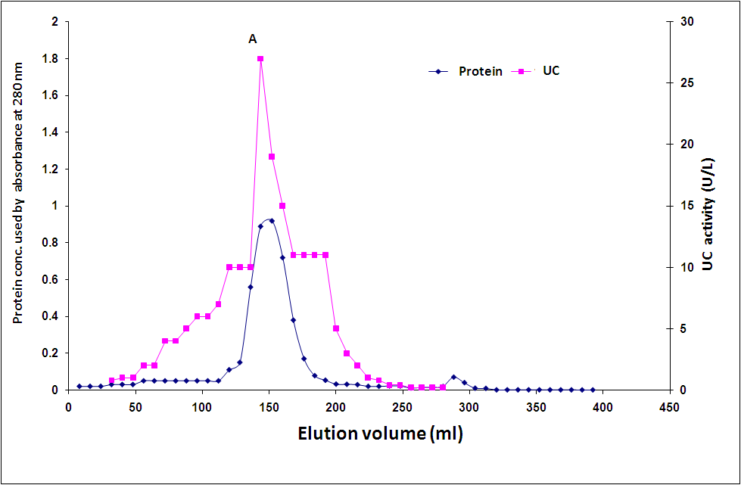
Figure 2: Elution profile uricase for seeds of leek (Allium ampeloprasum) on sephadex G-100.

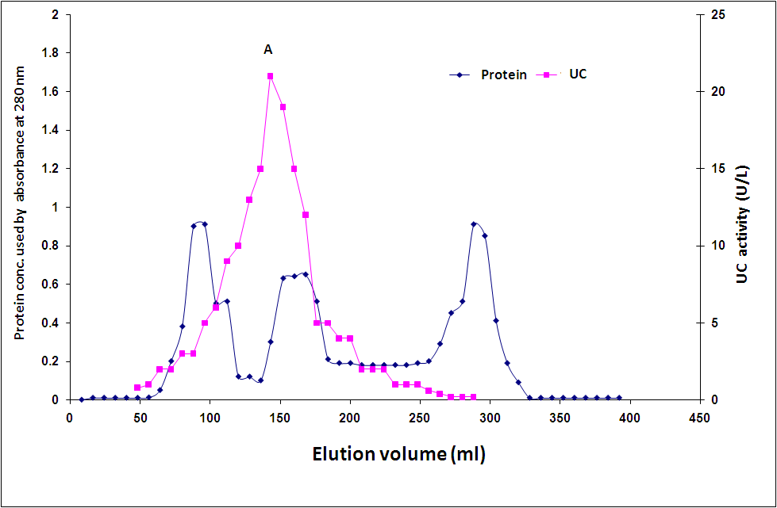
Figure 3: Elution profile uricase for seeds of celery(Apium graveolens)on sephadex G-100.

Figure 4: Elution profile UC for seeds of arugula (Eruca sativa) on sephadex G-100.

Molecular weight determination of UC by gel filtration
The molecular weight of first peak (A) as a source of UC was determined by gel filtration chromatography using sephadex G-100 column (2.0×117)cm calibrated with known molecular weight proteins that are listed in Table (4).

Materials | Molecular weight (Dalton) | Elution volume  (ml)
Blue dextran (Void volume(V°)) | 2000000 | 87
Bovine serum albumin | 67000 | 97
Egg albumin | 45000 | 137
Trpsin | 36000 | 145
Insulin | 23000 | 293
Tryptophan (Internal volume(V_{i})) | 204 | 377
Unknown (peak A ) from Allium ampeloprasum | 59614 | *143.5
Unknown (peak A ) from Apium graveolens | 59429 | **144
Unknown (peak A ) from Eruca sativa | 59799 | ***143
Table 4: Elution volumes of known molecular weight materials on sephadex G-100.
*This value was obtained from Figure (2). **This value was obtained from Figure (3).
***This value was obtained from Figure (4).

A plot of logarithmic molecular weight of each material versus the elution volumes indicated in Table (4) gives a straight line as illustrated in Figure (5).
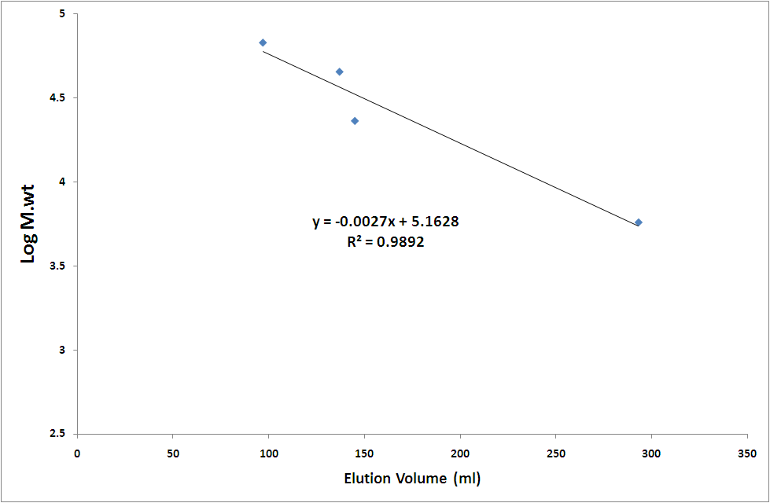
Figure 5: A plot of the logarithm molecular weights of known proteins versus elution volume on a sephadex G-100.

The molecular weight of unknown protein compound separated by the column chromatography as shown in (step IV) was determined from the standard curve, which was represented by Figure (5). The comparative molecular weight of peak (A) of UC are approximately equal to (59600 + 209)Dalton for leek, (59430 + 221)Dalton for celery and (59800 + 190) Dalton for arugula . This finding was in a agreement with the previous results where it was found and reported that the molecular weight of purified UC from E. coli and Gliomastix gueg were 60000 Dalton^{(29, 30)} and from Pseudomonas aeruginosa was 68000 Dalton ⁽²⁵⁾. In another study, the molecular weight of the UC was estimated to be 34000 -54000 Dalton ^{(31, 32)} . Uricase from different sources may have different molecular masses and amino acid sequences ⁽³²⁾.

Optimum Conditions for Uricase Activity
To develop assay conditions where UC from seeds of leek (Allium ampeloprasum ), celery (Apium graveolens) and arugula (Eruca sativa) shows a maximum activity, a series of experiments were performed. These included enzyme concentration, pH of the assay conditions, incubation time, incubation temperature and substrate concentration⁽³³⁾.
Several investigators^{(27, 34)}studied the optimal temperature and pH for UC from microorganisms. The effect of various carbon and nitrogen sources on the formation of UC by microorganisms was studied by several authors ^{(27, 34, 35)}.

1.Effect of enzyme concentration on uricase activity:
It is important to establish that the activity varies linearly with enzyme concentration. The activity of enzyme was measured in the presence of different concentrations of partially purified enzyme from seeds of vegetables between (0-180) µg/ml as shown in Figure (6).
The result indicated that the enzyme activity increased with increasing the concentration of protein as a source of the enzyme a good agreement with Aly et al.⁽³⁶⁾. For the next experiment (100)µg/ml, as a source of the enzyme was selected for determination other optimum conditions .

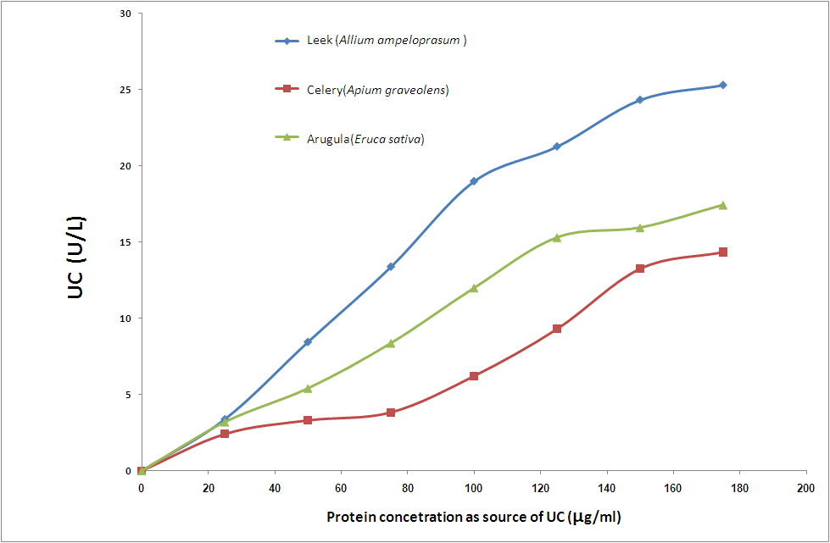
Figure 6: Effect of different protein concentrations on UC activity

2.Effect of pH on the uricase activity:
The influence of pH upon the activity of UC was investigated by using (100 µg/ml) as a source for enzyme in (0.2) mol/liter borate buffer. The assay conditions were conducted in the same manner as described earlier at pH range of (5.0 - 9.0). Maximum UC activity was obtained at pH (7.0, 7.0 and 6.5) for leek, celery and arugula respectively as indicated in Figure (7). Extremes of pH above of 7.0 can lead to denaturation of the enzyme and decreased activity, because the structure of the catalytically active site for enzyme depends on the ionic character of the amino acid side chains⁽²³⁾.
In other studies the alkaline medium (pH 9.0 and 8.0) were the best for the experimental fungi and higher temperatures (45º and 35ºC) ⁽³⁷⁾, and from E. coli showed an optimal pH and temperature of 8.0 and 37◦C, respectively⁽³⁰⁾, beside of Saeed et al.⁽²⁵⁾, Rajoka et al. ⁽³⁸⁾, Khucharoenphaisan and Sinma, ⁽³⁹⁾ who founds that purified enzyme exhibited maximum uricolytic activity at pH 9.0 and 8.5 respectively.

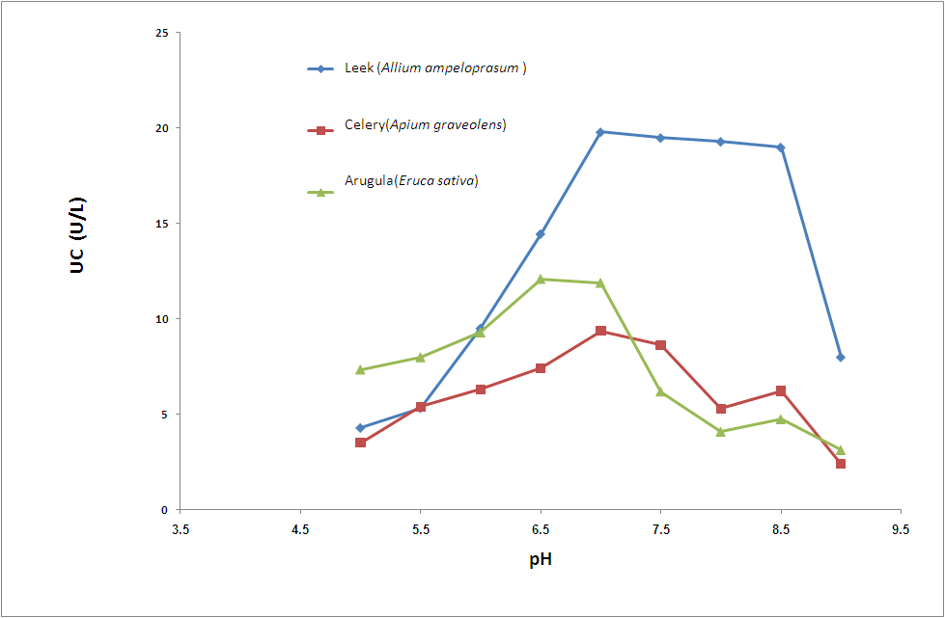
Figure 7: Effect of pH on UC activity using (0.2)mol/liter borate buffer and (100 µg/ml) as a source for the enzyme.

3. Incubation time as a function of enzyme activity
To determine the incubation time of UC activity under assay conditions, a series of experiments were performed at different time intervals. The results indicated that maximum enzyme activity was obtained after 15 min (Figure 8).

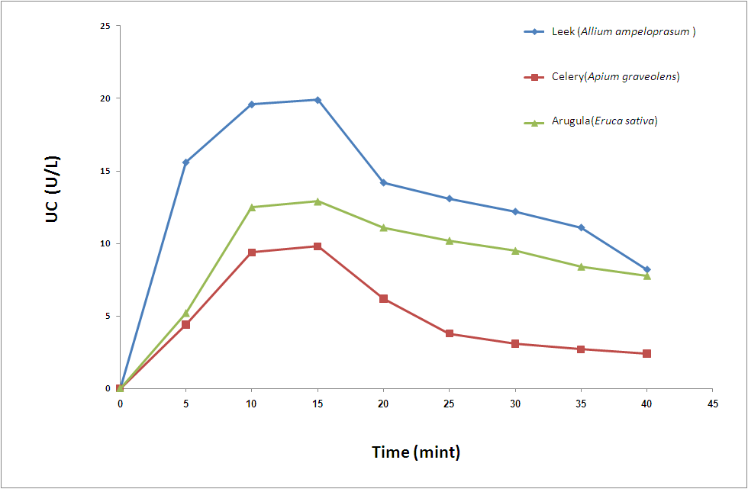

Figure 8: Effect of incubation time on UC activity.

4.Effect of temperature on uricase activity:
It has been found that as the temperature increased, there was a concave up increase in the enzyme activity until it reached a maximum value at a temperature of (40 °C) for leek (Allium ampeloprasum ) and celery (Apium graveolens) and (35 °C) for arugula (Eruca sativa) then dropped gradually after that (Figure 9). This increase is the result of the increased number of molecules having sufficient energy to pass over the energy barrier and form the products of the reaction. Further elevation of the temperature results in a decrease in reaction velocity as a result of temperature-induced denaturation of the enzyme ⁽⁹⁾. In other study, the optimum temperature was at 30ºC at pH 8.0 for UC isolated from Gliomastix gueg ⁽²⁹⁾ .

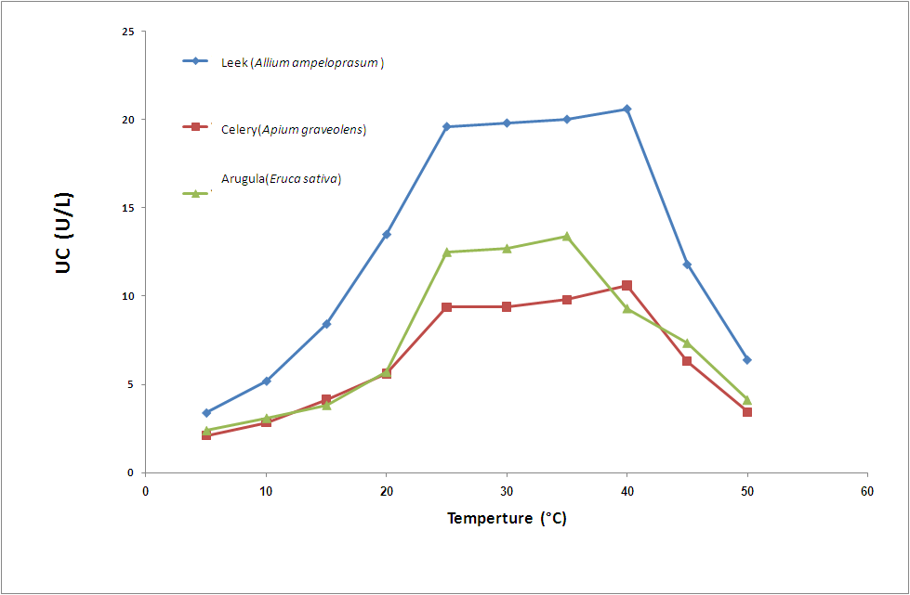
Figure 9: Effect of temperature (°C) on UC activity.

The recent study also reported that the maximum activity of purified UC produced by Gliomastix gueg was optimized at 35°C temperature at 9.0 pH⁽²⁹⁾, and the optimum temperature and pH for UC activity of Saccharopolyspora sp. PNR11 was 37°C and 8.5 ⁽³⁹⁾. In other research, the optimum temperature and pH was 30°C and 8.5 for purified UC produced by Microbacterium sp. strain ZZJ4-1 ⁽⁴⁰⁾.
5.Effect of substrate concentration on the enzyme activity:
The effect of substrate concentration (uric acid) on the enzyme activity was determined. Line Weaver-Burk was plotted by drawing the reciprocal of the initial velocity versus the reciprocal of the substrate concentration. A linear relationship were obtained Figures (10, 11, 12) the values of maximum velocity (V_{max}) and Michaelis constant (K_{m}) were (33.3 µmol/ min) and (83.3 mmol/l) for leek, (40 µmol/ min) and (285.7 mmol/l) for celery while (27 µmol/ min) and (166.6 mmol/l) respectively for arugula .
In others studies, the K_{m} value from leaves of chickpea (Cicer arietimum L.), broad bean (Vicia faba major L.), and wheat (Triticum aestivum L.) was equal to (9 – 24) μmol ⁽²⁾ and reached to 0.033922 mmol/ min for UC from gram negative bacteria⁽⁴²⁾, and from fungi A. flavus was reached to 8 μmol/min ⁽⁴²⁾ .

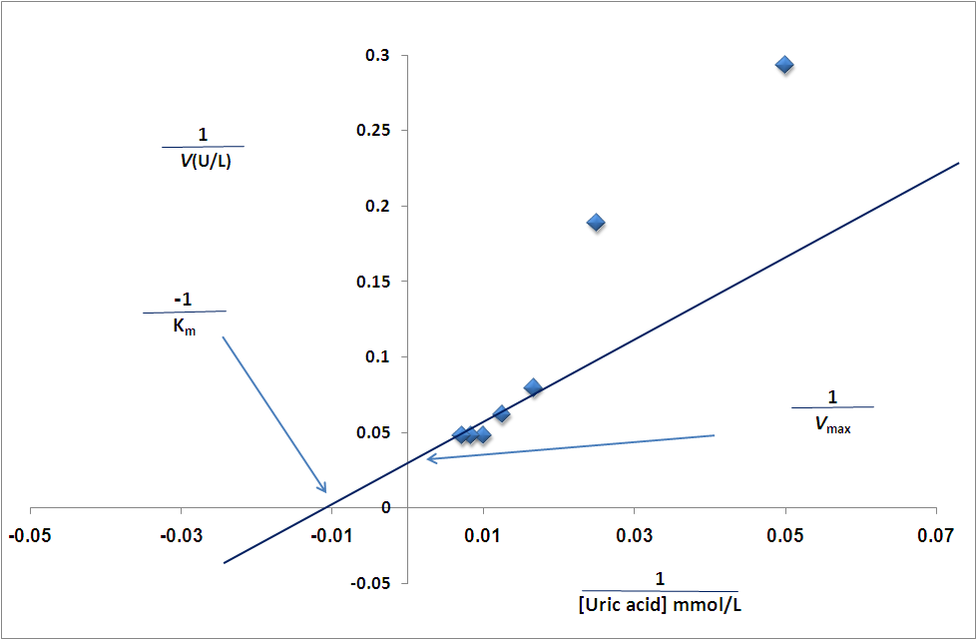
Figure 10: Line Weaver-Burk plot of partially purified UC from leek (Allium ampeloprasum ) .
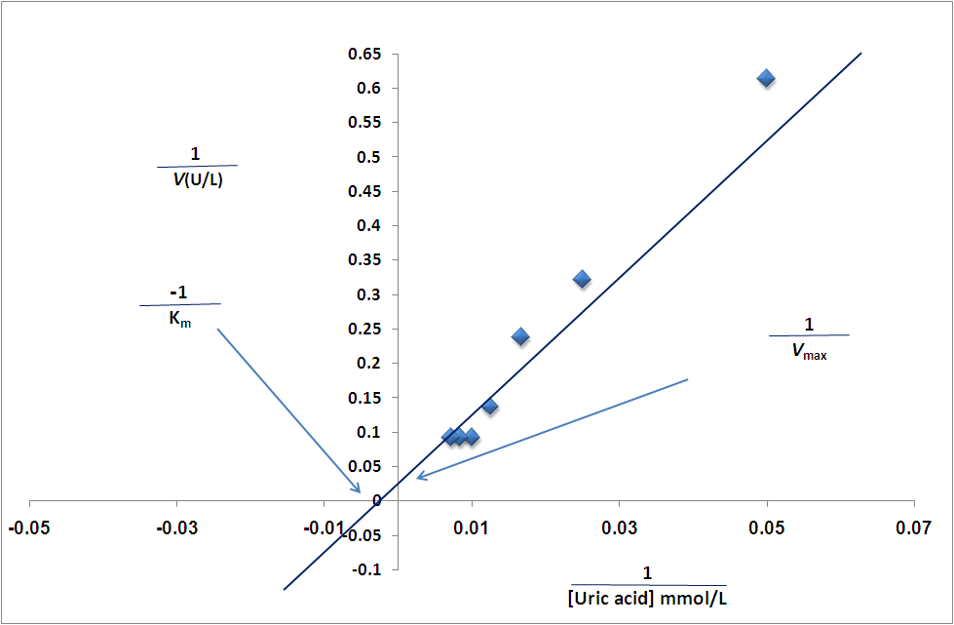
Figure 11: Line Weaver-Burk plot of partially purified UC from celery (Apium graveolens) .
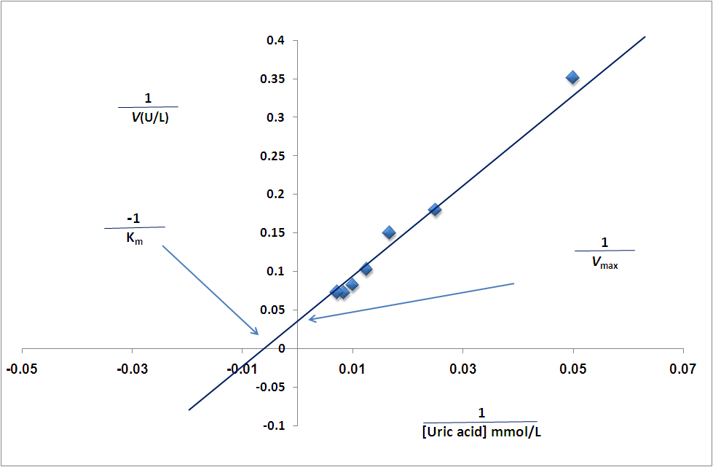
Figure 12: Line Weaver-Burk plot of partially purified UC from arugula (Eruca sativa).

6. Optimum conditions of the purified uricase :
The optimum conditions of the purified UC from seeds of leek (Allium ampeloprasum ), celery (Apium graveolens) and arugula (Eruca sativa) are shown in the following Table (5):

Table 5: Optimum conditions of the purified UC .
Type of vegetables seeds | Enzyme  Conc. (µg/ml) | pH | Time  (min) | Temp.  (°C ) | K_{m}  (mmol/liter) | V_{max}  (µmol/min)
Allium ampeloprasum | 100 | 7.0 | 15 | 40 | 83.3 | 33.3
Apium graveolens | 100 | 7.0 | 15 | 40 | 285.7 | 40
Eruca sativa | 100 | 6.5 | 15 | 35 | 166.6 | 27

7. The effect of some chemical compounds on the enzyme activity:
The results showed decreased activity of enzyme in the presence of (100 mM) for mercuric chloride(HgCl₂), ferrous chloride (FeCl₂) and ethylene diamine tetra acetic acid (EDTA) (Table 6), but increased activity of enzyme in calcium chloride (CaCl₂), manganese sulphate (MnSO₄), magnesium sulphate (MgSO₄) and potassium chloride (KCl) especially when calcium chloride was used (Table 6) .

The earlier study reported that metal ions such as Co²⁺, Mg²⁺ and Fe²⁺ reduce the enzyme activity and maximum increasing of
UC activity was indicated in the presence of Ca²⁺ ions ⁽²⁹⁾. The previous study also reported that the inhibition of UC activity was noticed with Co²⁺, Fe²⁺ and Zn²⁺ and enhanced with Cu²⁺ and Ca²⁺ ⁽²⁵⁾. While, the effect of metal ions on UC activity produced from Microbacterium sp. strain ZZJ4-1 showed that, Mn^{2+,} Fe³⁺, Zn²⁺ and Ca²⁺ had no inhibitory activity on UC enzyme ⁽⁴⁰⁾.

In other study, it was shown that among the metal ions, Li⁺, Ag⁺ , Hg⁺ and EDTA significantly inhibited the enzyme activity whereas Ca⁺² and Fe⁺² enhanced significantly UC activity isolated from Streptomyces exfoliates⁽³⁶⁾. While, the UC isolated from Pseudomonas aeruginosa showed the metal ions such as Co²⁺, Mn²⁺, Mg²⁺, Fe²⁺, Zn²⁺ and Cu²⁺ were reduced the enzyme activity to 33.17%, 92.18%, 72.47%, 32.73%, 64.32% and 90.10%, whereas Ca²⁺ enhanced UC activity to 126% ⁽⁴³⁾.

Some uricases require certain metal ions or cofactors that are strongly bonded and form part of the uricase structure. These ions are very important for maintaining maximum catalytic activity⁽⁴⁴⁾ . Li⁺, Ag⁺ , and Hg⁺ ions and the chelating reagent (20 mM EDTA) greatly inhibited the enzyme activity. In some cases, uricase can exist as a tetramer of identical subunits, each containing 2 copper-binding sites ⁽⁴⁴⁾.

Table 6 : Effect of chemical compounds on UC activity.
Arugula (Eruca sativa) |  | Celery (Apium graveolens) |  | Leek (Allium ampeloprasum ) |  | Chemical compounds  (100 mM)
***% Inhibition or Activation | Uricase activity (U/L) | **% Inhibition or Activation | Uricase activity (U/L) | *% Inhibition or Activation | Uricase activity (U/L) | Chemical compounds  (100 mM)
-27.46 | 10.01 | -32.56 | 7.35 | -22.44 | 16.21 | EDTA
-34.92 | 8.98 | -57.52 | 4.63 | -51.53 | 10.13 | Mercuric chloride(HgCl₂)
-36.66 | 8.74 | -27.15 | 7.94 | -23.30 | 16.03 | Ferrous chloride (FeCl₂)
+15.29 | 15.91 | +20.18 | 13.1 | +11.0 | 23.2 | Manganese sulphate (MnSO₄)
+47.24 | 20.32 | +73.85 | 18.95 | +38.32 | 28.91 | Calcium chloride (CaCl₂)
+9.06 | 15.05 | +66.05 | 18.1 | +19.13 | 24.9 | Magnesium sulphate (MgSO₄)
+22.61 | 16.92 | +46.14 | 15.93 | +4.9 | 21.4 | Potassium chloride (KCl)
* The value of uricase activity for Leek (Allium ampeloprasum ) from optimum condition of enzyme (20.9 U/l).
** The value of uricase activity for Celery (Apium graveolens) from optimum condition of enzyme (10.9 U/l).
*** The value of uricase activity for Arugula (Eruca sativa) from optimum condition of enzyme (13.8 U/l).

153

References
1. Wallrath,L .L. and Friedman, T.B. (1991). Species differences in the temporal pattern of Drosophila urate oxidase gene expression are attributed to trans-acting regulatory changes. Proc. Natl Acad. Sci. USA 88,54 89–5493.
2- Montalbini , P., Redondo, J., Caballero, J. L., Cárdenas, J., Pineda, M. (1997). Uricase from leaves: its purification and characterization from three different higher plants. Kerbala J. Pharm. Sci. 202: 277-283 .
3- Yuichi,H. , Tetsuhiko, S., Hajime,I. (2000) Cloning,se quence analysis and expression in Escherichia coli of the gene encoding a uricase from the yeast-like symbiont of the brown planthopper, Nilaparvata lugens. Insect Biochem. Mol. Biol. 30,173 –182.
4- Yamamoto, K., Kojima,Y., Kikuchi, T., Shigyo,T .,Sugihara, K., Takashio, M.(1996) Nucleotide sequence of the uricase gene from Bacillus sp. TB-90. J. Biochem. 119,80–84.
5- Merriman, T.R., Dalbeth, N.(2011). The genetic basis of hyperuricaemia and gout. Joint Bone Spine 7:35–40.
6- Oda, M., Satta, Y., Takenaka, O. (2002). Loss of urate oxidase activity in hominoids and its evolutionary implications. Mol. Biol. Evol.19:640–53.
7- Alderman, M.H., Cohen, H., Madhavan, S., Kivlighn, S. (1999). Serum uric acid and cardiovascular events in successfully treated hypertensive patients. Hypertens 34: 144-50.
8- Masseoud, D., Rott, K., Liu-Bryan, R., Agudelo, C. (2005). Overview of hyperuricaemia and gout. Curr. Pharm. Des. 11: 4117–4124.
9- Capasso, G., Jaeger, Ph., Robertson, W.G., Unwin, R.J. (2005). Uric acid and the kidney: urate transport, Stone disease and progressive renal failure. Curr. Pharm. Des. 11: 4153–4159.
10- Larsen, G., Loghman-Adham, M.(1996). Acute renal failure with hyperuricemia as initial presentation of leukemia in children. J. Pediatr. Hematol. Oncol. 18: 191–194.
11- Gochman, N., Schmitz, M.J. (1971). Automated determination of uric acid, with use of a uricase –peroxidase system. Clin. Chem 17: 1154–1159.
12- Colloch., H. M.E., Bachet, B. L., Hermite, G., Schiltz, M., Parange T. (1997). Crystal structure of the protein drug urate oxidase-inhibitor complex at 2.05 A resolution. Nat. Struct. Biol. 4: 947–952.
13- Arslan, F. (2008). An Amperometric biosensor for uric acid determination prepared from uricase immobilized in polyaniline-polypyrrole film. Sensors 8: 5492-5500.
14- Nakagawa, S., Oda, H., Anazawa, H.(1995). High cell density cultivation and high recombinant protein production of Eschericia coli strain expressing uricase. Bioscience Biotech. Bioch. 59: 2263–2267.
15- Garaya, R. P., El-Gewelyb, M. R., Labaunec, J., Richetted, P.(2012). Therapeutic perspectives on uricases for gout. Joint Bone Spine 79: 237–242.
16-Avicenna, B. (1998). Canon of Medicine. Book II, English Translation, Jamia Hamdard, Hamdard University, New Delhi, India, , pp. 382.
17- Oran, S. A., Al-Eisawi, D. M. (1998). Check list of medicinal plants in Jordan. Dirasat, Medic. Biolo. Sci. 25(2),84-112.
18- Chopra, R.N., Nayar, S.L., Chopra, I.C.(1956). Glossary of Indian medicinal plants. New Delhi: Council of Scientific and Industrial Research, 110 .
19- Yanir, Z., Schaffermann, D., Zmar, Z. (1998). Tradition, uses and biodiversity of rocket (Eruva sativa, Brassicaceae) in Israel. Econ. Bot. 52: 394-400.
20- Sarwar A. M., Kaur, G., Jabbar, Z., Javed, K., Athar, M.(2007). Eruca sativa seeds possess antioxidant activity and exert a protective effect on mercuric chloride induced renal toxicity. Food Chem. Toxicol. 45: 910-920 .
21- Adamek, V., Kralova, B., Suchova, M., Valentova, O., Demnerova, K. (1989). Purification of microbial uricase. J. Chromatography 497, 268-275.
22- Schacterle, G. R., Pollack, R. L. 1973. A simplified method for the quantitative assay of small amount of protein in biological material. Anal. Biochem. 51, 654-655.
23- Harvey, R. A., Ferrier, D. R. 2014. " Lippincott’s Illustrated Reviews: Biochemistry "5th ed. Lippincott Williams and Wilkins, China. P.20,71,61.
24- Robyt, F. J., White, J. B. 1987. "Biochemical Techniques Theory and Practice". Books / Cole Publishing Com., USA.
25- Saeed, M.H., Abdel-Fatah,Y., Gohar, M., Elbaz, A.M.(2004). Purification and characterization of extracellular Pseudomonas aeruginosa urate oxidase enzyme. Polish J. Microbiology. 53 (1), 45-52.
26- Neveen S. Geweely and Lubna S. Nawar.(2011). Production, optimization, purification and properties of uricase isolated from some fungal Flora in Saudi arabian soil. Australian J. Basic and App. Sci., 5(10): 220-230.
27- Lotfy, W. A. (2008). Production of thermostable uricase by a novel Bacillus thermocatenulatus strain. Bioresource Technology 99, 699-702.
28- Chohan, S., Becker, M. A. (2009). Update on emerging urate lowering therapies. Current Opinion in Rheumatology. 21 (2): 143–149.
29- Mabrouk., A., M., Hamed, E. R., Farag, M. M. (2010). Purification and characterization of uricase enzyme produced by Gliomastix gueg. www.Gate2Biotech.com 2 (11):1-13
30- Pfrimer, P., deMoraes, L. P., Galdino, A. S., Salles, L. (2010). Cloning, Purification, and partial characterization of Bacillus subtilis urate oxidase expressed in Escherichia coli . J. Biomed. Biotech. 674908: 6 .
31- Lucas, K., Boland, M.J., Schubert, K.R.(1983). Uricase from soybean root nodules: purification, properties, and comparison with the enzyme from cowpea. Arch. Biochem. Biophys. 226(1):190-7.
32- Koyama, Y., Ichikawa, T., Nakano E. (1996). Cloning, sequence analysis, and expression in Escherichia coli of the gene encoding the Candida utilis urate oxidase (uricase). J. Biochem. 120: 969–973.
33- Murray R. K., Bender D. A., Botham K. M., Kennelly P. J., Rodwell V. W. 2009. " Harper's Illustrated Biochemistry". 28 ed. The McGraw-Hill Companies, Chapter 8.
34- Zhou, X., Ma, X., Sun, G., Li, X. and Guo, K. (2005). Isolation of a thermostable uricase producing bacterium and study on its enzyme production conditions. Process Biochemistry 40, 3749-3753.
35- Geweely, S. N., Nawar, S.L. (2011): Production, optimization, purification and properties of uricase isolated from some fungal flora in Saudi arabian soil. Australian J. Basic Appl. Sci., 5(10): 220-230
36- Aly, M., Tork, S., Al-Garni, S., Allam, R.(2013). Production and characterization of uricase from Streptomyces exfoliates UR10 isolated from farm wastes. Turk. J. Biol. 37: 520-529.
37- Usama F. A., Zeinab, M. I. (2013). Effect of irradiation on uricase produced by two strains of Asperigillus niger. Life Sci. J. 10(1):962-967.
38- Rajoka, M. I., Rehman, K., Tabish, T., Zia, M. A. (2006). Thermal characterization of purified glucose oxidase from a newly isolated Aspergillus Niger UAF-1. J. microbiology and biotechnology 22: 288-291.
39- Khucharoenphaisan, K., Sinma, K. (2011). Production and partial characterization of uric acid degrading enzyme from new source Saccharopolyspora sp. PNR11. Pakistan J. Bio. Sci. 14: 226-231.
40- Lei Kai., X. M., Xue-Lai Z., Xiao-Ming J., Xia L., Kang Ping G.(2007). Purification and characterization of a thermostable uricase from Microbacterium sp. strain ZZJ4-1. World J. Microb. Biotech. 24 (3): 401-406.
41- Sarkar, G.P. (2010). Amperometric biosensor for uric acid estimation using microbial enzyme source. National Seminar On Frontiers In Nanomaterials and Biosensors (NSFNMB’10), Karaikudi, 4-5 March, 2010(AWARDED BEST PAPER).
42- Bomalaski, J. S., Holtsberg, F. W., Ensor, C. M., Clark, M. A. (2002). Uricase formulated with polyethylene glycol (uricase-PEG 20): biochemical rationale and preclinical studies. J. Rheumatol. 29(9): 1924- 1949 .
43- Anderson, A., Vijayakumar, S.(2011). Purification and optimization of uricase enzyme produced by Pseudomonas aeruginosa. J. Exp. Sci. 2(11): 05-08.
44- Wu, X.W., Lee, C.C., Muzny, D.M. (1989). Urate oxidase: primary structure and evolutionary implications. P. Natl. Acad. Sci. USA 86: 9412– 9416.

