The New C-2,C-3 Substituted Heterocyclic Derivatives of L-Ascorbic acid: Synthesis, Characterization, and Bacterial Activity

Muna Sameer Al-Rawi, Jumbad Hermiz Tomma and Dhuha Faruk Hussein
dr.m1967@yahoo.com Jumbadtomma@yahoo.com duhaF.Hussien@yahoo.com
Department of Chemistry , College of Education Ibn Al- HaithamUniversity of Baghdad.

(NJC)
(Received on 2/6/2014) (Accepted for publication 28/8/2014)

Abstract
New Schiff bases derivatives [IV]_{a-e} is prepared via condensation of D-erythroascorbic acid with p-substituted aldehydes in dry benzene. To obtain these derivatives, the 5,6-O-isopropylidene-L-ascorbic acid[I] was chosen as starting material, compound prepared from the reaction of L-ascorbic acid as starting material. Compound[I] was prepared from the reaction of L-ascorbic acid with dry acetone in the presence of hydrogen chloride. The esterification of hydroxyl groups at C-2 and C-3 positions with excess ofethyl α –chloroacetate in the presence of sodium acetate produce acorresebonding ester [II] , which was condensed with hydrazine hydrate to give new hydrazide [III] . The new Schiff bases [IV]_{a-e} were synthesized by reaction of acid hydrizide with different p-substituted benzaldehyde in dry benzene . The new 1,3-oxazepine derivatives [V]_{a-e}were obtained by Diels-Alder reaction of Schiff bases with phthalic anhydride in dry benzene (Scheme 1) . All the synthesized compounds have been characterized by melting points , FTIR and ¹HMNR (of some of theme) spectroscopy. The biological activity of synthesized compounds was examined against two types of bacteria; G(+) and G(-).
Key words : L- ascorbic acid, Hydrazied, Schiff bases, 1,3-Oxazepine.

الخلاصة
حضرت قواعد شف جديدة من تكاثف D-ارثرو حامض اسكوربيك مع الديهايداتاروماتية معوضة في موقع بارا . تم اختيار 5, 6- O –ايزوبروبلدين-L- اسكوربيك اسد [I] كمادة اولية, والذي تم تحضيره من تفاعل L- اسكوربيك اسد كمادة اولية مع الاسيتون الجاف في وجود كلوريد الهيدروجين. تم تحويل مجاميع الهيدروكسيل في C-2 و C-3بتفاعلها مع اثيل كلورواسيتات بوجود خلات الصوديوم ليعطي الاستر الجديد [II] , والذي تم تكثيفه مع الهايدرازين المائي ليعطي مركب الهايدرازايد[III]. قواعد شف الجديدة [IV]_{a-e} حضرت من تفاعل مركبات الهايدرازايد مع بنزالديهايدات المعوضة في موقع بارا في البنزين الجاف . اما مشتقات 1, 3 – اوكسازبين الجديدة [V]_{a-e} تم الحصول عليها من تفاعل الاضافة لقواعد شف مع انهيدريد الفثالك في البنزين الجاف مع التصعيد العكسي (الشكل 1) . شخصت المركبات المحضرة بقياس درجات انصهارها وبواسطة طيف FTIRوطيف¹HNMR للبعض منها درست الفعالية البايولوجية للمركبات المحضرة ضد نوعين من البكتريا واظهرت النتائج فعالية بايولوجية تراوحت بين العالية والمتوسطة والواطئة ضد نوعين من البكتريا Staphylococcus (G+) ,Echerichia coli (G-) الكلمات المفتاحية: حامض الاسكوربيك , قواعد شف, الهايدرازايد, 1, 3- اوكسازبين .

Introduction
L-ascorbic acid is one of the natural antioxidant present in biological system because of its activity to attack the free radicals and other reactive oxygen species, as the literatures point to the great role which ascorbic acid plays to prevent a number of diseases and its importance in food industry ^{[1,2]}.
Hydrazides derivatives have growing importance because of the wide spectrum of their biological applications like antibacterial, antitumoral, anti-inflammatory, antifungal and antitubercular agents^{[3,4]} .
Hydrazones possessing an azomethine –NHN=CH- proton constitute
an important class of compound for new drug development^{[5,6]}, and the imine group played a good intermediate in the organic synthesis of many heterocyclic compounds, as in1, 3-Oxazepine derivativesis^{[7]}.
1, 3-Oxazepine non-homologuos seven member rings, that contains oxygen at position 1 and nitrogen at position 3. Oxazepine is used in the medical field and has been much chemically and biologically studied. Many workers synthesized and studied the oxozepine derivatives mentioned as in the literates^{[8,9]}.

Scheme(1)

Experimental
MATERIALS : All the chemicals were supplied from Merck , GCC and Aldrich Chemicals Co. and used as received .
Techniques : FTIR spectra were recorded using potassium bromide discs on a Shimadzo (Ir prestige-21) FTIR spectrophotometer .¹HNMR spectra were carried out by company : Bruker , model: ultra shield 300 MHz , origin : Switzerland and are reported in ppm(δ), DMSO was used as a solvent with TMS as an internal standard . Measurements were made at chemistry department, Al-albyat university , Uncorrected melting points were determined by using Hot-Stage, Gallen Kamp melting point apparatus.
SYNTHESIS METHODS
Preparation of 5,6-O-isopropylidene-L-ascorbic acid[I]:
This compound was prepared from the reaction of L-ascorbic acid with dry acetone in a acidic media , following Salomonmethode ^{[10]}.
Synthesis of 2,3-O-diethylacetate -5,6 –O-isopropylidene-L-ascorbic acid[II]:
A mixture of compound [I] (0.01mole), ethylchloroacetate (0.02mole) and sodium acetate (0.06mole) in (10mL) ethanol was heated under reflux for 4hrs , then cooled and poured into water. The resulting of a white crystals solid was filtered off, washed with water, dried and recrystallized by ethanol to give compound [II]. m.p (60-62)⁰C, yield 87%.

Preparation of 2,3-O-dihydrazide methylene-5,6-O-isopropylidene-L-ascorbic acid[III]:
Compound [II] (0.01mol) was dissolved in minimum amount of ethanol. hydrazine hydrate(0.002 mol) was added slowly and the mixture was heated under reflux for 6hrs. Then the mixture was cooled and the glow yellow solid was filtered, and recrystallized from petroleumether. m.p(220-222)⁰C, yield 78%.
Synthesis of Schiff bases [IV]_{a-e}
A mixture of new hydrazide compounds [III] (0.01 mol) , p-substituted benzaldehyde (0.02 mol) , dry benzene (15 mL) was refluxed for 6hrs . The solvent was evaporated under vaccum and the residue crystallized from chloroform. The physical data of all Schiff bases are listed in Table (1).
Synthesis of1,3-oxazepine [V]_{a-e}
A mixture of equimolar amounts (0.01mol) of Schiff bases [IV]_{a-e} and phthalicanhydriedein dry benzene as a solvent was refluxed for 8 hrs , the solvent was removed and the resulting colored crystalline solid recrystallized from petroleum ether to obtained 1,3-oxazipenes [IV]_{a-e.}The physical properties of all synthesized 1,3-oxazepines are listed in Table (1) .

Results and Discussion
The first step employs the protection of the hydroxyl groups at C-5 and C-6 positions in L- ascorbic acid with acetal leading to formation compound 5,6-O-isopropylidene-L-ascorbic acid [I] using dry acetone in acidic media, following Salomon^{[10]} method. The FTIR spectrum showed a broad stretching band in the region (3240-3074) cm⁻¹ for O-H vinylic, stretching bands between (2993-2890) cm⁻¹ for C-H aliphatic, a stretching band at 1751 cm⁻¹ due to C=O of Lactone ring, a stretching band at 1663 cm⁻¹ for C=C and stretching bands at (1141) cm⁻¹ for C-O stretching .
This is followed by reaction of the hydroxyl groups at C-2 and C-3 positions with two mole of ethyl chloro acetate in basic media. The FTIR spectrum for compound [II] has confirmed the formation of compound [II] by disappearance the bands for (O-H) of compound [I] and exhibited appearance of a stretching band at (1707) cm⁻¹ for (C=O) of the ester group. Stretching bands are between( 2924-2834)cm⁻¹ for C-H aliphatic group.
Condensation of one mole of compound [II] with two mole of hydrazine hydrate give a new hydrazide [III] ,which is characterized by its melting point, FTIR spectrum, which showed the following absorption bands: C=O of amide group at (1677) cm⁻¹, bands in the regions (3450, 3200, 3194) cm⁻¹ due to asymmetric and symmetric stretching vibration of NH , NH₂ groups. Also the spectrum showed band at (2987-2853) cm⁻¹ assignable to thestretching of aliphatic (C-H).The ¹HNMR spectrum (in DMSO) showed a sharp singlet signal at δ 1.38 ppm for protons of CH₂ groups , a doublet signal at δ 2.28ppmfor NH-NH₂ protons,singlet signal at δ 3.10ppm for three protons of CH₃acetal groups and asingle at 3.79 ppm for NH group^{[11]}.
New Schiff bases [IV]_{a-e} are prepared via condensation of hydrazide compound [III] and p- substituted benzaldehyde in dry benzene. These Schiff bases [IV]_{a-e} are characterized by their melting, FTIR and ¹HNMR Spectroscopy . FTIR absorption-spectra showedthe disappearance of absorption bands due to NH₂ and C=O groups of the starting materials together with appearance of new absorption stretching band for imine C=N group.
The other data of functional groups which are characteristics of these compounds are given in Table 2.
The ¹HNMR spectrum (in DMSO), Figure (1) of compounds [IV]_{c} showed a sharp signal at δ 2.60 ppm for protons of methylene groups and a signal at δ 3.15ppm which could be for three protons of CH₃acetal groups, doublet of doublets at δ( 6.57-7.41) ppm could be attribiuted to eight aromatic protons. Furthermore, a sharp signal for N-H proton was absorbed at δ 8.28 ppm .
The 1,3-oxazepine derivatives [V]a-e were obtained by Diels-Alder reaction of Schiff bases[IV]a-e with phthalic anhydridesin dry benzene.The characteristic FTIR absorption bands of these compounds, was confirmed from the disappearance of band due to C=N of schiff base and other peaks characterized of cyclic anhydride of the starting materials together, with appearance of new bands for oxazepine ring. All the spectral data of FTIR spectroscopy of these compounds are listed in Table (2).The ¹HNMR spectrum of compound [V]_{e} (in DMSO), Figure (2) , showed a singlet signal of N-CH proton absorbed at δ (8.51) ppm, the aromatic ring protons appear at the range (δ 6.90-8.16) ppm, a singlet signals at δ(3.61) ppm for CH₃acetal groups, finally, a singlet signal at δ (1.98) ppm that could be attributed to the proton of CH₂ groups.

Table 1: Physical properties of synthesized compounds [IV]a-e and [V]a-e
Comp. No. | Nomencalture | Structural Formula | Molecular Formula | M.P⁰C | Yield% | Color
[IV]_{a} | 2,3-O-bis[ (4`-hydroxy phenyl ) semicarbazone methylene]- 5,6-O-isopropylidene-L-ascorbic acid |  | C₂₆H₂₈N₄O₁₀ | 198-200 | 78 | Yellow
[IV]_{b} | 2,3-O-bis[(4`-nitro phenyl semicarba -zone methylene]- 5,6-O-isopropylidene-L-ascorbic acid |  | C₂₆H₂₆N₆O₁₂ | 118-120 | 75 | Green- yellow
[IV]_{c} | 2,3-O-bis[(4`-chlorophenyl) semicarbazone methylene]- 5,6-O-isopropylidene-L-ascorbic acid |  | C₂₆H₂₆N₄O₈ Cl₂ | 106-108 | 72 | Dark  Yellw
[IV]_{d} | 2,3-O-bis[ (4`-methoxyphenyl ) semicarbazone methylene]- 5,6-O-isopropylidene-L-ascorbic acid |  | C₂₈H₃₂N₄O₁₀ | 164-166 | 55 | Orange
[IV]_{e} | 2,3-O-bis[ (4`-bromophenyl ) semicarbazone methylene]- 5,6-O-isopropylidene-L-ascorbic acid |  | C₂₆H₂₆N₄O₈Br₂ | 132-134 | 50 | Red-brown
[V]_{a} | 2,3-O-bis[ (4`-hydroxyphenyl) 2,3-dihydro benz [1,2e][1,3]oxazepine-4,7-diones-methyl ene]- 5,6-O-isopropylidene-L-ascorbic acid |  | C₄₂H₄₀N₄O₁₆ | 182-184 | 80 | Pale  Orange
[V]_{b} | 2,3-O-bis[ (4`-nitro phenyl) 2,3-dihydro benz [1,2e] [1,3] oxazepine-4,7-diones-methylene]- 5,6-O-isopropylidene-L-ascorbic acid |  | C₄₂H₃₈N₆O₁₈ | 124-126 | 82 | White
[V]_{c} | 2,3-O-bis[ (4`-chlorophenyl ) 2,3-dihydro benz [1,2e][1,3]oxazepine-4,7-diones-methyl ene]- 5,6-O-isopropylidene-L-ascorbic acid |  | C₄₂H₃₈N₄O₁₄ Cl₂ | 176-178 | 75 | Brown
[V]_{d} | 2,3-O-bis[ (4`-methoxy phenyl ) 2,3-dihydro benz [1,2e][1,3]oxazepine-4,7-diones-methyl ene]- 5,6-O-isopropylidene-L-ascorbic acid |  | C₄₄H₄₄N₄O₁₆ | 168-170 | 70 | Pale  Brown
[V]_{e} | 2,3-O-bis[ (4`-bromophenyl ) 2,3-dihydro benz [1,2e][1,3]oxazepine-4,7-diones-methyl ene]- 5,6-O-isopropylidene-L-ascorbic acid |  | C₄₂H₃₈N₄O₁₄ Br₂ | 140-142 | 50 | Brown

Table 2: Characteristic FTIR absorption bands of synthesized compounds
Other | CO-NH | νC=C  arom. | νC=N | νC-H  arom. | νC-H  aliph. | Comp. No.
4-OH:3450 | 1681 | 1558 | 1639 | 2960 | 2800 | [IV]_{a}
4-NO₂:1385-1360 | 1678 | 1556 | 1616 | 2920 | 2839 | [IV]_{b}
4-Cl:800 | 1666 | 1558 | 1618 | 2940 | 2872 | [IV]_{c}
4-OCH₃:1259 | 1689 | 1577 | 1602 | 2985 | 2852 | [IV]_{d}
4-Br:750 | 1681 | 1589 | 1620 | 2922 | 2850 | [IV]_{e}
4-OH:3336 | 1687 | 1585 |  | 2990 | 2889 | [V]_{a}
4-NO₂:1384-1359 | 1681 | 1585 |  | 2924 | 2859 | [V]_{b}
4-Cl:760 | 1683 | 1593 |  | 2960 | 2850 | [V]_{c}
4-OCH₃:1282 | 1697 | 1585 |  | 3007 | 2820 | [V]_{d}
4-Br:750 | 1683 | 1585 |  | 2993 | 2812 | [V]_{e}

Table 3 : Antibacterial activity of the synthesized compounds [IV]_{a-e}-[V]_{a-e}
Comp. No. | E.Coli(G-) | Staphlococcusaurus(G+) | Comp. No. | E.Coli(G-) | Staphlococcusaurus(G+)
[IV]_{a} | - | + + | [V]_{a} | ++ | +++
[IV]_{b} | ++ | + | [V]_{b} | + | +++
[IV]_{c} | - | - | [V]_{c} | ++ | +++
[IV]_{d} | + + | ++ | [V]_{d} | ++ | ++
[IV]_{e} | + | + + | [V]_{e} | +++ | +++

Key to symbols: Highly active = + + +(mor than)15 mm.
Moderately active = + +(11-15) mm. and Slightly active = + (5-10) .

Biological Activity
The antibacterial activity of the synthesized compounds was performed according to the agar diffusion method^{[12]}. The synthesized compounds were tested against E.coli and Staph. aureus. Each compound was dissolved in DMSO to give concentration 1ppm. The plates were then incubated at 37ᵒC and examined after 24 hrs. The zone of inhibition formed were measured in millimeter and clarity as in Table 3. All the compounds exhibit the highest or low biological activity against both the organisms . Most of the 1,3-oxazepin compounds showed a high inhibition against gram(+) becteria that could be related to the heterocyclic ring. While the Schiff bases compounds showed low- moderiate activity against two types of the bacteria gram(+) and garm (-). Finally, the Schiff base [IV]_{e} did not show any biological activity towards bacteria gram(+) and garm(-) .

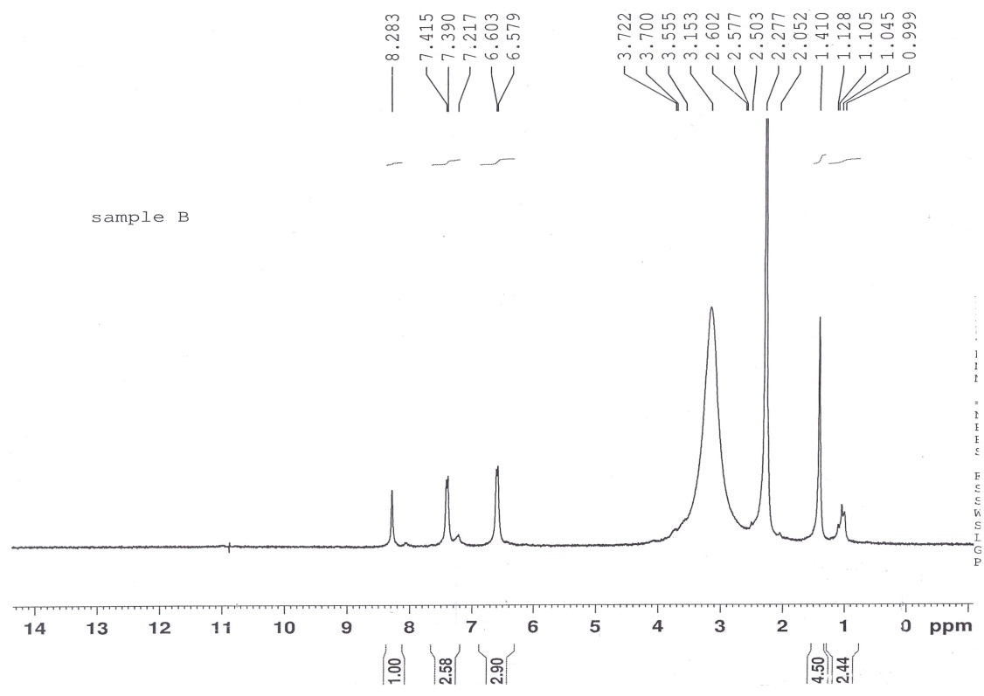

Figure (1)¹HNMR spectrum of compound [IV]_{c}
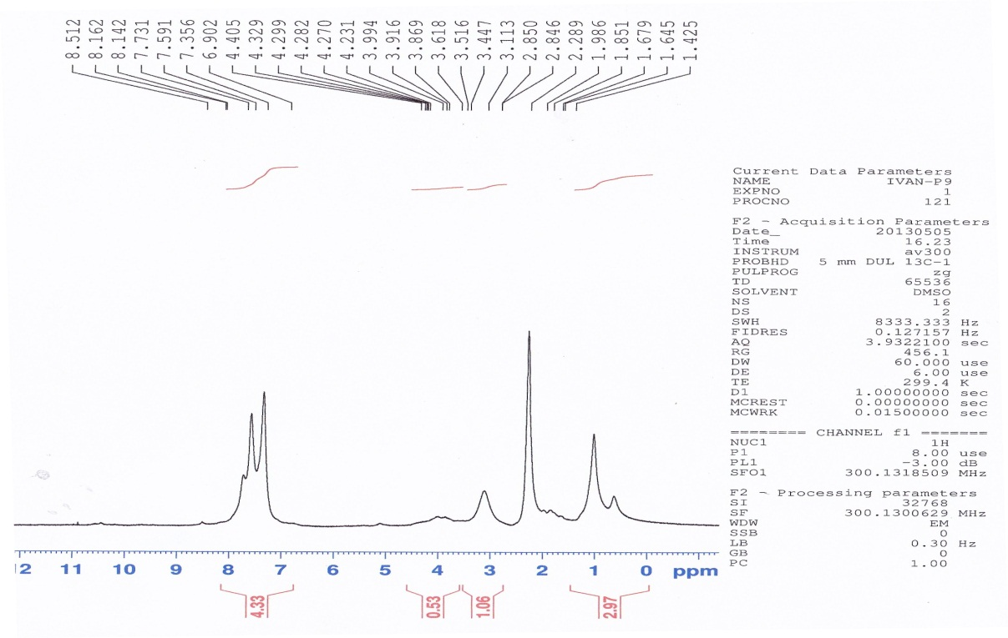

//

Figure (2)¹HNMR spectrum of compound [V]_{e}

References
1. Victoriano V. and Miguel A. Botella, Trends in plant science.; 2004,9, 12.
2. Robert D. Hancock, Recent Patents on Food, Nutrition & Agriculture, 2009, 1, 39-49.
3. Prasanna M.K., Pradeep K. K., ,Int J Pharm Biomed Sci, 2013, 4(1), 24-29.
4. Prasanna M.K. and Pradeep Kumar K., Int. J. Pharm Biomed Sci, 2013, 4(1), 24-29, ISSN No: 0976-5263.
5. Madhavan N., Lekshmy H. and Devakiamma T. J. Serb. Chem. Soc. 2011, 76 (2) , 221–233 (2011).
6.Sunilkumar K. Patil, Vinayak M. Naik and Nirmalkumar B. Mallur, Der PharmaChemica, 2012, 4(5): 1812-1818.
7.Michael H., Serrano-Wu, Denis R.,Yijun Ch.,Stella H.,Kin-Ray L.,James A.,Charles E.,Terry M.Thomas P., Henry S.BaluN., Bioorganic& Medicinal Chemistry Letters, 2002, 12 (19) : 2757–2760.
8. Khuluod F. H.*, Hamid H. E., International Journal of Chem.Tech Research , 2013, 5 (6) : 0974-4290 , 2924-2940.
9.Sevim B., Orhan B., Özlem B., Murat G., and Nimet K., ARKIVOC, 2009, (xiii), 185-192, ISSN No: 0976-5263.
10. L. Salomon, Experientia , 1963, 19(12) , 619.
11.F. A. Carey, “Organic Chemistry”, 6th Ed., the McGraw-Hill Companies, Inc., New York, 140(2006).
12. Muna S. Al-Rawi, Jumbad H. Tomma, Abdul-Jabber A. M., Ammar H. Al-Dujaili, American Journal of Organic Chemistry, 2013, 3(1): 1-8.

