Oxidation of Different Poly(thioethers)
Ali Jassim. Al-Zuhairi
E-mail: alijassim33@yahoo.com
Department of Chemistry, College of Science, Babylon University

(NJC)
(Received on 10/8 /2014) (Accepted for publication 28/8/2014)

Abstract
Several poly(alkylene sulfone)s have been synthesized in excellent yields from reactions of poly(alkylene sulfide)s with H₂O₂ at 25 °C for 24 h. The structure of the poly(alkylene sulfone)s obtained was confirmed by ¹H NMR, ¹³C NMR. Different properties have been studied such as melting point and molecular weight.
Keywords: polymeric sulfides; poly(thioethers); hydrogen peroxide; oxidation
الخلاصة
تم تحضير عدة انواع من بوليمرات البولي الكايلين سلفون بحصيلة عالية من خلال تفاعل انواع مختلفة من بولي الكايلين سلفايد مع بيروكسيد الهيدروجين بدرجة حرارة 25 مئوي وبوقت 24 ساعة . تم تشخيض البوليمرات المحضرة باستخدام طيف الرنين النووي المغناطيسي كما تم دراسة التغيير في بعض الصفات منها درجة الانصهار والوزن الجزيئي.
الكلمات المفتاحية: البولي سلفايد, البولي ثايو ايثر, بيروكسيد الهيدروجين, الاكسدة.

Introduction
Poly(alkylene sulfide)s are essential polymers and their applications have been reviewed recently ^{[1]}. They have excellent thermal stability, weatherability, solvent resistance and oil resistance^{[2-4]} and hence are widely used in coatings, adhesives, sealants, insulators and other applications^{[5-8]}. Also, poly(alkylene sulfide)s find application in vulcanizing rubbers^{[9]}. Moreover, the ionic conductivities of poly(alkylene sulfide)–AgNO₃ electrolytes are comparable to those of poly(ethylene oxide) or its alkali metal salts^{[10]}. Therefore, the syntheses of such polymers are always of interest.
Poly(alkylene sulfide)s are usually prepared by one of four major methods: polymerization of episulfides; reactions of dithiols with carbonyl compounds; addition of dithiols to diolefins; and reactions of dithiols with dihalides.
Recently we have been able to produce a range of polymers simply from reactions of dihaloalkanes with cheap sodium sulfide nonahydrate by use of reflux conditions in the absence of a catalyst or additional solvent. The process has been applied to dihaloalkanes with spacer lengths from 2 to 10 carbons and generally gives excellent yields^{[11]}.
Oxidation of poly(alkyl sulfides) is a method for obtaining poly(alkyl sulfones) with the general structure [-(CH₂)_{n}-SO₂-]_{m}. Although poly(ethylene sulfone) is obtained by polymerization of ethylene and sulfur dioxide,^{[12]} poly(alkylene sulfones) containing more than two carbon atoms between the sulfone groups are obtained by oxidation. Poly(ethylene sulfone) has been prepared by selective oxidation of poly (ethylene sulfide).using HNO₃/CH₃SO₃H system at 0 °C for 24 h^{[13]} . The resulting poly(ethylene sulfone) was soluble in 60% HNO₃, methanesulfonic acid, and trifloromethane sulfonic acid, though poly(ethylene sulfide) was insoluble in any solvent at room temperature^{[14]}. Poly(ethylene sulfide) is not of great industrial value as a material due to its insolubility^{[15]}. The physical properties of these polymers show important variations as the number of methylene groups increases. Poly(alkylene sulfide)s with different spacer group length (n= 3-10) had a limited range of solubility(11). The limitation in solubility would highly decrease the industrial applications of these polymers.
Taking these observation in our considerations, we report the results obtained on the oxidation of various poly(alkylene sulfide)s with two different purposes: a) The investigation of the solubility of the oxidized polymers. b) The study of the properties of the poly sulfones that are obtained. These properties are related to the molecular weight and melting point.
Results and Discussion
Various α,ω-dibromoalkanes having different spacer group chain lengths from 2 to 10 carbons were used (Scheme 1)11. The molar ratio of Na₂S.9H₂O/dibromoalkane was kept at 1.5 but the reaction time was varied for each dibromoalkane in order to provide high yields of polymeric material. Table 1 gives the reaction times, yields, melting points, average molecular weights calculated by GPC and the average number of repeating units calculated from the ¹H NMR spectrum for poly(alkylene sulfide)s 1–9. No NMR spectroscopy or GPC analysis was carried out for 1 since that material was highly insoluble in organic solvents.

Scheme 1. Synthesis of poly(alkylene sulfide)s 1–9 from polycondensation of dibromoalkanes with Na₂S.9H₂O.

Table 1. Synthesis of various poly(alkylene sulfide)s 1–9 from reactions of dibromoalkanes and sodium sulfide nonahydrate according to Scheme 1.ª

polymer | n | Time (h) | M.P. (°C) | Yield (%)^{b} | Mn^{c} | Approximate number of repeating units (y)^{d}
1e | 2 | 1 | 185–186 | 100 | not known | not known
2 | 3 | 4 | 55–57 | 100 | 4546 | 24
3 | 4 | 6 | 65–68 | 15 | 5939 | 43
4 | 5 | 4 | 70–75 | 94 | 3921 | 33
5 | 6 | 4 | 70–77 | 100 | 4068 | 33
6 | 7 | 5 | 78–85 | 90 | 4308 | 33
7 | 8 | 5 | 58–64 | 97 | 1201 | 3
8 | 9 | 5 | 70–76 | 92 | 2082 | 5
9 | 10 | 5 | 70–78 | 95 | 1700 | 5

Notes: ª A mixture of dibromoalkane (0.10 mmol) and Na₂S.9H₂O (36.0 g, 0.15 mmol) was heated under reflux in an oil bath set at 140–160°C for the indicated reaction time.
^{b} Yield based on an assumed empirical formula for the product of (CH₂)_{n}S.
^{c} The average molecular weight calculated by GPC.
^{d} Calculated from the ¹H NMR spectrum by comparison of the integrations of the CH₂Br and CH₂S signals.
^{e} The polymeric material was highly insoluble in solvents.

Different poly(alkylene sulfone)s were obtained from different poly(alkylene sulfide)s 1–9 by oxidation in solution. Fifty milliliters of chloroform were used as solvent for 0.2 g of the corresponding polymer and 0.1 ml of H₂O₂ were added with vigorous stirring at 25 ^{ᵒ}C. After 24 h the precipitated polymer was recovered by filtration, washed with ethanol, and dried under vacuum (Scheme 2).

Scheme 2. Synthesis of poly(alkylene sulfone)s 1–9 from poly(alkyene sulfide)s and H₂O₂.

Table 2 gives the reaction times, yields, melting points, average molecular weights calculated by GPC and the average number of repeating units calculated from the ¹H NMR spectrum for poly(alkylene sulfone)s 1–9.

Table 2. Synthesis of various poly(alkylene sulfone)s 1–9 from poly(alkyene sulfide)s and H₂O₂. according to Scheme 2.ª

polymer | n | M.P. (°C) | Yield (%)^{b} | Mn^{c} | Approximate number of repeating units (y)^{d}
1 | 2 | 255–258 | 97 | 9000 | 75
2 | 3 | 85–88 | 92 | 5326 | 24
3 | 4 | 94–97 | 90 | 6342 | 43
4 | 5 | 102–105 | 85 | 4424 | 33
5 | 6 | 110–115 | 91 | 4562 | 33
6 | 7 | 118–119 | 90 | 4838 | 33
7 | 8 | 85–89 | 90 | 1651 | 20
8 | 9 | 113–116 | 96 | 2942 | 5
9 | 10 | 120–124 | 92 | 1700 | 5

Notes: ª A mixture of Polymeric sulfide (0.2 g) and H₂O₂ (6.5M, 50ml) was stirred for 24 h.
^{b} Yield based on an assumed empirical formula for the product of (CH₂)_{n}SO₂.
^{c} The average molecular weight calculated by GPC.
^{d} Calculated from the ¹H NMR spectrum by comparison of the integrations of the CH₂Br and CH₂SO₂ signals.

The average of molecular weights calculated by GPC were usually higher than those calculated based on the number of repeating units calculated from the ratio of end groups CH₂Br to internal CH₂SO₂ units in the ¹H NMR spectra (figures 1-9). In some cases this may be because of a disordered interfacial structure giving by non ordering conformation of 15-20% of the chain units. Another factor may be because polystyrene was used as the GPC standard rather than a polymeric sulfide. However, the trends in molecular weights derived from GPC analysis were consistent with the trends in the number of repeating units calculated based on ¹H NMR spectra. From table 2 we can note some increases in the Mn of the polysulfons compared to the Mn of the polysulfides (table 1). The increase in the Mn units might be due to the increase in the solubility of the polysulfons in chloroform (the solvent been used in GPC analysis).
Moreover, from table 2 we can see significant increase in the melting temperature of the prepared polysulfons compared to the melting point of the polysulfides (table 1). There is no direct explanation for this fact and the only reasonable statement on this point is that some SO₂ groups are included in the crystals. In other words, when oxidation increases, not only the interface is changed but also the crystal surfaces are oxidized although the internal regions are less available.
Experimental
-General
Melting point determinations were performed by the open capillary method using a Gallenkamp melting point apparatus and are reported uncorrected. ¹H and ¹³C NMR spectra were recorded on a Bruker AV500 spectrometer operating at 500 MHz for ¹H and 125 MHz for ¹³C measurements. Chemical shifts are reported relative to TMS and coupling constants J are in Hz and have been rounded to the nearest whole number. Assignments of signals are based on coupling patterns and expected chemical shift values and have not been rigorously confirmed. Signals with similar characteristics might be interchanged. Gel permeation chromatography (GPC) was carried out at using a GPC MAX variable loop equipped with two KF-805L SHODEX columns in CHCl₃, with a RI (VE3580) detector using a GPC MAX pump operating at flow rate of 1 ml/min. Calibration was achieved using a series of Viscotek polystyrene standards up to Mw = 9.4 x 10⁵. Chemicals were obtained from Aldrich Chemical Company and used without further purification.
-Typical experimental procedure for the synthesis of polymeric sulfides 1-9
Dibromoalkane (0.10 mol) and sodium sulfide nonahydrate (36.0 g, 0.15 mol) were placed in a 1 liter round bottom flask that contained a magnetic bar. The flask was equipped with a water condenser and placed in an oil bath set at 140–160°C. The mixture was heated under reflux for 1–6 h with vigorous stirring, until viscous material resulted. Water (ca. 30 ml) was added to the hot reaction mixture, which was then poured into a clean beaker and vigorously stirred before being left to cool to room temperature. The solid mass was then collected by filtration, washed thoroughly with water (3 x 10 ml) and dried at 50°C under reduced pressure to give a white powdery solid. The physical properties of 1–9 are represented in Tables 1.
-Typical experimental procedure for the synthesis of poly(alky sulfone)s 1-9
Polymeric sulfide (0.2 g) and H₂O₂ (6.5M, 50ml) were placed in a round bottom flask that contained a magnetic bar. The mixture was stirred for 24 h and, after the reaction was allowed to sit at room temperature before the product was isolated. The solid was separated by filtration, repeatedly washed with ethanol, and dried in vacuum oven. The physical properties and NMR spectroscopic data of 1–9 are represented in Tables 2 , 3 and Figures 1-9 respectively.

Table 3. NMR spectra for poly(alkyl sulfon)s 1-9.

Polymer ¹H NMR (δ, ppm; CDCl₃)
1 | 4.15 (t, J = 7 Hz, 4 H, CH₂SO₂), 3.35 (t, J = 7 Hz, 0.05 H, CH₂Br)
2 | 1.70 (m, 2 H, CH₂CH₂SO₂), 4.15 (t, J = 7 Hz, 4 H, CH₂SO₂), 3.35 (t, J = 7 Hz, 0.166 H, CH₂Br)
3 | 1.70 (m, 4 H, CH₂CH₂SO₂), 4.15 (t, J = 7 Hz, 4 H, CH₂SO₂), 3.35 (t, J = 7 Hz, 0.093 H, CH₂Br)
4 | 1.40 (m, 2 H, CH₂CH₂CH₂SO₂), 1.50 (m, 4 H, CH₂CH₂SO₂), 4.15 (t, J = 7 Hz, 4 H, CH₂SO₂), 3.35 (t, J = 7 Hz, 0.12 H, CH₂Br)
5 | 1.35 (m, 4 H, CH₂CH₂CH₂SO₂), 1.50 (m, 4 H, CH₂CH₂SO₂), 4.15 (t, J = 7 Hz, 4 H, CH₂SO₂), 3.35 (t, J = 7 Hz, 0.12 H, CH₂Br)
6 | 1.20-1.35 (m, 6 H, CH₂CH₂CH₂CH₂SO₂ and CH₂CH₂CH₂SO₂), 1.50 (m, 4 H, CH₂CH₂SO₂), 4.15 (t, J = 7 Hz, 4 H, CH₂SO₂), 3.45 (t, J = 7 Hz, 0.12 H, CH₂Br)
7 | 1.27-1.45 (m, 8 H, CH₂CH₂CH₂CH₂SO₂), 1.50 (m, 4 H, CH₂CH₂CH₂SO₂), 2.45 (t, J = 7 Hz, 4 H, CH₂SO₂), 3.35 (t, J = 7 Hz, 0.20 H, CH₂Br)
8 | 1.16-1.40 (m, 10 H, CH₂CH₂CH₂CH₂CH₂SO₂ and CH₂CH₂CH₂CH₂SO₂), 1.50 (m, 4 H, CH₂CH₂SO₂), 4.15 (t, J = 7 Hz, 4 H, CH₂SO₂), 3.35 (t, J = 7 Hz, 0.8 H, CH₂Br)
9 | 1.17-1.25 (m, 8 H, CH₂CH₂CH₂CH₂CH₂SO₂), 1.27-1.40 (m, 4 H, CH₂CH₂CH₂SO₂), 1.50 (m, 4 H, CH₂CH₂SO₂), 4.15 (t, J = 7 Hz, 4 H, CH₂S O2), 3.35 (t, J = 7 Hz, 0.86 H, CH₂Br)
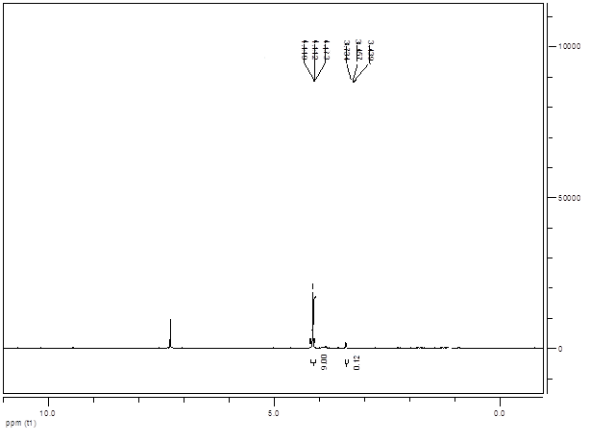
Figur 1: The ¹H NMR spectra of poly(alky sulfone) (n=2)

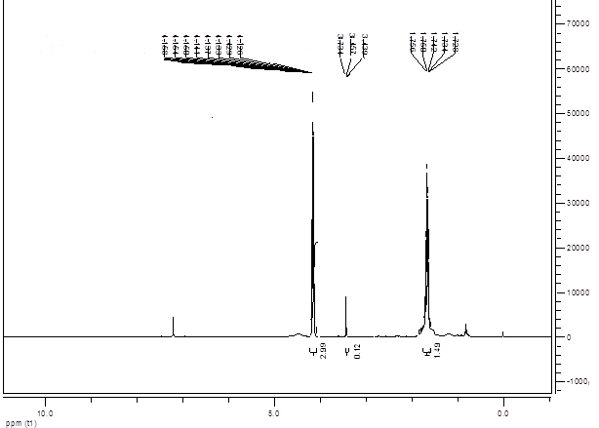
Figur 2: The ¹H NMR spectra of poly(alky sulfone) (n=3)
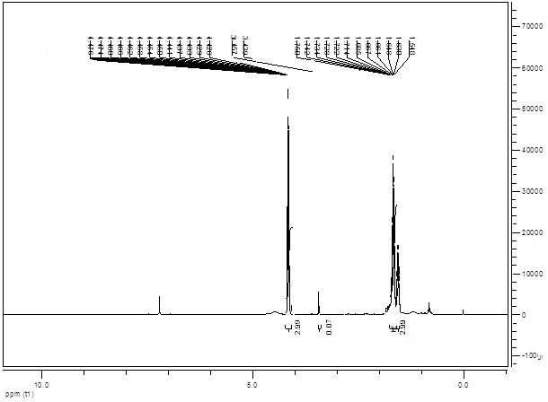
Figur 3: The ¹H NMR spectra of poly(alky sulfone) (n=4)

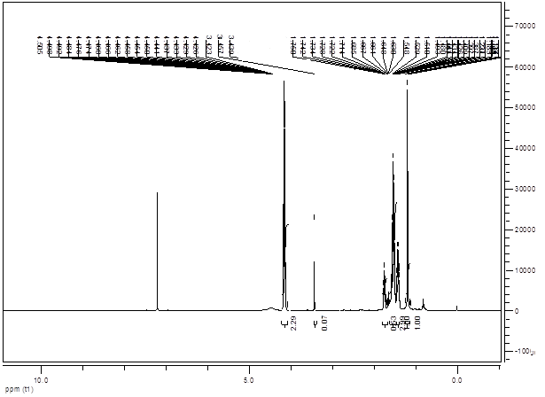
Figur 4: The ¹H NMR spectra of poly(alky sulfone) (n=5)
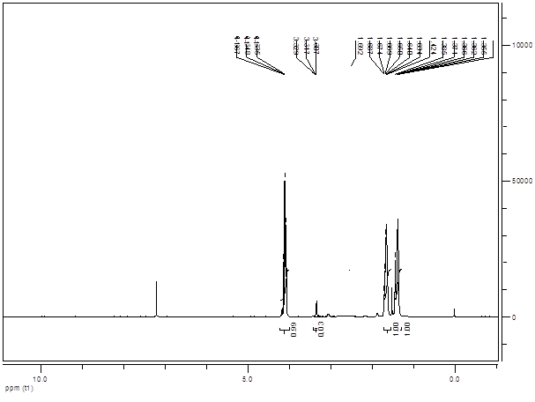
Figur 5: The ¹H NMR spectra of poly(alky sulfone) (n=6)

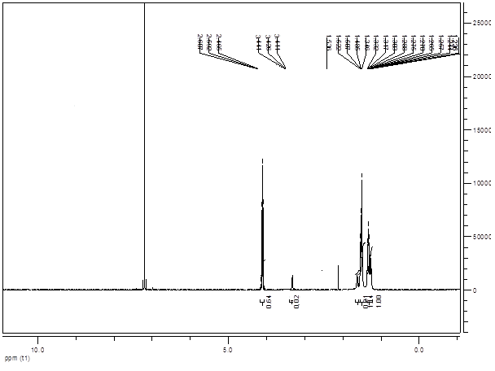
Figur 6: The ¹H NMR spectra of poly(alky sulfone) (n=7)
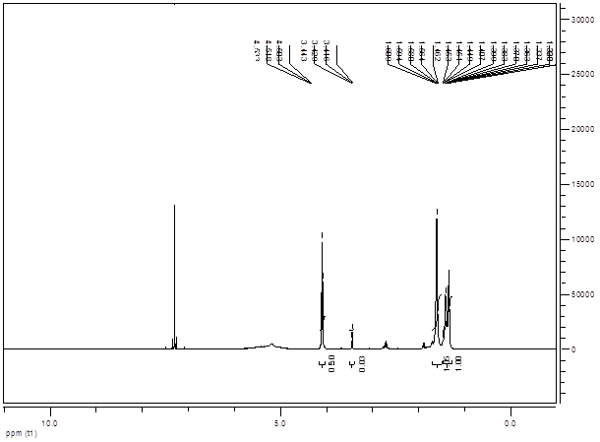
Figur 7: The ¹H NMR spectra of poly(alky sulfone) (n=8)

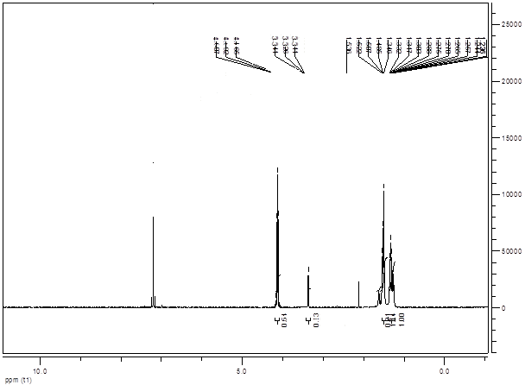
Figur 8: The ¹H NMR spectra of poly(alky sulfone) (n=9)
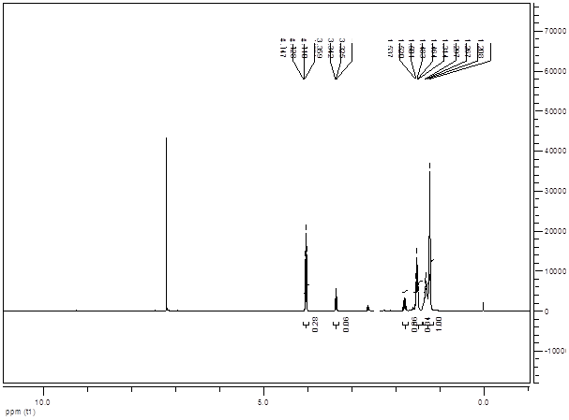
Figur 9: The ¹H NMR spectra of poly(alky sulfone) (n=10)

References
(1) C.D. Vo, G. Kilcher, N. Tirelli, Macromol. Rapid Commun., 2009, 30, 299–315.
(2) S. Ellerstein, In Handbook of Polymer, 3rd ed., Wiley-Interscience: New York, 1985.
(3) T.C.P. Lee, In Properties and Applications of Elastomeric Polysulfides; R. Dolbey, Ed.; Rapra Technology Ltd.: Shrewsbury, 1999; Vol. 9.
(4) A. Mahon, T.J. Kemp, R.J. Coates, Polym. Degrad. Stab., 1998, 62, 15–24.
(5) C. Lee, T.C Chang, Y.-H. Huang, US Patent, 5432257, 1995.
(6) A.V. Tobolsky, In The Chemistry of Sulfides, Wiley-Interscience: New York, 1968.
(7) C.A. Bahh, J.I. Baah, P. Gianadda, C. Fisher, Mater. Des, 2000, 21, 211–215.
(8) H. Lucke, ALIPS–Aliphatic Polysulfides, Hüthig and Wepf: Basel, 1994.
(9) E.M. Fettes, J.S Jorczak, J.R. Panek, Ind. Eng. Chem., 1954, 46, 1539–1541.
(10) S. Clancy, D.F. Shriver, L.A. Ochrymowycz, Macromolecules, 1986, 19, 606–611.
(11) K. Smith, G.H. El-Hiti, A. Al-Zuhairi, J. Sulfur Chem. 2011, 1-11.
(12) R. Hill, “Fibers from Synthetic Polymers”; Elsevier; New Yourk, 1953; p 312.
(13) T. Oyama K. Naka, Y. Chujo, Macromolecules, 1999, 32, 5240-5242.
(14) P. Sigwait, N. Spassky, “In Ring-Opening Polymerization” Elsevier; London and New York, 1984; Vol. 2, Chapter 9.
(15) A. Nicco, J. P. Machon, H. Fremaux, J. P. Pied, B. Zindy, M. Thiery Eur. Polym. J. 1970, 6, 1427.

