The Effect of Ortho and Para -Hydroxy cinnamic acid and Caffeic acid on Adventitious Root Formation of Mung bean Cuttings in Presence or Absence of Boron

Abdullah I. Shaheed,
Department of Biology, College of Science, University of Babylon.

Oda M. Yasser Marwa Saad Mohammed Kheider
Marwas48@yahoo.com
Department of Chemistry, College of Science, University of Babylon.

(NJC)

(Received on 7/1/2014) (Accepted for publication 13/4/2014)

Abstract
The effect of O- and P- Hydroxy cinnamic acid and Caffeic acid on rooting response of mung bean cuttings with respect to auxin (IAA) & boron has been studied . The effective concentration is 10⁻³M for all of the above tested compounds, whether cuttings were taken from 10 –day-old light grown seedlings in deionized H₂O or in boric acid (5µg\ml). The results were revealed that at this conc. the above compounds induce adventitious rooting by 267.7% ,219.1% , 202.9% over control respectively , in cuttings taken from seedlings grown in Deionized \H₂O; whereas, the percentage of induction was declined to 188.3%, 174.6%, 180.6% respectively in cuttings taken from seedlings grown in boric acid (5µg\ml). However, caffeic acid was significantly increase adventitious root formation in simultaneous application with IAA over control in presence or absence of boric acid compared to o- coumaric acid & p-coumaric acid, but the rooting response was declined in cuttings were taken from seedlings grown in boric acid compared to d\d H₂O ( 533.9% & 498%) respectively . The role of boron in combination with the above phenolic compounds individually was suggested to affects the decarboxylation of IAA that catalyzed by IAA-Oxidase.

Key words : Boron, Decarboxylation , IAA , IAA-Oxidase, mung bean cuttings , Phenolic compounds, Rooting Response.

الخلاصة
إن تأثير الأورثو – والبارا-هيدروكسي حامض السيناميك وكذلك حامض الكافيئيك في استجابة تجذير عقل ألماش وعلاقة ذلك بهرمون الأوكسين (IAA) وحامض البوريك قد درست . وكان التركيز المؤثر ايجابياْ لجميع المركبات اعلاه هو 10⁻³M , بغض النظر عن كون العقل مأخوذة من بادرات نامية في الماء أو حامض البوريك (5 مايكروغرام /مل ) . لقد بينت النتائج إن جميع المركبات اعلاه وعند هذا التركيز قد استحثت تكوين الجذور العرضية بنسبة ( 267.7 , 219.1 , 202.9) % على التوالي عن معاملة السيطرة في العقل النامية في الماء الخالي من الايونات , بينما انخفضت جميع النسب الى ( 188.3 , 174.6 , 180.6 ) % على التوالي في العقل المأخوذة من بادرات نامية في حامض البوريك . هذا ومن جانب آخر , فأن Caffeic acid قد زاد معنويأ من استجابة التجذير عندما يجهز في أن واحد مع IAA بوجود / غياب حامض البوريك مقارنة مع ortho و para حامض الكيوماريك . فضلا عن إن استجابة التجذير قد انخفضت بشكل عام في العقل المأخوذة من بادرات نامية في حامض البوريك مقارنة بالماء المقطر , حيث كانت القيم 533.9% و 498 % على التوالي . إن دور البورون ضمن توليفة مع المركبات الفينولية اعلاه بشكل منفرد قد تم اقتراحه من خلال تأثيره في عملية IAA- decarboxylation بمساعدة إنزيم IAA-oxidase .

Introduction
Rooting is a complex process, which is affected by multiple factors including phytohormones , phenolic compounds ,nutritional status and genetic characteristics¹. Adventitious root formation comprises, generally, two phases : first is the initiation phase , and second, is the growth and development phase . Jarvis (1986)² subdivided the initiation phase into three phases in Phaseolus aureus var. Berkin:-a) Induction phase: characterized by the accumulation of IAA in root initiation zone (hypocoltyl), and declining in the activity of IAA-Oxidase (Foong & Barnes, 1981)³. In addition to basipetal transport of carbohydrate & auxin protectors (O-diphenols) as a result of wounding (Stonier, 1971)⁴. b) Early initiation phase : In which cell division take place by the accumulative IAA that subsequently, leads to the formation of root primordia. c) Late initiation phase : characterized by reaching IAA-Oxidase it's peak of the activity, that caused diminishing of IAA level and consequently promoting the development of root primordial. Second, Growth & development phase , include the converstion of root primordia into visible roots.
The formation of root primordium cells depends on the endogenous auxins in the cutting and on a synergic compound such as a diphenol . It has been concluded by observations on different plant species that high concentration of free auxin are needed during the induction phase of adventitious rooting , whereas during later stages , high auxin levels obviously have an inhibitory action on differentiation and outgrowth of root primordia⁵. One well known IAA metabolic pathway consists of the oxidative decarboxylation of the side chain of IAA by IAA-Oxidase [E.C. 1.11.3.8] that oxidize IAA and supposedly destroy it's physiological activity ,leading to the formation of either indole-3-methanol or 3-methyleneoxindole^{6,7}.The effectiveness of phenolic compounds depends on number of OH-groups and on their position at the aromatic ring ⁸. It is noteworthy, that phenolic compounds may act in different ways during metabolism that occurs in cuttings. For example phenolic compounds may effect on auxin-conjugation⁹, the transpiration loss (e.g. caffeic acid) and hence, the auxin uptake, when supplied to cuttings simultaneously with phenolic compounds¹⁰. Alternatively, the roles of phenolic compounds (e.g.Cinnamic acid,10⁻³M) is in offsetting or stopping the processes that leads to diminish rooting response in aged cuttings of mung bean¹⁰ . The letter was suggested that cinnamic acid may act as auxin-protector against IAA-oxidase and caused significant rooting response in aged cuttings as it was the case in fresh cuttings. Boron, is required for development of root primordia on stem cuttings of mung bean light grown seedlings¹¹. Auxin initiate the regeneration of roots but boron must be supplied even during the growth of stock plant from which cuttings are derived , it is not required for primordial development until 72h after cuttings were taken¹². In the presence of Boron in the form of borate , it is possible by complexing of borate with orthodiphenols the enhancing of IAA-Oxidase activity occur , the diminished auxin concentration resulting from this permits development and subsequent growth of root primordia ¹³. The aim of study is Investigation the effect of the Phenolic compounds (Mono & Di Hydroxyl groups) On the adventitious root formation in the presence or absence of Boron .

Materials & Methods
Seed germination :
Mung bean (Phaseolus aureus Roxb.) seeds were soaked in tap water for 12 h and then sown in moistened sterilized sawdust in plastic trays. Seedlings were grown in growth cabinet provided with a continuous light (light intensity 1500 – 1800 Lux), temperature 251C and relative humidity 60-70%.

Preparation of cuttings :
Cuttings were made from10-day-old light grown seedlings according to Hess²⁶. These cuttings are consisted of a terminal bud, pair of fully expanded primary leaves, a whole epicotyl and hypocotyl (3-cm length) under cotyledonary nodes, after removal of root system.

Basal treatment of cuttings:
Six out of twelve cuttings per treatment were placed in 50-ml beaker containing 31 ml of deionized water or tested solutions. The cuttings were treated with phenolic compounds (O-coumaric acid , P-coumaric acid & Caffeic acid) at (10⁻³,10⁻⁴,10⁻⁵,10⁻⁶ M) for 24 h, then transferred to rooting medium [ d\H2O if seedlings grown in boric acid (5µg\ml), or boric acid (5µg\ml) for seedlings grown in deionized water ]. Number of visible roots was determined 6 day after cuttings treatment. After detection of the effective concentration for each phenolic compound , cuttings were treated in combination of [the effective Conc. of each phenolic compound with the optimal concentration of IAA (5×10⁻⁴M)] .

Preparation of solutions
Boric acid solution:
Prepared (5µg\ml) and employed as rooting medium¹⁴. Because of it's necessity in development of root primordia into visible roots (Middleton, 1978b)¹⁵.

Phenolic compounds solutions: Three phenolic compounds were used,
(O-hydroxycinnamic acid, P-hydrdoxycinnamic acid and Caffeic acid). All of these compounds were prepared at four different concentrations 10⁻⁶,10⁻⁵,10⁻⁴, and 10⁻³ M for each.

Indole-3-acetic acid solution:
IAA was prepared by dissolving in small amount of absolute alcohol (Middleton, 1978a)¹⁶.at it's optimal concentration(5×10⁻⁴M) (Shaheed, 1987)¹⁷.

The Combination solutions :
The concentrations of each phenolic compound and IAA was doubled & the volume was reduced to half , before mixing together .

Discussion and Result
The influence of o-coumaric acid on rooting response of mung bean cuttings taken from 10-day-old light grown seedlings in deionized water (A) and Boric acid (B) was observed in table (1). Cuttings treated with deionized water for 24h developed (6.2 , 6 roots/cutting) in case of A & B respectively , this was attributed to endogenous IAA in cuttings . However, o-coumaric acid was developed statistically the same number of adventitious roots ( 5.8 , 5.5 , 7.7 in case of B ) at lower concentrations at (10⁻⁶,10⁻⁵,10⁻⁴) whereas, (6.2, 7.3) at (10⁻⁶M) &(10⁻⁵M). However, the no. of roots increased proportionally with increasing Concentration. The higher value (22.8, 17.3) roots correlated with the higher Conc. (10⁻³), this no. equal 3.6 time (or 267.7%) compared to control (6.2) in case of A and approximately 3 folds of roots compared to control or (188.3%) over control (6) in case of B .

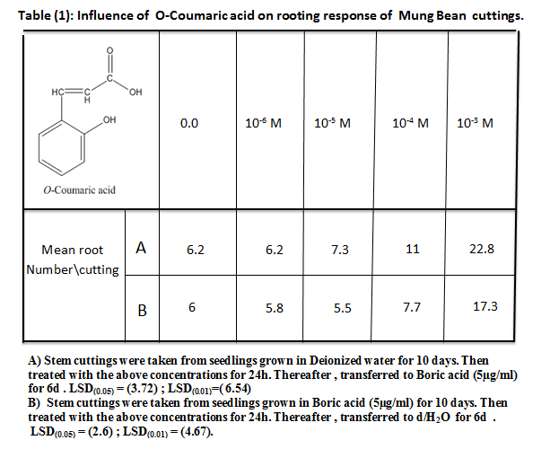

Table (2) revealed that p-coumaric acid is not significantly influence the rooting response of mung bean cuttings at low concentrations except for the highest concentration used (10⁻³M) which developed (21.7, 17.3 roots in case of A & B respectively ) that equal to approximately (3.5, 3) folds compared to control or (219.1% , 174.6%) in cuttings taken from seedlings grown in A & B respectively.

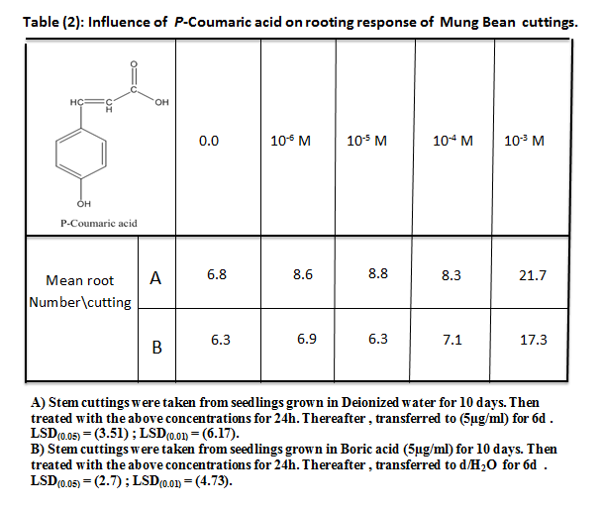

Table (3) pointed to the effect of caffeic acid on the rooting response of mung bean cuttings taken from seedlings grown for 10 days in (A & B) . Untreated cuttings developed (6.7 roots/cutting in each cases A & B), However, cuttings supplied with caffeic acid at Conc. between 10⁻⁶-10⁻⁴ were promoted little increment in roots no. but statistically are not significant. Whereas , no. of roots increased to the highest value (20.3 , 18.8roots/cutting in A & B respectively ) with the highest Conc. (10⁻³M). This no. equal (3 , 2.8) folds in comparison to control (6.7 roots/cutting) or by (202.9%, 180.6%) over control for A & B respectively.

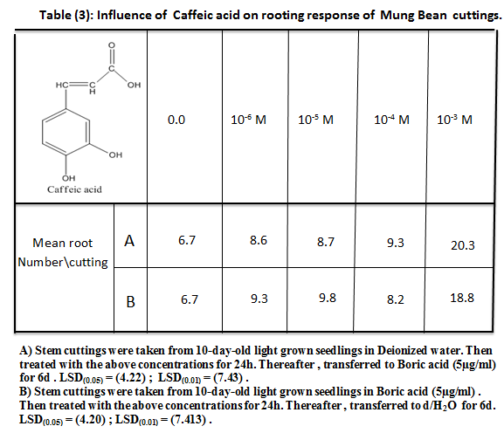

Obviously, a conclusion was raised from the comparison between tables (1,2,3) that rooting response declined in mung bean cuttings taken from seedlings grown in boric acid (5µg/ml) , and for all concentrations of o-coumaric acid , p-coumaric acid and caffeic acid. These results confirming the suggestion introduced by (Shaheed, 1987)¹⁷including that boric acid increase the activity of the enzyme IAA-oxidase that destroy IAA acting as it's substrate , leading to reduce rooting response . It is necessary to remind that, the priority of adventitious root formation in cuttings depends on auxins (Norcini&Heuser, 1988)¹⁸.
The current results was in accordance with that introduced by (Shaheed et al., 2010)¹⁹ that at this concentration (10⁻³M) highly significant increase in rooting response of cuttings aged in o-coumaric aid , caffeic acid and p-hydroquinone at 5% of the probability compared to control (d/H2O). . (Jarvis, 1986)² illustrated that phenolic compounds from many diverse compounds which are generally thought to influence auxin levels have been shown to influence root formation , where the possibility that O-dihydroxy compounds may influence root formation via an inhibitory influence on IAA-Oxidase. However (Fernqvist, 1966)²⁰ reported the dihydroxyphenols resorcinol and hydroquinone to be highly promotory in cuttings of mung bean . Furthermore P-coumaric, caffeic and chlorogenic acids all enhanced rooting when supplied individually and increased their effects when supplied with auxin²⁰.

Table (4) shows that treatment of cuttings were taken from seedlings grown in deionized water (A) or Boric acid (5µg/ml) (B) within a combination between the optimum concentration for both IAA (5×10⁻⁴M) and phenolic compounds at (10⁻³M) had made the phenolic compounds to act at high levels to promote rooting response . In other word, the phenolic compounds act synergistically with auxin (IAA). In case of A , Combination of o-coumaric acid with IAA developed (24 roots), p-coumric acid with IAA (29.5 roots) and caffeic acid with IAA ( 39.3 roots) that equal (4, ≈ 5 and 6.5 ) folds compared to control (6.2 roots) respectively . Obviously, the hydroxyl group located in Ortho position (as in o-coumaric acid) was better than it's location in Para position (as in p-coumaric acid ) while two hydroxyl groups when located in meta and para positions (as in caffeic acid ) would be more effective than the formers . This confirm the role of caffeic acid in inhibition the enzyme IAA-oxidase and finally resulted in increasing the level of IAA that reflected an increasing rooting response in mung bean cuttings. While in case of B, rooting response of cuttings taken from seedlings grown in boric acid (5µg/ml) was statistically equal response when cuttings supplied within combination of o-coumaric acid or p-coumaric with IAA. These combination were developed no. of roots equal to ( 19 , 18.6 ) respectively which are not significantly different from each other's ; whereas the combination of caffeic acid with IAA developed (29.9 roots) and that equal 5 folds compared to control or (498%) over control.

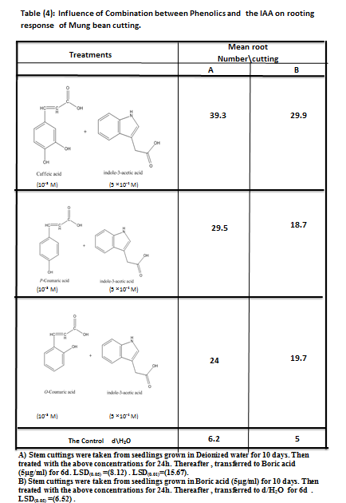

As a conclusion from the comparison between the values of A & B in tables (4) , all values of B treatments were represent diminishing of rooting response of cuttings taken from seedlings grown in boric acid (5µg/ml) compared to all values in A treatments for cuttings taken from seedlings grown in deionized water . This might confirms the formation of complexes between borate and phenolic compounds, drawing the latter from reaction field leaving IAA for the degradation via IAA-oxidase (Shaheed, 1987)¹⁷. The results are in agreement with (De Klerk and Guan, 2011)²¹ with IAA, all tested orthodiphenols, paradiphenols and triphenols promoted adventitious root formation from the (Malus 'Jork 9') stem slices. In addition, to The results obtained from using the concentration (10⁻³M) of cinnamic acid with simultaneous application with IAA for 3 days (aging period)developed large number of roots in aged cutting ,whichsignificantly approaches its number infresh cuttings (Shaheed et al., 2009 a)²² .The actions of auxin and auxin synergists on adventitious root primordium initiation and developments suggests that cellular dedifferentiation that leads to primordium initiation requires one or more enzymatically synthesized auxin-phenolic conjugates (Haissig, 1973a)²³. Moreover, (Hess, 1969)²⁴ showed catechol and pyrogallol to act synergistically with IAA. The latter suggests the structural requirements for a phenolic to act as a co-factor or synergist was an orthopositioning of hydroxyl group and a free para position .
It is noteworthy, that data of the current study confirms the previous information of (Jarvis, 1986 ; Foong and Bornes, 1986 ; Stonier, 1971)^{2,3,4} and revealed that the activity of IAA-oxidase immediately after cuttings were taken is 0.444 (µg IAA oxidized/30 min./ Fresh wt.) in the hypocotyls (root initiation zone ) of cuttings were taken from seedlings grown in boric acid . Moreover , the activity was declined to 0.067 (84.2% reduction) during 1 – st 24h of IAA treatment then raised after 72h to 0.435 (74% increament) in d/H₂O[table– 5] .
However, mung bean cuttings were revealed the same trend when taken from seedlings grown in boric acid [table – 6 ] as follows :- The activity of IAA-O immediately after cuttings were taken is 0.444 in hypocotyls . The activity was declined into 0.370 , 0.328 , 0.395 and 0.460 after 24h in d/H₂O , (Caf. + IAA) , (p-C + IAA) and (o-C + IAA) respectively. . Obviously, the activity of IAA-O at its lower level with the combination of Caffeic acid + IAA . This reflects the accumulation of IAA (due to the inhibitory effect of Caffeic acid on IAA-O), thereafter it's production of adv. root formation to its maximum value in presence of Caffeic acid compared to other phenolic compounds .
The results was in accordance with (Lee et al., 1982)²⁵ in that many phenols have a profound effect on the peroxidase catalyzed oxidation of IAA , and also with their illustration that number of hydroxyl- groups and their position relative to each other as well as to other substituents affect the activity . It has been suggested that phenolics protect auxins from decarboxylation so that after application of phenolics more auxin is available to induce roots¹¹. Phenolic compounds which interfere with the peroxidase-catalysed oxidation of IAA in vitro by introducing a lag prior to the onset of IAA oxidation that what was cited in (Gelinas, 1973)²⁶ work. However, the concept of (Stonier and Yoneda, 1967)²⁷ the "auxin protector" suggests that .

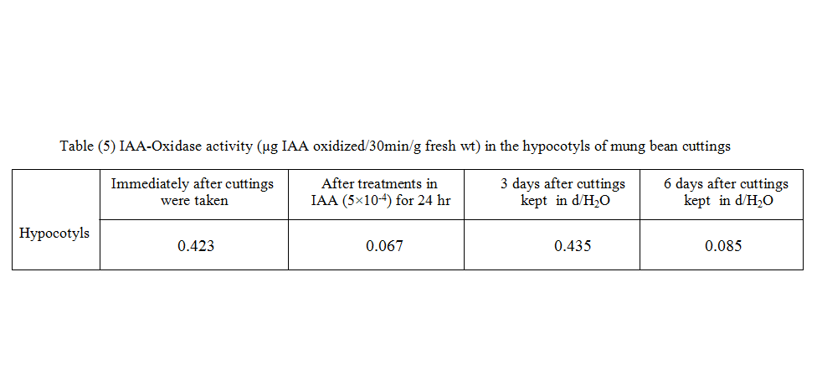

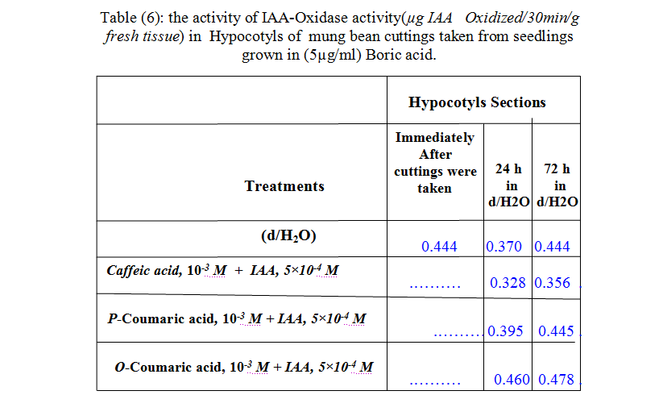

phenolic inhibitors promote growth by preventing IAA destruction via endogenous IAA-Oxidase. As (Gelinas, 1973)²⁶ reported that the generally accepted theory is that phenolic inhibitors trap free radical intermediates which would otherwise contribute to the oxidation of IAA. Alternatively, phenolic compounds were acts generally as anti-oxidants. Meanwhile, the differences between their effectiveness depend on electronic conjugation area & hydrogen bonding of phenolic compounds in terms of rooting response of mung bean cuttings which are treated primarily by IAA (Shaheed et al, 2010)¹⁹. .
As a conclusion a more inhibitory effect of Caffeic acid on the IAA-oxidase system may attributed to its formation of four hydrogen bonds with the amino acids residues in the active site of the enzyme system ( Bihijat-personal communication ) and as a result more restriction for the action of the IAA-oxidase upon it's substrate indole-3-acetic acid (IAA) . The interaction between the phenolic compounds used (O-coumaric acid, p-coumaric acid and Caffeic acid ) and IAA might interpreted either by their synergetic effect with IAA or by their effect via decarboxylation on the activity of IAA-Oxidase in term of adventitious root formation in cuttings, depending in both cases on their chemical structures.

References
1. Hand, P. (1994) Biochemical and molecular markers of cellular competence for adventitious rooting. In Biology of adventitious root formation . Eds. T.D. Davis and B.E. Haissig .Basic life Science 62, Plenum Press , New york , pp 111-121.
2.Jarvis, B.C. (1986). Endogenous control of adventitious rooting in non-woody cuttings. In New Root Formation in plants And cuttings.Ed.M.B. Jackson, MartinusNijhaff /Dr. W.Junk. Netherlands.
3.Foong, T.W . & Barnes, M.F. Rooting co-factors in Rhdodendron: the fractionation and activity of components from easy-to root and difficult-to-root variety. Biochem. Physiol. Pflanzen., 1981, 176, 507-523 .
4.Stonier, T. (1971). The role of auxin protector in autonomous growth. In.Les culture de tissue de planets, pp.423-435. Collaguesinternationux .C.N.R.S. pair (No. 193) (Cited by Blazichet al., 1983) .
5. De Klerk, G.J., van der Krieken, W. and de Jong, J , Review the formation of adventitious roots: new concepts, new possibilities. In Vitro Cell Develop. Biol Plant., 1999, 35,:189–199.
6. Grambow, H. J. and Langen beck-Schwich, B ,The relationship between oxidase activity, peroxidase activity, hydrogen peroxide, and phenolic compounds in the degradiation of Indole-3-acetic acid In Vitro. Planta, 1983, 157: 131-137.
7. Beffa, R., Martin, H and Pilet, P-E. , In Vitro Oxidation of Indoleacetic acid by soluble auxin-Oxidases and peroxidases from maize roots. Plant Physiol., 1999, 94:485-491.
8. Bandurski, R.S., Cohen, J.D., Slovin, J.P. and Reinecke, D.M., (1995) Auxin Biosynthesis and metabolism. In: Davies PJ (ed) Plant hormones.Kluwer Academic Publishers, Dordrecht, The Netherlands, pp 39–65.
9. Tomaszewaski, M. (1964)The Mechanism of Synergistic Effects between Auxin and Some Natural Phenolic Substances, Regulateursuaturels de la croissance vegetal, 335-351. Nitsch. Ed., Paris.
10. Shaheed, A. I. , Effect of Secondary Metabolites on the Aging of Mung Bean Stem Cuttings, Iraqi J. Sci.,1997, 38.
11. Josten, P. and Kutschera, U. The Micronutrient Boron causes the development of adventitious roots in Sunflower cuttings. Annals of Botany, 1999, 84: 337-342.
12 Jarvis, B.C., Ali, A.H.N. and Shaheed, A.I., Auxin and Boron In Relation to the Rooting Response and Aging of Mung bean cuttings . New Phytol., 1983, 95 : 509-518.
13.Robertson, G.A. and Loughman , B.C. Response to boron deficiency: a comparison with responses by produced by chemical methods of retarding root elongation. New Phytol . 1974, 73: 821-832.
14. Hess, C.E., The Mung bean bioassay for detection of root promoting substances. Plant physiol., 1961, 36(1): Suppl. 21.
15. .Middleton, W., Jarvis, B. C. & Booth, A. , New Phytol., 1978b , 81, 287.251-259.
16. Middleton, W., Jarvis, B. C. & Booth, A. New Phytol., 1978a, 81, 279.
17. Shaheed , A.I. (1987). The control of adventitious root development in cuttings of Phaseolus aureus Roxb. Ph.D. Thesis ,Univ. of Sheffield , U.K.
18.Norcini, J. G. & Heuser, C.W. Changes in the level of (C¹⁴) indole-3-acetic acid (C¹⁴) indole-acetyl aspartic acid during root formation in mung bean cuttings. Plant Physiol., 1988, 86(4) :1236 – 1239 .
19.Shaheed , A.I., Yasser, O.M. and Alwan, A.O., HYDROGEN BONDING OF PHENOLIC COMPOUNDS, ASCORBATE AND SUGARS AS ANTI-OXIDANT AGENTS ON INDOLE ACETIC ACID (IAA) LEVEL VIA OXIDATIVE HYPOTHESIS DURING AGING OF MUNG BEAN CUTTINGS. Int. J. Chem. Sci., 2010, 8(1) : 489-514.
20.Fernqvist, I., Studies on factors in adventitious root formation . Lantbruskhögskolans Annaler. , 1969, l
21. De Klerk, G.J. and Guan, H. Effects of phenolic compounds on adventitious root formation and oxidative decarboxylation of applied indoleacetic acid in Malus ' Jork 9' . Plant Growth Regul, 2011, 63: 175-185.
22.Shaheed , A.I., Yasser, O.M. and Alwan, A.O., The role of Trace Elements in Oxidative Hypothesis during Aging of Mung bean (Phaseolus aureus) Cuttings via Indole acetic (IAA) level. National Journal of Chemistry., 2009a, 35: 580-596.
23. Haissig, B. E., Influences of auxins and auxin synergists on adventitious root formation initiation and development. New Zealand Jornal of Forestry Science., 1973, 4(2): 311 – 319.
24. Hess, C.E., (1969) Internal and external factors regulating root initiation. In Root Growth (ed. W . J. Whitington)pp. 42-46. Butterworths. London.
25. Lee, T.T., Starratt, A.N. and Jenikar, J.J., Regulation of enzymic oxidation of indole-3-acetic acid by phenols : structure activity relationships. Phytochemistry ., 1982, 21: 517 – 523 .
26. Gelinas, D. A. , Proposed model for the peroxidase-catalyzed oxidation of indole-3-acetic acid in the presence of the inhibitor frolic acid . Plant Physiol., 1973, 51 : 976 – 972 .
27. Stonier, T., and Yoneda, Y. Stem internode elongation in the Japanese morning glory (pharbitis nil choisy) in relation to an inhibitor system of auxin destruction . Physiol. Plant., 1967, 20,13–19.

