Substituted of Imidazol As Pendent Bioactive Group Through Chains of Polymers
Khudheyer Jawad Kadem
Babylon University, College of Science , Dep. of Chemistry

(NJC)
(Received on 16/3/2014) (Accepted for publication 26/6/2014)

Abstract
In this research the two new bioactive polymers were prepared by modification of polyvinylpyrrrolidinone (PVP) or polyvinylchloride (PVC) with Imidazol as known antimicrobial agent. The two prepared polymers P₁ and P2 where characterized by FT-IR, ¹H-NMR and UV. spectroscopies. The physical properties were studied, and intrinsic viscosities were measured .
The controlled release rates for imidazole units were studied in different pH values at 37 ⁰C. The swelling percentages were calculated, the two new bioactive polymers could be used a biomaterials in different health applications.
الخلاصة
في هذا البحث حضر بوليمرين فعالين بايلوجيا بواسطة تحوير بولي فاينيل بايروليدينون (PVP) و بولي فاينيل كلورايد(PVC) مع الايميدازول المعروف كمضاد للمايكرو بات . شخصت البوليمرات المحضرة P₁ و P2 بواسطة اطياف الاشعة تحت الحمراء و طيف الرنين النووي المغناطيسي وطيف الاشعة فوق البنفسجية.
ودرست الصفات الفيزياوية وقيست اللزوجة الجوهرية . درست سرع التحرر لوحدات الايميدازول بدوال حامضية مختلفة وبدرجة 37 م⁵ وحسبت نسبة الانتفاخ المئوية . البوليمران المحضران يمكن استعمالها للأغراض الصحية المختلفة .

Introduction
The synthetic polymers with biological materials can also be favorable and desirable. Increasing attention has been paid to development of systems to deliver drugs for long time period at controlled rates ^{[1]}. Some investigators have focused their attention on the preparation of bioactive polymeric materials, by bounding the drug to a polymer through covalent linking, e.g. chloramphenicol was previously attached to a methacrylic by an acetal function and then copolymerized with 2-hydroxyl methacrylate ^{[2].} More recently, polymers have been used as non-viral vectors for the delivery of genetic materials for gene therapy ^{[3]}. There have been significant advancement in the area of polymeric drug delivery system (including commercial products) . The key point with traditional drug administration is that blood level of the agent should remain between a maximum value, which may represent a toxic level, and a minimum value, below which the drug is no longer effective ^{[4]}. Although polymers are used extensively as drug delivery agents, intrinsically bioactive polymers (polymers as active pharmaceutical ingredients) are a relatively development^{[5]}. Partly because of their high molecular weight, polymers would appear to offer several advantages over low molecular weight agents as potential therapeutic agents. The benefits may include lower toxicity, greater specificity of action, and enhanced activity due to multiple interactions (polyvalence)^{[6]}. Demonstrated that derivatives of penicillin bound to a copolymer of vinyl alcohol and allyl amine (2%) units, shows an activity which is 30-40 times longer lasting than the free pencillin.^{[7-8]}. Biomedical polymers (including additives and degradation products) should not exhibit toxic or irritant qualities, or elicit adverse physiological responses locally or systemically. Toxicity can also be affected by the rate of release of the substance and the biological processing and removal of the substance ^{[9]}. Ampicillin is a semisynthetic antibiotic, a member of the penicillin family of antibiotics, it has been synthesized first in 1961, to extent the usefulness of the penicillin to the treatment of infection caused by gram-negative ^{[10]}. A variety of ampicillin prodrugs have been prepared to increase the bioavailability, solubility, hydrophobicity of the agent to improve absorption or prevent decomposition in the stomach , where acid catalyzed decomposition may occur. Ampicillin which has both an amino and carboxylic group needs to mask one of them^{[11-14]}
The aim of this research included the synthesis of new modified biopolymers containing imidazole units as a pendent groups through chains of polymer.
Experimental
Imidazole, Polyvinylpyrrolidinone(PVP) and Polyvinylchloride (PVC) were purchased from Fluka, All available chemical reagents were used without further purification. FTIR spectra were taken on a Shimadzu spectrophotometer, Ultra violet spectra was recorded using shimadizu UV-vis. recorder over the rang 200nm. ¹H-NMR spectra was recorded on a Fourier transform spectrometry, company Bruker, model, Ultra shield 300MHZ, origin: Switzerland, in DMSO-d⁶, measurements were made at the Chemistry Department, Ahle Al bait University, Jordan.
Modification of PVC with imidazole(P₁)
(0.62g., 0.01 mole) of dissolved PVC in 10 ml of dioxane was placed in a round bottomed flask equipped with a reflux condenser and a magnetic stirrer. The (0.68g., 0.01mole) of dissolved imidazole was added gradually, the colorless polymer was obtained, after 15 mints. at 50 ⁰C. The solvent was evaporated and the viscose polymer was separated, washed with ethanol and dried at room temperature.
Modification of PVP with imidazole ( P₂)
A mixture of (4g., 0.036 mole ) of PVP and 10ml of dioxane were placed in a beaker then the.(2.44g.,0.036 mole) of imidazole was added gradually, the mixture was cooled at room temperature . the viscous polymeric material was obtained, washed with ether, and dried at 50 ⁰C under a vacuum oven.

Table (1) Physical properties of modified polymers
Poly. No. | Colour | Structure | Conversion% | intrinsic viscosity  η_{in} dl/g | Softening point ⁰C
P₁ | Colorless |  | 87 | 0.67 | 80-86
P₂ | White |  | 80 | 0.36 | 77-81

Controlled Released study ^{[15,16]}
A 100mg of modified imidazole drug polymer was kept in a cylinder containing 50:50ml of buffer:dioxane and in a water bath at 37 ⁰C without stirring. A sample from the release medium was periodically withdrawn and analyzed by UV. At 320nm to determine the amount of the released imidazole. A calibration curve was constructed with a software built in the computerized UV. Spectrophotometer, the amount 0.5mg of the released imidazole was determined directly from the software for many days, using the calibration curve in different pH (pH4 , pH10) values at 37⁰C.
Swelling %
Swelling Percentage of prepared imidazole polymer was studied in water at room temperature , swelling% was calculated according to
∆m= m₁-m₀/m₀ ×100
When m₀ is the weight of a dry imidazole polymer
m₁ is the swallowed imidazole polymer in non-solvent
Result and Discussion
Modification reaction of polymers were substituted with imidazole as known is an antimicrobial agent, it is incorporated into many important biological molecules . One of the applications of imidazole is in the purification of his aged proteins in immobilized metal affinity (14).
The PVC was converted with imidazole as illustrated in the following equation:

PVC was substituted by imidazole units, this a new modified polymer that substituted with a bioactive units are not limited to pendant groups on the backbone, useful products may also be used for many purpose such as antimicrobial agent.
The prepared polymer [P₁] was characterized by FT-IR spectra as shown in Figure (1) which indicated the forming of a new polymer. This is of CH aliphatic was observed at 2939 cm⁻¹, and NH was appeared at 3356 cm⁻¹, the C=N beak at1650cm⁻¹ and the peak at 819 cm⁻¹ due to C-Cl stretching .
The physical properties of prepared polymer P₁ were studied such as intrinsic viscosity which was measured at 30 ⁰C with Ostwald viscometer by using dioxane as a solvent , the swelling % of the prepared polymer was studied as shown in Figure (4). Also PVP was converted with imidazole by ring opening reaction, as shown below:

The imidazole acts as a nucleophilic through the –NH group, the mechanism is illustrated as in scheme (2).

Scheme (2).

Fig. (2) shows the FT-IR spectra of polymer P₂, the peaks at 3311 cm⁻¹ assigned to –NH , and the characteristic absorption of carbonyl group appeared at 1649 cm⁻¹, the peak at 2944cm⁻¹ assigned to aliphatic C-H stretching on the aliphatic chain , and the other peak appeared at 1649cm⁻¹ was attributed to C=N of imidazole ring. Fig.(3) shows the effects of pH values on the rate of controlled release and profiles of mole friction of imidazole units to total moles present in the sample versus time at pH 4 and 10 at 37⁰C . In basic the only nucleophilic acyl substitution reaction that amides is hydrolysis , Amides are fairly stable in water, but the amide group is cleavage on the strong acid producing the imidazole and the corresponding PVP, as shown in the scheme below:

Fig.(3) showed hydrolysis in acid and base medium it was concluded that the hydrolysis of imidazole polymer in basic medium due to presence of –OH in alkaline which is a stronger nucleophilic with respect to water, and the water take place faster hydrolyzed than acidic medium.
The swelling characteristics of the prepared polymer at room temperature are shown in figure (4).The P₂ has 18% which is higher swelling% than P₁which has 6.5 swelling% in water .
The ¹H-NMR spectrum of prepared polymer [P₁] ,Fig. (5), showed the following signals:-
δ 1.1ppm(CH₋CH₂, t), δ, 1.3ppm (CH-CH₂, d), δ 5ppm (NH) , δ 2.4-2.8ppm(CH-CH₂,d. and t of remained PVC . δ, 4.6-4.9ppm (CH=N, d), δ 6.5-6.9 ppm (-CH=CH-), δ7.1-7.4ppm of (CH=CH-CH)t. of imidazole ring .
We concluded from this work that the imidazole could release as antimicrobial agent for prolong time with controlled rate which could be a suitable for many health manufactures.

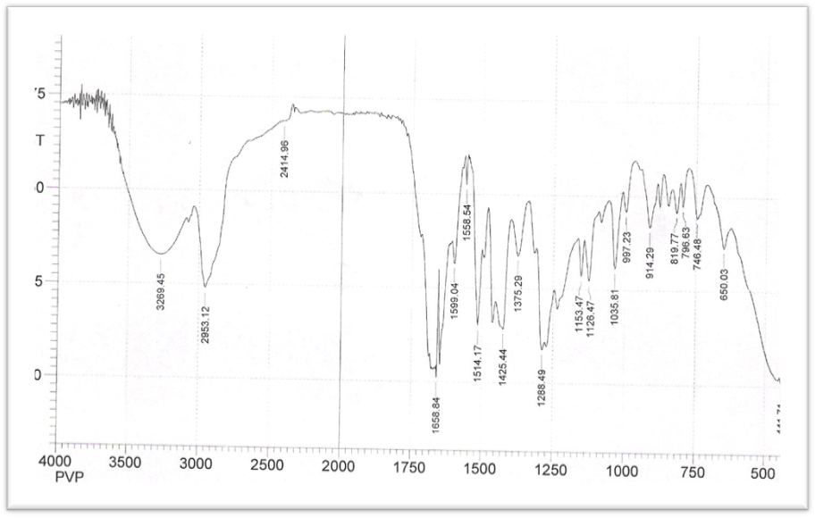
Fig.(1) FT-IR spectrum for prepared imidazole polymer P₁
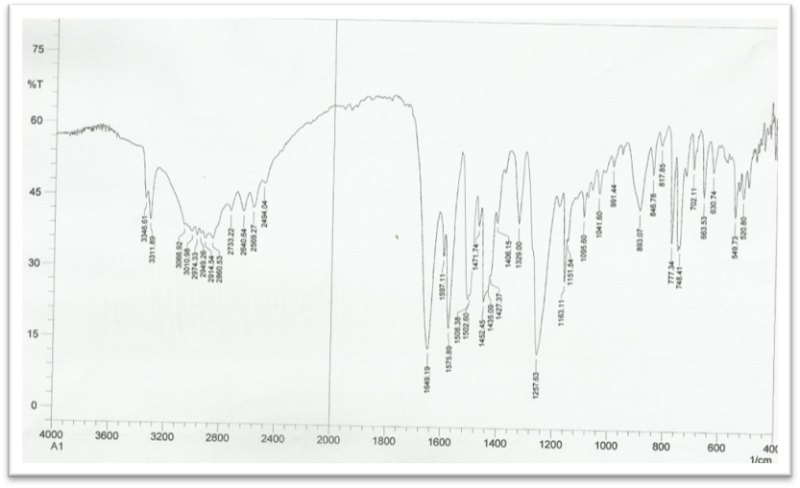
Fig.(2) FT-IR spectrum for prepared imidazole polymer P₂

Fig.(3) controlled release of imidazole polymer P1

Fig.(4) swelling % of imidazole polymers P1 &P2

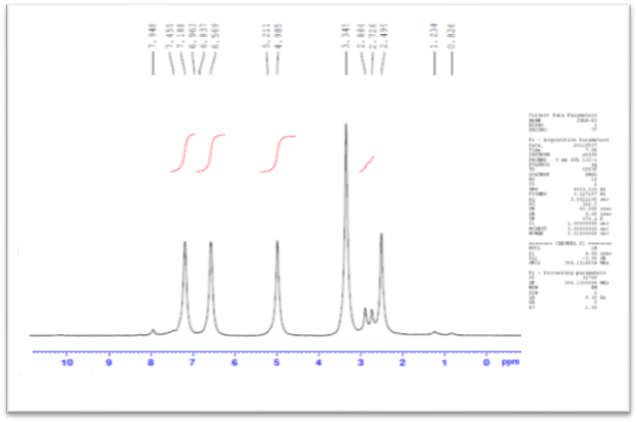
Fig(5) ¹H-NMR spectrum for prepared imidazole polymer P₂

References
- Vogelstein B. and Kinzler K., Cancer genes and the pathways they control. Nature Medicine, 2004, 10, 789-799.
- Julia D., Abramson M., Cancer center of the University of Pennsylvania, Posting Date: November, p.5.(2003).
- Desmedt S.C.,Demeester J., and Hennink W.E., Pharm. Res., 2000, 17, 113.
- Thamir J.M., Polymer Carriers of long –Acting Drug For Chronic Diseases , Ph D. thesis, University of Baghdad College of Education Ibn Al-Haitham (2005).
- Alonso M.J., Drug and the pharmaceutical sciences Vol.77, Micro particulate systems for the delivery of proteins and vaccines, Marcel Dekker Inc., USA,1996, 203-242.
- Duncan R., Park K. and Mrsny R.J., Controlled Drug Delivery( ACS Symposium Series 752), American Chemical Society, Washington, D.C, P.350,(2000).
- Al-Gouboury H.G., Synthesis and Study of Antimicrobial and Anticoagulant Properties of some Phenolic and Amino polymer, A thesis submitted to the college Iben-Alhaitham , Bagdad University for Msc.(2001).
- Mori H., Kato I., Matsuyama M. and Endo T., Polymerization of acrylamides contain proline and hydroxyproine moiety controlled synthesis of water soluble thermoresponsive polymers, Macromolecules, 2008, 41, 5604-5615.
- Lu S., Anseth K.S., Release behavior of high molecular weight solutes from poly(ethylene glycol) –based degradable networks . Macromolecules., 2000, 33, 2509-15.
- Mann J., The Elusive Magic Bullet: The Search for the perfect Drug .Oxford, UK: Oxford University press(1999).
- Dharmendra Singh, Development and Characterization of Chitosan nanoparticales loaded with Amoxicillin, Ph.D thesis , Rajasthan University,(2009).
- Sameaa J. Khammas Ph.D thesis.College of Science for woman Dep., of Chem. Univ. of Baghdad.(2009).
- Ardeshir K., Davood S., Minoo S.,and Seyed M., Synthesis and characterization of poly(8-hydroxyquinoline-p-styrene sulfonate) and study of its controlled release behavior. Iranian polymer journal, 2007, 16(5), .309-317.
- Wen.Chem, Dong-Keun Han, and Kwang-Duk Ahn ''Molecularly Imprinted Polymers having amidine and imidazole functional groups'' Macromolecular Research, 2002, 10(2) , 122-126.
- Johnson M., Koman L. and Neuse E., polymeric drug carriers functionalized with pairwise arranged , J. of Appli. Poly. Sci., 2005, 96(1), 10-19.
- Firyal M.A. , Abbas N.M. & Khudheyer J.Kadem. (2010) . Modification of Poly VinylPyrrolidinone with Amoxilline to Drug Polymer .fifth Scientific Conference-College of Science-University of Babylon, Iraq..Vol.5, 224-229.

