Potentiometric study for Determination of$\overline{\text{PKa}}$values for Schiff bases derived from 2- acetyl pyridine with heterocyclic amines

Dunia Butrus Toma Al-Bakzo
Emil: dn_842007@yahoo.com
Chemistry Department, College of Education , University of Mosul

(NJC)

(Received on 1/12/2013) (Accepted for publication 23/3/2014)

Abstract
The project was started by synthesis of two Schiff bases from 2- acetyl pyridine with 4- amino pyrimidine and 4- amino pyridine by a standard method . The structures of these Schiff bases had confirmed by physical method , namely by using U.V-IR spectra and melting points .
The main aims of the study was the determination of two consecutive nitrilium ions ionization constants pK₁ and pK₂ for in each molecule simultaneously . The last was regarded an improvement in potentiometric method for determination of pKa in these molecules . Finaly factors govern , the pK₁ or pK₂ values in these Schiff base ,as structure of imines, temperature and mixed solvent of ethanol in the range (10_60) % in water were given and discussed.

Key words : Ionization constant , Schiff bases, Heterocyclic ketone and amine , potentiometry .

الخلاصة
ابتداء البحث بتحضير قاعدتي شيف من 2- اسيتايل بريديين مع 4- امينو بريميدين و4- امينو برييدين وبطريقة قياسية .
تم إثبات الهيئتين التركيبيتين لقاعدتي شيف بالطريقة الفيزيائية وبالتحديد بأطياف U.V-IR ودرجات الانصهار .
الهدف الرئيسي للدراسة هو تعيين قيم ثوابت التأين المتعاقبة لايونات النتريليوم pK₁ وpK₂ في كل جريئة في آن واحد . الأخير يعتبر تطوير بالطريقة المجهادية في تعيين pKa في هذه الجزيئات . أخيرا أوضح البحث العوامل المؤثرة عل قيم pK₁ وpK₂ مثل الهيئات التركيبية , درجة الحرارة والمذيب المتمثل بالايثانول في المدى من (10-60)% والتي تمت مناقشتها.

الكلمات الدالة: ثابت التأين , قواعد شيف ,الكيتونات الحلقية غير المتجانسة ,الطريقة المجهادية .

Introduction
The chemistry of heterocyclic ketones and amines had faced a great deal of attention by many workers . This was for their applications in many fields .
Many workers had given a great deal of attention to the chemistry of imines during the last decades. These were in the direction of U.V⁽¹⁻³⁾ ,IR^{(4,5)} ,NMR⁽⁶⁾ and mass^{(6,7)} spectra .
Schiff bases had used in different fields as antimicrobial⁽⁸⁾ agents , fungicides⁽⁹⁾, biomarkers⁽¹⁰⁾ and of oxidative⁽¹¹⁾ stress in model diabetes mellitus .
During the lest years, potentiometric titration was applied successfully for the determination of pKa for amide⁽¹²⁾ ,ary azo pyrimidine⁽¹³⁾ , biochemical⁽¹⁴⁾ and drugs⁽¹⁵⁾ .
The present work deals with the determination of two pK₁ and pK₂ values for some heterocyclic imines derived from 2- acetyl pyridine with 4-amino pyrimidine and 4-amino pyridine, by using a developed potentiometric method . The study deals with influence of three factors affecting the acidities of imines such as type of structures , temperature and solvent .
The study illustrated how tertiary amino groups in imines were converted to nitrilium cation as a strong acid conjugate during potentiometric titration of imines under study with HCl titrant .

Experimental
2- acetyl pyridine,4-amino pyrimidine and 4-amino pyridine were supplied form Aldrich Chemical Company . They were used as supplied with out any further purification, Ethanol was bought from local market, Methyl 2-pyridyl ketonylidene 4-amino pyrimidine (I) and Methyl 2-pyridyl ketonylidene 4-amino pyridine (II) were prepared by standard method ⁽⁴⁾ i.e. by mixing(0.01) mole 2-acetyl pyridine with (0.01) mole 4-amino pyrimidine and 4-amino pyridine respectively. About (10) ml of ethanol was added to each mixture, followed by reflux for the mixture for about (1.5) hour, cooling and filtration of final products. Crude Schiff base (I) and (II) were recrystallized from ethanol, pure imines (I) and (II) having a melting points of (116) Cº and (131-133) Cº respectively.

Determination of pKa
Solutions required
1-(0.01)M of imine in 10% ethanol _water medium .
2-(0. 1)M of HCl .
Pipette (50) ml of 10⁻² M of Schiff base (I) or (II) and placed in a special titration cell containing double layers , for circulation of water inside the cell .Water was pumped from thermostat at any temperature range between (10-60) Cº .When the temperature of imine reached an equilibrium , addition of(0.2) ml successive quantity of (0.1) M HCl was done . The mixture was stirred with magnetic bar placed inside the cell after addition , followed by measurement of pH after addition . Titration was continued for seven times till (1.4) ml total volume of titrant added . Two pK₁ and pK₂ values for conjugate acids were determined . The first pK₁was estimated after addition of range (0.2-1) ml titrant .This represent half neutralization reaction . The second pK₂ was estimated at range volumes of (1.2-1.4) ml of titrant .The pKa values were calculated from Handerson Hassellbach equation^{(16,17)} of the from :

(1).............. $\text{pKa}=\text{pH}+\text{log}\frac{[\text{HA}]}{[{\text{BH}}^{+}]}$

Instrumentations
1.Electrothermal melting point apparatus was used for measurement of melting point of imines.
2. FT IR spectrophotometer was used for measurement of IR spectra of solid imines by KBr disc method .
3.A computerized double beam Shimadzu 1601 for measurement of U.V spectra of imines solution.
4.A memmert thermostat manufactured by Searle company model L200, for fixation the temperature of imine solution.
Water was pumped out from thermostat to cell using external water pump.

Results and discussion
The chemical structures of heterocyclic imines (I) and (II) were the following :

(I) (II)

These imines (I) and (II) were resemble each other in their structures having 4 and 3 nitrogen atoms respectively . Theoretically could be regarded as a weak bases and combined easily with HCl titrant during potentiometric titration forming strong acid conjugates or nitrilium ions.
At the beginning of this investigation it was found of a great importance to confirm the structures of imines (I) and (II) by physical mean , namely , melting points, U.V and IR spectra.
The melting points of imines (I) and (II) having a values of (116) Cº and (131-133) Cº respectively . This means that degree of association or polymerization of (II)was greater than (I). This possibly happen by dipole-dipole association method⁽¹¹⁾.
The IR spectra and U.V spectra of imines (I) and (II) in ethanol shown Table (1) and showed the following absorption bonds :

Table(1) U.V-IR spectra of imines:

IR wave number (cm⁻¹) |  |  | U.V in ethanol  (10⁻⁴) M |  | Imine No
-C-H- | --C=N | C-N | Ƹ max  Liter.mole⁻¹.cm⁻¹ | λmax  (nm) | Imine No
3169.59(m) | 1649.91(s) | 1477.17(s) | 6100 | 297 | I
3075.86(m) | 1649.31(s) | 1435.73(s) | 3065 | 268 | II

The U.V spectra of imines (I) and (II) showed a single absorption for each imine at optimum wavelengths λmax with molar extension coefficient vales greater than 1000 unit of Liter.mole⁻¹.cm⁻¹ . This confirmed π—π* transition⁽⁴⁾ in each planer molecule .
The IR spectra showed the following stretching vibration as follows :
1.A strong absorptions for C-N tertiary amine in the range (1435.73-1477.17) cm⁻¹ .
2. A strong stretching absorptions for -C=N- the azomethine linkages in the range (1649.31-1649.91) cm⁻¹.
3.A medium aromatic C-H group in the range(3075.86- 3169.59) cm⁻¹
These values of melting point , U.V and IR absorption bands confirmed⁽¹⁸⁾ the chemical structures of imines under study .
Before starting pKa determination of imines (I) and (II) , it was found of a great importance to check the stability of imines when prepared in 10⁻² M in 10% ethanol aqueous media .This was because some imines solutions under go a side reactions⁽⁶⁾ as hydrolysis ,solvolysis …..etc in medium stated .This encourage the worker in this investigation to measure the conductance of imines 10⁻² M solution for a period of 90 minutes as shown in Table (2)

Table (2): Conductance (ohm⁻¹) for 10⁻² M imines (I) and (II) in 10% ethanol-water medium at different times .

Conductance (ohm⁻¹) |  | Tim
II | I | Tim
91 | 8.85 | 0
89 | 8.89 | 5
88.1 | 8.81 | 10
88.1 | 8.72 | 15
88.1 | 8.72 | 20
88.1 | 8.71 | 25
88.5 | 8.75 | 30
89 | 8.79 | 35
89 | 8.8 | 40
89.1 | 8.8 | 45
89.5 | 8.8 | 50
89.9 | 8.8 | 55
90 | 8.85 | 60
90.1 | 8.85 | 65
90.5 | 8.89 | 70
90.5 | 8.91 | 75
90.9 | 8.95 | 80
91 | 9.0 | 85
91 | 9.0 | 90

Table (3): pK₁ and pK₂ for imines (I) in 10% ethanol and at different temperatures .

$$\overline{\text{pKa}}$$ | pKa | pH | ml of HCl | T_{(k)}
3.899* | 4.995  4.271  3.803  3.383  3.046 | 4.08  3.72  3.50  3.30  3.17 | 0.2  0.4  0.6  0.8  1 | 298
2.499** | 2.722  2.275 | 3.07  2.94 | 1.2  1.4 | 298
3.648* | 4.819  4.031  3.504  3.130  2.756 | 3.92  3.51  3.25  3.1  2.96 | 0.2  0.4  0.6  0.8  1 | 303
2.085** | 2.355  1.814 | 2.84  2.74 | 1.2  1.4 | 303
3.435* | 4.636  3.837  3.311  2.876  2.517 | 3.76  3.35  3.10  2.92  2.81 | 0.2  0.4  0.6  0.8  1 | 313
1.92** | 2.160  1.680 | 2.78  2.70 | 1.2  1.4 | 313
3.247* | 4.444  3.644  3.113  2.687  2.346 | 3.60  3.20  2.96  2.80  2.77 | 0.2  0.4  0.6  0.8  1 | 323
1.88** | 2.112  1.642 | 2.72  2.69 | 1.2  1.4 | 323
3.122* | 4.356  3.508  2.962  2.472  2.312 | 3.53  3.10  2.86  2.68  2.70 | 0.2  0.4  0.6  0.8  1 | 333
1.528** | 1.937  1.118 | 2.65  2.60 | 1.2  1.4 | 333

* pK₁
**pK₂

Table (4): pK₁ and pK₂ for imines (II) in 10% ethanol and at different temperatures

$$\overline{\text{pKa}}$$ | pKa | pH | ml of HCl | T_{(k)}
9.271* | 10.131  9.625  9.241  8.876  8.481 | 9.17  9.02  8.87  8.70  8.48 | 0.2  0.4  0.6  0.8  1 | 298
7.492** | 8.024  7.800  6.652 | 8.20  7.80  7.61 | 1.2  1.4  1.8 | 298
8.925* | 9.777  9.273  8.889  8.526  8.160 | 8.82  8.67  8.52  8.35  8.16 | 0.2  0.4  0.6  0.8  1 | 303
7.189** | 7.744  7.233  6.592 | 7.92  7.60  7.55 | 1.2  1.4  1.8 | 303
8.579* | 9.436  8.933  8.529  8.186  7.810 | 8.48  8.33  8.16  8.01  7.81 | 0.2  0.4  0.6  0.8  1 | 313
6.876** | 7.394  6.933  6.302 | 7.57  7.30  7.26 | 1.2  1.4  1.8 | 313
8.222* | 9.095  8.582  8.179  7.816  7.440 | 8.14  7.98  7.81  7.64  7.44 | 0.2  0.4  0.6  0.8  1 | 323
6.286** | 6.974  6.433  5.542 | 7.15  6.80  6.41 | 1.2  1.4  1.8 | 323
8.118* | 8.975  8.472  8.079  7.716  7.350 | 8.02  7.87  7.71  7.54  7.35 | 0.2  0.4  0.6  0.8  1 | 333
6.046** | 6.824  5.983  5.332 | 7.00  6.35  6.29 | 1.2  1.4  1.8 | 333

* pK₁
**pK₂

Table (2) showed a stability of conductance for 10⁻² M imines solutions for the whole period of 90 minutes .A very small variation in conductance measurements were observed some times , due to voltage change in A.C current . The last as expected produced by fluctuation in the conductances and their values lie with in experimental errors .
The stable10⁻² M imines solutions in 10% ethanol aqueous medium encourage the worker to deal with pKa determination of imines by potentiometric method .Hence the following division of results were thought to be necessary:-

1.Influence of structures on pK₁ and pK₂
Table(3,4) showed pK₁ and pK₂ values for imines (I) and (II) at fixed 10% ethanol aqueous medium and at different temperatures range between (20-60) Cº. At these temperatures pK₁ and pK₂ values for imine (I) had a range of value (3.899-3.122) and (2.499-1.528) respectively. Similarly imine (II) had a range of pK₁ and pK₂ values (9.271-8.118) and (7.492-6.046) respectively .This means acidities of pK₁ and pK₂ in imine (I) were greater than imine (II). This agreed with the higher basicity of imine (I) as compared with imine (II). In other words they contained 4 and 3 nitrogen atoms in imines (I) and (II) respectively. This increased in basicity of imine (I) as compared with imine (II), gave a greater chance to imine(I)to react with protons of HCl titrant during potentiometric titration to produce higher concentrations of conjugated acids . This comes in agreement ⁽¹⁶⁾ with influence of structures of imines derived from benzoyl acetone and dimedone on their acidites, on their acidities.
2. Influence of temperatures on pK₁ and pK₂ Table(3)showed the influence of temperatures in the range (293-333) K on ionization constants pK₁ and pK₂ for nitrilium ions produced by reactions of basic Schiff bases (I) and (II) with HCl titrant, during potentiometric titration.
This facilitated the evaluation of thermodynamic parameters namely $\overline{ΔG},\overline{ΔH}$ and $\overline{ΔS}$from standard ⁽¹⁷⁾ equations of the forms:-

∆G ₌- RT ln K_{i} ………..(2)
i₌1 or 2
K_{i} ₌Ionization constant of nitrilium ion
R₌8.314 J.mole⁻¹ .K⁻¹
T₌Absolute temperature
All$\overline{ΔG}$ values collected in Table (5) had a range of positive
values between (20.7-51.5)kJ.mole⁻¹.
This happed , because organic compounds contain covalent bondings and ionized with difficulty .
The variation of ln K_{i} with absolute temperature , encourage
the worker in this investigation to evaluate the enthalpy $\overline{ΔH}$parameter for two ionization constants K₁ and K₂ from integrated Vant Hoff equation of the form :-
∆H
RT
ln K = constant- .............(3)

The plots of lnK₁or lnK₂ of Versus T⁻¹ imines (I) and (II)showed a four linear straight lines of correlation coefficients range (0.927-0.982) as in fig (1-2) for imines (I) and (II)respectively .The two positive signs of $\overline{ΔH}$ thermodynamic parameter in each imine mean that ionization process occurred in an endothermic process . In any imine the second heat of ionization is greater than the first or ∆H₂˃ ∆H₁. This was accepted and agreed in literature⁽¹⁹⁾ since in second ionization reaction need more energy was required to perform the ionization reaction .
The change in entropy $\overline{ΔS}$ accompanied ionization reaction in imines (I) and (II) were calculated from Gibbs equation (4) of the from :
$\overline{ΔG}$₌ $\overline{ΔH}$_ $T\overline{ΔS}$…………………(4)
Table (5) showed a positive two $\overline{ΔS}$ values for each imine. This positive sign stated mean that ionization reaction occurred by an increase in random i.e. S₂˃S₁
S₂₌ entropy of product
S₁₌ entropy of reactant
Also in any imine ∆S₂ value was greater than ∆S₁ .These two last observations were in full agreement⁽¹⁹⁾ with any ionization reactions having two ionization steps.

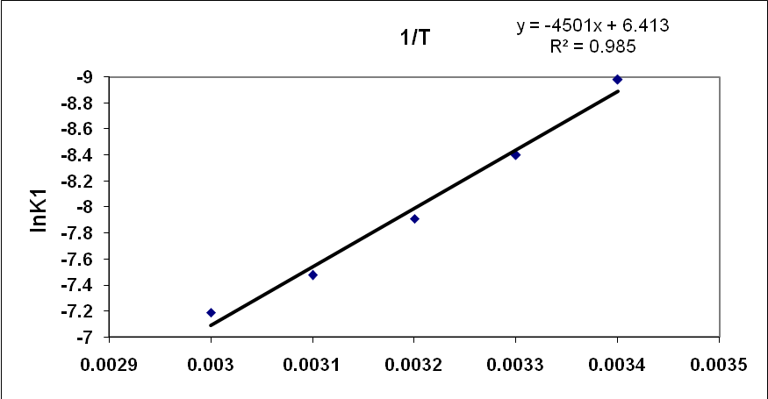

(a)

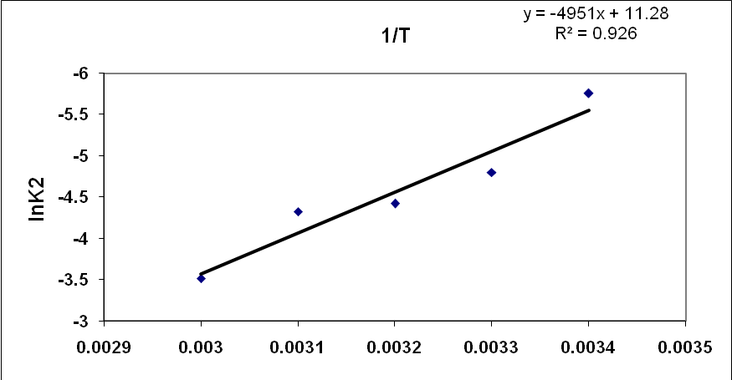

(b)
Fig(1): Vant Hoff plots for imine (I)
a- lnK₁ versus 1/T
b- lnK₂ versus 1/T

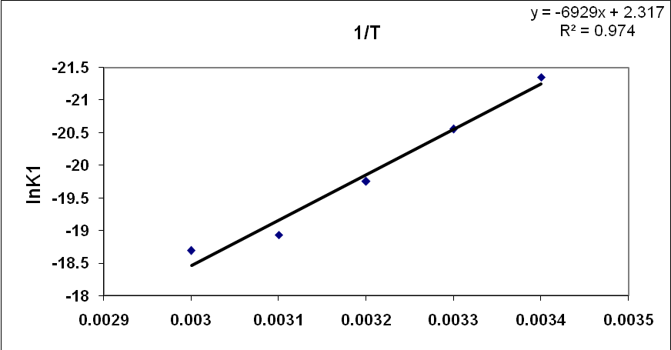
(a)

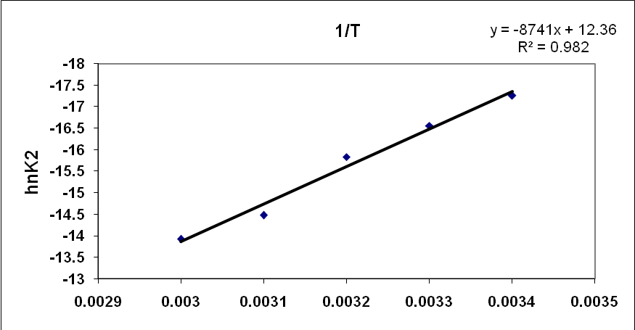
(b)

Fig(2): Vant Hoff plots for imine (IІ)
a- lnK₁ versus 1/T
b- lnK₂ versus 1/T

Table (5) Thermodynamic parameters $\overline{ΔG}$,$\overline{ΔH}$, $\overline{ΔS}$ for ionization constants pK₁ and pK₂ in imines (I) and (II).

$$\overline{ΔS}$$ | $$\overline{ΔG}$$ | $$\overline{ΔH}$$ | S∆  J.mol⁻¹. k⁻¹ | ∆G  J.mol⁻¹ | ∆H  J.mol⁻¹ | ^{ln k} | Temp  K | com  NO.
53.32 | 20717.9 | 37406.3 | 53.32  53.32  53.32  53.32  53.32 | 21870.4  21158.3  20581.4  20076.2  19903.2 | 37492.5  37313.5  37269.9  37297.8  37657.9 | -.8.978  -8.399  -7.909  -7.476  -7.189 | 293  303  313  323  333 | 1*
93.78 | 11792.4 | 41146.1 | 93.78  93.78  93.78  93.78  93.78 | 14016.8  12094.4  11504.7  11606.4  9739.8 | 41494.9  40510.3  40858.4  41897.9  40969.2 | -5.754  -4.801  -4.421  -4.322  -3.518 | 293  303  313  323  333 | 1**
19.27 | 51557.4 | 57586.9 | 19.27  19.27  19.27  19.27  19.27 | 52001.3  51770.9  51413.3  50840.4  51761.0 | 57647.0  57609.3  57436.5  57064.1  58177.5 | -21.347  -20.551  -19.754  -18.932  -18.692 | 293  303  313  323  333 | 2*
102.79 | 40467.9 | 72642.6 | 102.79  102.79  102.79  102.70  102.79 | 42023.5  41704.4  41201.9  38868.8  38541.2 | 72142.2  72851.1  73376.5  72071.4  72771.7 | -17.251  -16.555  -15.833  -14.474  -13.921 | 293  303  313  323  333 | 2**
1*and 1** for pK₁ and pK₂ in imine (I).
2* and 2**for pK₁ and pK₂ in imine(II).

3.Influence of solvent on ionization constant
The percentages of ethanol in aqueous medium as a solvent were changed in a range (10-60)% . The ionization constants pK₁ and pK₂ for imines (I) and (II) were determined in six mixtures stated . The percentages of ethanol in water were converted in to dielectric constants (D) from literature⁽²⁰⁾ .A plots between pK₁ or pK₂ for each imine versus D as in fig. (3-4).These showed four graphs of bell shape . In other words a direct relation ship between pK₁ or pK₂ versus (D) , then suddenly converted in an inverse relation ship . This comes in agreement with earlier works^{(21,22)}.

Fig(3): The relation ship between pK₁ or pK₂ versus dielectric constant (D) of the media in imine І .

Fig(4): The relation ship between pK₁ or pK₂ versus dielectric constant (D) of the media in imine ІІ.

Conclusions
1.Schiff bases 1 and 2 were prepared by standard method .Their structures were confirmed by physical method , using melting points and U.V-IR spectra .
2.Asimple ,fast and accurate potentiometric titration method was applied for the determination of pk₁ and Pk₂ ionization constants for nitrilium ions in imines 1-2.
3.pk₁ and Pk₂ were calculated from Handerson Hassellbach equation after addition of titrant HCl having maximum values of 1.0ml and 1.4 ml respectively.
4.The thermodynamic parameters calculated namely $\overline{ΔG},\overline{ΔH}$ and $\overline{ΔS}$ show that ionization reaction of nitrilium ions were endothermic , non spontaneous and accompanied by an increase of random process.
5. ∆S₂ >∆S₁ in any Schiff base (S) which agreed with ionization reaction of type (1-2) respectively :
SH₂ ⁺⁺ S +2H⁺ ………..(1)
SH⁺ S + H⁺ …………(2)

SH₂ ⁺⁺ and SH ⁺ were called the double and mono nitrilium ions of any Schiff base produced during titration .
6.The relationship between pk₁ and Pk₂ versus D in any imine showed a bell shape ,as agreed with literature⁽¹⁶⁻¹⁷⁾ .

References
1.A.S.P.Azzouz and A.B.N.AL-Dabagh, Nat.J.Chem. ,2008,32,677.
2.A. A. Saeed, A. W. Sultan, S. A. Selman and N. A. Abood , Can. Spectrosc.; 1983, 28, 104.
3.A.S.P.Azzouz and A.N.Obed Agha, Phy. Chem.An Indian J.,2007,2(3),15.
4. A.S.P.Azzouz and A.A.Rahman and A.G.Taki ,J.Edu.Sci.; 2003,15(2),1.
5.A. A. Saeed, N. A. Abood, N. A. AL-Mosoudi and G. T. Matti, Can. J. Spectrosc.; 1985, 30, 142.
6.Ed.S.Patai, The Chemistry of Carbon Nitrogen Double Bond , Tohn Wiley ,1979,New York.
7.A.S.P.Azzouz, Spectrosc. Letter, 1995, 28, 1.
8.A.K.Mittal and O.P.Singhal,T. Indian Chem .Soc.; 1986,63,759.
9.B.Dash,M.Patra and P.K.Mahapatra, J.Indian Chem .Soc.; 1983,60,772.
10.P.Korytra ,M.Molnorova ,M.Sivvonova F.Zitnanova, O.Ulicna, A.Liptakova ,J.Carsky and Z.Duraskova ,Gen.Physiol .Biophys.; 2002,21,337.
11.R.Chang ,Physical Chemistry with Applications to Biological Systems, Macmillan Publishing Co., New York ,1981,pp.487-501.
12.R.K.Jameel, Mutah. J.Res and Stud.;1994,9,105.
13.M.S.Masoud ,E.K.Khalil, A.A.Ibrahim and A. A. Marghany. Z. Phy. Chem.; 1999, 211, 113.
14.M.Meloun ,Z.Ferencikova ,H.Malkova and T.Pekarek, Cent . Eur.J .Chem.; 2012,10(2),338.
15.V.Ravichandiran ,V.Devarajan and K.Masilamani, Der pharmacia Lettre ,2011, 3(4),183.
16.A.S.P.Azzouz and F.H.Maree, J.Edu.Sci.; 2010,23(3),17.
17.A.S.P.Azzouz and R.D. Sulayman, Asian J.Chem.; 2013,25(10),5303.
18.R. M. Silverstein, G. C. Bassler and J, C.Morril, Spectrometric Indentification of Organic Compounds, 1974, John Wiley and Sons , New York.
19.A.Albert and E.P.Serjeant ,The Determination of Ionization Constant , 3rd ed., Chapman and Hall; 1984, London.
20.G.Akerlof,J.Amer.Chem.Soc.;1932, 54(11),4125.
21.A.S.P.Azzouz and H.J.AL-Moula, J.Edu.Sci.; 2012,25(4), 30.
22.A.S.P.Azzouz and R.D.Sulayman, Iraqi. J. Chem.; 2012, 47, 333.

