Novel Activated Carbon Produced from Iraqi Luffa (IL)
with Organic and Inorganic Applications

Wijdan Mohamed Saleh
wjdanwjdan@yahoo.com
Dept of Chemical Industries; Institute of Technical,Mosul,
Al-Mjmoaa Al-Thaqafea; Mosul
Shakir Mahmood Saied
shakirmsaied@yahoo.com
Corresponding Author; Dept. of Pharmacy; Institute of Technical, Mosul
Al-Mjmoaa Al-Thaqafea; Mosul
Assim Adel Sabah
asim7071@yahoo.com
Dept. of Sciences; College of Basic Education; Univ. of Mosul
Al-Mjmoaa Al-Thaqafea; Mosul;

(NJC)
(Received on 26/12/2013) (Accepted for publication 23/3/2014)

Abstract
In this study, synthesis and characterization of novel activated carbon (AC) produces from Iraqi Luffa (IL). This material was applied in organic and inorganic applications. The results indicates that the quality of activated carbon samples is highly dependent on the preparation conditions and the optimum results (of high volume and pore surface area) were obtained by treating with potassium hydroxide impregnation ratio 1/2 . The highest yield was 70% for all samples except AC⁵, indicating that the pores surfaces and structures of these samples were the best developed.
Thermal gravimetric analysis (TGA) of activated carbon samples signposted that all of these samples were stable between 250 – 350 ºC, TGA-DTG(Differential thermal analysis) showed that the initial weight loss begins at around 100ºC. This means that the major weight loss occurred in the temperature range of 285~500ºC due to decomposition of cellulose and lignin leaving behind a carbon preform.
The activated carbon samples were an effective adsorbent material for removing toxic element (Lead) in water (or wastewater), the removal percentages were varied from 26 to 64%.
Also these samples could be used in organic applications as catalyst or catalyst support for oxidation of chalcone using hydrogen peroxide.
The iodine number, methylene blue, ash content %, densities, thermal gravimetric analysis (TGA) and Differential thermal analysis(DTG), in addition to IR spectra were used to characterized these samples. Also atomic absorption was used to determined the quantities of toxic element (lead).

Keywords:
Iraqi Luffa (IL); Activated Carbon; Catalyst Supports; Oxiranes Synthesis; Adsorption of Heavy Metal Ions; (lead removal).

الخلاصة
في هذا البحث تم تحضير ودراسة خواص نوع جديد من الفحم المنشط من الليف العراقي مع تطبيقات استخدامه فى الكيمياء العضوية واللاعضوية. اشارت الدراسة الى ان نوعية النماذج المحضرة تعتمد بشكل كبير على ظروف التحضير ، وان افضل الظروف (زيادة في الحجم ومسامية المساحة السطحية) كانت عند المعاملة بنسبة 1/2 من هيدروكسيد البوتاسيوم. ان اعلى نسبة منتوج كانت 60-70 % لجميع النتائج عدا النموذج (AC⁵) مما يدل على ان مسامية السطح واشكال النماذج هي من افضل المواصفات .تشير نتائج التحليل الوزني الحرارى للنماذج الى ان جميع هذه النتائج مستقرة حراريا بين 250-350 م⁰ . وقد اثبت التحليل الحرارى التفاضلي بان فقدان الوزن الابتدائي يبدا بدرجة حرارة 155 م⁰ تقريبا وهذا يعنى ان فقدان الوزن الرئيسي يحدث بدرجات حرارة 285-500 م⁰ بسبب تحطم مكونات السيليلوز واللكنين. ان نماذج الفحم المنشط ذات امتزازيه عالية وفعالة لإزالة العناصر السامة (الرصاص) من الماء وماء الصرف وكانت نسبة الازالة من 26-64 % . وكذلك امكن استخدام هذه النماذج في التطبيقات العضوية كعامل مساعد او حامل للعامل المساعد في اكسدة الجالكون باستخدام بيروكسيد الهدروجين.
استخدمت تقنيات التشخيص العدد اليود ، المثلين الازرق ، نسبة الرماد, الكثافة، التحليل الوزني الحرارى ، التحليل الحرارى التفاضلي اضاقة الى اطياف الاشعة تحت الحمراء لتشخيص النماذج كما ستخدم جهاز المطيافية الذرية لحساب كميات الرصاص.

الكلمات المفتاحية:الليف العراقى، حامل للعمل المساعد، تصنيع الاوكسيران، امتزاز ايونات الفلزات الثقيلة، (ازالة الرصاص).

Introduction
Most of the available surface area of activated carbon AC is nonpolar in nature, and during production the interaction of it's surface with oxygen produces specific active sites giving the surface slightly polar nature. As a result of that activated carbon tend to be hydrophobic and organophilic ^{[1]} and this need to proceed our organic reactions. In addition to that AC is applied widely in hydrometallurgy for the recovery of metals such as gold and silver ^{[2]} .
One of the important methods to prepare AC in a single operation using potassium hydroxide as chemical activation agent for preparation of large surface area active carbons^{[3]}. It was shown that activation made by using potassium hydroxide gave the highest adsorption capacity ^{[4]}.
Activated carbon was used in a number of new fields and technologies, such as catalysts and catalyst supports ^{[5]}, continuous catalytic wet air oxidation (CWAO) was investigated as a suitable precursor for the biological treatment of industrial wastewater that contained phenols derivatives in a fixed bed reactor in trickle flow regime, using a commercial AC as catalyst ^{[6]} . Zazo and co-workers used Fe on AC catalyst to prepare and test for phenol oxidation with H₂O₂ in aqueous solution at low concentration ^{[7]}.
Also, activated carbon can be used for removal of poisonous heavy metal ions from aqueous solutions (heavy metals are toxic to aquatic flora, animals and human beings even at relatively low concentrations) ^{[8]}.
The removal efficiency is influenced by various factors, such as solution concentration, solution pH, ionic strength, nature of adsorbate, adsorbent modification procedure, physical properties (surface area, porosity), and the chemical nature of AC. This removal was investigated using high-grade ions salts as heavy metal samples. Commercial activated carbon AC was used as adsorbents^{[9]}.
The safe level of lead in drinking water for humans varies depending on the sources, but tends to be pegged at 1.5 to 2.0 mg/l. Hence, removal of lead from water and wastewater assumes important^{[10-11]}.
In this work, AC was prepared from Iraqi Luffa (IL) and used as catalyst supported in continuous catalytic hydrogen peroxide oxidation (CCHPO) of chalcone to oxirane and in removal of Lead from water and wastewater.

Experimental
Carbonization and Chemical Activation:
Iraqi Luffa (IL), was collected from Mosul processed cleaning, cut into small pieces (0.5 – 1.0 cm in length), and dried in the oven at 150⁰C for one hour. Seven samples of this carbon(AC²⁻⁸ and one was left as blank AC¹), each of them was mixed with KOH as impregnation ratio (KOH/carbon weight ratios) as in Table (1). The mixtures were heated into the burning chamber for charring. The charred products was allowed to cool down to room temperature, ground to a workable size with mortar and pestle. The next step involve purification of the sample in 0.5 M hydrochloric acid solution followed by rinsing with distilled water to remove the excess acid. The samples were then deride in the oven at
110 ⁰C for 24 hours^{[12]}.

Activated carbon yield :
The activated carbon yield was calculated based on the following Eq.
Yield(%) = w_{c}/w_{o} × 100
where w_{c} is the dry weight (g) of ﬁnal activated carbon and w_{o}
is the dry weight (g) of precursor^{[13]}. These yields were listed in Table (1).

A.C.  Sample No. | Impregnation Ratio | Yield ( %)
AC¹ | -------- | ------
AC² | 1/1 | 70
AC³ | 1/2 | 70
AC⁴ | 1/3 | 70
AC⁵ | 1/4 | 70
AC⁶ | 2/1 | 70
AC⁷ | 3/1 | 50
AC⁸ | 4/1 | 70
Table (1) showed impregnation ratio with %yields of samples.

The iodine number determination[14] :
Hydrochloric acid (10 ml of 5 % by weight) was added to 1 g of activated carbon sample (AC¹⁻⁸) and was allowed to boil. After the solution was cooled to room temperature, iodine solution (100 ml of 0.1N) was added. The content was shaken vigorously and filtered, the filtrate was titrated with sodium thiosulphate (0.1N) in the presence of starch as indicator. All the iodine number values were listed in Table (2).

Table (2): Physical properties of the Activated Carbon samples
Sample  No. | Iodine No. mg/g | Methylene Blue mg/g | Ash  % | Density  g/cm³ | Humidity
AC¹ | 781.691 | 33.8 | 3.4 | 0.2248 | 0.200
AC² | 962.129 | 42.8 | 0.98 | 0.1672 | 0.710
AC³ | 727.562 | 53.2 | 1.7 | 0.2584 | 0.800
AC⁴ | 777.827 | 66 | 1.1 | 0.2508 | 0.810
AC⁵ | 917.450 | 73.4 | 1.3 | 0.2176 | 0.720
AC⁶ | 881.148 | 87.3 | 2.4 | 0.3536 | 0.860
AC⁷ | 775.034 | 68 | 2.2 | 0.4540 | 0.870
AC⁸ | 847.638 | 75.3 | 3.1 | 0.4420 | 0.900
AC^{BDH*} | 908.000 | 90.00 | 3.5 | 3.345 | 0.800

*AC^{BDH} Commercial activated carbon.

Methylene Blue
To determine the decolorizing power of the resulting activated carbon, methylene blue solution (50 ml of 200 ppm) was shaken for 30 minutes in a 250 ml Erlenmeyer flask containing AC(0.1 g) and then filtered using a membrane filter. The color of the filtrate was compared with a control using Shimadzu UV–160A Spectrophotometer.
Activated carbon sample (10.0 m) is placed in contact with methylene blue solution (10.0 ml) at different concentrations (10, 25, 50, 100, 250, 500 and 1000 mgL⁻¹) for 24 h at room temperature. The remaining concentration of methylene blue is analyzed using a UV/Vis spectrophotometer (Biosystems SP-2000) at 645 nm^{[15]}.
The amount of methylene blue adsorbed from each solution is calculated by eq.(1):
q_{eq}(mg/gm) = C₀ - C_{e} / M ……….eq.(1)
where C₀ (mg l⁻¹) is the concentration of the methylene blue solution at starting time (t = 0), C_{e} (mg l⁻¹) is the concentration of the methylene blue solution at equilibrium time, V (l) is the volume of the solution treated and M (gm) is the mass of the adsorbent. To determine
the methylene blue number for the samples model, a q_{eq} plot is made in
function of C_{e}. The Langmuir parameters (q_{max} and K_{L}) are found by a least squares fitting regression. All the Methylene Blue number values were listed in Table (2).

Determining of Ash Content
Activated carbon(0.1g) was heated at 500°C for 4 hours, cooled in a desiccator and weighed[14]. The results were listed in Table (2).

Determining of Density
For bulk density, a glass cylinder (25 ml) was filled to a specified volume with activated carbon and dried in an oven at 80°C overnight. The cylinder was tapped for 1-2 minutes to compact the carbon and the bulk density calculated^{[2,15]}. Weight of dry material (g) /Volume of Packed dry materials (ml) × 100 All the experiments were carried out in triplicate and the averages were presented. The results were listed in Table (2).

Synthesis of 1a-acetyl-1aH-oxireno[2,3-c]chromen-2(7bH)-one :
A chromatography column of (15 cm height and 1 cm i.d) was packed with glass wool, then a bed (2 g = 5 cm) of activated carbon was introduced into the column. . This was followed by treatment

With 30% hydrogen peroxide solution (10ml.) for one day. Next another (10ml.) was transferred into the column and allowed to pass through the adsorbent bed^{[16]} .
A mixture of (1g) sodium carbonate dissolved in (1ml) distilled water and a hot ethanolic solution of (0.01mole) of 3-acetylcoumarinein(10ml) was transferred into the column with a flow rate of (15 drop/min). Then the column was eluted with ethanol until the product yellow color disappears. The ethanol was removed under pressure and the solid product was crystallized from aqueous ethanol to give the novel oxiran compound(i).

FT-IR analysis:
FT-IR investigates the surface carbon-oxygen groups. The activated or unactivated carbon was diluted with KBr, compressed into wafer and FT-IR spectra were recorded by Mattson 5000 FT-IR spectrophotometer.
A pellet prepared with an equivalent quantity of pure KBr powder was used as control. Oxiran also was characterized by it's IR spectra ^{[2,17]}.

The adsorption of heavy metal (lead ions): (lead (II) chloride Batch adsorption):
Lead(II)chloride (50 ml) solution with predetermined initial concentration of (200) ppm was put inside the 100 ml stoppered conical flask bottles, which contained 1 g of activated carbon.
The container bottles with activated carbon–PbCl₂ mixture were shaken using an orbital incubator shaker, which operated at 300 rpm and 30ºC (±2ºC) for 1 hour The solution was diluted and analyzed with a SensAA GBC Atomic Absorption Spectrometer (AAS). Blank solutions were treated similarly without the adsorbent, and the recorded concentrations at the end of each operation were taken as the initial. The final concentrations of the solution were then determined from a calibration curve^{[9]}.

Thermogravimetry analytical methods (TGA): and Differential thermal analysis (DTA):
Horizontal balance was use in order to scanning TGA. Experiments were carried out using mettler-toledo tga/dcs star system in pottery (silica) crucibles at temperatures ranging from (25 to 600◦C) with heating rate of (20◦C/min) under air atmosphere.

Results and Discussion:
Synthesis of Activated Carbon:
Fig (3) summarized the diagram of the all processes followed in this work. The activated carbon was characterized by its surface area, porosity, adsorption of iodine, adsorption of methylene blue, ash content and TGA with DTG analysis .

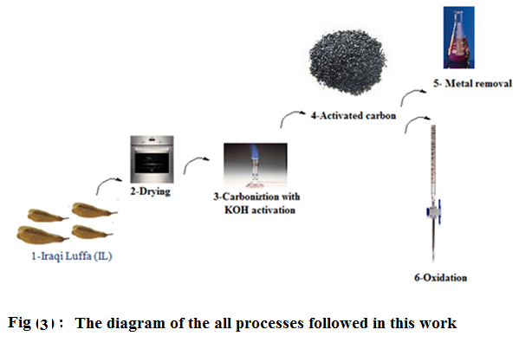

Hydrogen and oxygen are first removed in gaseous form by pyrolytic decomposition of the starting materials during carbonization. The free atoms of elementary carbon are grouped into organized crystallographic formations known as elementary graphite crystallites.The original organic substance may be split into fragments which regroup to form the thermo-stable aromatic structure existing in the hexagon ^{[18]}.
The effect of activating with KOH was evaluated by the iodine value and % yield of activated carbon (This ratio gives an idea about the amount of content that has left the substrate during production of the sample^{[19]}. The highest yield samples were 60-70% for all samples except AC⁵, indicating that the pores surfaces and structures were the best developed. The increase in the porosity of KOH activated carbons is associated with the gasification reaction. It is assumed that, during carbonization,
KOH is reduced to metallic potassium. The reaction of KOH and carbon occurs as follows ^{[20]}:

Consequently, with increasing the ratio of KOH/AC, more pores with large surface areas would be formed while, when the ratio arrived at a certain value, the pores would be widened and burnt off ^{[21]}
These results are in a a good agreement with the iodine adsorption values
, samples AC^{2,5,6and8} after activation have much more iodine adsorption capability about 847~962 mg/g than that of the blank (A¹ = 781.691mg/g), the pores of their pyrolyzed carbons were reformed and gave high iodine adsorption capability.^{[22]}. The iodine number value is an indication to the surface area of the activated carbon according to Puri and Bansal ^{[23-24]}.

As the activated carbon sample(AC²) gave the best value of iodine number (962.129 mg/g), it had the lowest ash percentage (0.98%). Ash is non-carbon or mineral additives, which is not chemically combined with the carbon surface^{[9]}, it consists of various useless mineral substances, which become more concentrate during the activation process, it comprises of 1-20 % and primarily depends on the type of raw material. High ash content is undesirable for activated carbon since it reduces the mechanical strength of carbon and affects adsorptive capacity ^{[14]}. Here all the samples gave a very good results(up to 3.1%), but the AC^{2&5} Iodine No. mg/gm (962.129 and 917.450 respectively) which are better even than the commercial AC^{BDH} (908.000), Table (2)
The FT-IR spectrum of activated carbon AC² which was selected as a representative for these samples came in a good agreement with the proposed structure The disappearing of absorption bands at 1246 cm⁻¹, 1377 –1447 cm⁻¹ and 1520 – 1622 cm⁻¹ predicting the declining of phenolic, lactonic and OH groups respectively, which related to unactivated carbon ^{[17]}.The IR of oxiran showed frequency of C-O str.(890cm⁻¹) specific for trans epoxides, and the disappearing of absorption bands of aliphatic double bond frequency and relative increased of carbonyl frequency to 1685-1700 cm⁻¹ indicates the absence of conjugation .

Thermogravimetric analysis and differentialthermal analysis (TGA/DTG) of biomass sample:
Thermal Gravimetric Analysis (TGA):

Figure (4) indicated that most of AC are stable between 250 – 350 ºC, and if we compare the activated carbon with Iraqi Luffa , the Iraqi Luffa stable tell 285 ºC but decompose faster than activated carbon [18].
TGA-DTG curve of pine wood carried out in nitrogen atmosphere which was shown in Fig(5) indicated that the initial weight loss begins at around 100ºC due to presence of moisture. Further weight loss was observed in temperature range between 230~350ºC due to decomposition of hemicelluloses and also volatile present in the Luffa. A major weight loss occurred in the temperature range of 285~500ºC due to decomposition of cellulose and lignin leaving behind a carbon preform.

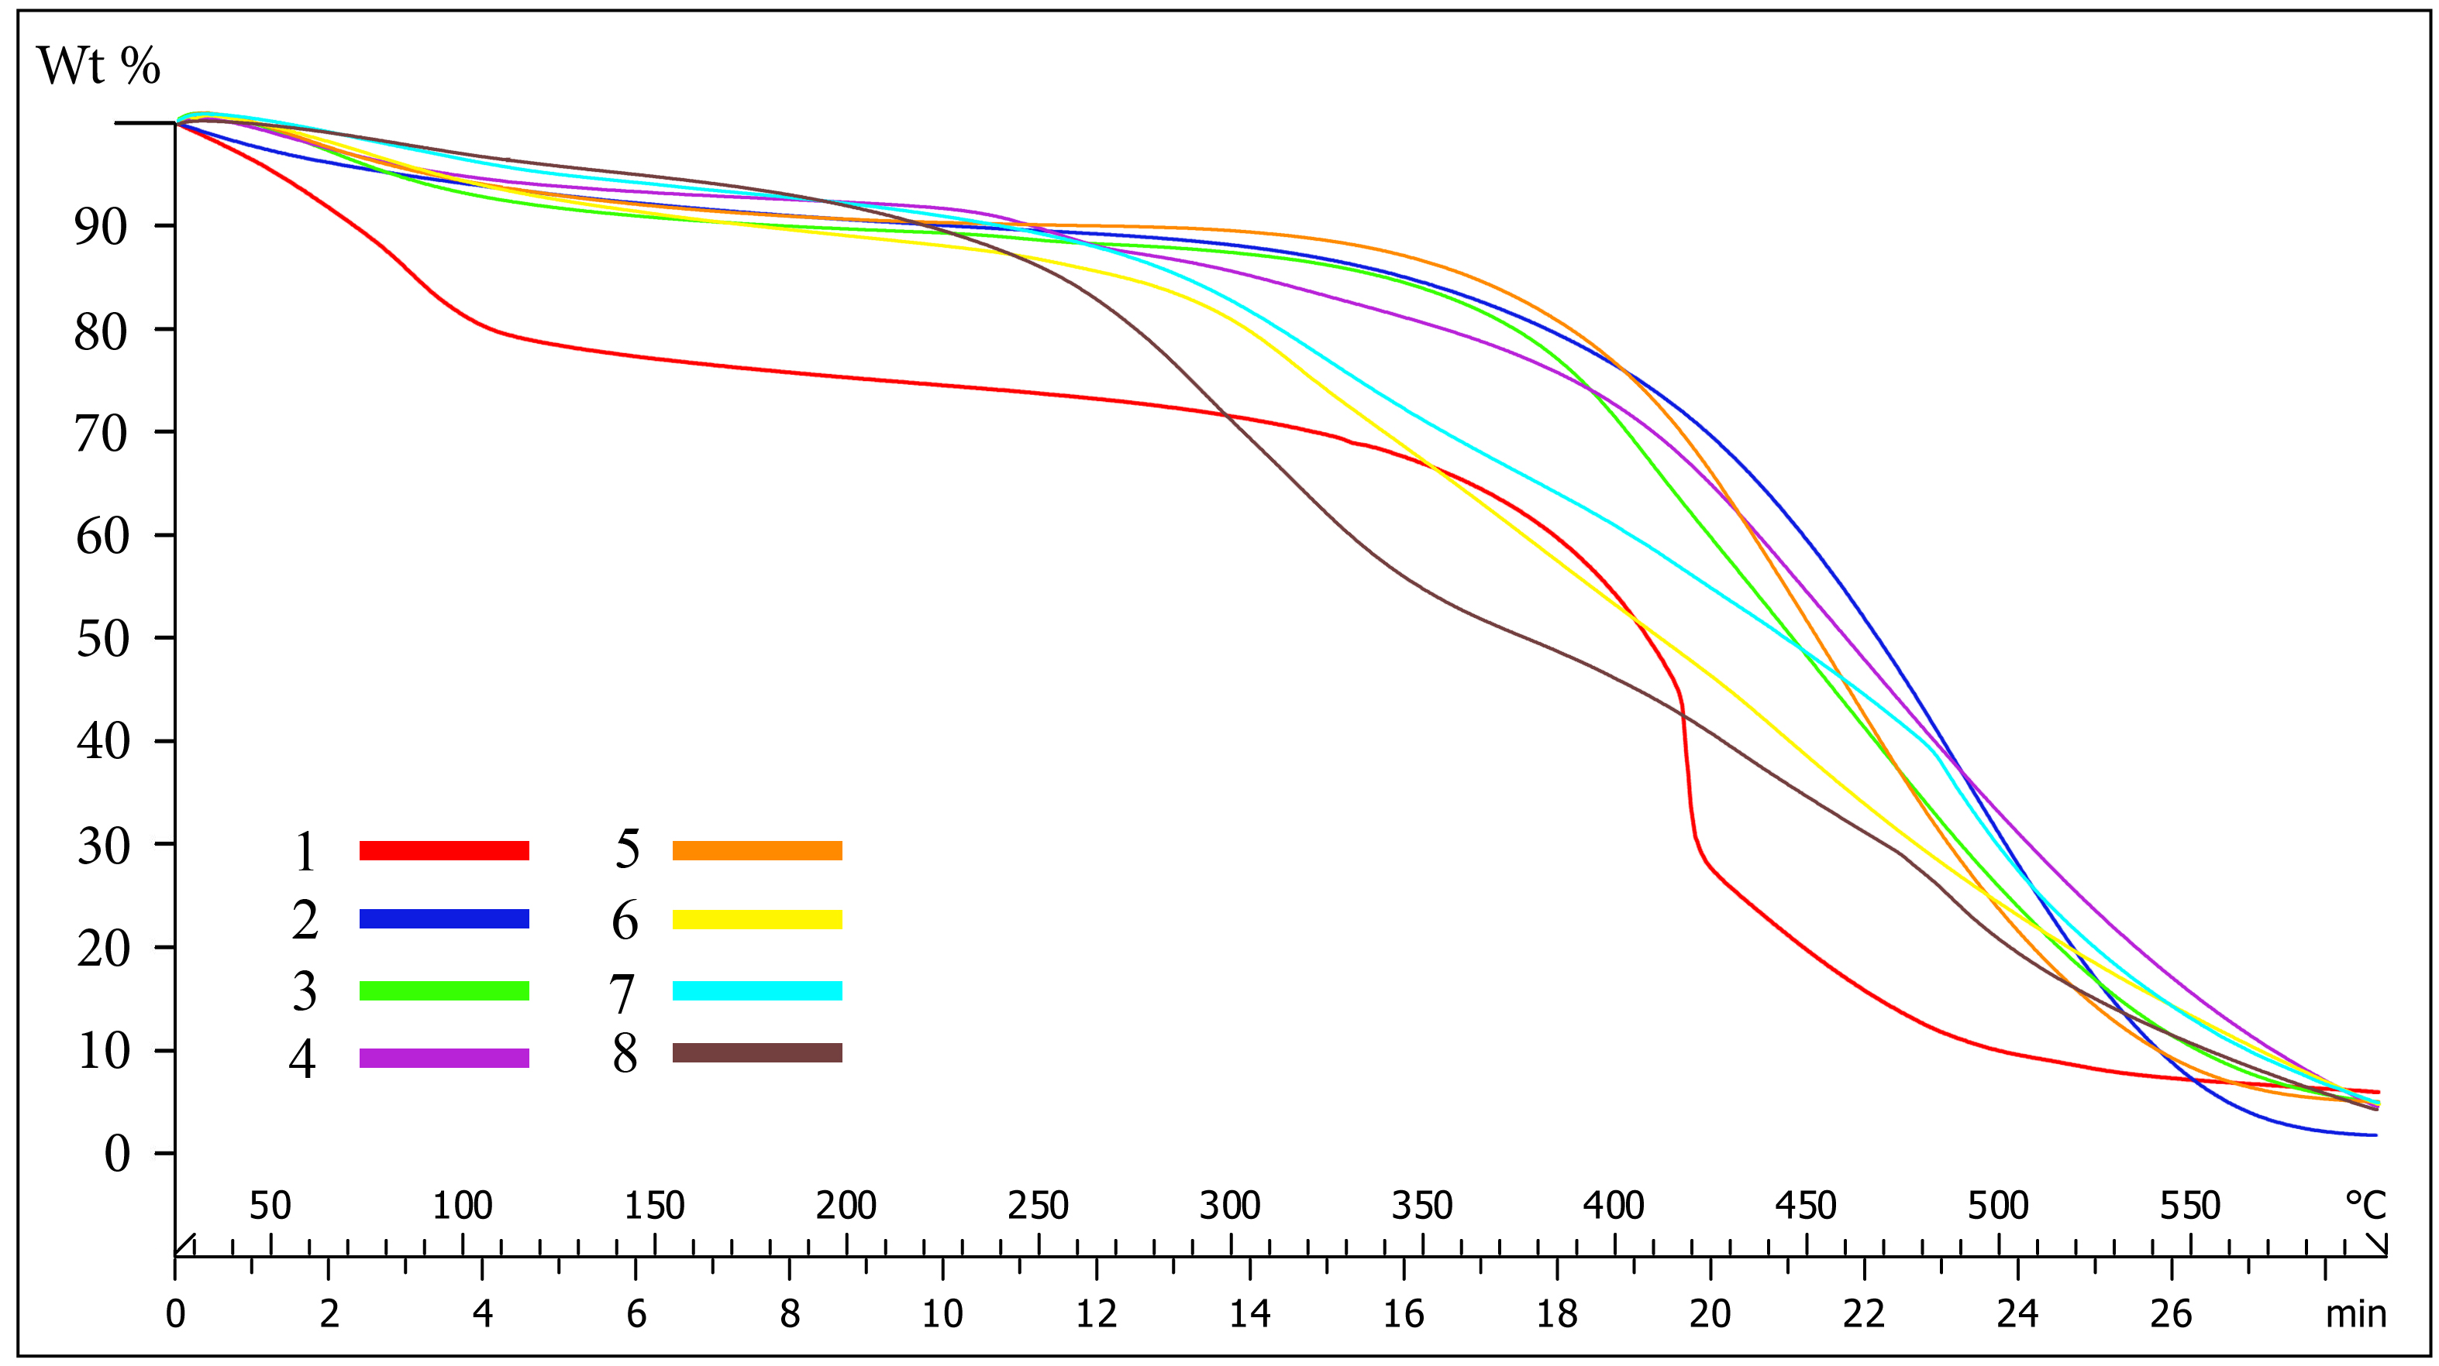
Figure (4): Thermal diagram of the activated carbon samples (AC¹⁻⁸)

Figure (5): The TGA and DTG of the activated carbon samples (AC¹⁻⁸)

Oxidation of chalcones to oxiranes:
In recent years, carbon materials have found many new applications such as catalyst supports , such applications usually possess high mesoporosity thereby allowing efficient adsorption of molecules and ions that are too large to enter micropores. It has been reported that the pore size and pore size distributions of activated carbons have a strong effect on the adsorption of organic compounds^{[22]}.
Adsorption/catalytic oxidation process can be divided into two categories: in situ and out situ adsorption with catalytic oxidation, according to whether adsorption process and oxidation process occur in the same reactor.
Advanced oxidation methods were used to oxidizing chalcones to oxiranes in aqueous solutions, as show in the following Scheme (1).

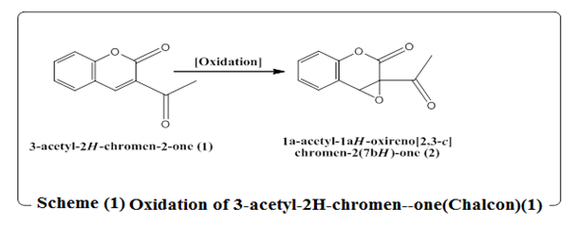

Wet peroxide oxidation (WPO) was found to be the best method in terms of the peroxidation of chalcones. 3-Acetyl-2H-chromen-2-one was chosen as a model for determining the suitable reaction conditions include H₂O₂ dosage and catalyst (sodium bicarbonate) usage.
The continuous catalytic hydrogen peroxide oxidation (CCHPO) of chalcone to oxirane and. The initial oxidation rate is proportional to the H₂O₂ dosage, no oxidation color change is observed until the dosage of H₂O₂ is more than 100% of the stoichiometric mount of the compounds and their hydrides^{[25]}. The reaction occurring on the support surface of AC by an autocatalytic mechanism in which the key role is played by H₂O_{2,} Scheme 2. One of the most important features of the surface reaction is the relatively slow oxidation with high yield and purity.

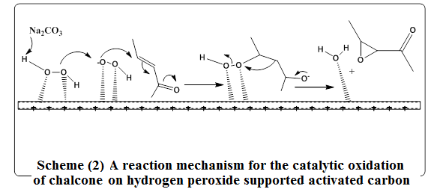

Heavy metal removal :
The removal of heavy metal ions via adsorption over solid adsorbents (activated carbons) is one of the most d useconvenient methods^{[26]}.
Trace concentrations of lead ions in water can be removed using activated carbon. The removal percentages were varied from 26 to 64% which indicated that this was an effective technique for the treatment of Lead aqueous wastewater as shown in Table (3).

Table (3) : Lead removal percentage by using activated carbon
A.C.Sample No. | Lead removal % | A.C.Sample No. | Lead removal %
1 | 13 | 5 | 64
2 | 52 | 6 | 26
3 | 28 | 7 | 37
4 | 61 | 8 | 45

Conclusion
The study indicates that the quality of activated carbon samples (AC²⁻⁸) prepared by chemical activation in KOH and heated into the burning chamber for charring is highly dependent on the preparation conditions and the optimum condition (with high pore surface area and volume) as the treatment with impregnation ratio 1/2 . The highest yield samples were 60-70% for all samples except AC⁵, indicating that the pores surfaces and structures were the best developed accessible for different adsorbents comparative with the non-activated carbon (AC¹) of the lower surface area .
While thermal gravimetric analysis (TGA) of activated carbon is important. It was observed that most of activated carbon are stable between 250 – 350 ºC, TGA-DTG showed that the initial weight loss begins at around 100ºC due to presence of moisture. Further weight loss was observed in temperature range between 230~350ºC due to decomposition of hemicelluloses and also volatile present in the Luffa.
A major weight loss occurred in the temperature range of 285~500ºC due to decomposition of cellulose and lignin leaving behind a carbon preform.
In conclusion, the prepared activated carbon is good in inorganic applications as an effective adsorbent material for removal of toxic element (lead) in water (or wastewater).The removal percentages were varied from 26 to 64%. Also these samples could be used in organic applications as catalyst or catalyst support for oxidation of chalcones using hydrogen peroxide.
References
1-D. M., Ruthven,Principle of Adsorption and Adsorption Process, John Wiley and Sons, New York, (1984).
2-P. Sugumaran, V. Priya Susan, P. Ravichandran and S. Seshadri"
Production and Characterization of Activated Carbon from Banana Empty Fruit Bunch and Delonix regia Fruit Pod , Journal of Sustainable Energy & Environment 3 , 2012, 125-132.
3- W.T. Tsai, C.Y.Chang, S.Y.Wang, C.F.Chang, S.F.Chhien and H.F. Sun"Preparation of activated carbons from corn cob catalyzedby potassium salts and subsequent gasification with CO₂", Bioresorcer Technology, 2001, 78, 203-208.
4-Y.Zou and B.Han " High-Surface-Area Activated Carbon from Chinese Coal" Energy Fuels, 2001, 15 (6), 1383–1386.
5-J. Economy, M. Daley, C. Mangun, Activated Carbon Fibers – Past, Present and Futur. AmericanChemical Society, Division of Fuel Chemistry Preprints, New Orleans, L. A. , p., 1996, 321.
6-M. E.Suarez;O.F. Stüber, A. Fortuny, A.Fabregat, J. Carrera and J. Font," Catalytic wet air oxidation of substituted phenols using activated carbon as catalyst" Applied Catalysis B: Environmental, 2005, 58, Issues 1–2, 8 , 105–114.
7-.J.A. Zazo; J.A. Casas; A.F. Mohedano andJ.J. Rodríguez" Catalytic wet peroxide oxidation of phenol with a Fe/active carbon catalyst " Applied Catalysis B: Environmental, 65, Issues 3–4, 6 June , 61–268.
8-S.Sirvestava and P.Goyal; Novel Bio Materials Decontamination of Toxic Metals From Waste Water"; Environmental Science and Engineering; Series Editors: R. Allan;U. Förstner;W. Salomons, Publish by : D. Franz" pp13-45(2012).
9-I. Uzun and , F. G¨uzel"Adsorption of Some Heavy Metal Ions from Aqueous Solution by Activated Carbon and Comparison of Percent Adsorption Results of Activated Carbon with those of Some Other Adsorbents" Turk J Chem, 2000, 24 , 291 – 297.
10-N. D. Tumin, A. L.Chuah, Z. ZAWANI , S.A. Rashid" Adsorption of Copper from Aqueous Solution by Elais Guinensis Kerrnel Activated Carbon" Journal of Engineering Science and Technology, 2008, 3(2), 180 – 189.
11-J. McGeer, G. Henningsen, R. Lanno, N. Fisher, K. Sappington, and J.Drexle" The Bioavailability and Bioaccumulation of metals"; Natural Resources Canada, Ottawa, ISSUE PAPER (2004).
12-Cleiton A. Nunes e Mário C. Guerreiro, "Estimation of Surface Area and Pore Volum of Activated Carbons by Methylene Blue and Iodine Numbers"Quim. Nova, 2011, 34(3), 472-476.
13-I.A.W. Tan, A.L. Ahmad and B.H. Hameed" Preparation of activated carbon from coconut husk: Optimization study on removal of 2,4,6-trichlorophenol using response surface methodology"; Journal of Hazardous Materials, 2008, 153, 709–717.
14-A.H.Abdullah, A.Kassim, Z. Zainal, M. Z.Hussien, D., F. Ahmad and O. S.Wooi, " Preparation and Characterization of Activated Carbon from GelamWood Bark (Melaleuca cajuputi)", Malaysian Journal of Analytical Sciences, 2001, 7(1), 65-68.
15-A.C. Nunes and M.C. Guerreiro"Estimation of surface area and pore volume of activated carbons by methylene blue and iodine numbers"Quím. Nova, 34(3) São Paulo ( 2011).
16-S.M.Saied, "Synthesis of Important Heterocyclic Compounds Oxygenous and Nitrogenous Five and Six Membered Rings", PhD Thesis, Mosul University. ,Col. Of Science ,Iraq(2000).
17-M. A. Al-Omair and E. A. El-Sharkawy"Removal of heavy metals via adsorption on activated carbon synthesised from solid wastes." Removal of Heavy Metals via Adsorption on Activated Carbons Synthesized from solid wastes; Arabian J. Chem., 2012, 1(2), 61-71.
18-L. M. Manocha, Ashish Warrier, S. Manocha, D.D. Edie, A.A. Ogale,
"Microstructure of Carbon- Carbon composite reinforced with pitch based ribbon shape carbon fibers"; 2003, l(No. and Issue No. 41), 1425-1436.
19-S. Dinesh"Development and Characterization of Pellet Activated Carbon from new Precursor"; BSC Thesis, IIT, Rourkela(2011).
20-X.Juanin,Z.M.Yu and Y. Wu "Preparation of Activated Carbon from Lignine Obtained by KOH and K2CO3 Chmical Activation"Cellulose Chem. Technol, 2012, 46 (1-2), 79-85.
21-X.J.JIN,Z.M.Yu and Y. Wu "Cellulose Chem. Technol., 2012, 46 (1-2), 79-85.
22-W.C. Oh; J.G.Kim; H.Kim; M.L.Chen; F.J.Zhang; K.Zhang; and Z.D. Meng" Preparation of Spherical Activated Carbon and Their
Physicochemical Properties " Journal of the Korean Ceramic Society, 2009,
46(6), 568~573.
23-J. Kipling and R. B. Wilson. . "Adsorption of methylene blue in the determination of surface areas". J. Applied Chem. 1960, 10, 109-113.
24-B. R. Puri and R. C. Bansal. Iodine adsorption method for measuring surface area of carbon blacks. Carbon. 3, 227-230(1965).
25-G.Chen, L.Lei and P.Yue "Wet Oxidation of High-Concentration eactive Dyes" Ind. Eng. Chem. Res., 1999, 38 (5), 1837–1843.
26-QU Jiuhui" Research progress of novel adsorption processes in water
purification: A review"; Journal of Environmental Sciences, 2008, 20, 1–13.

