Determination of Selenium , Magnesium , and Malondialdehyde (MDA)for Ischemic Heart Disease Patients

Ali Abdul Razzaq Abdul Wahid Nadhum Abdul Nabi Awad
E-mail : alirazaq2013@yahoo.com
University of Basrah , College of Science

Abdul Raheem Hussain Dawood
University of Basrah , College of Medicine

(NJC)

(Received on 27/10/2013) (Accepted for publication 23/3/2014)

Abstract
One hundred and nineteen ischemic heart disease (unstable angina and myocardial infarction ) patients (65 male and 54 female) aged between 40 to 85 years with a mean age of (61±11.27) were included in this study . The control group comprises one hundred twenty four healthy subjects (62 male and 62 female) aged between 30 to 60 years with a mean age of (36.37±7.72).
The present study were included the measurements of two essential elements (Selenium and Magnesium) and Malondialdehyde (MDA) for patients suffering from ischemic heart disease.
The work results show low levels of (Se and Mg) in the whole blood and serum of patients (58.21±6.72) ng/ml , (15.47±0.53) µg/ml respectively as compared with the mean values for control group (83.87±6.53) ng/ml , (22.79±0.76) µg/ml respectively with high significant differences (P˂0.001) between controls and patients groups. The level of (MDA) for controls was (2.08±0.16) mmol/l and (6.86±0.80) mmol/l for patients.
الخلاصة
تضمنت الدراسة الحالية 119 حالة مرضية لأشخاص يعانون من قصور في عضلة القلب (الذبحة والجلطة) بواقع 65 ذكر و54 أنثى تراوحت اعمارهم بين 40 الى 85 بمعدل (61±11.27) سنة ، بالإضافة الى 124 شخص من الاصحاء اللذين يمثلون مجموعة السيطرة بواقع 62 ذكر و 62 أنثى تتراوح اعمارهم بين 30 الى 60 سنة بمعدل (36.37±7.72) سنة .
تم قياس معدلات أثنين من العناصر الاساسية في الجسم وهما السيلينيوم والمغنيسيوم بالإضافة الى قياس معدل المالوندايالديهيد فيدم ومصل الاشخاص الخاضعين للدراسة ، ولقد وجد أن معدلات السيلينيوم والمغنيسيوم في دم ومصل الاشخاص المصابين بالمرض يساوي (58.21±6.72) نانوغرام/مل و (15.47±0.053) مايكروغرام/مل على التوالي وهي معدلات واطئة بالمقارنة مع معدلاتها في الاشخاص الاصحاء التي كانت تساوي (83.87±6.53)نانوغرام/مل و (22.79±0.76) مايركوغرام/مل على التوالي بفرق معنوي أقل من 0.001. كما وجد أن معدل المالوندايالديهيد في مصل الاشخاص الاصحاء يساوي (2.08±0.16) مليمول/لتر مقابل (6.86±0.08)مليمول/لتر في مصل الاشخاص المصابين بالمرض.
الكلمات المفتاحية : مرض قصور القلب ، المالوندايلديهيد ، السيلينيوم ، تصلب الشرايين.

Introduction
Ischemic heart disease characterized by reduction of blood flow in coronary arteries (the main source of blood for the heart) provide for the heart to function normally . Atherosclerosis is the commonest cause of ischemia starts by some fatty and calcium deposits on the wall of the coronary arteries and the fibrous tissue build up that lead to narrowing of the coronary arteries and reduction of blood flow which ultimately lead to reduction of nutrient and oxygen supply to myocardial tissue .^{[1,2]}
Compelling evidence now exists linking oxidative stress and the pathogenesis and progression of ischemic heart disease^{[3-6]} Oxidative Stress can be defined most simply as the imbalance between production of highly reactive molecules and the body’s antioxidants defense, potentially leading to damage to specific molecules with consequential injury to cells or tissue^{[7-9]}.Oxidative stress is thought to contribute to the development of a wide range of diseases including alzheimer's disease^{[10][11]}, parkinson's disease^{[12]}, the pathologies caused by diabetes^{[13][14]}, rheumatoid arthritis^{[15]}, and neurodegeneration in motor neuron diseases^{[16]} and finally ischemic heartdisease ^{[6][9][17][18]}.
Selenium is an essential trace mineral involved in protection against oxidative damage via selenium-dependent glutathione peroxidases and other selenoproteins^{[19]}. Current recommendations on dietary intake of selenium are based on optimizing the activity of plasma glutathione peroxidases^{[20]}. The recommended dietary allowance (RDA) for selenium that is estimated to be sufficient to meet the nutritional needs of nearly all healthy adults is 55 g/d ^{[20][21]}.
Magnesium is widely distributed in foods. Cereals and vegetables are rich in magnesium. The recommended dietary allowance of magnesium is 300 mg/day for adult non-pregnant woman and 350 mg/day for adult man. An adult human body contain about 25 g of magnesium and it is the second most abundant intracellular element in the body. About 1% of the total body magnesium is found in blood plasma, about a third of which is bound to proteins ^{[22][23]}.
In the recent past, it has been thought that a pure magnesium deficiency hardly ever occurred in man. Now, it is established that such a condition does really exist. Pure magnesium deficiency is characterized by a number of clinical features including muscular tremor, vertigo, ataxia, tetany, convulsions and organic brain syndrome. ^{[24]}.
Subjects
In the present work the study of effect some essential trace elements such as Se , Mg , and MDA in human blood and serum were measured in different subjects included (119) patients (65 male and 54 female) suffering from myocardial infarction (MI) and unstable angina aged between 40 to 85 years , matched with control group comprised of (124) healthy individuals (55 male and 69 female).
Samples Collection :
The blood samples of patients were collected from the Cardio Care Unit (CCU) in selected hospitals in Basrah City in Iraq. About (6 ml) of blood was drawn from forearm vein of patients suffering from myocardial infarction or unstable angina.
Three milliliter of blood samples was allowed to clot for about (10 minutes) at room temperature and centrifuged in (402 X g) for (15 minutes) , the serum was stored in deep freeze and became ready to use in digestion procedures for determining magnesium and Malondialdehyde (MDA) .
The rest of whole blood samples was kept in tubes containing heparin as an anticoagulant and became ready in digestion procedures for determining selenium.
Determination of Selenium by Hydride Generation Flame AAS:
The samples were digested by transferring (1 ml) of whole blood into a pyrex test tube, adding (1 ml) of conc. HNO₃ and (1 ml) of conc. H₂SO₄ , placing in oil bath at 130⁰C for 45 minutes , until nitric acid (brown fumes) boiling away. After that the tubes removed from bath and cooled to room temperature, added (1 ml) ml of 5M HClO4 , then replaced in oil bath at 130⁰C for 45 minutes , the tubes removed again from bath and cooled to room temperature , added (1 ml) of 6M HCl , replaced the tubes in bath at 95⁰C for 30 minutes then cooled to room temperature and diluted to (10 ml) by 6M HCl. ^{[25][26]}
Stock standard solutions of selenium prepared by taking (1 ml) of 1000 mg/l Se and diluting it to (100 ml) by 6M HCl , a 10 mg/l standard was formed then it used to made up (50 – 250) µg/l stock standards. All stock standards prepared by 6M HCl as a diluent. ^{[27]}
Determination of Magnesium by Flame AAS:
Stock standard solutions of magnesium were prepared by dissolving (10.140 gm) of MgSO₄.7H₂O in water containing (1 ml) of conc. H₂SO₄ and diluting the solution with deionized water in a volumetric flask to one liter. A (1000 µg/ml) standard was formed then it used to make up (0.5 – 30) µg/ml stock standards. All stock standards were prepared using deionized water as diluent.^{[28]}
The samples were digested by transferring (0.5 ml) of serum into a pyrex test tube, adding (4 ml) of (1:1) [conc. HNO₃ and conc. HClO₄] , placing in oil bath at 160⁰C for one hour. After that the tubes were removed from bath and cooled at room temperature, then the volume was completed to (10 ml) by 0.5 M HCl. ^{[25][26]}

Determination of Malondialdehyde:
- The blank and sample were prepared as follows:

Reagent | Blank | Sample
Serum | - | 150 µl
Trichloroacetic acid (TCA) (17.5%) | 1 ml | 1 ml
2-thiobarbituric acid (TBA) (0.6%) | 1 ml | 1 ml

2. The mixtures were mixed well by vortex and incubated in boiling water bath for 15 minutes , then allowed to cool.
3. A (1 ml) of TCA (70% w/v) was added for both tubes (blank and sample).
4. The mixture was let to stand at room temperature for 20 minutes and centrifuged at 1200 x g for 15 minutes , and the supernatant was taken out to read the absorbance of sample at 532 nm.
Statistical Analysis:
Data were analyzed using SPSS software (Version 20.0) and the values were expressed as mean and standard deviation. Pearson’s correlation analysis was carried out. All comparison were 2-tailed , and p value of <0.05 or <0.01 were considered significant.
Results:
The participants in this work were divided according to some affected factors including age , gender , and smoking.
A- Age Effect:
- Age Effect on Selenium Concentrations:
Table (1) and figure (1) show the concentration of selenium in controls and patients group for all life spans.

Table (1): Concentration of SeleniumRelated to Life Span.

 |  | Selenium Concentration (ng/ml)
Life Span | Age Range | Control | Patients | P-Value
1 | 30 – 40 | 84.06±6.30 | - | -
2 | 41 – 50 | 83.50±5.80 | 64.82±2.58 | ˂0.001
3 | 51 – 60 | 81.00±7.93 | 58.88±5.65 | ˂0.001
4 | 61 – 70 | - | 57.67±5.38 | -
5 | 71 -85 | - | 51.61±5.56 | -
Total |  | 83.87±6.53 | 58.21±6.72 | ˂0.001

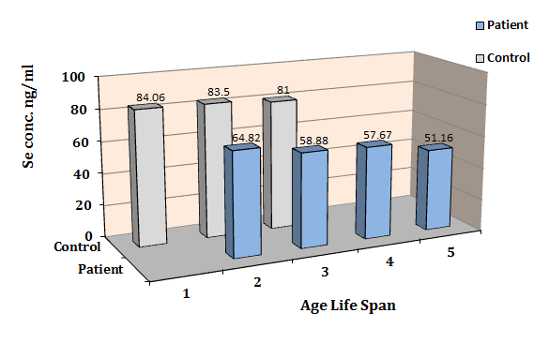

Figure (1 ) : Concentrations of Selenium Related to Life Span.

2 . Age Effect on Magnesium Concentrations:
Table (2) and figure (2) show the concentration
of magnesium in controls and patients group for all
life spans.

Table ( 2 ): Concentrations of Magnesium Related to Life Span.
 |  | Magnesium Concentration(µg/ml)
Life Span | Age Range | Control | Patients | P-Value
1 | 30 – 40 | 23.07±0.24 | - | -
2 | 41 – 50 | 22.78±0.73 | 15.43±0.55 | ˂0.001
3 | 51 – 60 | 22.76±0.81 | 15.10±0.48 | ˂0.001
4 | 61 – 70 | - | 15.39±0.61 | -
5 | 71 -85 | - | 15.70±0.54 | -
Total |  | 22.79±0.76 | 15.47±0.53 | ˂0.001
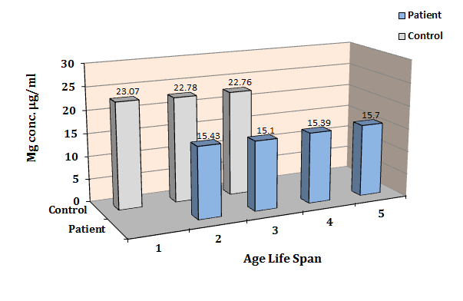

Figure (2 ) : Concentration of Magnesium Related to Life Span.

B- Gender Effect:
1.GenderEffect on Selenium Concentrations:
Table (3) and figure (3) show the concentrations of
selenium related to gender.

Table (3): Concentrations of Selenium Related to Gender.

 | SeleniumnConcentration(ng/ml)
Gender | Control | Patients | P-Value
Male | 90.05±2.39 | 62.36±3.75 | ˂0.001
Female | 77.31±1.84 | 53.13±6.07 | ˂0.001

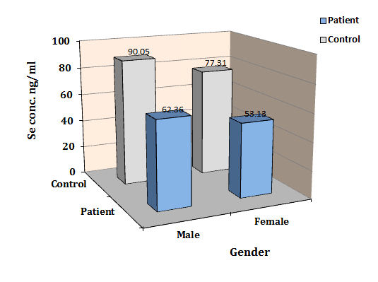

Figure (3 ) : Concentrations of Selenium Related to Gender.

2.GenderEffect on Magnesium Concentrations:
Table (4 ) and figure (4 ) show the concentrations
of magnesium related to gender.

Table (4 ): Concentrations of Magnesium Related to Gender.
 | Magnesium Concentration (µg/ml)
Gender | Control | Patients | P-Value
Male | 22.94±0.84 | 15.48±0.46 | ˂0.001
Female | 22.64±0.67 | 15.05±0.63 | ˂0.001

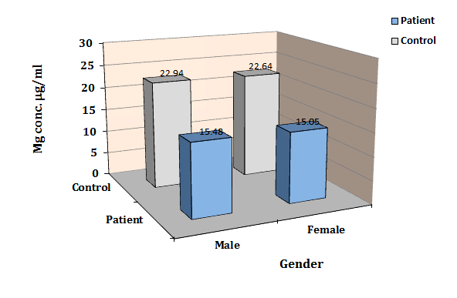

Figure (4 ) : Concentrations of Magnesium Related to Gender.

C- Smoking Effects:
- SmokingEffect on Selenium Concentrations:
Table (5) and figure (5) show the statistical result
which clarify the relationship between concentrations
of selenium and smoking status.

Table (5 ): Concentrations of Selenium Related to Smoking Status.
 |  |  | Selenium Concentration (ng/ml)
Manner | Gender | Control |  | Patients | P-Value
Non-Smoking | Male | 90.05±2.39 |  | 64.25±3.19 | ˂0.001
 | Female | 77.31±1.84 |  | 53.06±5.90 | ˂0.001
Smoking | Male | - |  | 51.24±3.75 | -
 | Female | - |  | 49.90±7.21 | -
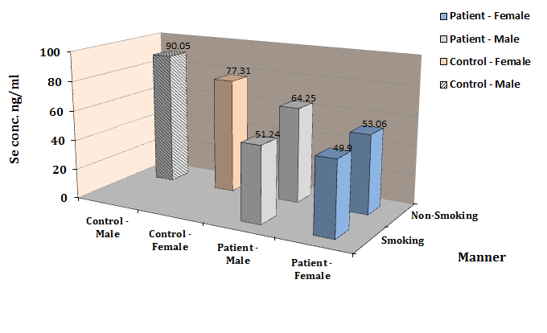

Figure (5 ) : Concentration of Selenium Related to Smoking Status.

1.Smoking Effect on Magnesium Concentrations:
Table (6) and figure (6) show the statistical result
which clarify the relationship between concentrations
of magnesium and smoking status.
Table (6 ): Concentrations of Magnesium Related to Smoking Effect.
 |  |  | Magnesium Concentration (µg/ml)
Manner | Gender | Control |  | Patients | P-Value
Non-Smoking | Male | 22.94±0.84 |  | 15.36±0.35 | ˂0.001
 | Female | 22.64±0.67 |  | 15.42±0.68 | ˂0.001
Smoking | Male | - |  | 15.58±0.52 | -
 | Female | - |  | 15.71±0.13 | -
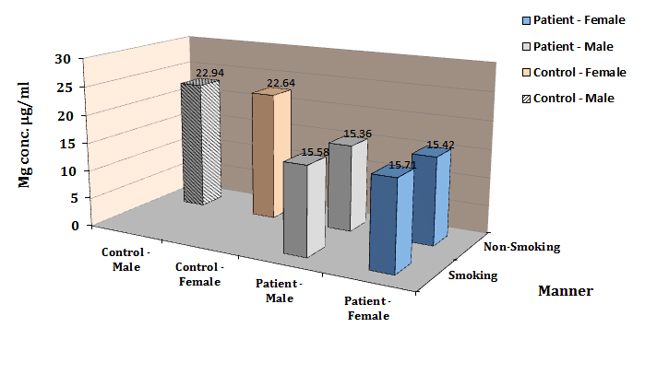

Figure (6) : Concentrations of Magnesium Related to Smoking Effect.

Discussion
In this study the age factor was divided into five life spans , the first life span (30-40) year including controls only because under current study disease (myocardial infarction and unstable angina) rarely occur in this age period.
Fourth and fifth life span (61-70) year and (71-85) year including patients only because of a lot of health problems happened in this period and therefore , that were difficult of obtaining control subjects. As a consequence left only two life span (41-50) year and (51-60) year shared between patients and control groups.
Statistical analysis results in table (1) and figure (1) showed the total selenium concentrations in blood of control group were higher than its total concentration in patients group (83.87±6.53 vs. 58.21±6.72) ng/ml with high statistical significant (P˂0.001) , where the averages of selenium concentration in common life span were higher in control group as compared with patients group. These results are in consistent with many other studies ,Miettinen et. al. ^{[29]} reported that the selenium concentration was found for myocardial infarction patients (71.6 ± 13.7) ng/ml whereas its concentration for control was (72.9 ± 14.4) ng/ml .
Another study by Beagleholeet. al.^{[30]} reported that the selenium levels for ischemic heart disease patients lower than its levels in healthy subjects (82.7 ± 20.2 , 88.2 ± 20.7) ng/ml respectively ,on the other hand, Oster O. et. al.^{[31]}found that the selenium concentration in coronary heart disease was (64 ± 16) ng/ml whereas its level was (93 ± 15) ng/ml in whole blood of healthy group with (p<0.001).
The decreased levels of selenium in ischemic heart disease patients can be attributed to the role of selenium as antioxidant.
Table (2 ) and figure (2 ) show the results of statistical analysis for total magnesium concentrations in blood of control group were higher than its total concentration in blood of patients group (22.79±0.76 vs. 15.47±0.53) µg/ml with high statistical significant (P˂0.001) , and the averages of magnesium concentration in common life span were higher in control group with comparison with patients group.
Our finding was similar to results found in studies , for example Oster O. et. al.^{[31]} found that the magnesium level in whole blood of coronary heart disease patients was (20.40 ± 3.60) µg/l whereas its level was (19.92 ± 2.40) µg/l in whole blood of healthy group .
Another study conducted by Tan I. et. al.^{[32]} reported that the magnesium concentration for acute myocardial infarction patients was (20 µg/ml) whereas its concentration for control was (21 µg/ml) .
Statistical analysis in tables (3) , (4) and figures (3) , (4) showed that selenium, magnesium levels in male were higher than their levels in female for both controls and patients groups , the study also showed that there were very high significant differences (P˂0.001) when comparing male and female individually between patients and healthy controls.
These gender related differences might be attributed to the physiological differences between two genders.
The smoking effect on myocardial infarction and unstable angina had been studied through the investigation of the relationship between the blood or serum level of essential elements (selenium , magnesium) with cigarette smoking.
This study were not included smoker female in control group , whereas68.06% of patients were smokers.
Statistical results in tables (5) , (6) and in figures (5 ) , (6) showed that the levels of selenium and magnesium in smoking patients were lower than their levels in non-smokers.
The study of Sam K. et. al.^{[33]} improve this result , which they found that the smoking lead to reduce the serum concentrations of selenium and zinc among adult Bangladesh males with heart disease.
Due to the fact said the elements under present study (Se, Mg) plays an important role as antioxidants, usually these levels was tend to decrease in smokers because the smoking is tend to increase oxidative stress and impair oxidant defense system.^{[34]}

References
- O. Bonow , L. Mann , P. Zipes , P. Libby and E. Braunwald"Braunwald's Heart Disease: A Textbook of Cardiovascular Medicine" , 8thedition. , Elsevier Saunders ,Philadelphia (2007).
- S. Mahomed and B. Spencer, "Contemporary Diagnosis and Management of Ischemic Heart Disease" , 1st edition , Handbooks in Health Care , US , (2003).
- M. J. Thomson, V. Puntmann and J. Kaski, "Atherosclerosis and Oxidant Stress: The End of the Road for Antioxidant Vitamin Treatment", Cardiovasc. Drugs Ther.;2007,21,195-210.
- N. A. Strobel, R. G. Fassett, S. A.Marsh and J. S. Coombes, "Oxidative stress biomarkers as predictors of cardiovascular disease", Int. J. of Cardiology.;2011,147, 191-201.
- I. M. Fearon and S. P.Faux, "Oxidative stress and cardiovascular disease: Novel tools give (free) radical insight", J. Molec. &Cellu. Cardiology.; 2009 , 47 , 372-381.
- D. Heistad, Y. Wakisaka, J. Miller, Y. Chu and R. Pena-Silva, "Novel Aspects of Oxidative Stress in Cardiovascular Diseases", Circulation .;2009,73(2), 201-207.
- I. V. Turko, S. Marcondesand F. Murad, "Diabetes-associated nitration of tyrosine and inactivation of succinyl-CoA:3-oxoacid CoA-transferase", Am. J. Physiol. Heart Circ. Physiol.; 2001 , (281,6), 2289-2294.
- A. C. Maritim, R. A. Sanders and J. B. Watkins, "Diabetes, oxidative stress, and antioxidants: a review", J. Bio. Chem. Mol.Toxicol., 2003 ; 17 , 1 , 24-38.
- S. Cottone, M. Lorito and R. Riccobene, "Oxidative stress, inﬂammation and cardiovascular disease in chronic renal failure", J. Nephrol., 2008 ; 21 , 175–9.
- Y. Christen, "Oxidative stress and Alzheimer disease", Am. J. Clin. Nutr. , 2000 ; 71 , 2 , 621–629.
- A. Nunomura, R. Castellani, X. Zhu, P. Moreira, G. Perry and M. Smith, "Involvement of oxidative stress in Alzheimer disease", J. Neuropathol. Exp. Neurol. , 2006 ; 65 , 7 , 631–41.
- A. Wood-Kaczmar, S. Gandhi and N. Wood, "Understanding the molecular causes of Parkinson's disease", Trends Mol. Med. , 2006 ; 12 , 11 , 521–8.
- G. Davì, A. Falco and C. Patrono, "Lipid peroxidation in diabetes mellitus", Antioxid. Redox Signal. , 2005 ; 7 , (1–2) , 256–68.
- D. Giugliano, A. Ceriello and G. Paolisso, "Oxidative stress and diabetic vascular complications", Diabetes Care, 1996 ; 19 , 3 , 257–67.
- C. Hitchon and H. El-Gabalawy, "Oxidation in rheumatoid arthritis", Arthritis Res. Ther. , (2004) ; 6 , 6 , 265–78.
- M. Cookson and P. Shaw, "Oxidative stress and motor neurone disease", Brain Pathol. , (1999) ; 9 , 1 , 165–86.
- L. Van, I. Mertens and C. De Block, "Mechanisms linking obesity with cardiovascular disease", Nature , (2006) ; 444 , 7121 , 875–80.
- M. Aviram, "Review of human studies on oxidative damage and antioxidant protection related to cardiovascular diseases", Free Radic. Res., (2000) ; 33 , 85–97.
- M. P. Rayman, "The importance of Selenium to Human health", Lancet, (2000) ; 356 , 233–41.
- Institute of medicine, Panel on Dietary Antioxidants and Related Compounds. Dietary Reference In takes for vitamin C, vitamin E, Selenium and Carotenoids. Washington, DC : National Academy Press, (2000).
- M. P. Rayman, "A review of the evidence and mechanism of action", Pro.Nutr. Soc., (2005) ; 64 , 527–42.
- F. Liao, A. Folsom and F. Brancati, "Is low magnesium concentration a risk factor for coronary heart disease ? The atherosclerosis in community", Am. Heart. J., (1998) ; 136 , 480–490.
- E. M. Hampton, D.D. Whang, R. Whang, "Intravenous magnesium therapy in acute myocardial infarction",Ann. Pharmacother., (1994) ; 28 , 212-219.
- Y. Itokawa and J. Durlach,"Magnesium in health and Disease", 1^{st.} ed., John Libby and Co. Ltd., London ., (1989).
- R. Weatherby , "Reference Guide to Blood Chemistry Analysis", 2 nd edition , Bear Mountain Publishing , US. , (2000).
- D. Weatherby , and S. Feruson , "Blood Chemistry and CBC Analysis" , 1st edition , Weatherby& Associates , UK. , (2004).
- Z. Marczenko , "Spectrophotometric Determination of Elements" , 1st edition ,Ellis Horwood , Poland , (1976).
- P. Pinon and J. C. Kaski, "Inflammation, atherosclerosis and cardiovascular disease risk" Rev. Esp. Cardiol., (2006) ; 59 , 247-58.
- T. Miettinen , G. Alfthan , and J. Huttunen , "Serum Selenium Concentration Related to Myocardial Infarction and Fatty Acid Content of Serum Lipids" , Med J Clin Res , (1983) ; 287 , 517–9.
- R. Beaglehole , R. Jackson , J. Watkinson , R. Scragg , and R. Yee , "Decreased Blood Selenium and Risk of Myocardial Infarction" , Int J Epidemiol , (1990) ; 19 , 918 –22.
- O. Oster, M. Dahm , H. Oelert , and W. Prellwltz , "Concentrationsof Some Trace Elements (Se, Zn, Cu, Fe, Mg, K) in Bloodand Heart Tissue of Patientswith Coronary Heart Disease" , Clin. Chem. , (1989) , 35 , 5, 851-6.
- I. Tan, K.Chua,andA.Toh, "Serum Magnesium, Copper, and Zinc Concentrations in Acute Myocardial Infarction" , J Clin Lab Anal. , (1992) ;6 , 53 , 24-8.
- S. K. Bashar and A. K. Mitra , "Effect of Smoking on Vitamin A, Vitamin E, and other Trace Elements in Patients with Cardiovascular Disease in Bangladesh: a Cross-Sectional Study" , Nutrition Journal , (2004) , 3 , 18 , 1-5.
- S. Kim , J. Kim , H. Shin , and C. Keen , "Influence of smoking on markers of oxidative stress and Serum mineral Concentrations in Teenage girls in Korea" , Nutrition , (2003) ; 19 , 240-3.

