The Protective Effect of Quercetin on Diazinon-Induced Oxidative Stress in Rats
Mohammed Talat Abbas
Department of Clinical Laboratory Science, College of Pharmacy, Kerbala

(NJC)
(Received on 10/11/2013) (Accepted for publication11/3/2014)

Abstract:
The aim of this study is to evaluate the protective effect of quercetin on diazinon-induced oxidative stress in the liver, kidney and heart tissues of male albino rats. The current study included 24 male rats, which were divided into 4 groups, each group included 6 rats: group 1 as a control group ,Group 2 was given diazinon at 10 mg/kg /day, orally via gavage ,Group 3 was given quercetin as intraperitoneal (IP) at 25 mg/kg/day and diazinon + quercetin group were given diazinon at 10 mg/kg/day/orally via gavage and quercetin at 25 mg/kg/day, IP for 4 weeks. The results show significantly increase in serum ( AST and ALT activity),(urea and creatinine levels) and (Creatine kinase activity) which is associated with histopathological damage of the liver, kidney and heart tissue's architecture respectively due to the administration of the diazinon and this increase or damage is positively correlate with concentrations of the liver, kidney and heart MDA and negative correlation with the activity of catalase, superoxide dismutase and glutathione peroxidase on the liver, kidney and heart tissue homogenate, this modulation of the biological parameter histological damage is significantly neutralized by the administration of the quercetin. Our data suggest that supplementation of quercetin may be useful in reducing diazinon hepatotoxicity, nephrotoxicity and cardiotoxicity in rats which has the potential protective effect of quercetin and can be said.
Key words: Diazinon, Quercetin, Oxidative stress, Rats
الخلاصة
الهدف من الدراسة هي تقييم استخدام مادة الكوارستين لمعالجة جهد الاكسدة الناتج من استخدام الديازينون. في هذه التجربة تم استخدام 24 جرذا , قسمت الى اربع مجاميع كل مجموعة تضم 6 جرذا. المجموعة الاولى كانت المجموعة الضابطة, المجموعة الثانية كانت مجموعة الديازينون في هذه المجموعة اعطيت للجرذان
مادة الديازينون عن طريق الفم بواسطة الانبوب المعوي بتركيز 10/ملغم/كغم يوميا , المجموعة الثالثة كانت مجموعة الكوارستين هذه المجموعة حقنت بمادة الكوارستين بتركيز 25/ملغم/كغم يوميا اما المجموعة الرابعة كانت مجموعة الديازينون+ الكوارستين هذه المجموعة استقبلت الديازينون عن طريق الفم وبواسطة الانبوب المعوي بتركيز 10/ملغم/كغم يوميا بالاضافة الى ذلك حقنت بمادة الكوارستين بتركيز 25/ملغم/كغم يوميا ولمدة اربعة اسابيع.اظهرت النتائج زيادة معنوية في تركيز مصل اليوريا, الكرياتينين, الكرياتين كاينيز, الالنين امينوتر انسفيريز واسبارتيت ترانسفيريز وهذه الزيادة متزامنة مع التلف في معمارية خلايا الكبد,الكلية والقلب بالترتيب نتيجة الحقن بالديازينون وهذه الزيادة او التلف ترتبط ايجابيا بتركيز من المالونداي الدهايد وسلبيا بفعالية كل من الكاتاليز,سوبر اوكسايد دسميوتاز والكلوتاثايون بيروكسديز في خلايا الكبد , الكلية والقلب وهذا الاختلاف في هذه التحاليل الحيوية عدلت باستخدام مادة الكوارستين بصورة معنوية.من خلال النتائج التي تم التوصل اليها تبين بان تجهيز الجرذان المعرضة للديازينون بالكوارستين تكون مفيدة للتقليل من سمية الكبد,الكلية والقلب. ويمكن ان نقول بان الكوارستين له تاثيرات حافظية قوية.
كلمة المفتاح: الديازينون,الكوارستين,الجهد المؤكسد,الجرذان.

Introduction:

Oxidative stress is defined as the imbalance between reactive oxygen species and antioxidants; it is produced when the reactive oxygen species are more than the antioxidant capacity.¹⁻³Several conditions are associated with oxidative stress shortage of antioxidant vitamin and selenium intake, pollution, smoking, diseases, and drugs.^{3,4}
Pesticides are synthetic chemical substances that are deliberately introduced into the environment tocontrol any type of unwanted organisms. Contact with organophosphorus (OP) pesticides is an important health problem for agricultural workers.⁵Some of these pesticides are highly toxic for humans and animals.^{6,7}OP insecticides represent a major class of pesticides in use today. OP insecticides are used throughout the world for control of agricultural and domestic insect pests. These chemicals act by interfering with the activities of cholinesterase, an enzyme that is essential for the proper working of the nervous systems of both humans and insects⁸⁻¹¹
Diazinon (DZN) (C₁₂ H₂₁ N₂ O₃ PS), O,O-diethyl O-(2-isopropyl-6-methyl4 pyrimidinyl) phosphorothioate (Fig. 1) is the common name for a synthetic organophosphate pesticide first registered in the United States in 1956. DZN is a non-systemic insecticide used in agriculture to control soil and foliage insects and pests on a variety of fruit, vegetable, nut and field crops. DZN is also used on non-lactating cattle in an insecticidal ear tag.¹²⁻¹⁴

Figure (1):The chemical structure of diazinon.

DZN inhibits acetyl cholinesterase activity and other organic functions.¹⁵Mohammadet al. reported that toxic manifestations induced by OP may be related with the enhanced production of reactive oxygen species (ROS) . In the body, these pesticides can disturb the balance of antioxidants as well as lipid peroxidation (LPO) .¹⁶Some reports have been published with respect to DZN and its effects on haematological and biochemical parameters of rat, rabbits and mice .¹⁷⁻²¹Toxicities of OP insecticide DZN cause adverse effects on many organs ¹⁸. Other systems that could be affected are immune system , urinary system , reproductive system , pancreas , liver ,kidney and heart.^{13,22-25}
Flavonoids or bioflavonoids (from the Latin word flavus meaning yellow), also collectively known as vitamin P and citrin, are a class of plant secondary metabolites or yellow pigments having a structure similar to that of flavones. Flavonoids are a group of polyphenolic compounds, which are widely distributed throughout the plant kingdom. Flavonoids are constituents of fruits, vegetables, and plant-derived beverages, as well as components in herbal-containing dietary supplements.²⁶Among flavonoids, the flavonol quercetin (3,3',4',5,7-pentahydroxyflavone) (Figure .2) is one of the most widely distributed in human dietary sources. It is found in onions, apple, legumes, green tea, red grape wines, brassica green vegetables, citrus fruits and so on.²⁷ This molecule has been reported to have potent antioxidant property and was found to be effective in various models of oxidative stress. ²⁸⁻ ³¹ It is prevents oxidative injury and cell death by several mechanisms, including scavenging oxygen radicals , inhibiting xanthine oxidase , lipid peroxidation, and chelating metal ions .³²⁻³⁵ In addition to that Quercetin have cardioprotective ,anti inflammatory, anti-cancer , anti-ulcer , anti-inflammatory, anti-allergic, antiviral and antibacterial effects .³⁶⁻⁴⁰ The aim of this study is to evaluatethe protective effect of Quercetin on Diazinon-induced oxidative stress in male albino rats.

Figure (2): Structure of quercetin.

Materials and Methods
Chemicals:

All chemicals used in this study were purchased from Sigma Chemical Co. (St. Louis, MO, USA) and were of analytical grade or the highest grade available. Diazinon 60 EC was applied as a commercial emulsifiable concentrate formulation containing 60% active ingredient, then, it was further diluted in distilled water to obtain the desired concentration. Rats were treated with Diazinon at a dose of 10 mg/kg/day, given orally via gavage for 4 weeks.⁴¹Quercetin was given intraperitoneal (IP) at a dose of 25 mg/kg/day as described.⁴²
Animals:
Twenty four male albino rats weighing about 200-220 g were used in this study. The animals were kept under good ventilation and received a balanced diet and water ad libitum throughout the experimental period. The experimental was carried out according to the guidelines of the committee for the purpose of control and supervision of experiments of animals, and approved by the animals ethical committee of kerbala University. Rats were divided randomly into four main groups (n= 6) as follow:
1) Control group received, standard diet without any treatment;
2) Diazinon-treated group, received standard diet supplemented orally with diazinon at dose of 10 mg/kg/day for a period of 4 weeks;
3) Quercetin-treated group, received standard diet, which was injected IP with Quercetin at a dose of 25mg /kg/day for a period of 4 weeks and
4) Diazinon+Quercetin-treated group,rats were treated with diazinon(10 mg/kg) and quercetin (25 mg/kg) daily for 4 weeks.
After 4 weeks, overnight fasted animals were sacrificed by cervical dislocation, and blood samples were collected in centrifuge tubes. Serum was separated from coagulant blood by centrifugation at 860^{X}g for 20 min, and then quickly frozen at -20°C for biochemical analysis (AST, ALT, urea, creatinine and CK). Small pieces of liver, kidney and heart tissues were separately weighed and homogenized in 10 volumes of cold 0.01 M Tris-HCL buffer (pH 7.4), using an automatic homogenizer. The homogenates were then centrifuged at 15,000 rpm for 15 min at 4 °C. Clear supernatants were used for the Malondialdehyde(MDA), Catalase (CAT),Superoxide Dismutase(SOD), and glutathione peroxidase (GSH_{PX)} assays.
Biochemical analysis:
Serum alanine aminotrasferase (ALT) and aspartate aminotransferase (AST) activities were estimated according to Reitman and Frankel methods.⁴³Serum creatinine concentration was measured by Jaffè reaction .⁴⁴Where as serum urea concentration was measured by enzymatic colorimetric method .⁴⁵Creatine kinase (CK) was measured by Rosalkimethods.⁴⁶ Tissue protein levels were measured according to the method used by Lowry et al. ⁴⁷ Tissue MDA assays were performed according to the guidelines of Ohkawa et al.⁴⁸ MDA is a product of lipid peroxidation that reacts with Thiobarbituric acid (TBA) under acidic conditions at 95 °C, forming a pink complex that absorbs at 532 nm. 1,1,3,3 Tetraethoxypropane was used as the standard. The results are expressed as nmol/g tissue.SOD activity was measured according to the method of Winterbourn.⁴⁹ It is based on the ability of superoxide dismutase to inhibit the reduction of nitroblutetrazolum(NBT) by superoxide, absorbances were monitored at wave length 560 nm. Tissue catalase was assayed according to the method of Beers and Sizer.⁵⁰Catalase catalyses the decomposition of hydrogen peroxide (H₂O₂) to water and oxygen, The enzyme activity was followed by the decreasing in absorbance at 240 nm at 15 second intervals. Tissue glutathione peroxidase was assayed according to the method of Leopold Flone et al . ⁵¹Oxidized glutathione formed during glutathione peroxidase reaction is instantly and continuously reduced by an excess of glutathione reductase activity for a constant level of glutathione. The concomitant oxidization of NADPH is monitored spectrophotometrically at 340 nm.
Histopathological studies:
The kidney, heart and liver tissues were excised and fixed in 10% formalin and stained with hematoxylin and eosin and then observed under microscope for histopathological changes.⁵²
Statistical analysis:
The data was analyzed using the Statistical Package for Social Science program (SPSS 12). For comparison between different experimental rat groups, one way analysis of variance (ANOVA) was used followed by Tukey’s test. The results were expressed as means ± MSE and P < 0.05 was considered to be statistically significant.
Results:
The administration of diazinon to the rats, cause the significant increase in blood urea, serum creatinine levels, AST , ALT and CK activity when we compared with control group .Co-administration of quercetin will decrease the rise in blood urea , serum creatinine levels, AST ,ALT and CK activity.(figure 3,4,5,6 and 7 respectively).

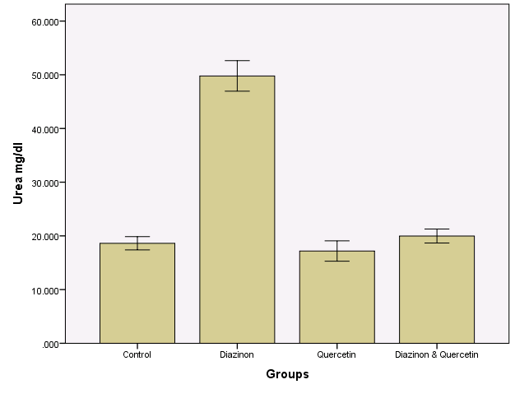
18.618ª
49.787^{b}
17.180ª
19.970ª

Figure(3 ):The effect of the treatments of the groups in blood urea concentration,
values are expressed as mean ± SME (n=6) P values where calculated by student t-tests, mean with different superscripts (a, b, c) differ significantly, P<0.05

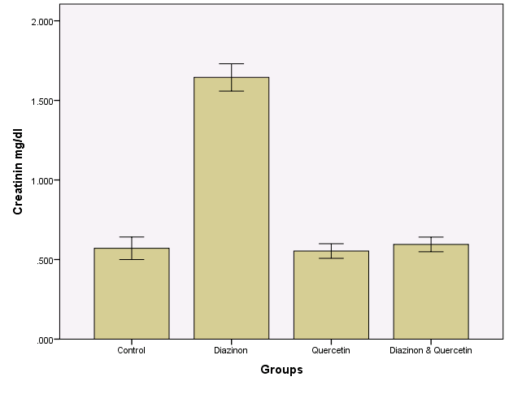
0.571ª

0.553ª
1.645^{b}
0.595 ª
Figure (4):The effect of the treatments of the groups in serum creatinine concentration, values are expressed as mean ± SME (n=6) P values where calculated by student t-tests, mean with different superscripts (a, b, c) differ significantly, P<0.05

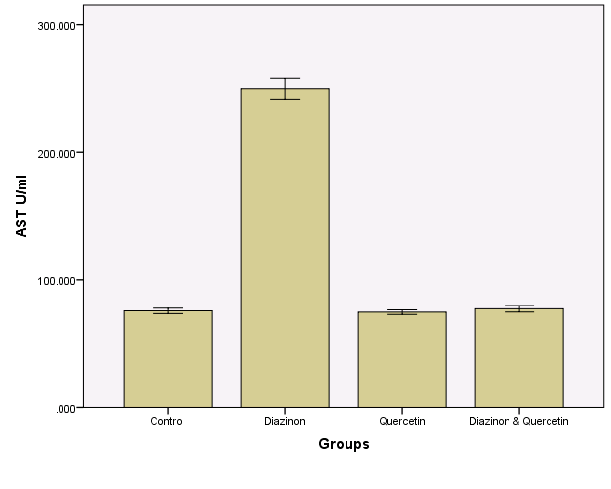
75.733ª
74.700 ª

250.100 ^{b} 00
77.367 ª
Figure (5):The effect of the treatments of the groups in serum AST activity ,
values are expressed as mean ± SME (n=6) P values where calculated by student t-tests, mean with different superscripts (a, b, c) differ significantly, P<0.05.

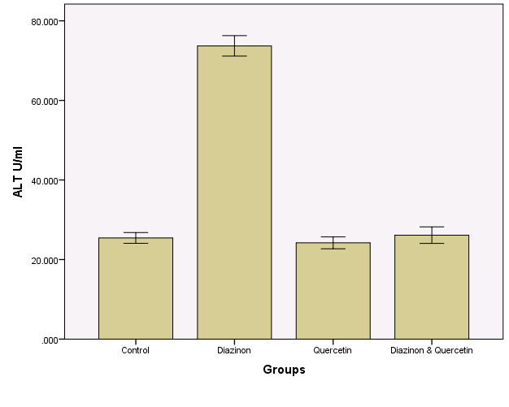
25.433 ª
24.200 ª
73.700^{bb}
26.133 ª

Figure (6):The effect of the treatments of the groups in serum ALT activity ,
values are expressed as mean ± SME (n=6) P values where calculated by student t-tests, mean with different superscripts (a, b, c) differ significantly, P<0.05.

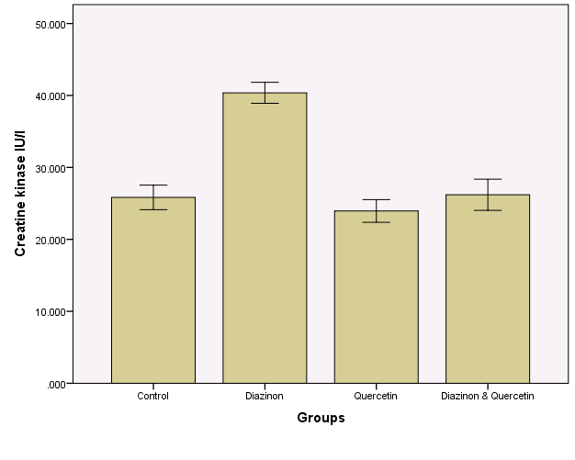
26.200ª
25.840 ª
40.368 ^{b}
23.955ª
Figure (7):The effect of the treatments of the groups in serum CK activity ,
values are expressed as mean ± SME (n=6) P values where calculated by student t-tests, mean with different superscripts (a, b, c) differ significantly, P<0.05.

In the liver, kidney and heart tissues ,MDA was significantly increased in diazinon treated group as compared to control group and this rise in MDA was decreased by quercetin. Antioxidant enzyme (SOD, CAT,GPx) activities were significantly different between the diazinon and the diazinon+quercetin groups. Compared to the control group, diazinon administration significantly decreased SOD, CAT, GP_{X} activity in the liver, kidney and heart tissues, while quercetin administration increased them compared with that in the diazinon group (figure 8,9,10,11,12,13,14,15,16,17,18and 19).

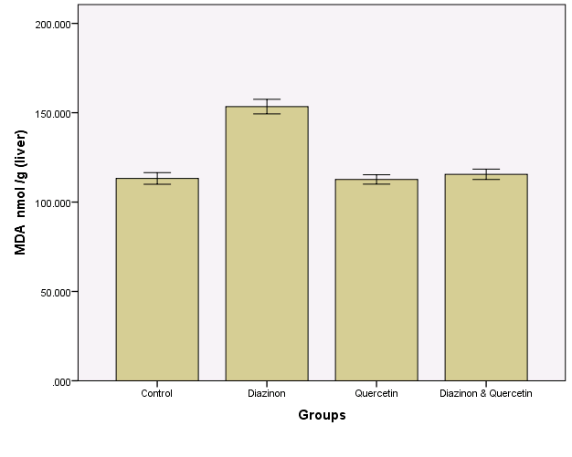
113.205ª
112.655 ª
115.537 ª
153.440^{b}

Figure (8):The effect of the treatments of the groups in MDA concentration in liver
homogenate, values are expressed as mean ± SME (n=6) P values where calculated by
student t-tests, mean with different superscripts (a, b, c) differ significantly, P<0.05.

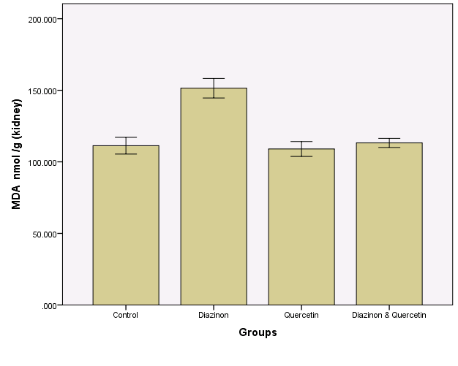
111.283 ª
151.462^{b}
109.010 ª
113.218 ª
Figure (9): The effect of the treatments of the groups in MDA concentration in kidney homogenate, values are expressed as mean ± SME (n=6) P values where calculated by student t-tests, mean with different superscripts (a, b, c) differ significantly, P<0.05

120.765 ^{b}
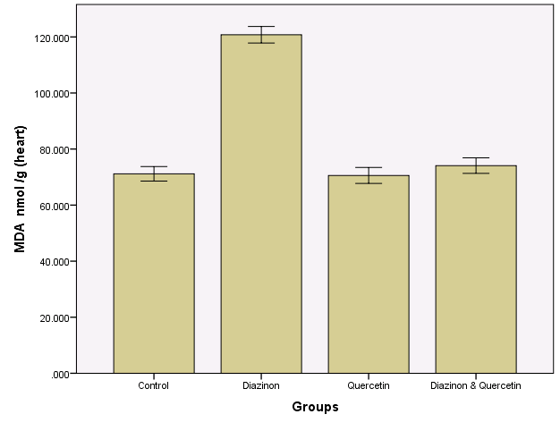
71.153 ª
70.580 ª
74.083 ª
Figure (10):The effect of the treatments of the groups in MDA concentration in heart
homogenate, values are expressed as mean ± SME (n=6) P values where calculated by
student t-tests, mean with different superscripts (a, b, c) differ significantly, P<0.05

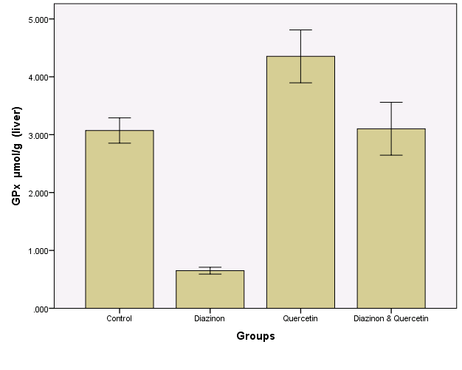
3.071 ^{b}
71
0.650 ª
4.353 ^{b}
3.103 ^{b}
Figure (11): The effect of the treatments of the groups in GPx activity in liver
homogenate, values are expressed as mean ± SME (n=6) P values where calculated by
student t-tests, mean with different superscripts (a, b, c) differ significantly, P<0.05

3.436 ^{b}
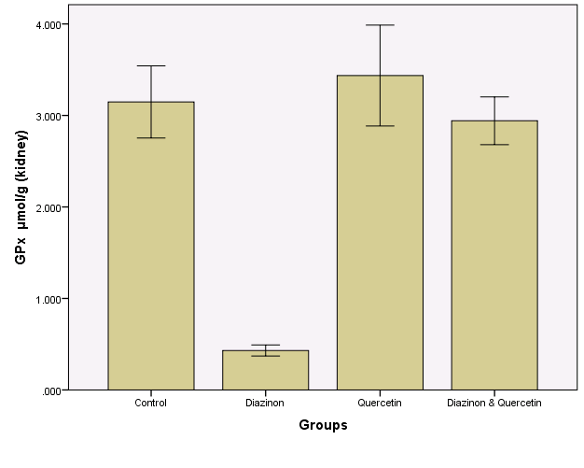
3.147^{b}
0.431 ª
2.942 ^{b}
Figure (12):The effect of the treatments of the groups in GPx activity in kidney
homogenate, values are expressed as mean ± SME (n=6) P values where calculated by
student t-tests, mean with different superscripts (a, b, c) differ significantly, P<0.05

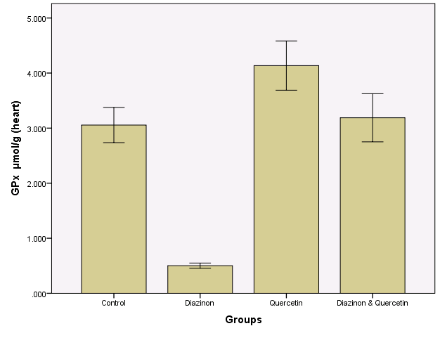
3.055^{b}
0.501ª
4.136 ^{b}
3.188^{b}
Figure (13):The effect of the treatments of the groups in GPx activity in heart homogenate, values are expressed as mean ± SME (n=6) P values where calculated bystudent t-tests, mean with different superscripts (a, b, c) differ significantly, P<0.05
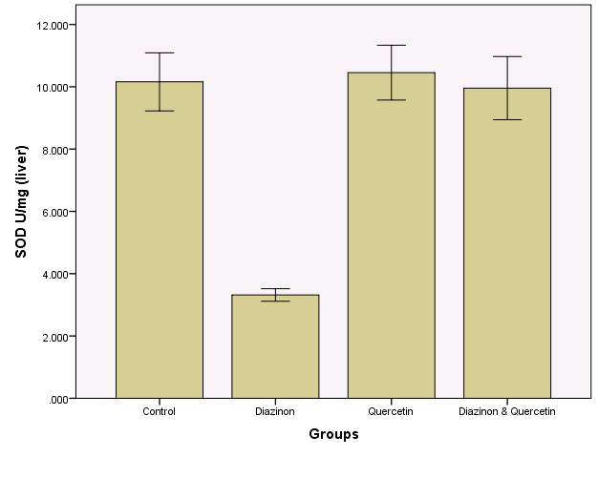Figure (14):The effect of the treatments of the groups in SOD activity in liver
10.157 ^{b}
3.317 ª
10.453 ^{b}
9.957 ^{b}
homogenate, values are expressed as mean ± SME (n=6) P values where calculated by
student t-tests, mean with different superscripts (a, b, c) differ significantly, P<0.05
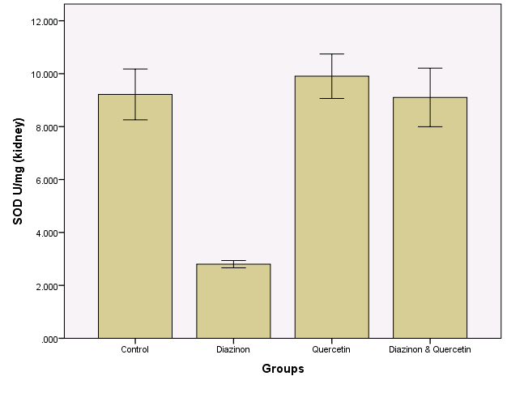
9.217 ^{b}
2.800 ª
9.905 ^{b}
9.103 ^{b}
Figure (15): The effect of the treatments of the groups in SOD activity in kidney
homogenate, values are expressed as mean ± SME (n=6) P values where calculated by
student t-tests, mean with different superscripts (a, b, c) differ significantly, P<0.05

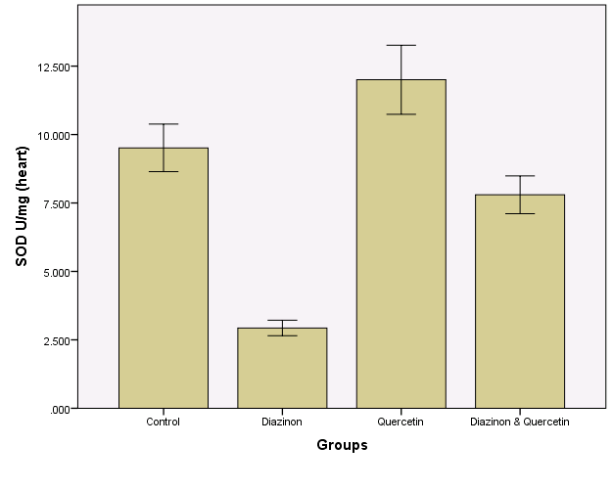Figure (16): The effect of the treatments of the groups in SOD activity in heart
9.513 ^{bc}
2.933 ª
12.002 ^{c}
7.800 ^{b}
homogenate, values are expressed as mean ± SME (n=6) P values where calculated by
student t-tests, mean with different superscripts (a, b, c) differ significantly, P<0.05

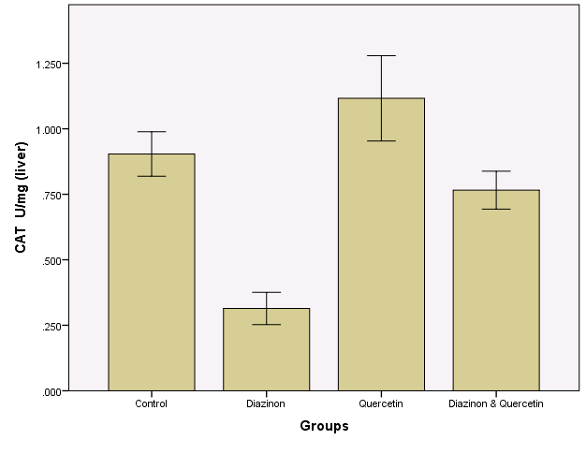Figure (17): The effect of the treatments of the groups in CAT activity in liver
0.904 ^{b}
0.314 ª
1.116 ^{b}
0.766 ^{b}
homogenate, values are expressed as mean ± SME (n=6) P values where calculated by
student t-tests, mean with different superscripts (a, b, c) differ significantly, P<0.05

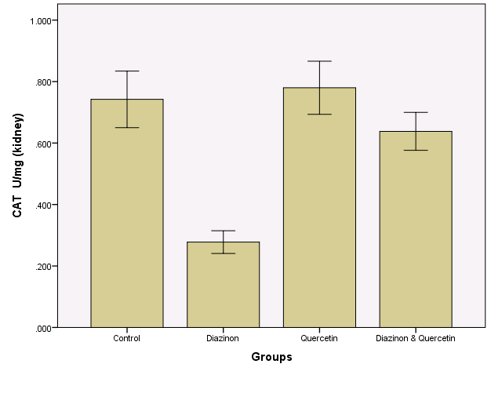Figure (18): The effect of the treatments of the groups in CAT activity in kidney homogenate, values are expressed as mean ± SME (n=6) P values where calculated by student t-tests, mean with different superscripts (a, b, c) differ significantly, P<0.05
0.742 ^{b}
0.278 ª
0.780 ^{b}
0.638 ^{b}
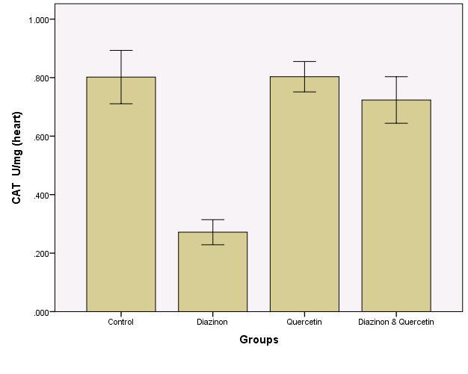
0.802^{b}
0.272 ª
0.803 ^{b}
0.724 ^{b}
Figure (19): The effect of the treatments of the groups in CAT activity in kidney
homogenate, values are expressed as mean ± SME (n=6) P values where calculated by
student t-tests, mean with different superscripts (a, b, c) differ significantly, P<0.05

Histopathological observation - The histology of the heart tissue from control and quercetin-treated animals showed normal morphological appearances, (Figure 20 and Figure 21) whereas in diazinon group, showed necrosis ,congestion ,degeneration ,disruptions of loss of myofibrils and vacuolization of the cytoplasm were observed.(Figure 22) The histology of heart tissues from Diazinon+ Quercetin group showed less necrosis, degeneration, loss of myofibrils and vacuolization of the cytoplasm.(Figure23).
The histology of the liver tissue from control and quercetin-treated animals showed normal histological structure of hepatocytes , central vein and blood sinusoid , nucleus .(figure 24 and 25), whereas in diazinon group, showed cellular infiltrations ,degenerative changes of hepatic cells with cell necrosis and disarrangement of normal hepatic cells were observed.(figure 26) The histology of liver tissues from Diazinon+ Quercetin group showed less degeneration , necrosis and disarrangement of normal hepatic cells.(figure 27)
The histology of the kidney tissue from control and Quercetin-treated animals showed normal morphological appearances(figure 28 and 29), whereas in diazinon group showed congestion, necrosis , degeneration in the epithelial cells of renal tubules and swelling in the lining endothelium of the glomerulus . (figure 30) The histology of kidney tissues from Diazinon+ Quercetin group showed less congestion, necrosis , degeneration in the epithelial cells of renal tubules and swelling in the lining endothelium of the glomerulus. (figure 31).


Figure (20): heart section from a control rat showing normal morphology.

Figure (21) :heart section from rat treated with Quercetin showing normal structure.


Figure (22) :heart section from rat treated with diazinon showing , necrosis ,congestion ,degeneration ,disruptions of loss of myofibrils and vacuolization of the cytoplasm .


Figure (23) :Heart section from rat treated with diazinon+Quercetin showing less necrosis, degeneration, loss of myofibrils and vacuolization of the cytoplasm when compared with diazinon group.

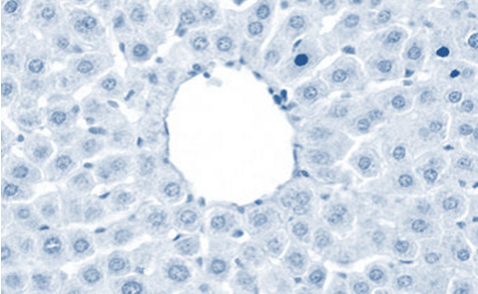
Figure (24): Liver section from a control rat showing showed normal histological structure of Hepatocytes , Central Vein and blood Sinusoid , Nucleus.

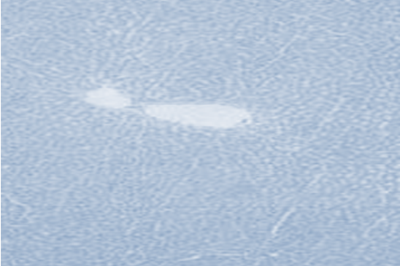
Figure (25): Liver section from rat treated with Quercetin showing normal morphology.
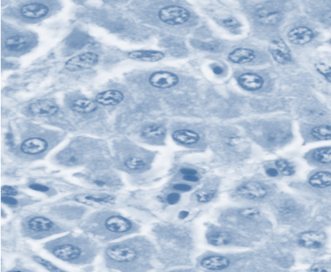
Figure (26) :Liver section from rat treated with diazinon showing Cellular infiltrations ,degenerative changes of hepatic cells with cell necrosis and disarrangement of normal hepatic cells.

Figure (27) :Liver section from rat treated with Quercetin showing less cellular infiltrations and degenerative changes of hepatic cells with cell necrosis.

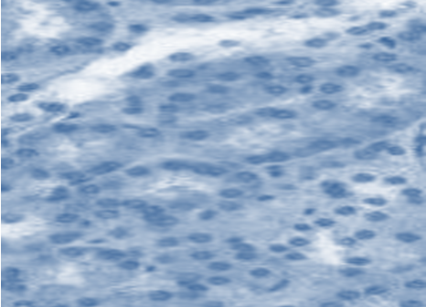
Figure (28) :Kidney section from a control rat showing normal structure of glomerulus and proximal tubule.
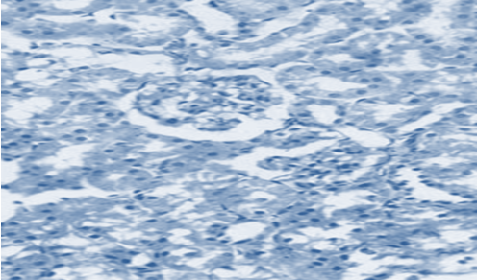
Figure (29) :Kidney section from rat treated with Quercetin showing normal structure.
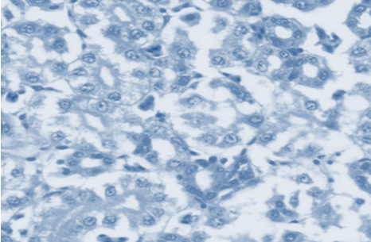
Figure (30):Kidney section from rat treated with diazinon showing congestion, necrosis , degeneration in the epithelial cells of renal tubules and swelling in the lining endothelium of the glomerulus .

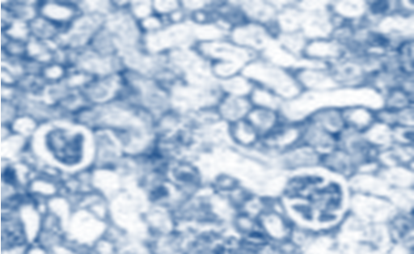
Figure (31) :Kidney section from rat treated with diazinon+ Quercetin showing less necrosis , degeneration in the epithelial cells of renal tubules and swelling in the lining endothelium of the glomerulus .

Discussion:
This study aimed to evaluate the protective effects of quercetin against diazinon-induced oxidative stress in rats. This study evaluated kidney function by measuring serum creatinine and urea values, that of liver by activities of ALT and AST, and that of heart by activity of CK.
Diazinon treatment causes significant increase in the serum activity of liver function markers such as ALT and AST as compared to control group, indicating hepatic dysfunction. These dysfunction may be due to the production of free radicals and involvement of oxidative stress to hepatic toxicity caused by diazinon treatment. The results from this study confirmed that diazinon at a dose of 10 mg/kg/day for 4 weeks produces significant hepatotoxicity as evidenced by increase in serum AST and ALT . Transaminases ( AST and ALT) were considered to be a more sensitive measure in evaluating liver function and damage.⁵³
Hatoff,⁵⁴ reported that elevations in serum levels of these enzymes were mostly attributed to acute hepatocellular damage or extrahepatic obstruction, or both. These enzymes were secreted to blood in hepatocellular injury and their levels increased .¹⁸The liver cells are the sites of toxic action of DZN , which affects mitochondrial membrane transportation in liver and caused swelling of mitochondria in hepatocytes resulting in increased of biochemical indices and liver enzymes.⁵⁵⁻⁵⁸ This results obtained in this study are agree with other reports showing elevations of these enzymes in experimental animals exposed to diazinon and other pesticides. However, administration of quercetin along with diazinon caused significant decrease in AST and ALT suggested the protective effects of quercetin.
Diazinon treatment is found to elevate creatinine and urea levels in serum. These observations are generally in agreement with other studies on pesticides induce relative effects.^{7,13,21,59-61} Creatinine and urea are waste products of protein metabolism that need to be excreted by the kidney, therefore a marked increase of these parameters, as observed in this study, confirms an indication of functional damage to the kidney.⁶² Urea level can be increased by many other factors such as dehydration, antidiuretic drugs and diet, while creatinine is more specific to the kidney, since kidney is the only significant factor that increases the serum creatinine level.⁶³ The increase in creatinine recorded in this work might be due to impaired kidney function by the used pesticide. This view was supported by Kluwe ,⁶⁴who indicated that an elevation of creatinine level in the blood is an indicative of impaired kidney function.
CK is primarily found in skeletal muscle, cardiac muscle and brain tissue. Damage to any of these tissues may result in increased levels of CK activity in serum.CK is the first heart enzyme to appear in the blood after a heart attack and it also disappears quickly from the blood. In the present study, the activity of serum CK was increased in diazinon-treated rats. This is may be due to leakage from the heart as a result of diazinon-induced necrosis.^{13,65} Several studies showed that diazinon and other pesticides induced cardiotoxicity in experimental animals.^{24,58,66-68.}
According to the findings obtained, MDA levels in the liver, kidney and heart tissues were significantly higher in the diazinon-induced group when compared to the control group. This increase is a result of oxidative stress and lipid peroxidation. MDA is an indicator of lipid peroxidation.⁶⁹Lipid peroxidation is regarded as one of the basic mechanisms of tissue damage caused by free radicals.⁷⁰ Free radicals are highly reactive molecules with odd number of electrons. They are constantly being generated in the body through various mechanisms and also being removed by endogenous antioxidant defense mechanism that acts by scavenging free radicals, decomposing peroxides and binding with pro-oxidant metal ion. Free radical mediated oxidative stress results usually from deficient natural antioxidant defense. In case of reduced or impaired defense mechanism and excess generation of free radicals that are not counter balanced by endogenous antioxidant defense exogenously administered antioxidants have been proven useful to overcome oxidative damage .^{71,72} In recent years, a number of studies have showed that diazinon and other pesticides administration increases lipid peroxidation in the rat tissues.⁷³⁻⁷⁹ However, adminstration of quercetin along with diazinon caused significant decrease in MDA levels suggested the protective effects of diazinon.This protection offered by Quercetin may be attributed to its free radical scavenging property.⁸⁰ polyphenols compounds have the ability to protect cell from oxidative stress, it have antioxidant properties.⁸¹
Antioxidants acts as radical scavenger and inhibit LPO and other free radical-mediated processes, thereby protecting the human body from various diseases. There is a natural dynamic balance between the output of free radicals generated in the body and the antioxidant defense system that quenches or scavenges them and thereby protecting the body against pathogenesis. The first lines of defence against free radicals are endogenous enzymic antioxidants such as SOD, Cat, GPx and the Second lines of defence are the non-enzymic antioxidants such as glutathione, Vitamin-C and Vitamin-E.⁸²⁻⁸⁵ In the present study showed a significant decrease in SOD,CAT,GSH-px activity in liver, kidney and heart tissues treated with Diazinon. This is due to Diazinon generate free radicals, disturbing the antioxidant status and ultimately leading to oxidative stress. This results agree with others.⁷⁵
On the other hand, there was a significant increase in SOD, GSH-px, CAT activities in liver, kidney and heart tissues treated with quercetin. It has been reported that administration of quercetin significantly decreased lipid peroxidation and increased endogenous antioxidants, such as SOD, CAT, and GSH-_{PX}.^{29,30} Oxidative stress-induced tissue damage can be prevented or ameliorated by favoring the balance towards a lower oxidative stress status. It appears that the protective effect of quercetin involves the maintenance of antioxidant capacity in protecting the tissues against oxidative stress. Our study shows that treatment with Quercetin improved the activities of SOD,CAT and GSH-_{PX} in rat tissues. This improvement may have resulted from quercetin provided a significant recovery in the level of ROS in diazinon exposed animals in blood and tissues. Protection offered by Quercetin, may be attributed due to changes in the redox state of the cellular environment, altering the antioxidant defense system by these flavonoids.⁸⁶
In conclusion, we have shown that addition of diazinon to rats increased lipid peroxidation. Quercetin decreased the MDA levels in diazinon treated animals. quercetin improved GSH-Px, CAT and SOD activities levels in liver ,kidney and heart tissues. We obtained, according to data application with diazinon against oxidative damage in the liver, kidney and heart which has the potential protective effect of quercetin and can be said.

Refrences:
1.El-Ashmawy I. M., El-Nahas A. F., Salama O. M.: Basic Clin. Pharmacol.Toxicol.;2006,99, 230 .
2.Vardi N., Parlakpinar H., Ozturk F., Acet A.: Fundam. Clin. Pharmacol.; 2005,19, 173 .
3.Zayni M.M.Protective Effect of Terfezia claveryi Extract on Gentamicin-Induced oxidative stress in Rats. Kerbala Journal of Pharmaceutical Sciences.;2012,4,1-2.
4.Munoz-Castaneda J.R., Montilla P., Munoz M.C., Bujalance I., Muntane J., Tunez I.: Basic Clin. Pharmacol.Toxicol.;2005, 97, 174.
5. Hurtig, A. K., San Sebastian, M., Soto, A., Shingre A., Zambrano, D. and Guerrero, W. Pesticide use among farmers in the Amazon basin of Ecuador. Arch. Environ. Health.; 2003,58, 223-228.
6.Abdel-Salam, E. B. and Ford, E. J. H.The effect of induced liver, kidney & lung lesions on the toxicity of levamisole and diazinon in claves. J. Comp Pathol.;1987, 97, 619-627.
7. El-Shenawy, N. S., Al-Eisa, R. A., El-Salmy, F. and Salah, O., Prophylactic effect of vitamin E against hepatotoxicity, nephrotoxicity, haematological induces and histopathology induced by diazinon insecticide in mice, Curr. Zool.,; 2009,55 (3), 219-226
8.Menn, J.J., J.R. Dc Braun and J.B. Mc Barn,. Recent advances in the metabolism of organophosphorus insecticides. Fed. Proc.;1976,35(14), 2598-2602.
9.Ware, G.W.,. The pesticide book. Fresno, CA., Thomson Publications. pp: 181. Yagi, K., 1987. Lipid peroxides in human disease. Chem. Phys. Lipids.;2000,45(2-4),337-351.
10.LÓbpez, D., C. Alcixandre, M. Merchan and E. Carrasca1,. In vitro induction of alterations in peripheral blood lymphocytes by different doses of diazinon. Bull. Environ. Contam.Toxicol.;1986,37(1),517-522.
12. I.R.E.D Facts Diazinon; U.S. Environmental Protection and Toxic Substances, Office of Pesticide Programs. http://www.epa.gov/oppsrrd1/REDs/factsheets/diazinon_ired_fs.htm (accessed Jan 2008), updated May 2004.
13. Atef M. Al-Attar and Wafa'a A. Al-Taisan. Preventive Effects of Black Seed (Nigella Sativa) Extract on Sprague Dawley Rats Exposed to Diazinon. Australian Journal of Basic and Applied Sciences.; 2010, 4(5), 957-968.
14. Reregistration Eligibility Decision (RED) Diazinon; EPA 738-R-04-006; U.S. Environmental Protection Agency, Office of Prevention, Pesticides and
Toxic Substances, Office of Pesticide Programs, U.S. Government Printing Office: Washington, DC, (2006).

15. Timchalk, C. Organophosphate Pharmacokinetics. Handbook of Pesticide Toxicology, Krieger, R., Ed.; Academic Press: San Diego.;2001, 2(398), 936-939.
16.Mohammad A, Arkam R, Shahin S, Shekoufeh N, Ali R: Pesticides and oxidative stress.A review. Med Sci Monitor.;2004,10,141-147.
17. Quistad, G. B. Sparksand, S. E. Casida, J. E. Fatty acid amide hydrolase inhibition by neruotoxic organophosphorus pesticides, Toxicol. Appl. Pharmacol.; 2001,173 ,48-55.
18.Kalender, . S. Ogutcu, A. Uzunhisarcikli, M. Acikgoz, F. Durak, D. Ulusoy, Y. Kalender,Y..Diazinon-induced hepatotoxicity and protective effect of vitamin E on some biochemical indices and ultrastructural changes, Toxicol.;2005,211,197-206.
19. Kalender, Y. Uzunhisarcikli, M. Ogutcu, A. Acikgoz, F. Kalender S., Effects of diazinon on pseudocholinesterase activity and haematological indices in rats: the protective role of vitamin E, Environ. Toxicol. Pharmacol.; 2006, 22(1), 46-51.
20. Yehia, M. A. El-Banna, S. G. Okab, A. B. Diazinon toxicity affects histophysiological and biochemical parameters in rabbits, Exper. Toxicol.Pathol.;2007,59, 215-225.
21.SarhanO.M.M , Al-Sahhaf1 Z.Y.. Histological and Biochemical Effects of Diazinon on Liver and Kidney of Rabbits. Life Science Journal.;2011, 8 (4).
22. Ibrahim, N. A. El-Gamal, B. A. Effect of DZN, an organophosphate insecticide, on plasma lipid constituents in experimental animals, J. Biochem. Mol. Biol. Biol.; 2003 , 36(5), 499-504.
23. Cox, C, Insecticide factsheet (Diazinon toxicology), J. of Pesticide Reform/ Summer .;2000,20,1-2.
24. Kalender, S. Kalender, Y. Ogutcu, A. Uzunhisarcikli, M. Durak, F. Acikgoz, D. Endosulfan-induced cardiotoxicity and free radical metabolism in rats: the protective effect of vitamin E, Toxicology.; 2004,3, 227-235.
25. Singh, M. Kaur, P. Sandhir, R. Kiran, R. Protective effects of vitamin E against atrazine-induced genotoxicity in rats, Mutat.;2008, 654,145-149.
26.Mori A, et al. Cytotoxicity of plant flavonoids against Hela cells. Phytochemistry.;1988, 27,1017-20.
27.Hertog MGL, Feskens EJM, Hollman PCH, Katan MB, Kromhout D. Dietary antioxidant flavonoids and risk of coronary heart disease: the Zutphen elderly study. Lancet.; 1993,342, 1007–1011.
28. Singh D, Chander V, Chopra K. The effect of quercetin, a bioflavonoid on ischemia/reperfusion induced renal injury in rats. Arch Med Res.;2004, 35, 484-94.
29. Anjaneyulu M, Chopra K. Quercetin, an anti-oxidant bioflavonoid, attenuates diabetic nephropathy in rats. Clin Exp Pharm Phys.; 2004,31:244-8.
30. Dias AS, Porawski M, Alonso M, Marroni N, Collado PS, Gonzalez Gallego J. Quercetin decreases oxidative stress, activation of NF-kB Activation, and iNOS overexpression in liver of streptozotocin-induced diabetic rats. J Nut.; 2005, 135,2299-304.

31. Yokoyama A, Sakakibara H, Crozier A, Kawai Y, Matsui A, Terao J, Kumazawa S, Shimoi K. Quercetin metabolites and
protection against peroxynitrite-induced oxidative hepatic injury in rats. Free Rad Res.;(2009, 43913-21.
32.Larocca, L. M., Teofili, L., and Sica, S et al., Quercetin inhibits the growth of leukemic progenitors and induces the expression of transforming growth factor-B1 in these cells. Blood.; 1995, 85, 3654–3661.
33.Chang, W. S., Lee, Y. J., Lu, F. J. and Chiang, H. C. Inhibitory effects of flavonoids on xanthine oxidase. Anticancer Res.;1993,13, 2165– 2170.
34.Chen, Y. T., Zheng, R. L., Jia, Z. J., and Ju, Y. Flavonoids as superoxide scavengers and antioxidants. Free Radic. Biol. Med.;1990,9,19–20.
35.Cox, D., Whichelow, M. J. and Prevost, T. A. Antioxidant effects of flavonoids: Public Health Nutr.; 1990, 3,19–29.
36.Comalada M, Ballester I, Bailon E et al. Inhibition of pro-inflammatory markers in primary bone marrow-derived mouse macrophages by naturally occurring flavonoids: analysis of the structure activity relationship. Biochem Pharmacol.; 2006, 72, 1010–1021.
37.Middleton E, Kandaswami C, Theoharides TC. The effects of plant flavonoids on mammalian cells: implications for inflammation, heart disease, and cancer. Pharmacol Rev.; 2000,52,673–751.
38.Duarte J, Jimenez R, O'Valle F et al. Protective effects of the flavonoid quercetin in chronic nitric oxide deficient rats. J Hypertens.; 2002, 20,1843–1854.
39.Bronner, C. and Landry, Y. Kinetics of inhibitory effect of flavonoids on histamine secretion from mast cells. Agents Action.;1985,16,147–151.
40.Stavric, B. Quercetin in our diet: from potent mutagen to probable anticarcinogen. Clin. Biochem.;1994, 27,245.
41. Venees F. Yassa, Shenouda M. Girgisand Iman M.K. Abumourad .Potential protective effects of vitamin E on diazinon-induced DNA damage and some haematological and biochemical alterations in rats. Journal of Mediterranean Ecology.; 2011, 1,31-39.
42.Pilkhwal, S. Tirkey, D. kuhad .A. and chopra K. Effect of Bioflavonoid Quercetin on Endotoxin-`Induced Hepatotoxicity and Oxidative Stress in Rat Liver. Iranian Journal of pharmacology & Therapeutics.; 2010, 9, 47-53.
43. Reitman S and Frankel S. A colorimetric method for the determination of serum glutamic oxaloacetic and glutamic pyruvic transaminase. Am J Clin.; 1957, 28,56-63.
44.Spencer K. Analytical reviews in clinical biochemistry: the estimation of creatinine. Ann Clin Biochem.;1986, 23,1-25.
45.Fawcett JK, Scott JE. A rapid and precise method for the determination of urea. J Clin Path.;1960,13,156.
46.Rosalki SB. An improved procedure for serum creatine kinase determination. J Lab Clin Med.; 1967,69, 696-705.
47. Lowry OH, Rosebrough NJ, Farr AL, Randall RJ. Protein measurements with the folin phenol reagent. The Journal of Biological Chemistry.; 1951,193, 265-75.
48. Ohkawa H, Ohishi N, Yagi K. Assay for lipid peroxides in animal tissues by thiobarbituric acid reaction. Analytical Biochemistry.;1979, 95, 351-8.
49. Worthington. V. Worthington Enzyme Manual, Lakewood, New Jersey.;1975,5,20-21.
50. Beers R.F. Jrand I.W. Sizer. Journal of Biological Chemistry.; 1952, 195,133-140 .
51. Flohéand L. Günzler W.A .Methods in enzymology.;1984,105, 114-120.
52. Begum, N. A. Dewan, Z.F. Nahar, N. ,Mamun. M.I.R. Bangladesh Journal of Pharmacology.;2006,1,16-20.
53. Sherlock, H. Disease of the Liver and Biliary System ., Oxford, Blackwell scientific publications.;1981,4,42-44.
54. Hatoff, D. E. and Hardison, W. J. Hepatic bile acid content control alkaline phosphatase during cholestasis. Gastroenterology.;1980, 78, 1307.
55.Teimouri, F. Amirkabirian, N.Esmaily, H. Mohammad irad, A.Ali ahmadi, A. Abdollahi, M. Alteration of hepatic cells glucose metabolism as a non – cholinergic detoxification mechanism in counteracting diazinon – induced oxidative stress. Hum Exp Toxicol.;2006,25 ,697-703.
56. Kappers, W. A. Edwards, R. J. Murray, S. Boobies, A. R. Diazinon is activated by CYP2C19 in human liver. Toxicol Appl Pharmacol.;2001,177 ,68-76.
57. Sams, C. Cocker, J. Lennard ,M. S.. Metabolism of chlorpyrifos and diazinon by human liver microsomes, Toxicol Lett.;2003,144-146.
58. A. Ogutcu, M. Uzunhisarcikli, S. Kalender, D. Durak, F. Bayrakdar, Y. Kalender, The effects of organophosphate insecticide diazinon on malondialdehyde levels and myocardial cells in rat heart tissue and protective role of vitamin E. Pesticide Biochemistry and Physiology.;2006, 86,93-98.
59.Eraslan, G., A. Bilgili, D. Essiz, M. Akdogan and F. Sahindokuyucu. The effects of deltamethrin on some serum biochemical parameters in mice. Pestic. Biochem. Physiol.;2007,87(2), 123-130.
60.Yousef, M.I., F.M. el-Demerdash, K.I. Kamel, K.S. Al-Salhen, 2003. Changes in some hematological and biochemical indices of rabbits induced by isoflavones and cypermethrin. Toxicology.;2003,189(3), 223-234.
61.Omurtag, G.Z., A. Tozan, A.O. Sehirli and G. Sener. Melatonin protects against endosulfan-induced oxidative tissue damage in rats. J. Pineal Res.; 2008, 44(4), 432-438.
62.Panda, N.C.,. Kidney. In: Textbook of Biochemistry and Human biology. second ed., Prentise hall India.;1999, 290-296.
63.Cheesbrough, M.,. Clinical chemistry tests. In: District laboratory practice in tropical countries. Cambridge new edition.; 1998, 331-363.
64.Kluwe, W.Renal function tests as indicators of kidney injury in subacute toxicity. Toxicol. Appl. Pharmacol.; 1981, 57, 414-424.
65. Tietz, N.W., Fundamentals of Clinical Chemistry, Philadelphia, W. B. Saunders Co.;1982, 682-689 .
66.Courtney, K.D. and M.T. Ebron. 2,4,5-T effects on cardiac and serum lactic dehydrogenase (LDH) and creatine kinase (CK) isozymes I. Maternal enzyme activities and isozyme profiles. Arch. Environ. Contam. Toxicol.; 1981, 10(5), 571-581.
67.Sauviat, M.P. and N. Pages,. Cardiotoxicity of lindane, a gamma isomer of hexachlorocyclohexane. J.Soc. Biol.;2002,196(4),339-348.
68.Jalili, S., A.A. Farshid, R. Heydari, M. Ilkhanipour and S. Salehi,. Histopathological observations on protective effects of vitamin E on endosulfan induced cardiotoxicity in rats. Pak. J. Biol. Sci.;2007,10(11), 1922-1925.
69. Jacob RA and Burri BJ: Oxidative damage and defense. Am. J. Clin. Nutr.; 1996, 63, 985-990.
70.Esterbauer H, Schaur R J, Zollner. Chemistry and biochemistry of 4-hydroxynonenal, malonaldehyde and related aldehydes.Free Rad Biol Med.; 1991 ,11, 81–128.
71.Halliwell B., Drug antioxidant effects. A basis for drug selection? Drugs, 1991, 42, 569-605.
72. Supratim R., Evaluation of Protective role of Morin on Busulfan-induced Lipid Peroxidation. International Journal of Pharm Tech Research CODEN (USA).;2011,3, 2222-2227.
73. Shah, M. D., Iqbal, M. Diazinon-induced oxidative stress and renal dysfunction in rats. Food Chem Toxicol.;2010,48(12),3345-3353.
74. Amirkabirian N., Teimouri F., Esmaily H., Mohammadirad A., Aliahmadi A. and AbdollahiM. Protection by pentoxifylline of diazinon-induced toxic stress in rat liver and muscle. Toxicol Mech Methods.;2007,17(4), 215-221.
75.Akturk, O., H. Demirin, R. Sutcu, N. Yilmaz, H. Koylu and I. Altuntas, .The effects of diazinon on lipid peroxidation and antioxidant enzymes in rat tissues and ameliorating role of vitamin E and vitamin C. Cell Biol. Toxicol.;2006, 22(6), 455-461.
76.Ozden, S. and B. Alpertunga ,. Effects of methiocarb on lipid peroxidation and glutathione level in rat tissues. Drug Chem. Toxicol.;2010,33(1),50-54.
77.Mansour, S.A. and A.H. Mossa, .Comparative effects of some insecticides as technical and formulated on male albino rats. J. Egypt Soc. Toxicol.; 2005, 32, 41–54.
78.Fortunato, J.J., F.R. Agostinho, G.Z. Reus, F.C. Petronilho, F. Dal-Pizzol and J. Quevedo, .Lipid peroxidative damage on malathion exposure in rats. Neurotox. Res.;2006,9(1),: 23-28.
79.Altuntas, U. and N. Delubas,. The effects of fenthion on lipid peroxidation and some liver enzymes: The possible protective role of vitamins E and C. Turk. J. Med. Sci.;2002, 32, 293-297.
80. Bors, W., Michel, C. & Saran, M. Flavonoid antioxidants: rate constants for reactions with oxygen radicals. Methods Enzymol.;1994,234:420-429
81. Kitagawa S, Sakamoto H, Tano H. Inhibitory effects of flavonoids on free radical-induced hemolysis and their oxidative effects on hemoglobin. Chem Pharm Bull.;2004,52:999-1001.
82. Czinner E, Hagmasi K, Blazovics A, Kery A, Szoke E, Lemberkovics E. The in vitro effect of Helichrysiflos on microsomal lipid peroxidation. Journal of Ethnopharmacology.; 2001, 77, 31–35.
83. Kolanjiappan K, Manoharan S, Kayalvizhi M. Measurement of erythrocyte lipids, lipid peroxidation, antioxidants and osmotic fragility in cervical cancer patients. Clin Chim Acta.;2002,326(1-2),143-9.
84. Liebler DC. The role of metabolism in the antioxidant function of vitamin E. Crit Rev Toxicol.;1993,23(2),147-69.
85.Langeswaran K, Jagadeesan A. J, VijayaprakashS,Balasubramanian M. P. Hepatoprotective and Antioxidant activity of Scopariadulcis Linn, against N Nitrosodiethylamine(DEN) induced Hepatotoxicity in experimental Rats. International Journal of Drug Development &Research.;2012,4,1-3.
86. Schmitt-schillig, S., Schaffer, S., Weber, C. C., Eckert, G. P. & Müller, W. E. Flavonoids and the aging brain. J Physiol Pharmacol.;2005,56:23-36 .

