Spectrophotometric Determination of Cobalt (II) Using 4-(6-Bromo 2-benzothiazolylazo) Orcinol as an Organic Reagent

Azhar A. Ghali
Azharghali35@yahoo.com
Department of Chemistry, College of Education , University of Al – Qadisiya

(NJC)
(Received on 16/1/2014) (Accepted for publication 20/2/2014)

Abstract
A sensitive, simple and selective spectrophotometric method was proposed for the rapid determination of cobalt(II) using 4-(6-Bromo 2-benzothiazolylazo) Orcinol(6-BrBTAO). Alcoholic solution of 6-BrBTAO form a 1:2 pink complex with cobalt(II) ions at pH ranges 5.0-10.0, absorbing maximum at 514 nm. The molar absorptivity and the Sandell’s sensitivity of the complex are 2.574x10³L mol⁻¹cm⁻¹ and 0.022μg.cm⁻² respectively. . Under the optimum established conditions, which led to a detection limit of 0.51 µg.mL⁻¹ of Co (II) and concentration range of 0.7-30 µg.mL⁻¹ with percent recovery of 100.43±1.23. The precision for seven replicate measurements of 15 µg.mL⁻¹ Co(II) was of 1.7%. The method was applied to the determination of cobalt in some vegetables samples such as radish, carrot and spinach with satisfactory results.

Key Words: 4-(6-Bromo 2-benzothiazolylazo) Orcinol , Cobalt, Vegetables samples, Spectrophotometry.

الخلاصة
طريقة طيفية حساسة وانتقائية وسريعة لتحديد الكوبالت باستخدام 4 - (6 برومو 2-بنزوثيازوليل ازو) أورسينول (6BrBTAO). المحلول الكحولي من 6-BrBTAO تشكل 1:2 معقد وردي مع الكوبالت (II) في درجة الحموضة تتراوح 5.0-10.0، الامتصاص الأعظم عند 514 نانومتر. والامتصاصية المولارية وحساسية ساندل هي2.574 x 10³ لتر مول-¹ سم-¹ و0.022مايكروغرام سم -² على التوالي. . تحت الظروف المثلى المعمول بها، مما أدى إلى الحد من الكشف 0.51 مايكرو غرام مل-¹ ومدى التركيز ،7-30 ميكروغرام مل-¹ مع الاستردادية في المئة من 100.43 ± 1.23. كانت الدقة لسبعة قياسات متكررة من 15 ميكروغرام مل-¹ كوبالت (II) يساوي 1.7٪. تم تطبيق الطريقة لتحديد الكوبالت في بعض عينات الخضروات مثل الفجل ,الجزر والسبانخ بنتائج مرضية.
الكلمات المفتاحیة : كاشف4- (6- برومو-2- بنزوثيازوليل آزو) اورسينول ، الكوبالت ، عينات من الخضروات , المطيافية الجزيئية .

Introduction
Chemists, in recent years, have shown a growing concern in studying complexes formed by heterocyclic compounds analogues of benzothaizoles and derivatives have attracted strong interest due to their useful biological and pharmacological properties¹.
Thiazolylazo dyes are sensitive chromogenic reagents in addition to being interesting complexing agents, and have been used as reagents for spectrophotometry, solid phase extraction , and liquid chromatography . The application in spectrophotometry is based on the colored compounds resulting from their reaction with most metals, particularly some transition metals, usually stable chelate complexes are produced. Some of them have also proved to be particularly useful as indicators in complexometric titrations ^{2,3}.
Cobalt is very important mineral element for environmental chemistry, and human biochemical metabolism ⁴ and it is one of the most essential trace metals. Cobalt can be beneficial for humans because It is a component of cyanocobalamin or vitamin B12 which is needed by human beings ^{5,6} and, since organism is unable to synthesize it, there is the need of the ingestion of foods that contain it, such as fish, oysters, eggs, milk and green vegetables . The recommended dietary allowance (RDA) for vitamin B12 for adults is 2.4 µg day⁻¹, which contains 0.1µg of cobalt, and its deficiency can lead to pernicious anemia⁷. The daily intake of this metal in human diet is about 5 μg/day and toxic effects of cobalt have not been reported much and are possible only when cobalt compounds have been deliberately added during food processing or used in high doses therapeutically for the treatment of “Anaemia” and “Goitre” which is the side-effect of cobalt therapy⁸.
The primary use of cobalt is in the metallurgical industry to make stainless steel and alloys highly resistive to oxidation at high temperatures when used as turbine blades and cutting tools and It is used in medicine as an important radioactive tracer and as a cancer treatment agent as well as in biological activities such as vitamin B (cyanocobalamin)⁹.
It is clear that cobalt is an essential element and has significant importance, both biological and industrial. For the quantative determination of Co(II) in trace amount, there are several frequently adopted methods such as spectrophotometry¹⁰⁻¹², AAS¹³⁻¹⁶, ICP-AES¹⁷, ICP-MS ¹⁸, stripping voltametry¹⁹, FIA²⁰ etc . Among these, spectrophotometric methods are preferred as they are economical, easy to handle, with a comparable sensitivity and accuracy and good precision. It is one of the most commonly used techniques for routine analysis of metals.
The aim of this work was to spectrophotometric determination of cobalt by the use 4-(6-Bromo 2-benzothiazolylazo) Orcinol (6-BrBTAO) reagent as a complexing agent was prepared by Kasim H. Kadhim and Shaimaa M. Eassa and using to determination of Ag, Ni and Cu ions^{21,22}.

Materials and MethodsS
Reagents and Chemicals
4-(6-Bromo 2-benzothiazolylazo) Orcinol (6-BrBTAO) Solution
6-BrBTAO was used as a 3.3 x 10⁻⁴ M solution prepared by dissolving 0.0110 g in 100 mL of pure ethanol.

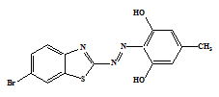

Figure 1. Structure of the reagent

(6-BrBTAO)

Standard Cobalt(II) Solution
A stock solution of Co²⁺(1000 mg L⁻¹) was prepared by dissolving 0.4037 g of cobalt(II) chloride (B.D.H) in appropriate amount of water and made to 100 mL with distilled water. Working standard solutions of metal ion were freshly prepared by appropriate dilutions of the stock solution.
Determination of Cobalt(II)
To a suitable aliquot of sample containing 0.7-30.0 μg.mL⁻¹ of cobalt(II), add 1.5 mL of 3.3x10⁻⁴ M 6-BrBTAO solution in ethanol followed by 2 mL of 0.1 M ammonium acetate to maintain pH ~ 9.0 and make up the volume to 10 mL with distilled water. Measure the absorbance at 514 nm against a corresponding reagent blank prepared under identical conditions.

Apparatus
UV-Visible Spectrophotometer 1600, SHIMADZU, (Japan) equipped with 10- mm optical path cell were used for the scanning study of absorption spectra of the complexes formed, while absorbance measurements were carried out with spectrophotometer UV-Visible Spectrophotometer ,single beam ,Apel PD-303 UV.FTIR-8400S, Shimadzu, Japan , The effect of temperature was investigated by using a water bath WB 710 model (OPTIMA, Japan). A Microprocessor pH meter 211 mode(Triup International Corp, Italy) with a combined electrode was used for pH measurements.
Preparation of vegetables samples

Fresh samples of vegetables including radish, carrot, spinach were taken for the study. Firstly, samples were thoroughly washed to remove mud and dust and then rinsed with distilled water. All vegetable samples were then sliced with the help of knife into small pieces and then oven dried at 45 to 80ºC till the constant weight was obtained. After drying, they were ground by porcelain mortar and piston to fine particle size and directly stored in fresh plastic containers for further analysis. Wet acid digestion was done by standard methods reported by AOAC²³. 1.0 gm of each dried sample was added to 10 ml of conc. HNO₃ in 50 ml beaker and placed on the electric hot plate for 1 hour to get semi dried sample. Again 10 ml of conc. HNO₃ and 4ml of H₂O₂ were added and again kept on hot plate and heated vigorously. Addition of HNO₃ and H₂O₂ was continued till to colorless solution and its volume reduced up to 2-3ml. It was cooled and filtered with the help of Whattmann filter paper. The filtrate was stored in 10 ml sample bottles or vials. Then transferred quantitatively to 25 mL volumetric flask and diluted to the mark with de-ionized water then analyzed²⁴.

Results and Discussion
Infrared spectra
The IR spectra of the free ligand and its metal chelates were carried out in the 4000–400 cm⁻¹ range (Figure 2,3). IR spectra of the ligand show a broad band at about 3394 cm⁻¹ due to the OH groups. In the metal complexes this broad band is still broad due to other OH group of orcinol, which renders it difficult to attribute to the involvement of phenolic OH group in coordination. The stretching vibration of the thiazolylazo nitrogenυ (–C=N–) is observed in the form of an intense band at 1630 cm⁻¹ in the free ligand. The spectral region at 1600–1400 cm⁻¹ is complicated because of the stretching modes of –C=C– and –N=N– which are superimposed in the same region. However, the band appearing at 1587 cm⁻¹ can be assigned to υ (N=N) of the azo group of the ligand. The strong band appearing at 1273 cm⁻¹ in the free ligand is due to the υ (C–O) vibration . The involvement of the deprotonated phenolic OH group in chelation is confirmed by the blue-shift of the υ (C–O) stretching band, to the extent of 61–84 cm_1 (1189–1212 cm⁻¹) in the complex. This is further supported by the appearance of the band at 525–580 cm⁻¹ due to metal-oxygen stretching vibrations in the complex. The υ (C=N) band is shifted to lower (21–40 cm⁻¹)
frequencies in the complexes indicating that it has been affected upon coordination to the metal ion . This view is further supported by the appearance of the band corresponding to the metal-nitrogen stretching vibration of thiazole nitrogen at 445–519 cm⁻¹ in the complex. The band at 774 cm⁻¹ in the ligand is still in the same position in the complex indicating the non-involvementof the thiazole S in coordination. Then (N=N) band is shifted to lower (95–45 cm⁻¹) frequencies in the complexes indicating that it has been affected upon coordination to the metal ions. The presence of new medium intensity bands in the 422–448 cm^{–1} region, assignable to (M–N) in the spectra of the complex. Therefore, the IR spectra indicate that the coordination sites being ArOH, N=N and
the N atom of the thiazole moiety²⁵⁻³⁰.

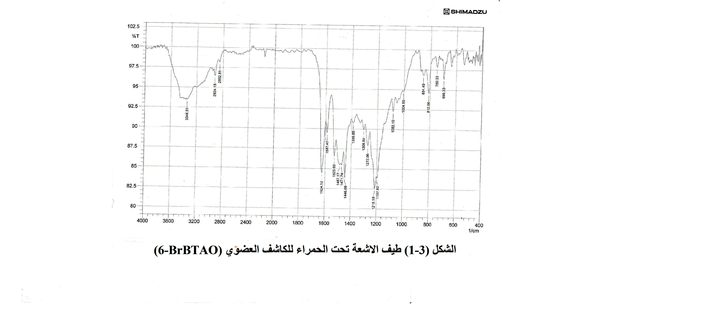
Figure 2.IR spectrum of the ligand (6-BrBTAO)

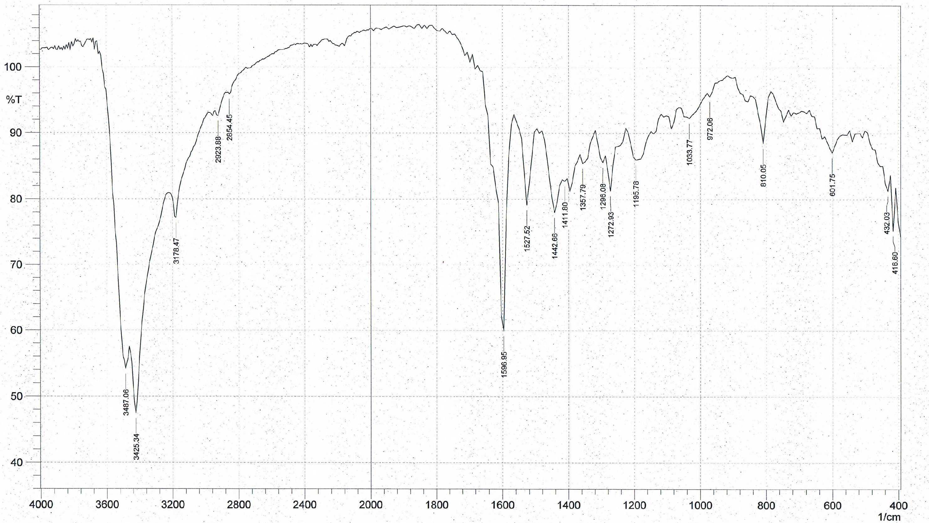
Figure 3. IR spectrum of the ligand
(6-BrBTAO) – Co complex.

Absorption Spectra
The absorption spectra of reagent 6-BrBTAO and Cobalt (II) complex under the optimum conditions are shown in Figure 4. And the spectral characteristic are given in Table 1. The absorption spectra of cobalt complex shows the absorbance maxima at 514 nm. The effects of various parameters were carried out to develop a simple and sensitive for the spectrophotometric determination of cobalt.

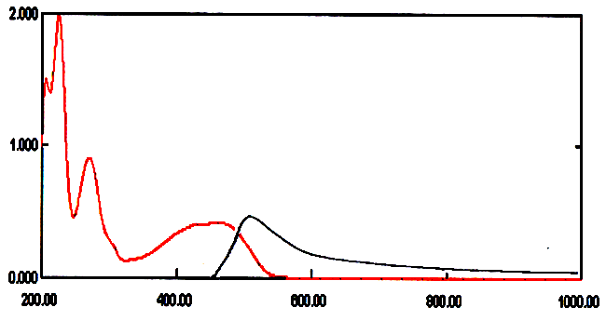

Figure 4. Absorption spectra (-) Reagent (6-BrBTAO) = 3.3 x 10⁻⁴ M (-) Co(II)- (6-BrBTAO)

complex , Co(II) = 15 µg mL⁻¹ , 1.5 ml of (6-BrBTAO) = 3.3 x 10⁻⁴ M , Buffer pH= 9.0( 3 mL ) .

Effect of pH
pH is always considered as quite important and critical for complex formation and its stability. It is always inevitable to find the optimum pH at which the complex is most stable. Effects of pH and buffer solution on cobalt–(6-BrBTAO) complex are given in Figure 5. The results show that pH 9 is most suitable for the complexation of cobalt with (6-BrBTAO).

Figure 5. Effect of pH on the formation of (6-BrBTAO)- Co(II) complex .Conditions :
Co(II) =15 µg. mL⁻¹ , 1.5 ml of (6-BrBTAO) = 3.3 x 10⁻⁴ M .

Effect of Temperature
The influence of temperature on the formation of (6-BrBTAO)- Co(II) complex is shown in Figure 4. The study was performed at temperature between 10°C and 80°C .The maximum absorption was obtained when the temperature was varied between 20°C and 30°C. At higher temperature than 40°C the absorbance gradually decreased with increasing temperature until it reaches 80°C which may be attributed to dissociation of the chelates complexes .

Figure 6. Effect of the temperature on the absorbance for Co(II) complex. Conditions :
Co(II) = 15 µg mL⁻¹ , 1.5 mL of (6-BrBTAO) = 3.3 x 10⁻⁴ M , 3mL pH 9.0 .

Effect of Time
Stability of the cobalt–(6-BrBTAO) complex with respect to time is given in Figure 5. The cobalt–(6-BrBTAO) complex was formed immediately on mixing the reactants giving violet colour. This instantaneous reaction reveals that the complex remains stable for a period of 24 hours as the absorbance remained almost constant.

Figure 7. Effect of time on the absorbance for Co(II) complex. Conditions :
Co(II) = 15µg mL⁻¹ , 1.5 mL of(6-BrBTAO) = 3.3 x 10⁻⁴ M , pH 9.0, temp 30 ͦ C.

Effect of Reagent Concentration
The effect of reagent concentration on the intensity of the colour of the complexes was investigated by varying the reagent concentration under the optimum conditions. The results indicated that the suitable reagent concentration is 1.5 mL from 3.3 x 10⁻⁴ M (6-BrBTAO).

Stoichiometry of the complexes
The composition of the Co(II)-complexes with the reagent was established by the continuous variation and mole ratio methods. Both methods showed that the molar ratio Figures 8 and 9 of Co(II) ion to reagent (6-BrBTAO) is 1:2. The molar conductivity of the prepared solid complex was measured by dissolving an adequate weight in two solvents different polarity such as ethanol and DMF separately . The complex of Co ( II ) gain the molar conductivity measurement values 1.34 S.mol⁻¹.cm² and 3.51 S.mol⁻¹ . cm² in ethanol and DMF respectively , at room temperature these values indicating that no conductive species are exist³¹ . According to these results the suggested related chemical structures is shown in Figure 10.

Figure 8. Mole ration method for Co(II)-complex at pH=9.0.
Figure 9. Continuous variation method for Co(II)-complex at pH=9.0.

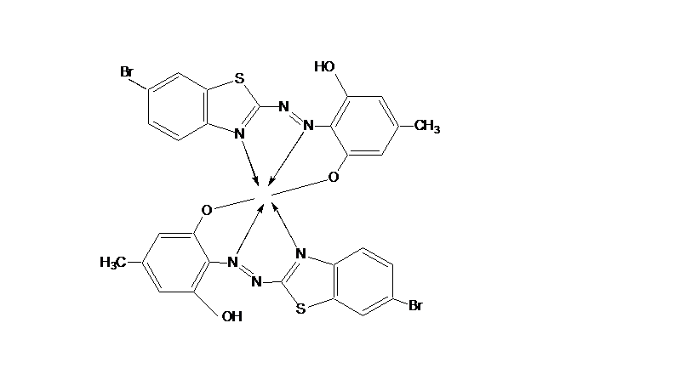
Co

Figure 10. The proposed structural formula of Co(II) complex .

Beer’s law and sensitivity
Series of standard solutions of cobalt(II) were prepared and complexed with (6-BrBTAO) at the optimized conditions . The absorbance of each standard solution is measured. The results obtained show a linear relationship between absorbance and concentration in the range of 0.7-30 µg mL⁻¹. The molar absorptivity as calculated from the linear part of Beer’s law plots was 2.574 × 10³ L.mol⁻¹cm⁻¹. the limit of detection of 0.51 µg mL⁻¹ in the suggested protocol was achieved calculated as three times the standard deviation for blank signal divided by the slope of the calibration curve.
Table 1. Analytical figures of merits of the spectrophotometric determination of Co(II).Precision and Accuracy
Seven replicate analyses of 15 μg mL^{–1} cobalt solution following the general procedure gave repeatability in term of relative standard deviation (RSD%) of 1. 7% (Table1).
In order to assess the validity of the proposed method, the method was applied for the quantitative determination of cobalt in vegetables samples were spiked by adding known amount of cobalt (II) determined by the proposed method and then the same steps were followed with the general procedure. The results were tabulated in Table 2.The results are found satisfactory.

Table 1. Analytical figures of merits of the spectrophotometric determination of Co(II).

Parameter | Value
λ_{max} (nm) | 514
Regression equation with CPE | A= 0.0132 conc. + 0.0029
Correlation coefficient(r) | 0.9998
C.L. for the slope (b±tsb) at 95% | 0.0132± 0.173
C.L. for the intercept (a±tsb) at 95% | 0.0029± 0.097
Concentration range/ (µg. mL⁻¹) | 0.7-30
Limit of Detection /( µg. mL⁻¹) | 0.51
Limit of Quantitation / (µg. mL⁻¹) | 1.69
Sandell's sensitivity / (µg.cm⁻²) | 0.0224
Molar absorptivity / (L.mol⁻¹.cm⁻¹) | 2.574x10³
Composition of complex (M: L)* | 1:2
RSD% (n=7) at 15 µg. mL⁻¹ | 1.7%

Table 2. Accuracy of the proposed method

Sample | Amount Co(II)taken  (µ g mL⁻¹) | Amount Co(II)found  (µ g mL⁻¹) | Recovery(%) | E_{rel}(%)
radish | 5.5  10.5  15.5 | 5.56  10.45  15.41 | 101  99.52  99.41 | 1.09  -0.47  -0.58
carrot | 5.5  10.5  15.5 | 5.58  10.60  15.58 | 101.45  100.95  100.51 | 1.45  0.95  0.51
spinach | 5.5  10.5  15.5 | 5.58  10.59  15.63 | 101.45  100.85  100.83 | 1.45  0.85  0.83

Interference Studies
The possibility of analytical application of the proposed method was assessed by examining the effect of various ions which potentially interfere with the determination of cobalt. In the determination of Co(II) at the 10 μg/ ml level and excess amount of foreign ions were investigated. The tolerable concentration of each foreign ion was taken as the highest concentration causing an error of less than ±5%. , Mg²⁺ , Fe²⁺, Sb³⁺, Hg²⁺ did not interfere even at 1000-fold excess. However, Ag¹⁺,Ni²⁺, Zn²⁺, Cu²⁺ , Pb²⁺, Cd²⁺ were found to interfere seriously. Studies also show that fair amounts of mask agents can be used to mask a number of transition metals which interfere in the determination of Co(II) in Table 3.

Table-3: Tolerance limits of diverse ions on the determination of 10 μg/ml of Co(II).
Foreign ions | Tolerance limits(ppm) | Masking agents
Ag¹⁺ | 200 | NaF
Ni²⁺ | 250 | KI, NaNO₂
Cu²⁺ | 250 | Oxalic acid
Zn²⁺ | 100 | Tartaric acid, NaNO₂
Pb²⁺ | 250 | Tartaric acid, NaF
Cd²⁺ | 200 | Tartaric acid, Oxalic acid

References
1-M. Manuela M. Raposo , M. Cidalia R. Castro , M. Belsley , A. Maurício C. Fonseca , , Dyes and Pigments.; 2011 , 91,454-465.
2- Chen, W., Y. Wu, D. Gu and F. Gan. Mater. Lett.; 2007,61,4181–4184.
3- K. Pytlakowska , V.Kozik,M.Dabioch , Talanta.;2013,110 , 202–228
4- M. Angelova, A. Stoyanova, A. Alexiev , Trakia Journal of Sciences.; 2008,6(1), 12-17.
5- Daftsis, E. J., Zachariadis, G. A., Talanta.; 2007, 71,722.
6- V. A. Lemos, R. S. Franc¸ B. O. Moreira , Separation and Purification Technology.; 2007,54,349–354.
7- F. Ismail, M.R. Anjum, A.N. Mamon and T.G. Kazi, Pakistan Journal of Nutrition.; 2011,10(4), 365-372.
8- Reilly, C. London: Applied Science.;1980, 172.
9- V. Kaur, A. K. Malik and N. Verma, Journal of the Chinese Chemical Society.; 2007, 54, 715-722.
10- G.L. Donati , C.C. Nascentes , A. R. A. Nogueira, M. A. Z. Arruda and J. A. Nóbrega ,Microchem.J.;2006,82,189-195.
11- B.R. Reddy, P. Radhika, J.R. Kumar ,
D.N. Priya and K. Rajgopal, Anal Sci.; 2004,923(20),345-349.
12- A.M. Jamaluddin and U.M. Nasir , Chemosphere.;2007,67, 2020-2027.
13- D.L. Tsalev, Progres in analytical metodology, 1995, Boca Raton, CRC Pres vol III.
14- T. Minami , K. Atsumi , J. Ueda , Anal. Sci.;2003,19,313- 315.
15- N. Todorovska , I, Karadjova , S. Arpadjan and T. Stafilov, Acta Pharm.;2003,53,83-90.
16- E. Kendüzler and AR. Türker , Int. J. Environ. Anal. Chem., 2006 86: 843-853.
17- J. Nakajima , M. Fujinami and K. Oguma , Anal. Sci.; 2004, 20,1733-1736.
18- T. Tanaka , Y. Ando , T. Saitoh and M. Hiraide , J. Anal. At. Spectrom.; 2002,17, 1556-1559.
19-A. Bobrowski , K. Vytras , L. Husáková , J. Šrámková and A. Królicka , Talanta.; 2005,66, 999-1004.
20- M. J. Ruedas Rama , A. Ruiz Medina and
A. Molina Díaz , Anal. Bioanal. Chem.; 2003,376,527-533.
21- K. H. Kadhim and S. M. Eassa, Iraqi National Journal of Chemistry.; 2012,47,281-292.

22- S. M. Eassa , M. Sc; Thesis, Al-Qadisiya University,2013.
23- AOAC, 1990. Official method of analysis. 15th Edn.Washington, DC.
24- I. H. BUKHARI, M. RAMZAN, M. RIAZ, International Journal of Current Pharmaceutical Research.; 2013 ,5,2.
25-P. Hankare , S. Chavan , Synthesis and Reactivity in Inorganic Metal-Organic Chemistry.; 2003,33(3),423–34.
26-M. Omar , G. Mohamed ,Spectrochimica
Acta Part A.; 2005,61(5),929–36.
27- G. Pandey , K. Narang . Synthesis and Reactivity in Inorganic Metal-Organic Chemistry.; 2004,34(2),291–311.
28- R. Roy , P. Chattopadhyay , C. Sinha , S. Chattopadhyay ,Polyhedron.;1996, 15(19),3361–9.
29-Z.M. Zaki . Spectral, Spectrochimica Acta A.; 2000,56(10),1917–23.
30- G. Mohamed , M. Zayed , El-Gamel NEA. ,Spectrochimica Acta A.;2002,58(14), 3167–78.
31- W.Geary, Coord. Chem. Rev.;1971,7,81.

