Preparation of Benzobinacole Using Photochemical Irradiation Reductions and Thermodynamic Computational Study

Yaman Qays Sa'dullah AL-Azawy
E-mail : yamaqays@yahoo.com
Dept. of Pharmacy,Technical Institute Mosul

(NJC)
(Received on 23/9/2013) (Accepted for publication 11/2/2014)

Abstract:
The study of chemical reactions and physical behavior that may occur to the reaction of benzophenone with isopropyl alcohol and catalysis amount of glacial acetic acid under the influence of photochemical effects of visible sun light, IR light, laser irradiation or mixing of IR and sun light using four methods gave different percentage yields of (a, 70; b, 30; c, 23 and d, 90 respectively). Computational study of this reaction indicated that the heat of formation of the product benzopinacol was more stable by 20.255 kcal /mole than those of reactant benzophenone , in the same way the single occupied molecular orbital of benzophenol radical SOMO was also more stable than that of reactant and less than the final product . The suggested free radical mechanism was given.
The structures of these compounds were confirmed by their physical properties in addition to the IR and UV Spectra.
Keyword:photochemical , visible sun light, IR light, laser irradiation , Benzopinacol, Computational chemistry.

الخلاصة:
تمت دراسة تحضير البنزوبيناكول باستخدام تفاعلات التشعيع الضوئية ودراسة حركية ذلك بالكمبيوتر والتى قد تؤثر على تفاعل البنزو فينون مع الكحول الايزوبروبيل وبوجود كميات مساعدة من حامض الخليك الثلجي تحت تأثير الكيمياء الضوئية لضوء الشمس المرئي والاشعة تحت الحمراء والتشعيع بالليزر او خليط الأشعة تحت لحمراء وضوء الشمس التي أعطت نسبة منتوج مختلفة ((a, 70; b, 30; c, 23 and d, 9 على التوالي .
اجريت دراسة في الحاسوب لهذه التفاعلات اشارت الى ان كمية تكوين ناتج البنزوبيناكول كان اكثر استقرارا بــ 20.255 كيلو سعرة / مول عن المادة المتفاعلة ( البنزوفينون ) وبنفس الوقت فان طاقة محتوى الاوربيتال الفردي لجذر البنزوفينول اكثر استقرارا من المواد المتفاعلة واقل طاقة من الناتج ذكرت الميكانيكية المقترحة لإلية تكون الجذر الحر .
تم إثبات التراكيب الكيمياوية للمركبات بوساطة خواصها الفيزيائية إضافة إلى أطيافها في منطقة الأشعة فوق البنفسجية وتحت الحمراء.
الكلمات المفتاحية :الكيماء الضوئية , ضوء الشمس المرئي , ضوء الاشعة تحت الحمراء , التشعيع بالليزر, بنزوبيناكول , كيمياء الحاسوب .

Introduction:
The study of chemical reactions, isomerizations and physical behavior that may occur under the influence of visible and/or ultraviolet light is called Photochemistry[1].Absorption of visible and/or ultraviolet light by a molecule introduces energy sufficient to break or reorganize most covalent bonds from the relationship E = hc / λ, thus the longer wavelength visible light (400 to 800 nm) is less energetic (70 to 40 kcal/mole) than light in the accessible shorter wavelength (200 to 400 nm) near ultraviolet region (150 to 70 kcal/mole). Consequently, ultraviolet light is most often used to effect photochemical change[2].
The light required for a photochemical reaction may come from many sources. Ciamician used sunlight for much of his research at the University of Bologna in the early 1900's. Depending on the compounds being studied and the information being sought, bright incandescent lamps (chiefly infrared and visible light), low, medium and high pressure mercury lamps (185 - 255 nm, 255 -1000 nm & 220 -1400 nm respectively), high intensity flash sources and lasers have all been used[3-6]. In careful studies of specific chromophores,sources of monochromatic light may be desired.
Sunlight, in the broad sense, is the total frequency spectrum of electromagnetic radiation given off by the Sun, particularly Infrared, visible, and ultraviolet light. On Earth, sunlight is filtered through the Earth’s atmosphere, and solar radiation is obvious as daylight when the sun is above the horizoni [7].
Over the decades, many interesting but puzzling organic photochemical reactions were discovered that did not proceed by ordinary organic ground state processes. Rather, they arose from the electronic excited states. The real problem was that, at the time, organic chemists were not versed in quantum mechanics and physical chemists were not versed in organic chemistry. Real mechanistic treatments were not possible [8- 11].
Thus, in this work, and as a part of continuous program directed toward the studying on radiation photochemistry [12]. avery useful irradiation tools (IR, ultrasound and laser) in addition to sun light irradiations were used inphysio-chemical study on some important photochemical irradiation reductions in addition to computational study on these reactions.
Experimental:

Materials , Apparatus and Methods:
All the solvents and reagents (benzophenon , isopropyl alcohol and glacial acetic acid) were used without further purification.
IR Spectra were recorded on Unicam SP 2000 Spectrometer at a range (400-4000) cm⁻¹ using Nujol mull discs at Ninava Drug Industry. Electronic spectra were recorded on a Shimadzu UV/Vis Spectrophotometer UV- 160 for 10⁻³M solution of the complexes in DMF at ambient temperature (25 ^{O}C), also this solvent was the solvent used for molar conductivity measurements 4010 conductivity meter (Jenway). The melting point measurements was carried at Al-Hokamaa Drug Industry using electrothermal 9300 engineering. The laser light torches used was 20mvolts .The Heat of formations and steric energies of products in addition to the geometry (three dimensional structure) of complexe (II) at minimized energy (MM2) with HOMO,LOMO and SOMO calculations were established by Chem3D Ultra 11.0(2008); Molecular Modeling and Analysis.
Method (A), Sun light irradiation:[7]
A tightly-fitted stoppered flask of a mixture of benzophenon(10mmole, 1.82gm) , isopropyl alcohol(10mmole, 0.77ml) and one drop ofglacial aceticacid was lifted in sunlight about 72 hours. The crystallized product was collected, filtered and dried.
Method (B), IR light irradiation:[13]
A tightly-fitted stoppered flask of a mixture of benzophenon (10mmole, 1.82gm) , isopropyl alcohol(10mmole, 0.77ml) and one drop of glacial acetic acid was lifted in IR light about 120hours. The crystallized product was collected, filtered and dried.Fig(1a)
Method (C), Laser light irradiation: [13]
A tightly-fitted stoppered flask of a mixture of benzophenon (10mmole, 1.82gm) , isopropyl alcohol(10mmole, 0.77ml) and one drop of glacial acetic acid was lifted in two laser light torches about120hours. The crystallized product was collected, filtered and dried. Fig(1b). The physical properties were listed in Table (1)

Method (D), Sun light irradiation and IR light irradiation:[13]
A tightly-fitted stoppered flask of a mixture of benzophenon (10mmole, 1.82gm) , isopropyl alcohol (10mmole, 0.77ml) and one drop of glacial acetic acid was lifted in in IR light and sun light for two days (24hours) days and nights. The crystallized product was collected, filtered and dried. Fig(3). The physical and spectral data of product benzopinacole (i) were listed in Table(1).

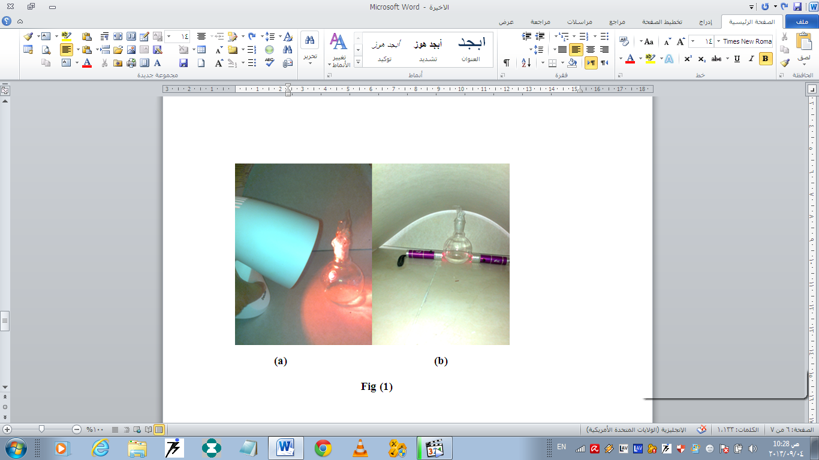

Table (1): Physical and spectral data of product (i)
M.P.^{O}C | Method and Yield% |  |  |  | Uvλmax(nm)  MeOH | IR, KBr,cm-1
M.P.^{O}C | A | B | C | D | 200-350 | 1690-3550
186-87  (188-89lit[7] | 70 | 30 | 23 | 90 | 200-350 | 1690-3550

Results and Discussions:
light is always one of the reactants in a photochemical system. Electromagnetic radiation with the wavelength ranging from ~800 nm (near-IR) to ~150 nm (far UV) is of primary importance for photochemistry and photobiology, but the wavelength regions adjacent to this range are also of interest for certain applications. With the advent of lasers, multiphoton photochemistry, i.e. chemistry initiated by simultaneous absorption of two or more photons, came into wide use. This made IR radiation of particular interests for photochemists. The wavelength range of 150-800nm corresponds to the photon energy ranging from 800 to 150kJmol⁻¹ [14]. Fig (2).

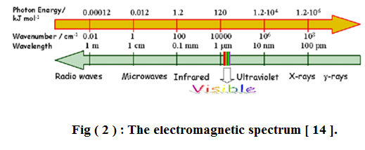

Benzophenone which is a colorless substance and absorbs no light in the visible region of the spectrum. it does have an unsaturated carbonyl group which is paired, or''conjugated'' with the double bonds of the two phenyl groups and hence it is not surprising that the compound absorbs ultraviolet rays. The loosely held electrons of the unsaturated centers are set in vibration by rays of short wave-length through a resonance effect. When the molecule acquires energy in this way from the sunlight it becomes activated and in this state it is capable of entering into reactions which are not otherwise possible. Under ordinary conditions benzophenone is not at all easily reduced; it is in fact one of the least reactive of the simple ketones.Isopropyl alcohol, on the other hand, is certainly not a powerful reducing agent. When, however, mixture of these two relatively unreactive substances is exposed to the sunlight benzophenone is reduced by isopropyl alcohol with remarkable ease to benzopinacol, according to the equation given above. It is interesting to note that the aliphatic ketones are not capable of undergoing a similar bimolecular reduction under the influence of photocatalysis, presumably because they lack the extensive unsaturation and conjugation of the di-aryl ketones. Acetone is a product of the above reaction and yet it is not affected by the irradeation.
Many chemical reactions were proceeded by sun light irradiation, because of the experiment of exposure a mixture of benzophenone and isopropyl alcohol to the sunlight to afforded benzopinacol is slow and the benzophenone may have to be brought into solution by periodic heating (if there is not continued bright sunshine)[10], and because the earliest days sunlight was employed while in more modem times ultraviolet lamps are employed. When, however, a mixture of two relatively unreactive substances (isopropyl alcohol and benzophenone) were exposed to the bright of sunlight , the first benzopinacol crystals (i) were separated in about 5 hours according to the equation in Scheme (1), and the reaction was practically complete ( 95 per cent yield) in four days. In the winter there action may take as long as two weeks [11]

The reaction of benzophenone in the triplet excited state with isopropanol provides an example for hydrogen atom abstraction reactions by which an excited-state electron transfer constitutes key step in the entire process of photosynthesis mechanism as suggested by this work which shown in (Scheme 2) [7] [14]. The dimethylacetyl radical produced transfers a hydrogen atom to benzophenone in the ground state to produce another diphenylacetyl radical. It is interesting that only one photon is needed to convert two molecules of the reactant and the quantum yield of benzophenone decomposition [14]. The suggested free radical mechanism was given in Scheme(2). All analysis proved that there were no another probability for this reaction.

Aryl

ketones such as acetophenone, undergo rapid intersystem crossing of the n → π* singlet excited state to an energetically close π → π* triplet state. The latter then quickly decays to the lower energy n → π* triplet, as shown for benzophenone in the Fig(3). This pathway is not available to most aliphatic ketones, so their intersystem crossing rates from n → π* singlets to triplets are slow.
As noted in the diagram, there is very little fluorescent decay from the S₁ state, and radiationless decay to S₀ is less than 1% of the intersystem crossing to T₂. In the absence of quenching reactions, T₁returns to S₀ by a mixture of phosphorescent and radiationless decay [14 ]

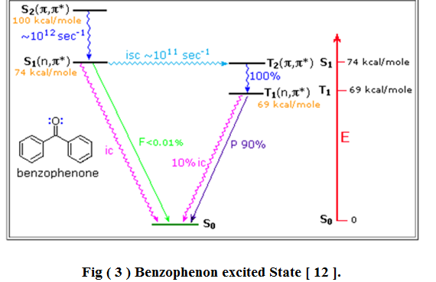

The UV spectra of product (i) , Fig(3) showed the increase of absorption from that of benzophenon (280nm) to benzopinacole (300nm), due to the increase of conjugation which increase the stability by resonance thus increased absorbency in ultraviolet region [15]. The IR spectra of the benzophenone product (i) was given in Figs (5) the absorption shown the disappearing of the benzophenone carbonyl bond absorption at 1690cm⁻¹and the present of two hydroxyl groups at 3550cm⁻¹ indicated the correct of the benzopinacole structure.

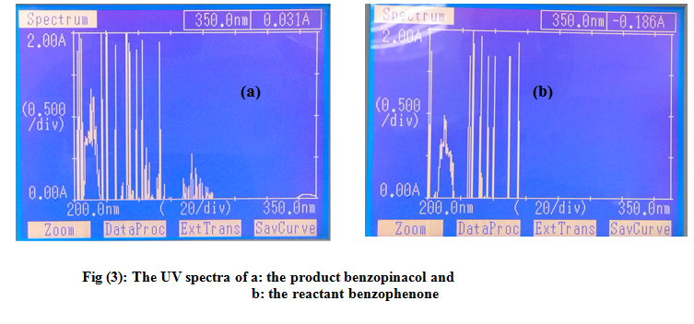
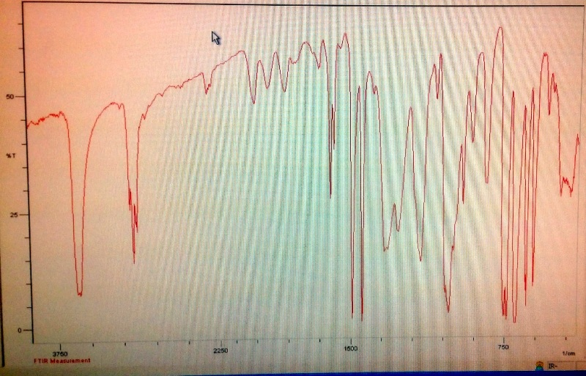
Fig (4): The IR spectra of the product benzopinacol (i)

Computational Study:[16-17]
Molecular orbital (MO) surfaces visually represent the various stable electron distributions of a molecule. According to frontier orbital theory, the shapes and symmetries of the highest-occupied and lowest-unoccupied molecular orbitals (HOMO and LUMO) are crucial in predicting the reactivity of a species and the stereochemical and regiochemical outcome of a chemical reaction.
The energy gap is the difference between HOMO Fig (5) and LOMO, the MO for larger molecules tend to be more complicated (the electrons are spread out all over the big molecule). At this point there are many such orbitals (an infinite number) but the focusing always on the electrons that are most important for the chemistry. These are: the highest occupied molecule orbital or HOMO and the lowest un-occupied molecular orbital or LUMO. The HOMO is the highest energy MO that has any electrons in it. The LUMO is the next highest energy orbital (it will be empty). The LUMO is the lowest energy place to put or excite an electron .Fig (5) showed the 3D structures of benzophenone(a), isopropyl alcohol (b)and the product benzopenacole (i), drawn as solvent accessible space filling with translucent display model

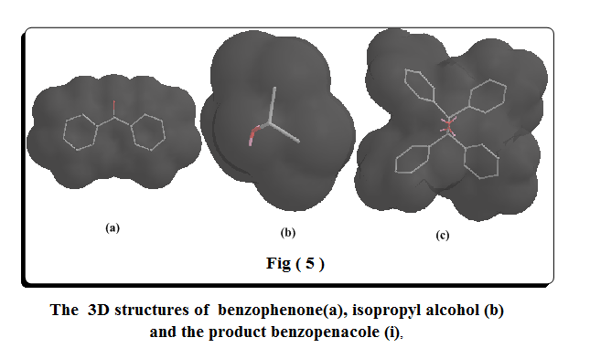

Thus, E gap of benzophenone :
ΔE=Ho– Lu =- 5.750 –(-3.223)= -2.527ev.
The HOMO and LOMO 3D representations were of the product Benzopinacol.
While, that of the product benzopinacol(i): Fig( 6 )

ΔE = -11.775 – (-1.418) = - 10.357ev. as the E gap of product is less that that of reactant the reaction is more sutabel and these resuls were in agreed with that of heat of formation as follows:
The final steric energy of the product (i) is = -6.0756 Kcal / mole, while the
While the final steric energy of the reactant benzophenone is = 14.1794

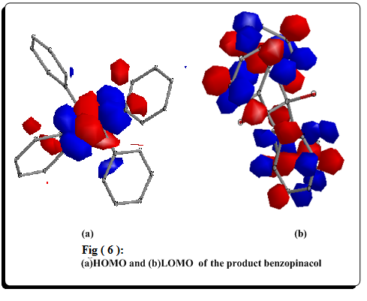

This indicated that the product benzopinacol(i) was more stable by 20.255 kcal /mole. In the same way the single occupied orbital of benzophenol radical SOMO =- 0.0150 ev and LUMO = 0.2775ev(and the E gap = -0.2925ev), which is more stable than that of reactant and less than the final product (i), and this was an additional of the formation of the product by the irradiation.

Acknowledgements:
The author wish to express his gratitude for Dr.Shakir M. Saied , Assist. Professorof organic chemistry for suggestion the idea of this work , and also express his thanks to Ninava Drug Industry and Al-Hokamaa Drug Industry especially Sofyan A. Abed Alla , Asst. Lecturer in pharmacy, for help in IR and UV spectra of the product compound.

References:
1- J. Mattay, A. G. Griesbeck: Photochemical Key Steps in Organic Synthesis, WileyVCH, (1994.(
2- N. J. Turro, Modern Molecular Photochemistry , University Science Books, Mill-Valley, California((1991).
3- F. A. Carey, R. J. Sundberg, Advanced Organic Chemistry, Plenum PublishingCorporation, (2000.(
4- A. Gillbert, J. Baggott, Essentials of Molecular Photochemistry , BlackwellScientific Publications, London(1991).
5- M. Klessinger, J. Michl, Excited States and Photochemistry of Organic Molecules, Wiley-VCH, New York(1994).
6- R.B .Woodward; Hoffmann, R. The Conservation of Orbital Symmetry. VerlagChemie Academic Press,( 2004(.
7- H.T, Okamoto Y, U.K, Kojima N: Toxicol Lett .,2006,167:1-7 .
8- International Lighting Vocabulary; 4th Edition; ‘Number 17.4.CIE(1987).
9- H.D.Angew; Chem.Int.Ed.,1989,1,93-1207.
10- ZKimmerman, H.E.; Schuster, D.I. J.Am.Chem..Soc.,1961,83,4486-4487.
11- F. Louis. Fieser ; Experiments in Organic Chemistry; 2ndedd.; D.C Heated and Co.: New York; USA(1941 ).
12- Y. Q Al-Azawy; MSc Thesis , University of Mosul , Mosul , Iraq (2003).
13- Y.V.,Ilichev; "PHOTOCHEMISTRY : Theoretical Concepts and Reaction Mechanisms" Cordis Corporation, a Johnson and Johnson Company; Welsh and McKean Roads, Spring House(2012).
14- C.E., Wayne and, Wayne, R.P. Photochemistry, Oxford: Oxford University Press.,1996, p96 .
15- R. M. Silverstein and F. X. Webster;" Spectrometric Identification of Organic Compounds " John Wiley & Sons, 6th Edition, (1997).
16- C.F. Ferrer, J.Donoso, and F. Munoz, Chemistry & Biodiversity.,2005,2,p645. P99.
17- S.M. Saied. W.Y. Yaakob and Yaman. Q. AL-Azawy; AL-TAQANI; 2011,(Vo.24;no.2).;pp101-14.

