Indirect Spectrophotometric Determination of Paracetamol in Different Pharmaceutical Samples

Farha Khalaf Omar
Department of Chemistry. Education College for girls. University of Mosul

(NJC)
(Received on 24/11/2013) (Accepted for publication 9/2/2014)

Abstract
A simple ,accurate and sensitive indirect spectrophotometric method for the determination of paracetamol in different pharmaceutical preparations has been developed. The method is based on the acid hydrolysis of paracetamol to p-aminophenol, which reacts with thymol in alkaline medium to yield a color compound shows maximum absorbance at 600 nm. Beer҆ s law was obeyed in the concentration range of 1-14µg/ml . The molar absorptivity and Sandell҆s sensitivity of the colored complex are 0.613x10⁴ l/mol.cm. and 24.66 ng/cm² respectively .The analytical parameters were optimized and the present method compared statistically with official method using (t)values. The method was successfully applied to the determination of paracetamol in pure form, and its pharmaceutical preparations( tablets ,syrup,suppositories)
Keywords:paracetamol,Indirect Spectrophotometry,Pharmaceutical preparations

الخلاصة
تم تطوير طريقة طيفية غير مباشرة تمتاز بالبساطة والدقة والحساسية لتقدير الباراسيتامول في مستحضراته الصيدلانية. تعتمد الطريقة على التحلل ألحامضي للباراسيتامول لينتج بارا-امينو فينول والذي يتفاعل مع الثايمول في وسط قاعدي مكونا معقد مستقر ازرق اللون له اقصى امتصاص عند 600 نانو ميتر. وقد لوحظ إن قانون بير يسري على الكميات التي تتراوح بين1-14مايكروغرام/مل وان قيم معامل الامتصاص المولاري ودلالة ساندل كانتا.613.0×10⁴ لتر/مول.سم و.6624نانوغرام/سم² على التوالي .وتم تثبيت الظروف المثلى للتفاعل وتم اختبار نجاح ألطريقه بمقارنه نتائجها مع ألطريقه القياسية المعتمدة باستخدام اختبار tوطبقت الطريقة بنجاح لتقديرالباراسيتامول بشكله النقي وفي مستحضراته الصيدلانية ( الاقراص , الشراب والتحاميل ).

Introduction

Paracetamol (acetaminophen or N-acetyl-4-aminophenol), is a popular antipyretic and analgesic agent and having the following structural. Formula^{(1,2)}.

C8H9NO2 MM ı151.2

It is one of the most used medicines as an alternative to aspirin (acetylsalicylic acid). Several analytical methods have been devised for the determination of paracetamol. These methods include titrimetric methods⁽³⁾ .the instrumental methods include HPLC⁽⁴⁻¹⁰⁾, voltammetry⁽¹¹⁻¹³⁾ Spectrofluorometric⁽¹⁴⁻¹⁶⁾ , capillary zone electrophoresis⁽¹⁷⁾.and spectrophotometric methods⁽¹⁸⁻²⁶⁾.In this paper we describe a simple, selective and precise method for spectrophotometric determination of paracetamol in different pharmaceutical formulations. The method is based on the acid hydrolysis of paracetamol to p-aminophenol, which reacts with thymol in alkaline medium to yield a colored compound that shows maximum absorbance at 600 nm. Experimental
Apparatus
Shimadzu UV- 1700 pharma spec (double beam) spectrophotometer with 1.0 cm quartz cells was used for absorption measurement, and Jenway 3310 pH meter was used.
Reagents
All chemical used were of analytical or pharmaceutical grade and paracetamol standard material was provided from AL-hokamaa company for pharmaceutical industries (HPI) Mosul-Iraq.
Thymol solution(6.65x10⁻⁴M):
This solution was prepared by dissolving 0.1 gm of thymol (Merck) in 100ml ethanol and diluting to 1Lwith distilled water.
NaOH (0.1 M) :
This solution was prepared by dissolving 4 gm of NaOH in 1L distilled water.
Working solution 0f paracetamol (0.5%):
This solution was prepared by dissolving 0.5 gm of pure paracetamol in 20 ml ethanol and diluting to 100mL with distilled water.
Hydrolysis procedure of paracetamol :Introduce100ml of 0.5% paracetamol and 25 ml of concentrated hydrochloric acid into a 250ml round-bottom flask equipped with condenser,reflex for 45 minutes and dilute the solution to 250 ml with distilled water.
Standard solution 0f paracetamol 50 ppm(3.3x10⁻⁴ M):This solution was prepared by neutralizing of 2.5 ml of hydrolyzed paracetamol with 5 M NaOH and diluting to 100 mL with distilled water.
General procedure :
Different aliquots of standard solution of paracetamol (hydrolyzed product eg.,p-aminophenol) equivalent 1-14 µg/ml (0.5-7mL) were transferred into a series of 25mL volumetric flasks, 3ml of 0.1 M NaOH solution , and 3mL of thymol solution were added. The content was mixed and let stand for 5min with occasional shaking. The volume was diluted to the mark with distilled water and mixed well. The absorbance of each solution was measured against a reagent blank solution prepared in the same manner but containing no paracetamol at 600 nm

Results and Discussion :
The absorption spectrum of the resulting colored product shown in figure (1).The maximum absorbance of the blue product at 600nm against blank and this wavelength recommended for determination.

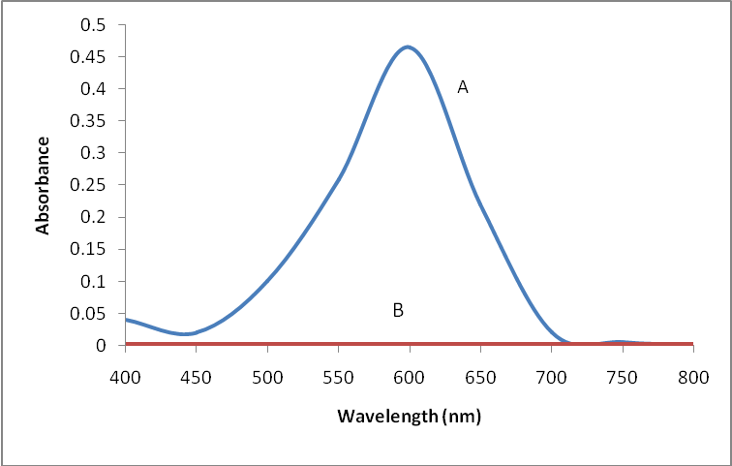
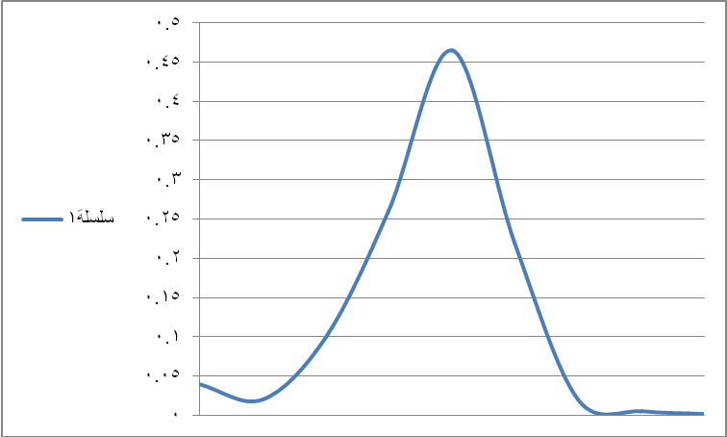
Fig [1] ;Absorption spectra of 10 g / ml Paracetamol, A- Paracetamol –Thymol product against blank, B- blank against water

Effect of amount of NaOH solution:
The preliminary examination of color reaction of thymol with hydrolyzed paracetamol indicated that a characteristic blue color of the product was formed only in alkaline solution .The maximum constant blue color intensity was reached when using 3 ml of 0.1N NaOH and remained constant up to 5ml.However 3 ml of NaOH solution was selected for subsequent work
Effect of hydrolysis time:
Sample solutions of paracetamol were treated with concentrated hydrochloric acid and refluxed for different periods of time ranging between 15 and 120 minutes. The p-aminophenol formed was measured spectrophotometrically (after neutralization) using the general procedure.The result obtained indicated that p-aminophenol-thymol product gave maximum absorbance when the acidic paracetamol solution was refluxed for 45 minutes. This results was selected for this work.
Effect of amount of Thymol reagent solution:
The amount of reagent solution were carried out by varying reagent amount to obtain maximum absorbance. It was observed that the addition of more than 2ml of (6.65x10⁻⁴M) reagent, reproducible absorbance for 10μg/ml of paracetamol was obtained. There for 3ml of reagent solution were used throughout the study.
Effect of time:
The minimum time for complete color development of the product was found to be 5 minutes at room temperature. The absorbance was then stable for at least 24 hour.

Order of the addition of reagents: Totest the effect of order of the addition of the reagents on the absorbance, different order were tested. The selected order was the p-amino phenol, NaOH, followed by the reagent solution, because of high absorbance value.
Beer ҆s law :Employing the conditions described in the general procedure a linear calibration graph of paracetamol was obtained fig(2), which shows that Beer’s law was obeyed over the concentration range 1-14 µg/ml with correlation coefficient of (R²= 0.999, intercept of 0.058 and slope of 0.0405 .The conditional molar absorptivity of the product formed and sandell҆ s sensitivity were found to be 0.613x10⁴ L/ mol .cm and 24.66 ng/cm² respectively.

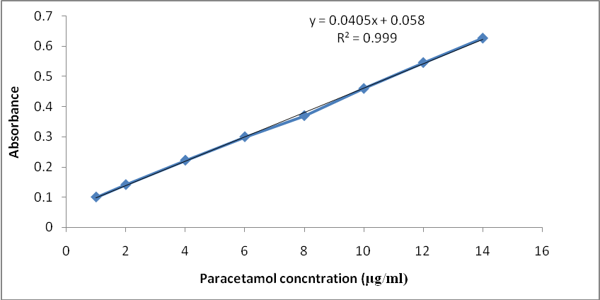
Fig. (2): Calibration graph ofparacetamol.

Accuracy and precision
The accuracy and precision of the method was established by analyzing the pure drug solution at three different levels. each determination being repeated ten times. The average recovery which is a measure of
accuracy is 100 ± 0.18 revealing high accuracy of the method . The relative standard deviation (RSD%) , which is an indicator of precision is less than 1.2% . The results are complied in Table[1] .

Table [1]: Optical characteristics and statistical data for regression equation of the proposed method
Parameters | Value
λ max (nm)  Beer´s law limits (µg .ml⁻¹)  Molar absorpitivity (1.mol⁻¹.cm⁻¹)  Sandell s Sensitivity(ng/cm²)  Correlation coefficient (r² )  Regression equation (Y= a × + b )  Slope (a)  Intercept (b)  Recovery %  Relative standard deviation (%) | 600  1-14  0.613× 10⁴  24.66  0.999  0.0405  0.058  100 ± 0.18  <1.2

Composition of the product :
The mole-ratio method⁽²⁷⁾ was employed to establish the composition of the product.The result indicate the formation of 1:1 product between p-aminophenol and thymol. The suggested reaction and structure of the product might be written as follows^{(28,29)}

Analytical applications:
The recommended condition described above and mentioned in the general procedure has been applied satisfactorily for determination of paracetamol in colden, paracetamol tablets , anti pyrol syrup and suppositories. The same sample analyzed by the British pharmacopoeia⁽³⁾,and compared statistically by student t-test at 95% confidence level.The calculated t- values did not exceed the theoretical value indicating that there was no significant differences between the precision of the proposed and literature method as cited in table [1].
Tablets:Weigh and powder 20 tablets.Transfer an accurately weighed portion of the powder equivalent to 500 mg paracetamol.Treat the sample as mentioned under hydrolysis procedure of paracetamol , and determine the concentration of paracetamol with calibration procedure for pure paracetamol using the general procedure mentioned before .The same sample analyzed by the British pharmacopoeia⁽³⁾.

Syrup:
Take a volume of syrup containing 500mg of paracetamol .Treat the Sample as mentioned under hydrolysis procedure of paracetamol, and determine the concentration of

paracetamol with calibration procedure for pure paracetamol using the general procedure mentioned before .The same sample analyzed by the British pharmacopoeia³ as shown in table [1].

Suppositories: Transfer amount of suppositories containing 500mg of paracetamol . Treat the sample as mentioned under hydrolysis procedure of paracetamol, and determine the concentration of paracetamol with calibration procedure for pure paracetamol using the general procedure mentioned before . .The same sample analyzed by the British pharmacopoeia⁽³⁾ as shown in table [2].

Table [2]: Determination of paracetamol indifferent pharmaceutical preparations.
t value | Certified value | BP pharmacopoeia | Present method | Pharmaceutical preparations
1.93  2.05  1.22  0.75 | 450mg/tablet  500mg/tablet  120mg/5 ml  250mg/suppository | 445.4mg/tab  510mg/tab  118.5mg/5ml  248.93mg/supp | 446.5mg/tab  507mg/tab  118.76mg/5ml  249.23mg/supp | Colden tablet  Paracetamol tablet  Antipyrol syrup  Anti pyrol suppositories
Mean of six determinations
t values (n=6, at 95% confidence level tabulated value 2.571).

Conclusion

The proposed method was accurate, sensitive and low economical cost. Furthermore, the proposed method doesn’t require elaboration of procedures, which are usually associated with chromatographic methods. The proposed method could be applied successfully for determination of paracetamol in pure form as well as in different dosage forms (tablets, syrup and suppositories)
Acknowledgments
The author wishes to express gratitude to Al-hokamaa state company of drug industries and medical appliance (HDI) Nineveh – Iraq for providing gift samples of paracetamol standard materials and pharmaceutical preparations.

References
1-The pharmaceutical codex, Incorporating the British pharmaceutical codex,11thEdn, pharmaceutical press, London 1979 . p. 638-641.

2- Sweetman SC, editors. Matindale - The Complete Drug Reference. 36th edition. London: Pharmaceutical Press; 2009. 108, 1895.
3-British Pharmacopoeia, H.M .Stationery office ,London ,UK, 2009, p . 4548, 9671.
4-Goyal A,Jain S. Acta Pharm Sciencia 2007; 49: 147-151.

5-M.V. Vertzoni, H.A. Archontaki, and P. Galanopoulou. J. Pharm. Biomed. Anal.;2003.32,487–493
6- B.S. Nagaralli, J. Seetharamappa, B.G. Gowda, and M.B. Melwanki. J. Chromatogr. B.;2003.798, 49–54.
7-Cemal A, Ismail TD, Ahmet S, Ahmet A, Yalcin O Huamettin G. Turk. J. Med. Sci.,2008,38(2), 167-173.
8-Gopinath, R. Rajan, S., Meyyanathan, S.N., Krishnaveni, N., Suresh, B. J. of pharmaceutical sciences, 2007,69 (1), 137-140.
9-Senthamil Selvan, P., Gopinath, R., Saravanan, V.S., Gopal, N., Sarvana Kumar, A., periyasamy, K., Asian J. of chemistry.2007.19(2),1004-1010.
10- A.W. Qare and M.B. Abou-Donia. J. Pharm. Biomed. Anal.2001,26, 939–47.
11-Jia L, Zhang XH, Li Q, Wang SF. J Anal Chem.;2007 ,62,266
12-Ghorbani-Bidkorbeh F, Shahrokhian S, Mohammadi A, Dinarvand R; Electrochim Acta.; 2010 , 55,2752.
13- Ni, Y., Wang, Y., Kokot, S., Analytical Letters,2004.37,3219-3235.
14-Hossein Tavallali , Yahya Hamid, Asian Journal of Biochemical and Pharmaceutical Research.;2011, 1(2),685-589
15-Martos NR, Diaz AM, Navalon A, Capitan- Vallvey LF Anal. Lett.;2001,34, 579-595.
16-De Los A. Oliva, M., Olsina, R.A., Masi, A.N. Talanta.; 2005,66(1), 229-235.
17-Azhagvuel, S., Sekar, R.J. of Pharmaceutical and Biomedical Analysis.; 2007, 43 (3), 873-878.
18-Criado A, Cardenas S, Gallego M, Valcarcel M. Talanta, 2000,53, 417-423.
19-Wahbi AM, Gazy AA, Abdel-Razak O, Mahgoub H, Moneeb MS. Saudi Pharm J, 2003,11, 192-200.
20-Khoshayand MR, Abdollahi H, Shariatpanahi M, Saadatfard A, Mohammadi A. Spectrochim Acta Part A.; 2008,70, 491-9.
21-Sena, M.M., Freitas, C.B. Silva, L.C, Perez, C.N., De paula, Y.O. Quimica Nova.;2007,30(1),75-79.
22-Khan F, Lohiya RT, Umekar MJ. Int. J. Chem Tech Res.;2010, 2(3), 1586-1591.
23-Murty B Sreerama, G V S R Pavan Kumar, Ramana P. and Sravanthi N. J. Indian Chem. Soc.;2011, 88(6), 893-895.
24-Afkhami Abbas, SarlakNahid and Ali Reza Zarei Acta Chim. Slov.; 2006, 53, 357–362.
25-Kamyabi Mohammad Ali ,Journal of the Chinese Chemical Society.; 2009,56, 142-149.
26-Nief.R.A,Heba.A and Najwa. A, J.Educ.Sci.;2003,15,32-40..
27-Bouer.H.H, Christian.G.D and Oreilly .J.E; Instrumental Analysis; Allyn and Bacon. Incm Boston, 1978,pp178-179.
28-Morrison and Bayd; Organic Chemistry;3rdEdn. Allyn and Bacon, Inc,USP,1973,p.793.
29-Nief.R.Ahmad and Aesa.W; Journal of Education and Science.;2004,16 (1),52-59.

