Indirect Spectrophotometric Determination of PABA in Pharmaceutical Preparation(capsules)

Nabeel Sabeeh Othman
nsn20002004@yahoo.com
Chemistry Dept. College of Science, Mosul University

Rawaa Abdul-Aleem Zakaria
rawaa_ zakaria72@yahoo.com
Chemistry Dept. College of Education, Mosul University

(NJC)
(Received on 24/9/2013) (Accepted for publication 23/2/2014)

Abstract
An indirect spectrophotometric method is developed for
the determination of p-aminobenzoic acid (PABA) is developed for the determination of PABA as pure and in pharmaceutical preparations. The method is based on the oxidation of PABA with iron(III) in acidic medium, then reaction of iron(II) with 1,10-phenathroline to produce a red complex which is water-soluble, stable and has a maximum absorption at
510 nm against the reagent blank with a molar absorptivity of 4.93×10⁴ L.mol⁻¹ .cm⁻¹ . The variables affecting the intensity of complex have been studied and optimized. Under the optimum conditions, the calibration graph is linear over the range 5-80 µg /25 ml (0.2-3.2 ppm), with a relative error of -0.41 to -0.09 and a relative standard deviation of ±0.060 to ±0.507 depending on concentration level. The proposed method is applied to determine PABA in pharmaceutical preparation (capsules).
Key words: p-aminobenzoic acid, Spectrophotometric determination, 1,10- phenathroline .

الخلاصة
تم تطوير طريقة طيفية غير مباشرة لتقدير بارا- امينو حامض البنزويك بشكله الحر وفي مستحضره الصيدلاني (الكبسول). تعتمد الطريقة على أكسدة البارا- امينو حامض البنزويك بوساطة الحديد الثلاثي في الوسط الحامضي ومفاعله الحديد الثنائي مع الكاشف 10,1 فيناثرولين لينتج معقد الفيرون الذي يكون ذائب في الماء ومستقر ويعطي أعلى امتصاص عند الطول الموجي 510 نانوميتر مقابل المحلول الصوري, وكانت قيمة الامتصاصية المولارية 4.93×⁴10 لتر.مول⁻¹.سم⁻¹. وينطبق قانون بير في مدى التركيز5 الى 80 مايكروغرام بارا- امينو حامض البنزويك في حجم نهائي 25 مللتر(0.2 -3.2 جزء/مليون) ، الخطأ النسبي بين 1- 0.4 و0.09 % ، والانحراف القياسي النسبي من ±0.060 الى ±0.507 % اعتماد على مستوى التركيز. تم تطبيق الطريقة بنجاح في تقدير البارا- امينوحامض البنزويك في مستحضره الدوائي (الكبسول).
الكلمات المفتاحية: بارا- امينو حامض البنزويك, التقدير الطيفي, 10,1- فيناثرولين

Introduction
P-aminobenzoic acid (PABA), also called vitamin B₁₀ or factor R, is found to be the part of the folic acids⁽¹⁾. It is a non- protein amino acid that is widely distributed in nature. Since a small amount of it is present in the vitamin B-complex, it is included as a member of the vitamin family. It is essential for the growth of microorganisms, but less essential as a nutrient for the human body ⁽²⁾. It also is observed that it possessed an anti sulphanil amide activity ⁽³⁾.
Various methods have been used for the determination of PABA in biological fluids and pharmaceu-tical preparations. These methods are potentiometric titration⁽⁴⁾, chromatographic (LC, HPLC)⁽⁵⁻⁸⁾, flow injection analysis^{(9,10)}, spectrophotometric⁽¹¹⁻¹⁵⁾ , oxidative coupling reaction ⁽¹⁶⁾ , fluoro- metric ⁽¹⁷⁾ .
The present paper reports a new indirect colorimetric method for the determination of PABA in its pharmaceutical preparation, based on the oxidation of PABA with ferric ion in acidic medium and subsequent complication of ferrous ion with 1,10- phenathroline reagent in aqueous solution to produce red complex of ferrous
ion - 1,10- phenathroline which its intensity proportional to amount of PABA .

Materials and Methods

Apparatus
The spectrophotometric measurements are carried out on Shimadzu UV-Visible Recording Spectrophotometric UV-210, using 1-cm silica cells.

Reagents
All chemicals used are of the
highest purity available.
Working PABA solution, 50 μg / ml. A 0.0100g amount of PABA is dissolved in 2 ml ethanol and 30 ml distilled water (heating is necessary to increase solubility ) and the volume is completed to 200 ml in a volumetric flask, the solution is stable for about one week.
Iron (III) nitrate nanohydrate solution, 0.03M: This solution is prepared by dissolving 1.2120 g of ferric nitrate monohydrate in 8 ml of nitric acid (1M) and then the volume is completed to 100ml in a volumetric flask with distilled water.
1,10-phenanthroline mono-hydrate solution, 0.05M: This solution is prepared by dissolving 0.9911 g of 1,10-phenathroline monohydrate (Fluka) in ethanol in a 100 ml volumetric flask.
New care capsules solution 50 μg / ml. Weight and mix the contents of six capsules (each one contains 20 mg PABA), an accurately weighed amount of powder equivalent to 0.0100g PABA is dissolved in 2 ml ethanol and 30 ml distilled water (heating is necessary to increase solubility) and the volume is completed to 200 ml in a volumetric flask to prepare a solution of 50 ppm PABA.
Procedure and calibration graph:
To a set of 25 ml volumetric flasks aliquot covering the range of 5-120 µg (0.2-4.8 ppm) of PABA solution are transferred, then 0.3 ml of 0.03M (Fe(NO₃)₃.9H₂O solution is added, followed by 2ml of 0.05M 1,10-phenathroline monohydrate solution after the volumes are completed to the

mark with distilled water, the solutions left for 40 minutes in water-bath adjusted at 80°C, then the solution left to stand for 15 minutes at room temperature before the absorba-nces of the red colored product are measured at 510 nm against the reagent blank. A linear calibration graph is obtained over the concentration range of 5-80µg PABA/25ml and a concentration above 80µg/ 25ml gives a negative deviation (Fig.1). The molar absorptivity has been found to be 4.93×10⁴ l.mol⁻¹.cm⁻¹.

µg PABA / 25 ml
Fig. 1: Calibration graph of PABA determination

Results and Discusion
Principle of the method
Iron (III) ion can act as an oxidant and reacts with PABA to produce quantitatively iron (II) ion. The amount
of iron (II) ion can be determined by using 1,10-phenathroline monohydrate reagent and the intensity of the red complex can be used to developed a spectrophotometric method for the determination of PABA in pharmaceutical preparation(capsules).

Effect of pH
Different acids with different amounts of 0.05N (HCl, HNO_{3,} H₃PO₄ and CH₃COOH) have been used and the results indicate that the components of reaction without acid added pH =3.38 give high intensity of the complex formed.
Effect of temperature
The effect of temperature on the color intensity of the resulting complex is investigated. The results indicated that absorbance of the complex increased with increasing temperature (Table 1).

Table 1: Effect of temperature
Temperature C° | 30 | 50 | 60 | 70 | 80 | 90
*Absorbance | 0.021 | 0.162 | 0.189 | 0.230 | 0.271 | 0.275
*Using 1ml of ferric nitrate

The result in Table 1 indicated that practically there is no significant difference in intensity when the color is developed at 80°C or 90°C, however, 80°C is recommended.

Effect of ferric nitrate nano-hydrate concentration
The effect of changing the ferric nitrate nanohydrate amount on the absorbance of the red complex formed has been investigated (Table2).

Table 2. The effect of ferric nitrate nanohydrate amount on absorbance
Absorbance | ml ferric nitrate (0.03M) solution
0.498 | 0.1
0.590 | 0.2
0.709 | 0.3
0.555 | 0.5
0.291 | 1.0
Turbid | 2.0

The results illustrated in Table 2 indicated that 0.3 ml of 0.03 M ferric nitrate nanohydrate solution was the optimum amount ,it gives the highest absorbance. ,therefore it is recommended for the subsequent experiments .
Effect of 1,10-phenathroline monohydrate reagent amount
The effect of different amounts of 1,10-phenathroline monohydrate reagent on the absorbance of solution containing different amounts of PABA is studied.
The results indicated that the absorbance increases with increasing reagent concentration and reached maximum on using a volume of 2 ml of 0.05M 1,10-phenathroline monohydrate ,therefore it is used in the subsequent experiments (Table 3).

Table 3. The effect of reagent amount on absorbance
Absorbance | ml of 1,10-phenathroline  (0.05M) solution
0.714 | 1.0
0.738 | 1.5
0.774 | 2.0
0.703 | 2.5
0.589 | 3.0

Effect of time
The effect of time on the development and stability period of the red complex is investigated under optimum experimental conditions for the determination of

PABA. The results in Table 4 show that the red complex formed from two different amounts of PABA is complete after 15 minutes after removing the flasks from water bath and the absorbance remained constant at least for 45 minutes.

Table 4: Effect of time on absorbance
PABA  (µg /25ml) | Absorbance/ min. standing time
PABA  (µg /25ml) | 5 | 10 | 15 | 20 | 30 | 40 | 50 | 60
30 | 0.484 | 0.487 | 0.510 | 0.512 | 0.515 | 0.516 | 0.514 | 0.513
50 | 0.763 | 0.769 | 0.771 | 0.773 | 0.774 | 0.773 | 0.772 | 0.771

Final absorption spectrum

When PABA is treated according to the recommended procedure, the absorption spectrum shows a maximum absorption at
510 nm, characteristics of the
ferroin chromophore in contrast to the reagent blank which shows a slight absorption at 510 nm (Fig. 2).

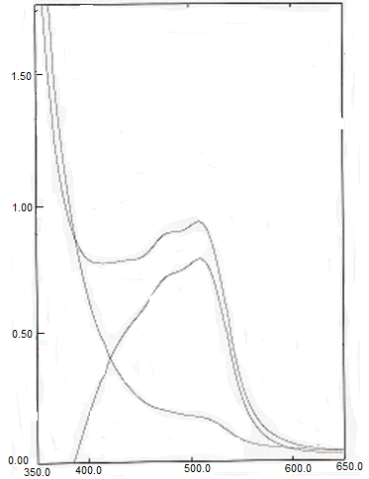
C
B

A
Absorbance

Wavelength, nm

Fig. 2: Absorption spectra of 50µg PABA /25ml treated according to the
procedure and measured against (A) reagent blank, (B) distilled water and (C) reagent blank measured against distilled water

Interference
In order to asses the possible analytical application of the proposed methods, the effect of some foreign substances which often accompany the pharmaceu-tical preparations are studied by adding different amounts of these foreign substances to 50µg PABA /25 ml. It is found that the studied foreign species do not interfere in the present method (Table 5).

Table 5:Effect of foreign compounds for assay of PABA
Recovery (%) of 50µg PABA per µg foreign compound added |  |  | Foreign compound
1000 | 200 | 50 | Foreign compound
104.2 | 103.9 | 102.9 | Glucose
105.0 | 95.0 | 101.8 | Fructose
101.0 | 100.3 | 102.4 | Acacia
102.3 | 99.3 | 98.6 | Starch

Accuracy and precision
To check the accuracy and precision of the method, PABA is determined at

three different concentrations. The results illustrated in Table 6 indicated that the method is satisfactory.

Table 6. The accuracy and precision
µg PABA/25ml | Relative error, %* | Relative standard deviation, %* | Recovery, %*
30 | -0.412 | ±0.507 | 99.7
50 | -0.310 | ±0.510 | 99.8
70 | -0.090 | ±0.060 | 100.2
*Average of five determinations

Stoichiometry of the reaction

The stoichiometry of the reaction of PABA with ferric ion [Fe⁺³] has been investigated by applying the continuous variations and mole-ratio methods.

The results indicate that the product is formed in the ratio of PABA : Fe⁺³ is 1:1 (Fig.3 and 4).

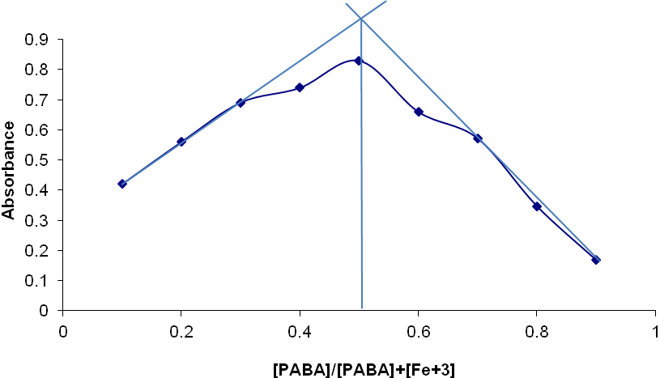
0.5-4.5 ml of 1×10⁻³ [PABA]
4.5-0.5 ml of 1×10⁻³ [Fe⁺³]
Fig.3: Job^{ʼ}s plot for PABA-Fe⁺³
1ml of 1×10⁻³ [PABA]
0.25-3 ml of 1×10⁻³ [Fe⁺³]

Fig.4: The mole-ratio plot for PABA-Fe⁺³

The ferrous ion produced is chelated by 1,10-phenathroline to

form the well-known red chelated⁽¹⁸⁾ [1] Fe⁺² : 3 ( 1,10-phenathroline)

Red complex

Analytical applications

The proposed method is successfully applied to determine of PABA in its pharmaceutical preparation (capsules). The performance of the proposed methods is assessed by calculation of the t-test compared with the standard method⁽¹⁹⁾ (potentiometric titration with sodium hydroxide ) for 95% confidence level with six degrees of freedom. The results (Table 7) have been shown that the t-values is less than the critical value (2.447), indicating no significant difference between the proposed and standard method for the determination of PABA.

Table 7:Application of methods
Drug | g PABAµ  present/ 25 ml | Recovery*, %  presence method | Recovery*, %  standard method | value-t
Newcare per capsule 20mg p-aminobenzoic acid  Asia pharmaceutical Industries-Syria | 50 | 99.8 | 100.4 | ±1.024
*Average for four determinations

Comparison of the methods

Table 8 shows the comparison between some of analytical variables for the present method with that of other literature spectrophotometric methods.

Table 8. Comparison of the methods
Analytical parameters | Present method | Literature method⁽¹⁴⁾ | Literature method⁽¹³⁾ | Literature method⁽²⁰⁾
pH | 3.38 | 7.7 | 12.57 | 12.13
Temperature (°C) | 80ºC | Room temperature | Room temperature | Room temperature
_{λmax} (nm) | 510 | 365 | 419 | 436
Reagent | 1,10-phenathroline- monohydrate | Methyl  acetoacetate | Phloroglucinol | Histidine
Beer’s law range (ppm) | 0.2-3.2 | 0.4-10.4 | 0.4-5.6 | 0.2-8.8
(ɛ, l.mol⁻¹.cm⁻¹) | 4.93×10⁴ | 2.41 ×10⁴ | 4.7×10⁴ | 2.02×10⁴
Application of the method | Determination of PABA in capsules | Determination of PABA in procaine-penicillin | Determination of PABA in procaine-penicillin | Determination of PABA in procaine-penicillin  and folic acid in tablets

The results indicate that the proposed method is more sensitive than the literature methods and it needs heating the components of reaction at 80 ºC for 45 minutes. The proposed method has an application part, but the present method needs longer time of analysis.

Conclusion
Indirect spectrophotometric method has been proposed for the determination of PABA in pure form. It has been shown that the proposed method is more sensitive for the assay of PABA in its pharmaceutical preparation (capsules) without interference from commonly used excipients.

References
1. Galaction A. Camarut M., Cascaval D. Chemical Industry and Chemical Engineering Quarterly, 2008, 14, 159-165.
2. Mirzaei M. Khayat M. and Saeidi A. “Scientia Iranica C,2012,19,561-564.
3. Charles O., Ole G. and Robert F.“ Textbook of Organic Medicinal and Pharmaceutical Chemistry”, 7th Edn., Lippincott Company, Toronto, (1977), 927.
4. Vladescu L. Badea I. and Moja D. Roum. Biotechnol. Lett., 2002, 7, 655-660.
5. Hayakawa Y. J. Chromatogr.,1986, 383,148-152.
6. Wang L. Huang W. and Tai H.
J. Pharm. Biomed. Anal.,2007, 43, 1430-1436.
7. Dhananjeyan MR. Bykowski C. Trendel JA. Sarver JG. Ando H. and Erhardt PW. J. Chromatogr. B Anal. Technol. Biomed. Life Sci. 2007, 847, 224-230.
8. Dhananjeyan M. Trendel J. Bykowski C. Sarver J. Ando H. and Erhardt P. J.Chromatogr. B:;2008,867,247-252.
9. Chisvert A. Izquierdo J. and Salvador A.; Anal. Bioanal. Chem. 2002, 374, 963-967.
10. Algar S. Martos N. and Diaz A. Anal. Bioanal. Chem.; 2008, 391, 715-719 .
11. Bratton AC. and Marshall EK. J.Biol. Chem.1939, 128, 537.
12. Yamato C. and Kinoshita K.
Anal. Biochem.,1979, 98, 13.
13. Othman N. and Mansour S.
Tkrit J. of Pur. Sc.(2005, 10, 139.
14. Othman N.and Salih Z.College of Basic Education Researchers Journal , 2007, 5, 193-206.
15. Hamdon I. Tkrit J. of Pur. Sc.;2007, 12, 189-194.
16. Al-Abachi M.Q. Al-Ghabsha T.S. and Salih E.S. Microchem. J.;1990, 41, 64.
17. Lianidou ES. and Ioannou PC. Clin. Chem.; 1996, 42, 1659-1665.
18. Christian GD. " Analytical Chemistry " 4th Edn., John Wiley and Sons, New York, (1986), 598.
19. British Pharmacopeia on CD-ROM, 5rd Edn., System Simula-tion Ltd, the stationary office, London (2007).
20. Othman N. and Salih Z." J. Edu.& Sci.; 2008, 21, 91-102.

