Development of New Spectrophotometric Method for Determination of Sulfamethoxazole Based on Diazo Coupling Reaction

Samar Ahmed Darweesh Ibdul Mohsin Abdul hamed Al-Haidari

Sarmad Bahjat Dikran Alaa Karem Mohammed

Chemistry Department, College of Education for Pure Science- Ibin Al-Haitham, University of Baghdad.
(NJC)
(Received on 30/9/2013) (Accepted for publication 27/2/2014)

Abstract
Sulfamethoxazole (SMX) was treated with sodium nitrite and hydrochloric acid for diazotization reaction followed by coupling with chromotropic acid in alkaline medium to form,an orange colored azo dye compound which exhibits maximum absorption (λ_{max}) at 513nm and the concentration of(SMX) was determined spectrophotometrically. The optimum reaction conditions and other analytical parameters were evaluated. In addition to classical univariate optimization, modified simplex method (MSM) has been applied in optimization of the variables affecting the color producing reaction.
Beer’s law obeyed in the concentration range of 0.5–20μg.mL⁻¹ with molar absorptivity of 3.1786×10⁴L.mol⁻¹.cm⁻¹. The limit of detection was found to be 0.043μg.mL⁻¹ and the Sandell's sensitivity value was 7.9681μg.cm⁻². The proposed method could be successfully applied to the determination of (SMX) in synthetic sample and urine.
Key words: Spectrophotometric determination, Sulfamethoxazole, Diazotization reaction, Coupling reaction.

الخلاصة
عومل عقار السلفاميثوكسازول(SMX) مع نتريت الصوديوم وحامض الهيدروكلوريك لأزوتته تبع ذلك اجراء تفاعل ازدواج مع حامض الكروموتروبيك في وسط قلوي لتكوين صبغة الأزو ذات اللون البرتقالي التي تظهر أعظم امتصاص (λ_{max}) عند513 نانومتر ومن ثم تم تقدير تركيز السلفاميثوكسازول طيفياً. وقد تم تعيين الظروف الفضلى التي تؤثر على التفاعل والعوامل التحليلية الأخرى.وبالإضافة الى الطريقة الكلاسيكية بنمط المتغير الواحد طبقت طريقة السمبلكس المحورة لتعيين الظروف الفضلى للمتغيرات التي تؤثر على التفاعل اللوني قيد الدراسة.
تم تطبيق قانون بير على مدى من التراكيز يتراوح بين (0.5–20 µg.mL⁻¹)وكانت قيمة معامل الامتصاص المولي مساوية لـ 3.1786×10⁴ L.mol⁻¹.cm⁻¹وكان حد الكشف يساويµg.mL⁻¹0.043 ومعامل ساندل يساوي 7.968 µg.cm⁻². لقد أمكن تطبيق الطريقة المقترحة بنجاح لتقدير السلفاميثوكسازول في نماذج محضرة وكذلك فى الادرار.
الكلمات المفتاحية: التقدير الطيفي, سلفاميثوكسازول, تفاعل الأزوتة, تفاعل الأزدواج.

Introduction

Chemically sulfamethoxazole (Figure1) is 4-Amino-N-(5-methyl-3-isoxazoyl) benzene sulfonamide) antibacterial drug that interferes with folic acid synthesis in susceptible bacteria. Its use has been limited by the development of resistance and it is now used mainly as a mixture with trimethoprim⁽¹⁾.

Figure 1: The chemical structure of sulfamethaxazole.

Sulfamethoxazole and other sulfonamides having similar structures to p-amino benzoic acid, are used in the treatment of urinary tract infections, eye infections and as a prophylaxis of rheumatic fever. It acts as competitive inhibitors of the enzyme dihydropteroate synthetase, DHPS in bacteria by blocking the conversion of p-aminobenzoic acid to dihydropteroate, a reduced form of folic acid⁽²⁾.A survey of literature revealed that several analytical methods such as high performance liquid chromatography ⁽³⁻⁵⁾,flow injection^{(6,7)}, high performancethin layer chromatography⁽⁸⁾,solidphase extraction⁽⁹⁾ , voltammetry⁽¹⁰⁾ and spectrophotometric methods⁽¹¹⁻¹⁶⁾ have been reported for the determination of sulfamethoxazole. Some of the reported spectrophotometric methods require long heating times for color development⁽¹⁶⁾, laborious⁽¹⁷⁻¹⁹⁾, applicable to high concentrations of the drug ^{(20,21)} or are less sensitive⁽²²⁾.
The present study describes the use of chromotropic acid as a chromogenic reagent in the development of simple, sensitive and a rapid spectrophotometric method for the estimation of SMX with reasonable precision, accuracy. Experimental conditions have been studied and the method optimized using univariate and multivariate simplex method.
Experimental
Instruments
The absorption spectra were recorded on a doublebeam shimadzu UV-1800 spectrophotometer, while CECIL 1011 UV-Visible single beam spectrophotometer with 1cm matched quartz cells was used for photometric measurements.

Materials and reagents
Pharmaceutical grade sulfamethoxazole was received as a powder in pure form (99.99%) as gift sample from the State Company for Drug Industries and Medical Appliances Samara-Iraq (SDI).All chemicals and reagents used were of analytical grade.

Reagents solutions
Sodium nitrite [0.5%(m/v)]: prepared by dissolving 0.5g of NaNO₂ in distilled water and diluted to 100mL in a volumetric flask.
Sulfamic acid [2 % (m/v)]: prepared by dissolving 2g of sulfamic acid in 100mL of distilled water.
Chromotropic acid (CTA) [ 2 % (m/v)] : prepared by dissolving 2g of CTA in 100mL of distilled water.
Sodium hydroxide [2M]: prepared by dissolving 8g of NaOHin100mL of distilled water.
Hydrochloric acid [5N]: 85mL of concentrated HCl was diluted to 200mL with distilled water.
Hydrochloric acid [2N]: prepared by diluting 16.72mL of concentrated reagent to 100mL with distilled water.
Standard sulfamethoxazole solution
(SMX)100µg.mL⁻¹
Standard solution of SMX was prepared by dissolving accurately weighted10mg of pure drug in 1.5mL of 5M HCl and further diluted to 100mL with distilled water.

Preparation of synthetic drug sample
- 20 mg of the bulk drug was mixed with 5mg of interfering substance mixture (consisting of 0.01 g of each of glucose, lactose, soluble starch, and vanillin).
- 12.5mg of the resulted mixture was dissolved by the same manner as used for the preparation standard drug to obtain 100μg.mL⁻¹.
22
Preparation of drug solution in urine
Solution of drug in urine was prepared by dissolving 10mg of (SMX) in 1.5mL of 5M HCl and complete volume to 100mL urine in volumetric flask to obtain 100μg.mL⁻¹ stock solution.

General Standard Procedures
Univariate method
Aliquots of the standard solution100μg.mL⁻¹ containing5–150μg of sulfamethoxazole were transferred into a series of 10mL volumetric flasks. After cooling in an ice bath,1.0mL of 0.05 % (m/v) sodium nitrite solution and 1.0 mL of 0.5MHCl were added to each flask. The solution was shaken thoroughly;1.5mL of 0.5% (m/v) sulfamic acid was added. The solutions were swirled and the resulting diazotized product was coupled with CTA by the addition of 1.0mL of 0.7% (m/v) this reagent followed by 2.0mL of 0.1M sodium hydroxide solution and allowed to stand for 10min.The solutions were made up to themark with distilled water. After mixing the solution well, the absorbance of orangecolored chromogenwas measured at 513nm against the reagent blank.

Simplex method
Aliquots of the standard solution100 µg.mL⁻¹containing 5–200μgof sulfamethoxazole were transferred into a series of 10mL volumetric flasks. After cooling in an ice bath, 1.0mL of 0.05 % (m/v) sodium nitrite solution and 1.0mL of 0.5MHCl were added to each flask. The solution was shaken thoroughly; 1.5mL of 0.25% (m/v)sulfamic acid was added. The solutions were swirled and the resulting diazotized product was coupled with CTA by the addition of 1.0mL of 0.4% (m/v) this reagent followed by 2.0mL of 0.2M sodium hydroxide solution and allowed to stand for 10min. The solutions were made up to the mark with distilled water. After mixing the solution well, the absorbance of orange colored chromogen was measured at 513nm against the reagent blank.
Results and Discussion Absorption spectrum and reaction scheme
The Primary aromatic amines are specifically and sensitivity determinable by diazotization of amine to corresponding diazonium compound, then coupling with activated aromatic compounds to yield an azo compounds as this reaction ⁽¹⁷⁾.
Ar-N₂⁺ + ArʹH → Ar-N=N-Arʹ + H⁺
The investigated method involves the diazotized sulfamethoxazole reaction with chromotropic acid in an alkaline medium to give an orange colored azo dye with a maximum absorption at 513nm (Figure 2). The reaction can be represented in Scheme1.

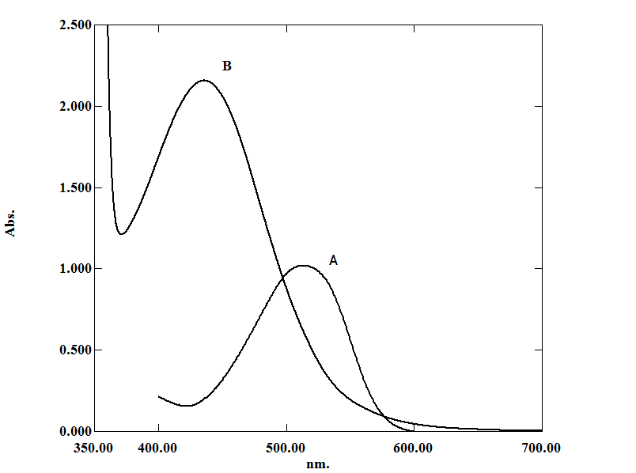
Figure 2:Absorption spectrum of: (A) 10 μg.mL⁻¹ SMX-CTA against reagent blank, (B) blank solution against distilled water.
23
Scheme1: The reaction mechanism for diazotization and reaction between SMX and CTA.

Optimization of reaction variables
Univariate method
A systematic study of the effects of various parameters on the development of color products were taken by varying the parameters one at a time and controlling all others fixed. These variables include effect of diazotization reaction time, sodium nitrite concentration, hydrochloric acid concentration, sulfamic acid concentration, chromotropic acid concentration, sodium hydroxide concentration and coupling reaction time.
Effect of diazotization reaction time
The optimum diazotization time was determined, at ~ 0 ºC, by following the absorbance of the formed azo-dye for the period of (0–20) minutes (Table1). It was found that the an orange colored product with maximum absorbance at 513nm has taken place instantaneous, after which no more increase in absorbance values was obtained.

Table1: Effect of diazotization reaction time.
Time (min.) | Absorption
0 | 0.117
5 | 0.105
10 | 0.102
15 | 0.100
20 | 0.098

24

Effect of sodium nitrite
The effect of the concentration of (NaNO₂) was studied by measuring the absorbance of the color products at 513nm (Figure3); it was found that 1.0mL of 0.05% m/v solution sodium nitrite was needed for maximum color intensity for azo dyes complex.

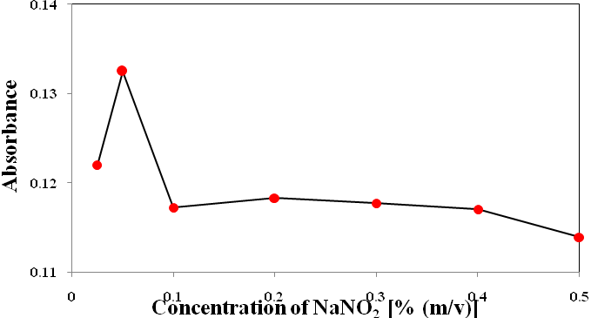
Figure3: Effect of sodium nitrite in the determination of 10µg.mL⁻¹of SMX.

Effect of acidity
The influence of hydrochloric acid concentration on the diazotization reaction was studied over the range 0.025–2.00 M. Maximum and constant absorption intensities were achieved at addition of 1.0mL of 0.5M HCl (Figure 4), after which the absorbance of the reaction product began to decrease.

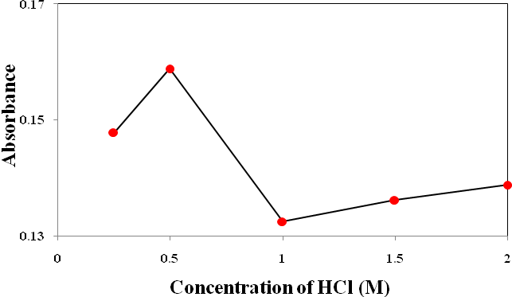
Figure 4: Effect of acidityon the color development of dye in the determination of 10µg.mL⁻¹ of SMX.

Effect of sulfamic acid concentration
To remove excess nitrite, sulfamic acid was added. The optimum sulfamic acid concentration was estimated by adding 1.5mL from various concentration of 0.25–2% m/v of sulfamic acid solution, it was found that 1.5mL of 0.5% m/v solution gave the highest absorbance value as shown in (Figure 5).
25

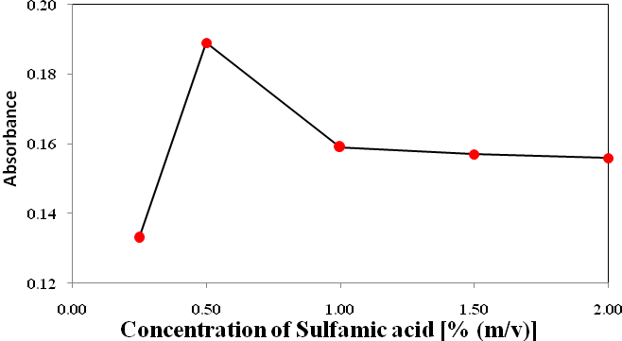
Figure 5: Effect of sulfamic acid concentration in the determination of 10µg.mL⁻¹ of SMX.

Effect of reagent concentration
Concentration of chromotropic acid ranged from 0.1–2.0 % m/v of1.0mL solutions were examined to found highest color intensity of the azo dye as shown in Figure 6. The investigation showed that 1.0mL of 0.7% m/v CTA gave maximum and stable color.

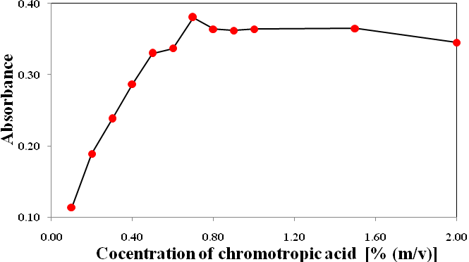
Figure 6: Effect of CTA concentration on the color development of dye in the determination of 10µg.mL⁻¹ of SMX.

Effect of alkalinity
It was found that the optimum concentration of sodium hydroxide leading to a maximum intensity of complex color was 2.0mL of 0.1M. Addition of more than 0.1M of alkali causes a decrease in absorbance; this may be attributed to the decolorization of colored azo dye (Figure7).
26

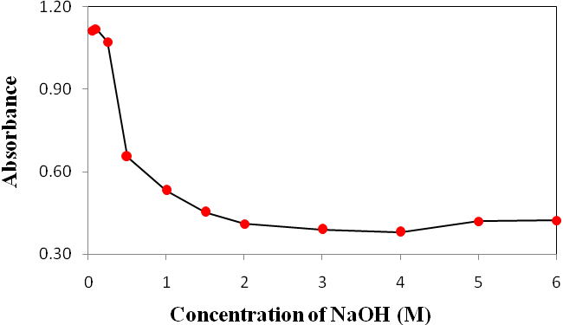

Figure 7: Effect of alkalinity in the determination of 10µg.mL⁻¹ of SMX.

Effect ofcoupling reaction time
The optimum time of coupling reaction (before dilution) was determined by following the color of the developed azo dye at room temperature. The reaction mixture was allowed to stand for different time intervals (Table 2), and it was found that 10min. period was required for full color development and the color last stable for at least 3h.

Table2: Effect of coupling reaction time.
Time | Absorption
0min. | 0.642
5min. | 1.048
10min. | 1.119
15min. | 1.114
20min. | 1.113
3h | 1.113

Simplex method
Multi simplex program was employed to find out the optimum experimental conditions for determination of (SMX). In this method three interest factors (n=3), namely concentration of sulfamic acid, chromotropic acid, and sodium hydroxide were chosen as independent variables and the absorbance of the formed azo dye at 513nmas response was assessed.
The boundary conditions for the three independent variables, delineated above, were set (Table 3) together with their step values.
27
Four (n+1) arbitrary experimental conditions were arbitrary chosen, by selecting the values of these parameters within specified boundaries for each, at which they affected the measured absorption signals of the colored products (experiments number 1-4in Table 4).The measured absorption signals of these four experiments were feed into the multi simplex computer program. The program then suggest a new set of conditions to be carried out and the resulted absorbance is feed again to the program and so on. Figure 8 shows the progress of the simplex, which indicates a gradual improvement in the response function. Only 19 experiments were enough to evaluate the proper conditions at maximum response function, two more experiments were done to ensure the obtained results (Table 4).
The conclude optimum operating conditions for the determination of (SMX)were found to be 0.25% m/v sulfamic acid, 0.4% m/v CTA and 0.2M sodium hydroxide.

Table 3: Boundary of simplex for the studied variables.
Variable | Minimum boundary | Maximum boundary | Step size
Conc. of sulfamic acid (%) m/v | 0.25 | 2.0 | 0.25
Conc. of CTA (%) m/v | 0.10 | 2.0 | 0.10
Conc. of NaOH(M) | 0.05 | 2.0 | 0.05

Table 4: Multivariate experiments (Simplex) for determination of 10μg.mL⁻¹ SMX.
Exp.  No. | Conc. of sulfamic acid(%) m/v | Conc. of chromotropic acid(%) m/v | Conc. of sodium hydroxide(M) | Abs.
1 | 0.25 | 0.1 | 0.30 | 1.230
2 | 0.75 | 0.8 | 0.70 | 0.488
3 | 1.25 | 1.1 | 1.50 | 0.383
4 | 2.00 | 0.5 | 1.80 | 0.349
5 | 0.25 | 0.1 | 0.05 | 0.622
6 | 0.25 | 0.1 | 0.10 | 0.771
7 | 0.50 | 0.3 | 0.60 | 0.485
8 | 0.25 | 0.1 | 0.20 | 0.929
9 | 0.25 | 0.2 | 0.25 | 1.250
10 | 0.25 | 0.2 | 0.40 | 0.712
11 | 0.25 | 0.2 | 0.35 | 1.088
12 | 0.25 | 0.2 | 0.30 | 1.241
13 | 0.25 | 0.3 | 0.45 | 0.704
14 | 0.25 | 0.1 | 0.20 | 0.929
15 | 0.25 | 0.3 | 0.20 | 1.259
16 | 0.25 | 0.3 | 0.15 | 1.157
17 | 0.25 | 0.4 | 0.15 | 1.193
18 | 0.25 | 0.3 | 0.25 | 1.266
19 | 0.25 | 0.4 | 0.20 | 1.269
20 | 0.25 | 0.5 | 0.20 | 1.128
21 | 0.25 | 0.3 | 0.30 | 1.182
28
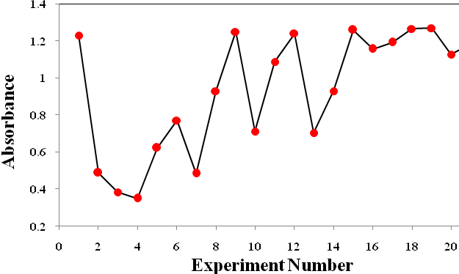
Figure 8: Response function progress for simplex.

Calibration curves and analytical data
І- Univariate optimization method
The effect of concentration on the absorbance behavior at optimum conditions of univariate method was investigated using authentic standard. The results are shown in Figure9. Beer’s law was obeyed in the range of (0.5-15.0) μg.mL⁻¹of SMX. The regression equation, correlation coefficient, molar absorptivity, Sandell's sensitivity and detection limit are calculated and listed in Table 5.

Table 5: Optical characteristics and statistical data for determination of SMX by univariate method.
Parameter | Value
λ_{max} (nm) | 513
Color | Orange
Linearity range (µg.mL⁻¹) | 0.5 – 15.0
Regression equation | Y=0.1148[SMX. µg.mL⁻¹]-0.0321
Calibration sensitivity (mL.μg⁻¹) | 0.1148
Correlation coefficient (R) | 0.9996
Correlation of linearity (R²) | 0.9992
Molar absorptivity (L.mol⁻¹.cm ⁻¹) | 2.9076*10⁴
Sandell's sensitivity (µg.cm⁻²) | 8.7109
Detection limit (µg.mL⁻¹)  29 | 0.066
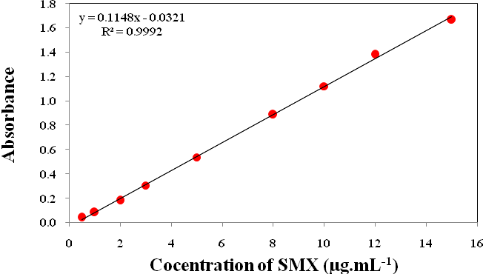
Figure 9: Calibration curve for the determination of SMX by univariate optimal conditions.

ІІ- Simplex optimization method
Optical characteristics and statistical data for the regression equation for the calibration graph constructed under experimental conditions obtained via simplex method are given in Figure 10 and Table 6.The results show better optical characteristics for calibration curve and statistical data were obtained under optimum conditions obtained by multi simplex optimization, in comparison with those obtained via univariate method.
A comparison of performance of the proposed method with already reported spectrophotometric procedures is given in Table 7; the results indicate that the proposed method is sensitive and rapid.

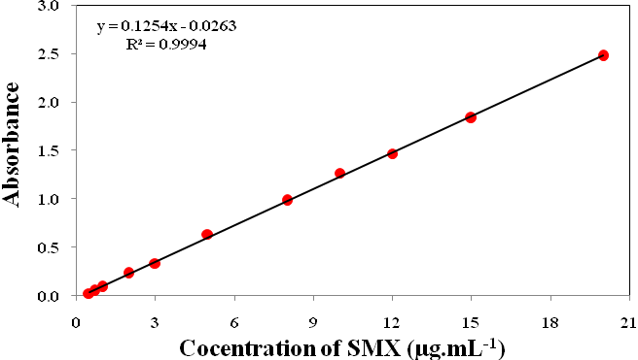
Figure10: Calibration curve for the determination of SMX by simplex optimal conditions.

30
Table 6: Optical characteristics and statistical data for determination of SMX by simplex method.
Parameter | Value
λ_{max} (nm) | 513
Color | Orange
Linearity range (µg.mL⁻¹) | 0.5 – 20.0
Regression equation | Y=0.1254[SMX. µg.mL⁻¹]-0.0263
Calibration sensitivity (mL.μg⁻¹) | 0.1254
Correlation coefficient (R) | 0.9996
Correlation of linearity (R²) | 0.9992
Molar absorptivity (L.mol⁻¹.cm ⁻¹) | 3.1761*10⁴
Sandell's sensitivity (µg.cm⁻²) | 7.9745
Detection limit (µg.mL⁻¹) | 0.043
Table7: Comparison of visible spectrophotometric methods for the determination of SMX.
Reagent | λ_{max} (nm) | Linearity range  (µg.mL⁻¹) | Ɛ(L.mol⁻¹ .cm⁻¹) | Detection limit  (µg.mL⁻¹) | Ref.
Phenosaframine | 272 | 1.07–16.70 | 4.90× 10⁴ | 0.4280-0.5730 | 18
Mo(V)-thiocyanate | 470 | 5–300 | 1.00× 10³ | 1.0200 | 19
O-Phthalaldehyde | 340 | 0.016–0.144 | …….. | …… | 20
2-naphthol | 482 | 40–130 | 1.34× 10⁴ | 4.0000 | 21
3-amino phenol | 460 | 0.1–8.0 | 4.32× 10⁴ | …… | 23
Iminodibenzyl | 580 | 0.05–4.00 | 4.79× 10⁴ | 0.0335 | 24
4-Dimethyl amine cinnamaldehyde | 545 | 0.4–4.8 | ……… | …… | 25
P-Benzoquinone | 500 | 40–55 | .……. | …… | 26
Chromotropic acid | 513 | 0.5-20.0 | 3.17× 10⁴ | 0.043 | Present work

Precision and Accuracy
The accuracy of the both methods(univariate and simplex) was established by analyzing five replicates of pure drug at three concentration levels, and the precision was examined by determining the relative standard deviation (RSD) on the same drug samples (Table 8).
The low values of RSD% (0.163–1.795) and the range of error at the levels percent (-1.000–0.428) indicate a high accuracy and precision of the proposed method.

Table 8: Evaluation of accuracy and precision for the determination of SMX by proposed method.
 | Conc. of SMX (µg.mL⁻¹) |  | Relative Error% | RSD%  n=(5)
 | Taken | Found* | Relative Error% | RSD%  n=(5)
For univariate | 2 | 1.980 | -1.000 | 1.795
For univariate | 7 | 7.030 | 0.428 | 0.313
For univariate | 15 | 15.000 | 0.026 | 0.212
For simplex | 2 | 1.990 | -0.500 | 0.918
For simplex | 7 | 7.020 | 0.285 | 0.227
For simplex | 15 | 14.960 | -0.266 | 0.163
*Average of five determinations.
31

Interference Studies
To assess the analytical potential of the proposed method, the effect of some common excipients; vanillin, glucose, lactose, starch which often accompany dug, were examined by carrying out the determination of 10μg.mL⁻¹ of SMX in the presence of above compounds. The results are presented in Table 9.

Table 9: Percent recovery for 10µg.mL⁻¹ of sulfamethoxazole in the presence of different concentration of the studied excipients.
Excipients | Conc. µg.mL⁻¹ | Sulfamethoxazole Conc. Taken 10µg.mL⁻¹
Excipients | Conc. µg.mL⁻¹ | Conc. Found µg.mL⁻¹ | % Recovery
Vanillin | 1000 | 9.813 | 98.130
Glucose | 1000 | 9.926 | 99.260
Lactose | 1000 | 10.160 | 101.600
Starch | 1000 | 10.000 | 100.000

Application on synthetic sample
Application of the proposed method to the determination of SMX in its
synthetic sample was successfully made; the results are listed in Table 10. The excellent recoveries obtained

indicate that the absence of any interference from the excipients. The range of recovery values were is (101.17–102.25%)and the values of relative standard deviation percent ranged from0.2569 to 1.1864%.

Table10:Application of the proposed method to the SMX concentration measurements in synthetic sample.
Sample | Weight* found mg/25mg | Conc. taken µg.mL⁻¹ | Conc.* found µg.mL⁻¹ | Recovery  % | RSD*  %
20mgSMX/25mg tablet | 20.45 | 2.000 | 2.045 | 102.25 | 1.1864
20mgSMX/25mg tablet | 20.32 | 5.000 | 5.080 | 101.60 | 0.4287
20mgSMX/25mg tablet | 20.23 | 10.000 | 10.117 | 101.17 | 0.2569
*Average of three determinations

Application in spiked urine
The proposed spectrophotometric method was also used to the in vitro determination of SMX in spiked human urine samples. Recovery studies were performed with the sample containing various amounts of SMX. The results of recovery percent and percentage relative standard deviation given in Table 11. The recovery values were in the range (95.0–98.4%) while standard deviation was ranged from (0.1754–0.9655%).

32

Table11:Application of the proposed method to the SMX concentration measurements in spiked urine.
Sample | Conc. taken µg.L⁻¹ | Conc.* found µg.L⁻¹ | Recovery  % | R.S.D*  %
SMX in urine | 2.00 | 1.99 | 95.0 | 0.9655
SMX in urine | 5.00 | 4.92 | 98.4 | 0.7158
SMX in urine | 10.00 | 9.73 | 97.3 | 0.1754
*Average of three determinations.

Application in spiked urine by standard additions method (SAM)
The standard addition technique which followed to check the validity of the proposed method has given good recoveries of the drug in presence of urine suggesting non-interference from spiked urine. Hence, this method can be recommended for adoption in routine analysis of SMX in quality control laboratories. Table12 shows the result of recovery % and relative standard deviation % for the standard additions method. Figure11shows the plot of the determination of SMX in urine by standard additions method.

Table12:Application of the proposed method to the SMX concentration measurements in spiked urine by standard additions method.

Sample | Conc. taken µg.mL⁻¹ | Conc.* found µg.mL⁻¹ | Recovery % | R.S.D*%
SMX in urine | 200.00 | 198.47 | 99.235 | 0.6418
*Average of three determinations.

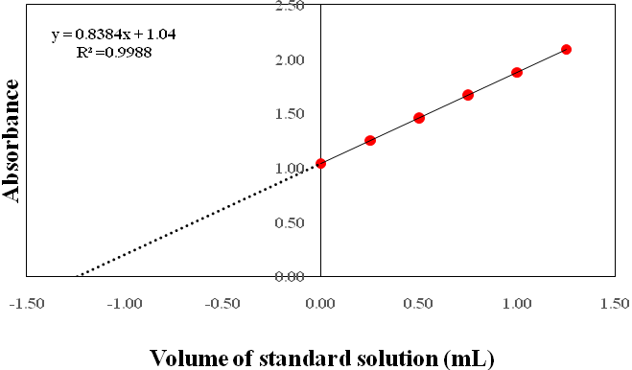

Figure11: Determination of SMX in urine by standard additions method.

33

Conclusions:
Diazotization reaction of primary amine group followed by coupling with chromotropic acid in alkaline medium was found to be a simple, sensitive, accurate and economic spectrophotometric method for quantitative determination of (SMX) in pure form

and synthetic samples. The classical univariate and modified simplex method have been used for optimizing the different variable affecting the completion of the reaction. The proposed method offers good linearity and precision.

References
- G. P., Wormser, Drugs.; 1982, 24(6), 459-518.
- Martindale, The Extra Pharmacopoeia,30th ed., Reynolds, J.E.F., ed.,Pharmaceutical Press (London, England:1993), 154, 209.
- J.B. Mengelers , M.B.M. Oorsprong, H.A. Kuiper, M.M.L. Aerts, E.R.VanGogh, A.S.J.P.A.M. Van Miert,Journal of Pharmaceutical and Biomedical Analysis.;1989,7, 1765–1776.
- E.Sayar, S.Sahin, S.Cevheroglu and A. A.Hıncal, Biomedical and Life SciencesEuropean Journal of Drug Metabolism and Pharmacokinetics.;2010,35(1-2), 41-46.
- R. S. J. Gapasin, H. J. Nelis, M. Chair and P. Sorgeloos, J. Appl. Ichthyol.;1996, 12, 39-42.
- C.Lopez Erroz, P. Viñas, M.Hernández Córdoba, Talanta.; 1994, 41, 2159–2164.
- J. Fan, Y. Chen, S.Feng, C. Ye, and J.Wang,
ANALYTICAL SCIENCES.; 2003, 19(3), 419-422.
- I. M.Choma, E.M.Grzelak, Journal of Chromatography A.; 2011, 1218 , 2684–2691.
- P.k. Chantarateepra, W. Siangproh, S. Motomizu, and O. Chailapakul, International Journal of Electrochemistry.; 2012, 1-9.
34
- S.P.Özkorucuklu, Y.Şahin and G.Alsancak, Sensors.; 2008, 8, 8463-8478, .
- P.Nagaraja, A.k. Shrestha, A.S.kumar, A. K. Gowda, Acta Pharm.;2010,60, 217–227.
- M. H. Givianradand M. Mohagheghian, E-Journal of Chemistry.;2012,9(2),680-692.
- M. R. Sohrabi, M.Fathabadi and A. H.Nouri,Journal of Applied Chemical Researches.;2010, 3(12), 47-52.
- E. Dinça, Y. Kadıoğlub, F. Demirkayab and D. Baleanuc,J. Iran. Chem. Soc.; 2011, 8(1), 90-99.
- S. Balyejjusaa, RO. Adomeb, and D. Musokec , Afr .Health Sci.; 2002, 2(2),56–62.
- G. V. Raja,J. Chem.;2009, 6, 357-360.
- K. A.Connors, Reaction Mechanisms in Organic Analytical Chemistry, John Wiley & Sons: New York, (1973).
- S. Amirah, AL. Atas, J. Saudi pharmaceutical.;2003,11,141-145.
- F. A. Nour EL-Dien, G. G. Mohamed, K. Elmorsy, E. Y. Z. Frag, Journal of Advanced Research.; 2010,1(3), 215-220.
- H. M.Faiyaz, M. Aminaddin, K. Mehmood, J.Pak. Pharm. Sci.; 2004, 17, 77-84.
- F. Shamsa, L. Amani, Iran. J. pharm. Research.;2006,1,31-36.
- J. J. Berzas,J. M.Lemus, G. C. Penalov,J.Anal. Chem.;1992, 342, 723-728.
- P. Nagaraja, H. S. Yathirajan, C. R. Raju, R. A. Vasantha, P. Nagendra, M. S. Memantha Kumar,Farmaco.; 2003 ,58(12), 1295-1300.
- P. Nagaraja, K. R. Sunitha, R. A. Vasantha,H.S.Yathirajan, European J. of Pharmaceuticsand Biopharmaceutics.;2002, 53,(2), 187-192.
- S. Raghuveer, I. R. K. Raju. D.K. Vatsa. C. M. R. Srivastava, Indian Drugs.;1993,30,132-135.
- X. G. Zhou, N. Zhang, Y. Q. Zhang, Fenxi-Huaxue.;1994, 22, 190-192.

35

