Synthesis, Spectral and Structural Studies of Neutral Co(II), Ni(II) and Cu(II) Macrocyclic Dithiocarbamate-Based Complexes Formed via one pot reaction

Aeed S. Al-Fahdawi, Hussain A. Al-Kafajy
Email: aeedchemistry@yahoo.co.uk
Department of Chemistry, College of Science, University of Babylon

Mohamad J. Al-Jeboori
Email: mohamadaljeboori@yahoo.com
Department of Chemical Engineering and Chemical Technology, Imperial College London, London, SW72AZ, UK.
Herman Potgieter
Email: h.potgeiter@mmu.ac.uk
School of Research, Enterprise and Innovation, Manchester Metropolitan University, Chester Street, Manchester, M1 5GD, UK.

(NJC)
(Received on 13/10 /2013) (Accepted for publication 19/ 11/2013)

Abstract
The synthesis of dinuclear transition metal(II) macrocyclic dithiocarbamate complexes and there characterisation are reported. The dithiocarbamate complexes were prepared via a one pot reaction by mixing the secondary amine {N1,N4-dibenzhydrylbenzene-1,4-diamine}, CS₂, KOH, and metal chloride. The modes of bonding and overall geometry of the compounds were determined through physicochemical and spectroscopic methods; elemental analysis, FTIR, UV-Vis, magnetic susceptibility, conductance, melting points, mass spectroscopy and ¹H-, ¹³C-, DEPT, ¹H- ¹H COSY, ¹H- ¹³C HQMC NMR spectroscopy. These studies revealed the formation of dimetal bisdithiocarbamate complexes of the general formula [M)L)]₂ with tetrahedral geometry about Co(II) and Ni(II) atoms. However, square planar geometries have been suggested for Cu(II) complex in a solid state but its exhibited octahedral ina liquid states.
Keywords: Bisdithiocarbamates; Transition metal complexes; One-pot reaction; Structural study

الخلاصة
تضمن البحث تحضير وتشخيص ليكاند ثنائي الثايوكاربميت ومعقداته الحلقية ثنائيه النواة ثم تحضير المعقدات باستخدام طريقه الاضافة الواحده للمواد المتفاعله في دورق التفاعل. اشتملت طريقه تحضير الليكاند ومعقداته من خلال تفاعل ثنائي الامين مع الكاربون ثنائي الكبريت بوجود هيدروكسيد البوتاسيوم كقاعده باستخدام الايثانول كوسط للتفاعل لتكون الليكاند الحر ثم مفاعلته مع املاح الفلز لتكوين المعقدات الحلقيه الكبيره لثنائي الكاربميت بطريقه تفاعل القالب
ذات الصيغه العامه :
[M(L)]₂:(where M =Co^{II}, Ni^{II}, Cu^{II})
شخصت الليكاندات والمعقدات بشكل متكامل بوساطه التحليل الدقيق للعناصر وتقنية اطياف الاشعة تحت الحمراء واطياف الاشعه فوق البنفسجيه والمرئيه والحساسيه المغناطيسيه والتوصيليه وقياس درجة الانصهار وتقنية طيف الكتله واطياف الرنين المغناطيسي:
¹H-,¹³C-, DEPT, ¹H-¹H COSY, ¹H- ¹³C HQMC NMR spectroscopy.
بينت قياسات الاشعة تحت الحمراء والرنين النووي المغناطيسي ان طبيعه الارتباط لمجموعة الكاربون ثنائي الكبريت هو ثنائيه الارتباط المخلبي كما اظهرت قياسات الاشعه تحت الحمراء ان المجاميع ارتبطت بشكل متماثل وغير متماثل . كشفت القياسات ( الفيزو-كيميائيه) ان التناسق في الحاله الصلبه حول ايونات الكوبلت والنيكل والنحاس في المعقدات الحلقيه المحضرة هو رباعي التناسق.من جانب اخر بينت قياسات الاشعه فوق البنفسجيه والمرئيه ان عدد التناسق في المحلول لمعقد النحاس هو سداسي التناسق نتيجه لارتباط جزيئتين من جزيئات المذيب بايون النحاس المركزي.
مفتاح الكلمات : ثنائي الثايوكاربميت, معقدات العنلصر الانتقاليه, تفاعل القالب, دراسات تركيبيه.

Introduction
Dithiocarbamate derivatives are well known class of compounds that have widely studies. This is due to their potentially applications in medicine ^{[1]}, coordination and analytical chemistry ^{[2]}, as well as widespread industrial applications in the vulcanization of rubber and in sensing ^{[3]}. Formation of complexes based on macrocyclic dithiocarbamates in which a metal plays a key role in the-directed self assembly is an interesting subject. This is due to their potential applications in supramolecular and materials science ^{[4].} One approach in the use of metal directed self-assembly techniques is to develop a facile route to novel host macrocyclics capable of binding charged and/or neutral guest substrates ^{[5]}. Depending on the coordination fashion of the ligand and preferred metal coordination geometry, many applications have been found for the dithiocarbamate. Dithiocarbamates ligands have shown the ability to stabilize of metal centers in a variety of oxidation states, and can coordinate to a wide range of transition metals ^{[6]}. Dithiocarbamate compounds have explored in clinical applications. These include their role in the removal of excess of copper from tissues suffering from Wilson’s disease ^{[5]}, and the use of bis(N-cyclohexyldithiocarbamato) nitrido technetium-99m complex [99mTcN-(CHDTC)2] (CHDTC:N-cyclohexyl dithiocarbamato) as a brain perfusion imaging agent^{[7]}. Dithiocarbamates are also showing characteristic photoluminescence properties in lanthanides complexes ^{[8]}. Furthermore, dithiocarbamates derivatives are used as precursors for the production of metal sulfide nanoparticles ^{[9]}, and in the preparation of pesticides ^{[10]}. In this paper, we report here a one-pot template preparation of new dimeric assemblies of dithiocarbamate-based complexes.
Experimental
Materials
All reagents were commercially available and used without further purification. Solvents were distilled from appropriate drying agents immediately prior to use.
Physical measurements
Elemental analyses (C, H, N, and S), were carried out on a Heraeus instrument (Vario EL). Melting points were obtained on a Buchi SMP-20 capillary melting point apparatus and are uncorrected. IR spectra were recorded as Attenuated total reflectance (ATR) uses a smart diamond ATR attachment on a Thermo - Nicolet FT-IR Spectrometer (AVATAR 320) in the range 4000-500 cm⁻¹, and as CsI discs using a Shimadzu 8300 FTIR spectrophotometer in the range 600-300 cm⁻¹. Electronic spectra were measured between 245-1000 nm with 10⁻³ M solutions in dimethylsulfoxide (DMSO) spectroscopic grade solvent at 25 °C using a Perkin-Elmer spectrophotometer Lambda. Mass spectra were obtained by positive Electron-Impact (EI) and Fast Atom Bombardment (FAB) was recorded on a VGautospec micromass spectrometer. NMR spectra (¹H, ¹³C, DEPT,¹H-¹H COSY, ¹³C- ¹H HMQC, - NMR) were acquired in DMSO-d6 solutions using Brucker AMX 400 MHz and Jeol Lambda 400 MHz spectrometers with tetramethylsilane (TMS). Conductivity measurements were made with DMSO solutions using a Jenway 4071 digital conductivity meter and room temperature magnetic moments were measured with a magnetic susceptibility balance (Johnson Matthey Catalytic System Division).
Synthesis Preparation of the bis-amine precursor
The free bis-amine precursor {N1, N4- dibenzhydrylbenzene-1,4-diamine} was prepared in two steps and as follows ^{[11-14]}:
Preparation of Schiff-base {N1,N4-bis(diphenylmethylene)benzene-1,4-diamine}
A mixture of benzophenone (1.69 g, 9.25 mmol), p-phenylenediamine (0.500 g, 4.62 mmol), and 1,4-diazabicyclo[2.2.2]octane (DABCO) (3.11 g, 27.7 mmol) in chlorobenzene (40 mL) was allowed to stir at RT for 10 min. A mixture of titanium (IV) tetrachloride (1.32 g, 6.93 mmol) in chlorobenzene (10 mL) was added dropwise using a pressure-equalised dropping funnel. The reaction mixture was heated in an oil bath at 125°C for 24 h. The precipitate was removed by filtration, and then the filtrate was concentrated. The Schiff-base product (1.83 g, 91%) was isolated by silica gel uniplate chromatography with eluent of a mixture of (hexane:ethylacetate; 9:1), R_{f} = 0.25. IR (ART cm⁻¹) 1620 (C=N),
1597 and 1570 (phenyl). NMR data (ppm), δ_{H} (400 MHz, CD₂Cl₂)

Figure (1) : 6.47 (4H, m), 7.06 (2H, d, J=7.33Hz), 7.73 (2H, d, J=7.33Hz), 7.27-7.40 (20H, m); δ_{C} (100.63 MHz, CD₂Cl₂) Figure (2): 121.53-136.75, 140.12, 147.37, 168.24. DEPT ¹³C NMR (Figure (3) exhibited no signals between 140-170 ppm. The assignment of chemical shifts of the protons was further confirmed by using the COSY ¹H-¹H technique, Figure (4).

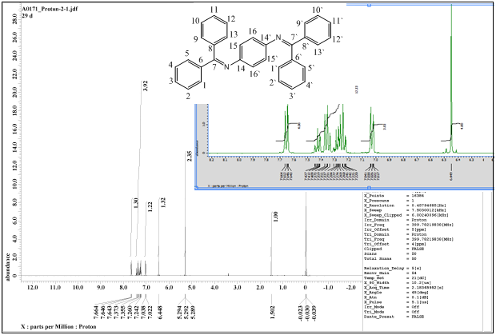
Figure (1): ¹H NMR spectrum of Schiff-base in CD₂Cl₂

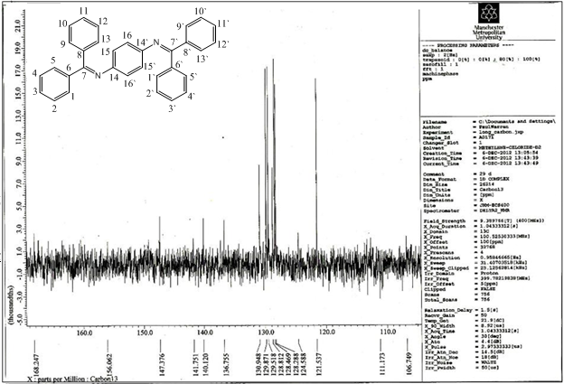
Figure (2): ¹³C NMR spectrum of Schiff-base in CD₂Cl₂
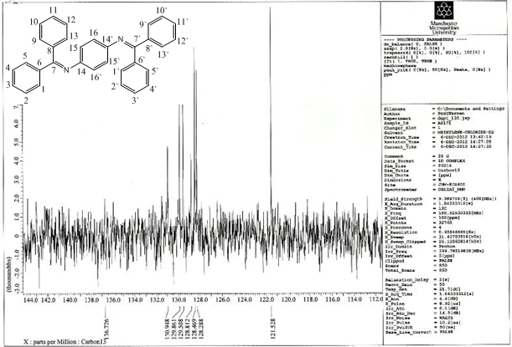
Figure (3): DEPT ¹³C NMR spectrum of Schiff-base in CD₂Cl₂
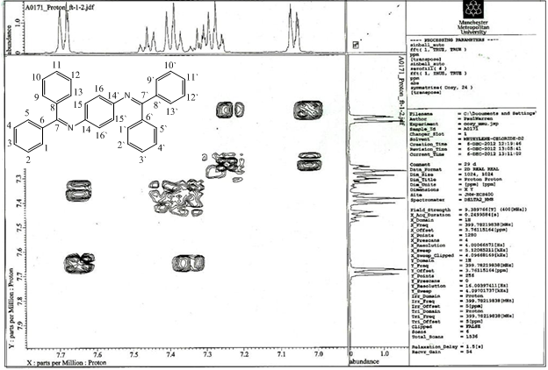
Figure (4): COSY ¹H-¹H NMR spectrum of Schiff-base in CD₂Cl₂

Preparation of bis-amine {N1,N4-dibenzhydrylbenzene-1,4-diamine}
To a mixture of Schiff-base {N1,N4-bis(diphenylmethylene)benzene-1,4-diamine} (0.500 g, 0.437 mmol), and SnCl₂ (0.17 g, 0.87 mmol) in a mixture of dichloromethane/ acetonitrile (1:1) (200 mL), was added cautiously NaBH₄ (0.06 g, 1.74 mmol) in small portions. The reaction mixture was stirred at room temperature for 10 min under an Argon atmosphere. The crude mixture was washed with an aqueous solution of 1% triethylamine (4x100), and the organic layer was dried using Na₂SO₄. The secondary bis-amine was purified from the crude product by uniplate silica gel chromatography with eleuent (hexane: acetonitrile: chloroform; 8: 2: 1), R_{f} = 0.5. Yield: (0.98 g, 54.14 %). IR (ATR cm⁻¹) 3392 (N-H), 2932 and 2873 (C-H) aliphatic, 1599 and 1510 (phenyl). NMR data (ppm), δ_{H} (400 MHz, CD₂Cl₂) Figure (5): 3.95 (2H, S), 5.36 (2H, S), 6.37 (4H, d, J=7.33Hz), 7.21-7.36 (20H, m, Ar-H); δ_{C} (100.63 MHz, CD₂Cl₂) Figure (6) : 49.10, 115.21, 127.25-129.04, 140, 144.07. DEPT ¹³C NMR Figure (6) exhibited no signals between 140-145 ppm. The positive ES (+) mass spectrum, Figure (7), of the bis-amine showed the parent ion peak at m/z =441.2362 (M+H)⁺ (95%) corresponding to C₃₂H₂₈N₂, requires =440.2252. Peaks detected at m/z =247.16 (100%) and 167.09 (98%), corresponding to [M-(ph)₂CH₂)]⁺, [M-(ph)₂CH₂+H₂N₂ph)]⁺, respectively. The assignment of chemical shifts of the protons and carbons nucleus of secondary amine was further confirmed by using the COSY ¹H-¹H and HMQC-NMR techniques, Figures (8) and (9), respectively
General one pot synthesis of the complexes
An ethanolic solution (20 mL) of the bis-secondary amine (1 mmol) and three equivalents of KOH was added in small portions to a mixture of CS₂ (4.5 mmol) in ethanol (10 mL). After stirring for 2 h at 0 ºC, a solution of metal salt (1.25 mmol) in ethanol (10 mL) was added. The reaction mixture was allowed to stir under Argon for 1 h, resulting in the formation of a solid mass which was filtered, collected and washed with a mixture of EtOH/H₂O 5:1 (5 mL), and then dried under vacuum. Elemental analysis data, colours, and yields for the complexes are given in (Table 1).

Table (1); Colours, yields, melting points and metal salts quantities of complexes
Found(Calcd)% |  |  |  |  | m.p.ºC | Colour | Yield(%) | M.Wt | Molecular formula | Weight of complex | metal salt(g) | Metal ion
S | N | H | C | M%
19.72  (19.74) | 4.27  (4.31) | 4.11  (4.03) | 62.87  (62.85) | 9.11  (9.07) | 293-295 | Dark red | 92.71 | 1299.55 | C₆₈H₅₂Co₂N₄S₈ | 0.13 | 0.05 | Co^{II}
19.76  (19.75) | 4.29  (4.31) | 4.05  (4.03) | 62.85  (62.87) | 9.09  (9.04) | 308* | Green | 85.21 | 1299.07 | C₆₈H₅₂N₄Ni₂S₈ | 0.12 | 0.05 | Ni^{II}
19.61  (19.60) | 4.26  (4.28) | 4.04  (4.00) | 62.37  (62.40) | 9.68  (9.71) | 330* | Light yellow | 90.74 | 1308.77 | C₆₈H₅₂Cu₂N₄S₈ | 0.11 | 0.03 | Cu^{II}
*=Decomposed

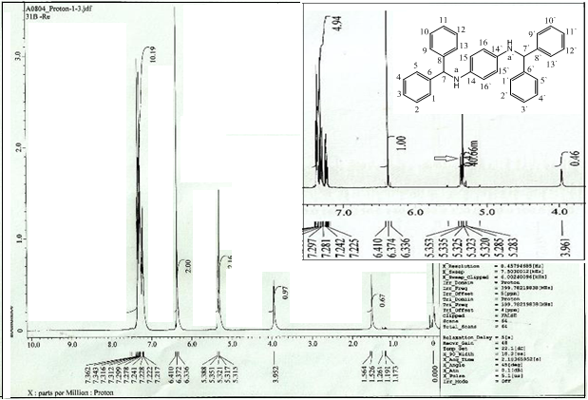
Figure (5): ¹H NMR spectrum of secondary amine in CD₂Cl₂
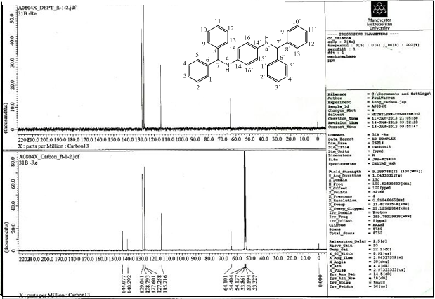
Figure (6): (DEPT&¹³C) NMR spectrum of secondary amine in CD₂Cl₂
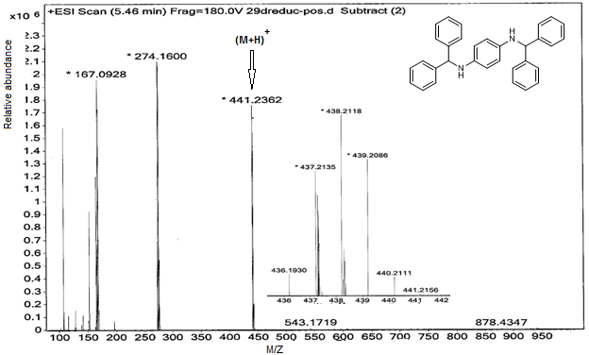
Figure (7): ES(+) mass spectrum of secondary amine

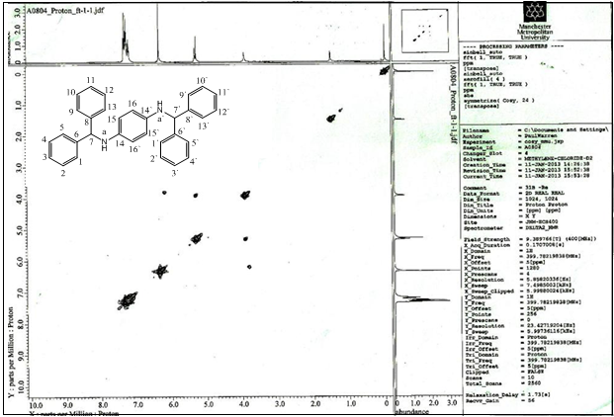
Figure (8): COSY ¹H-¹HNMR spectrum of secondary amine in CD₂Cl₂
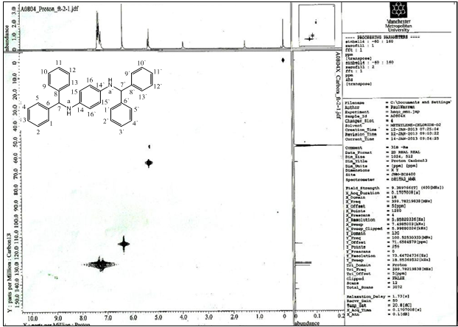
Figure (9): HQMC (¹H & ¹³C) NMR spectrum of secondary amine in CD₂Cl₂

Results and Discussion
Dithiocarbamate macrocyclic complexes were tailored from bis-secondery amine separated by aromatic ring spacer. This spacer conferred a degree of rigidity upon the formation of ligand, thus play a role in pre-organising it for self-assembly. Attempts to isolate the free ligand were unsuccessful. Therefore, a one pot approach was implemented to obtain metal complexes. The resulting bis-secondary amine was reacted with a base, carbon disulphide and metal(II) salt to yield the bis-metallic macrocyclic complexes. In these template reactions metal centres play a key role in assisted self-assemblies forming bimetallic dithiocarbamate macrocyclic complexes. The secondary amine was synthesised via two steps; (i)condensation reaction of benzophenone with p-phenylenediamine in chlorobenzene in the presence of titanium tetrachloride to give the Schiff base, and (ii) reduction of the Schiff base in methanolic media by sodium borohydrate giving the required bis-amine. Metal-directed self-assembly of the desired dinuclear macrocyclic complexes [M(L)]₂ (where M= Co^{II}, Ni^{II} and Cu^{II} and) was performed via the initial reaction of the bis-amine with potassium hydroxide and carbon disulphide in ethanol medium (Scheme1). This generated the potassium bis-dithiocarbamate salt that was not usually isolated. The complexes are air stable solid, completely soluble in DMSO under ultrasonic field (ultrasonic bath was used) with stirring over several h, and not soluble in other organic solvent. All attempts to isolate crystals suitable for X-ray single crystal diffraction analysis were unsuccessful. The molar conductance of solutions of the complexes in DMSO is indicative of their non-electrolytic nature ^{[11].}
FTIR spectra for complexes
The important infrared bands of complexes with their assignments are collected in Table (2) and shown in Figure (10). The IR spectra of the dinuclear macrocyclic gave evidence for the formation of the dithiocarbamate functions and their coordination to the metal fragments. The bands resulting from the stretching vibrations of the C-N-S bonds at 1494-1495 cm⁻¹ have a wave umber that are intermediate when compared to those reported for C-N single bonds (1250-1350 cm⁻¹) and C=N double bonds (1630-1690 cm⁻¹), suggesting partial delocalization of π- electron density within the dithiocarbamate functions ^{[12]}. For the CS₂ groups two bands were observed, ν(CS₂) asymmetric at(1082-1033 and 1028-1031) and one symmetric band ν(CS₂) at (951-988 cm⁻¹), respectively which are characteristic for an anisobidentate chelation mode of the ligand to the metal atoms ^{[13, 14]} . At lower frequency the complexes exhibited two sets of bands around 378 and 497cm⁻¹ which are assigned to the ν(M-S) vibration mode, and supporting the anisobidentate chelation mode of the ligand ^{[15]}.

Scheme (1): General synthetic route for complexes [M(L)]₂; where M=Co(II), Ni(II), Cu(II)e
Table (2): FTIR spectral data (wave number) cm⁻¹ of complexes
ν (M-S) | ν_{as,}s(CS₂) | ν (C-N) | δ(CH) | ν (N-CS₂) | ν_{ar}(C=C) | ν_{ali}(C-H) | ν_{ar}(C-H) | Comp.
497,378 | 1069, 1029 and 988 | 1290 | 1450 | 1494 | 1599, 1509 | 2927 | 3062, 3024 | [Co(L)]₂
No result | 1033, 1028 and 951 | 1223 | 1448 | 1495 | 1599, 1510 | 2939, 2843 | 3024 | [Ni(L)]₂
No result | 1082, 1031 and 989 | 1222 | 1448 | 1494 | 1510 | 2994, 2871 | 3062, 3024 | [Cu(L)]₂

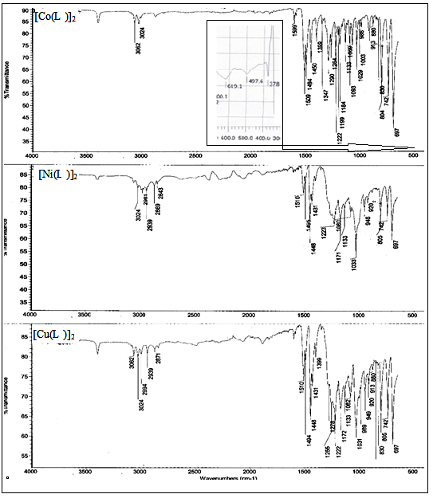
Figure (10): Overlay FTIR spectra of the Co^{II}, Ni^{II} and Cu^{II} complexes

Electronic spectra and magnetic moment measurements
The electronic spectra of the Co^{II}, Ni^{II} and Cu^{II} complexes in DMSO solution exhibited bands around 260-279 and 325-435 nm related to the intra-ligand π→π* and the (CT) transitions, respectively^{[16-18]}, (Table 3). The electronic spectrum of the Co^{II} complex gave a dark red colour in DMSO solutions. The spectrum exhibited low intensity band in the d-d region assigned for ⁴A₂g^{(F)} →⁴T₁g^{(F)}, which is characteristic for octahedral geometry around Co atom ^{[19, 20]}. This may be related to further coordination of solvent molecules to the metal centre. The magnetic moments value of µ_{eff} 4.2 B.M, attributed to tetrahedral geometry around Co atom. It is clear that the Co^{II} complex shows different geometries in the solid state (tetrahedral), and in solution (octahedral). The magnetic moment value of the Ni-complex µ_{eff} =3.78 B.M is consistent with its tetrahedral geometry ^{[18-20]}. The Cu-complex gave a dark brown solution in DMSO solvent. The spectrum showed peak around 816 nm, related to ²B₁g→ ²A₂g, and confirming a distortion from octahedral geometry about metal centre in solution. The magnetic moment value µ_{eff} of 1.6 B.M for the Cu^{II}-complex, as well as the other analytical data, are in agreement with square planar structures geometry in solid state ^{[21, 22]} .

Table (3): UV-Vis spectral data of complexes in DMSO solutions
Assignment | Extinction coefficient ε_{max}  _{(dm}³ _{mol}⁻¹ _{cm}⁻¹₎ | Wave number  (cm⁻¹) | Band  Positionλ_{nm} | Concen.  mol/L | Comp.
Intra-ligand π → π*, n → π*  C.T  ⁴A₂g^{(F)} →⁴T₁g^{(F)} | 4000  1000  700  20 | 62500  30769  24450  16639 | 260  325  405  601 | 1×10⁻⁴  1×10⁻⁴  1×10⁻⁴  1×10⁻³ | [Co(L)]₂
Intra-ligand π → π*, CT | 4000  900 | 38314  25707 | 261  389 | 1×10⁻⁴  1×10⁻⁴ | [Ni(L)]₂
Intra-ligand π → π*, C.T  ²B₁g→²A₂g | Off-scale  10  8 | 35842  22989  12255 | 279  435  816 | 1×10⁻³  1×10⁻³  1×10⁻³ | [Cu(L)]₂

Conclusions
The formation of some bimetallic dithiocarbamate macrocyclic complexes is reported. A one pot synthetic route reaction was used to isolate complexes. The mode of bonding and overall structure of the complexes were determined through physico-chemical and spectroscopic methods. These results revealed the preparation of four coordinated

complexes in the solid state. However, in DMSO solutions the Co^{II} and Cu^{II}
complexes revealed a six coordinate species. This was attributed to further coordination of two DMSO molecules to the metal-centre.

References
1. Bolzati C., Benini E., Cavazza-Ceccato M.,Cazzola E., Malago E., AgostiniS., Tisato F., Refosco F., and Bandoli G., Bioconjug Chem, 2006. 17(2): p. 419-428.
2. Jem-Maw L., Jun-Der L., Anal. Chem., 1994. 66(8): p. 1242-1248.
3. Sunderman F.W., Ann. Clin. Lab. Sci., 1979. 9(1): p. 1-10.
4. Singh, S. Bhattacharya N., Subrato., J.Organometallic Chem., 2012. 700: 69-77.
5. Bolzati C., Cavazza-Ceccato M., Agostini, S. Refosco F., Yamamichi Y., Tokunaga S., Carta D., Salvarese N., Bernardini D., Bandoli G., Bioconjug Chem., 2010. 21(5): 928-939.
6. Orescanin V., Mikelics L., Roje V., Lulic s., Anal. Chem. Acta., 2006. 570(2): 277-282.
7. Higuchi M., Shiki S., Ariga k., Yamamoto k., J. Am. Chem. Soc., 2001. 123(19): 4414-4420.
8. Higuchi M., Tsuruta M., Chiba H., Shiki S., Yamamoto K, Org.Lett., 2000. 2(20): 3079-3082.
9. Ochi Y., Suzuki M., Imaoka T., Murata M., Nishihara H., Einaga Y., Yamamoto K., J. Am. Chem. Soc., 2010. 132(14): 5061–5069.
10. Higuchi M., Tsuruta M., Chiba H., Shiki S., Yamamoto K., J. Am. Chem. Soc, 2003. 125(33): 9988-9997.
11. Canpolat E., Kaya M., J. Coord. Chem., 2005. 31(7): 511-515.
12. Faraglia G., Sitran S., Montagner D., Inorg. Chim. Acta, 2005. 358(4): 971-980.
13. Al-Jeboori M. J., Al-Jebouri F. A., Al-Azzawi M. A. R., Inorg. Chim. Acta., 2011. 379(1): 163-170.
14. Johnson B. F. G., Al-Obaidi K. H., Mecleverty J.A., J. Am. Chem. Soc. A 1969. 19: 1668-1670.
15. Hasan A. H.,Yousif E. I., Al-Jeboori M. J., Global J. Inorg. Chem., 2012. 3(10): 1-7.
16. Jowitt R. N., Mitchell P. C. H., J. Chem. Soc. A: 1970: 1702-1708.
17. Ronconi L., Giovagnini L., Marzano C., Bettı`o F., Graziani R., Fregona D., Pilloni G., Inorg. Chem, 2005. 44(6): 1867-1881.
18. Pandey P. K., Pandey A. K., Mishra A. N., Ojha K. K, Singh R. K., indian J. Sci. Res., 2012. 3(1): 119-122.
19. Li Z. H., Xue L. P., Wang J. G., 2013. 39(8): p. 588-592.
20. Ouyang Y., Zhang W., Xu N., Xu G. F., Liao D. Z., Yoshimura K, Yan S. P., Cheng P., Inorg. Chem., 2007. 46(21): 8454 8456.
21. Du M., Bu X.-H., Guo Y.-M., Ribas J., J. Chem., 2004. 10: 1345.
22. Al-Jeboori, M. J., Al-Tawel H. H., Mahmood R., Inorg. Chim. Acta., 2010. 363(6): 1301-1305.

