Synthesis And Characterization Of New 2-amino
pyridine Derivatives

Firyal Welly Askar Nisreen Kais Abood Nahida Abdul-Allah Jinzeel
firyal_62@gmail.com, serein_82@yahoo.com nahdachemist@yahoo.com

Marwa Sabbar Falih
Department of Chemistry ,College of Science, Al-Mustansiriya University
(NJC)
(Received on 9 /6 /2013) (Accepted for publication 26 /9 /2013)

Abstract
New series view of ethyl2-(pyridin-2-ylamino) acetate compounds were synthesized by react 2-amino pyridine with ethyl chloro acetate and KOH, then the ethyl2-(pyridin-2-ylamino)acetate react with hydrazine hydrate (99%)to give 2-(pyridin-2-ylamino)acetohydrazide[2], which the 2-(pyridin-2-ylamino) acetohydrazide treated with different substituted aromatic aldehydes formed various substituted arylidine derivatives [3a-d]. These arylidine derivatives on treatment with triethyl amine and chloroacetyl chloride yielded different azetidine derivatives [4a-d].Reaction of 2-aminopyridin with different aromatic aldehyde and CuCN formed various substituted cyanic [5a-c] .Reaction of [5a-c] compound with NaN₃,NH₄Cl and DMF afford tetrazole derivatives [6a-c].Also 2-amino pyridine reacted with 2-mercaptobenzoxazole,2-mercaptopyrimidin and 2-mercapto benzo thiazole to give the new derivatives of compounds[7,8,9].The molecular structure were characterized by FTIR,¹HNMR.
Key Worde: amino pyridine, arylidine , tetrazole.

الخلاصة
حضرت سلسلة مركبات جديدة من 1-اثل(2-امينوبريدين-2يل امينو)استيت من تفاعل 2-امينوبريدين مع اثل كلورواستيت بوجود هيروكسيدالبوتاسيوم,بعدما عومل المركب ]1[ مع الهيدرازين المائي (99%) ليعطي مشتق الهايدرازين ]2[ والذي تم تفاعله مع بعض الالديهايدات الاروماتية ليعطي مشتقات مختلفة من الاريلادين [3a-c] وعند تفاعل مشتقات اريلايدين مع كلورواستل كلورايد, تراي اثل امين نتجت مشتقات جديدة من ازيتادنيل[4a-c] , 2-امينو بريدين فعل مع بعض الالديهايدات المختلفة التعويض بوجود CuCN اعطى مشتقات جديدة من مركبات [5a-c]السيانيد والذي تم معاملة الاخير مع NaN₃NH₄Cl بوجود DMF ليعطي مشتقات التيترازول [6a-c] كذلك تفاعل 2-امينوبريدين مع 2-مركبتوبنزوكزازول,2-مركبتربايرميدين و 2-مركبتوبنزوثايزول ليعطي مشتقات جديدة[7,8,9] وفسرت هذه النواتج بالاعتماد على بعض الخواص الطيفية HNMR,FTIR¹
مفتاح الكلمة: امينوبريدين , اريلايدين , تيترازول.

Introduction
Different 2-amino pyridine derivatives of heterocyclic nuclease have shown potent pharmacological properties like antifungal⁽¹⁾, anti-tubercular⁽²⁾,anti-microbial⁽³⁾ and insecticidal activities⁽⁴⁾.βlactam (azetidinone) heterocyclic are still the most prescribed antibiotics used in medicine⁽⁵⁾. A large number of β lactam ring are known to exhibit various biological activities like antibiotic ⁽⁶⁾, antifungal ⁽⁷⁾ and anti-inflammatory activities⁽⁸⁾. The synthesis of novel tetrazole derivatives and investigation of their chemical and biological behaviors has gained more due to their broad spectrum of biological properties⁽⁹⁾ which act as anti-allergic⁽¹⁰⁾, antibiotic,anticonvulsant,analgesic, anti-inflammatory⁽¹¹⁾ and anticancer activity⁽¹²⁾ .On other hand the substituted tetrazoles have long been known for their pharmaceutical activity as stimulants or depressants on the central nervous system. ⁽¹³⁾
Experimental
The melting point were determined in open capillary tubes on a Gallen Kamp melting point apparatus and were uncorrected .The FT.IR Spectra of some prepared derivatives were taken on Shimadzu-2N,FTIR-8400 S.and the spectra were recored as KBr discs were recorded with Shimadzu-2N,FTIR-8400 S. ¹H-NMR Spectra of some prepared derivatives were recorded on a Varian-Mercury 300MHZ Spectrometer, d6-DMSO use as a solvent in¹H-NMR Spectra.

Synthesis of ethyl2-(pyridin-2-ylamino)acetate [1]
Ethyl chloro acetate (0.05 mole) was add drop wise to stirred solution of 2-amino pyridine (5.3g, 0.05mole), KOH(2.8g, 0.05 mole)in 30 ml ethanol. The mixture was refluxed 8 hrs. The filtrated was pourd on crushed ice. The resulting product was recrystallized from chloroform.
454
Synthesis of 2-(pyridin-2-ylamino)acetohydrazide [2]
To a solution of ethyl2-(pyridin-2-ylamino)acetate [1] (0.01 mole) in 20 ml ethanol ,hydrazine hydrate (0.02 mole) was added and the reaction mixture was refluxed 6hrs.Then filtered off and the product was recrystallized by ethanol.
Synthesis of N/ (arylbenzylidene)-2-pyridine -2-ylamino) acetohydrazide [3a-d]
To a suspension of compound [2] 2-(pyridin-2-ylamino)acetohydrazide. (0.012 mole) in ethanol 30 ml was refluxed with aryl aldehyde (0.012 mole) in the presence of few drops of glacial acetic acid for 7 hrs.After the completion of reaction ,the mixture was allowed to cool and filtered it .The precipitate solid was recrystallized from ethanol.
Synthesis of N-(3-chloro-2-(aryl phenyl)-4-oxoazetidin-1-yl)-2-(pyridine-2-ylamino)acetamide [4a-d]⁽⁶⁾
To a stirred solution of compound [3a-c] (0.01 mole)and triethylamin (0.02 mole) in dioxane (15ml), chloracetyl chloride (0.02 mole) was added dropwise at 0-5C°.The reaction mixture was stirred for about 5-7 hours .The mixture was then poured into ice water,the product was recrystallized from different solvent.

Synthesis of 2(arylphenyl) -2- (pyridine-2-ylamino) acetonitrile [5a-c]⁽²⁾
A (0.015 mole ) of the different aromatic aldehyds were added to the mixture of 2-amino pyridine (0.015 mole) was mixed with 2.5 ml concentrated HCl and 10g ice water and (0.015 mole)from CuCN in 4 ml water was add ,the reaction mixture was stirred over night at room temperature and filtrated off .

Synthesis of N(aryl phenyl)(1H-tetrazol-5-yl)methyl) pyridine-2-amin [6a-c]⁽⁹⁾
A mixture of compound [5a-c] (0.01 mole),(0.01 mole) sodium azid and (0.01 mole) ammonium chloride in 10 ml DMF was refluxed in oil bath 125C° for 7 hrs. The solvent was removed under reduced pressure .The residue was dissolved in 100ml of water then carefully acidified to pH=2 using hydrochloric acid then cooled to 5C°in ice bath and recrystallized from methanol.
General procedure [7,8,9]⁽¹⁴⁾
2-amino pyridine(0.94 g, 0.01 mole) react with 2-mercaptobenzoxazole (1.5g,0.01mole), 2-mercapto pyrimidin (1.12g,0.01mole) and 2-mercaptobenzothiazole (1.67 g , o.o1 mole) respectively in 30 ml ethanol was refluxed for (7-12) hours . The precipitated solid was collected and recrystallized from ethanol.

Scheme(1)
455

Results and Discussion
The new derivatives of 2-amino pyridine β lactam and tetrazoles were prepared by following the reaction sequences outlined in scheme 1.
The compound [1] ethyl2-(pyridin-2-ylamino) acetate was synthesized by the reaction of 2-amino pyridine with chloro ethyl acetate .The formation of this compound was indicated by presence in their IR spectra of carbonyl group (C=O) of ester at (1741cm⁻¹) table [1]. ¹HNMR (DMSO_d₆)ς(ppm)ofcompound[1]:1.23(t,3H,COOCH₂CH₃) ,4.01 (q,2H, COOCH₂CH₃) , 4.12 (d, 2H,NHCH₂) , 7.8 (s, 1H,NHCH₂), 6.1-7.6 ppm which belonged to aromatic protons.
Reaction between compound [1] and hydrazine hydrate (95%) afforded the acid hydrazid derivatives [2] in good yield. The spectrum showed the appearance of the (C=O)Amide at (1699cm⁻¹) and disappearance the carbonyl group (C=O)of ester at (1741 cm⁻¹), NH stretching absorption near (3385) cm⁻¹ table [1].¹HNMR (DMSO_ d₆) ς (ppm) of compound [2]: 4.5(d, 2H, NHNH₂), 9.1(s, 1H, NHNH₂), 3.01(d, 2H, NHCH₂), 7.2 (s, 1H, NH CH₂), 6.1-8.07 ppm which belonged to aromatic protons.
Condensation of compound [2] with different substituted aromatic aldehydes in absolute ethanol gave arylidine derivatives [3a-d]. The formation of these azomethines was indicated by the presence in their IR spectra of (CH=N) stretching bands at (1627)cm⁻¹combined with the disappearance of NH₂ stretching band table [1].¹HNMR (DMSO_ d₆) ς (ppm) of compound [3a]: 3.5(d, 2H, NH CH₂), 7.4(s, 1H, NH CH₂), 8.4 (s, 1H, N=CH), 10.1 (s, 1H, NHN=C), 6.2-8.4 ppm which belonged to aromatic protons.
456
Schiff bases Treatment with tri ethyl amine and chloro acetyl chloride yielded different azetidinyl derivatives [4a-d]. The IR Spectra of these
derivatives showed the disappearance bands of (CH=N) in theregion (1627) cm⁻¹ combined with the appearance of Absorption band at (1735) cm⁻¹ (C=O β lactam) table [2].¹HNMR(DMSO_ d₆) ς (ppm)of compound [4a]: 3.8 (d, 2H, NH CH₂), 8.1 (s, 1H, NH CH₂), 8.4(s, 1H, NHN-C), 5.7(d, 1H, CHCl-CH-Ar), 6.1-8.1 ppm which belonged to aromatic protons.
When the 2-amino pyridine reacts with different aldehydes in presence CUCN that gave compounds derivatives [5a-c]. The IR spectra that appearance the band of (C≡N) at (2166) cm⁻¹table [2].¹HNMR (DMSO_ d₆)ς (ppm)of compound [5a]: 5.9(d, 1H, NH CH), 4.2(s, 1H, NHCH), 6.6-8.1 ppm which belonged to aromatic protons.
Compounds [5a-c] react with sodium azid ,ammonium chloride in DMF gave the new derivatives of tetrazoles compounds [6a-c] .The IR. Spectra show the disappearance the band of (C≡N) at (2166) cm⁻¹and appearance the band of tetrazole ring (1192) cm⁻¹and (1296) cm⁻¹(N-N=N),table [3].¹HNMR (DMSO_ d₆)ς (ppm)of compound [6a]:5.4(d, 1H, NH CH), 3.98(s, 1H, NHCH), 8.4(s, 1H, NH-N=N), 6.5-7.9 ppm which belonged to aromatic protons.
Reaction of 2-amino pyridine with 2-mercaptobenzoxazole, 2-mercapto pyrimidinand 2-mercaptobenzothiazole respectively in ethanol gave new derivatives [7, 8, and 9] respectively .Course of the reaction steps wasfollowed up and make sure it occurs by use lead acetate paper, which is inferred from blackening the paper and the liberalization of H₂S and occurrence of the reaction according the following equation:

The IR Spectra show the disappearance the H₂S and appearance the stretching band of NH at (3210) cm⁻¹, table [4]. ¹HNMR (DMSO_ d₆) ς (ppm) of compound [7]: 4.3(s, 1H, NH), 6.6-8.1 ppm which belonged to aromatic protons.
The reaction may be explained as shown in mechanism⁽¹⁴⁾:

Scheme (2)

457
Table [1]:physical properties and Spectral data
NO | Compound | Yiel% | Mp.C° | Recrystallize | IR.(KBr) cm⁻¹
1 |  | 80 | 94-96 | Chloroform. | 1741 (C=O ester), 3043 CH aromatic, 2831CH aliphatic, 3201NH stretching, 1523 (C=C).
2 |  | 75 | 100-102 | Ethanol | 1699 (C=O amid), 3064CH aromatic, 2829CH aliphatic, 3265NH, 3385 NH₂, 1585 (C=C).
3a |  | 70 | 180-182 | Ethanol | 1653(C=O amid ),1626 (C=N) ,3043 CH aromatic,2943 CH aliphatic ,3252 NH,1585 (C=C),858 Para substitution
3b |  | 73 | 195-197 | Ethanol | 1699(C=O amid), 1627(C=N), 3043 CH aromatic, 2837 CH aliphatic, 3250 NH, 1589(C=C) ,779ortho substitution.
3c |  | 67 | 200-202 | Ethanol | 1685(C=O amid ),1626 (C=N) ,3090 CH aromatic, 2852 CH aliphatic,3260 NH,1587 (C=C), 758 ortho substitution.
3d |  | 65 | 178-180 | Ethanol | 1681(C=O amid ),1626(C=N),3153 CH aromatic, 2810 CH aliphatic,3310 NH,1587 (C=C).
4a |  | 65 | 230-232 | Ethanol / water | 1735 C=O β Lactam , 1678 C=0 amide , 3064 CH aromatic, 2991 CH aliphatic , 1487 C-N , 1597 C=C aromatic, 844 Para substitution .

458
Table [2]:physical properties and Spectral data
NO | Compound | Yied% | Mp.C° | Recrystillize | IR.(KBr) cm⁻¹
4b |  | 60 | 225-227 | Ethanol/ water | 1730 C=O β Lactam , 1651 C=0 amide , 3084 CH aromatic, 2955 CH aliphatic , 1425 C-N , 1523 C=C aromatic , 740 ortho substitution
4c |  | 67 | 240-242 | Benzene | 1734 C=O β Lactam , 1650 C=0 amide , 3086 CH aromatic, 2950 CH aliphatic , 1487 C-N , 1591 C=C aromatic, 794 ortho substitution
4d |  | 66 | 202-204 | Methanol | 1734 C=O β Lactam , 1645 C=0 amide , 3086CH aromatic, 2955 CH aliphatic , 1481 C-N , 1518 C=C aromatic .
5a |  | 70 | 186-190 | Benzene | 2166(C≡N),3066CH aromatic,2850 CH aliphatic,3387 NH,1543(C=C) aromatic , 850 Para substitution.
5b |  | 70 | 220-222 | Benzene | 2166(C≡N),3045CHaromatic ,2850 CH aliphatic,3387 NH,1585 (C=C) aromatic ,738orthosubstitution.

459
Table[3]:physical properties and Spectral data
NO | Compound | Yield% | Mp.C° | Recrystillize | IR.(KBr) cm⁻¹
5c |  | 75 | 236-240 | Benzene | 2162(C≡N),3031CH aromatic ,2921 CH aliphatic,3310 NH,1545 (C=C)aromatic,765ortho substitution.
`6a |  | 75 | 260-262 | Methanol | 1292(N-N=N),1182(tetrazo ring), 3043(CH-Ar.),2837CH aliphatic, 3250 NH,1589 (C=C) aromatic ,844 Para substitution.
6b |  | 68 | 270-272 | Ethanol | 1296(N-N=N),1188(tetrazol ring) ,3080(CH-Ar.),2852CH aliphatic, 3338 NH, 1577 (C=C) aromatic ,758 ortho substitution.
6c |  | 65 | 235-237 | Methanol | 1259(N-N=N),1192(tetrazol ring),3174(CH-Ar.), 2929 CH aliphatic,3327 NH,1577 (C=C) aromatic ,754ortho substitution.

460

Table [4]: physical properties and Spectral data
NO | Compound | Yield% | Mp.C° | Recrystillize | IR.(KBr) cm⁻¹
7 |  | 85 | 199-200 | Ethanol | 3176 starching NH, 3082 CH aromatic , 2960 CH aliphatic, 1217 C-O-C , 1568 C=C aromatic .
8 |  | 80 | 180-182 | Ethanol | 3200 starching NH, 3055 CH aromatic , 2962 CH aliphatic , 1564 C=N, 1521 C=C aromatic .
9 |  | 75 | 201-203 | Ethanol | 3210 starching NH , 3070 CH aromatic , 2981 CH aliphatic ,632 C-S-C , 1570 C=N, 1539 C=C aromatic .

Table [5]: Chemical shifts ¹HNMR spectra
461
NO. | ¹HNMR (DMSO_d₆) ς ppm
1 | 1.23 (t,3H,COOCH₂CH₃) , 4.01(q,2H,COOCH₂CH₃) , 4.12(d, 2H,NHCH₂) , 7.8(s, 1H,NHCH₂), 6.1-7.6 ppm which belonged to aromatic protons.
2 | 4.5(d, 2H, NHNH₂), 9.1(s, 1H, NHNH₂), 3.01(d, 2H, NHCH₂), 7.2 (s, 1H, NHCH₂), 6.1-8.07 ppm which belonged to aromatic protons.
3a | 3.5(d, 2H, NH CH₂), 7.4(s, 1H,NHCH₂), 8.4 (s,1H, N=CH), 10.1 (s, 1H, NHN=C), 6.2-8.4 ppm which belonged to aromatic protons.
4a | 3.8(d, 2H, NH CH₂), 8.1 (s, 1H,NHCH₂), 8.4(s,1H,NHN-C), 5.7(d, 1H,CHCl-CH-Ar), 6.4-8.2 ppm which belonged to aromatic protons.
5a | 5.9(d, 1H, NH CH), 4.2(s, 1H, NHCH), 6.6-8.1 ppm which belonged to aromatic protons.
6a | 5.4(d, 1H, NH CH), 3.9(s, 1H, NHCH), 8.4(s, 1H, NH-N=N), 6.5-7.9 ppm which belonged to aromatic protons.
7 | 4.3(s, 1H, NH), 6.6-8.1 ppm which belonged to aromatic protons.

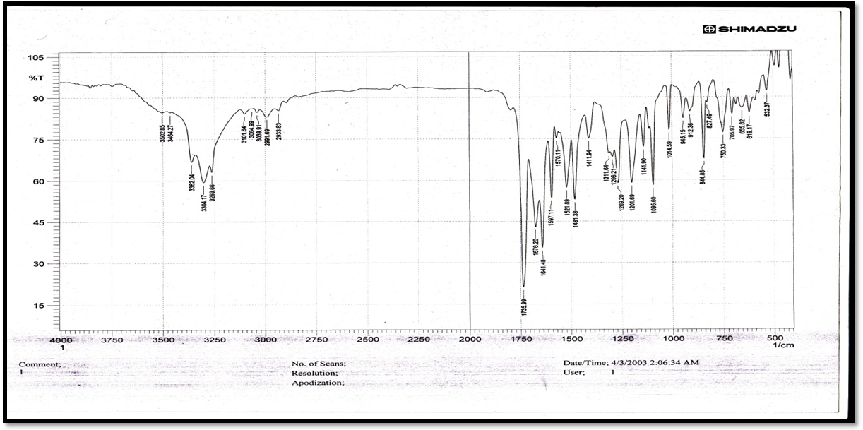
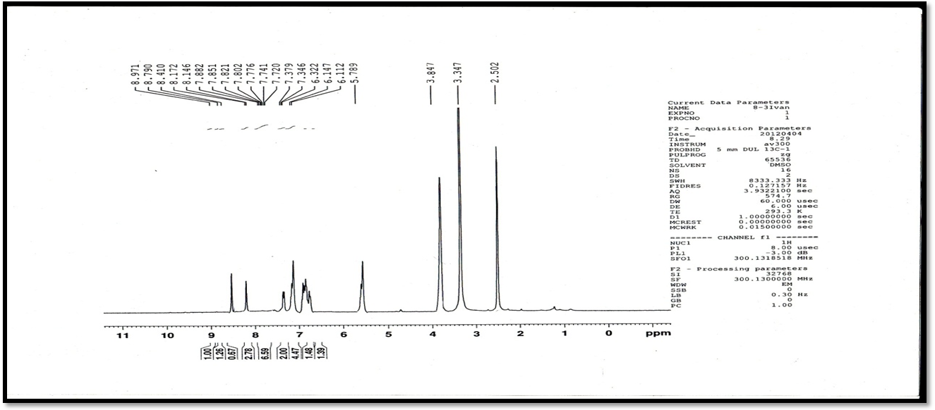
Figure.[1] FT.IR spectrum of compound [4a]
Figure [1] ¹HNMR of compound [4a]
462
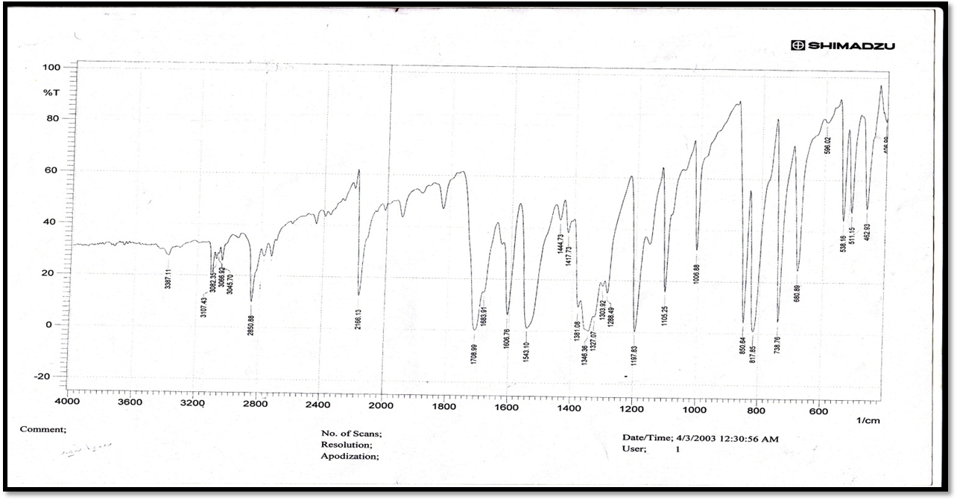
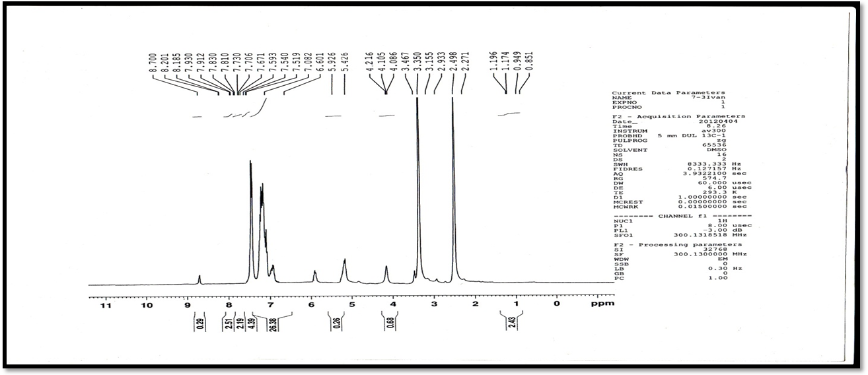
Figure.[2] FT.IR spectrum of compound [5a]
Figure [2] ¹HNMR of compound [5a]
463
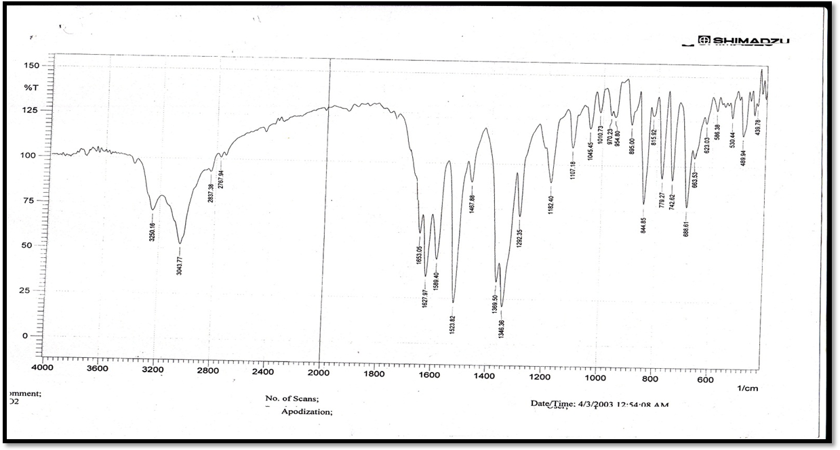
Figure.[3] FT.IR spectrum of compound [6a]
Figure [3] ¹HNMR of compound [6a]

464

References
1-Chaubey Ajit kumar1, Pandeya S.N., International Journal of PharmTech Research, 2012,.4(2), 590-598.
2-JumatSalimon,Nadia Salih,HasanHussien and EmadYousif "Synthesis and Characterization of New Heterocyclic Compounds Derived from 2-Aminopyridine" European Journal of Scientific Research Vol.31,2009.
3-Baltork, M., M.Moghadam, S.Tangestaninejad,V.,Mirkhani, M.Zolfigol and. S. Hojati, J. Iran. Chem. Soc., 2008, 5, S65.
4-Nitin G. Haswani, Sanjaykumar B. Bari , Turk J Chem, 2011, 35, 915 – 924.
5-RituSharma,PushkalSamadhiya,S D Srivastava and S K Srivastava, J Chem.Sci, 2012, 124(3).
6-Maity S. , Khan S. A.and Ahmad S., International Research Journal of Pharmacy, 2012, 3(4).
7- Manu Seth and PramillaSah, Journal of Chemical and Pharmaceutical Research, 2012. 4.
8-Ajay Bagherwal, AshishBaldi, Rakesh Kumar Nagar, Dinesh Kumar Patidar, International Journal of ChemTech Research, 2011, .3(1), 274-279.
9-K.srinivasa Saram,Vommina V.sureshbabu,Shankar A.Noik and G.chennakrish nareddy "synthesis of tetrazole analogues of amino acids: the fmoc approach" Jackie Wilce (Editor) on behalf of the Australian Peptide Association ,2007.
10- Ali Reza Modarresi Alam and Mahmoud Nasroll Ahzadeh , Turk J Chem., 2009, 33 ,267 – 280.
11-Varadaraj Dhaxanithi,Suban Shafi Syed, Kubaran Kumaran ,Kasireguraman Jaisankar, Ramas Wamy Veenkat Ragavan, Palusa Sanath Kumargoud, Nalilu Suchetha Kumari and Hari Narayan Pati, J. Serb. Chem. Soc., 2011, 76 (2), 165–175.
465
12-Choong Hwan Lim, Seongho Hong, Kyoo-Hyun Chung, Jin Seuk Kim, and Jin Rai Cho,Bull. Korean Chem. Soc., 2008, 29.
13-Y.R. Mirzaeia, and L. Edjlalib, J. Iran. Chem. Soc., 2010, 7( 3), 685-694.
14-Y.Watab,H.Yo.Shiwara and M.Kahaa. J.Heterocyclic Chem., 1982, 30,195.

