Synthesis and Biological Activity Study of Series of Various Compounds from Imine of Sugar
Nagham Mahmood Aljamali
E-mail :Dr.Nagham _mj @yahoo .com ( to corresponding)
Chem of Dept.,College of Education for Women, Kufa Univ

(NJC)
(Received on 2 /6 /2013) (Accepted for publication 26 /9 /2013)

Abstract
In this work , series of various compounds [1-11] were synthesized from anil –arabinose compound ,which contain two imine –groups can be react as starting material with other compounds (sodium azide ,chloro acetyl chloride , azo compound , thiol ,primary and secondary amine , maleic anhydride ) to give cyclic and substituted cyclic compounds like (azitidine , formazane , diazepine , thiazine , diazane and sulfide ) .
A detailed discussion of the structural elucidation of newly synthesized compounds [1-11] was confirmed by (melting points , elemental analysis C.H.N , FT.IR , ¹H.NMR )–spectra , and antimicrobial study on the Gram –positive and Gram –negative bacteria .
Keyword: Formazan, azetidine, Tetrazole , diazepine,sugar-imine.
الخلاصة
ترَكزَت الدراسة على تحضير سلسلة مختلفة من المركبات [11-1] حُضرت من مركب أنيل –أرابينوز و الذي يحتوي مجموعتين إيمين بإمكانها أن تتفاعل كمادة أساس مع مواد أخرى (كأزيد الصوديوم , كلورو استيل كلوريد , مركب أزو , الثايول , انهيدريد الماليك , امين أولي و ثانوي ) لينتج مركبات حلقية و أخرى معوضة بحلقة (الأزيتيدين , الفورمازان , الديازبين , الثيازين , الديازان , السلفايد ).شُخِصت المركبات المُحضرة الجديدة [11-1] من خلال بعض الثوابت الفيزياوية (درجات الانصهار , التحليل الدقيق (C.H.N ) , طيف الاشعة تحت الحمراء , طيف الرنين النووي المغناطيسي البروتوني ) ومن ثم الدراسة المايكروبية على نوعين من البكتريا وهي البكتريا الموجبة و السالبة لصبغة كرام .
كلمات مفتاحية: ,الفورمازان, الأزيتيدين ,. الديازيبين , سكر-أنيل.,تيترازول.

Introduction
Carbohydrate are amajor class of naturally occurring organic compounds,which involves only Two functional groups: ketone or aldehyde carbonyls and alcohol hydroxyl groups.During the Past few years carbohydrates have received increasing attention as stereo differentiating auxiliaries in stereo selective synthesis⁽¹⁻³⁾.
The presence of acarbohydrate moity side chain in any synthesized compound may overcome the Frequently observed water insolubility problem.
On the other hand,the incorporation of imine- mono saccahrides compound with other Compounds such as sodium azide or chloro acetyl chloride…etc ,to produce fused rings and open rings compounds which was known to possess various pharmacological activities like antibacterial,analegesic,anti inflammatory,anticonvulsant,antimicrobial activities⁽⁴⁻⁸⁾.
The hetero cyclic compounds bearing sugars in their structure have many applications in Biological science,and most of imine compounds bearing mono or bi cycles have chemical⁽⁵⁾and Biological importance⁽⁹⁻¹²⁾.

Experimental
All chemicals used (purity 99.98 %) , FT.IR -spectra :were recorded on shimadzu 8300 , KBr -disc , H.NMR-spectra were recorded on varian 300 MHz spectrometer using TMs as an internal standard carried out in Canada . (C.H.N)–elemental analysis (analyses system GmbH) –Germany Vario EL.III ,carried out in environmental science in Jordan. the melting points were determined in open capillary tubes by electro thermal 9300 LTD , U.K ., microbial study in lab of bio-department in Education College.

Synthesis of compound [1]: Bis (1–arabinose imine)
A mixture of (0.1 mole ,7 ml) of hydrazine hydrate with (0.2 mole ,30 gm) of arabinose sugar reacted under refluxing for (4 hrs) in presence of glacial acetic acid (drops ) and absolute ethanol as solvent with stirrer by used megnatic stirrer,the precipitate filtered and dried ,recrystallized from (25 ml) absolute ethanol to give 84% from imine –arabinose named compound [1] .

Synthesis of compounds[2-6]: Bis(4-arabinose-substituted of heterocyclic)
A mixture of compound [1] (0.01 mole , 2.96 gm) with (0.02 mole) from one of {(4 ml of chloro acetyl chloride ) ,(1.3 gm of sodium azide ) ,(2.4 gm of thiol benzoic acid ) , (5 ml of o-amine benzoic acid ) ,(2 gm ,0.02mole of salicylic acid )} respectively reacted in present of dioxan and stirrer for (5 hrs) then the precipitate filtered and dried , recrystallized to produce {compound[2] 88% , compound[3] 85% , compound[4] 88% , compound[5] 84% , compound[6] 83%} respectively .

Synthesis of compounds [7-9]:Bis(4-arabinose-substituted of heteroatomes)
A mixture of compound [1] (0.01 mole , 2.96 gm) in pyridine with one of (0.02 mole )of {(2.8 gm of benzene diazonium),(1.7 gm of morpholine ), (2.2 gm of benzene thiol)} in ice bath at (0-5)c for (6 hrs) ,the precipitate was filtered and washed till it was free from excess pyridine and recrystallized from ethanol to yield (86, 87,89)% respectively of formazane compound and other from compounds[7-9]
Synthesis of compounds[10,11]: Bis(4-arabinose-substituted of heterocyclic)
A mixture of compound [1] (0.01 mole, 2.9 gm) with (0.02 mole, 109 gm) of maleic anhydride ) were refluxed for (7 hrs) in presence of benzene ,the precipitate filtered and dried which (0.01 mole , 4.9 g) refluxed with (0.02 mole , 1.3 g) of amine hydroxyl in presence of benzene for (6 hrs) the precipitate filtered and dried crystallized from benzene to yield 82% from compound [11] .

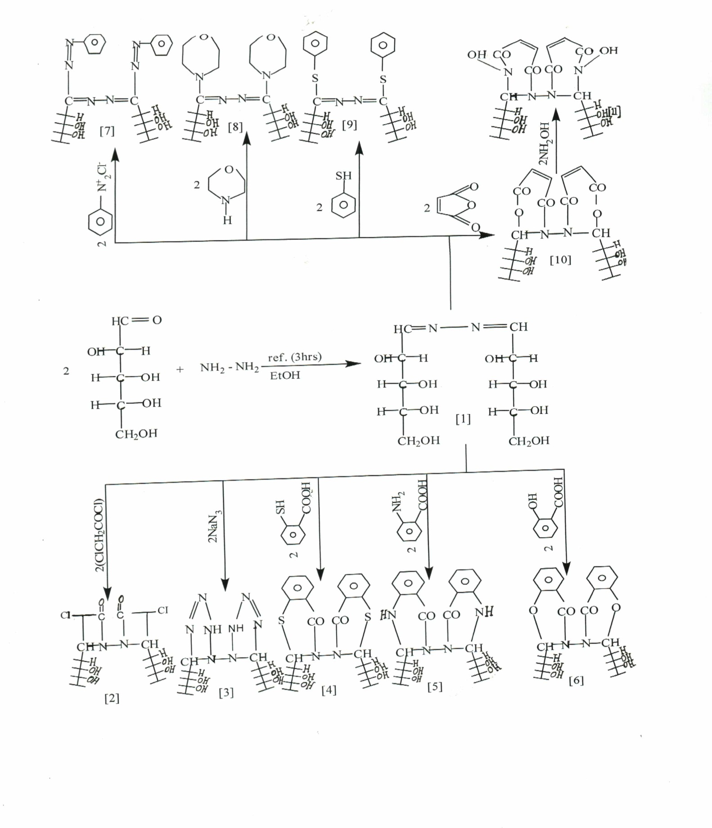
Scheme (1 )

Results and Discussion
Pentose sugar–anil compound [1] is used as starting material in synthesis of cyclic compounds [2-6 , 10-11] and substuted ring [7-9] , in this work , arabinose sugar reacted with hydrazine compound to produce anil compound [1] , which reacts with other compounds to yield (azetidine , tetrazole , oxazane ,thiazine ,oxazepine , diazepine ,sulfide , formazane ,diazane) named compounds [1-11] .
Formazane is one of synthesized compound in this work named compound [7] which contains azo group with imine group at same molecule .
All synthesized compounds [1-11] have been characterized by measurement melting points and spectral methods (FT.IR ,H.NMR ,C.H.N) –analysis and biological study .
Their FT.IR –spectrum , showed an absorption band at (1618)cm⁻¹ due to υ(CH=N) imine group⁽¹³⁾ in compound [1] , which disappeared and other bands appeared such as ((1688 of CO-N amide) , (728 of C-Cl of azetidine cycle )) in compound [2] , bands at υ ((3310 of NH) ,(1430 of N=N endo cycle of tetrazole )) in compound [3] , bands at ((1410 of CH-S) , (1695 of CO-N)) in compound [4], bands at ((3305 of NH) , (1690 of CO-N)) in compound [5] , bands at ((1610-1618 of (C=N) imine⁽¹³⁻¹⁵⁾ group))in compounds [7-9] and (1437 of N=N azo group) in compound [7] of formazane compound , bands at ((1730 of CO-O of oxazepine ), (1696 of CO-N amide of diazepine) in compounds [10,11] respectively and other data of functional groups shown in table (1) and figures (1-4) .
Their H.NMR –spectrum showed signal at б (8.86)due to (CH=N)proton of imine group⁽¹³⁾ in compound [1] , which disappeared and other signals appeared at б ((3.4 of CH-N) , б (2.98 of CH-Cl)) of azetidine in compound [2] , signals at [б 3.4 due to (N-NH-N), б 3.9 due to (N-CH-N), б 4.48 due to (S-CH-N) , б 4.05 due to (O-CH-N) , б 3.81-4.10 due to (O-CH₂CH₂₋N) in compounds [3-11] respectively , all compounds appeared signals at б (4.40 – 5.16)due to hydroxyl groups of arabinose sugar , and other signals shown in table (2) and figures (5,6) .
Their (C.H.N)- analysis and melting points , it was found from compared the calculated data with experimentally data of these compounds , the results compactable . the data of analysis , M.F and melting points are listed in table (3)

Assay of antibacterial activity ⁽¹⁶⁾:
Antimicrobial activity was tested by the filter paper disc diffusion method against gram positive bacteria (Staphylococcus . aureus ) and gram negative bacteria (E-Coli) , 0.1 ml of the bacterial suspensions was seeded on agar. To determine minimum inhibitory concentration(MIC) for each compounds[1-11] were ranged between (1-15)mg/ml by dissolved in (DMSO) and preparation 0.1mg/ml standard antibiotic ampiciline as positive standard and reference .
The positive results or sensitivity were established by the presence of clear zone of inhibition around active compounds which were measured with a meter rule and diameters were recorded based on (mm), the assays were performed with two replicates.
Generally, The results showed that the compounds[1-11] have great inhibitory effect against tested bacteria as compared with Synthetic antibiotic Ampiciline.
Table (4) showed the zone of inhibition of the compounds[1-11] in this study ranged (from30to7) mm. From results, we noted that the compounds[2-4] have higher antibacterial activity against S.aureus and E-Coli is due to the presence of sulfur and nitrogen atomes(O,N,S) with lactame group in some structures. Consequently,these compounds become more effective in precipitating proteins on bacteria cell walls. These atoms form hydrogen bonds with cell wall protein and hence ,destroying the cell membranes,these compounds had abroad antibacterial activity.
A knowledegement :
I would like to express my thanks to Mr. Uodai in Jordan for providing (C.H.N) element analytical , and Mr.Ahmad in Canada for providing H.NMR –spectra & melting points And express my thanks to(United Arabic Company) & (Zaidan Company of Chemical) for supplied some material .

Table (1) : FTIR absorption spectra (cm⁻¹) of prepared compounds [1-1] .

Comp.  No. | I.R_{(KBr)} (only important groups )
[1] | (CH=N) imine group: 1618 ; (OH) hydroxyl groups of arabinose sugar : 3317
[2] | υ (N-C=O) carbonyl of amide : 1688 ; (C–Cl) 728 , (OH) hydroxyl groups of arabinose sugar : 3312 .
[3] | (NH): 3310 ; (N=N) endocycle : 1430 ; (C–N) endocycle : 1240 ; (OH) hydroxyl groups of arabinose sugar : 3390 .
[4] | (CH–S): 1410 ; (CO–N) carbonyl of amide : 1695 ; (C–S) : 670 ; (OH) hydroxyl groups of arabinose sugar : 3395 .
[5] | (NH) : 3305 ; (CO –N) carbonyl of amide : 1690 ; (OH) hydroxyl of sugar : 3396.
[6] | (C–O–C): 1155 ;(CO–N): 1686 ; (OH) hydroxyl groups of arabinose sugar: 3428.
[7] | (C=N) : 1610 ; (-N=N) azo : 1437 ; (OH) of sugar : 3330 .
[8] | (C=N) : 1615 ; (OH) hydroxyl of sugar : 3395 .
[9] | (C=N) : 1618 ; (C –S) : 670 ; (OH) hydroxyl of sugar : 3385 .
[10] | (CO–O) of oxazepine : 1730 ; (CO–N) : 1696 ; (OH) of sugar : 3410 .
[11] | (CO–N) : 1696 , (OH) of sugar : 3317 .

Table (2) : ¹H.NMR –data (б _{PPm}) of compounds [1-11] .
Comp.No. | H.NMR (only important peaks )
[1] | 8.86 (CH=N) proton of imine group ; (4.40 , 4.43 , 4.45 , 4.48 ) protons of (CH–OH) hydroxyl of arabinose sugar .
[2] | 3.4 (CH –N) ; 2.98 (CH –Cl) of azitidine ; (4.40 , 4.43 , 4.45 , 4.48 ) hydroxyl of arabinose sugar .
[3] | 3.9 (-N–NH–N) ; 3.4 (N–CH–N) ; (4.77 , 4.89 , 4.97 , 5.12) hydroxyl of arabinose sugar
[4] | 4.48 (S–CH–N) ; (4.81 , 4.93 , 5.04 , 5.16) of (CH–OH) hydroxyl of arabinose sugar ; (6.72 – 7.30 ) protons of phenyl rings .
[5] | 3.6 (NH–CH–N) ; (4.76 , 4.84 , 4.98 , 5.12) of hydroxyl of arabinose ; (6.64–7.20) protons of phenyl rings .
[6] | 4.05 (O–CH–N) ; (4.40 , 4.43 , 4.45 , 4.46) protons of hydroxyl of arabinose ; (7.18 –7.36) protons of phenyl rings .
[7] | (4.79 , 4.88 , 5.00 , 5.13) protons of hydroxyl of arabinose ; (6.95 , 7.35) protons of phenyl rings .
[8] | (3.81,4.10) protons of (O-CH₂-CH₂-N); (4.74, 4.86, 4.99, 5.14) hydroxyl of arabinose sugar .
[9] | (6.92 , 7.15) protons of phenyl rings , (4.65 , 4.79 , 4.88 , 4.97) protons of hydroxyl of arabinose
[10] | 9.23 (O–CH–N) proton of oxazepine ring ; (2.33 , 2.51) proton of (CH=CH) of oxazepine ring ; (4.76 , 4.85 , 4.98 , 5.12) protons of hydroxyl of arabinose sugar
[11] | 3.41 (N–CH–N) ; 4.18 (N–OH) ; (2.49 , 3.34) proton of (CH=CH) of oxazepine ring ; (4.53 , 4.55 , 4.67 , 4.81) protons of hydroxyl of arabinose sugar .
Table (3) :some physical properties & (C.H.N)–analysis of compounds [1-11] .
Comp.No. | M.F | m.p(^{ﮦ}C)₍₊₂₎ | Name of compound | Calc. / Found.
 |  |  |  | C% | H% | N%
[1] | C₁₀H₂₀N₂O₈ | 152 | Bis (1-arabinose imine) | 40.540  40.431 | 6.756  6.613 | 9.459  9.324
[2] | C₁₄H₂₂N₂O₁₄Cl₂ | 178 | Bis(4-arabinose-3-chloro-azitidine-2-one) | 37.416  37.271 | 4.899  4.646 | 6.236  6.098
[3] | C₁₀H₂₂N₈O₈ | 190 | Bis(5-arabinose-tetrazole) | 31.413  31.286 | 5.759  5.516 | 29.319  29.20
[4] | C₂₄H₂₈N₂O₁₀S₂ | 212 | Bis(2-arabinose-5,6-benzo-4-one-1,3 thiazane ) | 50.704  50.551 | 4.929  4.801 | 4.929  4.783
[5] | C₂₄H₃₀N₄O₁₀ | 186 | Bis(2-arabinose-5,6-benzo-4-one-1,3 diazane ) | 53.932  53.684 | 5.617  5.548 | 10.486  10.319
[6] | C₂₄H₂₈N₂O₁₂ | 197 | Bis(2-arabinose-5,6-benzo-4-one-1,3-oxazane ) | 53.731  53.573 | 5.223  5.084 | 5.223  5.104
[7] | C₂₂H₂₈N₆O₈ | 182 | Bis(1-arabinose-1-phenyl azo-imine ) | 52.380  52.209 | 5.555  5.348 | 16.66  16.52
[8] | C₁₈H₃₄N₄O₁₀ | 196 | Bis(1-arabinose-1-morpholine- imine ) | 46.351  46.208 | 7.296  7.148 | 12.017  12.019
[9] | C₂₂H₂₈N₂O₈S₂ | 200 | Bis(1-arabinose-1-phenyl Sulfide-imine ) | 51.562  51.387 | 5.468  5.279 | 5.468  5.318
[10] | C₁₈H₂₄N₂O₁₄ | 229 | Bis(2-arabinose-4,7-dione-1,3-oxazepine ) | 43.902  43.781 | 4.878  4.693 | 5.691  5.503
[11] | C₁₈H₂₆N₄O₁₄ | 216 | Bis(2-arabinose-1-hydroxy-4,7-dione-1,3-diazepine ) | 41.379  41.198 | 4.980  4.814 | 10.727  10.603
Table(4):Antibacterial activity of the compounds[1-11] {diameter of zone (mm)} .
diameter of zone(mm) |  | Compounds[1-11] *
G-: E-Coli | G+: Staphylococcus. Aureus | Compounds[1-11] *
7  22  24  27  14  16  20  17  10  31 | 11  27  28  30  19  20  23 13 17  16  34 | compounds[1]  compounds[2]  compounds[3]  compounds[4]  compounds[5]  compounds[6]  compounds[7]  compounds[8]  compounds[9]  compounds[10] compounds[11]  Ampicilline**
*Minimum Inhibitory concentration (MIC)of compounds[1] (7mg/ml)
**Ampiciline (0.1mg/ml) .

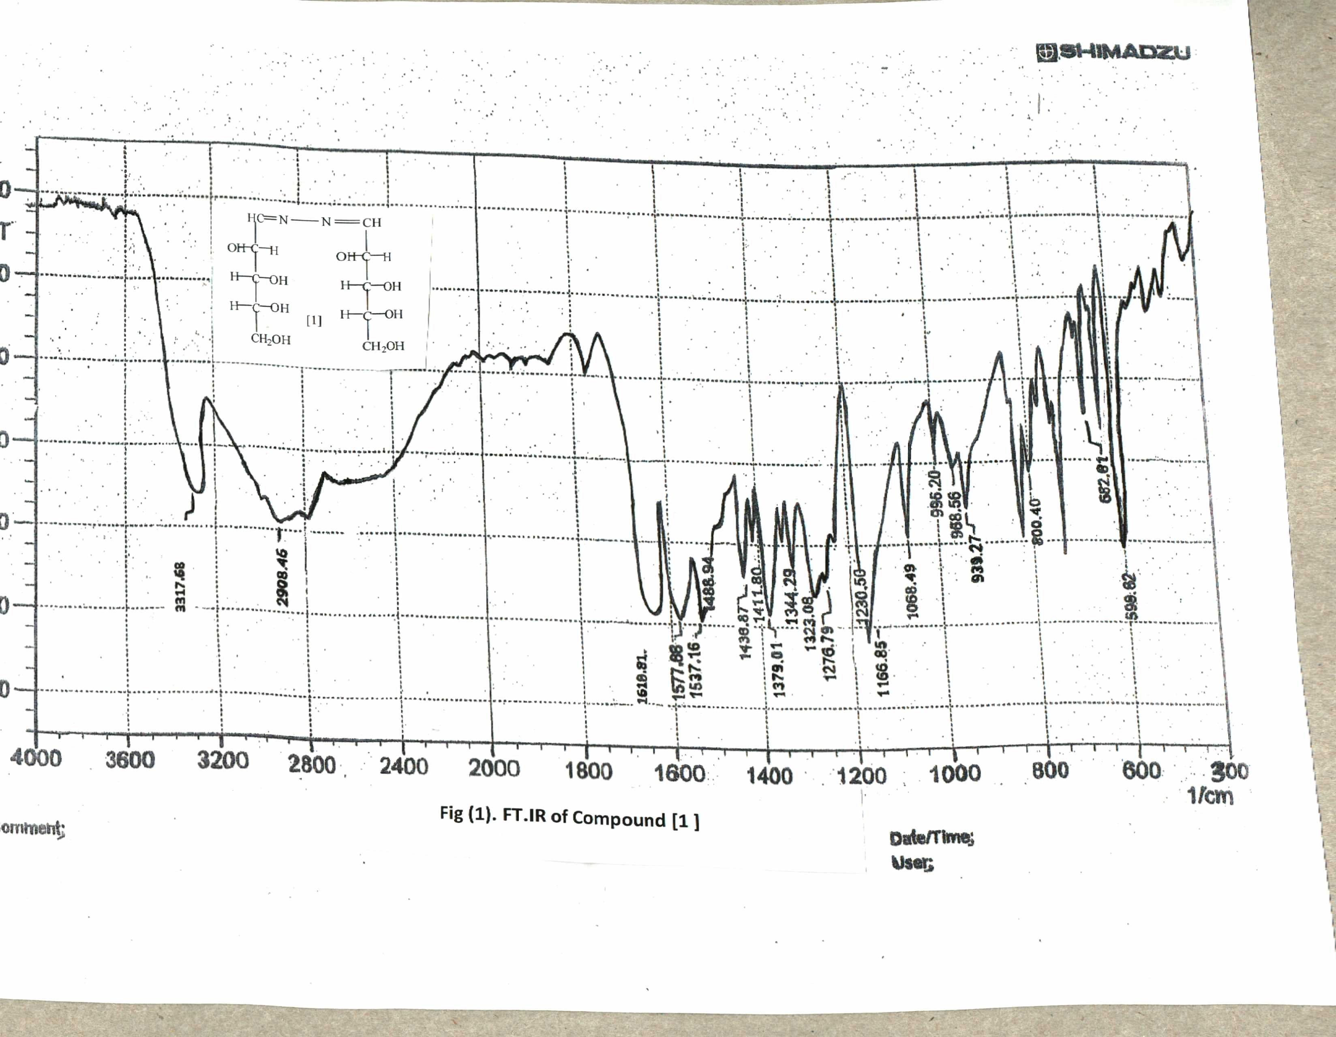

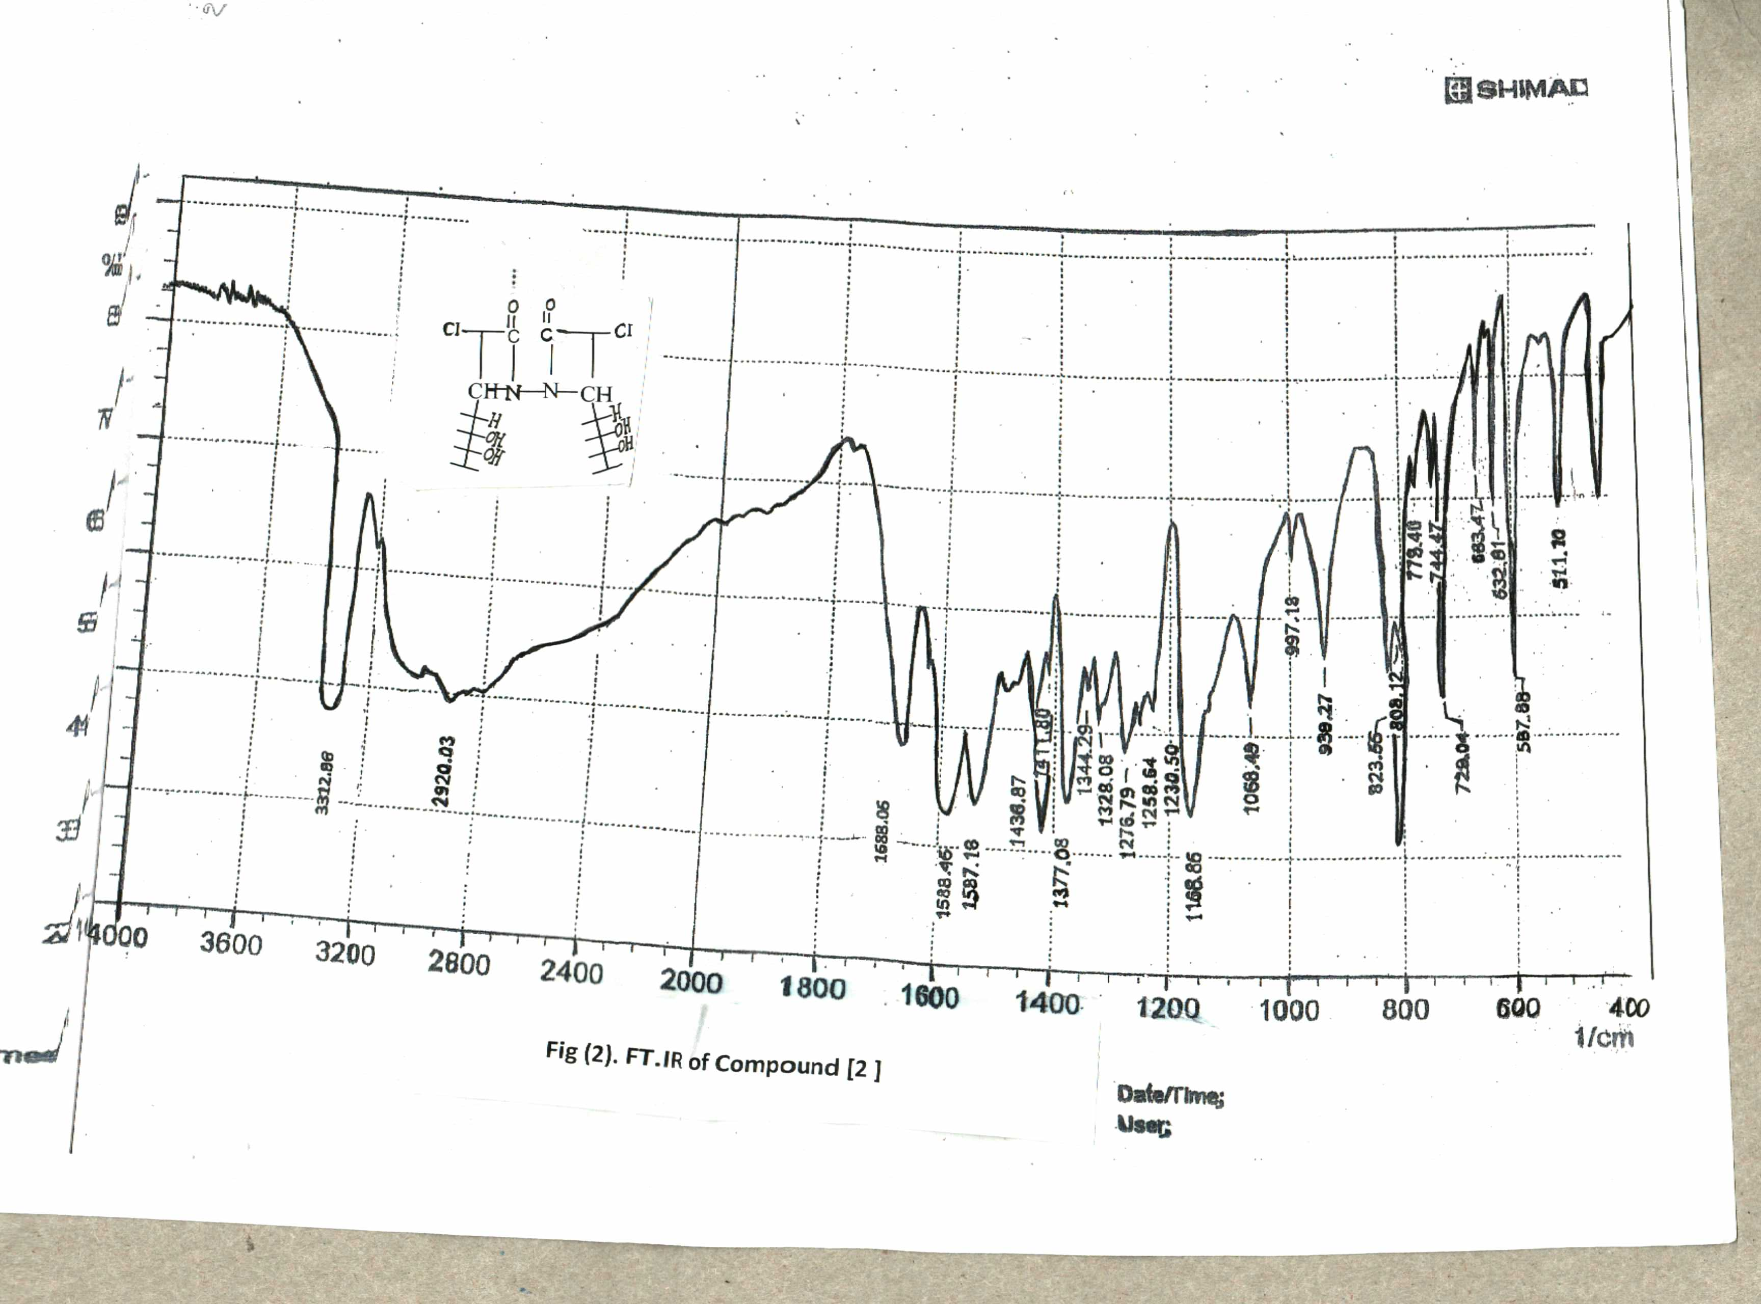

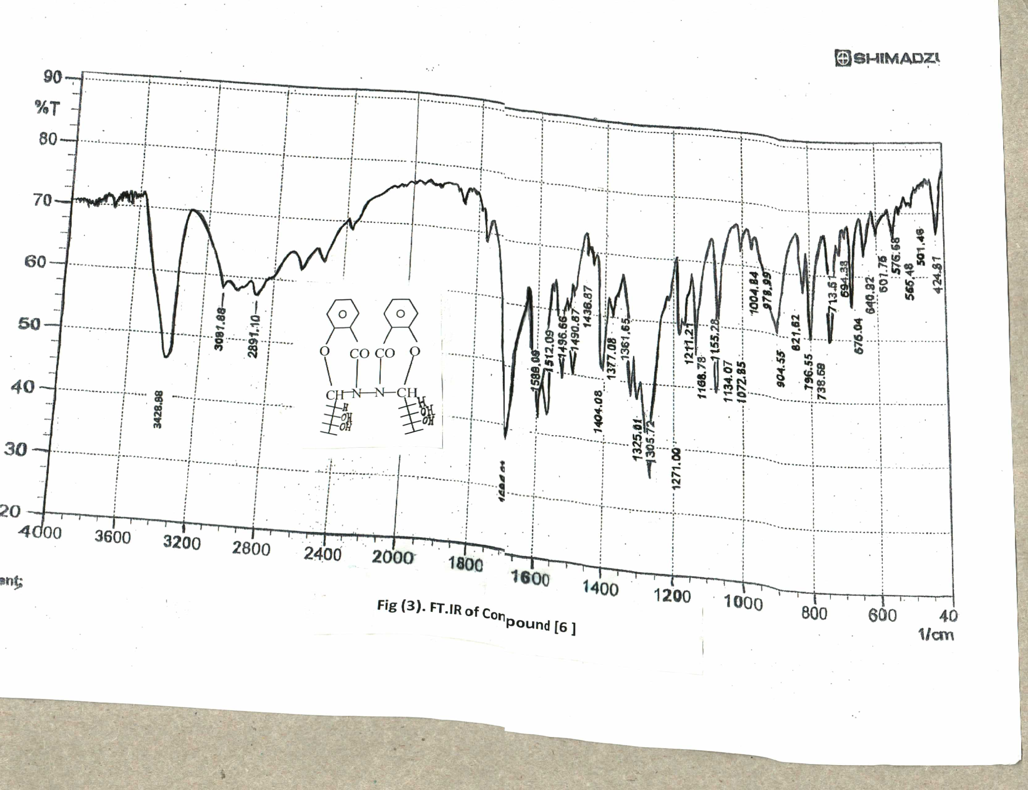

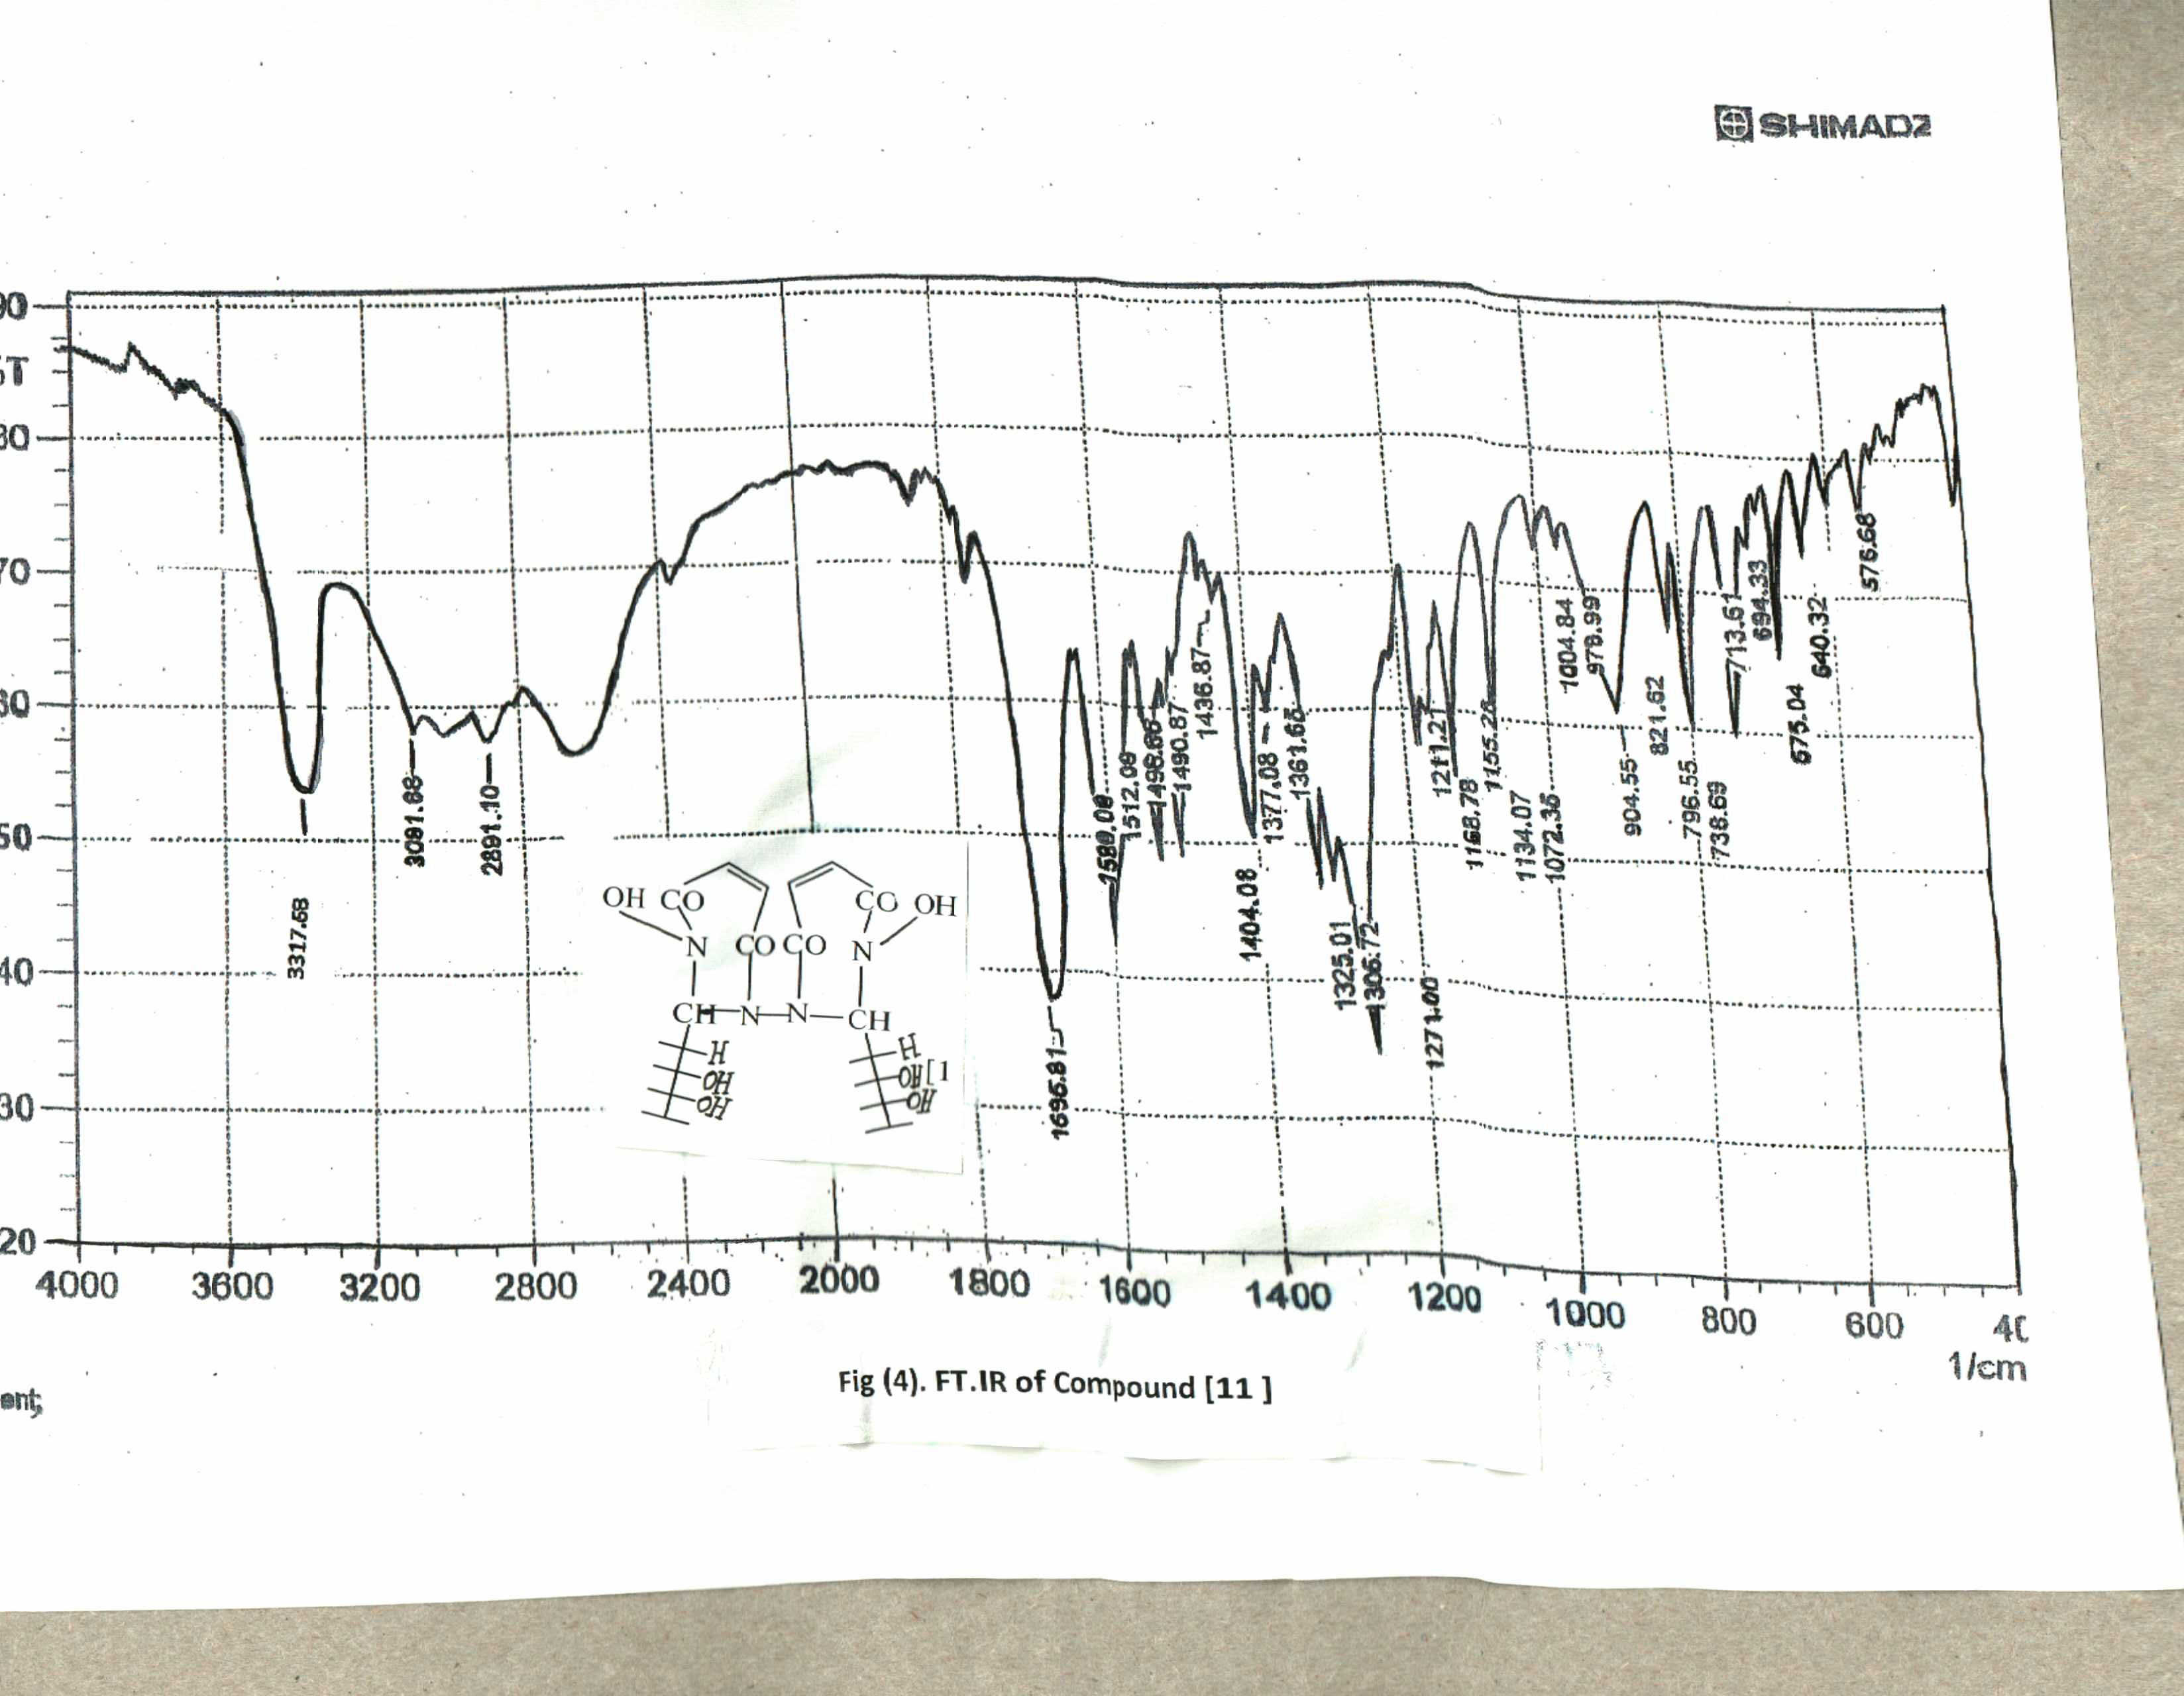

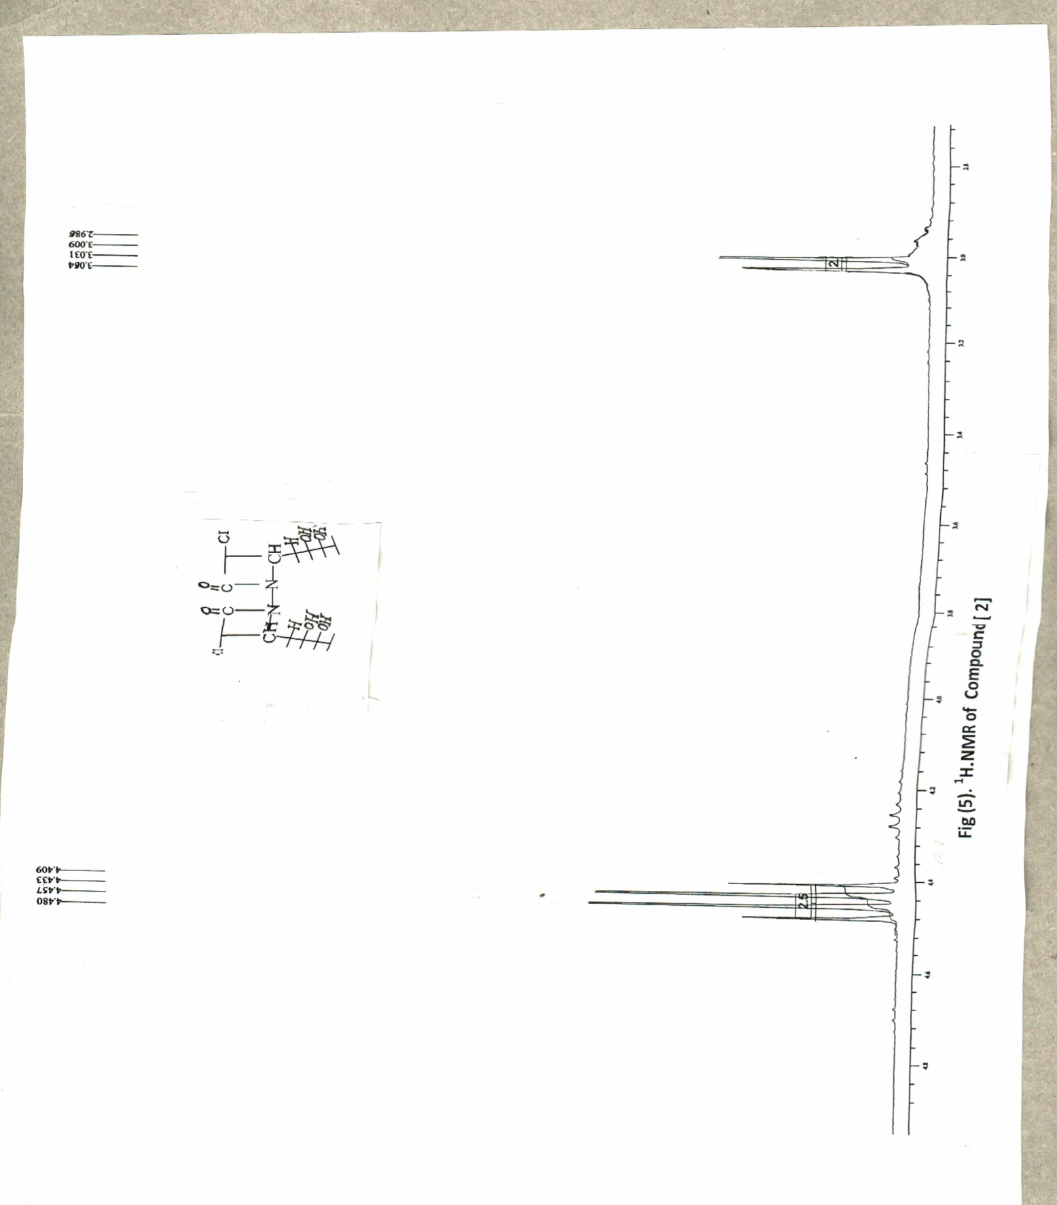

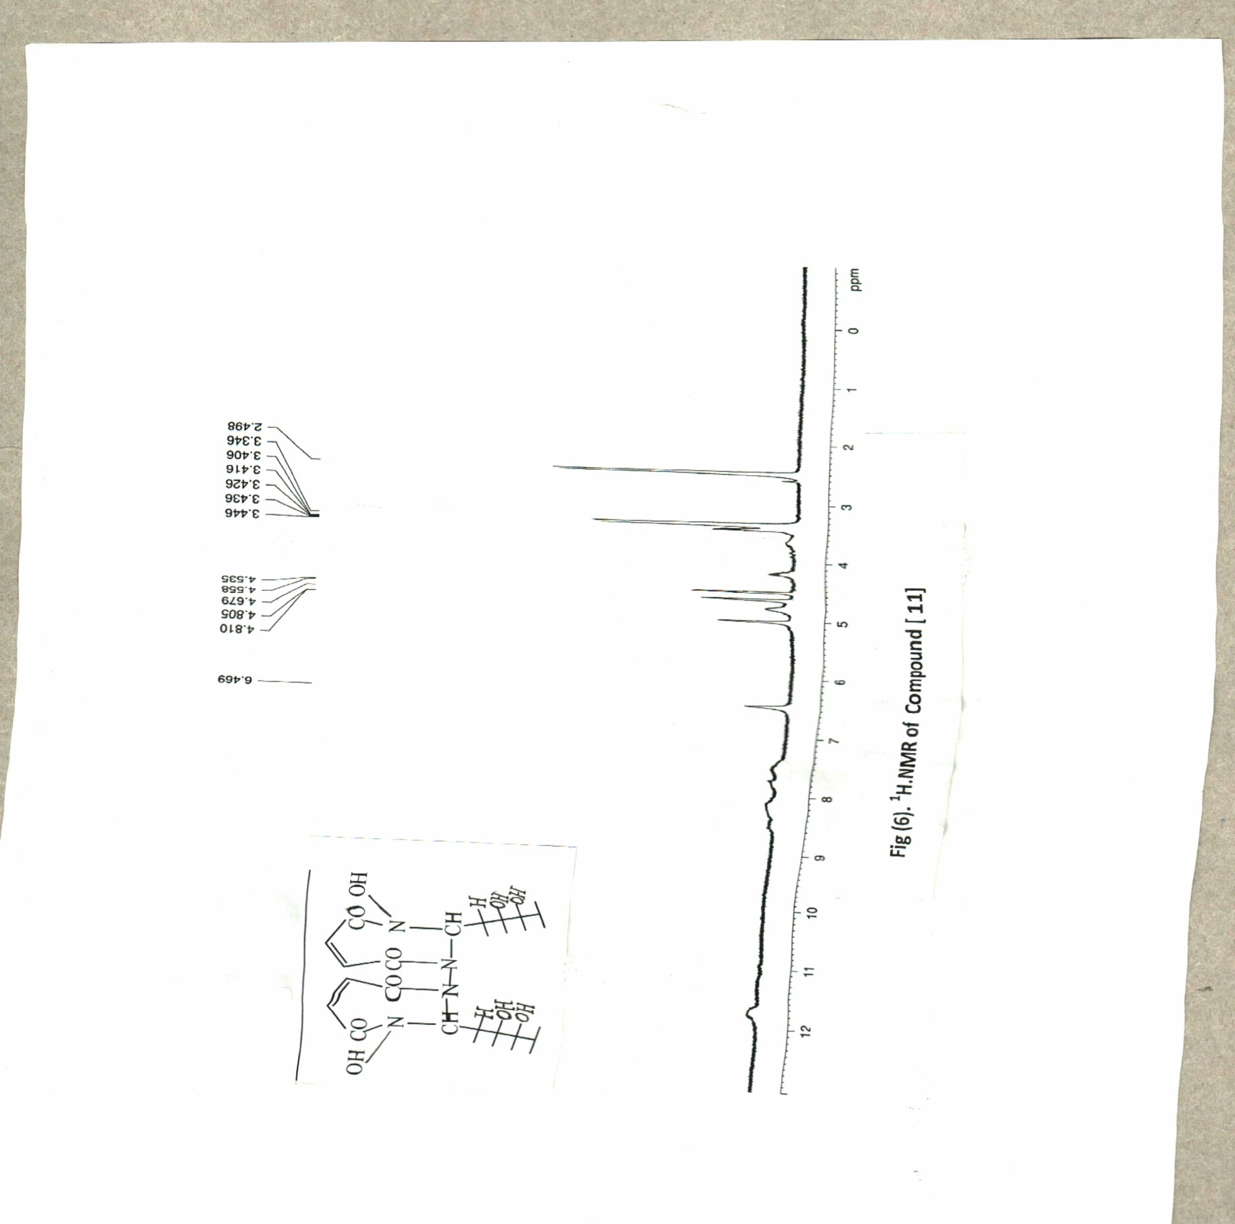

References
- Alok . P , Rajavel . R , Sandeep. C & Deepak. D ., E-Journal . Chem., 2012, 9,4, 2524–2531 .
- Saha .S , Bayerjee . M , Samantraky . A , Bahera . C & Azam .M ., Trop. J . Pharm. Res., 2008, 7,2, 961–968 .
- Magdy . E , Somaia . S , Mogedda . E and Mohammed . A ., Act . Poloniae . Pharma–Drug . Res , 2011, 68,3,357-373 .
- Arun . K , Ajit . K and Arit S ., Der Pharma .Chemica , 2011, 3,5, 146-154 .
- Nagham .M.Aljamali ., Asian. J. Exp.Chem ,2012, 7, 1, 52-56 .
Lin . L ,Lipeng .H ,Quanyi . F ,Yuting . L,Zhili .L , Jiang . S and Bing . L ., ,J.Molecules , 2012, 17, 12758-12770 .
Jarrahpour . A,Shekarriz . M and Taslimi . A ., J .Molecules , 2004, 9, 29-38.
Rashad . A,Shamroukh . A,Mohamed . I and Awad . H ., Acta . chem . Slov , 2005, 52,429-434 .
Henrik . J and Stein born . D .,Inorg . chimica .Acta ., 2003, 346,129-136 .
- John .P ,John .A and George . H., J.Bio .Chem ., 1986, ,10248-10256 .
- Gwaram . N ,Hapipah . M and Siddig . I ., Molecules , 2012, 17,2408-2427.
- Dandeya .S and Neha . R., Indo . Glo . J.Pharma.Sci, 2012, 2,1,76-84 .
- Silver Stein R M, and Webster F X( 2007) .,"Spectrometric Identication of Organic Comp" ., Wiley, New Delhi India,.
- .Gholamhossein.G, Aliakbar.D, Vida.T, Kazuma.G and Hiroyki.I., Polyhedrone, 2012, 31,265-271., Cited by IVSL.
- Xueguang.R, Lingyun.W, Derong.C, Yingcai.L and Jie.H., Appl.Orgmet.Chem, 2010, 25,9-15 , Cited by IVSL.
Athanari.S, Venkateshwaran.K, Vanitha.J, Saravahan .V, Ganesh.M, Vasudevan.M and Sivakumar.T., , Bangladesh .J.Pharm, 2009, 4,13-16

