Simple and Convenient Procedure for the Synthesis of 2-(3-(tert-Butoxycarbonylamino)propyl)-5-methylthiophenes
Asim A. Balakit
E-mail: asim_alsalehi@hotmail.com
Department of Chemistry, College of Science for Women, University of Babylon,
Gamal A. El-Hiti
E-mail: gelhiti@ksu.edu.sa; Fax: +966114693536; Tel: +966114693778
Cornea Research Chair, Department of Optometry, College of Applied Medical Sciences, KingSaud University, P.O. Box 10219, Riyadh 11433, Saudi Arabia
Keith Smith
School of Chemistry, Cardiff University, Main Building, Park Place, Cardiff, CF10 3AT, UK

(NJC)
(Received on 30 /9 /2013) (Accepted for publication 3 /12 /2013)

Abstract
2-(3-(tert-Butoxycarbonylamino)propyl)-5-methylthiophene and its 4-deuterio derivative have been synthesized by a simple and convenient method in a six step sequence from 2-methylthiophene. The final step involved bromine-lithium exchange on 4-bromo-2-(3-(tert-butoxycarbonylamino)propyl)-5-methylthiophene at low temperature in anhydrous tetrahydrofuran followed by treatment with water or D₂O.

Keywords: Bromine−lithium exchange; synthesis; 2-methylthiophene; heterocycles; 2-(3-(tert-butoxycarbonylamino)propyl)-5-methylthiophene.
الخلاصة
تتضمن هذه الدراسة تحضير 2--3-)ثلاثي-بيوتوكسي كاربونيل امينو)بروبيل)-5-مثيل ثايوفين ومشتقه المعوض بالديوتريوم في الموقع 4 بطريقة بسيطة وعملية بستة خطوات وابتداءا من 2- مثيل ثايوفين. الخطوة الاخيرة في هذا التحضير تضمنت تفاعل استبدال البروم بالليثيوم في درجة حرارة منخفضة باستخدام التتراهايدروفيوران الجاف كمذيب يعقبه معاملة مزيج التفاعل بالماء و ال D₂O.

المفاتيح: استبدال بروم-ليثيوم; تحضير; حلقات غير متجانسة;2--3-)ثلاثي-بيوتوكسي كاربونيل امينو)بروبيل)-5-مثيل ثايوفين.

Introduction
Derivatives of thiophene are useful compounds for a number of applications. For example, photochromic compoundswith thienyl groups have potential applications in optical memories, molecular switches, medical screening and electronic devices.^{[1-5]}In particular, compounds that have both photochromic and fluorescent properties in a single molecule are among the most interesting photochromic compounds and can be used in a wide range of applications.^{[6]} In order to link a thiophene unit to another moiety it would be advantageous for the unit to have a substituent bearing an active functionality and an amino group is attractive from that perspective. It would also be useful for the thiophene to carry a Br substituent, which can be replaced by a variety of alternative groups.
In the course of our own studies of lithiation reactions we have developed several simple and efficient lithiation procedures for preparation of various substituted aromatics and heteroaromatics.^{[7−11]} Such processes have been applied for the production of various substituted heterocycles.^{[12−14]}We therefore decided to synthesize4-bromo-2-(3-(tert-butoxycarbonylamino)propyl)-5-methylthiophene (6), which contains both a protected aminoalkyl group and a Br substituent, and to demonstrate replacement of the Br by an alternative substituent.
Experimental
All reactions were performed under an inert atmosphere. Glassware was oven dried, assembled hot and allowed to cool under a stream of nitrogen gas. All chemicals and reagents were purchased from commercial sources and used without further purification. THF was distilled from sodium benzophenoneketyl and other solvents were purified by standard procedures.^{[15]}IR spectra were recorded as KBr discs for solid materials or by applying droplets of liquid materials on a NaCl plate using FT/IR-660 plus instrument. ¹H and ¹³C NMR spectra were recorded on a spectrometer operating at 400 MHz for ¹H and 100 MHz for ¹³C measurements (500 MHz for ¹H and 125 MHz for ¹³C measurements for compounds 6 and 7), respectively using Bruker machines. Chemical shifts δ are reported in parts per million (ppm) relative to tetramethylsilane (TMS). ¹³CNMR signals corresponding to CH, CH₂, or CH₃ are assigned from DEPT−90 and 135 spectra and all other carbons are quaternary (C). Low and high–resolution mass spectra were recorded on a time-of-fight mass spectrometer using electron impact (EI). Column chromatography was carried out using Fischer Scientific silica 60A (35−70 micron). Alkyllithiums were obtained from Aldrich Chemical Company and were estimated prior to use by the method of Watson and Eastham.^{[16]}3,5-Dibromo-2-methylthiophene (2) was synthesized according to a literature procedure.^{[17]}
Synthesis of 3-bromo-2-methylthiophene-5-carboxaldehyde (3):
A solution of n-BuLi (64.0 mL, 1.60 M; 64.00 mmol) in hexane was added in a dropwise manner over 5 min to a stirred solution of 3,5-dibromo-2-methylthiophene (2; 16.0 g, 62.5 mmol) in anhydrous THF (100 mL) at –78 ^{ο}C under nitrogen. The solution turned orange then greenish yellow and finally yellowish orange. The reaction mixture was stirred at –78 ^{ο}C for 30 min and DMF (4.80 g, 65.7 mmol) was then added. The cooling bath was removed and the mixture was stirred at room temperature for 16 h. The mixture was quenched with aqueous HCl (20 mL, 2 M) and the product was extracted with Et₂O (3 × 100 mL). The organic layer was washed with saturated aqueous NaHCO₃ solution and brine and then dried (MgSO₄). The solvent was removed under reduced pressure to give pure 3 (10.88 g, 53.05 mmol; 85%) as a yellow solid.
Mp: 56−57 ^{ο}C(lit. 57-58 ºC).[18]
¹H NMR (400 MHz, CDCl₃)δ (ppm): 9.69 (s, 1 H), 7.51 (s, 1 H) and 2.41 (s, 3 H).
¹³C NMR (100 MHz, CDCl₃) δ(ppm): 181.6 (d), 145.9 (s), 140.1 (s), 138.8 (d), 111.3 (s) and 15.9 (q).
EI-MS (m/z, %): 206 ([M⁸¹Br]⁺, 75], 205 (98), 204 ([M⁷⁹Br]⁺, 77), 203 (100), 177 (25), 125 (20), 96 (40), 84 (32) and 69 (49).
HRMS (EI): Calcd for C₆H₄BrOS [M⁷⁹Br - 1]⁺ 202.9172; Found, 202.9166.
FT–IR (ν_{max}, cm⁻¹): 3080 (aromatic CH), 2859 (aldehydic CH), 1678 (C=O).
Synthesis of 3-(4-bromo-5-methylthiophen-2-yl)acrylonitrile (4):
Sodium hydride (0.25 g of a 60 % dispersion in mineral oil, 6.25 mmol) was washed with dry, distilled hexane (2 × 50 mL) and then suspended in dry, distilled THF (50 mL) under inert atmosphere. Diethyl (cyanomethyl) phosphonate (0.94 g, 5.3 mmol) was added to the gray suspension via syringe (a small excess was added until a clear yellow solution was obtained). The resulting light yellow solution was stirred for 1 hour. 3-Bromo-2-methylthiophene-5-carboxaldehyde (3; 1.00 g, 4.90 mmol) was added in a dropwise manner to the solution via syringe over 10 min. The resulting thick dark red mixture was stirred overnight. Saturated aqueous ammonium chloride solution (25 mL) was added to quench the reaction followed by extraction with diethyl ether (4 × 50 mL). The organic phase was washed with saturated aqueous sodium hydrogen carbonate solution (50 mL) and brine (25 mL) and dried over anhydrous magnesium sulfate. The solvent was then removed under reduced pressure to give the solid crude product. After purification by column chromatography (silica gel, 50:50 Et₂O:hexane) to give a mixture of E- and Z-isomers of 4 in ca. 4:1 ratio in 88% yield (0.98 g, 4.30 mmol).Recrystallization of the E- and Z-isomers mixture of 4from diethyl ether gave colorless crystals of the E-isomer.
Mp: 80−81^{ο}C.
¹H NMR (400 MHz, CDCl₃)δ(ppm): 7.23 (d, J = 16.3 Hz, 0.8 H), 7.20 (d, J=11.7 Hz, 0.2 H), 6.98 (s, 1 H), 5.46 (d, J = 16.3 Hz, 0.8 H), 5.15 (d, J = 11.7 Hz, 0.2 H), 2.37 (s, 0.6 H), 2.35 (s, 2.4 H).
¹³C NMR (100 MHz, CDCl₃) δ(ppm): 141.6 (d), 140.0 (d), 138.9 (s), 135.2 (s), 134.8 (d), 133.5 (d), 117.8 (s), 110.9 (s), 94.5 (d), 91.2 (d), and 15.4 (q).
EI-MS (m/z, %): 229 ([M⁸¹Br]⁺, 80), 227 ([M⁷⁹Br]⁺, 78), 148 (100), 121 (10).
HRMS (EI): Calcd for C₈H₆BrNS [M⁷⁹Br]⁺ 226.9404; Found, 226.9402.
FT–IR (ν_{max}, cm⁻¹): 2211 (CN), 1653 (C=C).
Synthesis of 2-(3-aminopropyl)-4-bromo-2-methylthiophene (5):
In a 50 mL round-bottomed flask 3-(4-bromo-5-methylthiophen-2-yl)acrylonitrile (4; 0.50 g, 2.20 mmol) was dissolved in absolute methanol (25 mL). Anhydrous cobalt(II) chloride (0.60 g, 4.62 mmol) was then added. The blue suspension was cooled in ice/water. Sodium borohydride (0.35 g, 9.25 mmol) was added carefully in small portions. The mixture gave off gas and a black precipitate was produced. The mixture was stirred for 4 hours at room temperature. Hydrochloric acid (5M, 20 mL) was added followed by basification with concentrated ammonia until a pH of 12 was obtained. The basified mixture was extracted with diethyl ether (4×50mL). The organic phase was washed with saturated brine, dried over anhydrous magnesium sulfate and treated twice with charcoal (approx. 2 g, stirred at room temp. for 20 min). The solvent was removed under reduced pressure and compound 5 was obtained as clear, green oil in 77% yield (0.40 g, 1.71 mmol).
¹H NMR (400 MHz, CDCl₃) δ(ppm): 6.50 (s, 1 H), 2.65-2.71 (m, 4 H),2.30 (s, 3 H), 1.70 (app. quintet, J = 8 Hz, 2 H), 1.20 (s, exch., 2 H).
¹³C NMR (100 MHz, CDCl₃) δ(ppm): 142.1 (s), 131.6 (s), 126.7 (d), 108.0 (s), 41.3 (t), 35.1 (t), 27.4 (t), 14.6 (q).
EI-MS (m/z, %): 235 ([M⁸¹Br]⁺, 10), 233 ([M⁷⁹Br]⁺, 13), 218 (98), 216 (99), 191 (52), 189 (50), 137 (100), 123 (50), 111 (69).
HRMS (EI): Calcd for C₈H₁₂BrNS [M⁷⁹Br]⁺ 232.9874; Found, 232.9876.
FT–IR (ν_{max}, cm⁻¹): 3375 (NH), 3300 (NH), 2919 (CH), 2853 (CH).
Synthesis of tert-butyl 3-(4-bromo-5-methylthiophen-2-yl) propylcarbamate(6):
In a 50 mL round-bottom flask di-tert-butyl dicarbonate (0.490 g, 2.24 mmol) was dissolved in dry, distilled THF (10 mL). 2-Methyl-3-bromo-5-(3-aminopropyl) thiophene (5; 0.54 g, 2.30 mmol) was added and the solution was stirred for 16 h. The solvent was removed under reduced pressure. The oil obtained was dissolved in ethyl acetate (60 mL), and the resulting solution was washed with saturated aqueous sodium bicarbonate solution (40 mL), 5% aqueous sodium hydrogen sulfate solution (40 mL) and water (40 mL) and then dried over anhydrous magnesium sulfate. The solvent was removed under reduced pressure and the residue was purified by column chromatography (alumina, 5% ethyl acetate/hexane). Compound 6 was isolated as colorless oil in 93% yield (0.72 g, 2.15 mmol).
¹H NMR (500 MHz, CDCl₃) δ(ppm): 6.51 (s, 1 H), 4.48 (exch. s, 1 H), 3.10−3.00 (m, 2 H), , 2.67 (t, J = 7 Hz, 2 H), 2.26 (s, 3 H), 1.73 (app. quintet, J = 7 Hz, 2 H), 1.37 (s, 9 H).
¹³C NMR (125 MHz, CDCl₃) δ(ppm): 155.9 (s), 141.4 (s), 131.8 (s), 126.9 (d), 108.1 (s), 79.3 (s), 39.9 (t), 31.6 (t), 28.4 (q), 27.3 (t), 14.6 (q).
EI-MS (m/z, %): 335 ([M⁸¹Br]⁺, 2), 333 ([M⁷⁹Br]⁺, 2), 179 (49), 177 (50), 216 (100), 191 (61), 137 (56).
HRMS (EI): Calcd for C₁₃H₂₀BrNO₂S [M⁷⁹Br]⁺ 333.0398; Found, 333.0402.
FT–IR (ν_{max}, cm⁻¹): 3352 (NH), 2976 (CH), 2929 (CH), 1694 (C=O).
Synthesis of 2-(3-(tert-butoxycarbonylamino)propyl)-5-methylthiophene (7):
In an oven dried, 50 mL round-bottomed flushed with nitrogen 4-bromo-2-(3-(tert-butoxycarbonylamino)propyl)-5-methylthiophene (6; 0.10 g; 0.30 mmol) was dissolved in freshly distilled THF (25 mL) and cooled to –78 ^{ο}C under nitrogen. n-Butyllithium (0.19 mL of 1.60 M solution in hexane; 0.30 mmol) was added in a dropwise manner. The reaction mixture was stirred for 15 min, then t-butyllithium (0.19 mL of 1.60 M solution in hexane; 0.30 mmol) was added in a dropwise manner and the stirring was continued for 20 min at that low temperature. The cooling bath was removed and the reaction was quenched with water (2.0mL). The mixture was stirred for 10 min at room temperature. A saturated aqueous solution of ammonium chloride (NH₄Cl;10mL) and water (10 mL) were added subsequently, followed by extraction with diethyl ether (2 × 50 mL). The organic layer was washed with brine (100mL) and dried over anhydrous magnesium sulfate. Solvent was evaporated under reduced pressure. Compound7 was obtained as a colorless oil in 90% yield (0.070 g, 0.27 mmol).
¹H NMR (500 MHz, CDCl₃) δ(ppm): 6.49−6.46 (m, 2 H), 4.50 (exch. s, 1 H), 3.12−3.08 (m, 2 H), 2.70 (t, J = 7 Hz, 2 H), 2.35 (s, 3 H),1.75 (app. quintet, J = 7 Hz, 2 H), 1.37 (s, 9 H).
¹³C NMR (125 MHz, CDCl₃) δ(ppm): 156.0 (s), 142.0 (s), 137.5 (s), 124.7 (d), 124.0 (d), 79.2 (s), 40.0 (t), 32.0 (t), 28.4 (q), 27.3 (t), 15.2 (q).
EI-MS (m/z, %): 255 (M⁺, 12), 213 (18), 199 (90), 182 (53), 152 (27), 138 (97), 125 (88), 111 (97), 97 (21), 85 (100).
HRMS (EI): Calcd for C₁₃H₂₁NO₂S [M]⁺ 255.1293; Found, 255.1284.
FT–IR (ν_{max}, cm⁻¹): 3352 (NH), 2975 (CH), 2929 (CH), 1691 (C=O).
Synthesis of 2-(3-(tert-butoxycarbonylamino)propyl)-4-deuterio-5-methylthiophene(8):
Compound 8 was synthesized as described for the synthesis of 7 with deuterium oxide used for quenching the reaction instead of water. Product 8 was obtained as colorless oil in 90% yield (0.07 g, 0.27 mmol).
¹H NMR (400 MHz, CDCl₃)δ(ppm): 6.48 (s, 1 H) 4.53 (exch. s, 1 H), 3.10−3.00 (m, 2 H),2.69 (t, J = 7 Hz, 2 H), 2.34 (s, 3 H),1.74 (app. quintet, J = 7 Hz, 2 H), 1.37 (s, 9 H).
¹³C NMR (100 MHz, CDCl₃) δ(ppm): 156.0 (s), 142.0 (s), 137.4 (s), 124.7 (d), 123.0 (seen as three lines because of coupling to D), 79.2 (s), 40.0 (t), 32.0 (t), 28.4 (q), 27.3(t), 15.2 (q).
EI-MS (m/z, %): 256 (M⁺, 17), 200 (98), 183 (67), 139 (99), 124 (86), 112 (99), 84 (100), 74 (25).
HRMS (EI): Calcd for C₁₃DH₂₀NO₂S [M⁺] 256.1356; Found, 256.1353.
FT–IR (ν_{max}, cm⁻¹): 3351 (NH), 2973 (CH), 2927 (CH), 1692 (C=O).
Results and Discussion
2-Methylthiophene(1) represents the precursor of the majority of the molecular switches that have diarylethenes as the photochromic units.Therefore,this was the chosen starting material for production of compound 5 as shown in Scheme 1.

Scheme 1.Synthesis of compound5.

The first step was the bromination of 1 to get 2. The second step was the conversion of 2 to the aldehyde 3 by selective bromine-lithium exchangeof the α-bromo group, followed by treatment with dimethylformamide (DMF). Conversion of 3 into 4 involveda Horner/Wadsworth/Emmons reaction with a cyanomethylphosphonate. The structure of 4 was assigned by ¹HNMR, ¹³CNMR and FT-IR spectroscopy and high resolution mass spectrometry (HRMS)and confirmed further by x-ray crystallography (Figure1).^{[19]}See the experimental section for more details.

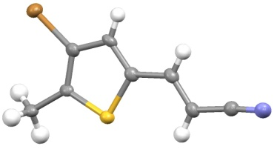
Figure 1:X-Ray crystal structure of compound 4^{[19]}

The target amine 5 required reduction to saturate the double and the triple bonds of the side chain, and this was accomplished by reaction with sodium borohydride in the presence of cobalt (II)chloride.
The substitution of the bromine atom at C-3 of 5 required a second bromine-lithiumexchange step. Because of the reactivity of the amino group toward bases,however, it was first necessary to protect this group. Compound 5 was protected with a tert-butoxycarbonyl (Boc) group by reaction with di-tert-butyl dicarbonate (Boc anhydride) to give the Boc-protected amine 6(Scheme 2).

Scheme 2: Synthesis of compound6.

The ¹HNMR spectrum of the isolated product (Figure 2a) clearly indicated the presence of the Boc group; it showed a singlet signal at δ = 1.37 ppm with an integration value of 9 H, corresponding to the three identical CH₃ groups, while the integration value for the exchangeable signal corresponded to justone proton (NH) rather than the 2 H of the NH₂ of compound 5. The ¹³CNMR spectrum(Figure 2b) showed all the expected signals for 6.The FT−IR confirmed the presence of the carbonyl group by a new signal at 1692 cm⁻¹. Finally the chemical formula of 6was confirmed by high resolution mass spectrometry. The HRMS of the molecular ion peak of compound 6showed that themeasured m/z was333.0402 which correlates well with the calculated value for C₁₃H₂₀BrNO₂S ([M⁷⁹Br]⁺) as 333.0398(see the experimental section for details).

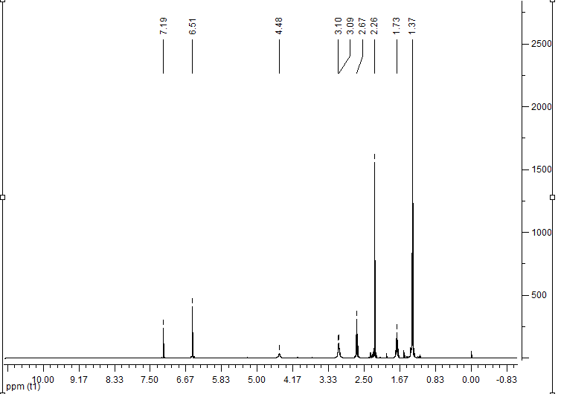
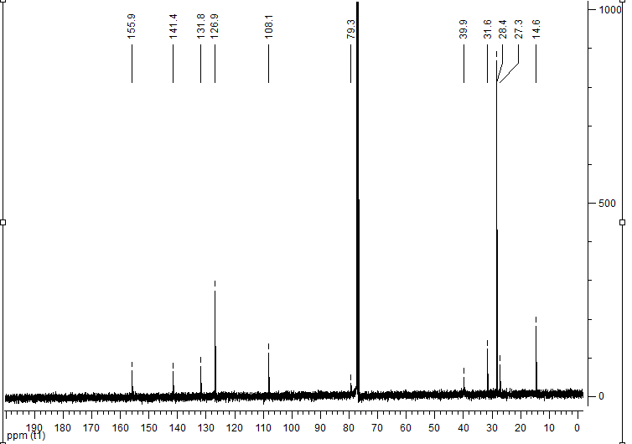
a

b

Figure 2:NMR Spectra of compound 6; (a) ¹HNMR and (b) ¹³C NMR.

The protected amine 6having been successfully synthesized, the next step was to test the replacement of the bromine atom at C-3 of 5 by other substituents. The success of this step would mean that the above described methodology could becomegeneral for the synthesis of many different types of substituted thiophenes having a useful linker arm. We used two simple electrophiles (H₂O and D₂O) to demonstrate the method. Although compound 6 is a protected amine, it still has an acidic hydrogen attached to the nitrogen atom. Therefore, we first treated it with one molar equivalent of methyllithiumat a low temperature (–78^{ο}C) for 15 minto remove the NH hydrogen before adding one molar equivalent of t-butyllithiumat the same low temperature and stirring for 15 min. In the first test case we used water as the electrophile(Scheme 3).

Scheme 3:Synthesis of compound 7.

The ¹HNMR spectrum of the isolated product (Figure 3a) showed that the 1H singlet signal at δ= 6.5 ppm of 6had been replaced by a multiplet with an integration value of 2 H which indicatedthat the bromine atom of 6had been replaced by a hydrogen atom. Shifts in the positions of the ¹³C signals (Figure 3b) were also observed. Mass spectrometry confirmed that the bromine of 6 had been replaced by a hydrogen atom. Finally the chemical formula of 7was confirmed by HRMS, whichshowed that themeasured m/zfor the molecular ion of compound 7 was255.1284which correlates well with the calculated value for C₁₃H₂₁NO₂S (M⁺)as255.1293(see the experimental section for details).

a
b
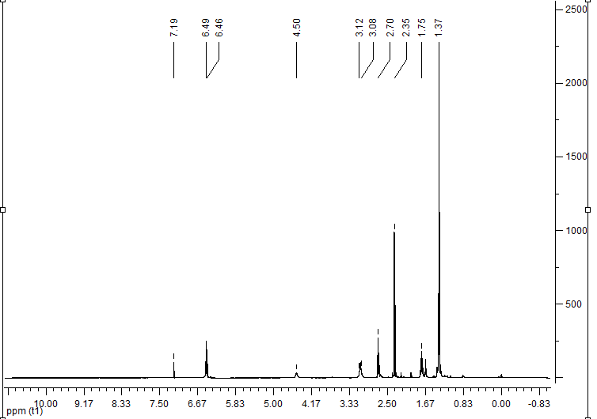
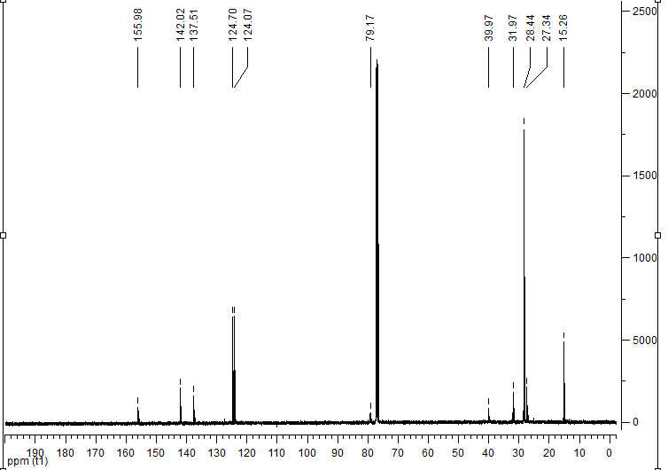
Figure 3:NMR Spectra of Compound 7; (a) ¹HNMR and (b) ¹³C NMR.

The second test reaction involved the use of deuterium oxide (D₂O) as electrophile(Scheme 4). In this case the reaction was carried out under the same conditions as the previous one but D₂O was used instead of H₂O to quench the reaction.

Scheme 4: Synthesis of compound 8.

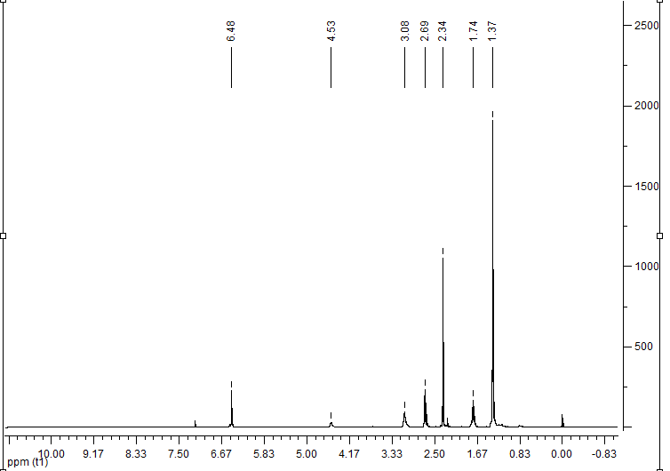
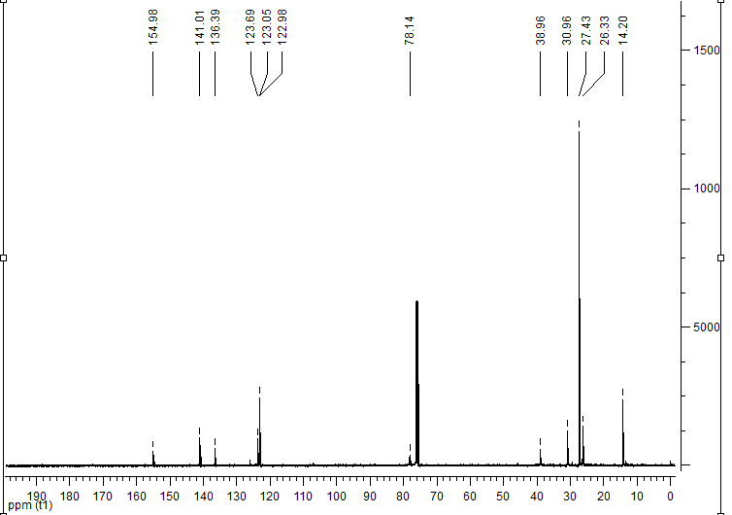
Figure 4:NMR Spectra of Compound 8; (a) ¹HNMR and (b) ¹³C NMR.

The ¹HMR spectrum of the isolated product (Figure 4a) was almost identical to that of 6, while the ¹³CNMR spectrum (Figure 4b) clearly indicated replacement of the bromine atom by a D atom, since the signal at δ = 123.0 appeared as three lines because of coupling to D and all signals of the other carbon atoms were present. Mass spectrometry confirmed that the bromine of 6had been replaced by a deuterium atom. Finally the chemical formula of 8, with a relative molecular mass one Dalton higher than for 7,was confirmed by HRMS, which confirmed that the m/z for the molecular ion peak of 8 was256.1353which correlates well with the calculated value for C₁₃DH₂₀NO₂S (M⁺) as256.1356(see the experimental section for details).
In conclusion, substitution atC-3 of 2-methylthiophene bearingan amino arm linker at C-5 has been achieved successfully. This method can be considered as an efficient,high yielding approach to the synthesis of 2-methylthienyl moietiescapable of being linked to other units without unwanted side products.
Acknowledgments:
G. A. El-Hiti would like to extend his appreciation to the College of Applied Medical Sciences Research Center and the Deanship of Scientific Research at King Saud University for its funding for this research.

References:
1. Lee, C. W.; Song, Y. H.; Lee, Y.; Ryu, K. S.; Chi, K.−W. Chem. Commun. 2009, 6282−6284.

2. Qin, B.; Chen, H.; Liang, H.; Fu, L.; Liu, X.; Qiu, X.; Liu, S.; Song, R.; Tang, Z. J. Am. Chem. Soc., 2010, 132, 2886−2888.

3. Yun, C.; You, J.; Kim, J.; Huh, J.; Kim, E. J. Photochem. Photobiol. C: Photochem. Rev.,2009, 10, 111−129.

4. Bizzarri, R.; Serresi, M.; Cardarelli, F.; Abbruzzetti, S.; Campanini, B.; Viappiani, C.; Beltram, F.J. Am. Chem. Soc., 2010, 132, 85−89.
5. Irie, M. Chem. Rev., 2000, 100, 1685−1716.

6. Fukaminato, T.; Doi, T.; Tamaoki, N.; Okuno, K.; Ishibashi, Y.; Miyasaka, H.; Irie, M., J. Am. Chem. Soc., 2011, 133, 4984–4990.
7. Smith, K.; El-Hiti, G. A.; Abdel-Megeed, M. F.; Abdo, M., J. Org. Chem., 1996, 61, 647−655.
8. Smith, K.; Barratt, M. L., J. Org. Chem., 2007, 72, 1031−1034.
9. Smith, K.; El-Hiti, G. A.; Alshammari, M. B. Synthesis, 2012, 44, 2013−2022.
10. Smith, K.; El-Hiti, G. A.; Alshammari, M. B. , J. Org. Chem., 2012, 77, 11210–11215.
11. Smith, K.; El-Hiti, G. A.; Alshammari, M. B. Synlett, 2013, 24, 117–119.
12. Smith, K.; El-Hiti, G. A.; Pritchard, G. J.; Hamilton, A. J. Chem. Soc., Perkin Trans.,1999, 1, 2299−2304.
13. Smith, K.; El-Hiti, G. A.; Hawes, A. C. Synthesis, 2003, 2047−2052.
14. Smith, K.; El-Hiti, G. A.; Hegazy, A. S. Chem. Commun., 2010, 46, 2790−2792.
15. Furniss, B. S.; Hannaford, A. J.; Smith, P. W. G.; Tatchell, A. R. Vogel’s Textbook of Practical Organic Chemistry; 5th ed.; Longman: Harlow, 1989.

16. Watson, S. C.; Eastham, J. F. J. Organomet. Chem.,1967, 9, 165−168.

17. Pu, S.; Fan, C.; Miao, W.; Liu, G. Dyes Pigments, 2010, 84, 25−35.
18. Zuckerman, N. B.; Kang, X.; Chen, S.; Konopelski, J. P. Tetrahedron Lett., 2013, 54,1482–1485.
19. El-Hiti, G. A.; Smith, K.;Balakit, A. A.;Masmali, A.; Kariuki, B. M.ActaCryst., 2013, E69, o1385.

