Spectrophtometric determination of Thymol in Various SampleS of Mouth Washes by coupling with Diazotized 4-bromo aniline

Zainab Talib Abd Al-Kadum Kassim Hassan Kadim
Chemistry Department, College of Science, Babylon University
@yahoo.com) E:Mail (zainab.aljubori
(NJC)
(Received on 11/6/2013) (Accepted for publication 1/7/2013)

Abstract
A simple, rapid and sensitive spectrophotometric method for determination of microgram amounts of Thymol in pure form and in mouth wash preparations was described.The method is based on a diazotization and coupling reaction between Thymol and diazotized 4-bromo aniline in basic medium to form an intense yellow water-soluble dye that is stable, which shows maximum absorption at 464nm. Beer’s law is obeyed over the concentration range of(0.6-7.2) μg.ml⁻¹ of Thymol, with a molar absorptivity of 3.0284×10⁴ l mol⁻¹ cm⁻¹, and Sandell sensitivity index of 0.004 μg/cm² The method does not resort to temperature control or to solvent extraction. The optimum conditions for all colour development are described and proposed methods were successfully applied to the determination of Thymol in mouth wash preparations. The common excipients and additives did not interfere in this method.

Key words: Spectrophotometric determination, Diazotization and coupling, Thymol,4-Bromo aniline.

الخلاصة
تم وصف طريقة طيفية سهلة وسريعة وحساسة لتقدير كميات مايكروغرامية من الثايمول في حالته النقية وفي مستحضرات غسول الفم.تعتمد الطريقة على تفاعل الازوتة والازدواج بين الثايمول و4- برومو انيلين في وسط قاعدي لتكوين صبغة صفراء ذائبة في الماء ومستقرة,والتي تعطي اعلى امتصاصية عند 464 نانوميتر .وجد ان قانون بير ينطبق ضمن مدى التراكيز ( (7.2 - 0.6مايكروغرام .مل⁻¹من الثايمول وان الامتصاصية المولارية 3.0284*10 ⁴ لتر.مول⁻¹سم⁻¹ ودلالة ساندل للحساسية 0.004 مايكروغرام\سم² .الطريقة لاتحتاج الى السيطرة على درجات الحرارة او الاستخلاص بالمذيب.وتم دراسة الظروف المثلى لتكوين المركب الملون وطبقت الطريقة المقترحة بنجاح لتقدير الثايمول في غسولات الفم كما وجد انه لايوجد تأثير للمضافات في هذه الطريقة.

مفتاح الكلمات:التقدير الطيفي , الاقتران والازوتة , ثايمول , 4- برومو انيلين .

Introduction
Thymol is a 2-isopropyl-5-methyl phenol,C₁₀H₁₄O,whereas its chemical structure is ^{[1]}

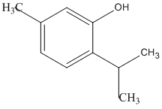

Thymol is a naturally occurring compound found in oil of thyme and plants including Thymus vulgaris. Thymol is an antiseptic and antifungal compound that has been used in traditional medicine for centuries, including such diverse regions such as China and Iraq ^{[2-4]}
Thymol has also many uses, including perfumes, food flavoring, mouthwashes, cosmetics and also as stabilizer to several therapeutic agents including halothane ^{[5,6]} . A number of analytical methods have been reported for the determination of Thymol, these included high performance liquid chromatography^{[7-9]} , liquid chromatography with electrochemical detection^{[10]}, gas chromatography ^{[11,12]} , differential-pulse voltammetry ^{[13]} , ultraviolet spectrometry^{[14]} , and colorimetric analysis ^{[15].}
In the present work, the stable diazotized 4-bromo aniline reagent has been proposed
to determine thymol in pure and mouth wash preparations by the azo-coupling reaction in alkaline medium. The yellow product was spectrophotometrically measured at 464 nm. The analytical procedure is simple,rapid and accurate. It has been satisfactorily applied for the determination of Thymol in pure and mouth wash preparations.

Experimental
Apparatus
- all spectral and absorbance measurements were carried out on UV-Visible 160 digital double - beam recording spectrometer .
- sencetive balance .
- Water bath

Material and Reagents
All Chemicals used are of the highest purity available,and without further purification.

Thymol (150 μg.ml⁻¹ ) solution
This solution is prepared by dissolving 0.015g of pure thymol (BDH) in ( 100)mL hot distilled water. This solution is then transferred to a dark bottle where it is stable for at least 1 month.
Diazotized 4-bromo-aniline (1x10⁻³M) reagent solution:
prepared by dissolving 0.004 gm of pure 4-bromo-aniline(Fluka) in amount of distilled water then added 1 mL of 1 M HCl (BDH) shaked well and followed by 2 mL of 0.025 M sodium nitrite (BDH) shake thoroughly, then the volume is diluted to 25 mL then cooled to about 5°C for 30 min, This solution is transferred to a darkbottle and kept in a refrigerator where it is stable for 2 weeks.
Hydrochloric acid (BDH) (1M): prepared by diluting suitable amount of concentrated hydrochloric acid to 100 mL with distilled water

Sodium hydroxide (BDH) (1M) :
prepared by dissolving 4.0 gm of NaOH in 100 mL volumetric flask and complete the volume to the mark with distilled water.

Procedure :
A series of 25mL volumetric flasks, increasing volumes of 150 μg.ml⁻¹ thymol working standard solution were transferred to cover the range (0.6-7.2)μg.ml⁻¹ in final dilution, 0.5mL of sodium hydroxide (1M) solution and 2 mL of diazotized 4-bromo aniline reagent (0.001M) solution are then added and diluted to the mark with distilled water. mixed well and left for 10min at room temperature, the absorbance of the yellow dye formed was measured at 464 nm against a reagent blank containing all materials except Thymol and a calibration curve was constructed.

Procedure for Assay of thymol in Pharmaceutical Preparations.
25 mL of a mouth wash sample is transferred to a 100 mL volumetric flasks and diluted to the mark with distilled water.An a liquot of 1mL of this solution is put in 25 mL volumetric flask ,0.5 mL(1M NaOH),2 mL of 0.001M diazonium agent were added and the volume was completed to the mark with distilled water,set a side for 10 minutes then the absorbance is measured at 464 nm.The concentration of thymol is obtained by using the calibration curve already made and described above .
This method was applied to 3 commercial types of mouth wash wich are:

1-Listerine cool mint-antiseptic mouth wash(USA): containing 0.064% Thymol, according to the product label .
2-Listerine fresh burst-antiseptic mouth wash(USA): containing 0.064% Thymol, according to the product label.

3- Mestril--antiseptic mouth wash ( MID PHARMA-JORDAN ): containing 0.063% Thymol, according to the product label.
And the % Thymol obtaind by the modified method is as follows.

Results and Discussion
Study of the optimum reaction conditions : The effects of various parameters on the optical properties of the azo dye have been Studied and the reaction conditions are optimized
1 – Effect of Reagent volume: The effect of diazonium reagent ( 0.001M) volume (0.1-5 mL) on the intensity of the absorbance, has been studied and 2 mL was found to be optimum.
2- Effect of acid:- It was found that the presence of acid led to increase the intensity of the produced product, therefore some acids such as HCl, CH₃COOH,H₂SO₄and HNO₃ are examined and was found that all these acids gave almost equal intensity, so;HCl was selected which was found that( 1 mL) of this acid give high sensitivity which selected in subsequent experiments.
3- Effect of base: The absorbance of the dye formed became more intense and stable in alkaline medium, therefore, the effect of different alkaline solutions on the colored product were studied such as sodium hydroxide, ammonium hydroxide, potassium hydroxide, sodium acetate and sodium carbonate. Maximum sensitivity and stability were obtained only when the reaction was carried out in the presence of sodium hydroxide solution. The effect of different concentrations of NaOH were studied, (0.1-4 M) and 1 M seems to be optimum. The effect of (1 M) NaOH volumes were also studied from 0.1 to 5 mL and 0.5mL was found optimum.

4- Effect of Order of Addition :- It was found that the best order of addition that gives the highest absorption( D+B+R)where ( D=drug substance ,B=base and R=reagent) which selected in subsequent experiments.
5- Effect of Temperature:-
The resulting product of the proposed method were studied at different temperatures. The results indicate that the absorbance values remain nearly constant in the temperature range (0-70)ºC, whereas, at higher temperatures the absorbance value decrease, indicating the dissociation of the product on prolonged heating. The coloured product was stable at room temperature (25 )ºC. Therefore room temperature is selected in this method.
6- Effect of Reaction Time:-
The colour intensity reached its maximum after the Thymol had been reacted immediately with the reagent solution became stable after 10 minutes. therefore 10 minutes development time was selected as optimum in the general procedure. The colour obtained was stable for at 65 minutes.
The experimental conditions for the determination of Thymol were established. Diazonium reaction occurred in an acidic medium ^{[16]} and hydrochloric acid of concentration of 1M was selected ^{[17]}, and the absorbance of the dye formed became more intense and stable in alkaline medium ^{[18]} ,
Absorption spectra
When a dilute solution of thymol, under the above-established conditions, is mixed with diazotized 4-bromo aniline in the presence of sodium hydroxide, the yellow colored dye immediately formed. This shows maximum absorption at 464nm in contrast to the colored reagent blank which shows no absorption.( Fig.1) Shows the absorption spectra. The wavelength of maximum absorption at 464nm is still used for the subsequent investigations.

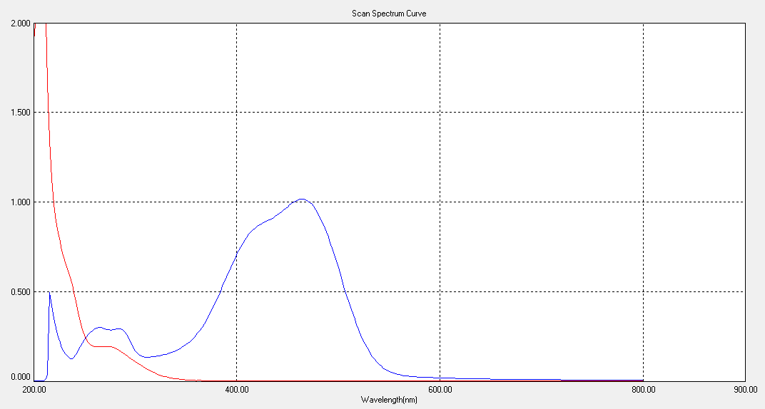
B
A

Fig (1) : Absorption spectra :
A : Thymol (6 μg . ml⁻¹) +4-bromo aniline (1x10⁻³) product versus reagent blank.
B : Reagent blank versus D.W.

Calibration curve:
Under the proposed experimental conditions linear relation between the absorbance and the concentration of thymol was observed over the concentration range 0.6- 7.2μg.ml⁻¹ (Fig 2) with a correlation coefficient of 0.9973 and intercept of 0.0114. A negative deviation from Beer,s law was observed above 7.2 μg.ml⁻¹ concentration of thymol .The molar absorptivity was 3.0284×10⁴ l.mol⁻¹.cm⁻¹.

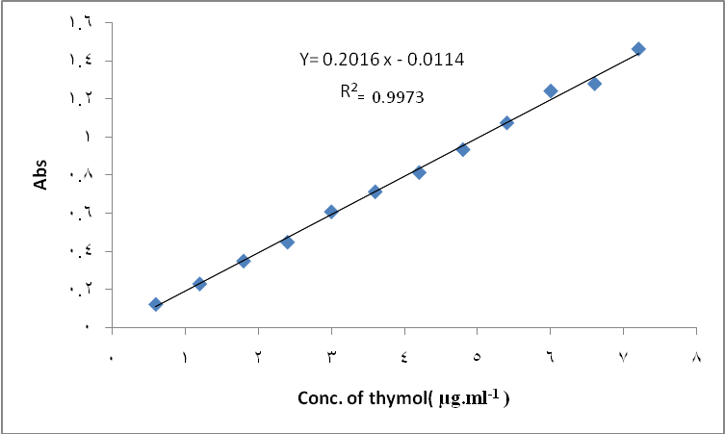
Fig (2) : calibration curve of thymol

Accuracy and precision
To determine the accuracy and precision of the calibration graph, thymol was determined at three different concentrations. The results shown in Table( 1) indicate a satisfactory precision and accuracy.

Table (1): Accuracy and precision of proposed method
R.S.D %* | Recovery* | Error %* | Conc. of thymol mg per25ml |  | No.
R.S.D %* | Recovery* | Error %* | found | present | No.
1.502 | 100.910 | +0.916 | 1.211 | 1.20 | 1
0.137 | 99.375 | -0.625 | 4.770 | 4.80 | 2
0.750 | 99.723 | -0.277 | 7.180 | 7.20 | 3
* Average for five determinations

Nature of product and reaction mechanism
To establish the composition (ratio of thymol to diazotized 4-bromo aniline reagent) of the yellow azo dye formed, Job’s method of continous variations and mole-ratio method have been used. The resulting data reveal that the dye has been formed by the reaction of thymol with diazotized 4-bromo aniline reagent in a ratio of 1:1, Fig(3&4), indicating a mono azo dye with probably of the following schem:

4-((4-bromophenyl)diazenyl)-2-isopropyl-5-methylphenol

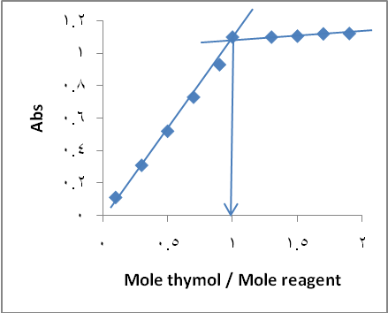

Fig(3) Continuous variation plot Fig (4) Mole ratio plot

The apparent stability constant of the azo dye in aqueous solution, under the
conditions of experimental procedure, has been calculated, and found to be 1.11×10⁷ l.mole⁻¹.
The regression equation obtained, and the analytical features of the procedure are summarized in (Table 2).

Table 2: Analytical characteristics of the procedure developed for the determination of Thymol

Parameters | Present method
Regression equation | Y=0.2016x- 0.0114
Linear range(μg ml⁻¹) | 0.6-7.2
Correlation coefficient, r² | 0.9973
Limit of detection  (μg ml⁻¹) | 0.04
Average of RSD) % | 0.796
Average of recovery % | 100.002
Molar absorptivity  (l mol⁻¹ cm⁻¹ | 3.0284*10 ⁴
Sandell’s sensitivity  (μg cm⁻²) | 0.004

Effect of interferences
In order to assess the possible analytical applications of the present proposed
method, the interfering effects of excipients at various levels on the determination of 6μg.ml⁻¹ of thymol by the proposed method have been examined and the results are given in Table(3).

Table 3: Effect of excipients on the determination of 6μg.ml⁻¹ of thymol
Exeipient Conc.60 µg.ml⁻¹ | Conc.of thymol µg.ml⁻¹ | E% | REC% Recovery
Lactose | 6.054 | +0.900 | 100.900
Talc | 5.970 | -0.500 | 99.500
Starch | 5.91 0 | -1.500 | 98.500
Mg stearate | 5.99 0 | -0.166 | 99.834
Poly vinylpyrolidone(pvp) | 6.110 | +1.830 | 101.830
Benzoic acid | 5.950 | -0.833 | 99.167
Ethanol | 5.890 | -1.830 | 98.170
* Average for five determinations

Application of the method
The suggested methods were applied to the quantitative determination of Thymol in mouth wash formulation. Three types of mouth wash preparations containing Thymol were analyzed and they gave a good accuracy and precision as shown in (Table 4). The proposed method were compared successfully with the official method ^{[19]} .

Table 4: Application of the proposed and official methods for the determination of mouth wash containing Thymol

Rec.* % standard method | Rec.* % proposed method | Pharmaceutical preparation
100.22 | 100.002 | Thymole pure
99.334 | 99.537 | Mestril
98.230 | 100.448 | Listerine cool mint
99.310 | 99.816 | Listerine fresh burst
* Average for five determinations

Conclusion

A simple, rapid, precise and sensitive spectrophotometric method has been developed for the determination of trace amounts of Thymol in aqueous solution based on its diazotized coupling reaction with 4-bromo aniline and also the method does not resort to temperature control or to solvent extraction.

References
1. “British Pharmacopoeia”, 2007, the Stationery Office on behalf of the Medicines and Healthcare products Regulatory Agency (MHRA). London, ^{5th}.ed.
2. Mohammed, M.J.; Al-Bayati, F.A.. Phytomedicine, 2009, 16, 632-637.
3. Zekovic, Z.; Lepojevic, Z.; Vujic, D. Chromatographia, 2000, 51, 175-179.
4. Liang, H.; Bao, F.; Dong, X.; Tan, R.; Zhang, C.; Lu, Q.; Molecules, 2007, 12, 1606-1613.
5. Katzung B. G., "Basis and clinical pharmacology", 4th Edn., Prentice – Hall International Inc., London, pp.614-615, 1989.
6. Neidle E. A. and Yagida J. A., "Pharmacology and therapeutics for dentistry", 3rd Edn., The C. V. Mosby Company, Philadelphia, pp.613-621, 1989 .
7. Thompson RD and Carlson M, J. Pharm. Biomed. Anal., 1989, 7 (10), 1199-1206.
8. Ji L, Wang YY, Tong Y, Li XD, Feng XF, Hang, LQ and Zhou, GP, Zhongguo Zhong Yao Za Zhi, 29: 1030-2,2004.
9. Kang LI, Jinsong YUAN and Weiwei SU, Yakugaku Zasshi, 2006, 126 (11), 1185-1190.
10.Gao H, Cao W, Liang Y, Cheng N, Wang B and Zheng J ,Chromatographia, 2010, 72 (3-4), 316-363.
11. Noall MW, Knight V, Hargrove WW and Elledge BW”, Anal. Biochem., 1975, 69 (1), 10-15.
12. Badertscher R, Kilchenmann V, Liniger A and Gallmann P, J. ApiProduct & ApiMedical Sci., 2010, 2 (3), 78-92.
13. Lau OW, Luk SF and Wong WC, Analyst, 1988, 113, 865-868.
14. Korany MA, Seif El-Din AA and Abdel-Salam NN, Anal. Lett., 1984, 17(A6), 483.
15. Fibranz L, Blake MI and Miller CE, J. Am. Pharm. Asso., 1985, 47 (2), 133–135.
16. Morrison RT and Boyed RN, “Organic Chemistry”, 3rd .ed., Allyn and Bucon, Inc., Bosten, 451, 1973.
17. Al-Abachi MQ, Al-Delami AMS and Al-Najafi AS, Analyst, 1988, 113, 1661.
18. J.D.Roberts, M.C.Caserio, “Basic Principles of Organic Chemistry”, W.A.Benjamin, Inc.,New York, 1964 .
19.pharmaceutical drug Analysis ,ASHUTOSH KAR ,NEWAGE INTERNATINOL PUBLISHERS COPYRIGHT 2005.

