Spectrophotometric Determination of chlorpromazine Hydrochloride in Pharmaceutical Preparations by Using Oxidative coupling reaction

Mohauman Mohammad Al-Rufaie
E:Mail : majeed@yahoo.com
Department of Chemistry, College of Science, Babylon University

Abas Noor Al-Sharefy Kasim Hassan kadim

Department of Chemistry, College of Science, Babylon University

(NJC)

(Received on 7/5/2013) (Accepted for publication 1/7/2013)

Abstract
A simple, rapid and sensitive spectrophotometric method for the determination of microgram amounts of chlorpromazine Hydrochloride drug in aqueous solution is described. The method is based on the Oxidative coupling reaction between chlorpromazine hydrochloride and para methoxy aniline in the presence of sodium periodate and Sulfuric acid to form an intense red -Violet colored product with maximum absorption at 546 nm. Beer’s law is obeyed over the concentration range of( 0.5 – 11.2) ppm with molar absorptivity of 6.398x10⁴ l.mol⁻¹.cm⁻¹ and Sandell`s sensitivity of 0.005
μg.cm⁻² . The method does not resort to temperature control or to solvent extraction. The optimum conditions for all colour development are described and the proposed method has been successfully applied for the determination of chlorpromazine hydrochloride in bulk drug and pharmaceutical Preparations(Largactil drug). The common excipients and additives did not interfere in this method.
Keys words :- Chlorpromazine Hydrochloride, Oxidative coupling Spectrophotometric Determination

الخلاصة
تم وصف طريقة طيفية سهلة وسريعة وحساسة لتقدير كميات مايكروغرامية من عقار الكلوربرومازين هيدروكلوريد في المحلول المائي . الطريقة تعتمد على تفاعل الاقتران التأكسدي بين الكلوربرومازين هيدروكلوريد والبارا ميثوكسي انلين وبوجود بيريودات الصوديوم وحامض الكبريتيك لكي تكون ناتج ملون بنفسجي محمر يمتلك امتصاصية عظمى عند 546 نانومتر .وجد ان مدى قانون بير ينطبق ضمن مدى التراكيز (0,5- 11,2) جزء بالمليون وبلغت قيمة معامل الامتصاص المولاري 6,398×10⁴ لتر. مول ⁻¹
.سم⁻¹ وحساسية ساندل 0,005مايكروغرام .سم⁻². الطريقة المقترحة لاتحتاج الى السيطرة على درجة الحرارة اوللاستخلاص بالمذيب . وتم دراسة الظروف المثلى لتكوين المركب الملون وطبقت الطريقة بنجاح في تقدير الكلوربرومازين هيدروكلوريد في حالته النقية او في مستحضراته الصيدلانية (دواء الارجكتيل). كما وجد ان لايوجد تأثير للمضافات الدوائية في الطريقة المقترحة.
الكلمات الدلالية: الكلوروبرمازين هيدروكلورايد، الاقتران التأكسدي، التقدير الطيفي .

Introduction
phenothiazine derivatives are widely used as drugs in the psychaitry⁽¹⁾,treatment of epilepsy⁽²⁾, Diseases of the stomach, liver, intestines , migraine headaches⁽³⁾, a counter-movement of ill-dwelling,counter- of Allergy and vomiting⁽⁴⁾, tetanus treatment and anti dopamine receptors⁽⁵⁾. Phenothiazine group has sixty four derivatives. They involved in being contain heterogeneous rings.these rings have a sulfur atom and a nitrogen atom. Among the most important of these derivatives was chlorpromazine hydrochloride(CPZ)⁽⁶⁾. Which was discovered in in the early 1950s⁽⁷⁾. And which has the following structure and its structure formula was C₁₇H₁₉ClN₂S, HCl and a molecular weight of 355.33 g / mol⁽⁸⁾showen in figure(1).

Figure(1) The chemical structure of chlorpromazine hydrochloride(CPZ)

Where the scientific name of (CPZ) According to (IUPAC) was
3-(2-Chloro-10H-phenothiazin-10-yl)-N,N-dimethylpropan-1-amine hydrochloride.it commercially marketed in Europe as Largactil In the United States on behalf of thorazine. It was a white crystalline powder has melting point 196 Cº with high solubility in water and ethanol ,also disintegrate when exposed to light or air⁽⁹⁾. The Pharmaceutical Preparations of (CPZ) were tablets , oral Solution and Injection. Due to its therapeutic importance. ​​many workers in the field of analytical chemistry have made many ways for determination Whether in its pure form or in pharmaceutical Preparations or in body fluids. The most important of these estimation methods is the direct spectroscopic methods. Which depend on the oxidation of drug to the radical
Cations⁽¹⁰⁾. and then subsequent measurement of absorption using one of the various oxidizing agents⁽¹¹⁻¹⁸⁾. Some of these methods suffer from some disadvantages such as the use of heating , lack of sensitivity , narrow range of the determination , critical working conditions and time-consuming^{(10,15,17)}. Procedures based on charge-transfer complex formation⁽¹⁹⁾. and ion-association complex formation with many acidic dyes such as bromocresol green⁽¹⁰⁾, chrome azurol S, bromophenol blue, eriochrome cyanine, amaranth and brilliant blue⁽²⁰⁻²⁴⁾..the other analytical methods are used for determination (CPZ)compound like high-performance liquid chromatography⁽²⁵⁻²⁷⁾,Gas chromatography^{(28,29)} and flow injection with different types of detection system^{(30,31)}.In this paper described a newly ,simple, rapid and sensitive procedure for the determined of micrograms amounts of chlorpromazine hydrochloride(CPZ) depending on the oxidative coupling reaction (reaction to the color generator). and through its reaction reagent(para methoxy aniline in the presence of sodium periodate as oxident in the midt of a strong acid and study the optimum conditions for this reaction .the application of the method on some different types of pharmaceutical Preparations which is containing distilled water (CPZ) compound was obtained by different doses and forms with high accuracy and precision.
Experimental
Apparatus
- all spectral and absorbance measurements were carried out on applied UV-Visible 160 digital double - beam recording spectrometer .
- pH meter , Jenway 3020 .sencetive balance ,water bath.
Material and Reagents
All Chemicals used were of high degree purity and used without further purification they were prepared by the following :-
- Chlorpromazine – HCl standard powder was provided from the state company for drug industries and medical appliances Samara –Iraq (SDI). The standard stock solution of( CPZ) at a concentration (100) ppm is prepared by dissolving (0.01)gm of pure material in(100)ml Distilled water. This solution is stable for at least a month after saving well away from the light.
- Sodium periodate NaIO₄ (0.01) M, It was provided from (BDH Chemicals Ltd, Laboratory reagent) company by dissolving (0.214)gm of pure material in(100)ml Distilled water.
- Sulfuric acid (1M):- It was provided from (GCC)at percentge (%98) company and used for preparation (1M)solution.
- Para methoxy aniline (0.01) M:- it was provided from (BDH Chemicals Ltd, Laboratory reagent) company by dissolving (0.0615)gm of pure material in(50 ml) ethanol abselute from(BDH Chemicals Ltd,%99.9) .

Recommended Procedure
In a series of volumetric flasks of (25ml), aliquots of standard solutions of,
chlorpromazine hydrochloride with concentrations of (0.1- 12)ppm
, respectively in final volume were added separately, followed by
addition of (1ml) para methoxy aniline (0.01) M and 2 ml of Sodium periodate (0.01) M, then addition after that(1ml)of sulfuric acid (1 M), the contents were in aseries of (CPZ) diluted to the mark with distilled water, The solutions were left for 10 minutes at room temperature and the absorbance was measured at (546 nm), respectively against reagent blank and a calibration curve was constructed.

Procedure for Assay of chlorpromazine Hydrochloride in Pharmaceutical Preparations.
a number of preparations Largactil containing (CPZ) as active ingredient were taken and it included the following:-
- Largactil tablets (100)mg :- they were supplied from (oubari pharma-aleppo-syria) company under licence from Aventis Laboratory-France.
- Largactil tablets (100)mg :- they ware supplied from (ruhsat sahibin- tukey,istanbul) company under licence from Aventis pharma-France.

- Largactil tablets (50)mg :- they were supplied from the state company for drug industries and medical appliances Samara –Iraq (SDI).
- Largactil tablets (25)mg :- they were supplied from (oubari pharma-aleppo-syria) company under licence from Aventis Laboratory-France.
- Largactil injections(25mg/5ml):- they were supplied from (oubari pharma-aleppo-syria) company under licence from: sanofi- Aventis -France.

Procedure for Tablets⁽⁹⁾:-
Ten tablets were weighed and finely powdered from each type of tablets separately . An accurately weighed portion of the powder equivalent to(0.01)gm of (CPZ) which depends on the type of tablets that be used, It was
dissolved in( 5 ml) of ethanol and (5ml) of (5M) hydrochloric acid with heating and after that filtering to separate the non-dissolved components. then
transferred into a (100ml) calibrated flask and diluted to the final volume with distilled water. followed take the suitable amount of each record solution and treated in the same conditions that were used in the based way of working was to find a concentration depending on a calibration curve.
Procedure for Injection⁽⁸⁾:-
(2 ml) from ampoule containing (25 mg/5ml) of Chlorpromazine – HCl was transferred into 100 ml volumetric flasks and diluted up to the mark with distilled water. Then we calculated the concentration depending on the standard calibration curve .
Results and Discussion
Study the optimum conditions for reaction:-
Different conditions were studied which are affecting the absorbance of the product formed so as to in order to improve it.

1 – Effect of Reagent volume :-
The effect of Reagent volume on the absorbance were studied .It was taken from (0.5 – 4)ml of the reagent para methoxy aniline (0.01M) with Presence(2ml)of the oxidizing agent and (1ml )from acidic solution (1 M). It was found that (1 mL) is the best volume of the reagent, that gives the highest absorption, which was used in the following experiments .

2 - Effect of oxidizing agent volume:
The effect of oxidizing agent volume on the intensity absorption were studied. .it was taken from (0.5–6)ml of Sodium periodate at concentration (0.01M). with Presence(1ml)of the reagent and (1ml )from acidic solution. It was found that (2 mL) is the best volume of the oxidizing agent, that gives the highest absorption, which was used in the following experiments.

3- Effect of acid:-
It was found that the presence of acid led to increase the intensity of the produced product, therefore some acids such as HCl, CH₃COOH,H₂SO₄and HNO₃ are examined it was found that all these acids gave the absorbance the color product, so; H₂SO₄ was selected which was found that( 1 ml) of this acid give high sensitivity which selected in subsequent experiments.
4- Effect of Order of Addition :-
It was found that the best order of addition that gives the highest absorption(R+D+O+A)where (R= Reagent, D=drug substance ,O= oxidizing agent and A=acidic solution) which selected in subsequent experiments.
5- Effect of Temperature:-
The resulting product of the proposed method were studied at different temperatures. The results indicate that the absorbance values remain nearly constant in the temperature range (0-70ºC), whereas, at higher temperatures the absorbance value decrease, indicating the dissociation of the product on prolonged heating. The coloured product was stable at room temperature (25ºC) which was giving the highest absorbance . The room temperature was selected in this method.
6- Effect of Reaction Time:-
The colour intensity appear its maximum after the drug (CPZ) had been reacted immediately with the reagent in the presence of sodium periodate and acidic solution became stable after 10 minutes. Therefore 10 minutes development time was selected as optimum in the general procedure. The colour obtained was stable at 65 minutes.
7- Absorption Spectra:-
The spectral scan was conducted to obtain the greater wavelength absorption of resulting compound resulting after installing the optimum conditions for reaction.a gainst blank solution that was containing the reagent , oxidizing agent and the acid . Figure(2) shows
the spectra of red product formed and of the reagent blank, the
maximum absorption at 546 nm where (A) spectrum represents compound product from the reaction and (B) is giving the spectum of blank .
A
B

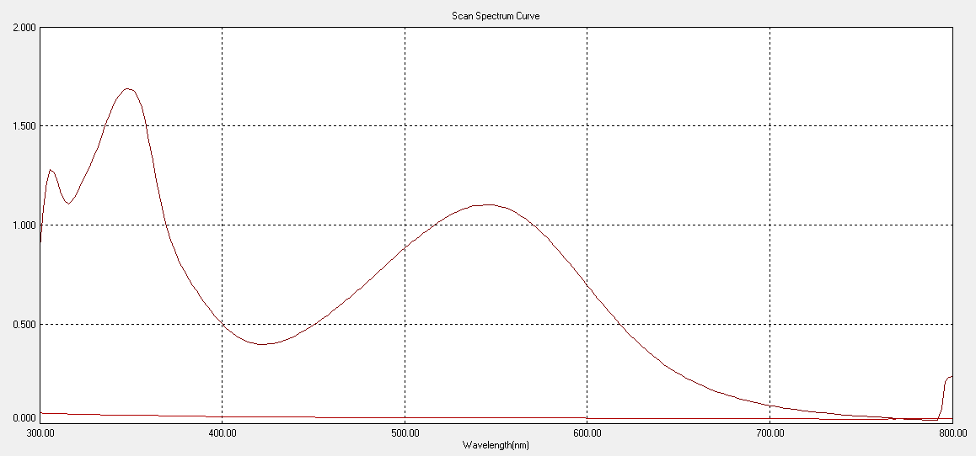
A spectra of colour product
B spectra of blank

Figure(2) shows the spectra of red product formed at(4ppm) of (CPZ) (A) and of the blank(B)at (0.01M) of reagent and oxidant and (1M) sulfuric acid.

8- Calibration curve:-
Employing the conditions described in the procedure, a linear calibration curve for Chlorpromazine – HCl is obtained (Figure 3), which shows that Beer’s law is obeyed over the concentration range of (0.5 – 9.8) ppm with correlation coefficient of 0.9996 and an intercept of 0.0089. the slope of curve was 0.1784.The conditional molar absorptivity of the red product formed was found to be 6.3385x10⁴ L.mol⁻¹.cm⁻¹. The Sandell's sensitivity was 0.005 (μg.cm ^{–2}).

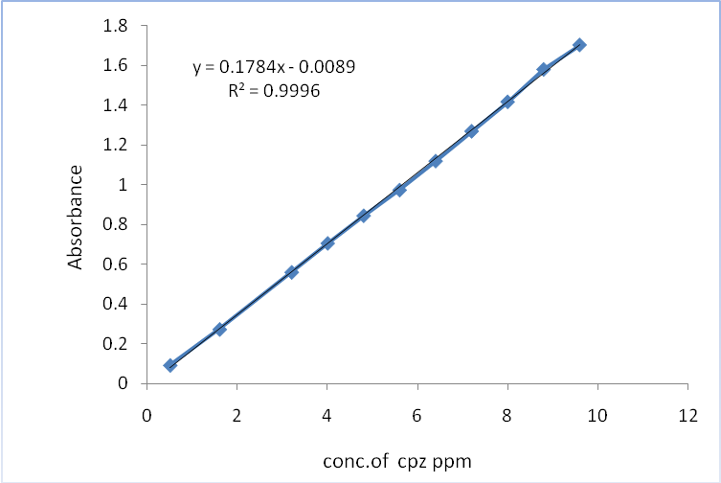

Figure(3) shows the Calibration curve of (CPZ)

9- Accuracy and precision:-
The accuracy and precision of the method, were checked by determining the Chlorpromazine – HCl at three different concentrations. The results represented in Table (1) indicate that the method is satisfactory. and have high accuracy and precision.

Table (1) Accuracy and precision of the proposed method.
Conc. Of (CPZ) ppm | % Error | % Recovery | % R.S.D
0.6 | - 1.83 | 98.17 | 0.209
3.2 | + 0.66 | 100.66 | 0.182
8 | + 0.85 | 100.85 | 0.153

10 – Stoicheiometry of reaction :-
The stoicheiometry of the reaction between Chlorpromazine – HCl and the reagent was investigated using Job’s method and mole ratio method; the results obtained that 1:1 drug to reagent complex was formed at 546nm shown (Figure 4). The product formed was soluble in water, The stability constant of the colour was calculated by comparing the absorbance of a solution containing stoicheiometric amount of Chlorpromazine – HCl and the reagent with that of solution containing the optimum amount (1ml of 2.8×10⁻³ M).and other solution reagent solution at five times the concentration of the original concentration. The average conditional stability constant of the colour product in water under the described experimental conditions was 1.40 ×10⁷ l¹.mol⁻¹.

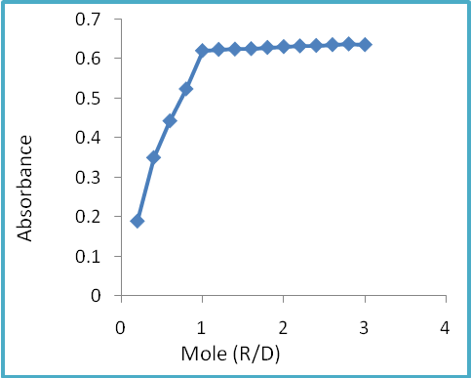
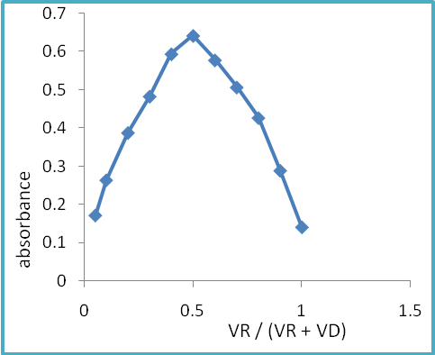Figure(4)mole ratio and job methods plots for reaction of (CPZ)with reagent in the presence of NalO4 and H₂SO₄.

The formation of the colour product between(doxy)and reagent in presence of H₂SO₄ was suggested at the scheme of reaction probably occurs as the following equation⁽³²⁾ Fig (5):

Figure(5) scheme of the oxidative coupling reaction

11- Effect of organic solvents:-
The spectrophotometric characteristics of the colour product in various organic solvents are given in Table (2). Water is shown to be the best medium from the point view of sensitivity and economy.( solvent used in dilution to the mark of (25ml) conical flask.

Table (2): Spectrophotometric characteristics of the colour product in various organic solvents
Solvent | λ_{max} ,nm | ε ,L.mol⁻¹.cm⁻¹
Acetone | 542 | 4.890 × 10³
chloroform | - | Turbid
2- propanol | 544,534 | 5.75 × 10³
Acetic acid | 544 | 1.57 × 10³
Dimethyl sulphoxide | 552 | 2.68 × 10³
CCl₄ | 552 | 1.210 × 10³
Dioxane | 554 | 2.5 × 10³
Dimethyl formamide | - | Turbid
Ethanol | 544 | 2.180 × 10³
Benzene | - | Two layers
Methanol | 552 | 1.420 × 10³
Teri butyl alcohol | 536 | 2.18 × 10³
Formic acid | - | Turbid
Pyridine | - | Turbid
Di ethyl ether | - | Two layers

12- Interferences:-
The excipients studied were, lactose, talc, starch, Acacia, Sucrose, Glucose, magnesium stearate, and polyvinylpirrolidone (PVP). For this study, solution was containing (CPZ) and each one of the excipients was taken separately in concentrations ten-times greater than that of(CPZ) were analyzed under the same procedure in the Calibration curve.(1ml) of (100)ppm solution of drug and (1ml) of each excipients was taken for interferences study and dilution to the mark of (25ml) conical flask . level of interference was considered to be acceptable if the error was not higher than ± 2% relative to the expected No interferences were observed in the determination of (CPZ) in the presence of the excipients studied(Average of three determinations). Table (3)

Table(3)Determination of (4ppm)chlorpromazine hydrochloride in the presence of excipients.
Interference | % Error | % Recovery
lactose | + 1.025 | 100.025
Talc | - 0.300 | 99.700
starch | - 0.225 | 99.775
Acacia | - 0.850 | 99.150
Sucrose | - 0.175 | 99.225
Glucose | + 0.525 | 100.525
magnesium stearate | - 1.100 | 98.900
PVP | - 0.650 | 99.350
345

13- Application of the method
The applicability of the method for the assay of pharmaceutical formulation was examined. The result of assay for available formulations of Chlorpromazine – HCl drugs are summarized in Table (4) .

Table (4) : Assay of Chlorpromazine – HCl in bulk and dosage forms .
preparations Largactil containing (CPZ) | Average recovery %
preparations Largactil containing (CPZ) | Proposed method | Standard method⁽⁸⁾
Pure (CPZ) | 99.402 | 100
Largactil tablets (100)mg Syria | 99.945 | 99.323
Largactil tablets (100)mg turkey | 99.559 | 99.765
Largactil tablets (50)mg (SDI) | 99.979 | 99.188
Largactil tablets (25)mg Syria | 99.667 | 99.661
Largactil injections(25mg/5ml) syria | 100.032 | 100.011

Where the average of three determinations. and the standard method were taken from British Pharmacopoeia (2009). The results were reproducible and the assay of formulations was cross checked by the Standard method.
Conclusion:- A simple, rapid, precise and sensitive spectrophotometric method has been developed for the determination of trace amounts of
chlorpromazine hydrochloride in aqueous solution based on its oxidative coupling reaction with para methoxy aniline and sodium periodate in the presence of sulfuric acid. The proposed method does not require temperature
control or the solvent extraction step; the method was applied, successfully for the determined of small amouts commercial (CPZ)drug.

References
1-Tarasiewicz, H. P.; Kuzmicka, L.; Karpinska, J. & Lukasiewicz, K.M., Anal. Sci., 2005, 21,1149.
2- Diaz, J. How drugs influence behavior a neuro behavioral approach Englewood Ciffs , N. J. Prentice Hall ,1997, 285.
3-Robinson,O.P.W., J.Med., Postgard,1973, 4,77.
4-Gordon, M., "Psychopharmacological Agents",. Vol. II, Academic Press , New York,1964,178.

346

5-Healy, D., " Explorations in a New World the Creation of
Psychopharmacology", Harvard University Press.,2004, 77.
6 -"The Merck Index on CD-Rom" 12th ed., copy right by Merck Co., Inc. Whiteho., 2000.
7- J. Karpinska, B. Starczewska, H. Puzanowska,Anal.Sci.,1996,12(2),161.
8 - British Pharmacopoeia, Her Majesty’s Stationary Office, London, 2009, p.1292-1293,8319-8324.
9- US Pharmacopoeia XXIIth Rev., US Pharmacopoeia Convention, Rockville, MD, 2007, pp.294-295.
10- Basavaiah, K. ; Krishnamurthy, G. Anal. Lett.,1998,31,1037-1046.
11- Basavaiah, K.; Swamy, J. M., Anal. Sci.,2001,17,963-976.
12- Revanasiddappa, H. D.; Veena, M. A. Zh. Analit. Khim.,2008,63,157-161.
13- Basavaiah, K.; Swamy, J. M.,. Chem. Anal.(Warsaw),2002,47,139-164
14- Misiuik, W.; Tarasiewicz M., Pharmazie,1993, 48, 66-67.
15- Taha, A. M.; El-Rabbat, N. A.; El-Kommos, M. E.; Refat, I.H,Analyst,1983,108,1500-1505.
16- Misiuik, W.; Tarasiewicz, M., Pharmazie,1996, 51, 62.
17- Hassan, S. M.; Belal F.; Ibrahim, F.; Aly, F. A., Anal.Lett.,1989, 22, 1485-1498.
18- Murthy, K.C.S.; Seetharamappa, J.,Indian J. Pharm. Sci.,2000,62,273-276.
19 - Basavaiah, K., , Il Farmaco,2004,59, 315-321.
20 - Basavaiah, K.; Swamy, J.M. ; Krishnamurthy, G.Chem.Anal. Warsaw,1999,44, 1049-1054.
21- El-Kerdawy, M. M.; Moustafa M. A.; El-Ashry, S. M. ; El-Wasee, D. R.,
, Anal.Lett.,1993, 26, 1669-1680.
22- Starczewska, B. ; Karpinska, J., Anal. Lett., 29,1996, 2475-2486.
23- Bhongade, S.L.; Kasture, A.V, Indian J. Pharm. Sci.,1993, 55, 151-154.
24- Bhongade, S. L.; Kasture, A. V., Talanta,1993, 40, 1525-1528.
25- Ohkubo,T.,Shimoyama.R.and Sugawara,K.,J.Chromatogr.,1993,614,328-332.
26-Chagonda,L.F.S.and Millership,J.S.Analyst(London), 1988,113(2),233-237.
27 – Tamai,G.,Yoshida,H.,and Imai, J.Chromatogr.,1987,423,163-168.
28. Gruenke,L.D.,Craig,J.C.,Klein, F. D.,Nguyen ,T.L, Hitzemann, B.A., Holaday, J.W.,mass spectrom., 1985,12,707-713.
29- Qi,F.,Shao,Y,Zhan,J, and Liu,Y., Yaoxue Tongbao,1985,6,346-348.
30- Zhu, J. P. Chen, H.W., and Fang, Q. J.,FenexI Huaxue,1997,5,573-575.
31-Kojlo,A. ,Anal. Lett.,1997,13, 2353-2363.
32- Tawa.A,and Hirose. Sh, Chem. Pharm.Bull., 1980,28,2136.

347

