Photocatalytic Degradation and COD Removal for Indigo Carmine Dye Using aqueous Suspension of Zinc Oxide
,288-300
Ahmed Hassan Ali
Chemical Engineering Department- College of Engineering
Al-Muthanna University
Email: dr.ahmedha@gmail.com

(NJC)
(Received on 7/4/2013) (Accepted for publication 21/7/2013)

Abstract
This paper reports on photocatalytic decolorization of a hazardous indigo carmine dye solution. The photocatalytic decolorization was carried out in the presence of the catalyst ZnO. The effect of catalyst dose, pH and initial dye concentration on the degradation process has been assessed. The aqueous dye solution was degraded in a photochemical reactor in the presence of UV light (365nm) along with suspended ZnO particles. 100 ml of dye solution (25ppm) was subjected to degradation under UV light. Different concentrations of ZnO photocatalyst (0.25, 0.50, 0.75, 1.0, and 1.25 g/L), different pH values (4, 7, 9 and 11) and different concentrations of indigo carmine dye (5, 10, 25, 50, 100 ppm) were employed for the present study. The decolorization rate of the hydrolysed dye solution was higher than that of the unhydrolysed dye solution.The chemical oxygen demand (COD) reduction at optimum conditions was examined. The decolorization of the dye was confirmed from the disappearance of peak at 608 nm.
Keywords: Degradation; Indigo carmine dye; Photocatalysis; Zinc oxide; Advance oxidation
*Corresponding author
الخلاصة
يتضمن هذا البحث ازالة صبغة النيل القرمزية وكذلك ازالة المتطلب الكيميائي للاوكسجين في المحلول المائي للصبغة. وقد أجريت عملية الازالة بوجود عامل مساعد من أوكسيد الزنك. تم تقييم تأثير تركيز العامل المساعد، ودرجة الحموضة وتركيز الصبغة الابتدائي على عملية الازالة. تمت ازالة الصبغة من المحلول المائي (بحجم 100 مليليتر) في مفاعل الاكسدة الضوئية بوجود ضوء الأشعة فوق البنفسجية بطول موجي 365 نانوميتر بوجود جزيئات أوكسيد الزنك كعامل مساعد.استخدمت تراكيز مختلفة من اوكسيد الزنك وهي (0.25، 0.50، 0.75، 1.0، و 1.25) غم/لتر ولذلك لغرض تحديد التركيز الامثل. وكذلك الحال بالنسبة للدالة الحامضية حيث استخدمت قيم مختلفة منها (4 و 7 و 9 و 11) ومن خلال تلك القيم تم تحديد الظروف المثالية لازالة الصبغة وهي التي اعطت اعلى نسبة مئوية للازالة وكانت عند تركيز 0.5 غم / لتر وحامضية 11 . بعد ذلك تم استخدام نفس الظروف المثالية السابقة مع تغيير قيم وتركيزات الصبغة الابتدائية (5، 10، 25، 50، 100 جزء في المليون). كذلك تم توسيع الدراسة لازالة المتطلب الكيميائي للاوكسجين COD في الظروف المثالية. ان انحلال وازالة الصبغة تم ملاحظته من خلال اختفاء قمة المنحني عند طول موجي 608 نانومتر.
الكلمات المفتاحية : أزالة صبغة النيل القرمزي ، الاكسدة الضوئية بالعامل المساعد ، اوكسيد الزنك، الاكسدة المتقدمة

Introduction
Dye pollutants are important sources of environmental contamination. Textile wastewater contains a considerable amount of unfixed dyes, many of which are azo compounds^{[1]} which can be effectively removed by photocatalysis with semiconductor catalysts of which, ZnO is widely utilized due to its outstanding stability, inexpensiveness, lack of toxicity and strong photoactivity ^{[2-6]}.
Traditional wastewater treatment methods have some limitations and disadvantages. Chemical oxidation technique is economically suitable for removal of pollutants of high concentration but it is unable to mineralize all organics^{[7]}. Biochemical treatment is slow and requires control of proper pH and temperature along with the problem of disposal of activated sludge^{[8]}. Activated carbon adsorption involves phase transfer of pollutants without decomposition, which induces another pollution problem. Elimination of toxic and bio resistant organic pollutants from industrial wastewater by their transformation into non-hazardous species is a demanding area of research. Current trend of wastewater treatment, therefore is intending towards complete mineralization of cocktail of organic pollutants. Advance oxidation processes (AOPs) involving hydrogen peroxide, ozone and Fenton’s reagent with or without ultra violet light have been reported to be useful for photo oxidation of organic pollutants in wastewater^{[9,10]}. It reduces substantial amount of chemical oxidation demand (COD) and Total Organic Carbon (TOC) from industrial effluents. Among the various AOPs, semiconductor mediated photo catalysis shows great importance over last few years due to its ability to destroy a wide range of organic and inorganic pollutants at ambient temperature and pressure, without generation of harmful byproducts. The most commonly used photocatalysts are TiO₂, ZnO, ZrO₂, CdS, andSnO₂^{[11,12]}.
The photocatalysed decolorization of a dye in solution is initiated by the photoexcitation of the semiconductor, followed by the formation of electron-hole pair on the surface of catalyst (Eq. (1)).The high oxidative potential of the hole (h_{VB}⁺) in the catalyst permits the direct oxidation of the dye to reactive intermediates (Eq. (2)).

(MO/MO₂) + hv (MO/MO₂) (1)
Metal oxide
h_{VB} + dye dye•⁺ oxidation of the dye (2)

Another reactive intermediate which is responsible for the degradation is hydroxyl radical (OH•). It is either formed by the decomposition of water (Eq. (3)) or by reaction of the hole with OH− (Eq. (4)). The hydroxyl radical is an extremely strong, nonselective oxidant (Eº =+3.06 V) which leads to the partial or complete mineralization of several organic chemicals ^{[13]}

h⁺_{VB}+H₂O H⁺ + •OH (3)
h⁺_{VB} + OH– •OH (4)
•OH + dye degradation of the dye (5)

Even in very small quantity dyes can be easily recognized either in industrial products or in the wastewaters ^{[14-16]}. Stability, important property of dyes, prevents treatment of their aqueous residues, even when it is present in low concentrations. Commonly used methods are either economically unfavorable and/or technically complicated ^{[17]}.
The aim of the present study is investigated the photocatalytic decolorization of indigo carmine dye over semiconductive, ZnO as a photocatalyst. This pigment has been used for many years in industries, such as textile, paper, and plastics, as colorant. The effects of operational parameters, such as catalyst dose, dye concentration and pH of the solution on the decolorization rate of aqueous dye solutions is examined. Having established optimal operating conditions. In this paper we have studied the photocatalytic degradation of indigo carmine.
Experimental Procedure
Materials
Indigo Carmine dye was obtained from Loba Chemie (India),structure of this dye is shown in Figure 1. Zinc oxide was obtained from Merck Inorganic Chemicals, (India) and was used as received without further purification. Double distilled water was used for preparation of various solutions. The pH value of the solutions was adjusted with 1 MHCI or 1 M NaOH.

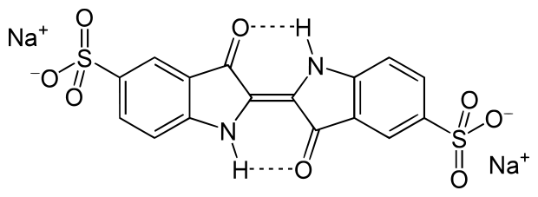
Figure (1):Chemical structure of indigo carmine dye

Photoreactor
Photocatalytic decolorization experiments were carried out in a 1000 ml Pyrex-glass cell in the UV chamber equipped with eight commercial UV tubes each of 18W (Philips) having a wavelength of 365 nm (Figure 2).UV light intensity was measured by UVA light meter (Model UVA-365, Lutron) and it was found to be 0.5 mW/cm² at 50 cm (reactor vessel point and it is constant for all experiments). A magnetic stirrer was used to ensure uniform mixing of solution in vessel. Prior to irradiation the dispersions were magnetically stirred in dark for 15 min to ensure the establishment of adsorption/desorption equilibrium. The pH of solutions was measured using Mac 12108. The temperature was maintained constant throughout the reaction time by circulating water in the jacketed wall reactor. The spectra were taken with UV–vis spectrophotometer (Systronics Double Beam UV-Vis Spectrophotometer 2202).

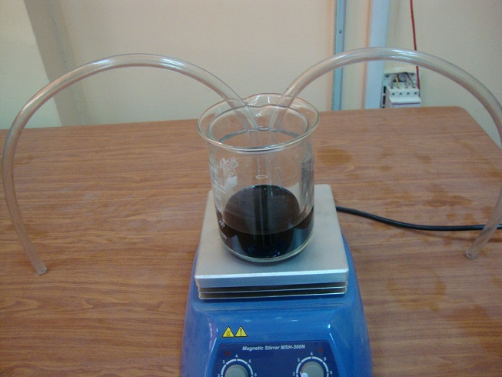
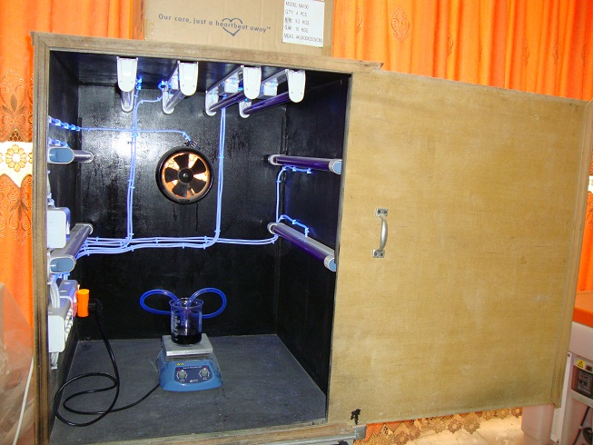

Figure (2): Photocatalytic Chamber and reactor vessel

Irradiation Experiments
The photocatalyst was added to 100 mL of dye solution and the suspension was irradiated under UV light. At different time intervals the aliquot was taken out with a syringe and then filtered through Millipore syringe filter of 0.45 µm. Then absorption spectra of the dye solutions were recorded and rate of decolorization was observed in terms of change in intensity at λ_{max} of the dye (Figure 3).
The decolorization efficiency (%) has been calculated as:

Decolorization efficiency $(\text{\%})=\frac{C_{o}−C}{C_{o}}×\text{100}$

Where C_{o} is the initial concentration of dye and C is the concentration of dye after photoirradiation. Figure 3 shows the calibration curve for converting absorbance to concentration.
A solution of unhydrolysed dye in this medium was prepared by mixing the components at room temperature and used as such. Conversion of the dye into its hydrolysed form was ensured by heating the solution near the boiling point for 5 minutes and allowing it to cool overnight.

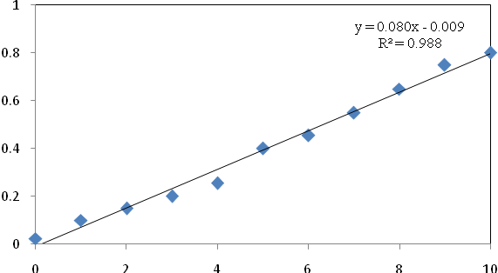
Final concentration (mg/L)
Absorbance @ 608 nm
Figure (3): Calibration Curve in absorption spectroscopy

Determination of Chemical Oxygen Demand (COD)
COD is a measure of the oxygen equivalent of the organic matter content of a sample that is susceptible to oxidation by a strong chemical oxidant. This analysis was carried out with WTW Photoflex with The rmoreactor CR 3200. Test solution (2 mL) was pipetted into 1.5 mL of reagent A and 2 mL of reagent B and then digested at 150 ⁰C for two hours. Thereafter it was cooled naturally and COD was measured with WTW Photoflex.

Results and Discussion
3.1 Effect of ZnO concentration
In slurry photocatalytic processes, catalyst dosage is an important parameter that has been extensively studied. Before treatment, the UV–vis spectra of indigo carmine exhibit three main absorption bands – two in the UV region (250 and 285 nm)and one in the visible region (608 nm). The UV band is characterized by two adjacent rings, and the visible band is associated with a long conjugated π system that is linked by two azo groups^{[18,19]}. The decolorization of indigo carmine was simultaneously monitored at 285 and 608 nm in the UV/ZnO system. Figure 4 displays the UV–vis spectral changes of indigo carmine in aUV/ZnO system under various ZnO doses after 20 min reaction.

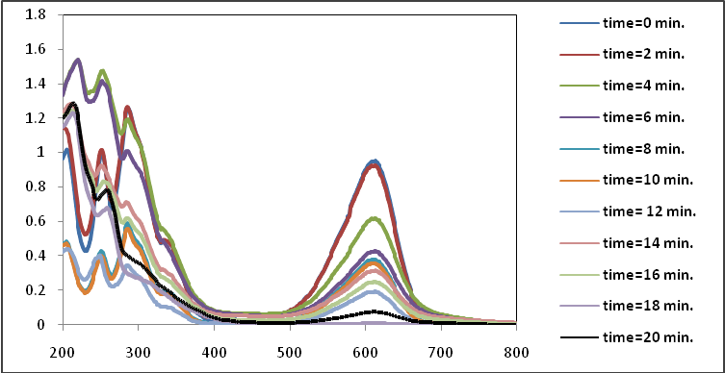
Absorbance (U.A)
Wave length (nm)
Figure(4): Absorbance spectra of indigo carmine dye
(Concentration of dye=25 ppm, catalyst dose 0.5 g/L, pH=11, light intensity=0.5 mW/cm² and Tem.=25 ºC).

Figure 5shows the effects of ZnO dosage in the UV/ZnO system. The removal percentage of indigo carmine increased with ZnO dosage; the visible and disappeared faster than the UV band. The decolorization rate of indigo carmine increased with ZnO dosage in the range 0.25–1.25g/L. Photogenerated holes and hydroxyl radicals are produced and the yield of holes and radicals increases with ZnO dosage. Hence, the proportion of hydroxyl radicals that attack indigo carmine and the reaction intermediates increases with ZnO dosage. However, adding a large amount of ZnO may reduce UV penetration and have a UV-screening effect, inhibiting photodecolorization [20,21].
This study also found that the UV-screening effect of 0.5g/L ZnO was associated with the highest decolorization rate. Accordingly, 0.5g/L ZnO was added in the following experiments. For all of the systems tested herein, the absorption intensity at 608 nm declines extremely rapid; however, the UV bands at250 nm and 285 nm disappeared more slowly than the visible band.

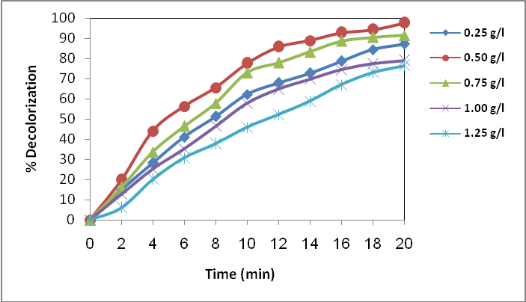
Figure (5):Effect of catalyst dose on decolorization efficiency of indigo carmine
(dye concentration=25 ppm, neutral pH,light intensity=0.5 mW/cm² and Tem.=25 ºC).

The disappearance rate of the visible band is approximately five times that of the UV band ^{[22]}. The substantially high rate of decay of the visible band is attributed to the fact that hydroxyl radicals most effectively attack the azo-links in the photodecolorization process. The decay of the absorbance at the UV band is considered to indicate aromatic fragment decolorization in the dye molecule and its intermediates ^{[19]}.The hydroxyl radicals initially attack azo groups and open the N=N bonds, which are more easily destroyed than are aromatic structures. The experimental results were similar to those of previous studies^{[23,24,25,26,27]} on azo dye decolorization.
Effect of pH
The interpretation of pH effects on the efficiency of dye photodecolorization process is a very difficult task since it has multiple roles. Because of the amphoteric behavior of most semiconductor oxides, an important parameter governing the rate of reaction taking place on semiconductor particle surface is the pH of the dispersions, since, it influences the surface-charge properties of the photocatalysts. Further, industrial effluents may not be neutral. Therefore, the effect of pH on the rate of decolorization needs to be considered. Experiments were carried out at pH values of(4–11) using 25ppmindigo carmine and0.5g/L ZnO.
Figure 6 shows the time–concentration profiles of decolorization of indigo carmine at various pHs. The extent of photocatalysis increased with increasing pH. The formation of hydroxyl radical from OH− is favored at high pH. The decrease in the photocatalytic decolorization at acidic pH may be due to dissolution of ZnO at low pH ^{[37–39]}.

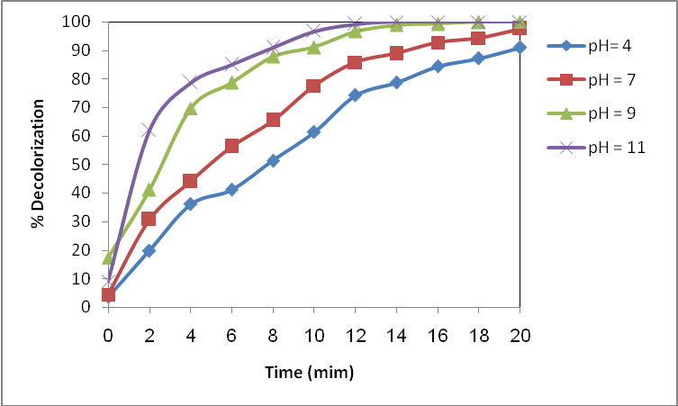
Figure(6): Effects of pH in UV/ZnO system
(dye concentration=25 ppm, catalyst dose=0.5 g/L,light intensity=0.5 mW/cm² and Tem.=25 ºC)

Effect of the initial dye concentration
The changes in color removal efficiency influenced by variations in the initial concentration of indigo carmine were studied. Five experiments with 5, 10, 25, 50 and 100 ppm dye solutions were carried out at constant catalyst dose and pH. The results are shown in Figure 7.It was observed that the extent of decolorization decreased with increase in initial concentration of dye ^{[43]}. The rate of removal was high in the lower dye concentrations.

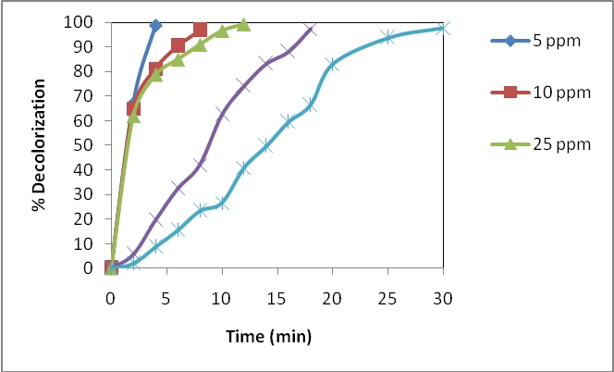
Figure (7): The effect of indigo dye carmine concentration on the photocatalytic decolorization
(catalyst concentration=0.5 g/L, pH=11, light intensity=0.5 mW/cm² and Tem.=25 ºC)

This is due to the availability of sufficient catalyst surface for dye adsorption as well as for hydroxyl radical generation in the solution. But the rate of removal slows down drastically at high concentration. Break down of dye molecules caused by hydroxyl radical attack, forms one or more intermediates, according to the complexity of the initial reactants^{[44]}. These will also compete with dye molecule for active sites resulting in lowering the rate of color removal at later stages. Similar behavior was observed by Neapolitan et al. ^{[45]} for reactive red 2 dye and by Saquib and Muneer ^{[46]} for acid green and acid red dye. Concentration of intermediates formed and absorption of photon by dye and intermediates increases at higher dye concentration resulting in lesser energy available for hydroxyl generation.

Hydrolyzed Study
The decolorization of the hydrolyzed indigo carmine dye solution was investigated at the optimum conditions. Figure 8 shows the comparison decolorization rate of the unhydrolyzed and hydrolyzed dye solutions. Figure 8 shows the deoclorization of hydrolyzed solution is higher than that of the unhydrolyzed dye solutions. This is due to the higher concentration of hydroxide ions in the hydrolyzed form of dye which lead to the photogeneration of more reactive hydroxyl radical species^{[47]}. It was also observed that the simulated dyebath effluent decolorized at a somewhat slower rate than hydrolysed and unhydrolyzed dye solutions, presumably due to competition from the additives/chemicals in the dye bath.

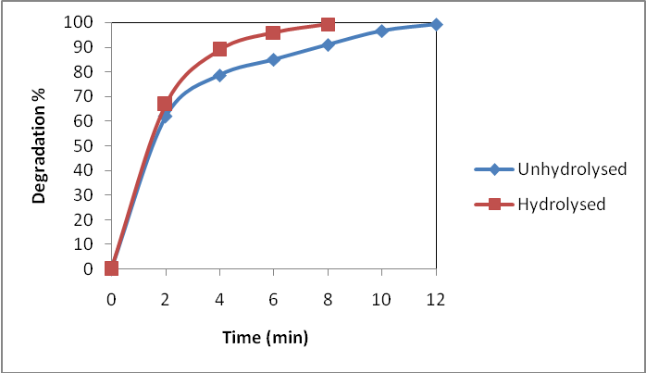
Figure (8):Comparison of %decolorization of unhydrolysed and hydrolysed 25 ppm dye solutions (catalyst concentration=0.5 g/L, pH=11, light intensity=0.5 mW/cm² and Tem.=25 ºC)

Kinetics study
Figure 9 shows the kinetics of disappearance of indigo carmine dye in both solutions forms (unhydrolyzed and hydrolyzed) for an initial concentration of 25 mg/L under optimized conditions. The results show that the photocatalytic decolorization of both solutions of dye in aqueous ZnO can be described by the first order kinetic model, ln(C₀/C) = kt, where C₀ is the initial concentration and C is the concentration at any time, t.

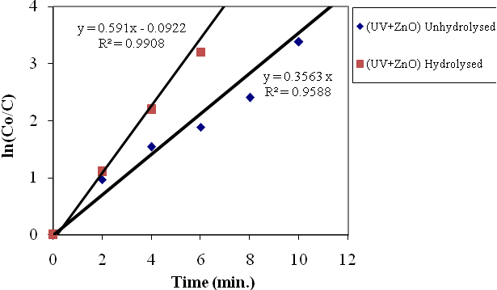
Figure (9):Kinetic analysis for the decolorization of indigo carmine dye for both solution unhydrolysis and hydrolysis (catalyst concentration=0.5 g/L, pH=11, light intensity=0.5 mW/cm² and Tem.=25 ºC)

The semilogarithmic plots of the concentration data gave a straight line. The correlation constant for the fitted line was calculated to beR² = 0.9588 for unhydrolysed solution and 0.9908 for hydrolyzed solution. The rate constants were calculated to be 0.3563min⁻¹ for unhydrolysed solution and 0.591 min⁻¹ for hydrolyzed solution. Tanaka et al. ^{[51]} concluded that the mechanism for the photocatalytic decolorization of azo dyes in water was an oxidative process and found that the first-order rate constants for the seven dyes examined varied from 0.007 to 0.032 min⁻¹. Yang et al. ^{[48]} fit the photodecolorization of Acid Blue 9 (AB9) by TiO₂ in an aqueous system at various pH conditions to a first-order reaction model.
The k values of indigo carmine in a UV/ZnO system are consistent with first-order kinetics, and various studies have demonstrated that dye decolorization rates can generally be approximated as first order kinetics ^{[7,21,26,28,29]}.
3.6 Reduction COD concentration
The effect of initial COD concentration of the wastewater solution on the percent COD reduction by photocatalytic decolorization was shown in Figure 10. The percent COD concentration reductionwith photocatalytic decolorization was found to increase with increase in the initial COD concentration and after reaching to saturation levels, it started decreasing. The rate of adsorption increased because of the increasing driving force. The reduction of COD reflects the extent of decolorization of an organic species, the percentage change in COD was studied for indigo carmine dye solution samples under optimized conditions as a function of irradiation time for two solution (hydrolyzed and unhydrolyzed). Figure 10 presents the comparison between COD removal for both dye solution as a function of irradiation time for initial concentration of indigo carmine dye solution 25 mg/L, indicating COD removal of hydrolyzed dye solution is higher than that of the unhydrolysed dye solutions. Yeber et al. ^{[53]} have also reported that the advanced oxidation of pulp mill bleaching effluent removes rapidly the COD especially in photocatalysed systems.

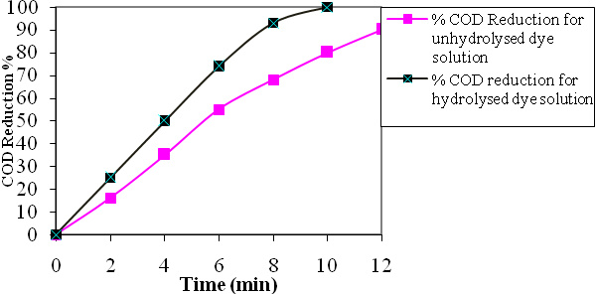
Figure (10):Comparison of % COD reduction of unhydrolysed and hydrolysed 25 ppm dye solutions (catalyst concentration=0.5 g/L, pH=11, light intensity=0.5 mW/cm² and Tem.=25 ºC)

Conclusion
Heterogeneous photocatalysis can be employed as a promising method for the decolorization of indigo carmine dye and its hydrolyzed form. ZnO is the most suitable catalyst for the decolorization of this dye and its optimum dose was found to be 0.5 g L⁻¹. Alkaline medium favored the decolorization . The rate of decolorization and COD reduction of hydrolysed dye was higher than its unhydrolysed dye solution.

References
1. Weber E.J., Stickney V.C. Hydrolysis kinetics of reactive blue 19-vinyl sulfone. Water Re. 27 (1993) 63-7.
2. Guettai N., Amar H.A., Desalination, 2005, 185, 427-37.
3. Saquib M., Muneer M. Desalination., 2003, 15 , 255-63.
4. Vinodgopal K., Bedja I., Hotchandani S., Kamat P. Langmuir., 1994, 10 , 1767-71.
5. Vinodgopal K., Kamat P.V. J Photochem Photobiol A.,1994, 83 , 141-6.
6. Mills A, Belghazi A, Davies RH,Worsley D, Morris S., A J Photochem Photobiol A., 1994, 79 , 131-9.
7. Takeda N., Teranishi, K. Environ. Contam. Toxicol., 1988, 41, 678–682.
8. Krumme, M.L., Boyd, Stephen A. Water Res., 1986, 22 (2), 171–177.
9. Krijgsheld, K., Vander Gen, R.A. Part I: Monochlorophenols and 2,4-dichlorophenol. Chemosphere,1986, 15 (7),825–860.
10. Chen, G., Lei, L., Yue, P.L., Ind. Eng. Chem. Res., 1999, 38 (5) , 1837–1843.
11. Brezova, V., Stasko, S., J. Catal., 1994, 147, 156–162.
12. Vione, D., Minero, Claudio, Maurino, Valter, Carlotti, Eugenia M., Picatonotto, Tatiana, Pelizzetti, Ezio., Appl. Catal. B: Environ., 2005, 58 (1–2), 79–88.
13. Daneshvar N., D. Solari, A.R. Khataee, J. Photochem. Photobiol. A Chem. 2 , 2003, 157, 111–116.
14. Robinson T., G. McMullan, R. Marchant and P. Nigam., Bioresour Technol, 2001, 77, 247.
15. Banat I.M., Nigam P., Singh D. and Marchant R., Bioresour Technol, 1996, 58, 217.
16. Zainal Z., Hui L.K., Hussein M.Z., Taufiq-Yap Y.H., Abdullah A.H. and Ramli I., J. Haz. Mat., 2005, 125 , 113.
17. Hachem C., Bocquillon F., Zahraa O. and Bouchy M., Dyes and Pigments, 2001, 49 , 117-125.
18. Silverstein R.M.C., Basdler G.C., Morrill G.C., Wiley, New York, 1991.
19. Ince N.H., Tezcanli G., Dyes Pigm.,2001, 49, 145–153.
20. S. Chitra, K. Paramasivan, P.K. Sinha, K.B. Lal., J. Cleaner Prod., 2004, 12, 429–435.
21. Dukkanci M., Gunduz G., Sonochem., 2006, 13, 517–522.
22. Goel M., Hongqiang H., Mujumdar A.S., Ray M.B., Water Res., 2004, 38, 4247–4261.
23. Wu C.H., Chang-Chien G.P., Lee W.S., J. Hazard. Mater., 2004, 114, 191–197.
24. Wu C.H., Dyes Pigm., 2008, 11, 31–38.
25. Ince N.H., G., Ultrasonics, 2004, 42 ,591–596.
26. WuC.H., Chang C.L., J. Hazard. Mater., 2006, 128, 265–272.
27. Tezcanli-Guyer G., Ince N.H., Ultrasonics , 2004, 42, 603–609.
28. Kry J., Keppert M., Jirkovsky J., Sˇtengl V., Sˇubrt J., Mater. Chem. Phys. , 2004, 86 , 333-339.
29. Saquib M., M. Muneer., Dyes Pigments , 2003, 56, 37-49.
30. Chun H., Yizhong W., Hongxiao T., Chemosphere, 2000, 41, 1205-1209.
31. Kansal S.K., Kaur, N., Singh S., Nanoscale Res. Lett., 2009, 4, 709–716.
32. Akyol A., YatmazH.C., Bayramoglu M. Appl. Catal. B Environ., 2004, 54, 19–24.
33. Sakthivel S., Neppolian B., Shankar B.V., Arabindoo B., Palanichamy, M., Murugesan V., Solar Energy Mater. Sol. Cells , 2003, 77 , 65–82.
34. Hasnat M.A., Siddiquey I.A, Nuruddin A., Dyes Pigments, 2005, 66, 185–188.
35. Hu C., Tang Y.C., Yu J.C., Appl. Catal. B: Environ., 2003, 40, 131-140.
36. Hu C., WangY.Z., Tang H.X., Appl. Catal. B: Environ., 2001, 35, 95.
37. Villasenor J., Mansilla H.D., J. Photochem. Photobiol. A: Chem., 1996, 93, 205.
38. Bekbolet M., Balcioglu I., Water Sci. Technol., 1996, 34, 73–80.
39. Goncalves M.S.T., Pinto E.M.S., Nkeonye P., Oliveira, Dyes Pigments , 2005, 64, 135–139.
40. Wu C.H., Chemosphere , 2004, 57, 601–608.
41. Qamar M., Saquib M., Muneer M., Dyes Pigments, 2005, 65 ,1–9.
42. Daneshvar N., Rabbani M., Modirshahla N., Behnajady M.A., J. Photochem. Photobiol. A, 2004, 168 , 39–45.
43. Golder A.K., Hridaya N., Samanta A.N., Ray S., J. Hazard. Mater., 2005, B127, 134–140.
44. Ollis D.F., Chem. Catal.: Chem., 2000, 3 , 405–411.
45. Neepolian B., Shankar M, Murugesan V.V., J. Sci. Ind. Res., 2002, 61, 224–230.
46. Saquib M., Muneer M., Soc. Dyers Colourists , 2002, 118, 307–315.
47. Gonclaves, M.S.T.; Pinto, E.M.M.S.; Nkeonye, P.; Oliveira-Campose, A.M.F., Dyes Pigments, 2005, 64, 135–139.
48. Lachheb H., Puzenat E., Houas A., Ksibi M., Elaloui E., Guillard C., Herrmann J.M., Appl. Catal. B, 2002, 39 , 75-90.
49. Tanaka K., Padermpole K., Hisanaga T., Water Res., 2000, 34, 327-333.
50. Tarasov V.V., Barancova G.S., Zaitsev N.K., Dongxiang Z., Process Safety Environ. Prot., 2003, 81, 243-249.
51. Turchi C.S., Ollis D.F., J. Catal., 1990, 122 , 178–192.
52. Yang T.C.-K., Wang S.-F., Tsai S.H.-Y., LinS.Y., Appl. Catal. B, 2001, 30, 293-301.
53. Yeber M.C., Rodriguez J., Freer, J. Duran N., Mansilla H.D. , Chemosphere, 2000, 41 , 1193.

