New spectrophotometric determination of roxithromycin in pharmaceutical preparations and environmental samples
Nief Rahman Ahmed
Department of Environmental Technology, College of Environment, University of Mosul
Aseel Nazar Jasim
The State Company for Drug Industries and Medical Appliances Mosul- Iraq

(NJC)
(Received on 22/1/2013) (Accepted for publication 5/9/2013)

Abstract A new, simple, selective, sensitive and accurate direct spectrophotometric method has been developed for the determination of roxithromycin in pure form , pharmaceutical preparations and environmental water samples. The method was based on the reaction of roxithromycin with concentrated sulfuric acid to form red color product having absorption maxima at 485nm .The molar absorptivity of the proposed method was 1.34×10⁵ l. mol⁻¹. cm ⁻¹ and its absorbance was linear with concentration rang 5- 50 µg/ml . The relative standard deviation of the method was less than 2% and accuracy (average recovery ) was 99.98% .The substance commonly found with roxithromycin did not interfere .The advantages of the proposed method include a high sensitivity and considered to be simple because it does not need heating or solvent extraction steps . The proposed method was successfully applied to the determination of roxithromycin in pure form ,pharmaceutical preparations and in environmental water samples.
Keywords: Roxithromycin, Spectrophotometric, Pharmaceutical preparations
الخلاصة
تم اختبار طريقة طيفية جديدة مباشرة لتقدير الروكسي ايرثرومايسين في حالته النقية وفي بعض مستحضراته الدوائية وفي نماذج بيئية (مياه) ,تتميز الطريقة بالبساطة والانتقائية والحساسية والدقة وتعتمد الطريقة على تفاعل الروكسي ايرثرومايسين مع حامض الكبريتيك المركز لتعطي ناتج احمر اللون له أقصى امتصاص عند الطول ألموجي 485 نانوميتر وان الامتصاص المولاري للطريقة المقترحة هو ×1.3410⁵ لتر .مول^{-1.}سم⁻¹ وأمكن تقدير الكميات التي تتراوح بين50-5 مايكروغرام\مل .ان الانحراف القياسي النسبي للطريقة أقل من2% وبدقة (معدل استرجاعية)99.98 %. ووجد بان المواد المتواجدة مع الروكسي ايرثرومايسين لا تتداخل ومن فوائد هذه الطريقة هي حساسيتها العالية وبساطتها حيث لاتحتاج إلى تسخين أو استخلاص مذيبي .وطبقت الطريقة بنجاح لتقدير الروكسي ايرثرومايسين في حالته النقية وفي مستحضراته الصيدلانية وفي بعض من النماذج البيئية (مياه).

Introduction
Roxithromycin is a semi synthetic macrolide antibiotic derived from erythromycin which acts on gram-positive bacteria and gram- negative bacteria. Chemically it is 9-(2`,5`-dioxahexyl oxy imino) erythromycin .

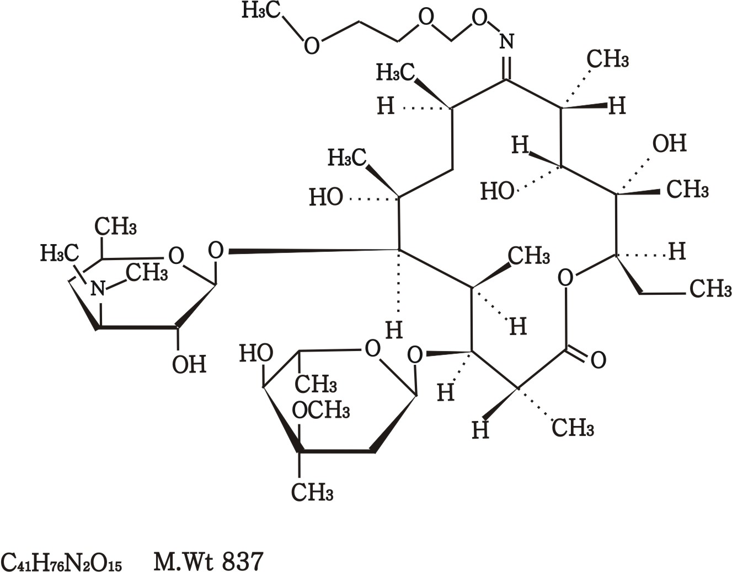

It is used in treatment of respiratory tract infection like pharyrogits, pneumonia, chronic bronchitis and bronchopneumonia ,and soft tissue infections . Roxithromycin was reported to be absorbed rapidly with the long elimination half time giving higher plasma levels than erythromycin . Therefore ,it can be effective at lower doses with less frequent administration ,which is regarded as an advantage in clinical settings .Due to these advantage it could be applied^{(1,2 )}. Roxithromycin is official in British pharmacopoeia⁽³⁾, and it is assayed by performance liquid chromatographic method . Literature survey reveals that roxithromycin is determined in pharmaceuticals by spectrophotometric ⁽⁴⁻¹⁰⁾, high performance liquid chromatographic methods (HPLC) ^{(3,11-14)}, voltametric ^{(15,16)}, fluorescence quenching ⁽¹⁷⁾, capillary electrophoresis ^{(18,19)}, and chemiluminescence methods^{(20,21)}. Some of these methods are time consuming and need expensive reagents .The present method described a simple , economical ,accurate ,sensitive and reproducible spectrophotometric method for the determination of roxithromycin in pharmaceutical preparations and in environmental water samples . In the present method, roxithromycin reacted with concentrated sulfuric acid to form a red colored product having absorption maxima at 485nm. The proposed method was successfully applied for determination of roxithromycin in pure form , its pharmaceutical preparations and in environmental water samples.

Experimental
Apparatus Optima sp-3000 plus UV- visible spectrophotometric with 1.0 cm quartz cells was used for all absorption measurements . Reagents
All chemicals used were of analytical or pharmaceutical grade. Roxithromycin standard material was provided from state company of drug industries and medical appliance (NDI) Nineveh - Iraq . A standard solution of roxithromycin (1000 ppm) was prepared by dissolving 0.1 gm of pure drug in 100ml of ethanol. It was later diluted with ethanol to get concentration of 100ppm . Ethanol and concentrated sulfuric acid (AR grade ,Laboratory and GCC chemicals Ltd)
Recommended Procedure
Different aliquots of standard roxithromycin solution equivalent 50-500 µg were transferred in to a series of 10 ml volumetric flasks . To each flask ,5ml concentrated sulfuric acid solution was added after a thoroughly shaking ,the flasks were set aside for 10 minutes for the development of color The volumes of each flask were adjusted to 10 ml with The absorbance of each solution was measured at 485 nm against reagent blank.
Assay procedure for pharmaceutical preparations
An amount of finely ground tablet /capsule powder equivalent to 100 mg of roxithromycin was accurately weighed into a 100ml calibrated flask ,60ml of ethanol added and shaken for 20 min. Then ,the volume was made up to the mark with ethanol ,mixed well, and filtered using a whatman No.42 filter paper .10ml of this solution was diluted to 100ml with ethanol in calibrated flask . 3ml of this solution was treated as mentioned under recommended procedure.
Environmental water samples
Distilled and tap water samples(100ml) were fortified with 0.01 g of roxithromycin, The fortified water samples were then evaporate to dryness in water bath. The residues were dissolved in 100 ml of ethanol and filtered using a whatman No.42 filter paper . 3ml of this solution was treated as mentioned under recommended procedure.

Results and Discussion
The present method was based on the quantitative reaction of Roxithromycin (1mg/25ml) with concentrated sulfuric acid to form red colored product having wavelength maxima at 485 nm .Fig [1] shows the spectrum of the product formed and of the reagent blank prepared under similar conditions which show no absorption .The maximum absorption at 485 nm was selected for all subsequent experiments.

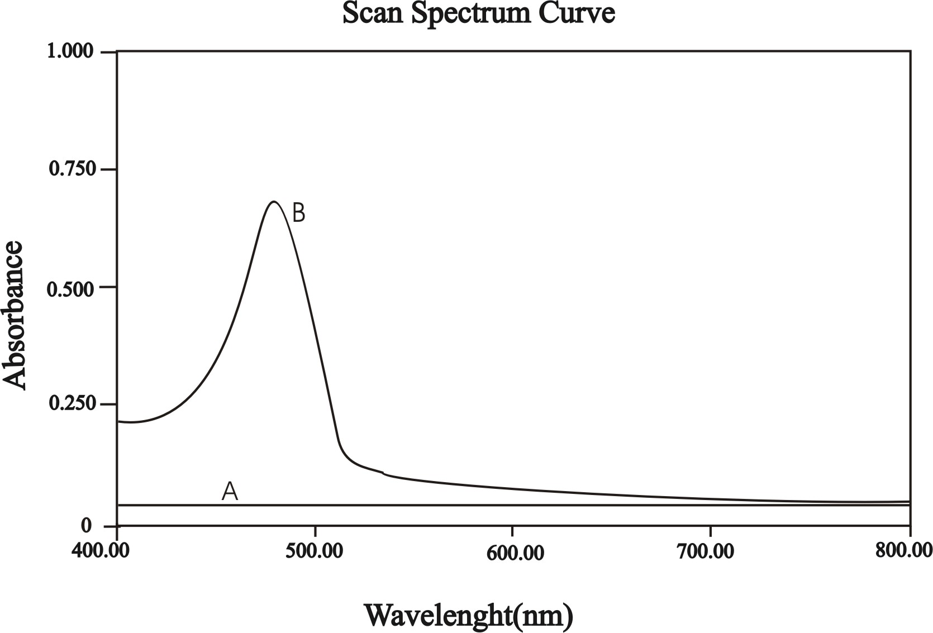
Fig [1]: Absorption spectra of 40µg / ml roxithromycin , A- blank against water, B- roxithromycin – H₂SO₄ product against blank

The amount of concentrated sulfuric acid for maximal color intensity was examined. A maximum color intensity was reached at 4 ml and remained constant up to 6ml. However 5 ml of the concentrated acid was selected for the subsequent work .The maximum time for product color development was found to be 10 minutes and stable for at least 2 hours .Employing the conditions described under recommended procedure ,a linear calibration graph for roxithromycin was obtained Fig [2] ,which show that beers law was obeyed over the concentration range of 5-50 µg / ml ,with correlation coefficient of 0.999 ,slope of 0.16 and intercept of 0.03 . The conditional molar absorptivity was found to be 1.34×10⁵ l.mol⁻¹ .cm⁻¹ .with accuracy (average recovery) was 99.98%and the relative standard deviation of less than 2% the optimum reaction conditions are given in Table [1] .

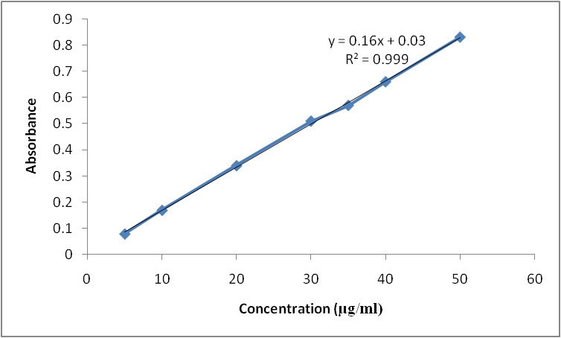
Fig [2] ; Calibration graph of roxithromycin

The limit of detection (LOD) and quantification (LOQ) was calculated using the formula LOD= 3.3 and LOQ 10 where is the standard deviation of seven reagent blank determination and s is the slope of the calibration curve ⁽²²⁾.The results also presented in table[1] and reveal the high sensitivity of the present method

Table [1] : Optimum reaction conditions
Parameter | Result
ג Max .nm | 485
Beer`s law limits µg/ml | 5-50
Molar extinction coefficient  (l. mol^{-1.} cm⁻¹) | 1.34×10⁵
Correlation coefficient (r²) | 0.999
Regression equation (b+ ac)
Slope(a) | 0.16
Intercept(b) | 0.03
Limit of detection .g.ml⁻¹ | 0.14
Limit of quantification .g.ml⁻¹ | 0.42
Average recovery % | 99.98
RSD% | <2
Development time(min) | 10
Amount of conc. H₂SO₄(ml) | 5

Effect of interferences
The interfering effects of foreign species that often accompany with roxithromycin in pharmaceutical preparations were studied by adding different amounts of foreign species to 30µg/ml of roxithromycin in solution and the recommended procedure for the determination of roxithromycin was followed. The species was considered not to interfere if it caused a change of less than 2% in the absorbance obtained for roxithromycin alone ⁽²³⁾ . It was observed that the starch, Lactose, magnesium stearate , methyl hydroxy benzoate and propyl hydroxy benzoate, didn`t interfere with the determination method at levels found in dosage form. So that the selectivity of method was very good .

Analytical applications
Two types of drugs containing roxithromycin (tablets and capsules) had been analyzed .The results obtained in table[2] showed that the found amount of roxithromycin in pharmaceutical preparations by present method agree closely with the amount of roxithromycin on the claim label value. The results were also compared statistically by student t-test and by the variance ratio F-test with those obtained by official BP method ⁽³⁾ at 95% confidence level. The calculated t- and F- values did not exceed the theoretical values indicating that there was no significant differences between the precision of the proposed and literature method as cited in Table[ 2] , and the results of water samples Table [3] show that the recovery values obtained were close to 100% .

Table[2] : Assay of roxithromycin in pharmaceutical preparations
Pharmaceutical preparations | Label amount | Amount found by proposed method(mg)* | Amount found  By official method⁽³⁾ | t value | F value
Roxithromycin(NDI) Tablets | 150mg | 149.92 | 149.96 | 1.15 | 4.2
Roxithromycin(NDI) Tablets | 300mg | 300.35 | 300.50 | 1.24 | 3.92
Roxithromycin(NDI) capsules | 150mg | 149.95 | 149.96 | 0.84 | 3.85
Roxithromycin(NDI) capsules | 300mg | 300.23 | 300.42 | 0.90 | 3.90
*Mean of five determinations
T values (n=5, at 95% confidence level tabulated value 2.776).
F values (n1-1 and n2-1 =4, at 95% confidence tabulated value 6.39).

Table[3]: Determination of roxithromycin in water samples
Water samples | Added µg/ml | Found µg/ml | Recovery%
Tap water | 4.0  12.0  20.0 | 3.84  11.76  19.6 | 96  98  98
Distilled water | 4.0  12.0  20.0 | 4.04  11.88  20.0 | 101  99  100
* mean value of six determinations

Application of the proposed method to content uniformity
Content uniformity or the Uniformity of dosage unit was defined as the degree of uniformity in the amount of active substance among dosage units. The risk assessment strategy underlying content uniformity testing is the assumption that some pre-specified limits exist where safety and efficacy outcomes may change if content uniformity fails. The proposed method proved to be suitable for the content uniformity test, where a great number of assays on individual capsules are required . Data presented in table [4] indicate that the proposed method can accurately and precisely quantitative roxithromycin in its commercially available capsules. The mean percentage (with RSD) of the labeled claim found in ten capsules was 100.1( 0.1118%) which fall within the content uniformity limits specified by the British pharmacopoeia ⁽³⁾ .

Table[4] : Content uniformity testing of roxithromycin capsules using the Proposed method
Parameter | % of the label claim
Capsule NO.1 | 100.15
Capsule NO.2 | 99.98
Capsule NO.3 | 100.22
Capsule NO.4 | 100.20
Capsule NO.5 | 99.99
Capsule NO.6 | 100.12
Capsule NO.7 | 99.98
Capsule NO.8 | 100.20
Capsule NO.9 | 100,21
Capsule NO.10 | 99.95
Mean(X) | 100.1
%RSD | 0.1118
Max. allowed unit value⁽³⁾ | ±15%

The proposed method was compared with other reported spectrophotometric methods and found to be superior , [Table 5].

Table (5):Comparison of the existing spectrophotometric methods with the proposed method for roxithromycin
Method 3 | Method 2 | Method 1 | Parameters
Proposed | 10 | 5 | References
485 | 420 | 412 | Max(nm)λ
5-50 | 20-70 | 10-75 | Linear range (µg/ml)
1.34x10⁵ | 6.814x10³ | 8.98x10³ | (l/mol.cm)
Less than 0.5 | Less than 1 | Less than 2 | Relative error
Pharmaceuticals and water | Pharmaceuticals | Pharmaceuticals | Application

Conclusion
In this work a simple , rapid , precise , and accurate spectrophotometric method was developed and validated for the determination of roxithromycin in pharmaceutical preparations .The method free from such experimental variables as heating or solvent extraction step .The method rely on the use of simple and cheap chemicals and techniques and can be used for rapid routine determination and quality control of roxithromycin in pure form, bulk sample ,pharmaceutical preparations (tablets and capsules) and in environmental water samples.
Acknowledgments
The first author wishes to express gratitude to his former company[ the state company of drug industries and medical appliance (NDI) ] ( Nineveh – Iraq.) for providing gift sample of roxithromycin standard materials and pharmaceutical preparations (tablets and capsules) and for permission and facilities to carry out the research work.
References
- Williams .JD and Sefton .AM . " J. Antyimicrob Chemother . 1993,31 ,11 .
- Budavari .S, "The Merck Index" , 14th Edn .Merck and Co .Inc. Whitehouse Station .NJ .USA ,2006 ,1429.
- British pharmacopoeia ,H.M .Stationery office ,London ,UK, 2009, P.5249.
- Kuchekarb . S, Singavia . A, Lates .G and Shinded B. Indian drugs , 2003, 40(1), 44 .
- Suhagia .BN, Shah .SA, Rathod .IS , Patel . HM ,Doshi . KR and parmar .VK, " Indian Journal of pharmaceutical sciences , 2006 . 68(4) , 543 .
- Reddy . MN, Murthy . TK ,Raju . VH ,Muralikrishng . J and Sankar . K " Indian Journal of pharmaceutical sciences , 2002,64 (1) , 73 .
- Chilukuri . S .P , Kolli . R and Davuluri . S .P " Mikrochim . Acta ,1996, 122, 53 .
- Li. Jun ,Liu. Ying, Fang. Chang , Wang, Li. Quan-min; Remote Sensing, Environment and Transportation Engineering (RSETE) ,2011,8190.
- Li .C. X., Han .J., Wang.Y., Yan Y. S., Xu X. H., and Pan. J. M.; Analytica Chimica Acta,. 2009. 653( 2), 178,
- Bhaskar Reddy .C. M. and Subbareddy .G. V,: Journal of Chemical and Pharmaceutical Research, 2012, 4(7),3684.
- Macek .J, Ptacek .P and klima . J ; Journal of chromatography . B, 1999,723(1) ,233 .
- Gł´owka .F. K. and Kara´ zniewicz-Łada .M.; Journal of Chromatography B, 2007. 852( 1-2), 669.
- Wang .P, Qi .M, and Jin .X,; Journal of Pharmaceutical and Biomedical Analysis, 2005, 39( 3-4), 618.
- Meiling Qi , Peng Wang , Ruihua Cong , Jianjun Yang ;,Journal of Pharmaceutical and Biomedical Analysis ,2004, 35 (5), 1287.

Wan .H., Zhao .F., Wu .W., and Zeng .B.; Colloids and Surfaces B, 2011. 82( 2), 427.
- Drljevi´c .K. M., Jovi´c .V. D., Lacnjevac U. C.; Electrochimica Acta, 2010. 56, (1), 47.
- Peng .J. and Hu. X.; Journal of Luminescence, 2011, 131 (5), 952.
- Wang .J., Yang .Z., Wang .X., and Yang .N.; Talanta, 2008.76(1), 85.
- Nali.T, Tian. Y. X, Jin .Y. M,; Chinese Chemical Letters, 2002. 13( 5), 440.
- Song .Z., Liu .Y., and Xie. X.; Current Drug Metabolism, 2006. 7( 4), 389.
- Jiangman .L, Huan. Y, Yun. Z, Min. W, Haixiang. Z, and Zhenghua. S. ; ISRN Analytical Chemistry,Volume 2012,(2012),1.
- Valcarcel . M ; Principles of Analytical Chemistry ; Atext book , Spring Villager, Berlin Heidelberg (2000),pp.96,207.
- Hung . S.Ch, Qu. C.L and Wu. S. Sh," Talanta , 1982, 29 ,629.

