Adsorption of Reactive Red 2 Dye onto Activated Carbon Prepared from Hazelnut Shells

Abbas N. Al-Sharify
College of Science, Babylon University
Email: alsharfawi@gmail.com
Zahraa H. Athab
Environmental Researches Center, Babylon University
Ahmed F. Halbus
College of Science, Babylon University
(NJC)
(Received on 23/6/2013) (Accepted for publication 22/8/2013)
Abstract
The prepared activated carbon from hazelnut shells (HS) was used to remove the reactive red 2 dye (RR 2) from aqueous solutions, the adsorption behavior of dye onto the porous carbon was studied by varying parameters such as different doses, pH, contact time and temperature. The amounts of reactive red 2 dye adsorbed increased with an increased temperature. Adsorption isotherms of reactive red 2 dyes on activated carbon were determined and correlated with common isotherms equations. It was found that the Langmuir and Freundlich model appears to fit the isotherm data. The maximum adsorption capacity of dye was 8.67 mg/g at 45 ºC and pH 3. The thermodynamic parameters (ΔGº, ΔHº, ΔSº) were also determined from the temperature dependence, the results showed that the process of adsorption reactive red 2 dye was spontaneous and endothermic process and an increase in temperature favored the adsorption.
Keywords: Reactive Red 2 dye, adsorption, activated carbon, isotherms, hazelnut shells.
الخلاصة
في هذا البحث تم استخدام الكاربون المنشط المحضر من قشور البندق كمادة امتزاز لإزالة الصبغة الفعالة الحمراء من محاليلها المائية، حيث درس سلوك عملية الامتزاز للصبغة على دقائق الكاربون بواسطة عدة عوامل مثلا كميات مختلفة من المادة المازة ، الدالة الحامضية ، زمن الاتزان و درجة الحرارة . من خلال النتائج وجد ان الكمية الممتزة من الصبغة الفعالة الحمراء تزداد مع زيادة درجة الحرارة . تم تحديد ايزوثيرم الامتزاز للصبغة الفعالة الحمراء على الكاربون المنشط ومعرفة خطيته مع معادلات الايزوثيرم ووجد انه مطابق لايزوثيرم فرنلش ولانكميور .
اعلى سعة لامتزاز الصبغة هي (8.67 mg/g) عند درجة حرارة 45 ºC ودالة حامضية pH 3 .
الدوال الثرموديناميكية (ΔGº, ΔHº, ΔSº) ايضا حسبت من خلال تغير درجة الحرارة ,النتائج بينت ان امتزاز الصبغة الفعالة الحمراء هي عملية تلقائية وماصة للحرارة و ان زيادة درجة الحرارة تعطي افضل امتزاز للصبغة .
مفتاح الكلمات: الصبغة الفعالة الحمراء , الامتزاز ,الكاربون المنشط ,ايزوثيرم , قشور البندق

Introduction
Many industries, such as dyestuffs, textile, paper and plastics, shown a significant increase in the use of organic dyes as coloring materials, and also consume substantial volumes of water ⁽¹⁾. The reactive dyes, which represent the largest class of dyes used in processing industries, are almost azo compounds, have molecules with one or several azo (N=N) bridges linking substituted aromatic structures. These dyes are designed to be chemically and photolytically stable; they exhibit a high resistance to microbial degradation and are highly persistent in natural environment ⁽²⁾.
Many of these dyes are also toxic and can cause dermatitis, skin irritation ⁽³⁾ and also provoke cancer ⁽⁴⁾ and mutation in humans ⁽⁵⁾.even carcinogenic and this
poses a serious hazard to aquatic living organisms^{(6,7)} . Due to, it is important to remove these pollutants from the organic content of industrial effluents, it is necessary to eliminate dyes from wastewater before it is discharged using ⁽⁸⁾. Various processes for color removal include physical, chemical and biological schemes such as ion exchange ^{(9, 10),} advanced oxidation ^{(11–13)}, filtration, and adsorption ^{(14, 15)}. Adsorption has been found efficient process to other techniques for water re-use in terms of initial cost, simplicity of design, use of operation and insensitivity to toxic substances ⁽¹⁶⁾. Adsorption has been used extensively in industrial process for separation and purification. The removal of coloured and colourless organic pollutants from industrial wastewater is considered as an important application of adsorption processes ⁽¹⁷⁾. Different adsorbents have been proposed for the removal of dyes from aqueous solutions such as silicas ⁽¹⁸⁾, activated clay ⁽¹⁹⁾, banana pith ⁽²⁰⁾, natural zeolite and activated carbon ⁽¹⁶⁾, have been investigated as low-cost adsorbent and were successfully employed for the removal of dyes from aqueous solutions. Activated carbons (AC) are an effective adsorbent for many pollutant compounds (organic, inorganic, and biological) ⁽²¹⁾. Activated carbons can be prepared from a large variety of carbon containing feedstocks. The most common feedstocks for the commercial production of activated carbons are anthracite and bituminous coal, lignite, peat, wood, coconut fiber, rice husk, nut shells and hazelnut shells, especially if the adsorbent is inexpensive , readily and and renewable additional source of activated carbons ⁽²²⁻²⁴⁾. Hazelnut shells are the most popular adsorbent and have been used widely ⁽²⁵⁾. In this study, the ability of activated carbon derived from hazelnut shell as low cost and an abundantly available adsorbent was used to remove the Reactive red 2 dyes from aqueous solution , also to study the adsorption isotherm model .

Materiala and Methods
Adsorbate: Reactive red 2 dyes (RR2), 2,7-Naphthalenedisulfonicacid,5-[(4,6-dichloro-1,3,5-triazin-2-yl) amino] -4- hydroxy-3- (2-phenyldiazenyl)-,sodium salt (1:2) was used as an adsorbate and without future purification to use. Distilled water was used to prepare all the solutions and reagents. Reactive red 2 dye has a chemical formula of C₁₉H₁₀Cl₂N₆Na₂O₇S₂, with molecular weight of 615.33 g/mol. The chemical structure of reactive red 2 dyes is illustrated in (Fig. 1).

Fig. 1: Chemical structure of Reactive Red 2 dyes

Preparation of activated carbon: Hazelnut shells were washed with distilled water to remove dust like impurities and dried at 110ºC. Hazelnut shells with the desired particle sizes were treated with 50% (wt.) H₃PO₄ solution as activating agent at 25ºC for 24 hours. After that was carbonized for 2 hours at a heating rate of 20ºC/min to reach carbonization temperatures of 500 ºC. After 2 hours of carbonization time, was cooled. The activated carbon product was washed with distilled water until the pH of the washing solution reached 6 and then dried at 110ºC. Hazelnut shells were crushed and the resulting particles were sieved by using the sieve (200 mesh) to obtain particle size (75μm). After that using in the adsorption experiments.

Batch adsorption studies: To study the effect of parameters such as amount of preparation activated carbon (PAC), initial pH, contact time and temperature for the removal of reactive red 2 dyes, batch adsorption experiments were carried out. The effect of initial pH on dye removal was studied over the pH range of 3-11. The initial pH of the dye solution was adjusted by the addition of 0.1N solution of HCl and NaOH. 100 mL of dye solution (C_{o}=20 mg/L) was agitated with 0.25 g of activated carbon using shaker water bath (Memmert) at 25 ºC. Agitation was made for (80min). The adsorption isotherm experiments were carried out by agitating 100 mL dye solutions of concentration of reactive red 2 dyes 20 mg/L. Equal mass of (0.25 g) activated carbon was added to each flask and kept in an isothermal shaker (15, 25, 35, 45 ºC). After agitation, the dye solutions were separated from the adsorbed by centrifugation at 6,000 rpm for 15 minutes and filtere to remove the particles. A second centrifuge was found necessary to remove fine particle of the adsorbed, the dye concentrations in the supernatant solutions were measured by using shimadzu 1650 PC. UV-visible spectrophotometer at 541 nm. Langmuir and Freundlich equations were employed to study the adsorption equilibrium. Samples were pipetted out at different time intervals and the concentrations of the solutions were determined. The efficiency of reactive red 2 dyes, % Removal, was calculated as ⁽²⁶⁾:

$$\text{\%} \text{Re}\text{moval}= \frac{C_{}}{C_{o}}×\text{100} (1)$$

Where C_{o} (mg/L) and C_{t} (mg/L) are the initial reactive red 2 dyes concentration and reactive red 2 dyes concentration after shaked with (PAC) at time t, respectively.

Results and Discussion
Calibration Curve of (Reactive Red 2 dye): The calibration curve of Reactive Red 2 dye was constructed using different concentrations of dye solutions in distilled water, in the range of (5-40) mg/L.
The absorbances were measured at the maximum absorbance wave length (ג max) (541nm) as shown in (Fig.2)

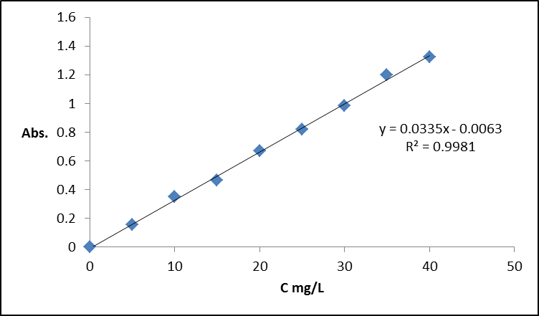
Fig.2: Calibration curve of Reactive Red 2 dye

Effect of contact time on reactive red 2 dye removal: The adsorption rate, obtained for reactive red 2 dyes adsorption on (PAC) was observed by increased of the amount of (PAC) shells within the adsorption medium with contact time. The time necessary to reach equilibrium for the removal of the reactive red 2 dyes molecules at different doses of (0.05, 0.1, 0.15, 0.2, 0.25 and 0.3 g) by (PAC) from aqueous solution was established about 30 minutes. After equilibrium, the amount of (PAC) did not change significantly with time in (Fig. 3). At 20 mg/L of reactive red 2 dyes, the removal rate in the first varies from 47% to 71% of the maximum removal onto hazelnut shells ^{(27, 28)}. The surface of (PAC) may contain a large number of active sites and the solute adsorption can be related to the active sites on equilibrium time. Also up to 68-71% of the total amount of reactive red 2 dyes adsorption was found to occur in the first rapid phase (30 min). The higher adsorption rate at the initial period (first 30 min) may be due to number of vacant sites available at the initial stage. As a result there exist concentration gradients between adsorbate in solution and onto adsorbent surface.

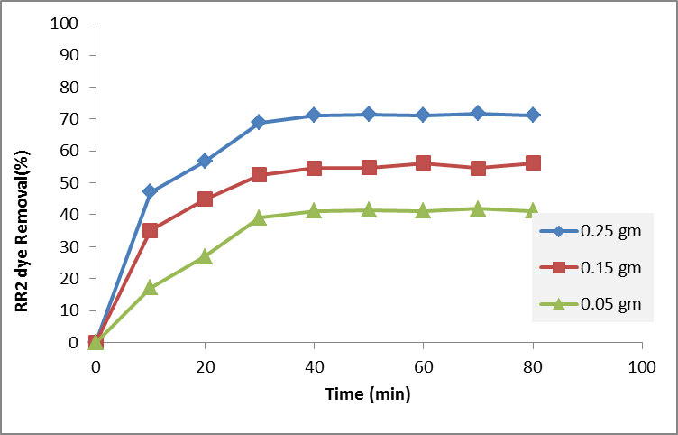
Fig. 3: Effect of contact time: with amount of (PAC) (0.05, 0.15 and 0.25 g) at on optimum condition: dye concentration 20 mg/L, pH 6, and temperature 25˚C.

Effect of pH on reactive red 2 dye adsorption: The pH of the solution was an important role in the adsorption of dye onto suspended particles. The pH of the solution affects the surface charge of the adsorbents as well as the degree of ionization of different pollutants. The hydrogen ion and hydroxyl ions are adsorbed quite strongly and therefore the adsorption of other ions is affected by the pH of the solution. Change of pH

affects the adsorptive process through dissociation of functional groups on the adsorbent surface active sites. This subsequently leads to a shift in reaction kinetics and equilibrium characteristics of adsorption process ⁽²⁹⁾. The effects of initial pH on the percentage of removal of the Reactive Red 2 dye using PAC adsorbents were evaluated within the pH range between 3 and 11 as shown in (Fig. 4).

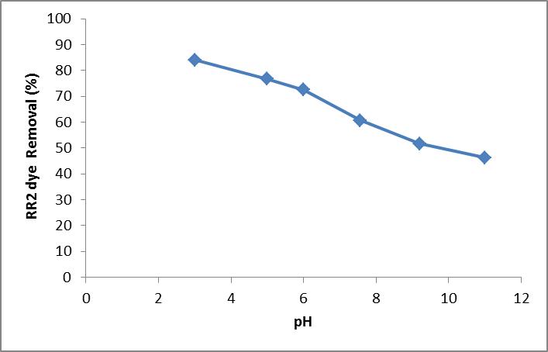
Fig. 4: Effect of pH on adsorption of reactive red 2 dyes at on optimum condition: dye concentration 20 mg/L, amount of (PAC) (0.25g), and temperature 25˚C.

Two possible mechanisms of adsorption of reactive red 2 dyes on the (PAC) adsorbent may be considered: (a) electrostatic interaction between the adsorbent and the reactive red 2 dyes molecule, (b) a chemical reaction between the reactive red 2 dyes and the adsorbent. The results shows the adsorption increase with decrease pH value due to an acidic pH the H⁺ ion concentration in the system increased and the surface of the (PAC) acquired positive charge by absorbing H⁺ ions. As the pH of the system increases, the number of negatively charged sites increases. Surface sites on the (PAC) do not favour the adsorption of reactive red 2 dyes anions due to the electrostatic repulsion. Also lower adsorption of reactive red 2 dyes at alkaline pH is due to the presence of excess OH¯ ions. The most effective pH was 3 and it was used in further studies.

Effect of adsorbent dosage: Removal of colors directly depends on the mass of hazelnut shells. The study of (PAC) dosages for removal of the reactive red 2 dyes from aqueous solution was carried out using mass of (PAC) adsorbent ranging from 0.05 to 0.3 g and fixing the initial reactive red 2 dyes concentration at 20 mg/L. It was observed that highest amount of reactive red 2 dyes removal was attained for adsorbent mass of at 0.2 gm (PAC) equivalent of 20 mg/L of reactive red 2 dye as shown in (Fig. 5).

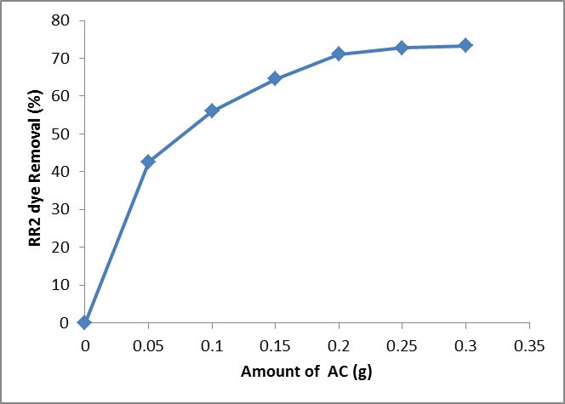
Fig. 5: Effect of hazelnut shells amount on reactive red 2 dyes removal, dye concentration 20 mg/L, pH = 6, and temperature 25˚C.

Effect of Temperature: As various reactive red 2 dyes effluents are discarded at relatively high temperature (15- 45)ºC, so temperature will be an important design parameter affecting the adsorption process in the real application adsorption by reactive red 2 dyes in future. The effect of temperature (Fig. 6) was studied in the temperature rang 15- 45±1ºC at pH=6 of reactive red 2 dyes. It was found that percent removal of reactive dye increased with increase of temperature.

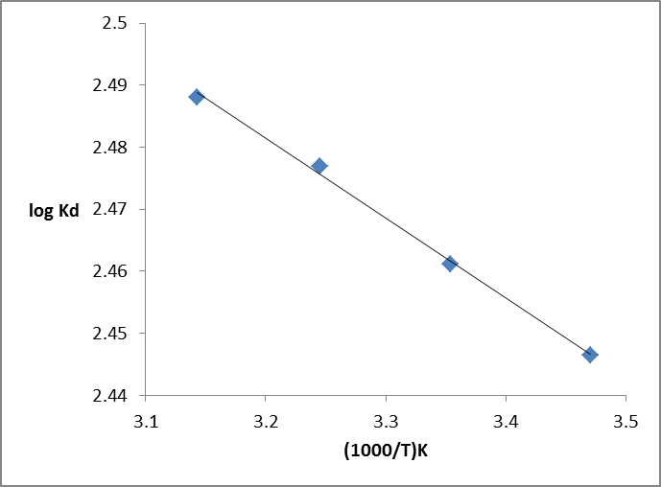
Fig. 6: Effect of temperature on reactive red 2 dyes removal, dye concentration 20 mg/L , amount of PAC (0.25 g/100 mL), at pH= 6.

The calculated thermodynamic parameters are presented in (Table 1). The positive value of ΔHº indicated that the adsorption of Reactive Red 2 dye on (PAC) was endothermic and chemical in nature that indicating the chemisorptions process. The negative values of ΔGº decreasing with the increase of temperature indicated more efficient adsorption at higher temperature and the spontaneity of the adsorption process over the temperature range tested.
The positive value of ΔSº reflected the affinity of the (PAC) for Reactive Red 2 dye indicates an irregular increase of the randomness at the solid/liquid interface during the sorption of Reactive Red 2 dye on to (PAC)

Table 1: Thermodynamic parameters of adsorption of Reactive Red 2 dye on (PAC).
T(K) |  | $$ΔG(\text{kJ}\text{.}{\text{mol}}^{−1})$$ | $$ΔH(\text{KJ}\text{.}\text{.}{\text{mol}}^{−1})$$
288 | 55.400 | -13.495 | 2.468
298 | 55.392 | -14.047
308 | 55.427 | -14.611

Adsorption isotherms: The adsorption isotherm indicates how the molecules distribute between the liquid phase and the solid phase when the adsorption process reaches equilibrium state. The analysis of the isotherm data by fitting them to different isotherm models is an important step to find the suitable model that can be used for design purposes. Adsorption isotherm is basically important to describe how solutes interact with adsorbents, and is critical in optimizing the use of adsorbents ⁽³⁰⁾, (Fig. 7) shows equilibrium adsorption isotherms of reactive red 2 dyes on to the prepared activated carbon from hazelnut shells at different temperatures.

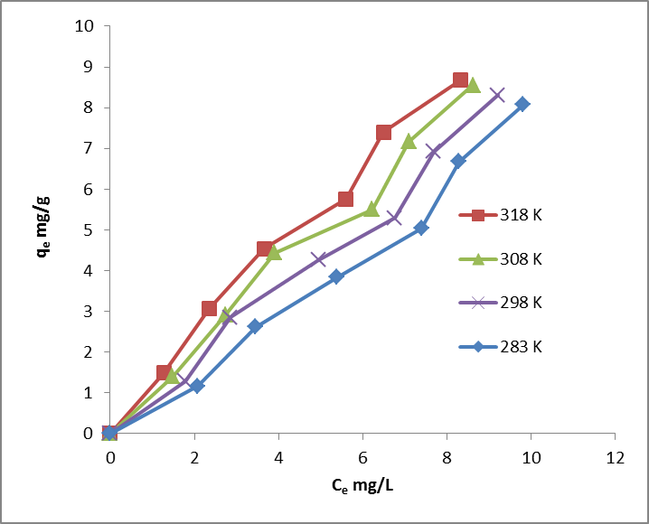
Fig.7: Adsorption isotherms of reactive red 2 dyes on (PAC) at different temperatures (C_{o}=5-30 mg/L,V=100 mL, m=0.25g,pH=6)

The adsorption equilibrium increased with an increase of temperature. This suggests that the adsorption process is endothermic in nature when temperature was increased from 15 to 45 ºC. Increasing the temperature is known to increase the rate of diffusion of the adsorbate molecules across the external boundary layer and in the internal pores of the adsorbent particle. The enhancement in the adsorption capacity might be due to the chemical interaction between adsorbate and adsorbent, creation of some new adsorption sites or the increased rate of intraparticle diffusion of dye molecules into the pores of the activated carbon at higher temperatures ^{(30,31)}. Various isotherm equations have been used to describe the equilibrium nature of adsorption. Two well known isotherm equations, the Langmuir and Freundlich, have been applied for reactive red 2 dyes adsorption. The linearized Langmuir equation is represented as follows ⁽³²⁾:

$1/{q_{e}}=1/{q_{m }}+1/{K_{L }}q_{m } C_{e} (2)$

Where , q_{e} (mg/g) is amounts of reactive red 2 dyes adsorbed per amount of (PAC) at equilibrium, q_{m} (mg/g) is the monolayer adsorption capacity, K_{L} (L/mg) is the Langmuir adsorption constant related to the free energy of adsorption and C_{e} (mg/L) is equilibrium reactive red 2 dyes concentration in the solution. As seen from (Table 2) the Langmuir equation represents the adsorption process very well. The correlation coefficients (R²) were found to be higher than 0.97, In all of the temperatures. This confirmed that the Langmuir isotherm was favorable for adsorption of reactive red 2 dyes on (PAC). The maximum adsorption capacities were found to be 8.07, 8.31, 8.55 and 8.67 mg/g at 15, 25, 35 and 45 ºC, respectively as shown in (Fig. 8) Maximum adsorption capacities of activated carbon increased with increased temperature. Conformation of the experimental data into Langmuir isotherm equation indicated the homogeneous nature of the surfaces of the activated carbon.

Table 2: Langmuir parameters for reactive red 2 dyes adsorption
T(K) | R² | q_{m} | K_{L}
283 | 0.9772 | 12.2399 | 0.0044
298 | 0.9630 | 24.0963 | 0.0030
308 | 0.9892 | 76.3358 | 0.0012
318 | 0.9914 | 136.9863 | 0.0009

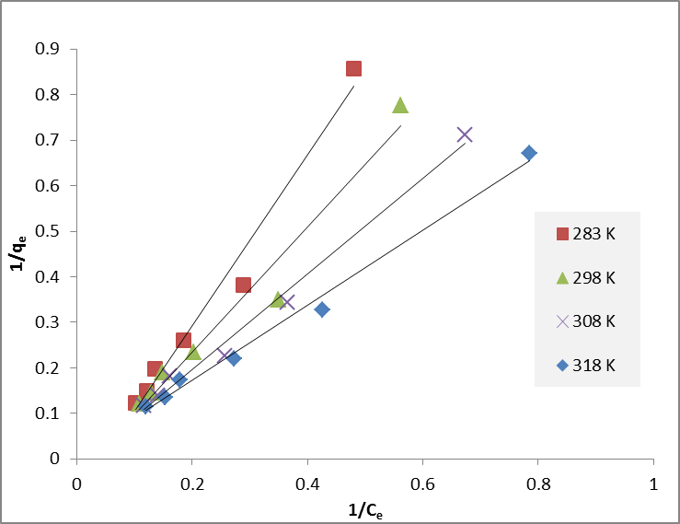
Fig. 8: Langmuir plots for adsorption of reactive red 2 dyes at different temperatures.
The Freundlich isotherm is an empirical equation used to describe heterogeneous systems. The Freundlich isotherm is given in logarithmic form as ⁽³²⁾:

$$\text{log}q_{e}=\text{log}K_{F}+1/n \text{log}C_{e} (3)$$

Where K_{F} is a Freundlich constant indicative of the relative adsorption capacity of the adsorbent (mg/g) (L/mg) 1/n and 1/n is the adsorption intensity. K_{F} and 1/n can be determined from the linear plot of log q_{e} vs. log C_{e} (Fig. 9) ^{(33,34)}. (Table 3) show the Freundlich parameters for reactive red 2 dyes adsorption

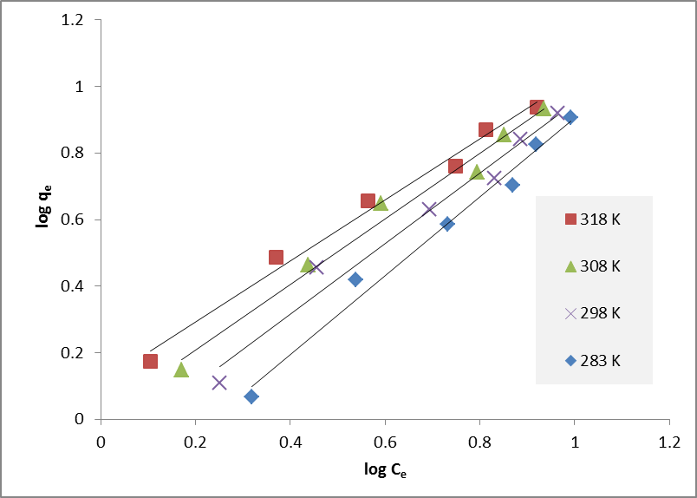
Fig. 9: Freundlich plots for adsorption of reactive red 2 dyes at different temperatures.

Table 3: Freundlich parameters for reactive red 2 dyes adsorption

T(K) | R² | K_{F} | n
283 | 0.9849 | 1.90 | 0.842
298 | 0.9741 | 1.27 | 0.946
308 | 0.9827 | 1.02 | 1.013
318 | 0.9875 | 1.28 | 1.090

Conclusions
In this study, activated carbon was produced from hazelnut shells by chemical activation and used for the removal of reactive red 2 dyes from aqueous solutions. Adsorption was influenced by various parameters such as amount of hazelnut shells, initial pH, contact time and temperature. The maximum adsorption of reactive red 2 dyes by activated carbon occurred at an initial pH of 3. The adsorption increased with increasing temperature. The Langmuir and Freundlich adsorption isotherm models were used for the description of the adsorption equilibrium. The equilibrium data fitted very well in a Langmuir and Freundlich isotherm equations. The present study concludes that the hazelnut shells could be employed as low-cost adsorbents for the removal of reactive red 2 dyes from aqueous solution in general.
The thermodynamic parameter, enthalpy of adsorption are determined, the positive value of ΔHº indicated that the adsorption of Reactive Red 2 dye on (PAC) was endothermic and and chemical in nature ,value of Gibbs's free energy changes indicate the spontaneous nature of the process, positive ΔSº values indicates that increase of the randomness at the PAC-solution interface during the adsorption.

Reference
1- I.M. Banat, P. Nigam, D. Singh, and R. Marchant, Bioresour. Technol., 1996,58, 217–227.
2- D. Suteu, and D. Bilba, Acta Chim. Slov. ,2005, 52, 73–79.
3- D.S. Brookstein, Dermatol. Clin., 2009 ,27 , 309–322.
4- R.O.A. de Lima, A.P. Bazo, D.M.F. Salvadori, C.M. Rech, D.P. Oliveira, and G.A. Umbuzeiro, Mutat. Res. Genet. Toxicol. Environ. Mutagen. ,2007,626 ,53–60.
5- P.A. Carneiro, G.A. Umbuzeiro, D.P. Oliveira, and M.V.B. Zanoni, J. Hazard. Mater., 2010,174 ,694–699.
6- C. O´Neill, F.R. Hawkes, D.L. Hawkes, N.D. Lourenco, H.M.Pinheiro, and, W.Dele´e, J. Chem. Technol. Biotechnol. ,1999,74, 1009–1018.
7- P.C. Vandevivere , R. Bianchi, and W.Verstraete, J. Chem. Technol. Biotechnol. ,1998 ,72, 289–302.
8- F.M. Machadoa, C. P. Bergmanna, T. H.M. Fernandesb, E.C. Limab,
B. Royerb, T. Calveteb, and S. B. Faganc, Journal of Hazardous Materials ,2011, 192 ,1122– 1131.
9- G. Annadurai, R. S. Juang, and D. J. Lee Journal of Hazardous Materials ,2002, 92, 263–274.
10- D. Suteu, D. Bilba, and V. M. Gorduza, Bull. I. P. Iassy (Romania) 1997, 43(1–2), 61–66.
11- I. Arslan-Alaton, A. Kornmüller, and M. R. Jekel, Color Technol. 2002, 118, 185–190.
12- Md. Mahbabal Masan, C. J. Hawkyard, Color Technol., 2003, 118, 104–111.
13- C. Hademal, F. Bocquillon, O. Zahraa, Dyes and Pigments, 2001, 49(2), 117–125.
14 – A. Namane, A. Mekarzia, K. Benrachedi, N. Bensemra, and A. Hellal, J. Hazard. Mater., 2005, 119, 189-194.
15- S. Senthilkumaar, P. Kalaamani, and C.V. Subburaam, J. Hazard. Mater. ,2006,136, 800-808.
16- V. Meshko, L. Markovska, M. Minchev, and A.E. Rodrigues, Water Research, 2001, 35(14), 3357.
17- Z.AL-QODAH, Water Research, 2000,34(17), 4295.
18- T. D. Khokhlova , Y.S.Nikitin, and A.L.Detistova, Adsorption Science and Technology, 1997,15(5), 333.
19- Y. C. HSU, C.C.CHIANG, and M.F.YU, Separation Science and
Technology, 1997, 32(15), 2513.
20- C. Namasiyam, D. Prabha, and M.Kumutha, Bioresources Technology, 1998,64(1), 77.
21- W. HASSLER, Purification with activated carbon, chemical publishing Co, Inc., New York, 1974.
22- M. Ahmedna, W.E. Marshall, R.M. Rao, Bioresour. Technol. ,2000,71, 113-123.
23- Y.C. Wong, M.S.R. Senan, and N.A. Atiqah, Journal of Basic & Applied Sciences, 2013, 9, 172-177 .
24- R.Sivaraj, C.Namasivayam, and K. Kadirvelu, Waste Manage.,2001, 21(1), 105.
25- M. Dogan , H. Abak and M. Alkan, Journal of Hazardous Materials ,2009, 164,172–181.
26- M.J. Ahmed and S. K. Dhedanb, Fluid Phase Equilibria, 2012, 317, 9– 14
27-B.Guo, L. Hong, H.X.Jiang, Ind. Eng. Chem. 2003, 42, 5559–5567.
28-P. Chingombe, B. Saha and R. J. Wakeman, J. Colloid Interf. Sci. 2006, 302, 408-416.
29-M.Dogan, M. Alkan, A. Alkan and Y. Ozdemir, J. Hazard. Mater . 2004, 109, 141–148.
30.I.A.W. Tan, A.L Ahmad, B.H Hameed, J. Hazard. Mater, 2008, 154, 337-346.
31-S. Wang, L. Li, H. Wu, Z.H. Zhu, J. Colloid Interface Sci. 2005, 292, 336-343.
32-Y. Bulut, H. Aydın, Desalination, 2006,194, 259-267.
33-Langmuir, the Journal of the American Chemical Society, 1918, 40, 1361–1403.
34-H. Freundlich, Journal of Physical Chemistry, 1985, 57, 387–470.

