Synthesis and Growing up a New Coloured Crystal from An Isomorphous Substances by Using The Overgrothes Phenomenon and Studied Its Pysical , Mecanical and Crystallographic Properties

Jassem Mohamad Abd Al Hassien
Dep. of Chem. , Col. of Sci. , Univ. of Babylon
Jasem_hilla @yahoo.com

(NJC)

(Received on 27/1/2013) (Accepted for publication 29/4/2013)

Abstract
Three crystals of sulfate salt were prepared under lab environments , these are : KAl(SO₄)₂.12H₂O , Cr₂(SO₄)₃ and KAlCr(SO₄)₂.12H₂O . The physical and mechanical properties for the KAl(SO₄)₂.12H₂O and KAlCr(SO₄)₂.12H₂O crystals were studied . We deal with the latter crystal which called overgrowths and prepared from the isomorphous substances ( aluminum sulfate and chromium sulfate ) .We prepared this crystal by insertion few Cr atoms in the same places of Al atoms in the KAl(SO₄)₂.12H₂O cubic lattic crystal . The crystallographic properties of an overgrothes crystal were studied. The new crystal crystallizes in the cubic system , space grope pa-3 . The cell dimentions are : a = b = c = 12.135 A^{O}, α = β =γ =90º , volume of Al cell = 1786.98 *10⁶ pm³ , volume of Al – Cr cell = 1800.26 *10⁶ pm³ and Z=4 . The volume of cell indicates that the chemical composition of the two layers of crystal are different as it shown in formula data obtained from X – Ray analysis . the retsults obtained from FT-IR and UV. Visib. Spectrum are also support this conclusion .
Keywords : Al sulphate – crystal , Cr sulphate – crystal , overgrowthes crystal , X – Ray analysis , isomorphose substances .

الخلاصة
حضرت ثلاثة بلورات لملح الكبريتات في الظروف المختبريه هي :
KAl(SO₄)₂.12H₂O and KAlCr(SO₄)₂.12H₂O Cr₂(SO₄)₃ , . تم دراسة الخواص الفيزياويه والميكانيكيه للبلورتين KAl(SO₄)₂.12H₂O and KAlCr(SO₄)₂.12H₂O , والبلورة التي يعنيها بحثنا هذاهي KAlCr(SO₄)₂.12H₂O )) والتي حضرت بظاهرة النماء المفرط من مواد isomorphous ( كبريتات الالمنيوم وكبريتات الكروم ) , وكان الشكل البلوري لها هو المكعبي والتي لايختلف عن الشكل البلوري للبلوره الاصليه ( KAl(SO₄)₂.12H₂O )
وتم تحضير هذه البلوره بحشر قليل من ذرات الكروم في نفس المواقع التي تحتلها ذرات الالمنيوم في الشبكه البلوريه امكعبيه لها . تعود كلا البلورتين الى نظام Pa-3 من انظمة المجموعه الفراغيه و ان ابعاد الخليه لهما هي a = b = c = 12.135 A^{O} α = β =γ =90º , volume of Al cell = 1786.98 *10⁶ pm³ ,
volume of Al – Cr cell = 1800.26 *10⁶ pm³ , Z=4 , ان الخواص الفيزياويه والميكانيكيه للبلورتين متشابهه تقريبا وان اختلاف حجم الخليه بينهما يدل على التركيب الكيمياوي المختلف قليلا لهما . ان معطيات فحص FT-IR و UV.Visb. تدعم هذه النتائج .
كلمات الدلاله : بلورة كبريتات الالمنيوم ، بلورة كبريتات الكروم ، بلورة النماء المفرط ، تحليل اشعة اكس ، المواد الآزومورفوزيه

Introduction
Isomorphose substances are analogous in their chemical and electrical properties , which form crystals belong to the same crystalline system and the same class of symmetry and it can develop the same forms , so these substances able to form overgrowths crystals and solid solutions in which one of these crystals can be generated from the other if the atoms of an element are substituted by the atoms of another element without changing the crystal system ^{(1,2 )} . The technique of isomorphous substitution , some times , referred to as isomorphous replacement has served to improve the understanding of metalloprotein active sites by replacing spectroscopically silent metals with ions that possess electronic or magnatic properties ^{(3,4)} . Jacobsen et al ⁽⁵⁾ applied this phenomenon by using sevsral isomorphous ligands to prepare cobalt(II) complexes , he found thate the crystalline system for all these complexes were monoclinic . Crystalline salts of the structur M^{I} M^{III}(SO₄)₂.12H₂O refe rred to as alums ( M^{I}=Na⁺ , K⁺ , …. M^{III} = Al³⁺ , Fe³⁺ , Cr³⁺ , …… ) , all of thes structures have cubic crystalline system ⁽⁶ ⁾ . there are many methods to draw the crystal theoretical structure such as cluster method ^{( 7 , 8 )} , electronic density function method ^{( 9 , 10 ,11 )} , but the main practically methods are X-Ray powder diffraction technique and X-
Ray diffraction by single crystal ⁽ ¹² ⁾ . The ionic radii of Al³⁺ in six coordination bonding is 0.54 A^{O} and it for Cr³⁺ in similar bonding is 0.62 A^{O} ^{( 13 , 14 )} . In many minerals the replacing between Al³⁺ and Cr³⁺ ions caused couloring these minerals such as beryl crystal (Be₃Al₂Si₆O₈ ) when few Cr³⁺ ions replace of Al³⁺ ions becomes green , coroundom ( Al₂O₃ ) also coulored to red by replacing few Cr³⁺ ions of Al³⁺ ions ⁽¹⁵ ⁾ . The formation and growth of crystals begin of the formation of crystal nucleii is called embryo crystals which are the centers on which and the crystal will growth around it ⁽ ¹⁶ ⁾ . The overgrowths may be occurs in nature , Brian Jones showed and studied a complex syntaxial overgrowths which are common on many dolomite crystals in the bluff formation exposed along the coastline of Grand Cayman , British West Indies ⁽ ¹⁷ ⁾ .
Experimental
Chemicals :
All chemicals used were of analytical reagent grade . The preparation of crystals was carried out in inorganic chemistry labs in Babylon university . All the spectra analysis were carried out by the instruments in the scince college labs in Babylon university .
Preparation of Al – alum crystal : It was prepared by mixing equimolecular portions of potassium and aluminium sulphate allowed the mixture to crystallize at 10 º C , 1 atm , 60 minute , colourless crystal was obtained and isolated by filtaration .
Preparation of Cr - crystal : It was obtained by reducing potassium dichromate solution by sulpher dioxide in sulphuric acid under lab conditions and allowed to crystallize a dark purple crystals , leave it for 24 hours , the crysal was isolated by filtaration .

$k_{2}{\text{Cr}}_{2}O_{7}+3{\text{SO}}_{2}+H_{2}{\text{SO}}_{4}→K_{2}{\text{SO}}_{4}+{\text{Cr}}_{2}{\left({\text{SO}}_{4}\right)}_{3}+H_{2}O$

Preparation the overgrowths – crystal : Purple crystal of chromium sulphate was suspended in slightly super – saturated solution of aluminum alum by time a colourless – fin purple layer was fomed and deposited on the purple center crystal . This action was continue with time to grow while preserving its orginal geometrical form until a colourless layer was obtaind in the course of time .Figure 5 shows the photograph of this overgrowth . Physical and Mechanical Properties:

Property Al – crystal Al –Cr – crystal
……………. …………………… ………………………..
Luster vitreous nonmetallic also
Colour clear voliet
Streak white also
Mohs Hardness 2.5 3.5
Tenacity brittle also
Density 5.0 g/cm³ 5.5 g/cm³
Cleavage good also
M. P. 91^{O}C 96^{O}C
Solubility in H₂O insoluble also
Conductivity in 4.31 ms/cm 4.57 ms/cm
aqueos solu.(0.02M)
Transparency translucent also

Optical Studies :
FT – IR Spectra :
FT – IR spectrum were recorded by FTIR – 84005 Shimadzu instrument for the two layers of the overgrowths crystal with the range ( 400 – 4000 ) cm⁻¹ with KBr disk . Figures 1 and 2 show the spectrum of these samples .
X – Ray Structure Determinations :
X – Ray measurements was made on a PANalytical X – Ray diffractometer with monochromated Cu – Kα radiation and a 12 KW rotating a node getenerator was used for determination of the cell unit and data collection . Crystallographic data and the refinement procedure are given in table 1and 2. The X – Ray spectrum were shown in figure 3 and 4 . The structure was solved by direct methods using SHELXS 97 program and expanded using fourier techniques ⁽ ¹⁹ ⁾ .
UV.Visb. Spectra :
The electronic spectra of the two layers of the crystal in aqeous solutions ( 10⁻³M ) were recorded by using UV – 1650PC SHIMADZU instrument with quartiz cells . figures 6 and 7 show the spectra of this techniqu .

Table 1 : Crystal data and structure refinement for Al – crystal :

Name and formula

Reference code: 01-070-4921

PDF index name: Potassium Aluminum Sulfate Hydrate

Empirical formula: AlH24KO20S2
Chemical formula: KAl ( SO4 )2 ( H2O )12

Crystallographic parameters

Crystal system: Cubic
Space group: Pa-3
Space group number: 205

a (Å): 12.1350
b (Å): 12.1350
c (Å): 12.1350
Alpha (°): 90.0000
Beta (°): 90.0000
Gamma (°): 90.0000

Calculated density (g/cm^3): 1.76
Volume of cell (10^6 pm^3): 1786.98
Z: 4.00

RIR: 1.44

Status, subfiles and quality

Status: Diffraction data collected at non ambient temperature
Alternate Pattern
Subfiles: Inorganic
Common Phase
Forensic
Pharmaceutical
ICSD Pattern
Quality: Blank (B)

Comments

ANX: ABC2X20.
Wyckoff Sequence: d4 c3 b a (PA3-).
CAS Number: 7784-24-9.
Temperature: 173 K.
ICSD collection code: 280547.
Test from ICSD: REF

References

Primary reference: Calculated from ICSD using POWD-12++
Structure: Nyburg, S., Steed, J., Aleksovska, S., Petrusevski, V., Acta Crystallogr., Sec. B: Struct. Sci., 56, 204, (2000)

Peak list

No. h k l d [A] 2Theta[deg] I [%]
1 1 1 1 7.00620 12.624 8.7
2 2 0 0 6.06750 14.587 0.1
3 2 1 0 5.42690 16.320 30.3
4 2 1 1 4.95410 17.890 13.2
5 2 2 0 4.29040 20.686 100.0
6 2 2 1 4.04500 21.956 43.2
7 3 1 1 3.65880 24.307 5.8
8 2 2 2 3.50310 25.405 0.3
9 0 2 3 3.36560 26.462 2.5
10 1 2 3 3.24320 27.480 52.3
11 4 0 0 3.03380 29.418 24.4
12 4 1 0 2.94320 30.345 14.9
13 4 1 1 2.86020 31.247 10.5
14 3 3 1 2.78400 32.125 29.8
15 4 2 0 2.71350 32.983 12.4
16 4 2 1 2.64810 33.822 7.2
17 3 3 2 2.58720 34.643 7.4
18 4 2 2 2.47700 36.237 6.4
19 4 3 0 2.42700 37.010 0.1
20 4 3 1 2.37990 37.770 4.6
21 5 1 1 2.33540 38.518 7.7
22 4 3 2 2.25340 39.978 4.2
23 1 2 5 2.21550 40.692 4.4
24 4 4 0 2.14520 42.088 2.1
25 4 4 1 2.11240 42.773 5.2
26 4 3 3 2.08110 43.449 1.6
27 1 3 5 2.05120 44.115 2.1
28 6 0 0 2.02250 44.775 6.5
29 6 1 0 1.99500 45.426 5.5
30 5 3 2 1.96860 46.070 7.6
31 0 2 6 1.91870 47.340 17.1
32 1 2 6 1.89520 47.964 1.6
33 1 4 5 1.87250 48.583 2.1
34 5 3 3 1.85060 49.195 5.9
35 6 2 2 1.82940 49.804 2.9
36 5 4 2 1.80900 50.405 2.9
37 6 3 1 1.78920 51.002 3.0
38 4 4 4 1.75150 52.182 0.1
39 2 3 6 1.73360 52.762 0.1
40 5 4 3 1.71620 53.339 1.2
41 7 1 1 1.69920 53.915 1.6
42 6 4 0 1.68280 54.484 4.0
43 6 4 1 1.66690 55.047 1.0
44 5 5 2 1.65140 55.609 1.0
45 2 4 6 1.62160 56.722 6.9
46 7 2 2 1.60730 57.273 4.7
47 1 3 7 1.57980 58.365 1.4
48 6 5 0 1.55370 59.443 0.6
49 6 5 1 1.54120 59.974 1.9
50 8 0 0 1.51690 61.036 0.1
51 8 1 0 1.50520 61.562 0.5
52 1 4 7 1.49370 62.088 1.7
53 7 3 3 1.48250 62.610 0.2
54 0 2 8 1.47160 63.127 5.5
55 1 2 8 1.46090 63.643 1.2
56 6 5 3 1.45040 64.159 0.1
57 6 6 0 1.43010 65.181 3.2
58 6 6 1 1.42030 65.688 0.2
59 7 4 3 1.41070 66.192 1.7
60 1 5 7 1.40120 66.699 0.8
61 6 6 2 1.39200 67.198 1.0
62 6 5 4 1.38290 67.700 1.4
63 7 5 2 1.37400 68.198 0.3
64 0 4 8 1.35670 69.190 1.6
65 8 4 1 1.34830 69.684 2.8
66 7 5 3 1.33200 70.663 1.3
67 8 4 2 1.32400 71.154 1.2
68 0 2 9 1.31620 71.641 1.9
69 9 2 1 1.30860 72.122 1.9
70 6 6 4 1.29360 73.092 1.9
71 9 2 2 1.28630 73.575 1.8
72 1 5 8 1.27910 74.058 1.3
73 1 3 9 1.27210 74.535 0.4
74 8 5 2 1.25830 75.494 0.7
75 9 3 2 1.25160 75.970 0.4
76 8 4 4 1.23850 76.919 1.3
77 0 4 9 1.23210 77.393 0.2
78 9 4 1 1.22580 77.865 0.5
79 9 3 3 1.21960 78.337 0.3
80 10 0 0 1.21350 78.807 1.0
81 9 4 2 1.20750 79.275 1.2
82 10 1 1 1.20150 79.750 0.1
83 8 6 2 1.18990 80.687 4.3
84 10 2 1 1.18420 81.156 0.7
85 9 4 3 1.17870 81.615 0.1
86 7 7 3 1.17310 82.088 0.4
87 10 2 2 1.16770 82.550 1.1
88 10 3 0 1.16230 83.018 1.0
89 10 3 1 1.15700 83.483 1.4
90 2 3 10 1.14160 84.870 0.5
91 8 5 5 1.13660 85.332 1.1
92 3 5 9 1.13160 85.799 0.5
93 10 4 0 1.12670 86.263 1.2
94 10 4 1 1.12190 86.724 1.3
95 10 3 3 1.11710 87.190 0.4
96 10 4 2 1.10780 88.109 0.2
97 2 6 9 1.10320 88.572 1.1
98 4 5 9 1.09860 89.041 1.4

Table 2 : Crystal data and structure refinement for Al -Cr crystal :

Name and formula

Reference code: 01-070-8492

Common name: Potassium Aluminum Chromium Sulfate Hydrate
PDF index name: Potassium Aluminum Chromium Sulfate Hydrate

Empirical formula: Al0.95Cr0.05H24KO20S2
Chemical formula: K ( Al0.95Cr0.05 ) ( SO4 )2 ( H2O )12

Crystallographic parameters

Crystal system: Cubic
Space group: Pa-3
Space group number: 205

a (Å): 12.1650
b (Å): 12.1650
c (Å): 12.1650
Alpha (°): 90.0000
Beta (°): 90.0000
Gamma (°): 90.0000

Volume of cell (10^6 pm^3): 1800.26
Z: 4.00

RIR: 1.39

Subfiles and Quality

Subfiles: Inorganic
ICSD Pattern
Quality: Blank (B)

Comments

ANX: ABC2X20.
Wyckoff Sequence: d4 c3 b a (PA3-).
ICSD collection code: 094546. Significant Warning: ICSD Warning: The coordinates are those given in the paper but the atomic distances do not agree with those calculated during testing.The coordinates are probably correct.

References

Primary reference: Calculated from ICSD using POWD-12++
Structure: Rozhdenstvenskaya, I.V., Frank-Kamenetskaya, O.V., Shtukenberg, A.G., Bannova, I.I., J. Struct. Chem. (USSR), 42, 628, (2001)

Peak list

No. h k l d [A] 2Theta[deg] I [%]
1 1 1 1 7.02350 12.593 10.9
2 2 0 0 6.08250 14.551 0.3
3 2 1 0 5.44040 16.280 32.1
4 2 1 1 4.96630 17.846 15.8
5 2 2 0 4.30100 20.634 100.0
6 2 2 1 4.05500 21.901 42.9
7 3 1 1 3.66790 24.246 5.7
8 2 2 2 3.51170 25.342 0.9
9 0 2 3 3.37400 26.395 2.2
10 1 2 3 3.25120 27.411 49.1
11 4 0 0 3.04120 29.344 20.8
12 4 1 0 2.95040 30.269 15.1
13 4 1 1 2.86730 31.168 9.5
14 3 3 1 2.79080 32.045 25.1
15 4 2 0 2.72020 32.900 12.8
16 1 2 4 2.65460 33.737 9.2
17 3 3 2 2.59360 34.555 7.2
18 4 2 2 2.48320 36.143 5.4
19 4 3 0 2.43300 36.915 0.2
20 4 3 1 2.38580 37.673 3.7
21 3 3 3 2.34120 38.419 5.8
22 0 2 5 2.25900 39.875 2.5
23 1 2 5 2.22100 40.587 4.2
24 4 4 0 2.15050 41.979 1.6
25 4 4 1 2.11760 42.663 3.6
26 4 3 3 2.08630 43.335 0.9
27 1 3 5 2.05630 44.000 1.8
28 6 0 0 2.02750 44.658 7.3
29 6 1 0 1.99990 45.308 4.3
30 5 3 2 1.97340 45.952 6.0
31 0 2 6 1.92350 47.215 12.4
32 1 2 6 1.89980 47.840 0.9
33 1 4 5 1.87710 48.456 1.9
34 5 3 3 1.85510 49.068 4.8
35 6 2 2 1.83390 49.673 3.4
36 5 4 2 1.81340 50.274 2.0
37 6 3 1 1.79360 50.868 2.3
38 4 4 4 1.75590 52.041 0.1
39 6 3 2 1.73790 52.621 0.1
40 5 4 3 1.72040 53.198 1.4
41 7 1 1 1.70340 53.772 2.0
42 6 4 0 1.68700 54.337 3.9
43 6 4 1 1.67100 54.901 1.0
44 5 5 2 1.65540 55.463 0.9
45 2 4 6 1.62560 56.570 5.0
46 7 2 2 1.61130 57.118 3.4
47 1 3 7 1.58380 58.203 1.2
48 6 5 0 1.55760 59.279 0.4
49 6 5 1 1.54500 59.812 1.4
50 8 0 0 1.52060 60.872 0.1
51 8 1 0 1.50890 61.395 0.4
52 1 4 7 1.49740 61.918 1.4
53 7 3 3 1.48620 62.437 0.3
54 0 2 8 1.47520 62.955 5.0
55 2 4 7 1.46450 63.469 1.2
56 6 5 3 1.45400 63.981 0.1
57 6 6 0 1.43370 64.997 2.6
58 6 6 1 1.42380 65.506 0.3
59 7 4 3 1.41420 66.007 1.4
60 1 5 7 1.40470 66.511 0.9
61 6 6 2 1.39540 67.013 0.9
62 6 5 4 1.38630 67.511 0.8
63 7 5 2 1.37740 68.007 0.1
64 0 4 8 1.36010 68.993 1.2
65 8 4 1 1.35170 69.483 1.9
66 3 5 7 1.33530 70.462 0.5
67 2 4 8 1.32730 70.950 0.8
68 0 2 9 1.31950 71.434 1.4
69 9 2 1 1.31180 71.918 1.2
70 6 6 4 1.29680 72.883 1.3
71 9 2 2 1.28950 73.363 1.1
72 1 5 8 1.28230 73.843 0.9
73 9 3 1 1.27520 74.323 0.2
74 8 5 2 1.26140 75.276 0.4
75 2 3 9 1.25470 75.749 0.4
76 8 4 4 1.24160 76.692 0.7
77 0 4 9 1.23520 77.162 0.3
78 9 4 1 1.22880 77.639 0.4
79 7 5 5 1.22260 78.108 0.6
80 10 0 0 1.21650 78.575 0.7
81 8 6 1 1.21050 79.040 0.7
82 10 1 1 1.20450 79.512 0.1
83 8 6 2 1.19290 80.442 2.8
84 10 2 1 1.18720 80.908 0.6
85 9 4 3 1.18160 81.372 0.1
86 1 5 9 1.17600 81.842 0.4
87 6 6 6 1.17060 82.301 0.9
88 8 6 3 1.16520 82.766 0.5
89 10 3 1 1.15990 83.228 1.2
90 2 3 10 1.14440 84.614 0.3
91 7 7 4 1.13940 85.073 0.6
92 3 5 9 1.13440 85.537 0.2
93 10 4 0 1.12950 85.998 0.7
94 10 4 1 1.12460 86.464 0.7
95 9 6 1 1.11990 86.917 0.2
96 2 4 10 1.11050 87.840 0.1
97 2 6 9 1.10590 88.300 0.7
98 4 5 9 1.10140 88.755 1.0
99 10 4 3 1.08810 90.134 0.1
100 9 6 3 1.08370 90.601 0.8
101 8 8 0 1.07520 91.520 0.5
102 11 2 2 1.07110 91.972 0.6
103 1 3 11 1.06290 92.890 0.1
104 10 4 4 1.05880 93.358 0.1
105 9 6 4 1.05480 93.820 0.3
106 2 3 11 1.05090 94.275 0.3
107 10 6 0 1.04310 95.203 0.5
108 1 6 10 1.03930 95.663 0.1
109 1 4 11 1.03560 96.116 0.3
110 11 3 3 1.03180 96.586 0.2
111 2 6 10 1.02810 97.050 0.1
112 2 4 11 1.02450 97.507 0.2
113 9 6 5 1.02090 97.969 0.1

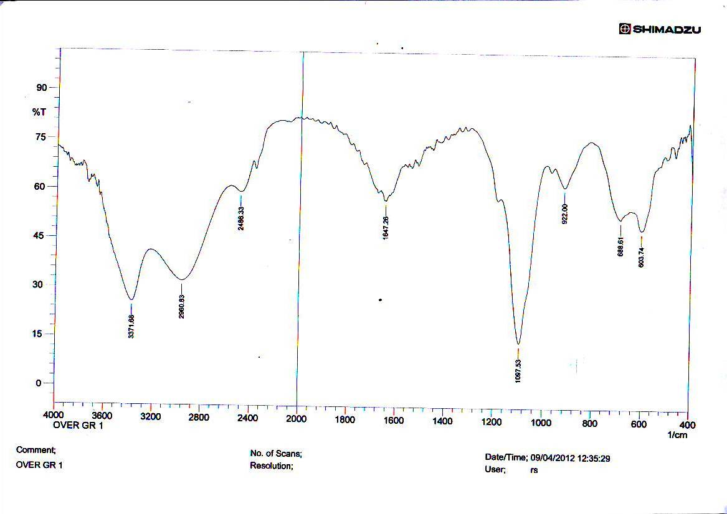
Figure 1 : FT – IR spectrum for Al - crystal

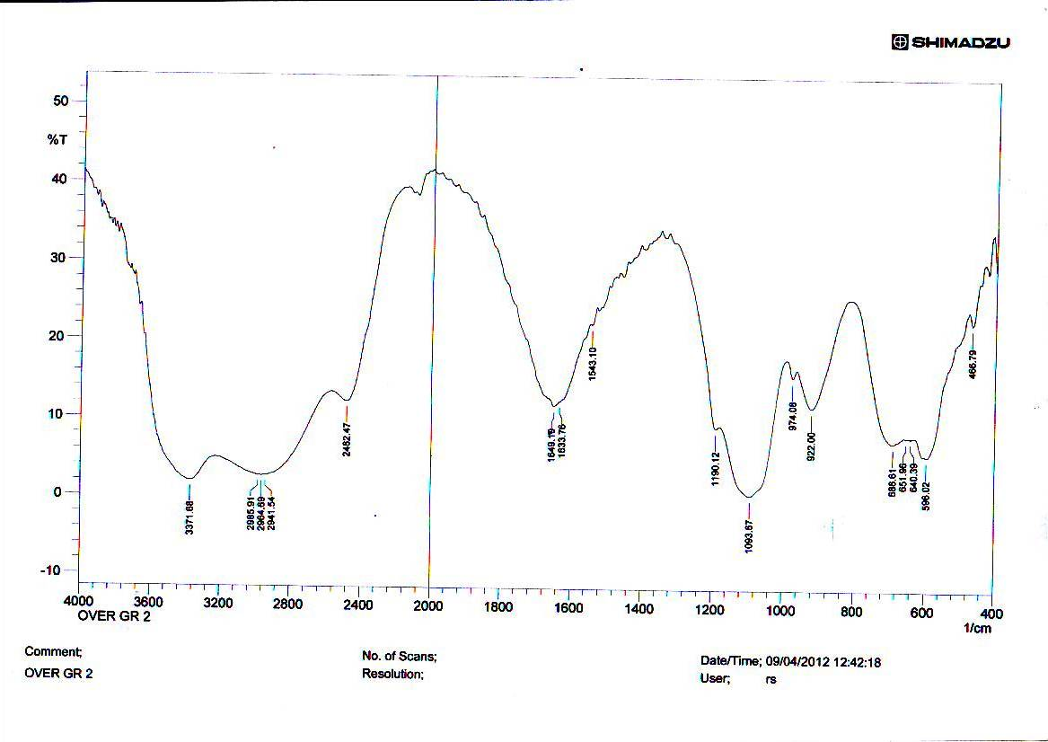

Figure 2 : FT – IR spectrum for Al - Cr - crystal

Stick Pattern

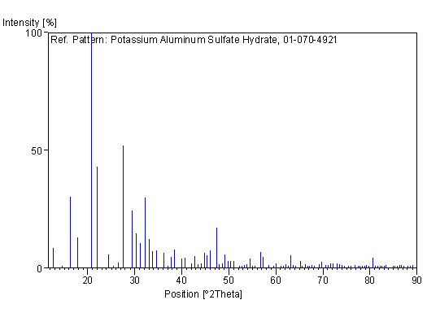

Figure 3 : X – Ray spectrum of the Al - crystal

Stick Pattern

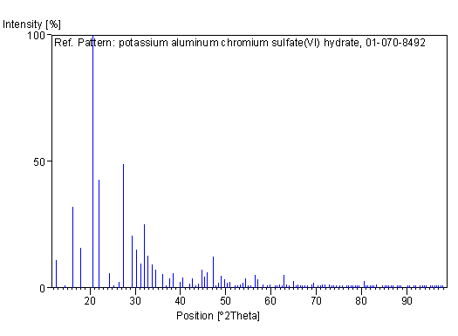 Figure 4 : X – Ray spectrum of the Al - Cr crystal

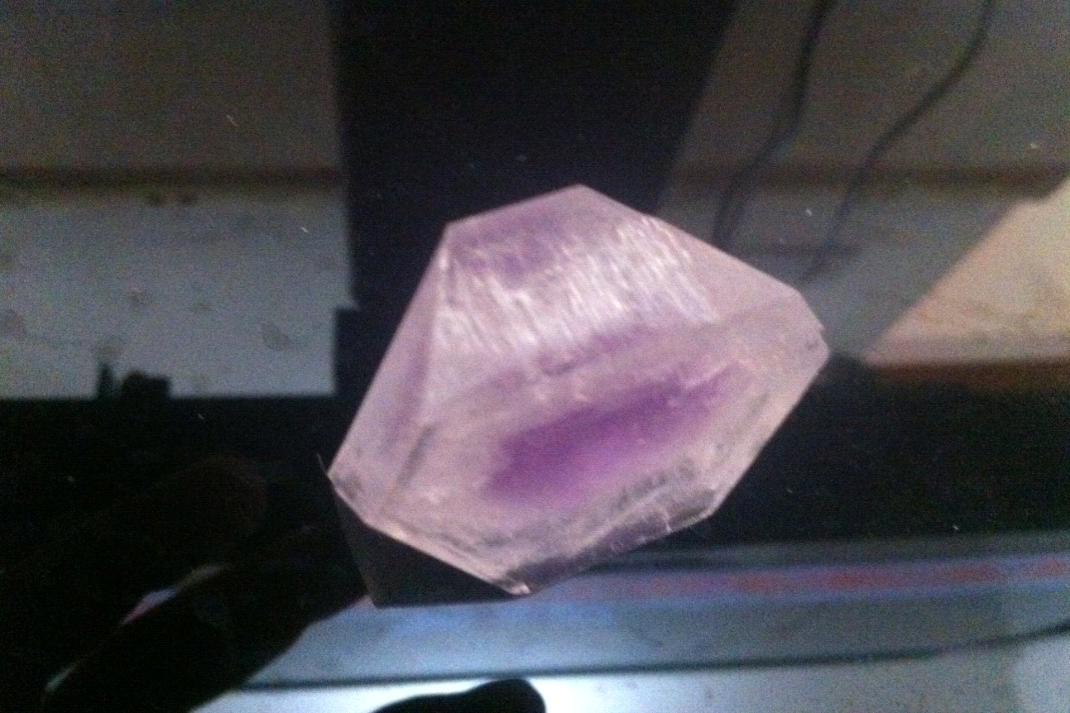
Figure 5 : The photograph of the overgrothes under our investigation

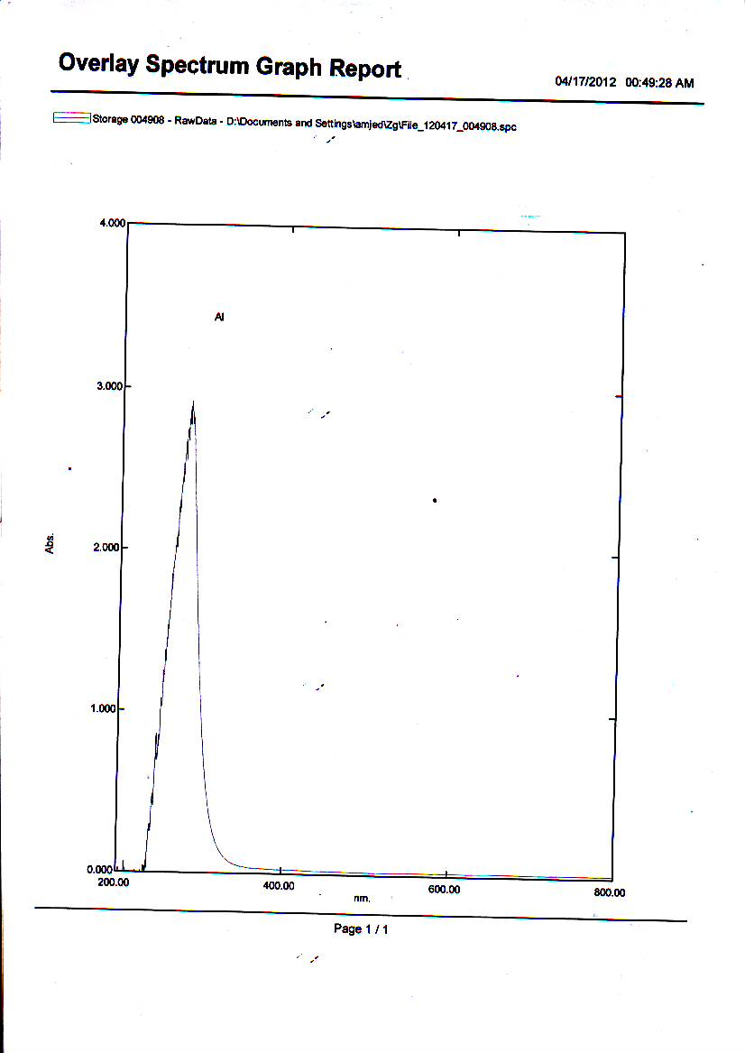
Figure 6 : UV.Visb. spectrum of the Al - crystal

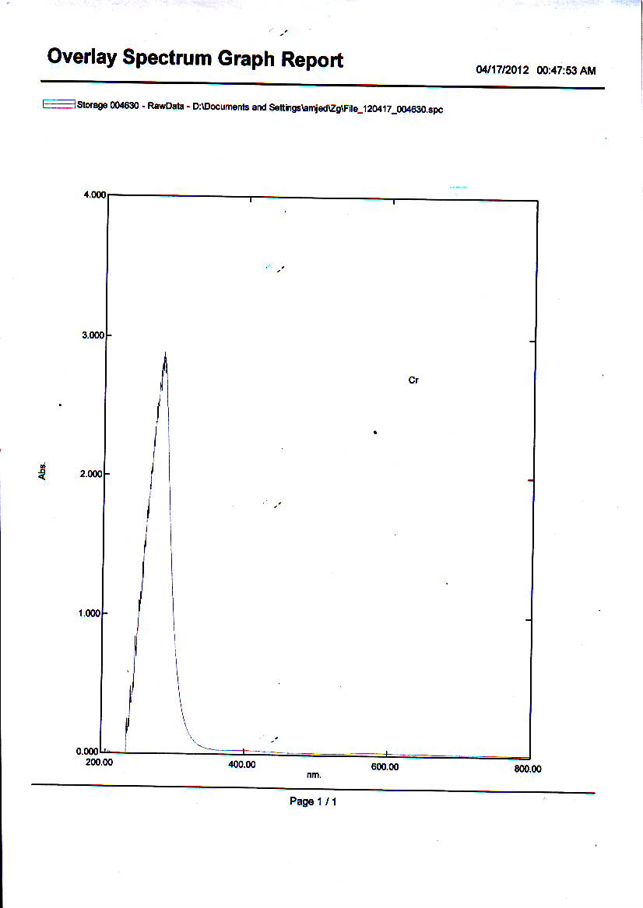
Figure 7 : UV.Visb. spectrum of the Al - Cr crystal

Results and Discutions
Figures 1 shows the FT – IR spectra of the outer layer of overgrowth crystal ( Al – crystal ) and figures 2 shows the FT – IR spectra of the middle layer of the overgrowth crystal which contain few Cr atoms in crystal space lattice of Al – crystal . Comparing the main IR frequenvies of the two layers , the following data were found : there were five strong absorpition peaks in both samples , 3371 cm⁻¹ is due to stretching of OH group , 2960 cm⁻¹ is due to stretching of H in H₂O molecules , 1647 cm⁻¹ is due to the bending of hydrogen water molecules , 1097 cm⁻¹ is due to the S=O stretching and 603 cm⁻¹ is due to S – O stretching . There are week peaks below 600 cm⁻¹ may be is due to Al – O stretching . The crystal data and refinement parameters of the two samples are summarized in table 1 and table 2 , the X –Ray spectrum are shown in figure 3 and figure 4 . the crystal lographic parameters for the two samples are similar . The Cr atoms are inserted inside the space lattice of the colourless Al – crystal to introduce the voliet isomorphouse crystal .The two layer inhibite the cubic system crystal due to the similarity of there electrical and chemical properties of Al and Cr atoms . figure 5 and figure 6 show the UV. Visib. Spectrum of the two layers , both including aband at 280 nm , hence there is no shift confirming a same crystal system in both samples . From the datd of physical and mechanical properties we see that all the measured parameters are nearly equal for the two samples , that indicate for the similarity of the two layers of the overgrothes crystal .
Acknowledgment :
I thank D. Jawad ( Geology Depatment , Babylon University ) for his help with the X-Ray struvtures determinations .

References
1 – P. J. Durant , General and Inorganic Chemistry , Third Edition , copyright P. J. Durant , 1964 .
2 – Ulrich Muller , Inorganic Structural Chemistry , Second Edit copyright , John Wiley and Sons Ltd , 2006 .
3 – S. J. lippard and J. M. Berg , Principles of Bioinorganic Chemistry , University Science Books , Mill Valley , CA , 1994 .
4 – L. J. Que , Physical Methods in Bioinorganic Chemistry , University Science Books , Sausalito , CA , 2000 .
5 – F. E. Jacobsen , R. M. Brrcce , W. K. Myers , D. L. Tierney and S. M. Cohen , Inorg. Chem. Jornal , 2006, 45, 7306 – 7315.
6 – F. A. Cotton and G. Wikinson , Advanced Inorganic Chemistry , Copyright C John Wiley and Sons , Inc. 1966 .
7 – F. Larkins , J. Phys. C. Solid State Physics , 1971, 4.3065.
8 – A. M. Wood , J. Phys. C. Solid State Physics , 1978, 11.2703 .
9 – Y. Mori ,T. Ikai , R. Teranishi and K. Takarub , Phys. Stat. Sol. ( b ), 2003, 235 , 302 .
10 – A. Benzair and H. Aourage , Phys. Stat. Sol. ( b ), 2002, 231 , 411 .
11 – T. Bredow , R. A. Evarestov and K. Jug , Phys. Stat. Sol. ( b ), 2000, 222 , 459 .
12 – W. R. Deer , R. H. Howie and J. Zussman , An Introduction to Practical Study of Crystals , Minerals and Rocks , Mc Graw Hill Co. , London , 1970 .
13 – R. D. Shnnon , Acta Crystallographica A32 :1976, 751 – 767 .
14 – L. H. Ahrens , Geobimica et Cosmocbimica Acta 2 : 2000, 155 - 16 1,952 .
15 – K. Cornelis and D. Barbara , Mineral Science , John Wiley and Sons , Inc. , 2008 .
16 – A. H. Al – Sayigh , F. A. Al – Kufaishi and Z. A. Al – Jubouri , Crystallography , Al – Hikma House , Baghdad University , 1989 .
17 – Brian Jones , J. of Sedimentary Research , September 1 , 1989, 59(5) .
18 – Atkins , The Elements of Physical Chemistry 3rd ed. , Oxford University , 2001 .
19 – Sheldrick GM SHELXS 97 Program for Solution of Crystal Structure , University of Gottingem Germany , 1997 .

