Synthesis and Characterization of New Some First Transition Metals Complexes of Schiff Base N,N'-bis[2-Methylenethiophene]-1,2-phenylenediimine.
Eman Muwafaq Ramadthan
Chemistry Department, College of Science, Mosul University Mosul-IRAQ
E-mail: e.Muwafaq84@yahoo.com

(NJC)

(Received on 27/11/2012) (Accepted for publication 16/6/2013)

Abstract
The Schiff base N,N'-bis[2-methylenethiophene]-1,2-phenylen-diimine (L) was prepared by the reaction of 1,2-phenylendiamine with 2-thiophencarboxaldehyde in (1:2) molar ratio, the reaction of above ligand with CoCl₂.6H₂O, NiCl₂.6H₂O,CuCl₂.2H₂O and ZnCl₂ respectively in (1:1), (2:1) and (2:2) ligand to metal molar ratio produce the complexes of the general formula [MLCl₂], [ML₂]Cl₂, [M₂L₂Cl₄], where M = Co(II), Ni(II), Cu(II) and Zn(II). These complexes were characterized by infrared and electronic spectra, magnetic moment measurement, conductivity measurement and metal content analysis. The result of electronic and magnetic measurements indicate a tetrahedral geometries for the complexes of the formula [MLCl₂], [M₂L₂Cl₄] while the complexes of the formula [ML₂]Cl₂ show square planer geometry.
Key word : Schiff base , 1,2-phenylendiamine , Transition Metals

154
الخلاصة
تم تحضير قاعدة شيف(L) N',N - بس2] - مثيلين ثايوفين[-1 - 2,فنيلين ثنائي إيمين من خلال مفاعلة 1و2- فنيلين ثنائي امين و 2- ثايوفين كاربوكسي الديهايد بنسبة مولية (2:1) وتم تحضير عدد من المعقدات الجديدة من خلال تفاعل الليكاند المحضر أعلاه (L) مع: ZnCl₂,CuCl₂.2H₂O,NiCl₂.6H₂O,CoCl₂.6H₂O بنسب مولية (1:1),(1:2),(2:2) على التوالي . وتبين أن المعقدات المحضرة تحمل الصيغ العامة [MLCl₂],[ML₂]Cl_{2 ,} [M₂L₂Cl₄]عندما Zn(II),Cu(II),Ni(II),Co(II)=M. ثم تشخيص المعقدات المحضرة بواسطة طيف الأشعة تحت الحمراء وفوق البنفسجية والحساسية المغناطيسية والتوصيلية المولارية وقياس المحتوى الفلزي . وتبين من القياسات المغناطيسية والطيف الالكتروني بأن المعقدات ذوات الصيغ المقترحة [MLCl₂], [M₂L₂Cl₄]تتخذ بنية رباعي السطوح بينما المعقدات ذوات الصيغ المقترحة [ML₂]Cl₂ تتخذ بنية المربع المستوي .
الكلمات الدالة : أورثو فنيلين ثنائي أمين , قاعدة شيف , العناصر الانتقالية

Introduction
Thio phenyl Schiff base are particulary interesting because of their wide range of activities such as anticancer activity antibacterial and antifungal activities typified by thiophenyl-azetidinones, cephalexins and vinyl aniline ^{[1-3]}, Metal complexes of Schiff base derived from 2-thiophene carboxaldehyde and 2-aminobenzoic acid (HL) are reported and characterized on the basis of elemental analysis, IR, ¹HNMR, solid reflectance, magnetic moment, molar conductance and thermal analysis (TGA). the complexes are found to have the formula [M(HL)₂]Cl_{n}.YH₂O where M = Co(II) (n = 2, Y = 1.5), Ni(II) (n = 2, Y = 1), and [M(L)₂]
155
where M = Cu(II) ^{[4]}.new amino vic-dioxime complexes derived from N, N'-[3,3-{ethane-1,2-di-y1-bis (oxy) bis(3,1-phenylene)}bis(N'-hydroxy)-2-(hydroxyimino)acetimidamide] (HL') with Cu(II), Ni(II), Co(II) and Cd(II) complexes of 6,7-O-cyclopentilydine-1-amino-4-azaheptane (HL'') used as metal salts have been prepared and characterized by different techniques^{[5]}.
A new series of coordination compounds of types [Cu(dienX₂Y₂)] and their adducts [Cu(dienX₂Y₂)(2a-5mt)] where dien = diethylentriamine, dienX₂= Schiff base of diethylentriamine with 2-furaldehyde or 2-thiophene carboxaldehyde , (X = O, S, Y = Cl, Br, NO₃, 2a-5mt = 2-amino-5-methylthiazole) were
synthesized by stepwise reactions and their structures were established by microanalysis, spectroscopic, magnetic and molar conductivity measurements. the isolated compounds are monomer paramagnetic and are (1:1) electrolyte in all cases ^{[6]} .
Two new Schiff base containing olefinic linkages have been synthesized by condensing aliphatic diamines with dicinnamoyl methane under specified conditions, Dibasic tetra dentate (N₂O₂) coordination of the compound in their [ML] complexes where M = Ni(II), Cu(II) and Zn(II), L = N - (2-thienylmethylene) methanamine ^{[7]}.
4-(Thiophen-3-yl)-aniline undergoes condensation with o-vanillin to form an ONS donor Schiff base, 2-methoxy-6-[(4-thiophene-3-yl-phenylimino)-methyl]-phenol, which forms complexes of the type [ML₂]xH₂O(where M = Mn, Co, Ni, Cu, Zn, pd) . The electronic, IR and CHN data are supportive of a 4- coordinate tetrahedral geometry for Mn(II), Co(II), Ni(II), and Zn(II) complexes and square-planar geometry for Cu(II) and Pd(II) complexes ^{[8]}.
Two complexes of Co(II) and Cu(II) with Schiff base derived from o-phenylendiamine and 2-hydroxyacetophenone have been prepared by condensation in acidic medium. The prepared complexes were investigated using different physical techniques ^{[9]}.
156
The Schiff base bis-[2-hydroxynaphthyl-2-y1]-N,Ń-thiosemi- carbazone H₂L, was prepared by the reaction of 2-hydroxy naphthaldehyde with thiocarbohydrazide in 2:1 molar ratio the mono and dinuclear complexes of Co(II), Ni(II), Cu(II) and Zn(II) were characterized Via elemental analysis , infrared and electronic spectra , magnetic moment measurements, conductivity measurement and metal content analysis, Conductivity measurements showed that’s the complexes are non- conductive assigning the formula [M(H₂L)Cl₂] and [M₂LCl₂] . On the basis of the above physicochemical data, electronic and magnetic measurements a tetrahedral geometries were assigned for the complexes^{[10]} .
According to the above interesting results and as continuation to our study N,N'-bis[2-Methylenethiophene]-1,2-phenylene-diimine as new Schiff base and their complexes. prepared anew ligand and its complexes with Co(II), Ni(II), Cu(II) and Zn(II) ion in different molar ratios .
Experimental
Physical measurements :
Metal content analysis were made on PYE UNICAM SP9 atomic absorption spectrophotometer Phillips. The IR spectra were recorded on an FTIR spectrophotometer bruker (Tensor 27) in the 200-4000 cm⁻¹ range using CsI discs. The Electronic spectra were recorded on a shimadzu UV160 spectrophotometer using dimethylformamide (DMF) for 10⁻³ M solution of complexes. The Conductivity measurements were made on 10⁻³ M solution of the complexes in DMF at room temperature using a conductivity meter model PCM3-Jenway. The Magnetic measurements were carried on a Bruker BM6 instrumental at 25 ºC following Faraday,s method ^{[11]}, corrections for diamagnetic were made by using pascal constants.
Materials
All chemicals of reagent grade, the chlorides salts of Co(II), Ni(II), Cu(II) were obtained from Fluka, 1,2-phenylenediamine,
157
2-thiophenecarboxaldehyde, DMF, were purchased from either Fluka or BDH .
- Synthesis of ligand N,N'-bis[2-Methylenethiophene]-1,2-phenylene-diimine (L):
A solution of (10.8 gm, 0.1 mol) 1,2-phenylenediamine in hot absolute ethanol (10 ml) was added to a solution of (18.3 ml, 0.2 mol) 2-thiophenecarboxaldehyde in absolute ethanol (10 ml). the reaction mixture was refluxed for 5 hours. Then the mixture is left for five days at room temperature giving a red precipitate which is filtered off, washed with ethanol and diethyl ether, and recrystallization from butanol then dried under vacuum for several days.
- Preparation of [MLCl₂] complexes.
To a solution of ligand (L)(0.30 g,0.001 mol) in tetra hydro furan (THF) (10) ml, CoCl₂.6H₂O (0.24 g, 0.001 mol) or NiCl₂.6H₂O (0.24 g, 0.001 mol) or CuCl₂.2H₂O (0.17 g, 0.001 mol) or ZnCl₂ (0.14 g, 0.001 mol) in ethanol (10) ml was added respectively. The solution was refluxed for 1 hour. the product was filtered off and washed with ethanol several times and then with diethyl ether .
- Preparation of [ML₂]Cl₂ complexes.
To a solution of ligand (L) (0.59 g, 0.002 mol) in tetra hydro furan (THF) (10 ml), CoCl₂.6H₂O (0.24 g, 0.001 mol) or NiCl₂.6H₂O (0.24 g, 0.001 mol) or CuCl₂.2H₂O (0.17 g, 0.001 mol) or ZnCl₂ (0.14 g, 0.001 mol) in hot ethanol was added. The mixture was stirred under reflux for 2 hours. The product filtered off and washed with diethyl ether then dried under vacuum .
- Preparation of [M₂L₂Cl₄] complexes.
To a solution of ligand (L) (0.59 g, 0.002 mol) in tetra hydro furan (THF) (10 ml), CoCl₂.6H₂O (0.48 g, 0.002 mol) or NiCl₂.6H₂O (0.48 g, 0.002 mol) or CuCl₂.2H₂O (0.34 g, 0.002 mol) or ZnCl₂ (0.28 g, 0.002 mol) in hot ethanol (10 ml) was added. The mixture was stirred under refluxed for 4 hours and during which time a coloured precipitate was formed. The mixture was cooled to room temperature and the solid was filtered off and washed with ethanol several times and then with diethyl ether successeirly then dried under vacuum .
158
Results and Discussion
The new ligand was prepared by the reaction of 1,2-phenylendiamine with 2-thiophenecarboxaldehyde to give the N,N'-bis[2-Methylenethiophene]-1,2-phenylenediimine. the complexes were prepared through direct reaction of the metal chlorides CoCl_{2.}6H₂O,NiCl₂.6H₂O, CuCl₂.2H₂O and ZnCl₂ with (L) in different molar ratio, gave the complexes of the general formula [MLCl₂], [ML₂]Cl₂, [M₂ L₂Cl₄]
The analytical data of the ligand and its complexes are given in Table(1).
Conductivity measurement:
The electrical molar conductance in (DMF) of the complexes no. (5-7) were (135-165) ohm⁻¹ mol⁻¹ cm² indicating a 1:2 electrolytic nature of the complexes, Whereas for the rest of the complexes the values were (18-25) ohm⁻¹mol⁻¹cm², indicating neutral nature of the complexes ^{[10]}. as shown in Table (1).

IR spectra :
The IR spectra of the complexes are compared to that of the free ligand in order to determine the changes that might have taken place during the complexation Fig(2). The strong band at (1649) cm⁻¹ is characteristic of the azomethine nitrogen atom present in the free ligand. The lowering in this frequency region to (1628-1638) cm⁻¹, observed in all the complexes indicates the involvement of the azomethine nitrogen atom in coordination ^{[9, 12, 13]}. Furthermore, the strong band observed at (850) cm⁻¹ in the free ligand is assigned to υ (C-S) vibration practically no effect on this frequency after complexation was observed, indicating the non involvement of this group in coordination with the metal ion ^{[14]}. The observation of new bands at (447-482) cm⁻¹ due to υ(M-N) is further evidence of coordination ^{[15, 8]}. These spectra also show bands in the region (229-324) cm⁻¹ which may be due to υ(M-Cl) vibration frequency ^{[16]} the IR-spectral data are shown in Table (2).
Magnetic measurement:
The measurements of the magnetic moment of Co(II) complexes (1,5,9) show that the complexes (1, 9) have magnetic moment of (4.67, 3.92) B.M complementary of high spin tetrahedral geometry for di and mono nuclear complexes and the magnetic moment of the complex (5) is 2.4 B.M this suggested the presence of one unpaired electron which reveald the low spin nature of the complex, this value suggested a square planer geometry. At measurement of the magnetic moment of Ni(II) complexes (2, 6, 10) show the complexes (2, 10) have magnetic moment of (2.98, 3.52) B.M. correspond to tetrahedral geometry and the diamagnetic nature of the complex (6) reflects the square planer enverivoment of complex (6) . The magnetic moment of Cu(II) complexes (3,7,11) are (1.58-2.1) B.M. These value suggest a square planer geometry for the complex (7) and , tetrahedral geometry for the complexes (3,11). The complexes (9,10,11) indicative of the presence of some anti-ferromagnetic interactions, operating through Co-Co, Ni-Ni, Cu-Cu interactions ^{[8,17]}. the Zn(II) complexes (4,8,12) are diamagnetic [Table 2].
159
Electronic Spectra:
The electronic spectra of the ligand (L) in DMF Table(2) and also shown in Fig(3) showed two distinctive bands at 340 nm assigned to π-π* or n-π* transition ^{[5]}. The electronic spectra of Co(II) complexes (1,9) show two bands in the visible region (474,650) nm which are corresponding to the transition from ⁴A₂g(F) ⁴T₁(P)(υ₃) which is consistent with tetrahedral geometry Fig(3) ^{[18]}, while complex (5) spectrum consists of band at (608) nm assigned to ²A₁g ²Eg transition and aband at (380) nm which may due to charge transfer. These values suggested square planer geometry around the Co(II) complexe (5) ^{[9]}. While the electronic spectra of Ni(II) complexes (2,10) are consisting of two bands at (668,842) nm which may be attributed to the transition ³T₁ (F) ³T₁(P)(υ₃) in tetrahedral geometry [19].
complexs (6) spectrum displays two bands at (404,640) nm assigned to ¹A₁g ¹A₂g and ¹A₁g ¹B₁g transition reflecting the square planer geometry adobted to this complex, Fig(3) ^{[20]}. electronic spectra of Cu(II) complexes (3,11) show two bands at (434,454) nm which correspond to the transition ²T₂g ²Eg and others transition at (382,376) nm correspond to chargetransfer, M-L indicating that Cu(II) complexes have tetrahedral geometry ^{[21]} and the complex (7) spectra display bands at (646,432) nm assigned to ²B₁g ²A₁g and ²B₂g ²E₁g transition respecting reflecting a square planer geometry^{[9,20]}. Electronic spectra of Zn(II) complexes (4,8,12) expectedly show only M-L charge transfer transitions and π π* transition.
160
160

Conclusion :
According to the mention spectral evidences the suggested geometrical structure of the prepared complexes are shown in Fig(1).
The bi dentate coordination of ligand (L) via the two azomethane nitrogens can be observed .

161
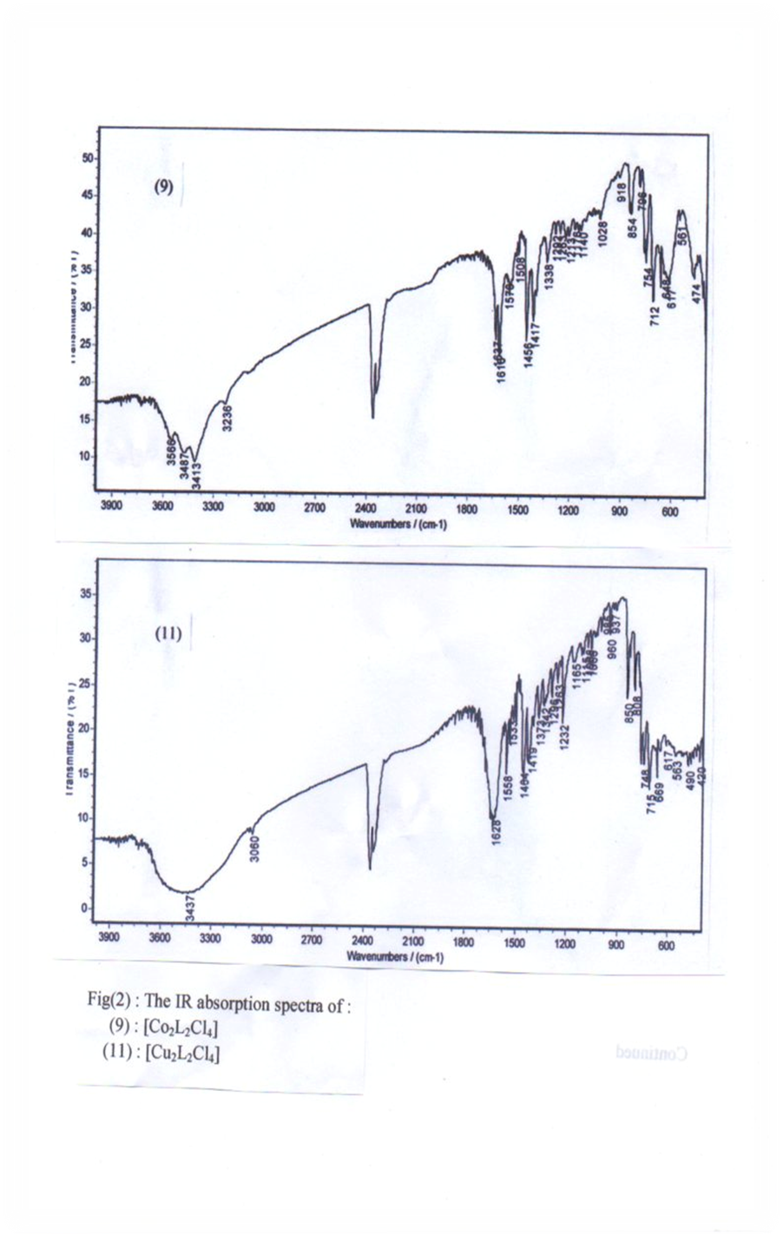
162

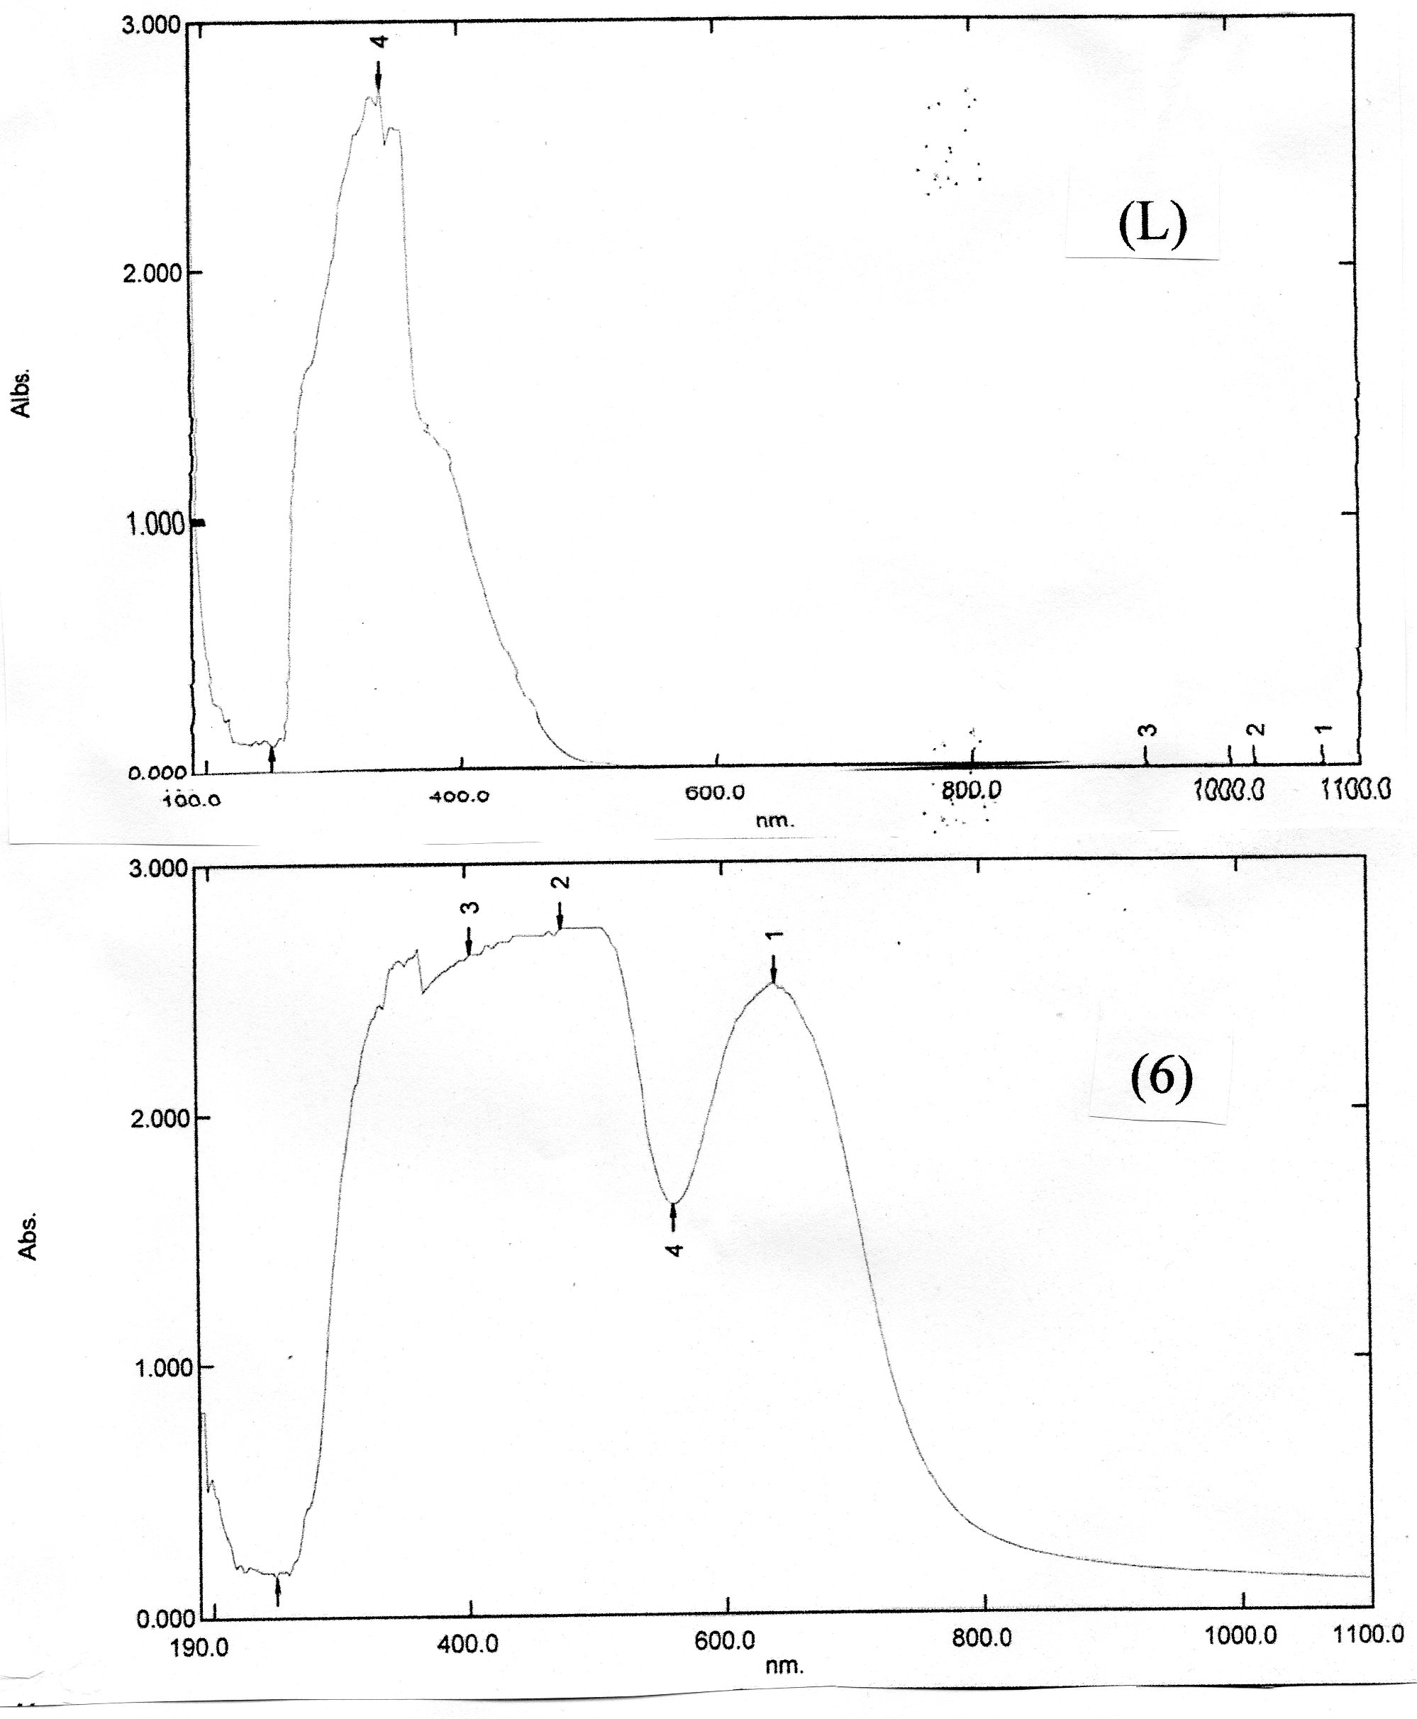

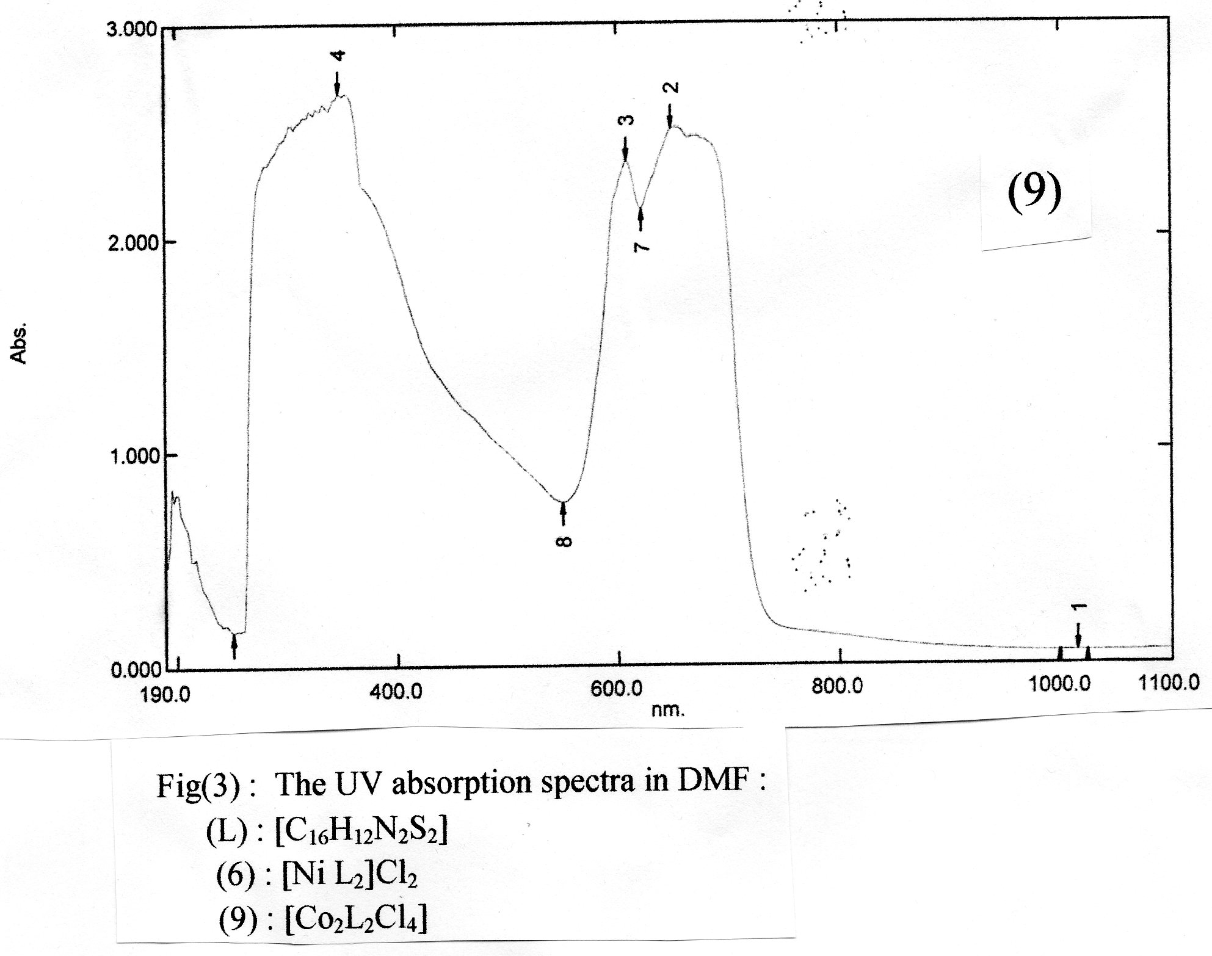
163
Table 1: Analytical, conductance and magnetic data of the ligand and its complexes.
No. | Compound | Colour | M.P  (Cº) | Analysis found (Cale.) | Λ  ohm⁻¹.cm².mol⁻¹ | µeff.  (B.M)  B.M
 |  |  |  | M% | Λ  ohm⁻¹.cm².mol⁻¹ | µeff.  (B.M)  B.M
L | C₁₆H₁₂N₂S₂ | Red | 120 | ----- | ----- | -----
1 | [CoLCl₂] | Dark green | 274 | (13.82)  13.9 | 13.9 | 4.67
2 | [NiLCl₂] | Dark green | 153 | (13.78)  13.5 | 20.4 | 3.52
3 | [CuLCl₂] | Redish brown | 228 | (14.75)  14.93 | 10.4 | 2.1
4 | [ZnLCl₂] | Yellowish red | 159 | (15.12)  15.23 | 11.5 | Dia
5 | [CoL₂]Cl₂ | Blue | 286 | (8.15)  8.2 | 135 | 2.4
6 | [NiL₂]Cl₂ | Yellowish brown | 144 | (8.13)  8.3 | 144 | Dia
7 | [CuL₂]Cl₂ | Pale green | 218^{d} | (8.74)  8.5 | 165 | 1.78
8 | [ZnL₂]Cl₂ | Yellow | 150 | (8.97)  8.5 | 150 | Dia
9 | [Co₂L₂Cl₄] | Green | 264^{d} | (13.82)  13.5 | 31.5 | 3.92
10 | [Ni₂L₂Cl₄] | Brown | 134 | (13.78)  13.9 | 29.6 | 2.98
11 | [Cu₂L₂Cl₄] | Greenish brown | 198 | (14.75)  14.6 | 26.5 | 1.58
12 | [Zn₂L₂Cl₄] | Yellowish | 232 | (15.12)  15.9 | 9.32 | Dia
d = decomposition temperature

164
Table 2: Infrared and electronic spectral data of the ligand and its complexes.
No. | Compound | IR Spectral bands cm⁻¹ |  |  | UV Spectral bands nm
No. | Compound | υ (C=N) | υ (M-N) | υ (M-Cl) | Charge transfer | d d
L | C₁₆H₁₂N₂S₂ | 1649s | ------- | ------- | 340 | -------
1 | [CoLCl₂] | 1637 | 482 | 229 | 338,306 | 374
2 | [NiLCl₂] | 1635 | 474 | 303 | 350 | 668
3 | [CuLCl₂] | 1635s | 442 | 312 | 382 | 434
4 | [ZnLCl₂] | 1624 | 472 | 315 | 308,336 | -------
5 | [CoL₂]Cl₂ | 1634 | 482 | ------- | 380 | 608
6 | [NiL₂]Cl₂ | 1628m | 467 | ------- | ------- | 404,640
7 | [CuL₂]Cl₂ | 1635 | 472 | ------- | ------- | 646,432
8 | [ZnL₂]Cl₂ | 1628 | 472 | ------- | 338 | -------
9 | [Co₂L₂Cl₄] | 1637 | 474 | 314 | 348 | 650
10 | [Ni₂L₂Cl₄] | 1637 | 467 | 324 | 352 | 842
11 | [Cu₂L₂Cl₄] | 1628w | 490 | 302 | 376 | 454
12 | [Zn₂L₂Cl₄] | 1638s | 472 | 300 | 340 | -------
S = strong, m = medium, w = weak.

References
- A.T.Chaviara, P.d.Cox, K.H.Repana, A.A.Pantazaki, K.T.Papazisis, A.H.Kortsaris, D.A.Kyriakidis, G.S.Nikolov and C.A.Bolos, J.Inorg.Biochem., 2005, 99(2), 467-476.
- N.S.Shailendra, N.Bharti, M.T.GonzalezGarza, D.E.Cruz-vega, J.C.Garza, K.Saleem, F.Naqvi and A.Azam, Bioorganic Medicinal Chemistry Letters, 2001, 11(20), 2675-2678.
165
- G.G.Mohamed, M.M.Omar and A.M.Hindy, Turk.J.Chem., 2006, 30, 361-382.
- G.G.Mohamed, M.M.Omar and A.M.Hindy, SpectroChimActa AMolBiomol Spectrosc., 2005, 62(4-5), 1140-1150.
- S.Duman, M.Sekerci, Intern.J. of Natu. and Engin. Scien., 2010, 4(2) : 23-28 .
- A.Th.Chaviara, P.J.Cox, K.H.Repana, R.M.Papi, K.T.Papazisis, D.Zambouli, A.H.Kortsaris, D.A.Kyriakidis and C.A.Bolos, J.Inorg.Biochem., 2004, 98(8), 1271-1283.
- K.Krishnankutty, P.Sayudevi and M.B.Ummathur, J. Serb.Chem. Soc. 2008, 73(4), 423-429.
- A.A.Osowole, Intern. J.Inorg.Chem., 2011, Article ID 650186, 7.
- A.M.Hamil, K.M.Khalifa, A.AL-Houni and M.M.El-ajaily, RASAYAN.J.Chem., 2009, 2(2), 261.
- N.H.Buttrus, E.M.Ramadthan, Intern.J.Chem., 2012, 22,3,159-164.
- S.F.A. Kettle, "coordination compounds", T.C. Waddington, university of Durham, 1977, 212.
- S.Chandra and K.Gupta, Spectro. Chimica Acta 61A, 2005, 269.
- K.Nakamoto, "Infrared and Raman spectra of inorganic and coordination compounds", 5th Ed., Wiely Interscience Publication, New York, part B(1997).
- J.Kamenicek, P.Solichova and Z.Sindelar, Acta Univ.Palaki.Olomuc.,2001, 40, 35.
- M.M.A.El-Zaher, J.Chinese Chem.Soc., 2001, 48, 153.
- N.H.Buttrus, AsianJ.Phys., 1997, 6, 104.
- M.G.B.Drew and P.C.Yates, Inorg. Chimi. Acta, 1986, 118(1), 37-47.
- H.H.Bayoumi, E.M.Shouky and M.M.Mostafa, Synth., React.Inorg.Met-org.Chem., 2001, 31(4), 579.
- T.A.K.Al-Allaf and A.Z.M.Sheet, Asian J.Chem., 1996, 8, 305.
- N.RAMAN, Y.P.RAJA and A.KULANDAISAMY, Indian, Acad.Sci.(Chem.Sci.), 2001, 113(3), 183-189).
- A.K.Rana and J.R.SHAH, Ind.Chem.Soc., 1986, LXIII, 281.

166

