Synthesis and Characterization and Biological Activity of some New Mannich Basesand Their Metal Complexes with
(Cd²⁺,Ni²⁺and Mn²⁺).

Nagham .Mahmood .Aljamali
Chem. Dept ., College of Education ., Univ . Kufa
E-mail: Dr.Nagham_mj@yahoo.com
Rajaa.Abed alameer
Chem.Dept., College of Education ,Univ. Kufa
Afaaq Kadhum Jaber
Chem.Dept., College of Education ,Univ .Kufa

(NJC)
(Received on 13/2/2013) (Accepted for publication 3/6/2013)

Abstract
In this work , five new compounds of mannich bases were synthesized by the reaction between diketone compounds and ammonia or amine derivatives to give enamino ketone as intermediate , which may react with aldehydes to yiled compounds [1-5] ,and complexes[6-8], mannich base[5] reacts with transition metal ions(Cd⁺²,Ni⁺² and Mn⁺²) ,to form complexes of the type [6-8].
The synthesized compounds[1-8] are characterized by{(C.H.N)–analysis ,¹H-NMR-spectra , FT.IR-spectra} ,stochiometric study, molar conductance ,melting points,biological study. The data obtained gave good support for synthesized compounds [1-8] .

Keyword: Mannich bases, complexes of mannich.
الخلاصة
تضمن هذا البحث تخليق خمسة مركبات جديدة من قواعد مانخ من خلال التفاعل بين مركبات ثنائية الكيتون مع الأمونيا أو مشتقات الأمين لتعطي وسيط كيتون الأينامين و الذي بدوره يتفاعل مع مركبات الألدهايد لتنتج المركبات ,[5-1]والمركب[5] يتفاعل بدوره مع ايونات(Cd²⁺,Ni²⁺, Mn²⁺,) لتكوين المعقدات [6-8]. شُخُصت المركبات المحضره بإستخدام تقنية (التحليل الكمي الدقيق للعناصر , طيف الرنين النووي المغناطيسي , طيف الأشعه تحت الحمراء) ,تكافؤية المعقدات, التوصيلية المولارية, نقاط الإنصهار مع دراسة بايولوجية للمعقدات. النتائج المستحصله دليل قاطع للمركبات المحضره[8-1] .
كلمات مفتاحية : قواعد مانخ , معقدات مانخ.

Introduction
Mannich bases are well known compounds for along time and still continue the object of considerable interest ,mainly due to their pharmacological activities⁽¹⁻³⁾ , technological applications in polymer industry specially as paints & surface –active reagents and other applications in different fields⁽⁴⁻⁷⁾ .
However its derivatives have long been used for their antibacterial, anti fungal activity⁽⁸⁻¹⁰⁾, it is also an important analytical reagent due to its chelating ability ,further the complexation of mannich bases with metal ions may enhance their antimicrobial properties and may also be used as potent drugs in the treatment of infectious diseases⁽¹¹⁻¹³⁾.
The original synthesis of mannich bases [1-8] are diketone compounds whichamonia react with amine derivatives to give anaminoketons as intermediates .These intermediates react with aldehyde compounds to yield Mannich bases. This reaction is highly regiospesific .

Experimental
-All chemical used where supplied from Fluka& Merck-chemical company.
-All measurement where carried out by:
- Melting points :Electro thermal 9300 , melting point Engineering LTD ,U.K .
- FT.IR-spectra: fourrier transform infrared shimadzu (8300) , (FT.IR) , KBr-disc was used .
- H.NMR-Spectra in DMSO-solvent ,in ppm unit,,& ( C.H.N)-Analysis.
- tuclave , oven ,incubator in bio-lab ,college of education in kufa university.

Synthesis of compound [1] :
A solution of 5,5–dimethycyclohexyl–1,3–dione (0.4 mole , 56 gm) with P-N,N-dimethyl benzaldehyde (0.2 mole , 29.8 gm) and ammonia (0.2 mole , 7 ml)was condensed.A precipitateformed,which was filtered and recrystallized using absolute ethanol to yield 79% of compound [1] .
Synthesis of compound [2] :
A solution of 2,5–hexan–dione(0.4mole, 15ml) and p-methyl mercaptobenzaldehyde (0.2 mole , 30.4 gm) with ammonia (0.2 mole , 7ml)was refluxed for (4hrs), after cooling, the precipitate was filtered and recrystallized to yield 81% of compound [2] .
Synthesis of compound [3] :
A solution of 2-mercapto benzothiazole (0.2 mole , 33.4 gm) with morpholone(0.2 mole , 17.4 gm) and formaldehyde (0.2 mole , 6 gm) was refluxed in ethanol for(5hrs). A precipitate formed was filtered and recrystallized to yield 85% of compound [3] .
Synthesis of compound [4] :
A solution of 5,5 – dimethyl cyclohexyl -1,3-dione (0.2 mole , 28 gm) was reacted with 2-amino thiazole (0.2 mole , 20 gm) in presence of ethanol , the precipitate was filtered and recrystallized to give 78%of compound[4].
Synthesis of compound [5] :
A solutionequimolar (0.01 mole) of ( p-nitro tuloune 1.37 g , morpholine 0.87 g , salicyldehyde 1.22 g) were reacted in presence of 100 ml absolute ethanol ,the mixture was continuously strring for (3hrs), a precipitation formed, which was filtered ,after standing for(24)hrs, dried( yield 84%).
Study of optimal condition of compound [5]with complexes:
The optimal conditions for formation of complexes were studied in this work ,from calibration curves ,the optimal concentration of ligand [5] is (1X10⁻³M) and concentration of metals ((0.95X10⁻⁴M from Mn²⁺) and (0.8x10⁻⁴M from Ni²⁺)and (0.60X10⁻⁴M from Cd²⁺) ,while optimal (PH=8) was base medium,other studies such as stochiometric of complexes by job method through mix equil volume from ligand and ions(Cd⁺², Ni⁺² or Mn⁺²) and mole ratio method through mix concentrations from ligand with ionsto give curve,which give ratio of (M:L) (1:1).,while determination λmax of ligand (360nm, yellow) but λmax of its complexes(Cd⁺² =388nm ,yellowish orang).,( Ni⁺²=395 ,orang)., ( Mn⁺²=405nm ,brown orang).
Synthesis of complexes [6-8] :
Tohot ethanolic solution (25) ml of ligand (compound 5) (0.01 mole) was added anethanolic solution (25) ml of (0.01 mole) metal chloride (Cd⁺², Ni⁺² or Mn⁺²) respectively with stirring for half an hour , solid products formed ,which was filtered and dried.
Reaction Scheme:

Results and Discussion
All synthesized compounds [1-8] have been characterized by their physical properties FT.IR- spectra, (C.H.N)-analysis ¹H.NMR-spectra) , stochiometric study of complexes , molar conductance, microbial study of complexes :
Analysis of IR spectra shows:
-Compound[1] :absorption bands at (3440) cm⁻¹ due to (N-H) endo cycle of pyridine , band at(1718) cm⁻¹ due to carbonyl of keton(-CO-) ,bands at (1538,1569)cm⁻¹ is due to (C-N) endocycle of pyridine and band at (1373) cm⁻¹ due to (4-N(CH₃)₂) .
-Compound[2]: shows absorption bands at (3338)cm⁻¹ is due to (N-H )
endocycle of pyridine , band at (1735) cm⁻¹ due to carbonyl of ketone ( -CO- ) ,band at (1587)cm⁻¹ due to (C-N) endocycle ,and band at (1411)cm⁻¹ due to (S-CH)group^{(14,15)}.
-Compound [3] :shows absorption bands at (1537)cm⁻¹ is due to (C-N) endo cycle , band at (1230)cm⁻¹ due to (C-O-C)⁽¹⁵⁾ of morpholone cycle & band at (729)cm⁻¹ due to (C-S) endo cycle⁽¹⁴⁾ of thiazole.
-Compound[4]:shows absorption bands at (1577)cm⁻¹ due to (C=N) endocycle⁽¹⁴⁾ of pyrimidine & band at (740)cm⁻¹ due to (C-S) endo cycle^{(14,17)} of thiazole.
-Compound[5]:shows band at (1350)cm⁻¹ due to (-NO₂) ,a broad band at (3417)cm⁻¹ due to (OH)⁽¹⁶⁾ of phenol and a band at (1232)cm⁻¹ due to⁽¹⁵ (C-O-C) of morpholine.
-While some of these bands shifted in their complexes of compounds[5]and new ligand bands appeared such as (M-O^{(16,2)}, M-N, M-Cl ), table (1).]
¹H.NMR Spectra of compounds [1-4] showed :
-Compounds [1]: singlet signal at £ 8.87 for proton of (N-H) group , signal at £ 7.26 for proton of pyridine ring& signal at £ 3.99 for six proton of dimethyl group (N(CH₃)₂).
-Compound [2]: singlet signal at £ 4.63 for protons of methy group (S-CH)^{(14,15)} , doublet Signal at £ 7.78 for para protons of phenyl (ph-S) , and signal at £ 8.69 for proton of (N-H) .
-Compound [3]: signal at £ 4.84 for protons of (` )⁽¹⁴⁾ of morpholone cycle and signal at £ 4.28 for protons of methylene group⁽¹⁵⁾ of ( ) in.
-Compound [4]:signal at £ 6.37 for proton of pyrimidine cycle C₄-H and signal at £ 7.82 for proton of thiazole.
-Compound [5]: signal at £ 4.80 for protons of (` )⁽¹⁴⁾ of morpholone cycle, signal at £ 11.08 for proton of (OH) of phenol ring
, and other peaks shown in figures (5-8) .
(C.H.N)–analysis M.F and melting points are listed in table (2) .
From spectral results (H.NMR, FT.IR, C.H.N), stochiometric of complexes (M:L) (1:1) by using ( mole ratio and job)-methods and molar conductance of compound[5] are assigned
indicating that the ligand is bi dentate , coordinated through nitrogen of morpholine and the (OH)-group of phenol giving 4-coordinated tetrahedral geometry to form seven-membered ring^{(2,6)}.
Assay of biological activity ⁽²⁾:
Antimicrobial activity carried out in bio-lab ,college of education –kufa university
and tested by filter paper disc diffusion method against gram positive bacteria (Staphylococcus .aureus ) and gram negative bacteria (E-Coli) , 0.1 ml of the bacterial suspensions was seeded on agar. To determine minimum inhibitory concentration(MIC) by using graduated concentrationof each compounds[1-8] were ranged between (1-10)mg/ml dissolved in ( DMSO) .
The positive results or sensitivity were established by the presence of clear zone of inhibition around active compounds which were measured with a meter rule and diameters were recorded based on (mm).The assays were performed with two replicates..
Generally, The results showed that complexes[6-8] have great inhibitory compared with compound[5] as a ligand and other compounds[1-4] effect against tested bacteria .
Table (3) showed the zone of inhibition of the compounds[1-8], in this study ranged (from 27 to 9) mm. From results, we noted that the complexes[6-8] have higher antibacterial activity against S.aureus and E-Coli probably due to complexes formation. Consequently,these complexes have more activity and effective in precipitating proteins on bacteria cell walls, and presence of heterocyclic ring in these compounds which increase microbial activity,destroying the cell membranes,these compounds had abroad antibacterial activity⁽¹⁸⁾
Acknowledgements
The auther is thankful to ((khaledcompany )) and ((united Arabic company )) for some materials .
And express thank to Dr.Audai Ahmad for providing (C.H.N)–elemental analysis , ¹H-NMR spectra ,molar conductance and melting points .

Table (1) : FT.IR data (cm⁻¹) of compounds [1-8]
Comp. No. | Structural formula | Name of compounds | Only (Importance groups)
[1] |  | 1,4-dihydro-{4-(N,N-dimethyl benzene)-2,3,5,6-bis (dimethyl cyclohexanone)}-pyridine. | ʋ(N-H):3440 ,( -CO- )of ketone : 1718S , (C-N)endo cycle of pyridine :1538,1569 , 4-N(Me)₂:Aromatic :1373
[2] |  | 1,4,5,6-Tetra hydro –{5-(methyl phenyl sulphide )-2,8-dimethyl -4,6-di acetoazine . | ʋ(N-H):3338 ,  ( -CO-)of ketone :1735,  (S-CH₃): 1411,  (C-N)endocycle:1537
[3] |  | 3-methylene Morpolone -2-thione –benzothiazole . | (C-N)endo cycle:1537 ,,(C-S)endocycle of thiazole: 729 ,  (C-O-C) of morpholone : 1230
[4] |  | 1,2-(thiazolino)-4,6-(5,5-dimethyl cyclo hexane)-2-hydropyrimidine | (C=N)endocycle of pyrimidine : 1577 S,  (C-S)endocycle of thiazole: 740
[5] | C₁₈H₂₀N₂O₄ | 4-nitro-2-(morpholinesalicyl) tuloune | (C-O-C)of morpholone :1232, (OH):3417 ,(NO₂):1350
[6] | Mn(C₁₈H₂₀N₂O₄) Cl₂ | complex | (C-O-C)of morpholone :1230, (OH):3430 ,(NO₂):1350 ,(M-O) :560 ,(M-N):460 ,(M-Cl):372
[7] | Ni(C₁₈H₂₀N₂O₄) Cl₂ | complex | (C-O-C)of morpholone:1236, (OH):3417 ,(NO₂):1355 ,(M-O) :554 ,(M-N):453 ,(M-Cl):360
[8] | Cd(C₁₈H₂₀N₂O₄) Cl₂ | complex | (C-O-C)of morpholone :1230, (OH):3420 ,(NO₂):1340 ,(M-O) :540 ,(M-N):446 ,(M-Cl):366

Table (2) :Physical properties& Elemental Analysis of compounds [1-8]
Comp.  No. | M.F | M.P  (°C) | Ω⁻¹.cm².mol⁻¹ | Calc./Found.  %C | %H | %N | M | Cl
[1] | C₂₅H₃₂N₂O₂ | 178 | -- | 76.530  76.428 | 8.163  8.113 | 7.142  7.029 | --- | ---
[2] | C₂₀H₂₅NO₂S | 171 | -- | 69.970  69.804 | 7.288  7.113 | 4.081  4.006 | --- | ---
[3] | C₁₂H₁₄N₂OS₂ | 165 | -- | 54.135  54.037 | 5.263  5.123 | 10.526  10.417 | --- | ---
[4] | C₁₁H₁₄N₂S | 157 | -- | 64.077  63.968 | 6.796  6.637 | 13.592  13.387 | --- | ---
[5] | C₁₈H₂₀N₂O₄ | 160 | -- | 65.853  65.697 | 6.097  6.001 | 8.536  8.477 | --- | ---
[6] | Mn(C₁₈H₂₀N₂O₄) Cl₂ | 220 | 10.92 | 39.710  39.503 | 3.676  3.447 | 6.168  6.023 | 12.10  12.24 | 15.64  15.97
[7] | Ni(C₁₈H₂₀N₂O₄) Cl₂ | 232 | 18.77 | 47.78  47.421 | 4.417  4.193 | 6.184  6.005 | 11.86  11.98 | 15.68  15.94
[8] | Cd(C₁₈H₂₀N₂O₄) Cl₂ | 247 | 14.62 | 42.270  42.045 | 3.91  3.701 | 5.479  5.215 | 21.917  21.982 | 13.89  13.94
Table(3):Antibacterial activity of the compounds[1-8] {diameter of zone (mm)} .
diameter of zone(mm) |  | Compounds[1-8] *
G-: E-Coli | G+: Staphylococcus. aureus | Compounds[1-8] *
8  15  13  11  9  21  21  23 | 13  18  15  14  14  23  24  27 | compounds[1]  compounds[2]  compounds[3]  compounds[4]  compounds[5]  complex[6]  complex[7]  complex[8]
*Minimum Inhibitory concentration (MIC)of compounds[1] (4mg/ml).

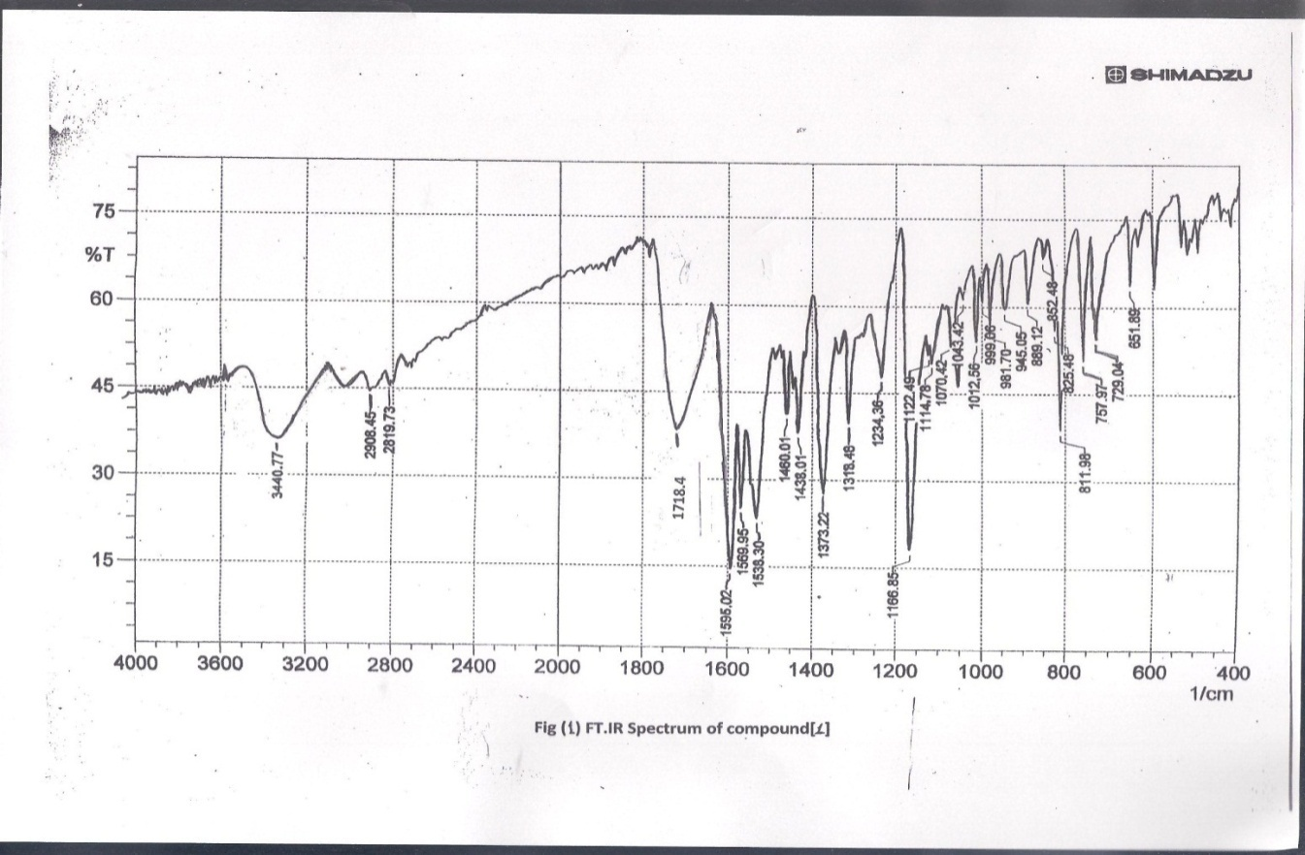
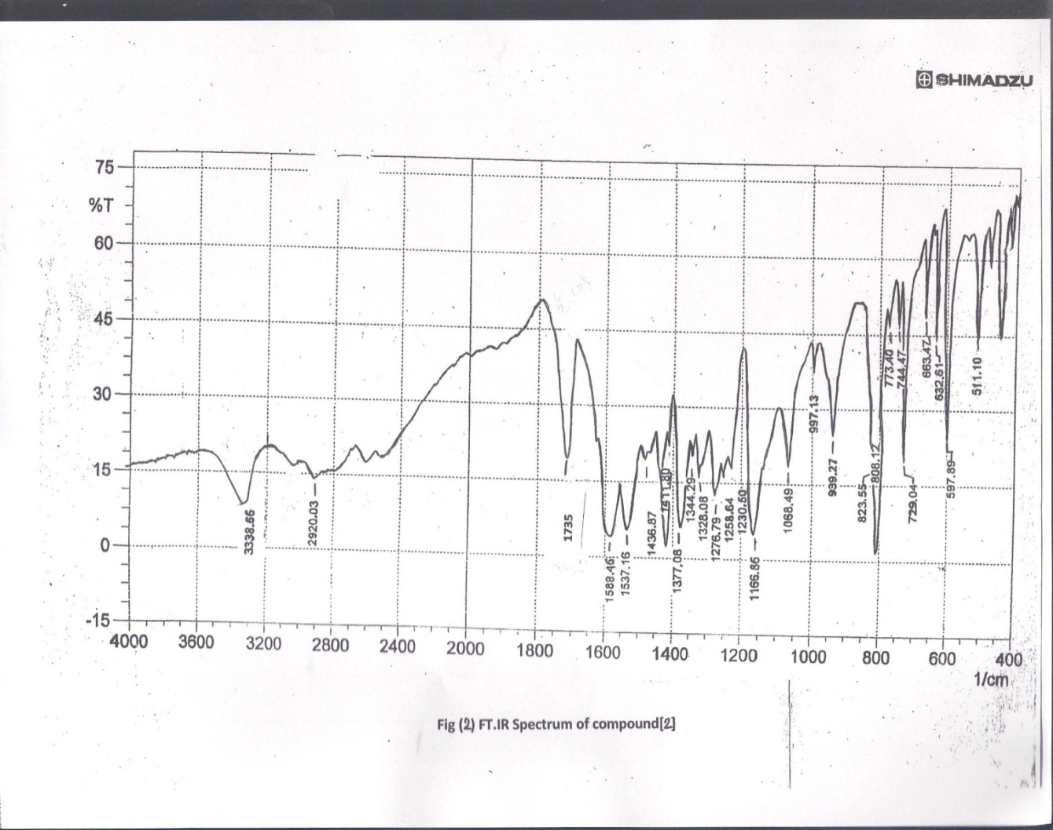
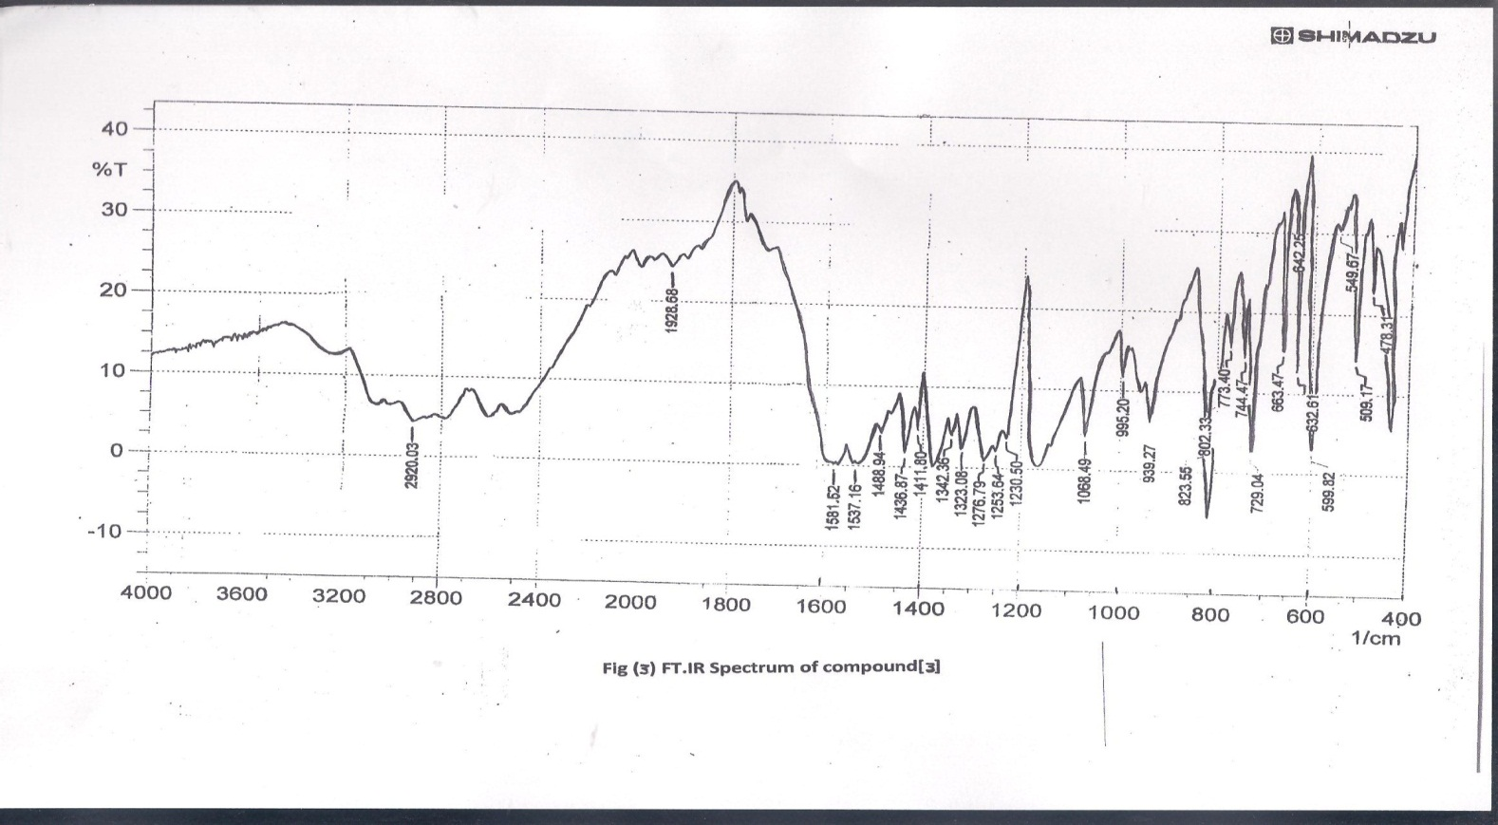
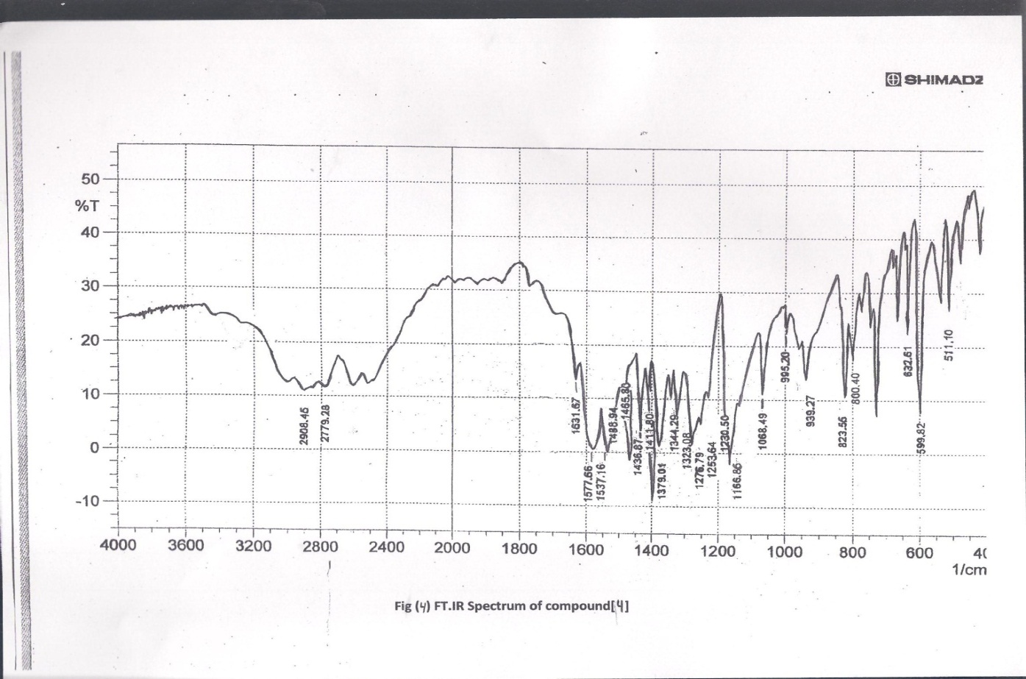
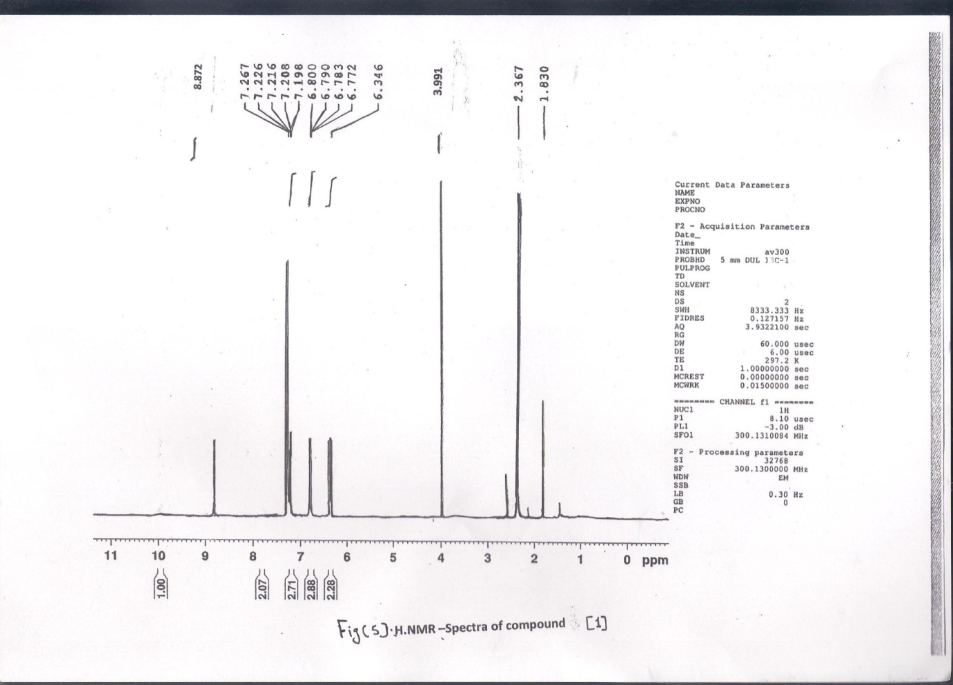
Fig (5) .H.NMR-spectra of compound [1]
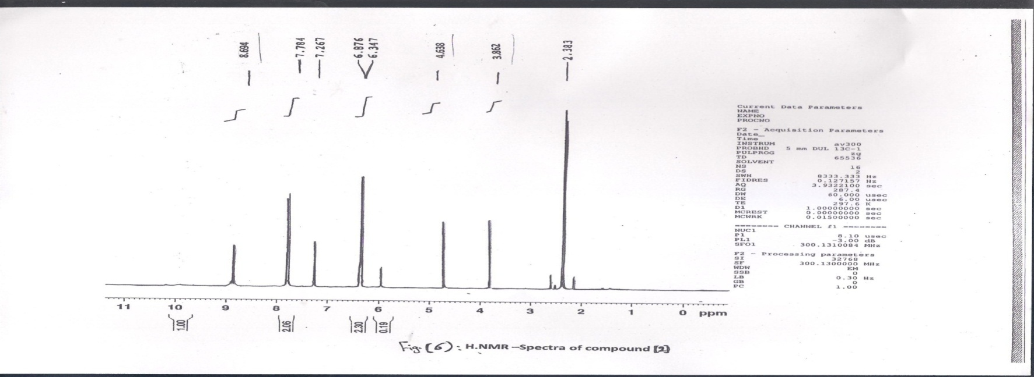
Fig (6) .H.NMR-spectra of compound [2]

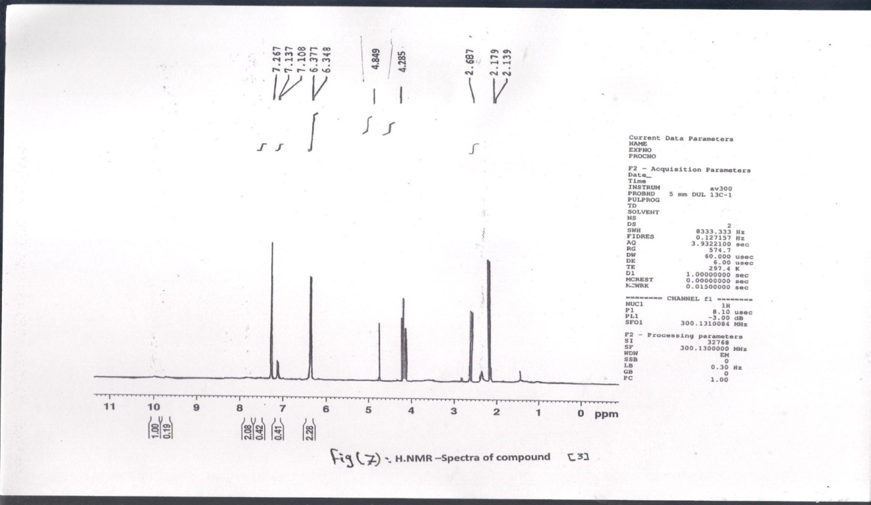
Fig (7) .H.NMR-spectra of compound [3]
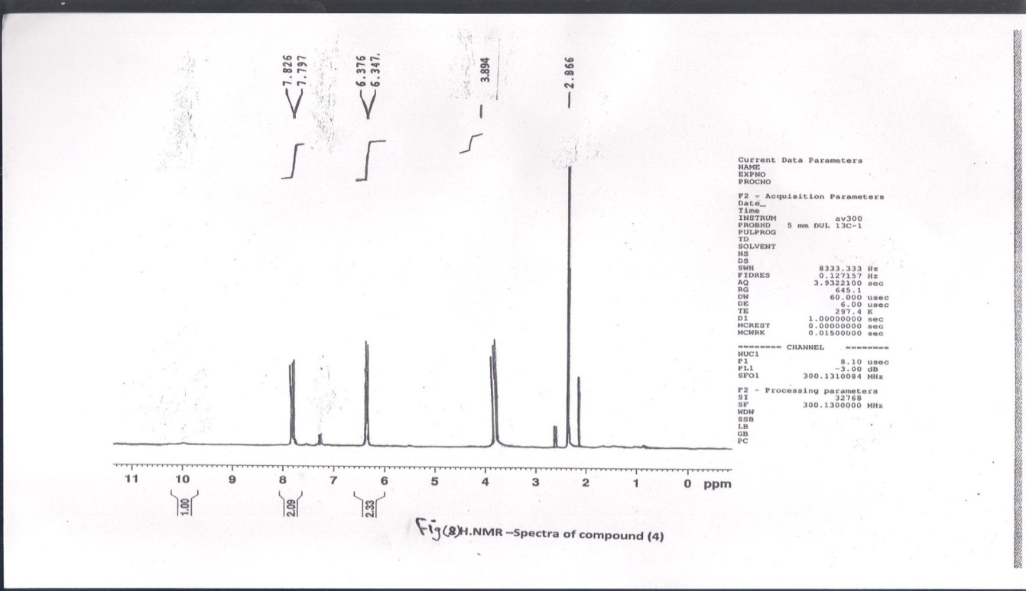
Fig (8) .H.NMR-spectra of compound [4]

References
1 – Wagner .E ,Becan.L and Nowakowska. E., Bioorg .Med . Chem. , 2004, 12 , 265.
2 – Muthukumar. C ,Sabastyan. A ,Ramesh.M ., Int.J.ChemTech.Res ,2012, 4,4,1322-1328.
3 – Kalluraya .B ,lingappa .B and Rai . N ., Phosphorous , sulphur and silicon and related elements., 2007, 182, 1393.
4 – Sridhar .S ,Pandeya . S , Stables . J and Ramesh .A ., Eur . J .Pharm .Science ., 2002, 16 , 129 .
5 – Lingappa .B ,Girisha .K , Balakrishna . K ,Satheesh . R and Nalilu .S .,Tran. Metal.Chem, 2008, 1 , 47B , 1858–1864.
6 – Anil .S , Sanjay . K and Jagir .S .,J.Chem. Soc., 2008, 1 , 67 , 95 – 111.
7 – Dilmaghani .K ,Zeynizadeh . B and Mirzaei .M ., Shiraz , J.Hetero., 2005, 10 , 11.
8 – Xia . J and Wang .G ., Synthesis ., 2005, 2379 – 2383.
9 – Lee . K and Ko .K .,Bull . Korean . Chem. Soc ., 2002, 23 , 1505 – 1506 .
10 – Lee . J and ko .K ,Bull . Korean . Chem. Soc ., 2004, 25 ,19 – 20 .
11 – Arguello .J , Nunez . V , Sturm . J and Suuella .J ., Electrochim . Acta ., 2004, 49 , 4849 – 4856 .
12 -Heravi .M and Ghassemzadeh .M.,Phosphorus. Sulfur& Silicon., 2005, 180,347-351.
13-Heravi,M.,Dirkwand.F,Oskooie.H and Ghassemzadeh.M.,Heterocycle .Common, 2005, 11,75-78.
14 -Nagham.M.Aljamali ., As .J . Exp . Chem. , 2012, 7,1, 52-56 .
15 -.Nagham.M.Aljamali., Am. J.Advs.Res,, 2012, 1, 5, 240-244.
16 -Mehmet. Tuncel and Selahattin. Serin ., Tran. Metal.Chem, 2006, 31, 805-812, cited by IVSL of Iraq.
17 – Nagham. M.Aljamali., Pharm. INNJ., 2013, 1,11,73.
18– Xueguang. Ran ,Lingyun. W ,Derong. C ,Yingcai. L and Jie. H ., Appl.Organometal.Chem , 2011, 25, 9-15, cited by IVSL of Iraq.

