Removing Reactive Orange Dye By Using Ceramic Purifier Type(AKPL1)
Sanaa Abdul-Razak Jassim Hazim Aziz Al-Robai
Technical Institute of Babylon College of Ecology , Qasim Green University
Email: sana_alkalil@yahoo.com Email:hazim_a2005@yahoo.com
Mysson Mahdi Al-Taee
College of Science, University of Babylon

(NJC)
(Received on 13/2/2013) (Accepted for publication 27/5/2013)

Abstract
Ceramic purifier made of Activated Kaolinite , Porcelinite and Limestone(A KPL1) were used to remove reactive orange dye from its solutions by using experiments batch. Operating variables studied were inflow pH and outflow discharge passing through the purifier(AKPL1). The purifier showed efficient ability to remove the dye at different inflow pH in addition to get outflow pH between(7.72 - 8.84). While the outflow discharge through the purifier was affecting the removal ability of the dye. Maximum dye removed was observed at inflow pH 2.25, 0.06 ml/hr outflow discharge.
Keywords: Reactive orange dye, ceramic purifier, adsorption, pH.
الخلاصة
استخدم المنقي الخزفي المصنوع من اطيان الكاؤولينايت مع البورسلينايت المفعل والنورة (AKPL1) في إزالة
الصبغة البرتقالية الفعالة من محاليلها باستخدام تجارب الـ batch . تم دراسة اثر المتغيرات التشغيلية المتمثلة بدرجة الحامضية للمحلول الداخل للمنقي و تدفق المحلول العابر خلال المنقي الخزفي(AKPL1). اظهر المنقي كفاءة في ازالة الصبغة عند درجات مختلفة من الحموضة للمحلول الداخل للمنقي بالاضافة الى الحصول على درجة حموضة تتراوح بين ( 7.72- 8.84 ) للمحلول الخارج. بينما كان لتدفق المحلول العابر خلال المنقي اثر في قابليته على ازالة الصبغة. حيث كانت اعلى نسبة ازالة تمت ملاحظتها عند درجة حموضة 2.25, وتدفق خارج 0.06 مل/الساعة.
الكلمات الدالة: الحامضية. الصبغة البرتقالية الفعالة, المنقي الخزفي, الامدصاص, الحامضية.

Introduction
The major problems concerning environmental pollution are removing colour from water and wastewater produced from industrial activities. Dyes are released into

wastewaters from various industrial units, mainly from the dye manufacturing and textiles and other fabric finishing⁽¹⁾. Most dyes are non-biodegradible in nature which are stable in nature to light and oxidation. Therefore, the degradation of dyes in
wastewater either traditional chemical or biological process has not been very effective^{( 2, 3)}.
Reactive dyes are most problematic compounds among other dyes in textile wastewater. Reactive dyes are highly water-soluble and estimated that 10 to 20% of reactive dyes remains in the wastewater during the production process of these dyes⁽⁴⁾ and nearly 50% of reactive dyes may lost to the effluent during dyeing processes of cellulose fibers⁽⁵⁾. Reactive dye wastewater has limited biodegradability in an aerobic environment and many azo dyes under anaerobic conditions decompose into potentially carcinogenic aromatic amines ⁽⁶⁾.
Adsorption process has been found a prominent method of treating aqueous effluent in industrial processes for a variety of separation and purification purpose ⁽⁷⁾. This technique also found to be highly efficient for the removal of colour in terms of initial cost, simplicity of design, ease of operation and insensitivity to toxic substances⁽⁸⁾. Therefore, adsorption using cheap substances reusable and environmentally friendly are recommended. This has led to search for such materials. Various studies were carried out using different materials to remove dyes from their aqueous. Posidonia oceanic and fiberous biomass were used to adsorb textile reactive dye⁽⁹⁾. Industrial residues were also used for adsorptive removal of reactive azo dyes⁽¹⁰⁾.
Activated carbons prepared from sugarcane and bagasse pith were used to adsorb reactive dye from aqueous solutions⁽¹¹⁾. Effect of solution pH, ionic strength, and temperature on adsorption behavior of reactive dyes on activated carbon were studied. Results indicated that activated carbon can adsorb reactive dyes at acid's pHs ⁽¹² ⁾. A cyclodextrin polymer was used for the removal of cationic dyes from aqueous solution⁽¹³⁾. Cross-linked chitosan, oil pal and ash composite beads were used to remove reactive orange 16 dye ⁽¹⁴⁾. The aqai palm stalk (Euterpe oleracea) is a food residue used in its natural form (AS) and also protonated (AAS) as biosorbents for the removal of the textile dyes C.I. Reactive Black 5 and C.I. Reactive Orange 16 from aqueous solutions⁽¹⁵⁾. Polymer composite as potential biomaterial were used for removal of reactive dye ⁽¹⁶⁾.
This study aimed to test the adsorption of reactive orange dye by using ceramic type(AKPL1).
Materials and Methods
The materials used to produce three Ceramic purifier were made of Activated Kaolinite , Porcelinite and Limestone(A KPL1). The ceramic purifiers were shaped as cylindrical discs with a diameter 5.0 cm and thickness 1.0 cm, by semi dry method
( Fig: 1).

Fig:1. The Produced Ceramic Discs (purifier).

The tests were carried out to find (KPL1) physical properties. They were measured according to ASTM-C373 Standards, 2006⁽¹⁷⁾. The physical properties were: apparent density,1.48gm/cm³, apparent porosity, 47.14,true porosity, 14.9, water absorption, 31.82%, and hydraulic conductivity, 0.0024 m/hr.
Reactive Orange Dye (RO)
The RO dye, an anionic dye used in this study was from Al-Hilla Textile
Factory. It was used without further purification. The aqueous solutions were prepared by dissolving solute in deionized water to the required concentration. A calibration curve of absorbance vs. concentration was constructed by using a UV spectrophotometer (Optima sp-3000 nano). The wavelength of maximum absorbance (_{λmax}) for reactive orange was 475 nm. Calibration curve for RO dye concentration was plotted( Fig: 2) showed the RO dye concentration calibration curve.

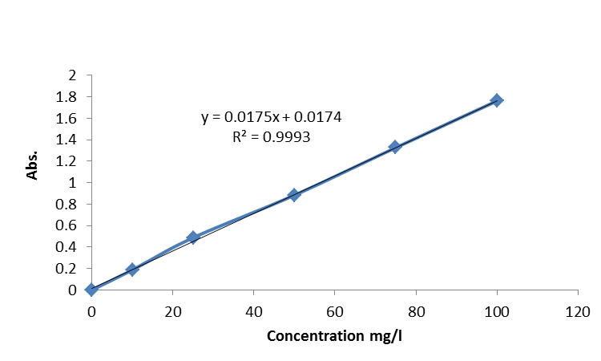
Fig:2. RO dye calibration curve.

Adsorption Test
Adsorption tests were carried out for each produced ceramic disc. The tests were carried out, at room temperature for by passing 250 ml of RO dye solution of known concentration(100 mg L⁻¹) at its natural pH(6), through the ceramic discs and measuring the concentration of dyes before and after passing. The test was started with 25cm RO dye solution column. Which led to average water discharge 2.5ml/hr.
123
Effect of pH
The effect of initial pH of dye
solution on the percentage removal of RO dye was studied by varying the initial pH under constant process parameters. The effect of pH on dye solutions was tested ,and there was no change in the wavelength which indicate that the molecule of RO dye did not degrade. The average water discharge was 2.5ml/hr. The pH of the solutions were adjusted to the required values by adding a few drops of 0.1M HCl or\and 0.1M NaOH.
After equilibrium, the final concentration(Ce) were measured. The percentage removal of dye was calculated by using the following expression:

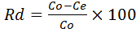
Where Rd is percentage of removal of dye, Co and Ce are the initial and final (equilibrium) concentrations of dye (mg L⁻¹), respectively.

Effect of outflow velocity
Twenty four adsorption tests, including three replication, were carried out to examine the effect of flow velocity through ceramic disc(purifier) on the adsorption of RO dye. four, including three replication, were carried out on a Pre- prepared solution of 100mg/l of RO dye, for the six difference inflow pH. The average velocity of solutions passed through the ceramic disc were measured in terms of discharge (ml/hr) by measuring the volume of purified solution passing out of the ceramic disc at a certain time. The solution velocity was used as indicator to the contact time between the RO dye and the ceramic disc purifier. The high velocity value means low contact time and vice versa.
Results and Discussion
Adsorption test
The ceramic discs ability for adsorption of RO dye from its solutions (conc. 100mg/l at its natural pH 6), were measured. Results showed that ceramic type (AKPL1) could adsorb some of the inflow dye. The outflow concentration of RO dye was 86.4mg/l. which means that AKPL1ceramic adsorbed 13.6% of RO dye at natural condition.
Effect of pH
The results showed that the adsorption efficiency of (AKPL1) was increased at higher and lower pH. As the pH of the dye solution increased from (6.0 to 7.5) the dye adsorption decreased (13.6% to 8.35%). Then when pH increased more to be 9.1 and 10.5 the dye adsorption increased to 17.78% and 47.22 respectively.
While the pH of the solution decreased from (6 to 4.25 and 2.25) the dye adsorption increased (13.6% to 23.78 and 89%) respectively. RO dyes are known to ionized to a high degree in aqueous solutions to form colored anions due to the sulfonate groups in their structures .Two sulfonate groups (SO3⁻) of RO dye are easily dissociated and have negative charges in the aquatic environment. As pH of the system decrease ,the protonated surface group (Si-O-N⁺H₂-C)facilitate the sorption of negatively charge dye. The number of positively charged sites increases resulting in an increase of binding sites for anionic dye molecules⁽¹⁸⁾. The optimum pH was attained at pH 2.25. That means when pH of the solution be in acid range or in alkaline range. In addition to that (AKPL1) could neutralize all the inflows pH to be in the range (7.5- 8.5) as shown in (Table 1). This behavior was referred to the original component of (AKPL1) which is composed of Kaolinite (Al₂Si₂O₅(OH)₄ ,Quartz (SiO₂), Low Cristobalite (SiO₂), Tridoymite (SiO₂), and Calcite (CaCO₃), respectively⁽¹⁹⁾. The structure of Kaolinite is a gibbsite sheet with a single tetrahedral silica sheet, and its water is present as H⁺ and OH⁻ ions⁽²⁰⁾. When the ceramic mixture heated to 1200 C○ water would evaporated. So hydrogen ions and hydroxyl groups would leave their positions with missing positive and negative charges. Then when water with acid's or alkali's pH passes through ceramic it will lose the effective H⁺ and OH⁻ by ceramic adsorption.

Table 1: inflow and outflow pH
Inflow pH | Outflow pH
2.25 | 7.84
4.25 | 8.02
6 | 8.62
7.5 | 8.0
9.1 | 7.72
10.5 | 7.91

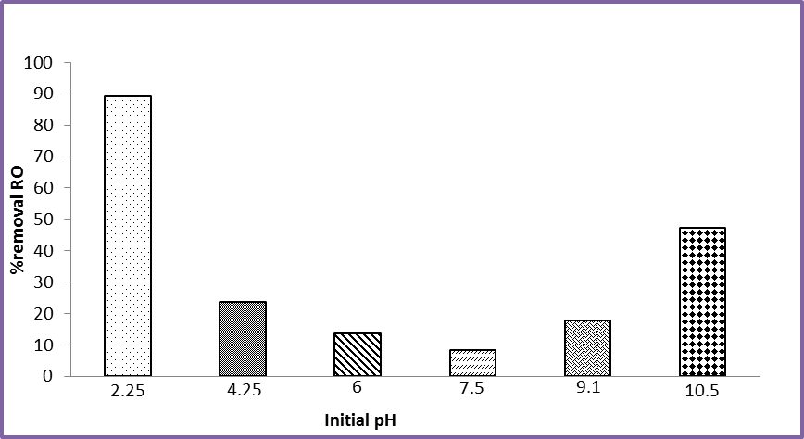
Fig: 3. percentages of removal of RO at different pH.

Effect of outflow velocity

The results of tests that were carried
out to examine RO dye adsorption properties of the produced ceramic filter discs using a pre- prepared solution of 100mg/l of RO, were shown in Figs 4-9. Generally, the results showed that all the ceramic filters could adsorbed RO dye when was passing through at different velocities. The adsorption ability increased when the velocity decreased at different pHs. At best pH 2.25 the removal varies between 89.10 and 98% of the initial concentration of RO dye. Which means that at this pH the ceramic would be very active and it could adsorb the RO dye. While at pH 10.5 the adsorption of RO dye varies between 47% and 90% of the initial concentration of RO dye.
125

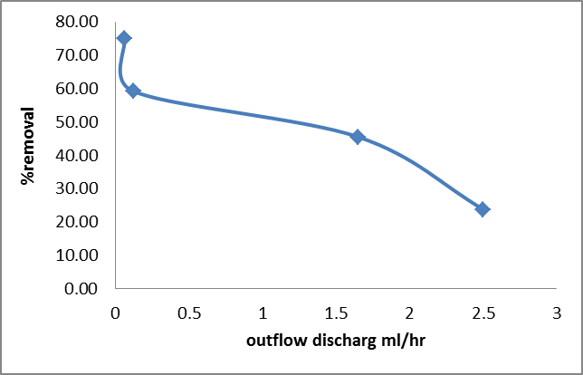
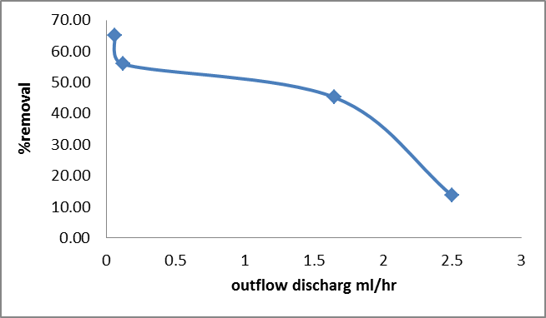

Fig: 4. percentage of removal of RO at pH 6
Fig: 5. percentage of removal of RO at pH4.25
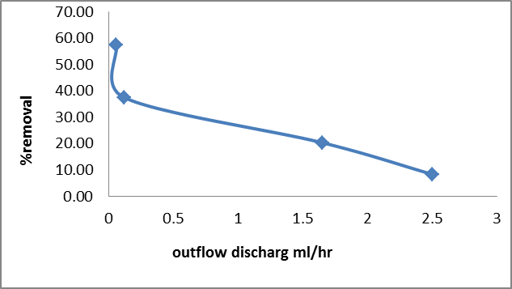
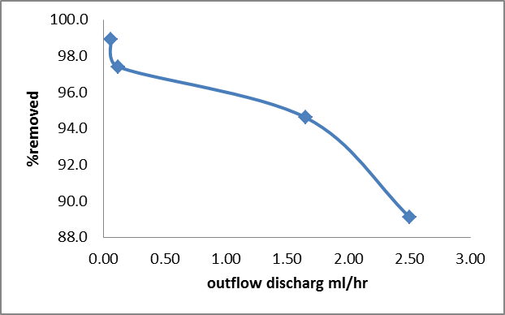
%removal

Fig:6.percentage of removal of RO at pH2.25
Fig: 7. percentage of removal of RO at pH7.5
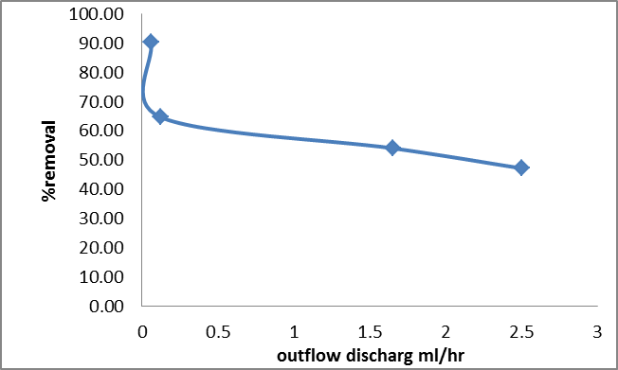
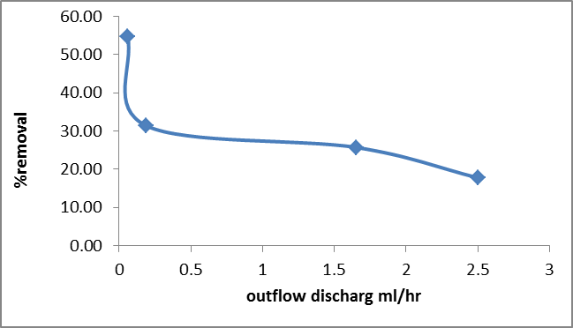

Fig:8.percentage of removal of RO at pH 9.1
Fig:9.percentage of removal of RO at pH10.5

References
- Janos, P., H. Buchtova and M. Ryznarova , J. of Water Res., 2003, 37, 4938.
- Metivier-Pignon, H.,C. Faur-Brasquet and P.L. Cloirec, J. of Sep. Purif. Technol., 2003, 31,3.
- Waranusantigul, P., P. Pokethitiyook, M. Kruatrachue and E. S. Upatham, J. of Environ. Pollut.,2003, 125, 385.
- Koprivanace, N., A. L. Bozic and Papic, J. of Dyes Pigm.,2000, 44, 33.
- Netpradit, S., P. Thiravetyan and S. Towprayoon, J. of Water Res., 2003, 37, 763.
- Panswad, T. and Luangdilok, J. of Water . Res., 2000, 34, 4177.
- Benkli, Y. E., M. F. Can, M. Turan and M. S. Celik, J.of Water Res., 2005, 39, 487.
- Garg, V. K., Amita, M., Kumar, R. and Gupta, R, J. of a timber industry waste. Dyes Pigments, 2004, 63, 243.
- Ncibi, M. C., Mahjoub,B. and Seffen, M, Int. J. of Environ. Sci. Tech., 2007, 4,4, 433.
- Admasu ,Adamu" Adsorptive removal of reactive azo dyes using industrial residue ". M.Sc. Thesis, School of Graduate Studies Addis Ababa University, 2008.
- Amin, Nevine Kamal , J. of Desalination, 2008, 223, 152.
- Yahya S. Al-Degs, Musa I. El-Barghouthi, Amjad H. El-Sheikh, Gavin M. Walker, J. of Dyes and Pigments, 2008, 77, 1 , 6.
- Crini, Gregore, J. of Dyes and Pigments, 2008, 77, 2, 415.
- Masitah , H.; Bassim, H. H.; Latif, A. A.; Zulfakar, M.; Naimah, I.; and Salwa, M. Z. M., J. of Applied Sciences, 2011, 11, 13, 2292.
- Natali F. Cardoso, Eder C. Lima, Tatiana Calvete, Isis S. Pinto, Camila V. Amavisca, Thais H. M. Fernandes, Rodrigo B. Pinto, and Wagner S. Alencar, J. of Chemical & Engineering Data, 2011, 56, 5, 1857.
- Palanisamy, P. N., Agalya, A., and Sivakumar, P., J. of Chemistry, 2012, 9, 4, 1823.
- ASTM C373– 88, 2006,Standard Test Method for Water Absorption, Bulk Density, Apparent Porosity, and Apparent Specific Gravity of Fired Whiteware Products, http://www.astm.org/Standards/C373.htm.
- M.S. Chiou and H.Y. Li, J. of Chemosphere, 2003, 50,1095.
- General Company of Geological Surveying and Mineralization, 2008, "Chemical and Physical Specifications of Industrial Produced Rocks". Iraq.
- Siddiqui, M. K. H., 1968, Bleaching Earths, Regional Research Laboratory, Hyderabad, India, Printed in G. B. by A. Wheaton & Exeter.

127

