Preparation of New transition and non-transition metals complexes
with N-acetylglucose amine(NAGA)

Ammar Abd-Aljabar Aziz;
Dept. of Pharmacy, Technical Institute Mosul
E-mail : shakirmsaied@yahoo.com

(NJC)

(Received on 19/12/2012) (Accepted for publication 27/5/2013)

Abstract
New transition and non-transition metals complexes were prepared by coordination of Mn(II) with each of Zn(II) , Cd(II) and Hg(II) metals and Fe(II)with each of Zn(II) , Cd(II) and Hg(II) with the ligand L = N-acetylglucose amine(NAGA) in 1:1:4 molar ratio. The metal ions were tridentate bonded to the ligand in the complexes. Complexes have been synthesized by three routes, conventional direct reaction in neutral medium and by microwave and altrasoud irradiation to give complexes of the general formula [MM/ (NAGA)₄] Cl₄ . The percentage yield were (50-60 , 80-90 and >95 and the reaction time (300,5,120 minutes respectively) of the first, second and third routes .
Physical measurements including IR and UV / Visible spectra, CHN analysis and molar conductivity measurements showed octahedral geometry around the metals. This geometry (three dimensional structure) of complex (i) as representative of these complexes at minimized energy was established by chem.3D Ultra; molecular modeling and analysis confirmed the suggested structure.

Keywords:N-Acetylglucose amine, Fe and Mn Transition and Zn , Cd and Mn non-transition Metal complexes

الخلاصة
تم تحضير معقدات فلزات العناصر الانتقالية وغير الانتقالية بوساطة تناسق فلز المنغنيز مع كل من الزنك والكادميوم والزئبق وكذلك فلز الحديد مع كل من فلز الزنك والكادميوم والزئبق مع الليكاند N استيل كلوكوز الامين بنسبة مولارية11:4: .وقد اعطت هذه الفلزات معقدات ثلاثية السن .حضرت هذه المعقدات بوساطة ثلاث مسالك للتفاعل , التقليدي المباشر (بوسط متعادل) او بالتشعيع بالميكروويف او بالأمواج فوق الصوتية لا عطاء معقدات ذات الصيغة[MM/ (NAG)₄] Cl₄ . كانت نسبة المنتوج (50-60 % , 80- 90 % واكثر من 95% ) ووقت التفاعل ( 300 / 5 / 120 دقيقة على التوالي) للمسالك الاول والثاني والثالث على التوالي.
القياسات الفيزيائية والمتضمنة أطياف الأشعة تحت الحمراء وفوق البنفسجية – المرئية والتحليل الدقيق للعناصر اضافة الى التوصيلة الكهربائية المولارية اعطت معقدات ثنائية النواة ثمانية السطوح . اثبتت هيئة المعقد(i) (بشكله الثلاثي الابعاد) كممثل عن بقية المعقدات وبالطاقة الدنيا والتي اثبت الإشكال المتوقعة.

Introduction
N-Acetylglucosamine (NAGA) (N-acetyl-2-amino-2-deoxy-D-glucose) is a monosaccharide derivative of glucose. It is an amide between glucosamine and acetic acid. It is significant in several biological systems. It is part of a biopolymer in the bacterial cell wall, built from alternating units of NAc and N-acetylmuramic acid (MurNAc), cross-linked with oligopeptides at the lactic acid residue of MurNAc. This layered structure is called peptidoglycan. GlcNAc is the monomeric unit of the polymer chitin, which forms the outer coverings of insects and crustaceans. It is the main component of the cell walls of fungi, the radulas of mollusks, and the beaks of cephalopods. Also it has been proposed as a treatment for autoimmune diseases^{[1]}. N-Acetylglucosamine (NAGA) derivatives were used for the treatment of arthritis and osteoporosis in rats^{[2]}.N-acetylglucosamine residue in Chitin was proved to be with a potential biocontrol agent for phytopathogenic fungi^{[3-4]}. The combined antifungals activity of NAGA and antimicrobial activity of heavy metals with a view to establish the relationship and importance of metal-drug interactions have been studied . Especially, the metal complexes of NAGA have been found to be more fungistatic than the drugs themselves^{[5]}.
Because of the complexes are more active than the parent ligands^{[6]}. The studies of bi-metal complexes of NAGA ligand of active amide nitrogen of anticipated biological activites have been reported in present work and to decrease the time of complexation a microwave irradiation was used to increase the yield in addition to simple, sensitive and reducing solvent amount^{[8]}, ultrasound irradiations techniques were used here^{[9]}
Experimental
IR Spectra were recorded on Shimadzu FT.IR(4800S) Spectrometer at a range
(200-4000) cm⁻¹ using KBr discs and Ultrasonic bath Digitas in Alhukamaa Drug Industry(Mosul-Iraq). Electronic spectra were recorded on a Shimadzu UV/Vis Spectrophotometer UV- 160 for 10 ⁻³M solution of the complexes in DMF at ambient temperature (25 ^{O}C), this solvent was also used for molar conductivity measurements.
The elements analysis were carried out using Analytical Functional Testing AFT, Vario EL. II chn ANALYZER . Heat of formations and steric energies of products in addition to the geometry (three dimensional structure) of complexe (II) at minimized energy (MM2) were established by Chem3D Ultra; Molecular Modeling and Analysis.

Preparation of Complexes:

1-Method A(Conventional direct reaction):

Ethanolic solution of NAGA (40mmol) was added to a mixture of equimolar amounts(10mmole) of metal salts MCl₂(M = Mn(II) or Fe(II) ) and M/Cl₂ (M/ = Zn(II) , Cd(II) or Hg(II) ). This result mixture was refluxed for 5hrs,cooled to R.T. and the solid product was filtered and washed with ethanol and dried in oven . Method and physical properties spectral data of the complexes were listed in Table (1), while spectral data were listed in Table (2).

2- Method B(Microwave irradiation): ^{[10]}

Ethanolic solution of NAGA (40mmol) was added to a mixture of equmolar amounts(10mmole) of metal salts MCl₂(M = Mn(II) or Fe(II) ) and M/Cl₂ (M/ = Zn(II) , Cd(II) or Hg(II) was placed in a flask and mixed with a spatula for a few min. The reaction mixture were placed in an open conical flask in a domestic microwave and irradiated for 6 minutes at 800 W( without stirring) . The solid mixture was allowed to attain RT. On completion of the reaction, mixture was cooled at room temperature the product was washed with ethanol and dried in oven . %Yields of this method were listed in Table (1).

3- Method C (Ultrasound irradiation technique)^{[11]}:
Ethanolic solution of NAGA (40mmol) was added to a mixture of equmolar amounts(10mmole) of metal salts MCl₂(M = Mn(II) or Fe(II) ) and M/Cl₂ (M/ = Zn(II) , Cd(II) or Hg(II) was placed in a flask and mixed with a spatula for a few min. The reaction mixture were placed in an open conical flask in a ultrasound bath and irradiated for 120 minutes ( without stirring). The solid mixture was washed with ethanol and dried in oven . %Yields of this method were listed in Table (1).

Table (1) : Methods and physical properties of ligand and the complexes(i-vi).

No. | Formula of  Ligand / complexes* | Color | Yield % ,  Method |  |  | Elemental analysis % |  |  |  |  |  | Conductivity  (Ohm⁻¹ cm² mol⁻¹)
No. | Formula of  Ligand / complexes* | Color | A | B | C | C |  | H |  | N |  | Conductivity  (Ohm⁻¹ cm² mol⁻¹)
 |  |  |  |  |  | Found | Calculated | Found | Calculated | Found | Calculated | Conductivity  (Ohm⁻¹ cm² mol⁻¹)
L | C₈H₁₅NO₆ | Yellow | ----- | ---- | ----- | ----- | ----- | ----- | ----- | ----- | ----- | -----
i | [MnZn(NAGA)₄]Cl₄ | Orange | 60 | 80 | 96 | 27.99 | 28.13 | 4.55 | 4.43 | 4.55 | 4.10 | 150
ii | [MnCd(NAGA)₄]Cl₄ | Orange | 60 | 80 | 96 | 24.77 | 24.73 | 3.90 | 3.89 | 3.89 | 3.89 | 140
iii | [MnHg(NAGA)₄]Cl₄ | Brown | 55 | 85 | 96 | 20.00 | 20.15 | 3.23 | 3.17 | 3.00 | 2.94 | 120
iv | [FeZn(NAGA)₄]Cl₄ | Orange | 60 | 90 | 97 | 28.22 | 28.06 | 4.50 | 4.41 | 4.12 | 4.09 | 130
v | [FeCd(NAGA)₄]Cl₄ | Orange | 58 | 80 | 97 | 24.70 | 24.67 | 3.77 | 3.88 | 3.10 | 3.60 | 145
vi | [FeHg(NAGA)₄]Cl₄ | Brown | 50 | 85 | 96 | 20.33 | 20.21 | 3.20 | 3.17 | 3.10 | 2.93 | 150
*All these complexes were decomposed . 300⁰C (MP of NAGA ligand is 211 ⁰C ).

Table (2): Spectral data of ligand and the complexes(i-vi).

No. | UV (EtOH)  d-d transitions λ max | I.R (KBr) , υ cm ⁻¹
No. | UV (EtOH)  d-d transitions λ max | C-OH | C-NH | M-O | M-N
L
i | 20830, 22522, 22935 | 1220 | 1640 | 530 | 750
ii | 19720, 22430, 23150 | 1200 | 1650 | 520 | 750
iii | 20580, 23100,23940 | 1200 | 1650 | 570 | 750
iv | 11860, 23795, 30138 | 1230 | 1650 | 530 | 740
v | 14016, 24560, 27720 | 1240 | 1640 | 525 | 730
vi | 11600, 25750, 29130 | 1230 | 1640 | 535 | 760

Results and Discussion
N-Acetylglucosamine (NAGA) (N-acetyl-2-amino-2-deoxy-D-glucose), Fig (1)

was coordinated with equimolar amounts of metal salts salts MCl₂(M = Mn(II) or Fe(II) ) and M/Cl₂ (M/ = Zn(II) , Cd(II) or Hg(II) using three routes, conventional direct reaction in neutral medium , by microwave irradiation or ultrasound irradiation to give complexes of the general formula [MM/ (NAGA)₄] Cl₄, Fig (2) showed complex (i) as representative for these complexes.

In the formation of unsymmetrical complexes microwave routes were 100 times faster than conventional route in stoichmometric reaction of metal chlorides with monofunctional bidentate ligands(2-hydroxy-N-phenyl benzamide) ^{[9]}.
In this work complexes have been synthesized by three routes, conventional direct reaction in neutral medium , microwave and ultrasound irradiation to give complexes of the general formula [MM/ (NAGA)₄] Cl₄ . The percentage yield were (50-60 , 80-90 and >95 and the reaction time (300,5,120 minutes respectively) of the first, second and third route . All the complexes have different colors and stable in air. The metal chelates shows decomposition point. Although these complexes were insoluble in water they were soluble in organic solvents such as DMF, DMSO with different colors to the solutions. All compounds gave satisfactory CHN elemental analysis with values in close agreement with the values calculated for expected molecular formulae , Table (1). Also the molar formula of these complexes were proved by the IR and UV-Visible spectra in addition to molar conductivity.
Uv spectra for these complexes Table (2) showed absorption bands attributed to N-acetylglucose amine (NAGA) in its complexes, these bands due to d-d transitions^{[12]} and indicated that these complexes were octahedral geometry^{[13]}.
The conductivity measurements in 10⁻³ M DMF have indicated that these complexes were ionic ^{[14-16]}.
A study and comparison of infrared spectra of free ligand and its metal complexes (Table 2) inferred that the ligand behaved as neutral tridentate and its metals are coordinated through N and two neighboring OH of glucose ring Fig (3).

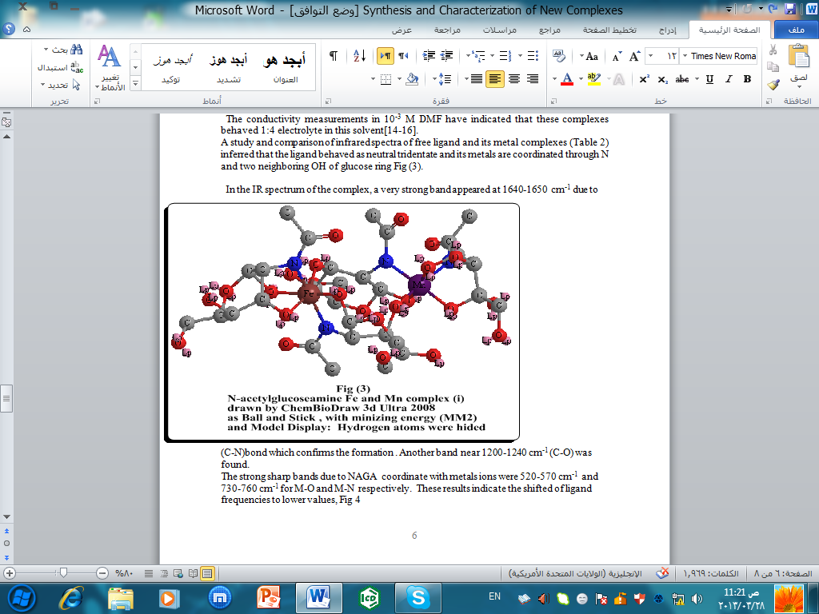

In the IR spectrum of the complex, a very strong band appeared at 1640-1650 cm⁻¹ due to (C-N)bond which confirms the formation . Another band near 1200-1240 cm⁻¹ (C-O) was found.
The strong sharp bands due to NAGA coordinate with metals ions were 520-570 cm⁻¹ and 730-760 cm⁻¹ for M-O and M-N respectively. These results indicate the shifted of ligand frequencies to lower values,Fig4

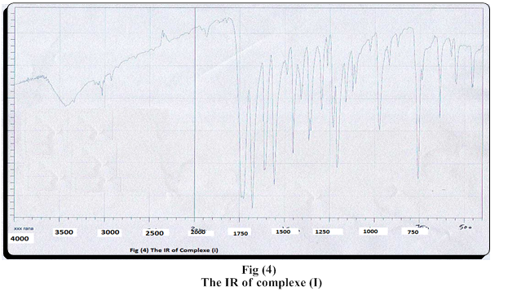

Acknowledgements
The author wish to express his gratitude for Al-Hokamaa Drug Industry Sofyan A. Abed Alla , Asst. Lecturer in pharmacy, for help in Ultrasound irradiation in their laboratory. He also thanks Ninava Drug Industry for (the IR spectra).

References
1-A.Pearson;(2007; New Scientist, 2607.
2-T. Anastassiades1; K Rees-Milton1 ; T. Anastassiades; K. Rees-Milton1; M. Grynpas and M.Grynpas; European Cells and Materials, 2008, 16. Suppl. 4,41.

3-D. Giridhar , Journal of Cell and Tissue Research, 2012.

4-Y.Yamashita and K.Okazaki, 2004; 68(10), 2193-2196.
5-X.Wang; Y. Du and; H.Liu, Carbohydrate Polymers, 2004, 56; 21–26.
6-M. K. Samota and G. Seth; Heteroatom Chemistry; 2010, 21, Issue 1; 1–50.
7- P. S. Verma and G. Seth, RJPBCS ; 2012, 3 Issue 1 ; 435.
8-B.T. Thaker and R.S. Barvalia, Acta Part A, 2011, 84 ; 51– 61.
9-B.Ildusovisov; O.V.Kharisov and U.O.Mendez, Ackmez Mudho; 2011, CRC Press; 107-125.
10-B.T. Thaker and R.S. Barvalia, Spectrochimica Acta Part A, 2011, 84 ; 51– 61 .
11-J.T.Li; X.H. Zhang and Z.P. Lin, Beilstein J Org Chem. 2007; 3: 13.
12-E.Koning and F. Madeji; Inorganic Chemistry Journal; 1967, 6; 48
13-D.F.Gerimaro;F. Mangas and B.Maria;" New Hepta Coordinated Organiotin II Complexes); J. Braz.Chem.Soc; 1999, 10 ; 21
14-N. Singh; n. k. Singh and C. Kaw, Bull.Chem.Soc.Japan; 1989, 62; 3328
15-R.C.A.Agarwall; B.Singh and S.Singh, Indian J. Chem.; 1982, 59; 269

