Preparation and Characterization of Nickel complex with new azo ligand 1- (6-bromo-benzothiazolyl )-azo]-2-hydroxy-3-naphthoic acid (6-BrBTANA)

Kassim Hassan Kadhim Hussein Abd Mohammed Nada Hassan Hussein
Dept. of Chemistry , College of Science , University of Babylon
Babylon-Iraq
Email: nada_ha2010@yahoo.com

(NJC)

(Received on 18/2/2013) (Accepted for publication 23/4/2013)

Abstract
A new heterocyclic azo dye 1-[(6-bromo-benzothiazolyl )-azo]-2-hydroxy-3-naphthoic acid (6-BrBTANA) was synthesized by coupling diazotized of(2-amino-6-bromo benzothiazol) (2-ABrBT) with 2-hydroxy-3-naphthoic acid in alkaline alcoholic solution.The organic compound was characterized by elemental analysis and spectrophotometric method such as Infra- red and electronic spectra . A sensitive and selective spectrophotometric method is proposed for the rapid determination of Nickel(II) using (6-BrBTANA), as anew spectrophotometric reagent. The reaction between this reagent and Nickle(II) is instantaneous at λ_{max} 614 nm and pH=6 to form a violet complex having a molar ratio of 1:2 (Ni – 6-BrBTANA) .The molar absorptivity of the complex is (1.112*10⁴ L.mol⁻¹.cm⁻¹) and the stability constant was found to be 3.33*10⁹ L².mole⁻². The physical and spectral studies of the solid complex indicated octahedral coordination via N and O atoms of azo and hydroxyl group respectievely and N in thiazolyl ring.
الخلاصة
تم تحضير صبغة ازو جديدة غير متجانسة الحلقة وهي 1-(6-برومو- بنزوثيازوليل ازو )-2-هيدروكسي-3-حامض النفثوك من ازدواج (2- امينو 6- برومو بنزو ثايوزول ) مع 2-هيدروكسي-3-حامض النفثوك في محلول قاعدي كحولي وقد شخص المركب العضوي بوساطة التحليل الدقيق للعناصر والطرق الطيفية باستخدام الاشعة تحت الحمراء والاطياف الالكترونية كما تضمن البحث تقدير النيكل(II) بطريقة طيفية حساسة وانتقائية وسريعة بأستخدام الليكاند(6-BrBTANA) .ان التفاعل بين الليكاند المذكور وايون النيكل يكون سريع وحساس عند الطول الموجي للامتصاص الاعظم 614 نانوميتر وpH=6 ليعطي معقد بنفسجي اللون وبنسبة مولية (2:1) من الايون الفلزي الى الليكاند.وكان معامل الامتصاص المولاري للمعقد 1.112*10⁴ لتر.مول⁻¹.سم⁻¹ وثابت الاستقرارية 3.33*10⁹ لتر² مول⁻². الدراسات الفيزياوية والطيفية للمعقد الصلب بينت ان المعقد ياخذ الشكل الثماني السطوح ويتم التناسق عبر ذرة نايتروجين مجموعة الازو وذرة اوكسجين مجموعة الهيدروكسيل وذرة نيتروجين حلقة الثيازول.
Keywords: أصباغ الأزو , ثيازوليل أزو , نيكل (II)

Indroduction
Azo dyes contain the largest group of organic reagents used in spectrophotometric analysis. They also are found in a variety of industrial applications mainly because of their colour fastness and low price. Azo dyes are also used for colouring numerous consumer goods, such as leather, clothes, food, toys, plastics and cosmetics ^{[1].}
Benzothiazoles are heterocyclic compounds with multiple applications. Thiazolylazo dyes are sensitive chromogenic reagents, in addition to being interesting complexing agents. These dyes have been used as reagents for spectrophotometric and extraction photometric determination of metal ions^{[2].}
The importance of the determination of heavy metal ions, such as nickel, in environment samples can hardly be overemphasized because they have undoubtedly a serious potential hazard to the human organism ^{[3]}.

Several techniques have been used for the determination of nickle in different samples , such as Atomic absorption spectrophotometry (AAS) using Flame atomic absorption spectrophotometry (FAAS)^{[4]} or Electrothermal atomization Atomic absorption spectrophotometry (ETAAS) ^{[5,6]}, high performance liquid chromatography ^{[7,8]}, chelation ion chromatography ^{[9,10]}, electroanalytical techniques ^{[11-13]},Neutron activation analysis (NAA)^{[14]} , X-ray fluorescence (XRF)^{[15],} and spectrophotometric methods^{[16,17]}.
The main reagents available for spectrophotometric determination of nickel are p-Methoxyphenylazo-bis-acetoxime ^{[18]}, alzarine red ^{[19]} , 1-(2-Benzothiazolylazo)2,3- naphthalenediol^{[20]},2-(5-Bromo-2-pyridylazo)-5-diethylamino phenol ^{[21]} , 2-(2-Thiazolylazo)-5- dimethylaminophenol^{[22]}, 1-(2-Thiazolylazo)-2- naphthol^{[23]}. 5-(6-methoxy-2-benzothiazoleazo)-8-aminoquinoline ^{[24]}.
In this work we describe here the synthesis of new heterocyclic azo liqand 1-[(6-Bromo- 2-benzothiazolyl)azo] -2-hydroxy-3-naphthoic acid and used it for spectrophotometric determination of nickel (II).

Experimental
Apparatus
IR spectra , in the 4000 – 400 cm⁻¹ range by using KBr disk were recorded on FTIR-8400 S Shimadzu fourier. transform. infrared. spectrophotometer. (Japan) . absorption spectra were measured on a T80 UV- Vis spectrophotometer and absorbance were measured on Apel PD - 303UV- visible spectrophotometer using 1cm quartz cells,.A pH meter model WTW multi 740 were used to adjusted and measure the pH of the solution , melting point were measured using SMP30 Stuart,UK., Elemental analyses were carried out on a EURO EA3000 single elemental analyzer(Europe).
The magnetic susceptibility measurements were carried out by using a magnetic susceptibility balance MSB-MKI, The molar conductivity for the solutions was measured by using a conductivity potentiometer INOLAB 740

Reagents
All reagents were used of analytical grade . distilled water was used for preparation of solution .

Synthesis of 2-Amino 6- Bromo Benzothiazol (2-ABrBT)^{[25]}
2-ABrBT is prepared by mixture of 4.3 gm (0.025 mol) of p-bromo aniline and 3.8 gm (0.005 mol) of ammonium thiocyanate were dissolved in 70 ml glycial acetic acid at 10 ºC was added by dropwise from burette (1.2 ml Br₂ + 15 ml glacial acetic acid). After 15 min add alkaline solution to precipitating the thiazole derivative .

Synthesis of the liqand 1-(6- Bromo 2- benzothiazolylazo)-2-hydroxy-3-naphthoic acid^{[26]}
A 1.14 gm ( 0.005 mol) of thiazole was dissolved in in 5 ml of HCl(37%) and (20ml) glacial acetic acid and cooled to 0˚C in ice-bath. After that, add dropwise of solution ( 0.34 gm NaNO₂ +20ml H₂O ) with stirring at 10 °C to form the diazonium salt , separately A(0.94 gm ,0.005 mol) of 2-hydroxy -3-naphthoic acid and (3 gm) of NaOH was dissolved in (50ml) of D.W and cooled to (0-5˚C) , the above diazo-salt solution was added dropwise to this solution with vigorous stirring , after mechanically stirring for a further 2 hours ,the mixture was allowed to stand overnight , A red solution was producted ,the crude product was obtained by pouring in D.W and filtering .Apurified red _brown solid was obtained by filteration and recrystallization with ethanol .Its percentage yield was 74% and the m.p = 213. Elemental analysis, C18H10SO3N3Br(M.wt=428.193g.mol⁻¹) required; 49.91%C,2.80%H , 9.75%N ,and 3.48%S. Found; 50.49%C, 2.33% H , 9.81% Nand 3.73%S.

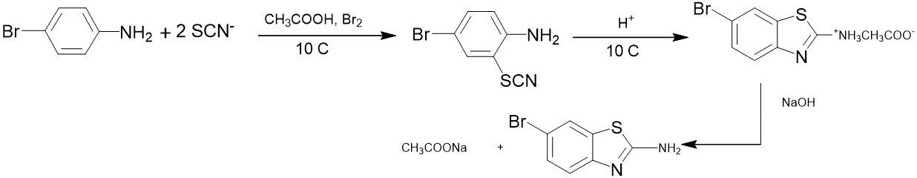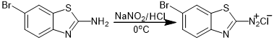

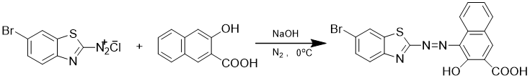

Standard solution of Nickel
A solution of Ni(II) (0. 01 M)was prepared by dissolving (0. 237 gm) of NiCl₂.6H₂O in (100 ml)distilled water. Other standard solutions of Ni(II)

were prepared freshly by dilution of stock solution

6-BrBTANA solution
(1*10⁻³) M.from 6-BrBTANA (0.0429 gm) was dissolved in 5 ml of absolute ethanol, this was transferred into a100 ml calibrated flask and diluted up to the mark with absolute ethanol.
General procedure
Into a 5ml standard flask , transfer 1ml of sample solution containing (1*10⁻³) of Nickel (II) and 2ml of (1× 10⁻⁴) M (6-BrBTANA) solution ,dilute to the mark with distilled water, adjust pH around 6 ,mix well and after 5 min measure the absorbance of solution at 504 nm at 30˚C in a 1 cm quartz cells against a liqand blank prepared in the same condition .

Results and Discussion
FTIR Spectrum of the Liqand (6-BrBTANA)
The active sites of the ligand and their bonding to the metal ions were characterized by careful comparison of the main Infrared absorption bands of the free ligand and the complex (Table 1) .^{[27]}

Table (1 ):The IR spectral data of the ligand and it complex
(KBr,cm⁻¹)
Ni-6-BrBTANA. | 6-BrBTANA | Bond
3300-3500 | 3200-3600 m | υ (O-H)
1633 s | 1710 m | υ (C=O)
1585 m | 1627m. | υ (C=N)
1529 m | 1529 m | υ (C=C)
1448 s | 1490 s | υ (N=N)
1274 m | 1274 m | υ (C-S)
1396 w  950 w | 1392 m  990 m | υ (C-N)
Under 400 | - | υ (M – O)
Under 400 | - | υ (M – N)

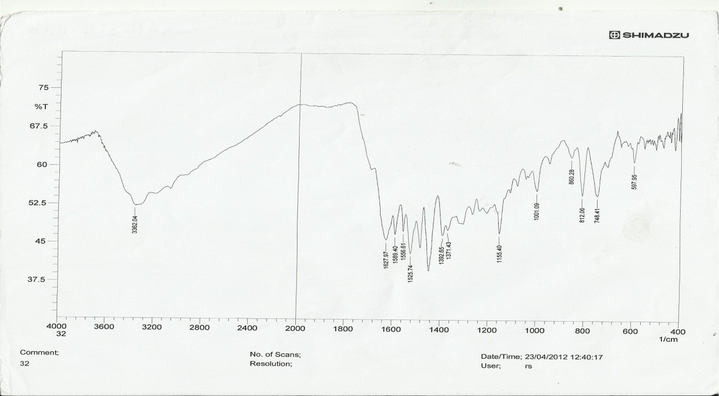
Fig(1);FTIR-Spectrum of Liqand (6-BrBTANA)
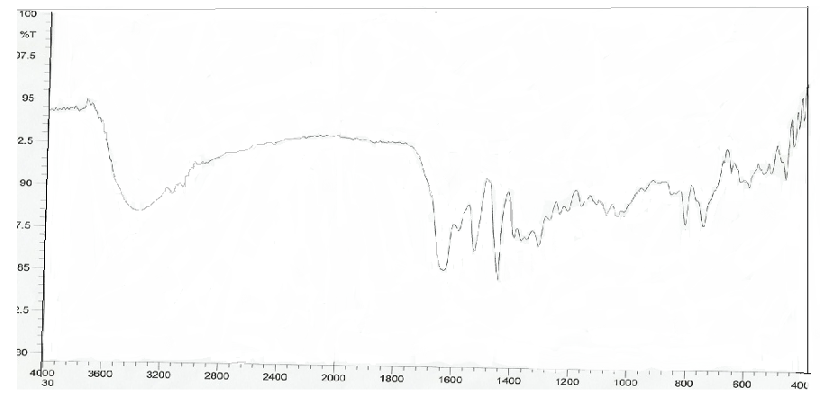Fig (2 ) FTIR –Spectrum of complex ( Ni- 6-BrBTANA)

Absorption spectra
A-Ultra violet - visible absorption spectra of (6-BrBTANA) liqand, and (Ni – 6-BrBTANA) complex under the optimum condition are shown in figure (3) . the reagent show the absorption band at 504 nm and the complex (Ni – 6-BrBTANA) at 614 nm at pH 6.

Fig. (3): Absorption Spectra of A : 6-BrBTANA liqand and B: Ni- 6-BrBTANA complex .
A
B

Effect of pH
The influence of pH complex was studied over the range (2-8) adjusted by means of dilute HCl and NH₄OH solution; fig( 4)shows the relationship between absorbance and pH , where the maximum absorbance obtained in the range of pH=(4.5 - 6.5) . At 6.5≤pH≤4.5a decrease in absorbance . Therefore , the optimum pH was 6.0, where the absorbance was maximum and stable.

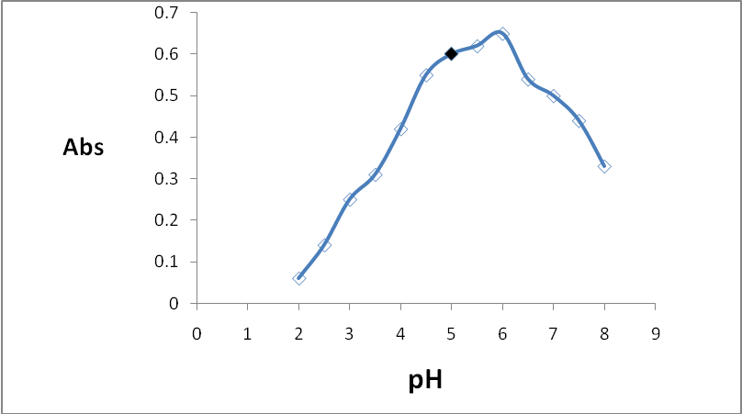
Fig(4):-Effect of pH on the absorbance of nickel complex ( Ni-6-BrBTANA) , λ_{max}=614 nm

Effect of temperature
The effect of temperature on the absorbance of the Ni-6-BrBTANA complex was studied. The study was performed at temperature between 10ºC and 70ºC fig(5 ). The maximum absorption was obtained when the temperature was varied between 10ºC and 40ºC ,the absorbance gradually decreased with increasing temperature until it reaches 70ºC which may be due to dissociation of the complex.

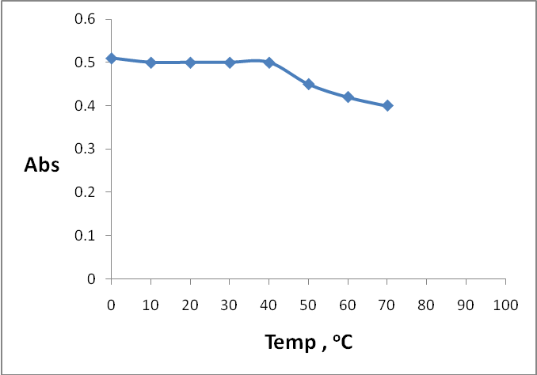
Fig.(5): Effect of temperature on the stability of Nickle complex ( Ni-6-BrBTANA) , λ_{max}=614 nm

Effect of time
It was found that the absorbance of Ni-6-BrBTANA complex chromogenic system reaches its maximum value with in 10 min at room temperature and remains stable for at least 24 hr. Fig(6 )

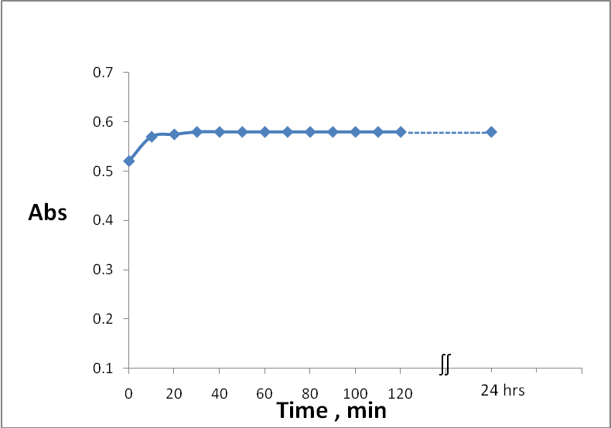
Fig.(6): Effect of Time on the stability of nickel complex( Ni-6-BrBTANA), (λ_{max}=614 nm)

Composition of complex and stability constant
The complex composition was determined by job's and mole-ratio methods [ fig ( 7,8) ] ,both methods indicated that the complex has a molar ratio of (1:2) (M:L) at pH 6 , and the stability constant (K_{stab.}) and (α) of complex was found to be (3.33*10⁹ L².mol⁻²) and (0.397) respectively by using the following equations:
$K_{\text{stab}\text{.}}=\frac{1}{K_{\text{inst}\text{.}}}$
$$K_{\text{inst}\text{.}}=\frac{(αc)\text{.}(nαc)^{n}}{c(1−α)}$$
$$α=\frac{E_{m}−E_{s}}{E_{m}}$$
Where α =dissociation degree . c =total conc.of the complex=1 x10⁻⁴., n =mole ratio = 2 .E_{m} = absorbance of a solution containing reagent two times excess than the amount of nickle . E_{s}= absorbance of a solution containing a stoichiometric amounts [reagent] = [ nickle] = 1 x10 ⁻⁴ .

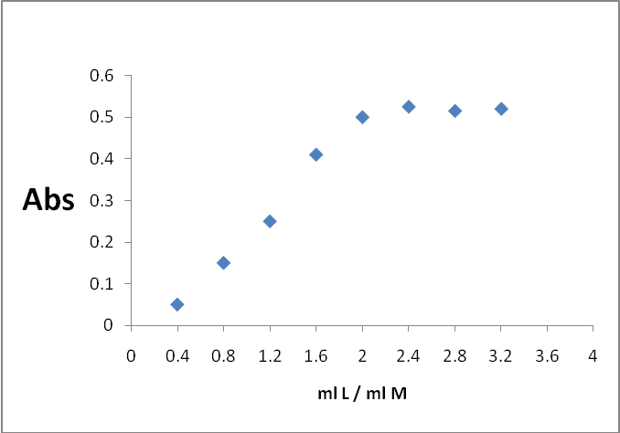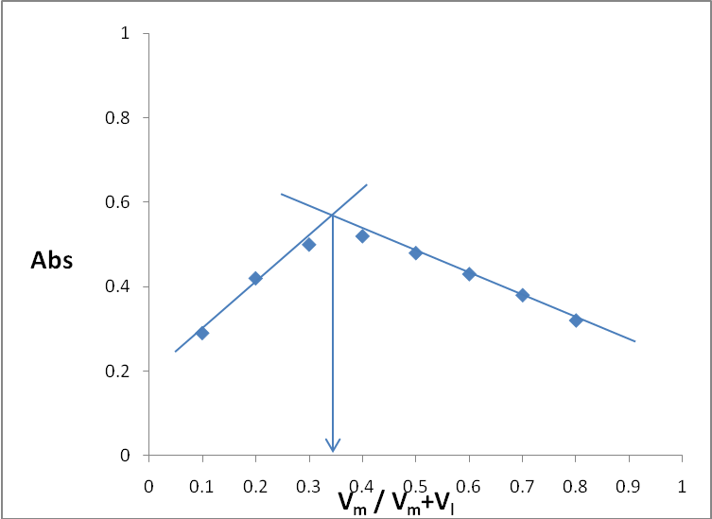Fig ( 7) Molar ratio method (M:L) Fig.(8): Continous variation method
For (Ni-6-BrBTANA )at pH 6 . for Ni-6-BrBTANA at pH 6.

Calibration curve
The calibration curve Fig (9 ) was made as described in the experimental procedure and good correlation coefficient (r) 0.9988 and the molar absorptivity was found (1.112*10⁴ L.mol⁻¹.cm⁻¹)

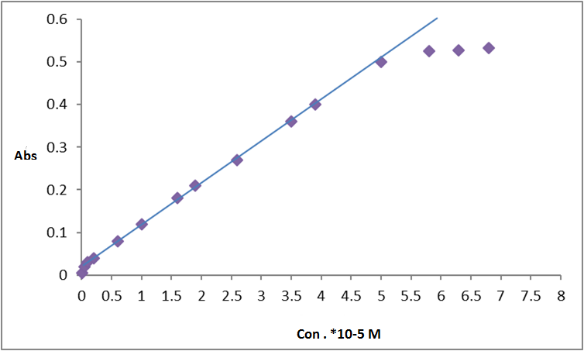
R²=0.9988
Y=0.0975+0.0183
Fig(9):-Calibration curve of Ni ⁺² Complex

Determination Of molar conductivity and magnetic properties of the complex
The value of magnetic moment for Ni(II) complex was found to be (2.63 B.M), which can be a normal value for octahedral high-spin Ni(II) complex^{[28].} The molar conductivity of the prepared solid complex was measured by dissolving an adequate weight in two solvents of different polarity like ethanol and D.M.F separately.Table
(2) which indicate its non electrolyte.

Table 2 : Molar conductivity of complex in D.M.F and ethanol solvents
Molar conductivity ,Cm².Ohm⁻¹.mol⁻¹ |  | Ni-(6-BrBTANA)₂
Ethanol | D.M.F | Ni-(6-BrBTANA)₂
4.46 | 7.12 | Ni-(6-BrBTANA)₂

Conclusions
The preparation of ligand (6-BrBTANA) and the complex are simple .After combining all the physical measurement ,the following molecular formular for the complex can be suggest octahydral configuration for Ni(II) complex. Stability constants refer to the high stability of nickel complexe. (Ni-6-BrBTANA) under optimum conditions are stable to more than 24 hour.

Suggestion of structural formula of the Nickel complex

References
1. m. L.Ahlstro¨, C .S.Eskilsson, E.Bjo¨rklund ,Trends Anal Chem.(2005), 24, 49.
2. H.R. Hovind, The Analyst. (1975), 100, 769.
3. P. Patnaik, Handbook of Environmental Analysis: Chemical Pollutants in Air, Water, Soil and Solid Wastes, CRC Press, Boca Raton, FL, 1997, p. 69.
4. J.Chen, K. C. Teo, Anal. Chim. Acta. 2001, 434, 325.
5. D.Zendelovska, G.Pavlovska, K.Cundeva, T. Stafilov, Talanta. 2001, 54, 139.
6. P. H.Lin, K. S. K.Danadurai, S. D. Huang, J. Anal. At. Spectrom. 2001, 16, 409.
7. V.G. Rodriguez, J.M.C. Romero, J.M.F. Solis, J.P. Iglesias and H.M.S. Lago, Anal. Lett. 1994, 27, 1399.
8. H. Niwa, T. Yasui, T. Ishizuki, A. Yuchi, H. Yamada and H. Wada, Talanta 1997, 45,349.
9. H.Lu, X.Yin, S.Mou, Riviello, J. M. J. Liq. Chromatogr. Relat. Technol. 2000, 23, 2033.
10. X.Ding, S.Mou, K.Liu, Y. Yan,. J. Chromatgr., A 2000, 883, 127.
11. M. M.Ghoneim, A. M.Hassanein, E.Hammam, A. M.Beltagi, J. Anal. Chem.,2000, 367, 378.
12. Opydo, J. Mikrochim. Acta .2001, 137, 157.
13. E. O.Reyes-Salas, M. A.Dosal-Gomez, M. H.Barcelo-Quintal, J. A.Manzanilla-Cano,. Anal. Lett. 2002, 35, 123
14. L Zecca,.; D.Tampellini,E.Rizzio, G.Giaveri,.; M.Gallorini,. J. Radioanal. Nucl. Chem. 2001, 248, 129.
15. L.P. Eksperiandova, A.B.Blank,Y. N. Makarovskaya, X-Ray Spectrom. 2002, 31, 259.
16. V. Rigin, Anal. Chim. Acta. 1993, 283, 895.
17. L. E. Attah ,Global, J.of Pure and Applied Sciences. 2009, 3, 357-363.
18. R. Khanam, J. Adv Scient Res. 2012, 3(2), 78-81
19. R.RAJNI and G.E.USHA, J.chem .2012, 9(3), 1357-1363.
20.A.S.Amin,Quim Anal.2001,20, 145
21. S. Vicenta, N. Maniasso, Z. F. Queiroz, and E. A. G. Zagatto, Talanta, 2002, 57, 475.
22.dos Santos W N L, dos Santos C M, Ferreira S L C .J Braz. Chem.Soc., 2005. 16, 727
23. L.S.G.Teixeira, A.C.S.Costa, S.Garrigues,and M.Guardia ,J. Braz.Chem.Soc., 2002 , 13, 54.
24.S. Zhao , X.Xia , Q.Hu ,J. Anal.chem. Acta, 1999 , 391, 365-371.
25. J.K.Malik, F.V.Manvi, B.K. Nanjwade,and S.Singh, Drug.Inven.Today, 2009,1, 32.
26. B.C.Dixit,H.M.Patel,R.B.Dixit,and D.J.Desai, J.Serb.Chem.Soc., 2010,75,607
27. R.D.Patel,M.P.Patel,and R.G. Patel, Indian J.of Chem., 2005, 44B, 1944.
28. L.Visentin, L.Ferreira, J.Bordinhão and C.Filgueiras, J. Braz. Chem. Soc., 2010, 21 ,7 .

