Determination of clioquinol as its Cu(II) complex in pharmaceutical and environmental wastewater samples
Nief Rahman Ahmad
Department of Environmental Technology, College of Environmental University of Mosul
(NJC)

(Received on 18/3/2013) (Accepted for publication 17/6/2013)

Abstract
To develop spectrophotometric method for the determination of clioquinol in commercial dosage forms and industrial wastewater samples. The method is based on the chelation of the drug with Cu(II) to form red colored metal chelate at room temperature which absorbs at 435 nm. Beers law is obeyed over the concentration range of 2-28 µg/mL with molar absorptivity and Sandell s sensitivity of 6.41x10³ L/mol.cm and 0.047µg/cm² respectively, relative standard deviation (RSD)is less than2.0 (n=10). The method is applied successfully for determination of clioquinol in some pharmaceutical formulations (creams) and industrial wastewater samples.
Keywords: Clioquinol, Spectrophotometry, Pharmaceutical Preparations , Industrial wastewater
الخلاصة
تم تَطوير طريقةِ طيفيةِ لتقديرِ كليوكوينول في مستحضراته الصيدلانية وعيناتِ من المياه الصناعيةِ المطروحة. تعتمد الطريقةَ على تكوين معقد كليتي بين الدواء وايون النحاس الثنائي لتَشكيل معقد احمر اللَوَّنِ في درجةِ حرارة الغرفةِ والذي له أقصى امتصا ص عند 435 نانوميتر. حيث ان قانون بير ينطبق على مدى تركيزَ 2-28 مايكروغرام \مل ووجد بان قيمة معامل الامتصاص المولاري ودلالة ساندل للطريقة هما 6.41x 10³ لتر\مول. سم و0.047 مايكروغرام\سم ² على التوالي،ان الانحراف القياسي النسبي للطريقة أقل مِنْ 2.0 % n=10)). تم تطبيق الطريقةَ بنجاح لتقدير كليوكوينول في بَعْض المستحضراتِ الصيدلانيةِ (كريم) وعينات مياه صناعيةِ مطروحة.

Introduction

Clioquinol (5-chloro-7-iodo-8-hydroxyquinoline; CQ;⁽¹⁾ Fig.( 1)
C9H5ClINOıı 305.5
Fig[1]: Chemical Structure of Clioquinol
It was first prepared in Germany in the early part of the last century ⁽²⁾ and has been widely used as an antibiotic for the treatment of diarrhea and skin infection. The metal-binding properties of clioquinol led to its use in a mouse model of Alzheimer's disease in which it was shown to reduce or prevent the formation of amyloid plaques in the brain ⁽³⁾. It was also shown to have efficacy in an animal model of Parkinson's disease ⁽⁴⁾. . Biochemical analysis revealed that clioquinol induced cancer cell death through apoptotic pathways that require caspase activity. Although clioquinol induced modest inhibition of SOD1 activity in treated cells, comparable inhibition by a known SOD1 inhibitor, diethyldithiocarbamate, did not result in cytotoxicity. ⁽⁵⁾. Few reports have been described for the determination of clioquinol , these include titrimetric methods^{(6,7)},spectrofluorimetric method⁽⁸⁾,spectrophotometric method⁽⁹⁾ extractive alkylation and gas-liquid chromatography⁽¹⁰⁾, high-performance liquid chromatography⁽¹¹⁻¹²⁾ and gas chromatography⁽¹³⁾ . These methods are not simple for routine analysis and required expensive or sophisticated instruments. The purpose of this work was to develop rapid accurate ,procedure for the determination of pure clioquinol, commercial dosage forms and environmental water samples . The method is based on the reaction of drug with Cu⁺²ion at pH4 resulting in the formation of yellow complex which absorbs maximally at 435 nm.

Experimental
Apparatus
A Shimadzu UV- 1700 pharmaspec double beam spectrophotometer equipped (Japan) with 1.0 cm quartz cells was used for absorption measurements, and Jen way 3310 pH meter was used.
Reagents
All chemical used were of analytical or pharmaceutical grade and clioquinol standard material was provided from state company of drug industries and medical appliance (NDI) Nineveh - Iraq .
Clioquinol standard solution(100 ppm)
This solution was prepared by dissolve 0.01 gm of clioquinol in 100 ml of ethanol(96%)in calibrated flask.

Copper sulfate penta hydrate : 1%
This solution was prepared by dissolve 1 gm of CuSO₄.5 H₂O in distilled water containing 1 ml of concentrated H₂SO₄ and diluted to 100ml in calibrated flask.
Buffer solution(pH 4)
This solution was prepared by mixing 41ml of 0.2 M acetic acid with 9 ml of 0.2M sodium acetate, then the volume is completed to 100 ml with distilled water in a volumetric flask⁽ ¹⁴⁾.

General procedure :
Different aliquots of standard solution of clioquinol equivalent 50-700 µg were transferred into a series of 25ml volumetric flasks, 1ml of buffer solution pH4 , and 3 ml of Copper sulfate solution were added. The content was mixed and let stand for 5min with occasional shaking. The volume was diluted to the mark with distilled water and mixed well. The absorbance of each solution was measured at 435 nm against a reagent blank.
Procedures for pharmaceutical preparations(creams)
The amount of cream equivalent to 10 mg of clioquinol was transferred quantitatively into a conical flask. The drug content of the cream extracted with three succesive30 ml of dimethyl formamide and collected in a 100 ml calibrated flask after filtering through a whatman no.1 filter paper. The solution was made up to the mark with dimethyl formamide. Treat 3ml of this solution as mentioned under general procedure. Procedure for wastewater samples
To demonstrate the practical applicability of the proposed method, real water samples were analyzed by this method. Industrial waste water from the state company for drug industries and medical appliances Mosul-Iraq, were fortified with the concentrations in the range of 4,10,16 µg/ml of clioquinol .The fortified water samples were analyzed as described above for general procedure and the concentration was calculated by using the calibration curve of this method.
Results and Discussion
Clioquinol was found to react with Cu(II) at room temperature resulting in formation of red colored complex which absorbed at435nm Fig [2].The various experimental affecting the development and stability of the reaction product was optimized by changing each variable in turn while keeping all other variables constant.

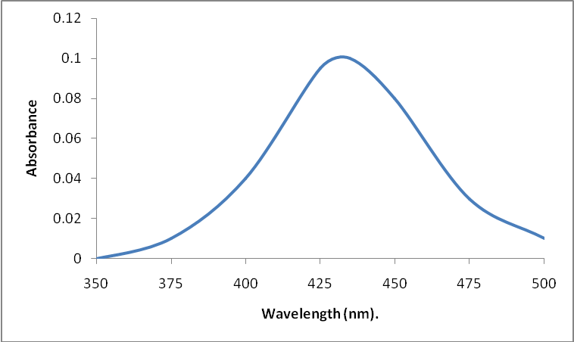
Fig[2]:Absorption spectrum of Clioquinol (12 µg/ml) – Cu(II) complex against reagent blank.

Effect of pH
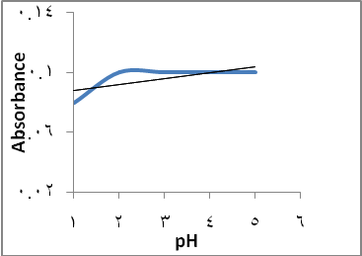
The effect of pH was investigated in the range 2-6.The results indicated that the product remained maximum and constant over the pH range 3.5-4.5 Fig[3]. There for a 1 ml of pH4 was selected for further study
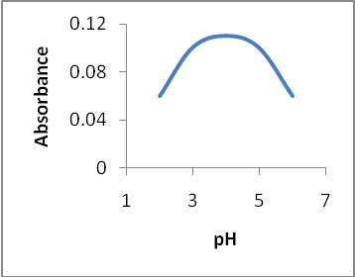

Fig[3]:Effect of pH
Effect of copper sulfate solution
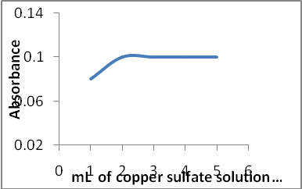
The amount of copper sulfate solution (1%) for maximal color intensity was examined the aximum constant intensity was reached at 2 ml of reagent solution and remained constant up to 5ml.Fig[4] .However 3ml of the reagent solution was selected for the subsequent work.

Fig(4):Effect of the amount of ferric ammonium sulfate solution
Effect of temperature and time:
The results obtained indicated that complete color formation occurred immediately and not effected by temperature therefore, room temperature was selected as suitable temperature. The absorbance remained constant for 6 hours at least, and 5 minutes was selected as a suitable time.
Effect of order of addition
To test the effect of order of the addition of the reagents on the absorbance of the product, different order were tested. The selected order was sample solution, buffer solution pH4 followed by copper sulfate solution which was gave high absorbance value.
Calibration graph
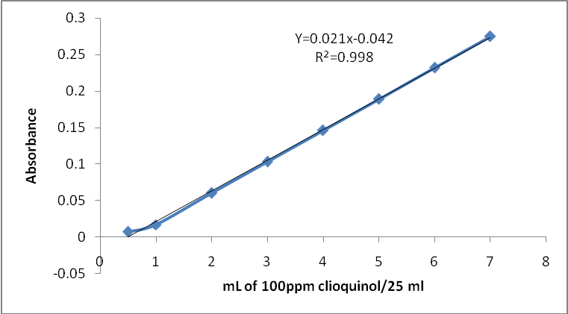
Employing the conditions described in the general procedure a linear calibration graph of clioquinol was obtained Fig[5], which shows that Beer’s law was obeyed over the concentration range 2-28 µg/mL with correlation coefficient of 0.9980, intercept of -0.042 and slope of 0.021. The conditional molar absorptivity of the product formed and sandell s sensitivity were found to be 6.41×10³ L/ mol .cm and 0.047µg/cm² respectively.

Fig[5]:Calibration curve of clioquinol.

Accuracy and precision
The accuracy and precision of the method was established by analyzing the pure drug solution at three different levels. each determination being repeated ten times. The average recovery which is a measure of accuracy is 100 ± 0.75 revealing high accuracy of the method. The relative standard deviation (RSD) , which is an indicator of precision is less than 2% . The results are complied in Table[1]

Table [1]: Optical characteristics and statistical data for regression equation of the proposed method
Parameters | Value
λ max (nm)  Beer´s law limits (µg .mL⁻¹)  Molar absorpitivity (L.mol⁻¹.cm⁻¹)  Sandell s Sensitivity (µg/cm²)  Correlation coefficient (r² )  Regression equation (Y= a × + b )  Slope (a)  Intercept (b)  Recovery %  Relative standard deviation (%) | 435  2-28  6.41× 10³  0.047  0.9980  0.021  -0.042  100 ± 0.75  < 2.0

Stoichiometry of reaction

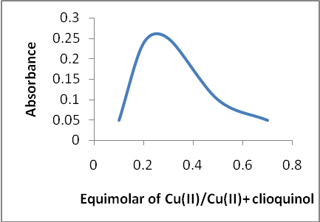
The stoicheiometry of the reaction between clioquinol and Cu(II) was investigated using job's method of continuous variation and mole ratio methods of equimolar solution (3.27x10⁻³M), the result obtained show that 1:2 Cu(II) to drug Fig[6].


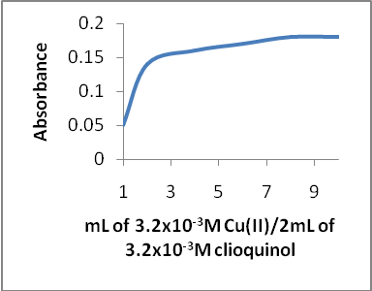


Fig[6] : Mole ratio and continuous variation plots for reaction of Cu(II) with
Clioquinol

The suggested reaction and structure of the product might be written as :
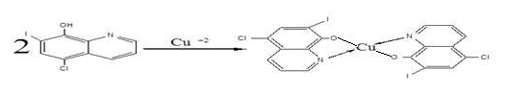

Effect of interferences
The interfering effect of foreign species often accompanied with clioquinol in the pharmaceutical preparations were studied by adding different amounts of foreign species to 20μg\ mL of clioquinol in solution and the recommended procedure for the determination of clioquinol was followed. The species are considered to interfere seriously if they cause a change of more than 2% in the absorbance obtained for clioquinol a lone ⁽¹⁵⁾. It was observed that the Betamethazone 17-valerate, gentamycine sulphate and tolnaftate don't interfere with determination method at levels found in the dosage form cited in table[2] so that the selectivity of method is very good.

Table [2]: determination of clioquinol in presence of excipients.
Excipients | Amount taken (μg) | Average recovery* %
Betamethazon 17-valerate | 30 | 100.05
Gentamycine sulphate | 30 | 100.0
Tolnaftate | 30 | 100.08
* Average of seven replicate analyses.

Application of the proposed method
The proposed method was successfully applied to the analysis of clioquinol in creams and industrial waste water samples. The result of analysis for pharmaceutical formulations revels that there is close agreement between the results obtained by the proposed method and the label claim Table[ 3]. The results were also compared statistically by student t-test

and by the variance ratio F-test with those obtained by official method ⁽⁷⁾at 95% confidence level. The calculated t- and F- values did not exceed the theoretical values indicating that there was no significant differences between the precision of the proposed and official BP method as cited in Table[3]. And the results of water samples Table [4] show that the recovery values obtained were close to 100%.

Table[3]: Assay of clioquinol in pharmaceutical formulations.
Pharmaceutical  formulation  supplied by NDI | Amount of clioquinol*  Proposed method | Label claim | Literature method ⁽⁷⁾ | T value | F value
Quadrim Cream | 9.98 | 10 | 9.99 | 1.96 | 2.23
*Mean of ten determinations.
T values (n=10, at 95% confidence level tabulated value 2.262).
F values (n1-1 and n2-1 =9, at 95% confidence tabulated value 3.18).

Table[4]: Determination of clioquinol in spiked industrial wastewater sample.
Recovery% | clioquinol (µg/ml) * | Water samples
100  99.5  99.37 | .044.0  10 9.95 16 15.9 | Industrial wastewater
*Mean of ten determinations

Conclusion

In this work, a simple, rapid, precise and accurate spectrophotometric method was developed and validated for the determination of clioquinol in pharmaceutical preparations and industrial waste water samples. The method free from such experimental variables as heating or solvent extraction step. The method rely on the use of simple and cheap chemicals and techniques and can be used for rapid routine determination and quality control of clioquinol pure form, bulk sample ,pharmaceutical preparations and real industrial waste water sample.
Acknowledgments
The author wishes to express gratitude to his former company[ the state company of drug industries and medical appliance (NDI) Nineveh – Iraq for providing gift samples of clioquinol standard materials and pharmaceutical preparations(Quadrim cream).

References
1-The pharmaceutical codex, 11Edn,the pharmaceutical press.London.1979,p .200.
2- Hollingshead R. The dihalogen and trihalogen derivatives. In: Oxine and its derivatives, vol. III. London: Butter worths Scientific Publications; 1956. p. 740.
3- Cherny RA, Atwood CS, Xilinas ME, et al. Treatment with a copper-zinc chelator markedly and rapidly inhibits β-amyloid accumulation in Alzheimer's disease transgenic mice. Neuron 2001, 30, 665–76.
4-Kaur D, Yantiri F, Rajagopalan S, et al. Genetic or pharmacological iron chelation prevents MPTP-induced neurotoxicity in vivo: a novel therapy for Parkinson's disease. Neuron ,2003, 37, 899–909.
5-Kenyon G Daniel, Di Chen, Shirley Orlu, Qiuzhi Cindy Cui1, Fred R Miller and Q Ping Dou,Clioquinol and pyrrolidine dithiocarbamate complex with copper to form proteasome inhibitors and apoptosis iducers in human breast cancer cells, Breast Cancer Research ,2005,7(6),897-908.
6-Sobhi.A"A simple method for the determination of 5,7- Diiodoquinoline -8-ol and 5-chloro7- iodoquinolin-8-ol(clioquinol) "Analyst,1975,100,696-702.
7- British pharmacopoeia ,H.M . Stationery office ,London ,UK, (2011), 539.
8-Glmenez.J,Guiteras.J,Izqulerde.A and Prat.D "Spectrofluorimetric determination of clioquinol in pharmaceutical preparations "Freseius J Anal Chem,1991 ,341,638-640.
9-Saha.U,San.A, and Das.T "Spectrophotometric determination of clioquinol and diiodoquin in pharmaceutical preparations using uranyl acetate as a chromogenic agent"Analyst,1988,113,1653-1655.
10-Degen.PH,

Schneider .W ,

Vuillard. P,

Geiger .UP, and

Riess W"The determination of clioquinol in biological materials by extractive alkylation and gas-liquid chromatography," Journal of Chromatography , 1976, 117 (2) , 407-413.
11-G.P. Bondiolotti a, C. Pollera b, R. Pirola a, S.R. Bareggi" Determination of 5- chloro- 7- iodo- 8- quinolinol (clioquinol) in plasma and tissues of hamsters by high-performance liquid chromatography and electrochemical
detection, Journal of Chromatography B, 2006, 837, 87–91.

12-Zhang,Xiru.G, and Jlang.J" Determination of Clioquinol and Its Related Substances by HPLC,"Chinese Journal of Modern Applied Pharmacy ,2009,10. 844-846.
13- The United State Pharmacopeia Convection,Inc,33-NF ,28, (2010) , 2555.
14-Perrin.D.D,and Demposey. B ;Buffers for pH and Metal ion control,;Champman and Hall Ltd, London,1974,pp.128-153.
15- Hung S. Ch., Qu C. L. and Wu S. Sh.,"Spectrophotometric Determination of Uranium with 2-(3,5) dibromo -2- pyridylazo -5- diethylaminophenol in the presence of a nionic surfactant.Talanta, 1982, 29, 629-631.

