Spectrophotometric Determination of Cefixime Through Schiff’s Base System Using Vanillin Reagents Inpharmaceutical Preparations

Nief Rahman Ahmad
Department of Environmental Technology, College of Environmental University of Mosul, Mosul-Iraq.
Farha Khalaf Omar
Department of Chemistry, Education College for girls, University of Mosul
Mosul-Iraq.

(NJC)

(Recevied on 22/10 /2012 ) (Accepted for publication 13/1/2013)

Abstract
A simple, rapid, accurate and sensitive spectrophotometric method for the determination of cefixime has been developed. The method is based on the formation of the schiff’s base between the primary amino group present in cefixime and aldehyde group present in the vanillin reagent to produce a yellow colored complex having maximum absorption at 414 nm. Bee^{ˈ}s law was obeyed over the concentration range of 2-20µg/ml,with molar absorptivity of 8.22x10⁴ l/mol.cm. The present method is considered to be simple because it does not need heating, hydrolysis and solvent extraction steps. The ingredients often formulated with cefixime have been shown not to interfere, and is suitable for the routine determination of cefixime. The proposed method has been successfully applied for the determination of cefixime in pure form and in pharmaceutical preparations(capsules)
Keywords: Cefixime, Spectrophotometry, Pharmaceutical preparations
الخلاصة
تم وصف طريقة طيفية سهلة وسريعة وحساسة لتقدير السيفكسين. تعتمد الطريقة على تكوين قاعده شيف بين مجموعه الامين للسفكسيم ومجموعه الالديهايد للفانلين لتكوين ناتج اصفر اللون له اقصى امتصاص عند طول موجي 414 نانو ميتر.ووجد بان قانون بير يسري على الكميات التي تتراوح بين2-20 مايكروغرام\ مل بامتصاصية مولارية 8.22 x 10⁴ لتر\مول.سم وتعد الطريقة الحالية بسيطة كونها لاتحتاج الى تسخين او تحلل مائي او استخلاص مذيبي حيث ان المواد الداخلة في تحضير المستحضرات المحللة لاتتداخل مع السيفكسيم مما جعلها طريقة ناجحة للتحليل الروتيني للسيفكسيم بشكله النقي وفي مستحضراته الصيدلانية ( الكبسول)

Introduction
Cefixime is a synthetic fluoroquinolone antibiotic and chemically is (6R,7R)-7-{[2-(2-amino-1,3-thiazol-4-yl)-2-(carboxymethoxy- imino)acetyl]amino}-3-ethenyl-8-oxo-5-thia-1-azabicyclo[4.2.0]oct-2-ene-2-carboxylic acid tri hydrate⁽¹⁾. fig (1), Cefixime is effective against a wide spectrum of sensitive Gram –Ve, Gram +Ve and anaerobic bacterial pathogens including β- lactamase producing strains⁽²⁾.Cefixime is given by mouth in the treatment of susceptible infections including gonorrhoea, otitis media, pharyngitis, lower respiratory-tract infections such as bronchitis, and urinary-tract infections. ⁽³⁾.

C₁₆H₁₅N₅O₇S₂,3H₂Oıı 507.5

Fig [1]: Chemical Structure of Cefixime

Literature survey reveals that various high-performance liquid chromatographic (HPLC ) methods have been reported for the determination of cefixime individually or with other drugs.^{(1,4-11)}, HPTLC⁽¹²⁾ and spectrophotometric methods.⁽¹³⁻¹⁵⁾
This paper report a simple, sensitive, and accurate , spectrophotometric method for the determination of cefixime in pure form and in pharmaceutical formulations.
Methodology

Apparatus
Spectro-scan 50 UV- visible (double beam) spectrophotometer with 1.0 cm quartz cells was used for absorption measurements,
Reagents
All chemical used were of analytical or pharmaceutical grade .
Standard materials and pharmaceutical preparations (Pharmaceutical grade cefixime and capsules 200,400 mg were kindlysupplied as a gift sample from state company of drug industries and medical appliance(NDI) Ninavah- Iraq,
Cefixime standard solution :100 µg/ml (1.97x10⁻⁴M)
Prepared by dissolving 0.01 gm of cefixime in 100 ml of ethanol in a calibrated flask.
Vanillin solution :0.1%
Prepared by dissolving 0.1 gm of vanillin in 100 ml of ethanol in a calibrated flask.
Sodium hydroxide solution (1N).

Recommended procedure.

An aliquots of standard solution of cefixime (50-500 μg) were transferred into aseries of 25ml volumetric flasks, 1 ml of 1N NaOH , and 1 ml of vanillin solution were added. The contents were diluted to the mark with distilled water. The absorbances were measured at 414 nm against a reagent blank.
Procedures for pharmaceutical preparations(Capsules):
An amount of finely ground capsule powder equivalent to 100 mg of cefixime was accurately weighed and transfered into a 100ml calibrated flask ,60ml of ethanol was added and the solution was shaked for 20 min. Then the volume was made up to the mark withethanol,mixed well, and filtered using a whatman No.42 filter paper .10ml of this solution was diluted to a 100ml with ethanol in a calibrated flask . 3ml of this solution was treated as mentioned under recommended procedure.
Results and Discussion
Spectrophotometric methods development for the determination of drugs has been increased considerably in recent years because of their importance in pharmaceutical analysis. A new method has been developed for the spectrophotometric determination of cefixime. The method was based on the formation of the schiff’s base between the primary amino group present in cefixime and aldehyde group present in the vanillin reagent to produce a yellow colored complex having maximum absorption at 414 nm against the corresponding reagent blank as shown below (Fig. 2).

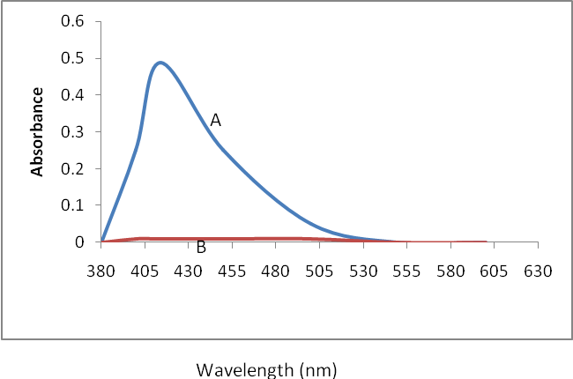
Fig 2 :Absorption spectra of (A)- 12µg/ml of cefixime with vanillin against reagent blank. (B) -reagent blank against water.

The optimum conditions were established by varying one parameter at a time and keeping the others fixed and observing the effect produced on the absorbance of colored species and incorporated in the procedure. The reaction was found to be quantitative in basic medium, 1ml of 1N NaOH is considered optimum and selected for the subsequent investigation.The effect of the amount of vanillin solution amounts on the absorbance was investigated. A maximum and constant absorbance was found with 1 ml..Under the experimental conditions described, Beer's law is obeyed over the concentration range 2.0- 20µg/ml Fig[3]. Linear regression equation: Y=0.162X+0.010 (r = 0.998 n = 6). Where Y is the absorbance and X is the concentration in µg\ml. The apparent molar absorptivity was 8.22×10⁴L/mol.cm and Sandell's sensitivity was 6.17ng.cm⁻².

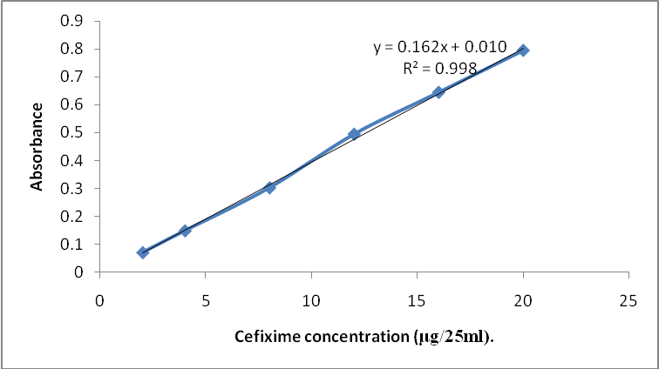
Fig[3]:Calibration curve of cefixime.

The optical characteristics such as absorption maxima, Beer’s law limits, Molar absorptivity and Sandell’s sensitivity for this method are presented in Table [1].

Accuracy and precision
The accuracy and precision of the method were established by analyzing the pure drug solution at three different levels. The average recovery which is a measure of accuracy is 100±0.55% revealing high accuracy of the method. The relative standard deviation (RSD), which is an indicator of precision, is less than 1.5% the results are complied in Table[1].

Table [1]: Optical characteristics and statistical data for regression equation of theproposed method.

Parameters | Value
λ max (nm) | 414
Beer's law limits, (μg.ml⁻¹) | 2-20
Molar absorptivity, (l.mol⁻¹.cm⁻¹) | 8.22x10⁴
Sandell's sensitivity, (ng\cm²) | 6.17
Correlation coefficient (r) | 0.998
Regression equation (y= a + bx) | Y= 0.162X+0.010
Intercept (a)  Slope (b) | 0.010  0.162
Recovery, (%) | 100 ±0.55
Relative standard deviation, (%) | < 1.5

Interference studies.
In order to assess the possible applications of the proposed method, the effect of substance that often accompany with cefixime in (capsules) were studied by adding

various amounts of substances to 10 µg of cefixime. An attractive feature of the method is its relative freedom from interference by the usual diluents and excipients in amounts for in excess of their normal occurrence in pharmaceutical preparations. The results are given in Table [2].

Table2: Determination of 10µg / ml of cefixime in the presence of excipients and other substances.
Interfering substances | Amount added(mg of interfering) | Amount of drug found*,µg | Recovery, %
Corn starch | 40 | 10.08 | 100.8
Microcrystalline cellulose | 20 | 9.98 | 99.8
Lactose | 30 | 9.96 | 99.6
Magnesium stearate | 40 | 10.09 | 100.9
Polyethylene glycol | 20 | 10.05 | 100.5
*Average of six determinations.

Composition of the colored product
The stoichiometry of the reaction between cefixime and vanillin was investigated using job's method of continuous variation and mole ratio methods of equimolar solution (1.97x10⁻⁴M),fig(4). The result obtained show that 1:1cefixime–vanillin at 414 nm.

 |  | 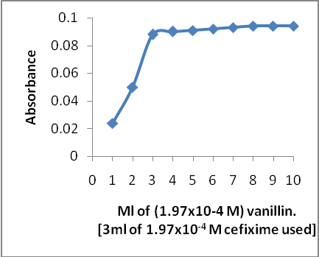 | 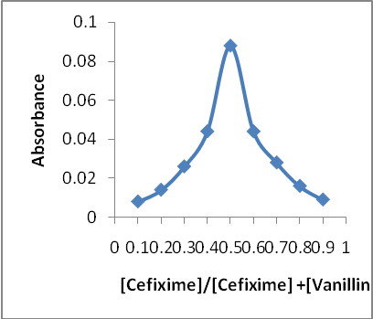
Fig(4) :Continuous variation and mole ratio plots for
reaction of cefixime with vanillin
:

The suggested reaction and structure of the product might be written as:

+——→

=
Yellow Schiff’s base compound

Apparent stability constant of the product
The conditional stability constant of the product was estimated by using the following equation ⁽¹⁷⁾:

K=a-(∆A/ε) /n^{n}(∆A/ε)

Where : a = cefixime total concentration.
∆A= sample absorbance in reagent excess minus the sample absorbance in
stoichiometric reagent amount.
ε = molar absorptivity at the measured wavelength.
and n = number of ligand.
The stability constant ( mean of five values ) is found to be3.777×10¹²l/mol, indicating that the product very stable.

Analytical application
The proposed method was satisfactorily applied to the determination of cefixime in its pharmaceutical preparations (capsules), the results of the assay of the pharmaceutical preparations revels that there is close agreement between the results obtained by the proposed method and the lable claim Table[ 3].

Table(3): Determination of cefixime in pharmaceutical formulations
Pharmaceutical formulations | Lable amount( mg) | Found by proposed method *mg | Recovery%
Capsules;Supnax(NDI) | 200mg/cap  400mg/cap | 199.90  400.75 | 99.95  100.18
*mean value of ten determinations

Conclusion

The developed method is found to be sensitive,accurate ,simple ,precise economical ,and can be used for routine quality control analysis of cefixime in pure form and pharmaceutical formulations
Acknowledgments
The first author wishes to express gratitude to his former company[ the state company of drug industries and medical appliance (NDI) ] ( Nineveh – Iraq.) for providing gift sample of cefixime standard materials and pharmaceutical preparations (capsules) and for permission and facilities to carry out the research work.

References
1- British pharmacopoeia ,H.M . Stationery office ,London ,UK, 2011,P.416
2- Wilson and Gisvold’s.;Text book of organic andmedicinal and pharmaceutical chemistry; 1998, Jaime N.Delgado and William A. Remers Lippincott – Raven
Philadelphia.10th Edition, pp-287.
3- Martindale, The Extra Pharmacopeia, 31st ed., Royal Pharmaceutical Society, London 1996, pp. 186 –190
4- The United State Pharmacopeia Convection,Inc,32-NF ,27,2009, pp.1834-1835..
5- D. Zendelovska, T. Stafilov, P. Miloševski.,” Bulletin of the Chemists and Technologists of Macedonia, , 2003, 22,(1) , 39-45.

6- M.V. Kumudhavalli , SandeepSahu, K. Abhiteja, Dr. B. Jayakar;International Journal of Pharma Recent Research,, 2010, 2(2),57-60.
7- Rolando G.H., Lauro N.P., Laritza S.M., Miguel L.L. and Joseph H;J. Liq. Chromatogr. Rel. Tech., 2001, 24, 2315-2324.
8- Khan I.U, Sharif S, Ashfaq M. and Asghar M.N; J. AOAC Int , 2008, 91, 744-749.
9- Rathinavel G., ukherjee P.B., Valarmathy J., Samueljoshua L., Ganesh M., Sivakumar T. and Saravanan T.,E-Journal of Chem., 2008, 5, 648-651.
10- Hafiz Muhammad Arshad, Shahnaz Gauhar, RaheelaBano and IyadNaeem Muhammad;Jordan Journal of Pharmaceutical Sciences, 2009 ,2(1), 53 -65.
11- Meng F, Chen X, Zeng Y, Zhong D;J Chromatogr B Analyt Technol Biomed Life Sci.2005, 819(2), 277-282.
12-S.Jovanovic,D.Agbaba,D.Stakic and S.Vladimirov;;J.Pharm.Biomed. Anal ,1998,18,893-898.
13-Ashok Kumar, Lalit Kishore, Anroop Nair, NavpreetKaur; Der Pharma Chemica, 2011, 3 (4), 279-291.
14-Nanda RK, Gaikwad J and Prakash A; International Journal of Pharm Tech Research, 2009, 1(3),488-491
15-Maheshwari R.K, Kinariwala M., Saxena M., Gahlot M., Chaki R. and Jagwani Y.,Asian J. Chem., 2008, 20, 6047-6050.
16- Bauer, H. H., Christian, G.D.; Oreilly, J. E." Instrumental Analysis", Allynand Bacon, Inc. Boston,. (1978), pp.178-179.
17- Nief Rahman Ahmed ,and Widad .E. Hassan,Jou..Raf. Sci, (2009), 20 (3), 66- 73,

