QSPR study of Glass Transition Temperatures (Tgºc) of Silicon – Containing Maleimide Polymers Using Calculation Methods

Kawkab Ali Hussain
Department of Chemistry – College of Education Pure Science –University of Basrah.
Basrah – Iraq

(NJC)

(Recevied on 9/1 /2013 ) (Accepted for publication 25/3/2013)

Abstract
Quantitative Structure–Property Relationship (QSPR) models based on molecular descriptors derived from molecular structures have been used for the prediction for computed the glass transition temperatures (Tgºc) of polymer compounds. QSPR model includes some molecular descriptors, regression quality indicates that these descriptors provide valuable information and have significant role in the assessment of the the glass transition temperatures (Tgºc) of polymers. Six QSPR equations for the prediction of glass transition have been drawn up by using the multiple regression technique. (Eqs 1-6) with the values of R² range from 0.905-0.999, the values of Q² range are from 0.895-0.999, and the values of S range are from 2.585-0.127, while the values of F range from 57.570-4372.359. The results show excellent model by Eq 6. with high of R², Q², F and minimum S by using six parameters [T. E, Si15_{CHARGE}, D. M, O14_{CHARGE}, H. F and W. B. O], was found and indicate that these parameters have important role in determining the properties of glass transition temperatures (Tgºc)this result encourages the application of QSPR to a wider selection of polymer properties and to other classes of polymers, including industrial, biopolymers.
Keywords: Silicon –containing maleimide polymers, glass transition temperatures (Tgºc) (QSPR) model
الخلاصة
الدراسة تقدم موديلات العلاقة التركيبية ل QSPR اعتمادا على حساب الموصوفات الجزيئية المشتقة من التركيب الجزيئي للتنبؤ وحساب درجة الانتقال الحراري الزجاجي للمركبات البوليمرية المدروسة .تضمنت تقنيات QSPR لبعض الموصوفات الجزيئية والتي اثبتت بان هذه الموصوفات تعطي معلومات وقيم مهمة ولها دور كبير في تحديد خواص درجة الانتقال الحراري الزجاجي للبوليمرات .بأستخدام ستة معادلات QSPR (eqs 1-6) وكانت الدوال الكمية المستحصلة من المعادلات ضمن المدى
R² =0.905-0.999, Q² = 0.895-0.999, S = 2.585-0.127, F = 57.570-4372.359.
اظهرت الدراسة بأن افضل موديل ممتاز كان باستخدام معادلة eq 6. اعتمادا على القيم العالية ل R², Q², F واقل القيم ل S والذي اعتمد على المتغيرات الجزيئية التالية
[T. E, Si15_{CHARGE}, D. M, O14_{CHARGE}, H. F and W. B. O ], والتي اظهرت بأن لها تأثير ودور كبير في تحديد خواص درجة الانتقال الحراري الزجاجي للبوليمرات المدروسة . تشجع هذه النتائج لدراسة وتطبيق تقنيات QSPR لمدى اوسع من الخواص البوليمرية وانواع اخرى من البوليمرات .
مفتاح الكلمات : بوليمرات السيليكون المحتويه على الماليمايد, درجة الانتقال الحراري الزجاجي, تقنيات(QSPR)

Introduction
Thermal properties are one of the most important properties of polymers and composites; they determine the temperature ranges for the treatment and use of these materials and terms prior to predicting and understanding other properties ⁽¹⁻³⁾. The glass transition is the most important transition and relaxation that occurs in polymers. It has a significant effect on the properties and processing characteristics of the polymers ⁽⁴⁾. The glass transition temperatures (Tgºc) is difficult to be determined because the transition happens over a comparatively wide temperature range and depends on the method, the duration and the pressure of the measuring device, besides these difficulties, the experiments are costly and time consuming⁽⁵⁻⁶⁾. Nowadays much interest is devoted to the prediction of physicochemical properties of molecules, such as their biological activity, chemical property, their retention on chromatographic systems, or electrochemical property, etc. This is usually accomplished by implementing so-called quantitative structure–activity/property relationship (QSAR/QSPR) models, which relate the property of interest, with a set of molecular descriptors. These descriptors code for the chemical information and are related to certain physicochemical properties of the molecule ⁽⁷⁾. In such studies, numerous physical properties of molecular systems have been successfully modeled, including boiling points, aqueous solubility and polymer properties, etc. ⁽⁸⁻¹³⁾. Application of quantitative structure-property relationship (QSPR) models in prediction and estimation of physical properties of materials is widely developing^{(14,15)}. In QSPR, advanced mathematical methods (Genetic algorithm, neural networks, and etc.) are used to find a relation between property of interest and the basic molecular properties which are obtained solely from the chemical structure of compounds and called "molecular descriptors ⁽¹⁶⁻¹⁷⁾.
In this paper a theoretical technique has been discussed by which the glass transition temperature (Tgºc) of polymers compounds can be measure prior to their synthesis. This technique shall reduce the coast, time and efforts, by using the parameters in deriving predictive QSPR models. The relation between the glass transition temperatures (Tgºc) and quantum chemical calculation parameters. To know the thermochemical behavior of silicon –containing maleimide polymers compounds, and to find out the effect of various the structural, chemical, physical and other properties of these compounds understudy on experimental glass transition temperature (Tgºc).
Modeling and Geometry Optimization
Theoretical calculations were performed on Arguslab (tm) program version 4.0⁽¹⁸⁾, running on a Pentium V PC-CPU 3400GHz. The geometries of the eight compounds were fully optaimization first at level (MM+) by molecular mechanics force field theory and then at level (PM3 semiempirical Hamiltonian) by semi- empirical theory^{(19,20)}.
Experimental
The experimental glass transition temperatures (Tgºc) data of 8 compounds under study has been taken from reference(21). Structures and optimized geometries of these compounds are shown in Figure.1,2.

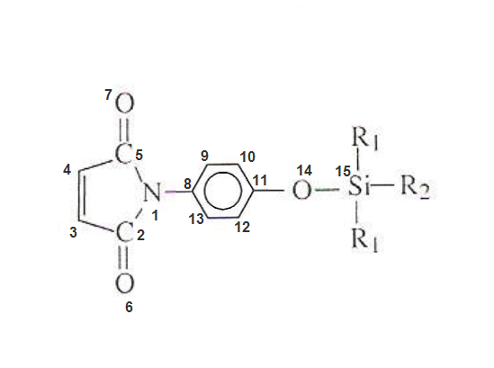

Figure 1. The general chemical structure of the compounds understudy.
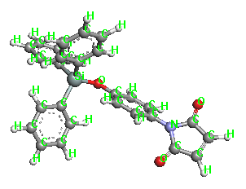

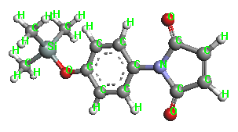

1 2

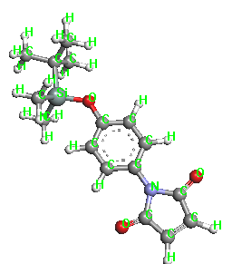
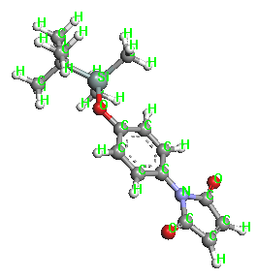

3 4

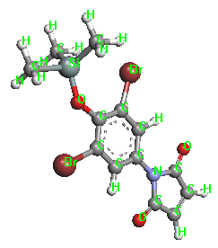
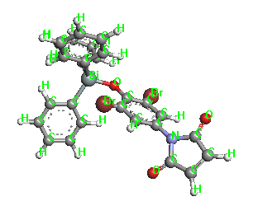

5 6

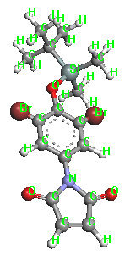
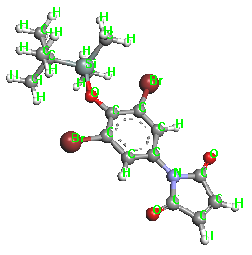

7 8

Figure 2. The optimized geometries of the compounds understudy in gas phase.

Results and Discussion
All polymers have wide molecular weight distributions, but they also possess high molecular weights. Thus, it is impossible to calculate descriptors directly for the entire molecule of a polymer. In this study, the silicon –containing maleimide polymers were represented by their repeating units end-capped by two carbon atoms to calculate molecular descriptors⁽²²⁾. To establish a mathematical model connecting the experimental temperatures characteristic of glass transition temperatures (Tgºc)to values obtained by quantum study of proposed descriptors (QSPR), and calculate the correlation between each descriptor and each property. The QSPR mathematical models consist of multiple regressions taking into account only the influential descriptors. Using the linear model, multiple linear regressions (MLR) were performed between glass transition temperatures (Tgºc)of polymer and some quantum chemical parameters/descriptors⁽²³⁻²⁵⁾.
All conformers generated for each structure were analyzed in conformational geometry panel and the lowest energy conformer of each structure was selected, transferred to a database viewer to compute
various physicochemical properties utilizing the QSPR descriptors module. The descriptors, which were significant for experimental data, were selected by QSPR-contingency module table 1.

Table 1. Recapitulation of descriptors as the independent variables used for QSPR analysis of polymers.

T. E | H. F | D. M | ^{C}Si15  _{CHARGE} | ^{A}O14 _{CHARGE} | W. B. O  O14-Si 15 | No. Compound
-66606.2607 | -121.9311 | 1.630458 | 0.9515 | -0.3611 | 0.850048 | I
-109666.958 | -23.3281 | 1.525981 | 1.1332 | -0.3391 | 0.874001 | 2
-76953.4838 | -140.1418 | 1.707047 | 0.9171 | -0.358 | 0.853933 | 3
-76955.6237 | -142.2817 | 1.554935 | 0.907 | -0.3638 | 0.839498 | 4
-82195.3225 | -105.4854 | 1.493847 | 0.9266 | -0.3426 | 0.802011 | 5
-125250.842 | -1.7051 | 2.798317 | 1.1073 | -0.3174 | 0.830905 | 6
-92539.1028 | -120.2533 | 2.318458 | 0.8543 | -0.3134 | 0.833215 | 7
-92538.3022 | -119.4528 | 1.760308 | 0.8861 | -0.3393 | 0.817771 | 8
Definition of Descriptors Used in This Study.

D. M= Dipole moment , deby, H. F= Heat of Formation in kcal/mol , T. E= Total Energy in a. u, W. B. O = Wiberg Bond Orders: The bond order between atoms O14-Si15, ^{A}O14 =Mullikan atomic charge on O atom number 14, ^{B}Si15=Mullikan atomic charge on Si atom number 15.
The prediction set, consisted of 8 molecules, was used to evaluate the generated model. It is clear that many MLR models will result using stepwise multiple regression procedure; among them we have to choose the best one. It is common to consider four statistical parameters for this purpose. These parameters are the number of descriptors, correlation coefficient (R²) for training and prediction sets, standard error (SE) for training and prediction sets, F sequential Fischer test and The cross-validation correlation coefficient (Q²). A reliable MLR model is one that has high R², Q² and F values, low SE and least number of descriptors. In addition to these, the model should have a high predictive ability⁽²⁶⁾. Establish the statistical correlation, the physicochemical parameters were taken as independent variables and glass transition temperatures(Tgºc) as dependent variable. The solutions of the above multiple linear regressions (MLR) are given by equations 1 to 6 for PM3, calculated to generated equations 1 to 6⁽²⁷⁻²⁹⁾.
The first model when depend on only one parameter [Si15_{CHARGE}] gave good model with correlation coefficient R2 values for this model of 0.905, and the cross-validation correlation coefficient 0.8957 as equation 1. The suggest that the glass transition temperatures (Tgºc)increases with increase values of this descriptor.

Tg = 72.0281 Si15 _{CHARGE}+100.7 ….Eq 1.

Statistical characteristics of the obtained equation :
R² = 0.905, Q² = 0.895, F = 57.570, S = 2.585

The relationship between the experimental data and predicted glass Transition Temperatures (Tgºc)was shown in Fig.3.

Figure 3. Plot of Tg ºc prediction versus Tg ºc experimental using eq 1.

Second model of the glass transition temperatures (Tgºc)of polymers compounds increases with increase T.E and Si15_{CHARGE} values. Second model depends on only 2 parameter gave good model with change in the correlation coefficient R2 values to 0.933. and the cross-validation correlation coefficient Q² = 0.928.
Tg = 97.1505+9.53E-05 T.E +84.689 Si15 _{CHARGE} ……….……..Eq 2.

Statistical characteristics of the obtained equation :
R²= 0.933, Q² = 0.933, F = 34.816,
S = 2.385

Fig 4. Show the relationship between the experimental data and predicted glass transition temperatures (Tgºc).

Figure 4. Plot of Tg ºc prediction versus Tg ºc experimental using eq 2.

Three- parameter correlations of the polymers were given in eq 3. In this equation it could be seen that increases of the correlation coefficient and the cross-validation correlation coefficient become 0.949, 0.947 respectively. When depends on parameters [T. E, Si15_{CHARGE} and D. M].
Tg = 1.762E-04T.E+92.057Si15 _{CHARGE}+3.287 D.M+91.305 ……… Eq 3.

Statistical characteristics of the obtained equation :
R² = 0.949, Q² = 0.947, F = 25.225, S = 2.309

The relationship between the experimental data and predicted glass transition temperatures (Tgºc), are given in Fig.5.

Figure 5. Plot of Tg ºc prediction versus Tg ºc experimental using eq 3.

By using four- parameters [T. E, Si15_{CHARGE}, D. M and O14_{CHARGE}] the correlations of the polymers were given in eq 4. Generate this model by adding the parameter O14_{CHARGE} to parameters eq 3, gave good model with high correlation coefficient 0.9709 and cross-validation correlation coefficient 0.970, eq 4.
Tg=3.11E-04T.E+105.96Si _{CHARGE}+1.709D.M+142.730O14 _{CHARGE}+141.843 ………Eq 4.
Statistical characteristics of the obtained equation :
R² = 0.9709, Q² = 0.970, F = 25.084, S = 2.0276

The relationship between the experimental data and predicted glass transition temperatures (Tgºc)are shown in Fig.6.

Figure 6. Plot of Tg ºc prediction versus Tg ºc experimental using eq 4.

On other hand, when the adding of a parameters H. F to the equation 4, obtained on equation 5. With the correlation coefficient 0.996 and cross-validation correlation coefficient 0.996. It is obvious from this result in a very minor improvement of the correlation coefficient and cross-validation correlation coefficient, in contrast standard error highest and a decrease of the F sequential Fischer test.

Tg=2.350E-04T.E+195.249Si _{CHARGE}+1.524D.M+334.326O14 _{CHARGE}- 0.222H.F+93.568……………. Eq 5.
Statistical characteristics of the obtained equation
R² = 0.996, Q² = 0.996, F = 126.537, S = 0.818

Fig 7. Represents the relationship between the experimental data and predicted glass transition temperatures (Tgºc).

Figure 7. Plot of Tg ºc prediction versus Tg ºc experimental using eq 5.

Excellent model equation when depends on six parameters [T. E, Si15_{CHARGE}, D. M, O14_{CHARGE}, H. F, W. B. O]. The resulting improvement of the correlation coefficient & cross-validation correlation coefficient, minimum standard error and a decrease of the F-test statistic, when adding the parameter [W. B. O] to parameters eq 5, gave the best model predicted in this study eq 6. This model equation depends on the six parameters[T. E, Si15_{CHARGE}, D. M, O14_{CHARGE}, H. F, W. B. O], have the significant rule suggesting the importance of the substituent's on the studied compounds on the glass transition temperature (Tgºc).
Tg = 2.062E-04T.E+289.737Si_{CHARGE}+1. 601D.M+501.144O14 _{CHARGE}-0.425H.F-69.976 W. B.
O+96.003 ……………. Eq 6.
Statistical characteristics of the obtained equation
R²= 0.999, Q² =0.999, F = 4372.359, S = 0.127

From eq 6., there is a direct correlation between (Tgºc)and charge of silicon and oxygen negative charge, as well as the total energy and wiberg bond orders because of their positive value, while the inverse relationship between (Tgºc) and nitrogen charge because of their negative value. The excellent relationship between the experimental data and predicted glass transition temperatures (Tgºc)as shown in Fig.8.

Figure 8. Plot of Tg ºc prediction versus Tg ºc experimental using eq 6.

To find the optimum number of descriptors describing (Tgºc) for the current set of organics, we analyzed multiparameter correlations containing up to 6 descriptors. Consequently, among different models, the best model was chosen, whose specifications are presented in figure 9. It is obvious that as the number of descriptors increase the R² will increase. Also shows the effect of increasing the number of descriptors on R² values. It can be seen from this figure that increasing the number of parameters only up to six has a large influence on improving correlation. Therefore, we have chosen six descriptors as optimum number of parameters. 1-6-parameter models for each of polymers understudy, which it has high correlation coefficient and cross-validation correlation coefficient, less standard error (SE) and high F values^{(24,30)}.

.

Fig. 9. Influence of number of descriptors on R² of MLR model

In construction of a QSAR/QSPR model, it is essential to validate the model as well as apply statistical parameters to evaluate its predictive performance. The models are formed mostly by multiple linear regressions (MLR) analysis. The quality of models can be evaluate by correlation coefficient squared (R²), coefficient of determination, or in the best, by external validation. Cross validation is used to judge the predictivity of the model, if no data remain for external validation. The original set of data is modified by taking off one (LOO – leave one out). data which are used to check a predictivity of a model formed from the remaining data. The correlation coefficient of regression between experimental and data estimated by cross validation is cross- validated correlation coefficient Q². The QSPR model is “good” if Q² > 0.5, excellent if Q² > 0.9. In this study the final model results from training on the entire dataset using the signature height and descriptor count assessed to have the highest predictive accuracy as measured by the (Q²). A representative plot showing Q² as a function of the correlation coefficient R² count as illustrated in figure 10, for the (Tgºc) dataset⁽³¹⁾.

The fact can be well established from the figure 10 showing a comparative plot of the values of Q², R² pred for the six different equations models that all the validations for the real MLR model confirm the self-consistency, robustness and good prediction power of the model, its stability to resamplings and the absence of chance correlation. The real MLR model shows excellent performance in predictive of glass transition temperatures (Tgºc), based on the high values for Q² and R² which are confident that the QSPR model gives good predictions glass transition temperatures (Tgºc)of polymer compounds that may be used to design better polymer compounds⁽³²⁾.

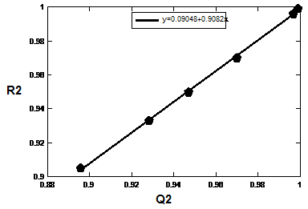
.

obtained by eq 1-6. Fig 10. The correlation between Q² vs R²

Table 2. It could be seen from this table the predicted of the glass transition temperature (Tgºc)values obtain from eq. 1-6 in this study and comparable with the experimental values in the Reference (21). It is obvious from this table 3. that the relations between descriptors which calculated in this study and experimental the glass transition temperature (Tgºc)values are excellent^{(11&33-38)}.

CALC BY Eq6 | CALC BY Eq5 | CALC BY Eq4 | CALC BY Eq3 | CALC BY Eq2 | CALC BY Eq1 | (Tgºc) (Exp)*
R²=0.999 | R²=0.996 | R²=0.970 | R²=0.949 | R²=0.933 | R²=0.905 | R²
  172.01
  182.99
  169.06
  164.9
  166.99
  179
  163.97
  160.05
  172.52
  183.17
  168.56
  164.89
  166.31
  178.85
  164.06
  160.59
  173.19
  182.01
  166.9
  164.74
  168.11
  179.69
  162.81
  161.53
  172.52
  181.31
  167.78
  166.35
  167.03
  180.36
  161.26
  162.35
  171.38
  182.66
  167.48
  166.62
  167.78
  178.98
  160.68
  163.37
  169.23
  182.32
  166.75
  166.02
  167.44
  180.45
  162.23
  164.52
  172
  183
  169
  165
  167
  179
  164
  160
Table 2. Predicated experimental data depends on eqs 1-6.

* References ; 18.

Conclusion
The study indicated that glass transition of temperature for polymers compounds can be modeled ansd successfully used for the derived a designer QSPR capable of predicting the Tg of silicon –containing maleimide polymers. The results obtained showed as the following:
1- The values of R² for the QSPR models eqs. 1-6 range from 0.905-0.999, the values of Q² range from 0.895-0.999, and the values of S in the eqs. 1-6 range from 2.585-0.127, while the values of F range from 57.570-4372.359 which are statistically significant at the 99% level. The values of R², S and F suggest that the QSPR models eqs. 1-6 are predictive and validate. From all the results the eq 6. have smaller the value of S and the larger the value of F, the better the QSPR model. As well as the glass transition temperatures (Tgºc) increases with increasing the descriptors understudy including [T. E, Si15_{CHARGE}, D. M, O14_{CHARGE}, H. F and W. B. O ], eq 6., showed insignificant role in the a predict the data of the glass transition temperatures (Tgºc). These values of correlations coefficient show clearly the influence of the electronic properties on the thermal properties of polymers studied.
2- The general feature is that the Mullikan atomic charge on Si atom, and other descriptors this implies that the glass transition temperatures (Tgºc) of such compounds could be enhanced by adding these moleculars to synthesis polymers. 3-This result encourages the application of QSPR techniques to a wider selection of polymer properties and this may be helpful for the industrial chemists to understanding the properties of the thermal behavior in polymer and the design of novel properties of polymers or extended to other polymer composite

References
1. Robert O. E., POLYMER SCIENCE AND TECHNOLOGY.. CRC Press LLC.( 2000).
2. Feldstein. M.M., Shandryuk . G.A., Platé. N.A. Polymer. 2001.42, 971-979.
3. Ziraoui. R., Elgour. M., Rami .N., Meghraoui .H., Tagmouti .H., Boukarata .K., Elharfi .A., J. Mater. Environ. Sci. 2011. 2 . 3, 225-232.
4. Bicerano. J., Encyclopedia of Polymer Science and Technology, Wiley, New York, 2003.
5. Gaur. M. S., Prashant. S., Tiwari. R. K., Anju. T., Singh. S. P. Indian Journal of Pure & Applied Physics, 2008, 46, 535-539.
6. Bicerano. J., Prediction of Polymers Properties, second ed., Marcel Dekker, New York.1996.
7. Todeschini .R., Consonni .V., Handbook of Molecular Descriptors;.Wiley-VCH: Weinheim, 2000.
8. CHEN J-T., LIU H-L., WANG F-Y., Chinese J. Struct. Chem. 2009, 28.12, 1561~1568.
9. Pablo. R. D., Alan. T., Luis. E. B-B., Eduardo. A. C., Bioorganic & Medicinal Chemistry , 2008. 16 ..7944–7955.
10. Davood. A., Ali. S., Hossein. B., Bull. Korean Chem. Soc. 2009.29, 10.
11. Kawkab A. H., Wisam. A-H. R.,. Sadiq. M-H I., J. Chem. Pharm. Res., 2012 . 4 (3):1702-1707.
12. Kawkab A. H. A., Methem. N.A., Sadiq. M-H. I. Journal of Basrah Researches((Sciences)), 2011, 37. No.4 A / 111-115.
13. Bahjat. A. S., Rita. S. E,. Sadiq M-H. I., Kawkab. A. H., American Journal of Applied Sciences,2011,8, (8), 773-776.
14. Taravat. G., Arezoo. S., Khosro. A., Fatemeh. P., Ali. N., Journal of Pharmaceutical Sciences,2007. 96, 3334–3351. (www.interscience.wiley.com). DOI 10.1002/jps.20990.
15. Ana. L. T., João. P. L., Andre. O. F., Journal of Cheminformatics. 2013, 5:9.
http://www.jcheminf.com/content/5/1/9.
16. Huixiao. H., Qian. X., Weigong .G.,Feng. Q., Hong. F., Leming. S., Zhenqiang. S., Roger. P., Weida T., J. Chem. Inf. Model. 2011.1337–1344.
17. Kyaw. Z. M., Xiang-Q. X., Int. J. Mol. Sci. 2010,11, 3846-3866; doi:10.3390/ijms11103846.
18. Arguslab ( tm ) version 4.0, Copyright ( C), Planaria software LLC, (1996-2003), Http://www.Planaria-software.com.
19. Thomas. M. S., Sherald. H. G., Richard. V. G., Carbohydrate Polymers. 1999. 39. 7–16
20. Emmanuel. I., Pablo. R. D., Erlinda. V. O., Eduardo. A. C. Chemometrics and Intelligent
Laboratory Systems. 2012.110. 81–88.
21. Wei-Jye S., Jiau-Ching H., Li-Hsiang. P., European Polymer Journal.2005. 41, 149–156, Available online at www. sciencedirect.com.
22. Iqmal. T., Karna. W., Bambang. S., Yuniawan. H., Bernd M. R., SSC8, 2003, P38. 1-8.
23. Irina. R., Victor. K., Olga. O., Eugeniy. M., Anatoliy. A., Sergei. A. , CHEMISTRY & CHEMICAL TECHNOLOGY. 2009, 3. 4.
24. Omar. D., Padmakar. V. K., Mohammad. G., Environmental Health Insights.2010, 4:33–47.
25. Kholodovycha .V., Smith . J. R.., Knight. D., Abramson. S., Kohn .J., Welsh .W. J.,Polymer. 2004, 45. 7367–7379 .
26. Bayat .Z., Abad M. F. Y.,J. Chem. Pharm. Res.2011, 3. 1,48-55,.
27. Abhijit. V. S., Margie. L. H., Charles. J. T., Hanying. Z., April. D. J., Kenneth. S. M., Adam. K. K., Shiao-Pin. S. Y., Margaret. A. R., Journal of The Electrochemical Society,2006, 153.11,
H209-H216.
28. Liu. T-B.,Peny. Y-F., Wu. X-M., Chinese J. Struct. Chem.2007, 26, 121466~1470 .
29. Zhang. S-H., Tan. Z-D, Chinese J. Struct. Chem.2011.30,7. 943~950.
30. Zahra. G-N., Journal of Chromatographic Science, 2010, 48.
31. Jord.i P-F., María. G-L., Jorge. G., Ramón. G-D., Int. J. Mol. Sci. 2011,12, 12811292; doi:10.3390/ijms12021281.
32. Rudolf. K., Mrcia. M. C. F.,J. Braz. Chem. Soc.2009,20, 4,770-787.
33. Vivek. K. V., Manjunath. G., Hitesh. K., Organic and Medicinal Chemistry Letters.2011,1:13. http://www.orgmedchemlett.com/content/1/1/13
34. Uzma. M., Sitara. R., S. Ishrat. A., Rasheeda. P., Zaheer-ul-H., Nida. A., Khalid M. K., Shahnaz. P., Wolfgang. V., Int. J. Mol. Sci., 2011,12. 8862-8877; doi:10.3390/ijms12128862.
35. Adrian. B., Ana Cristina. R., Marioara. B., Titus. C., Alexandru T. B., Internet Electronic Journal of Molecular Design. 2006. 5, 237–246.d
36. Beheshti. A., Norouzi .P., Ganjali .M. R.., Int. J. Electrochem. Sci.,2012.7. 4811 – 4821.
37. Antreas. A., Georgia. M., Haralambos. S., Panayiotis A. K., John. M., Olga I-M., Polymer .2006, 47.3240–3248
38. Jiwei. H., Xiaoyi. Z., Zhengwu. W., Int. J. Mol. Sci. 2010, 11,1020-1047 doi:. 10.3390 /ijms11031020.

