Indirect spectrophotometric determination of captopril in
pharmaceutical tablets and spiked environmental samples

Nief Rahman Ahmed
Department of Environmental Technology, Colleg of Environmental,
University of Mosul, Mosul-Iraq

(NJC)

(Recevied on 12/9 /2012 ) (Accepted for publication 13/1/2013)

Abstract
A simple ,accurate and sensitive indirect spectrophotometric method for the determination of captopril in pharmaceutical preparation(tablets) and environmental water samples has been developed. The method is based on the oxidation of captopril by a known excess of potassium iodate (KIO₃) in sulfuric acid medium to form iodide ion which reacts with excess iodate to liberate iodine which then reacts with starch to form a stable blue colored Iodine-starch complex which shows maximum absorbance at 606 nm. Beer,s law was obeyed in the concentration range ) 2-28 ppm). The molar absorptivity and Sandell,s sensitivity of the colored complex are 1.716x10⁴ l/mol.cm. and 12.66 ng/cm² respectively .The analytical parameters were optimized and the method was successfully applied to the determination of captopril in pure form, its tablets form and environmental water samples.
Keywords: Captopril, Indirect Spectrophotometry, Pharmaceutical tablets, Environmental Samples
الخلاصة
تم تطوير طريقة طيفية غير مباشرة تمتاز بالبساطة والدقة والحساسية لتقدير الكابتوبريل في مستحضراته الصيدلانية (الحبوب)وفي نماذج بيئية(مياه).تعتمد الطريقة على اكسدة الكابتوبريل بواسطة يودات البوتاسيوم في وسط حامض الكبريتيك لينتج يوديد البوتاسيوم والذي يتفاعل مع الكمية الفائضة من يودات البوتاسيوم محررا اليود الذي يتفاعل مع محلول النشأ مكونا معقد مستقر ازرق اللون له اقصى امتصاص عند 606 نانو ميتر. وقد لوحظ ان قانون بير يسري على الكميات التي تتراوح بين2-28 جزء بالمليون وان قيم معامل الامتصاص المولاري ودلالة ساندل كانتا 716.1×10⁴ لتر/مول.سم و.6612 نانوغرام/سم² على التوالي .وتم تثبيت الظروف المثلى للتفاعل وطبقت الطريقة بنجاح لتقدير الكابتوبريل بشكلة النقي وفي الحبوب وفي نماذج بيئية (مياه).

Introduction
Captopril , 1-[(2s)-3-mercapto-2-methyl propionyl]-l- proline ,that is used therapeutically as an antihypertensive agent ,it acts as a reactive and specific inhibitor of the zinc containing angiotensin converting enzyme, which is also prescribed for congestive heart failure ⁽¹⁻³⁾.

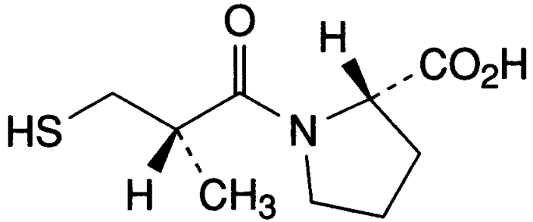
C9H15NO3Sıı 217.3
Chemical Structure of Captopril

Several analytical methods have been devised for the determination of captopril. These methods include titrimetric methods ⁽ ⁴⁻¹⁰⁾ . The instrumental methods include HPLC⁽ ¹¹⁾ , polarography ⁽ ¹²⁾, gas chromatography ⁽¹³⁾, voltametry ⁽¹⁴⁾ , flow injection ⁽¹⁵⁾,fluorimetry⁽ ¹⁶⁾, and indirect atomic absorption method⁽ ¹⁷⁾ . These methods are not simple for routine analysis and required expensive or sophisticated instruments . Many spectrophotometric reagents were used for the determination of captopril including chloranilic acid ⁽ ¹⁸⁾, dithionitro benzoic acid⁽ ¹⁹⁾ ,and silver nitrate⁽ ²⁰ ⁾. In this paper we report a simple, sensitive, and accurate spectrophotometric method for the determination of captopril in pure form , pharmaceutical formulations and environmental water samples . The method based on the reduction of iodate into iodid which reacts with excess iodate to liberate iodine which then reacts with starch to form a stable blue colored Iodine-starch complex that has a maximum absorption at λ max 606 nm. . Experimental
Apparatus
A Genway 6405 UV- visible spectrophotometer with 1.0 cm quartz cells was used for absorption measurements.
Reagents
All chemicals used were of analytical or pharmaceutical grade and high-purity water was used throughout. Captopril was obtained from (NDI): the state company for drug industries. Mosul-Iraq.
Captopril stock solution( 1000ppm):This solution was prepared by dissolving 0.1 gm of captopril in 100 ml distilled water in a volumetric flask.
.

Captopril standard solution (100 ppm) (4.6x10⁻⁴ M): This solution was prepared by diluting 10 ml of stock solution to 100 ml by distilled water in a volumetric flask.
Potassium iodate solution 0.1% (4.6X10⁻³ M): This solution was prepared by dissolving 0.1 gm of Potassium iodate (BDH) in 100 ml distilled water in a volumetric flask.
Sulfuric acid 1N: This solution was prepared by diluting 27.8 ml of (36 N sulfuric acid) to 1L by distilled water in a volumetric flask .
Starch solution 1% : This solution was prepared by dissolving 1gm of soluble starch in 50 ml of formamide (the starch dissolved within 1 minute) then completed to 100ml by distilled water⁽ ²¹⁾ in a volumetric flask.
Recommended procedure
A known volume of sample containing 50-700 μg of captopril was transferred into a series of 25ml calibrated flask followed by 1ml of 1N sulfuric acid solution ,3ml of 1% starch solution .and 1ml of 0.1% potassium iodate solution ,the volume was made up to the mark with distilled water. The absorbance was measured at 606 nm against a reagent blank prepared in the same way but containing no captopril drug.
Assay procedure for tablets
Weigh and powder 10 tablets . Dissolve a quantity of the powdered tablets containing 100mg of captopril in about 100 ml distilled water , mixed well for 20 min and then filtered. The filtrate was made up to 1L with distilled water . Treat 3 ml of this solution as mentioned under recommended procedure.
Procedure for water samples
Distilled and tap water samples (100ml)were spiked with 10 mg of captopril The spiked water samples were analyzed as desired under recommended procedure .

Results and Discussion
Captopril is a reducing agent owing to the presence of thiol group(-SH) in its structure. Captopril reduces KIO₃ to KI, but it is oxidized to disulfide. KI immediately react with the excess KIO₃ ,resulting in the formation of iodine which then reacts with starch to form blue colored I₂-starch complex ²²⁻²⁴. Which show maximum absorbance at606 nm Fig 1.

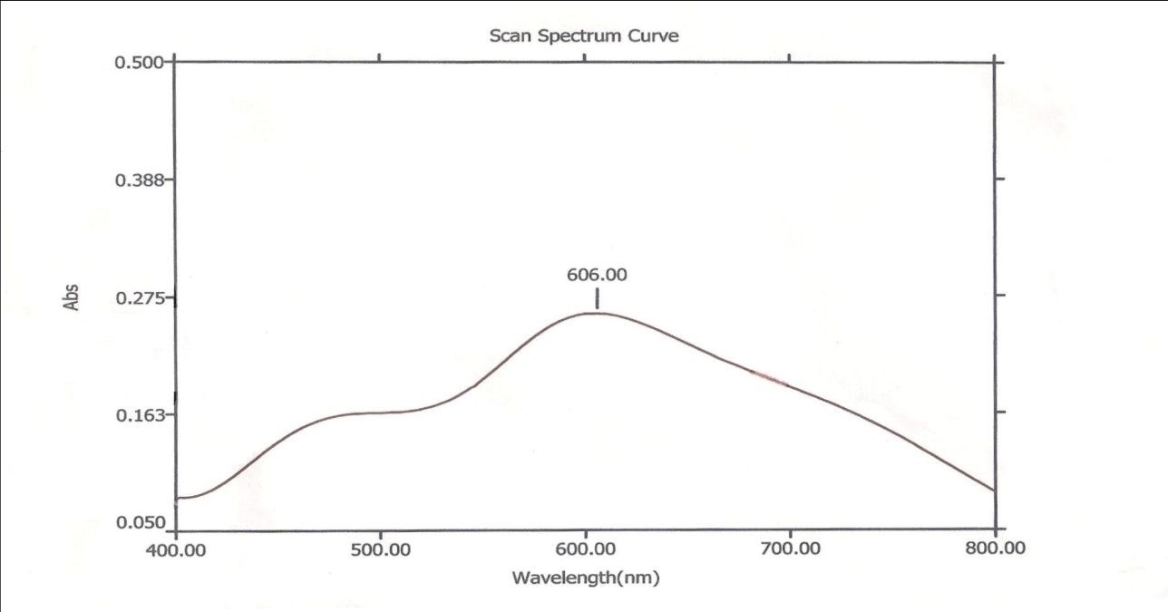
Fig [1] : Absorption spectra of 300µg/25ml captopril-KIO₃-Starch against blank.

The various experimental parameters affecting on the development and stability of the reaction product was optimized by changing each variable in turn while keeping all other variables constant.
Effect of acids
Trials were made to determine the drug through oxidation with KIO₃ was observed only in acidic solution. So that different volume of 1N of different acids have been tested for this purpose. 3ml of 1 N sulfuric acid give high sensitivity than the other.Table1.This amount was selected for subsequent work.

Table [1]:Effect of different acids on the absorbance
Acids | 1ml | 3ml | 5ml | 7ml
HCL | 0.01 | 0.015 | 0.01 | 0.01
H₂SO₄ | 0.232 | 0.256 | 0.256 | 0.247
HNO₃ | 0.211 | 0.110 | 0.054 | 0.020
H₃PO₄ | 0.125 | 0.213 | 0.222 | 0.211

Effect of starch concentration .
The amount of starch solution for maximum color intensity was examined . 2-10 ml were found enough to develop the color to its full intensity , 3 ml was selected in all subsequent experiments.
Effect of KIO₃ reagent
The amount of potassium iodate solution for maximal color intensity was examined .The maximum color intensity was reached at 1-3 ml. However 1ml of
0.1% reagent solution was selected

for the subsequent work.
Effect of reaction time
The time for complete color formation occurred immediately and remained stable for at least 2 hours.
Effect of order of addition
To obtain optimum results the order of addition of reagent should be followed as given under the recommended procedure . Otherwise a loss in color intensity was observed.

Calibration graph
Employing the conditions described in the recommended procedure a linear calibration graph of captopril is obtained Fig(2), which shows that Beer’s law is
obeyed over the concentration range of (2-28) µg/ml with correlation coefficient of 0.999, intercept of 0.015 and slope of 0.079. The conditional molar absorptivity of the product formed was found to be 1.716×10⁴ L. mol-1.cm-1.

 | 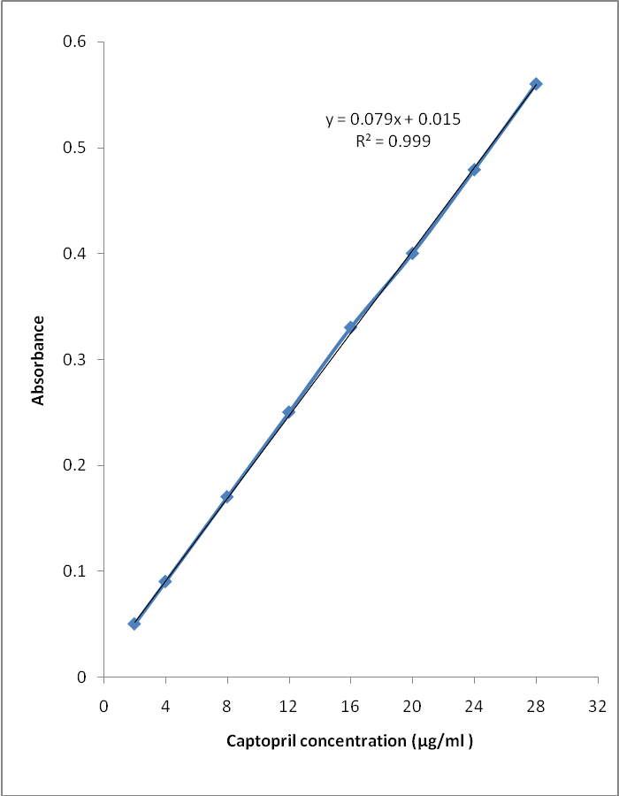 |  |  |  |  | 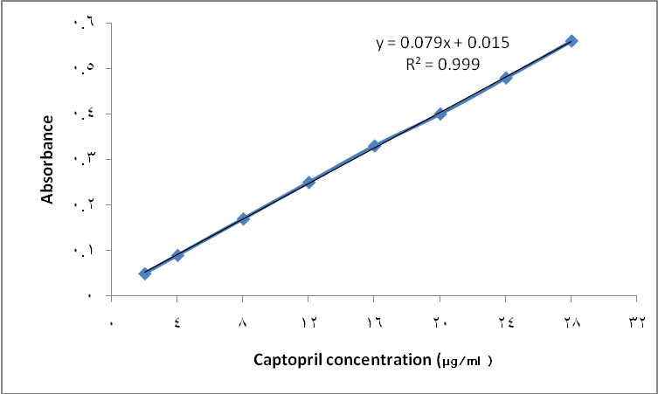
 | Fig[2]:Calibration curve for the determination of captopril.

Accuracy and precision of the proposed method.
To evaluate the accuracy and precision of the method, a pure drug solution was analyzed at three different concentrations, each determination being repeated six times the relative error (%) and relative standard deviation (%) values are summarized in Table (2). From Table (2), it is clear that the relative error was less than 1.6% and the method is found to be precise with RSD value less than 2.0%. For a better picture of reproducibility, a series of experiments were performed in which the standard drug solution was determined at three different levels each day for six days, with all solutions being prepared a fresh each day, each determination being repeated six times. The day-to-day relative standard deviation values were in the range of 1.3-1.9 % and represent the best appraisal of repeatability of the proposed methods.

Table(2): Accuracy and precision of the proposed method.
Captopril taken µg | E_{r} (%)ª | RSD %
100 | 1.2 | 1.3
300 | 1.3 | 1.9
600 | 1.5 | 1.5
a: Mean of six determinations

Stoichiometry of reaction
The stoichiometry of the reaction between captopril and KIO₃ was investigated using job's method of continuous variation method of equimolar solution(4.6x10⁻⁴M), , the result obtained show that 2:1 captopril to KIO₃ at 606 nm Fig(3), and the suggested reaction and structure of the product might be written as :

+KI

KIO₃ + 5 KI + 6H⁺ ➔ 3I₂ + 3H₂O
I₂ + Starch ➔ I₂—Starch (Blue complex).

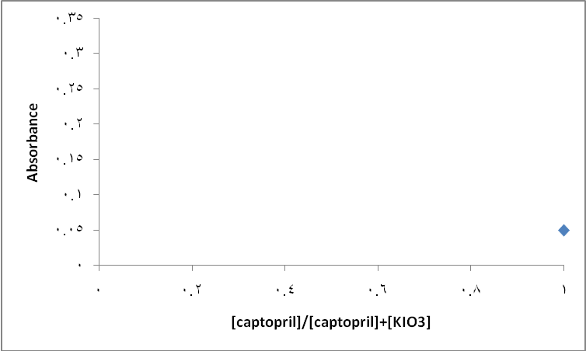
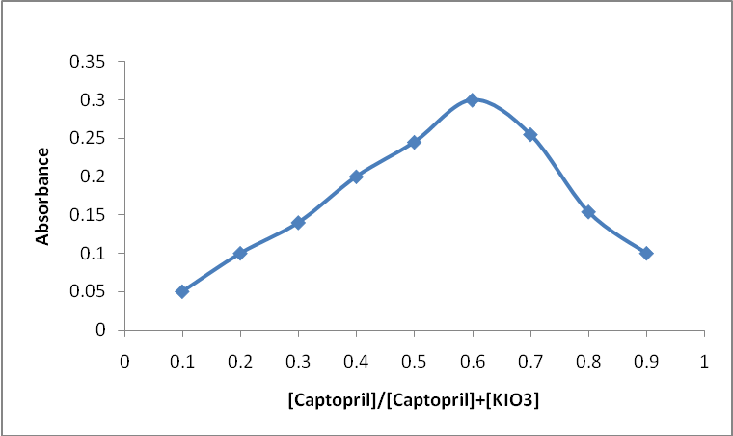

Fig(3) :Continuous variation plot for reaction of captopril with KIO₃

Effect of interferences:
In order to evaluate the selectivity of the developed method for the analysis of pharmaceutical preparations containing captopril, the effect of presence of several substance that can occur in the real sample was investigated. The excipients studied were: talc, magnesium stearate ,lactose, methyl paraben, polyvinyl pirrolidone, gelatin, and microcrystalline cellelose. For this study solutions containing captopril and each one of excipients taken separately in concentrations equal or ten-times greater than of captopril were analyzed under the same condition described under recommended procedure. A level of interference was considered to be acceptable if the error was not higher than ± 3% relative to the expected captopril value. No interferences were observed in the determination of captopril in the presence of the excipients studied.

Analytical application
The proposed method was satisfactorily applied to the determination of captopril in its pharmaceutical formulations (tablets) and water samples . the results of the assay of the pharmaceutical formulations revels that there is close agreement between the results obtained by the proposed method and the lable claim. Table( 3) , The results were also compared statistically by student t-test and by the variance ratio F-test with those obtained by official BP method ⁽⁸⁾ at 95% confidence level. The calculated t- and F- values did not exceed the theoretical values indicating that there was no significant differences between the precision of the proposed and literature method as cited in Table( 3) , And the results of water samples Table (4) show that the recovery values obtained were close to 100%.

Table(3): Determination of captopril in pharmaceutical formulations(tablets).
Pharmaceutical formulations (Captosam tablets (NDI)) | Lable amount mg | Found by proposed method * mg | official BP method⁽⁸⁾ | t value | F value
1 | 12.5 | 12.46 | 12.80 | 1.95 | 2.07
2 | 25 | 24.92 | 24.95 | 1.60 | 1.85
3 | 50 | 50.10 | 50.20 | 1.45 | 1.68
* mean value of six determinations.

T values (n=10, at 95% confidence level tabulated value 2.262).
F values (n1-1 and n2-1 =9, at 95% confidence tabulated value 3.18).

Table(4): Determination of captopril in water samples
Water samples | Added µg/ml | Found* µg/ml | Recovery %
Tap water | 100  300  600 | 99.8  300.6  598.9 | 99.8  100.2  99.8
Distilled water | 50  200  500 | 50.5  199.7  500 | 101  99.85  100
* mean value of ten determinations.
The proposed method was compared with other reported spectrophotometric methods and found to be superior , (Table 5).

Table (5):Comparison of the existing spectrophotometric methods with the proposed method for captopril.
Method 5 | Method 4 | Method 3 | Method 2 | Method 1 | Parameters
Proposed | 20 | 20 | 19 | 18 | References
606 | 550 | 520 | 412 | 520 | Max(nm)λ
2-28 | 0.25-4 | 2.5-50 | 2.17-21.7 | 40-140 | Linear range (µg/ml)
1.716x10⁴ | 1.4x10³ | 0.783x10⁵ | 1.35x10⁴ | 2.246x10² | (l/mol.cm)ε
Less than1.6 | Less than1.7 | Less than 0.3 | Less than 2 | Less than 3.4 | Relative error
Pharmaceutic-als and water | Pharmaceutic-als | Pharmaceutic-als | Pharmaceutic-als | Pharmaceutic-als | Application

Conclusion
The proposed method was simple, accurate, sensitive and low economical cost. Furthermore, the proposed method doesn’t require elaboration of procedures, which are usually associated with chromatographic methods. The proposed method could be applied successfully for determination of captopril in pure form as well as in different dosage forms (tablets) and in water samples .
Acknowledgments
The author wishes to express gratitude to his former company[ the state company of drug industries and medical appliance (NDI) Ninavah – Iraq for providing gift samples of captopril standard materials and pharmaceutical preparation(tablets).

References
1-Wester.K;Angiotensin converting enzyme inhibitor in refractory hypertension ; New England J.Med, 1978; 299, 363-364.
2-Davis.R,Ribner.H,and Keung.E; Treatment of chronic congestive heart-failure with captopril,an oral inhibitor of angiotensin converting enzyme ; New England J.Med, 1979; 301: 117-121.
3-Jankovic.H,Nagy.L, and Pellerito.L ;Coordination properties of the ACE inhibitor captopril towards Me₂Sn in aqueous solution ,and biological aspects of some dialkyl tin (IV) derivatives of this ligand;Journal of organometallic chemistry , 2003; 668: 129-139.
4-Stevan.R,Fanstaden.F, and Eucin.Y; A new construction for a potentiometric ,enantio selective membrane electrode-its utilization to the s-captopril assay; Talanta, 1999; 48: 1139-1143.
5-Brashy.A;Titrimetric determination of captopril in dosage form; Acta Pharm Hung, 1995; 65: 91-93.
6-Mohamad.M,Enin.H,Karem.E ; Potentiometric and visual titrimetric methods for analysis of captopril and its pharmaceutical forms; Anal.Leet, 1983; 16: 45-55.
7- Ribeiro.P,Santins.A,and Pezza.L; Potentiometric determination of captopril in pharmaceutical formulations; Ecletica Quimica, 2003; 28: 1-9
8- British pharmacopeia ,Her Majesty, Stationary Office ,London, 2009; P. 1020, 8210.
9- The United State Pharmacopeia Convection,Inc,32-NF ,27, 2009; pp. 1779,1781.
10-Basavaiah.K, and Pramecla.B; Assay of captopril by residual base neutralization methods;Journal of Scientific and Industrial Research, 2004; 63: 817-820.
11-Baldands.E,;Determination of thiol drugs in pharmaceutical formulations as their 5-pyridinum derivatives by HPLC with ultra violet detection; Freseniuos J.Anal.Chem, 1997; 358: 554-555.
12- Fraga.J,Abizanda.A, and Leon.J ;Application of principal comemovel of ponent regression to the determination of captopril by differential pulse polarography with prior removal of dissolved oxygen ;Talanta ,1998; 46: 75-82.
13- Leis.H,Wels.W ,and Malle.E; Determination of captopril in human blood by gas chromatography-negative-ion chemical ionization mass spectrometry with [1804]captopril as internal standard; J.Chromatogr, 1990; 529: 299-308
14- Ioannides.X,Econonmou.A ,and Voulgaropoulos.A;A study of the determination of the hypertensive drug captopril by square wave cathodic adsorptive stripping voltametry;Journal of pharmaceutical and biomedical analysis ,2003; 33: 309-316
15- Palomeque .M and Band.B; Floe injection bi amperometric determination of captopril ; J.Pharm. Biomed. Anal, 2002; 30: 547-552
16- Guerlen.R,Vives.S and Calatayud. J; Fluorometric determination of captopril by flow injection analysis; Microchem.J, 1991; 43: 176-180
17- Elreis .M, Abou Auta.F and Keuawy.I;Determination of captopril by AAS; J.Pharm.Biomed.Anal ,2000; 23:249-254
18- Agali.U,Okid.G and Nwod. N ;Spectrophotometric determination of captopril through charge transfer complexation ;Indian J. Pharm.Sci, 2004;66:92-96
19- Hossinimehr.S.Ebrahimi .P and Amini.M; Spectrophotometric determination of captopril with DTNB reagent in pharmaceutical formulation; Boll Chim. Farm, 2006; 143:249-251.

20- Basavaiah.K and Nagegowda.P,; Argenometric assayof captopril inbulk drug and in tablets;Journal of the Iranian Chemical Society; ,2004; 1: 106-114. 18-I.M.
21-Vogel.A ;A Text book of quantitative inorganic analysis;Third edition, Longman, 1961,p.347.
22-I.M. Kolthoff, R.Belcher , V.A. Stenger. And G. Matsuyama, " Volumetric Analysis, " Interscience publishers,New York ,1957; III : 247.
23-Vogel.A; A Text book of macro and semi micro qualitative inorganic analysis ;4th edn,Longman group limited,London,1974:p.372.
24- Marczenko . Z. Spectrophotometric determination of elements , " Ellits Howard, Chaichester , 1976 : p. 296.

