Batch and Flow-Injection Spectrophotometric Determination of Methyldopa Using Metochlopramide as diazotized Chromogenic Reagent
Mouyed Qassim Al-Abachi , Wasan Abdul Amir Al-Uzri* and
Sadeem Subhi Abed

Department of Chemistry, College of Science, University of Baghdad
Baghdad-Iraq
*E-mail :wasanuzri67@ yahoo. com

(NJC)

(Recevied on 19/12 /2012 ) (Accepted for publication 13/3/2013)

Abstract
New, simple and sensitive batch and Flow-injection spectrophotometric methods for the determination of Methyldopa in pure form and in pharmaceutical preparations were proposed. These methods were based on diazotization and coupling reaction between methyldopa and diazotized metochlopramide in alkaline medium to form an intense orange-red water-soluble dye that is stable and has a maximum absorption at 470nm. A graphs of absorbance versus concentration show that Beer's law is obeyed over the concentration range of 1-14 and 5-130 µg.mL⁻¹ of Methyldopa, with detection limits of 0.15 and 3.213 µg.mL⁻¹ of Methyldopa for batch and FIA methods, respectively. The FIA procedure sample throughput was 70h⁻¹. All different chemical and physical experimental parameters affecting on the development and stability of the colored product were carefully studied and the proposed methods were successfully applied to the determination of Methyldopa in pharmaceutical preparations.
Key words: Methyldopa, Spectrophotometric determination, Meotchlopramide, Diazotization and coupling, Flow injection.
الخلاصة
يتضمن البحث تطوير طرائق طيفية جديدة وبسيطة للتقدير الكمي لمقادير ضئيلة من المثيل دوبا في المحاليل المائية والمستحضرات الصيدلانية باستخدام طريقتي الدفعة التقليدية وتقنية الحقن الجرياني. تعتمد الطريقتين على تفاعل الازوتة والاقتران للمثيل دوبا مع كاشف ميتاكلوپرمايد المؤزوت في وسط قاعدي حيث تتكون صبغة برتقالية حمراء مستقرة وذائبة في الماء اعطت اعلى امتصاص عند طول موجي 470 نانوميتر. تشير منحنيات الامتصاص مقابل التركيز بان قانون بير ينطبق ضمن مدى التراكيز 1-14 و5-130 مايكروغرام.مل⁻¹ من المثيل دوبا وبحد كشف 0.15 و3.213 مايكروغرام.مل⁻¹ من المثيل دوبا لطريقتي الدفعة والحقن الجرياني على التوالي وبمعدل نمذجة 70 نموذج في الساعة بطريقة الحقن الجرياني، تم دراسة الظروف المثلى للتفاعل وجميع المتغيرات الكيميائية والفيزيائية بدقة، طبقت الطريقتين بنجاح على المستحضرات الصيدلانية الحاوية على المثيل دوبا .
الكلمات المفتاحية: مثيل دوبا ، التقدير الطيفي، ميتاكلوپرمايد ، الازوتة والازدواج ، الحقن الجرياني.

Introduction
Methyldopa (α-methyl-3, 4-dihydroxyphenylalanine), is a catecholamine derivative widely used in the control of moderate and severe arterial hypertension. Methyldopa is considered a prodrug since it acts mainly due to its metabolism in the central nervous system to α-methylnorepinephrine, a α₂-adrenergic agonist ^{[1]}. Several methods have been proposed to quantify Methyldopa in pharmaceutical formulations, including high-performance liquid chromatography (HPLC) with fluorescence detection ^{[2]}, colorimetry ^{[3,4]}, GLC ^{[5]}, titrimetry ^{[6]}, electrophoresis ^{[7]} ,NMR ^{[8]} ,thin layer ^{[9]},voltametry^{[10,11]},spectrophotometry^{[12-21]}and flow injection spectrophotometry ^{[22-25]}. However, some of these methods are time consuming and/or require expensive equipment and conditions.
The present study describes the development of batch and FIA methods based on diazotiazation and coupling reaction between diazotized metochlopramide reagent with Methyldopa in an alkaline medium. The yellowish-orange product was spectrophotometrically measured at 470 nm. The analytical procedure is simple, fast, accurate, and has been applied for the determination of Methyldopa in pure and pharmaceutical preparations. The reaction can be carried out either in batch and in FIA and the two approaches were compared.
Materials and Methods
Apparatus
All spectral and absorbance measurements were carried out on a Shimadzu UV-Visble-260 digital double-beam recording spectrophotometer (Tokyo-Japan), and photomech 301-D⁺ spectrophotometer (Optima-Japan) using 1-cm quartz cells. A quartz flow cell with 50 µl internal volume and 1 cm bath length was used for the absorbance measurements. A two channel manifold (Figure 3) was employed for the FIA spectrophotometric determination of Methyldopa. A peristaltic pump (Ismatec, Labortechnik-Analytic, CH-8152, Glatbrugg-Zurich, Switzerland, six channels) was used to transport the reagents solutions. Injection valve (Rheodyne, Altex 210, Supelco-USA) was employed to provide appropriate injection volumes of standard solutions and samples. Flexible vinyl tubing of 0.5 mm internal diameter was used for the peristaltic pump. Reaction coil (RC) was of Teflon with internal diameter of 0.5 mm. The metochlopramide, sodium nitrite and hydrochloric acid (A) stream was combined (Figure 3) with injected sample (Methyldopa) and they merged with sodium acetate (B) stream at T-link then mixed in reaction coil (RC) with length of 100 cm, injection loop of (150 μl), total flow rate of 2.4 ml/min, the absorbance was measured at 470nm. and at temperature (25° C).
Reagents and Materials
Analytical reagents grade chemicals and distilled water were used thoroughly.
Methyldopa stock solution (1000 µg.ml⁻¹ = 4.2 x 10⁻³M): a 0.100 gm amount of pure Methyldopa (SDI) was dissolved in distilled water then completed to 100 ml in a volumetric flask with the same solvent. More dilute solutions were prepared by suitable dilution of the stock standard solution with distilled water.
Sodium nitrite (5 x 10⁻³M): A 0.08625 gm amount of NaNO₂ (Merck) was dissolved in a 250 ml volumetric flask with distilled water.
Metochlopramide reagent solution (5 x 10⁻³M): prepared by dissolving 0.17715 gm of pure metochlopramide (SDI) in distilled water and completed the volume to a 100 ml in volumetric flask with distilled water.
Hydrochloric acid (BDH) (1M): was prepared by diluting 43 ml of 11.64 M of concentrated hydrochloric acid (BDH) with distilled water in 500 ml volumetric flask.
Sodium acetate (4M): A 82.03gm amount of CH₃COONa (Merck) was dissolved in a 250 ml volumetric flask with distilled water.0.5M of sodium acetate was prepared by dilution with distilled water.
Diazotized metochlopramide (4 x 10⁻³M) reagent solution: a 0.3543 gm amount of pure meotchlopramide (SDI) was dissolved in an amount of distilled water then 0.069 gm of sodium nitrite and 15 ml of (1M) Hydrochloric acid were added, shake well and completed to 250 ml in a volumetric flask with distilled water.
More dilute solutions were prepared fresh daily by dilution of the stock solution with distilled water.
Pharmaceutical preparations of Methyldopa
Pharmaceutical preparations were obtained from commercial sources.
1-Aldomatel tablets (Asia-Syria): 250mg methyldopa for each tablet.
2-Aldosam tablets (SDI-Iraq): 250mg methyldopa for each tablet.
General procedure for calibration
- General batch procedure
A 2mL of (5× 10⁻³ M) metochlopramide was transferred into a series of 25mL calibrated flask. To this solution was added equi-molar of sodium nitrite solution (5 × 10⁻³ M) and the acidity was adjusted with 2 ml of 1 M hydrochloric acid solution. The solution was shaken thoroughly. Then, an aliquot volumes of 0.25-3.5 ml of a standard solution 100 μg ml⁻¹ (4.2×10⁻⁴M) of methyldopa was transferred into this series of 25 ml calibrated flasks , 3 ml of 4 M sodium acetate solutions was added and the contents were diluted to the mark with distilled water and mixed well. After 15min, the absorbance of the colored azo dye was measured at 470nm against the corresponding reagent blank.

b. General FIA procedure
A Methyldopa solution in the range of 5- 130 µg.ml⁻¹ was prepared from the standard working solution of 500 µg.ml⁻¹. A 150 µl portion of Methyldopa was injected into the stream of diazotized metochlopramide (4 x 10⁻³M) then the mixture combined with (0.5 M) CH₃COONa at T-link with a total flow rate of 2.4 ml min⁻¹ for the two channels, the resulting absorbance of the orange-red product was measured at 470 nm and a calibration graph was constructed. Optimization of conditions was carried out on 50 µg.ml⁻¹ of Methyldopa.
Procedure for the assay of pharmaceutical preparations
Tablets solution (250 μg ml⁻¹)
An accurately weighed portion of 10 finally powder tablets equivalent to about 25 mg of methyldopa was dissolved in distilled water, transferred into a 100 ml volumetric flask, and completed to the mark with the same solvent. The solution was filtered and a further appropriate diluted solution were made up by dilution with distilled water.
Results and Discussion
Batch spectrophotometric determination
The factors affecting on the sensitivity and stability of the colored product resulting from the diazotization coupling reaction between diazotized metochlopramide and methyldopa in an alkaline medium were carefully studied. A typical spectrum for the azo dye formed was measured versus reagent blank which has negligible absorbance at λmax 470 nm (Figure 1).

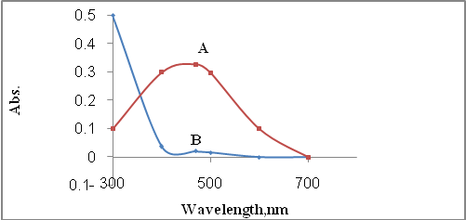
Fig. 1: Absorption spectra of the azo dye (8 ppm) of Methyldopa against reagent blank (A) and blank against distilled water (B).

The experimental conditions for the determination of methyldopa were established. The diazotization coupling reaction occurred in an acidic medium and a hydrochloric acid of concentration 1M was selected, the effect of different volumes of 1 M of HCl were studied and 2 ml volume seems to be optimum for an intense azo dye color. Effect of the volumes of reagent (metochlopramide, 5×10⁻³ M ) were studied in the range of 1-5 ml and 2 ml was found to be optimum. The absorbance of the dye formed increased and became more stable in alkaline medium, therefore, the effect of different alkaline solutions(4M) on the colored product was studied such as sodium hydroxide, ammonium hydroxide, potassium hydroxide, sodium acetate and sodium carbonate. Maximum sensitivity and stability were obtained only when the reaction was carried out in the presence of sodium acetate solution. The effect of different volumes (1-6 ml) of CH₃COONa (4 M) was studied.A volume of 3mL was found enough to obtain a maximum absorbance.
Experimental results revealed that the color intensity reach maximum after diazotized metochlopramide solution had been reacted with methyldopa in alkaline medium for 15 min, therefore, a 15 min development time was suggested as the optimum reaction time and remain stable for 120 min. The order of addition of the reagents is an essential part of the experiment, it was found that the order of addition of the reagent cited under general procedure gave maximum color intensity and the minimum absorbance of the blank and was used in all subsequent experiments.
The stoicheiometry of the reaction between methyldopa and diazotized metochlopramide was investigated using continuous variation method. The results obtained (figure 2) shows that a (1:1) azo dye was formed between methyldopa and diazotized metochlopramide(scheme1).

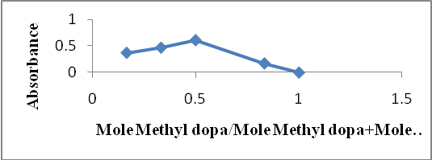
Fig. 2: Continuous variation plot of the reaction between methyl dopa and diazotized metchlopromide (4x10⁻³M)
Scheme (1): reaction sequence

The product formed was soluble in water. The apparent stability constant was calculated by comparing the absorbance of a solution containing stiochiometric amount of methyldopa (4x10⁻³M) and diazotized metochlopramide (4x10⁻³M) (A_{S}) with that of a solution containing a five – fold excess of diazotized metochlopramide reagent (A_{m}) and according to the analytical procedure used. The average stability constant (K)= 2.234x10³ l.mol⁻¹, where is [K=(1-α)/ α²C] and α=A_{m}-A_{s}/A_{m} ^{[26]}.
The regression equation obtained, and the analytical features of the procedure are summarized in (Table 1). It also summarized the main performance of the flow procedure developed for methyldopa determination in order to make an effective comparison between the two approaches.

FIA-spectrophotometric determination
The batch method for the determination of methyldopa was adopted as a basis to develop a FIA procedure. The manifold used for the determination of methyldopa was designed to provide different reaction conditions for magnifying the absorbance signal generated by the reaction of the diazotized metochlopramide with Methyldopa in sodium acetate medium. Maximum absorbance intensity was obtained when the sample (methyldopa 50 µg.ml⁻¹) was injected into a stream of diazotized metochlopramide and then mixed with sodium acetate as given in (Figure 3). The influence of different chemical and physical FIA parameters on the absorbance of the colored product was optimized as follows:

Fig. 3: A schematic diagram of FIA manifold Where: (A) and (B), solutions of diazotized metchlopromide and sodium acetate respectively; PP =peristaltic pump; S= injection sample Methyl dopa; IV= injection valve; T= T-link; RC= reaction coil; FC= flow cell; D= detector; W= waste.

Optimization of chemical parameters
The effect of various concentrations of hydrochloric acid (0.05-0.08M) was studied for the formation of diazotized metochlopramide in the presence of sodium nitrite, 0.06M HCl seems to be optimum as shown in (Figure 4).

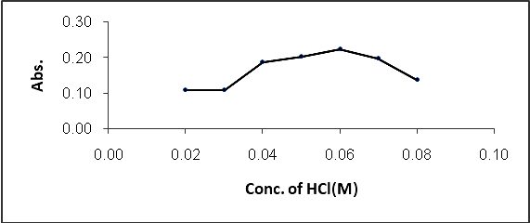
Fig. 4: Effect of the concentration of hydrochloric acid in (M)

The effect of various concentrations of metochlopramide was investigated. A concentration of (4x10⁻³M) metochlopramide, gave the highest absorbance and was chosen for further experiments as shown in (Figure 5).

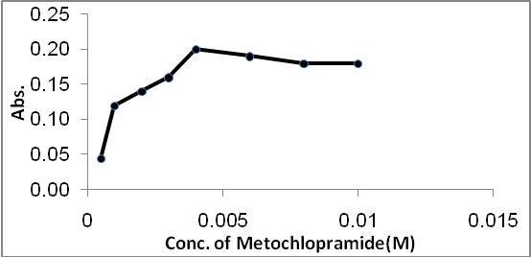
Fig. 5: Effect of the concentration of metochlopramide reagent in(0.5M) of CH3COONa

It was observed that the reaction between diazotized metochlopramide and methyldopa depends on alkaline medium, therefore the effect of different concentrations of sodium acetate was studied and 0.5M was found to be the optimum as shown in (Figure 6).

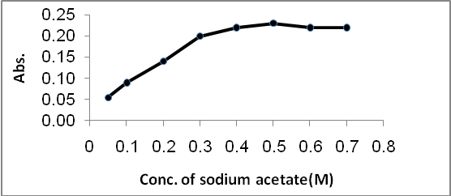
Fig.6: Effect of the concentration of CH₃COONa in (M)

Optimization of manifold parameters
The effect of total flow rate on the sensitivity of the colored reaction product was investigated in the range of 0.6-4ml min⁻¹.The results obtained showed that a total flow rate of 2.4 ml min⁻¹, (1.2 ml min⁻¹ in each line) gave the highest absorbance as shown in (Figure 7), and was used in all subsequent experiments.

Fig. 7: Effect of the total flow rate (ml/min)

The volume of the injection sample was varied between 50 and 250 µl using different lengths of sample loop. The results (Figure 8) obtained showed that injected sample of 150 µl gave the best absorbance.

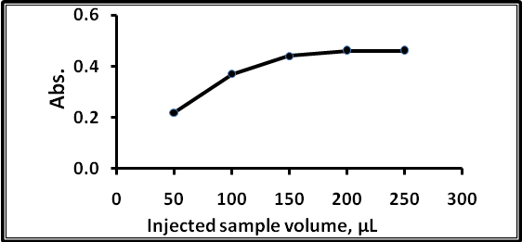
Fig. 8: Effect of the injection loop (µl)

The coil length is an essential parameter that affects on the sensitivity of the colored reaction product and was investigated in the range of 25-250 cm. the results obtained showed that a coil length of 100 cm gave the highest absorbance as shown in (Figure 9) and was used in all subsequent experiments.

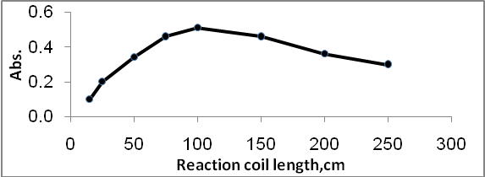
Fig. 9: Effect of the length of the reaction coil in (cm)

The reaction time is also an important parameter that affected on the sample throughput and was investigated by calculating the interval time between the sample injection and the appearance of the end of the signal. The reaction time of each sample was 51 sec, therefore the sample through put was 70 samples per hour.
Analytical characteristics
The analytical characteristics such as linear range, detection range, correlation coefficient and relative standard deviation (RSD) of each method were determined under the optimized conditions as shown in Table 1. A standard calibration line, obtained for a series of methyldopa standard solution and the main analytical figure of merits^{[27]} of the developed procedures are indicated in Table1.

Table 1: Analytical characteristics of the procedure developed for the determination of methyl dopa
Parameters | Batch procedure | FIA procedure
Regression equation | Y=0.0356x+0.0524 | Y=0.004x+0.0366
Linear range (µg ml⁻¹) | 1-14 | 5-130
Correlation coefficient, r² | 0.9997 | 0.9988
Limit of detection  (µg ml⁻¹) | 0.15 | 3.213
Relative standard deviation (RSD) % | 4.164 | 1.242
Average of recovery % | 99.856 | 100.688
Molar absorptivity  (L mol⁻¹cm⁻¹) | 1.218x10⁴ | 0.123x10⁴
Sandell’s sensitivity  (µg cm⁻²) | 19.55x10⁻³ | 19.413x10⁻²
Sample through-put (hr⁻¹) | 6 | 70

Pharmaceutical applications
In order to demonstrate the applicability of the proposed method for the determination of methyldopa , the method was successfully applied to the analysis of methyldopa in tablets. Table2 summarizes the results obtained for these preparations, there is no interference from the exipients in accordance with those obtained by the official method using HPLC^{[28]}. Finally, the results obtained by the proposed methods were compared with the official method by applying the F-test and the t-test at 95% confidence level. The calculated values for F-test were (3.963) and (4.003), and t-test values were(2.234) and(0.789)for the batch and FIA methods, respectively, did not exceed the critical values of F-test=19.009 and t-test=2.770(n₁+n₂-2=4). It reveals that there is no significant difference in precision and accuracy between the proposed methods and the official method for the determination of methyldopa in pharmaceutical preparations.

Table(2): Application of the proposed methods for determination of methyldopa in pharmaceutical preparations
Pharmaceutical preparation | Proposed methods
Pharmaceutical preparation | Batch |  |  | FIA |  |  | Official method  Recovery
Pharmaceutical preparation | Present Conc. (µgml⁻¹) | Rec.* (%) | R.S.D* (%) | Present  Conc.  (µgml⁻¹) | Rec.*  (%) | R.S.D*  (%) | Official method  Recovery
Aldomatel tablets (Asia-Syria)  250mg Methyldopa | 4 | 98.08 | 0.81 | 20 | 101.72 | 0.35 | 101.170
Aldomatel tablets (Asia-Syria)  250mg Methyldopa | 6 | 99.25 | 2.48 | 60 | 99.38 | 0.99 | 101.170
Aldosam tablets  ( SDI-Iraq) 250mg Methyldopa | 4 | 100.52 | 1.09 | 20 | 98.80 | 0.73 | 102.300
Aldosam tablets  ( SDI-Iraq) 250mg Methyldopa | 6 | 98.50 | 2.92 | 60 | 100.31 | 0.81 | 102.300
*average of four determinations

Conclusions
The application of diazo-couplimg reaction of diazotized metochlopramide in sodium acetate medium to the spectrophotometric determination of methyldopa in pharmaceutical preparations was described by batch and FIA systems. Although the batch system has the advantages of higher sensitivity and lower limit of detection over the FIA system, the FIA system has several advantages over the batch system. Simplicity, reliability, reproducibility, time saving, low reagent consumption, need of small sample volume, large dynamic range, and high sample through-put (70 sample h⁻¹) are important features of the FIA system. The proposed method offers good linearity and precision and can be applied to the analysis of a wide concentration range of methyldopa in real samples with satisfactory results .The proposed method is rapid, simple, and inexpensive since it requires simple instrumentation.

References
1- B.B. Hoffman, J.G. Hardman, L.E. Limbird and A. Goodman-Gilman (Eds.), As Bases Farmacológicas da Terapêutica, McGraw-Hill, Rio de Janeiro, (2003), pp. 163.
2-G. Bahrami, A. Kiani and S. Mirzaeei, J. Chromatogr. B Analyt. Technol., 2006, 832, 197.
3-PB.Issopoulos, Pharm. Weekb l Sci., 1989, 11, 213.
4-K. Nikolic and M. Medenica, Farmaco, 1990, 54, 1037.
5-JR.Watson and RC.Lawrence, J. of Chromatogr., 1975, 103, 63.
6-VN. Patthak, SR. Shukla and IC. Shukla, Analyst, 1982, 1278, 1086.
7-C.Wang, Z.Wang, D.Han, Y.Hu, J.Zhao, X.Yang and S. Song, Chinese J. of Chromatogr., 2006, 4, 389.
8-Z.Talebpour, S.Haghgoo and M.Shamsipur, Anal. Chimi. Acta, 2004, 506, 97.
9-M.U.Adikwn, U.Ajali, G.B.Okide and UE.Odoh, Boll. Chim. Farm., 2002, 141, 315.
10-S.A.Ali, A.Samad and S.M. Hussaini, J.Chem.Soc.Pak, 1992, 14, 257.
11-A.Mohammadi, A.Moghaddam, R. Dinarvand, J.Badraghi, F. Atyabi and A.A.Saboury, Int.J.Electrochem.Sci., 2008, 3, 1248.
12-P.R.S. Ribeiro, L. Pizza and H.R. Pizza, Ecle.Quim., 2005, 30(3), 60.
13-M.A.Gotardo, L.S. Lima, R. Sequinel, J.L. Rufino, L. Pizza and H.R. Pizza, Elcet.Quim., 2008, 33(3), 7.
14-T. Aman, I.U. Khan, N. Aslam and I. Ahmed, Anal. Lette., 1998, 31 (3), 1007.
15-M.Chamsaz, A.Safavi and J.Fadaee, Anal. Chim. Acta, 2007, 603, .140.
16-T.Madrakian, A. Afkhami, L. Khalafi and M. Mohammadnejad, J.Braz.Chem.Soc., 2006, 17(7), 1259.
17-S.M.T.Shaikh, D.H. Manjunatha, K. Harishkrishna, K.C. Ramesh, R.S. Kumar and J. Seetharamappa, J. of Anal.Chem., 2008,.63(7), 637.
18-A.Afkhami and H.A.Khatami, J.of Anal. Chem., 2003, 58(2), 135.
19-K.Sharma, S.p.Sharma and S.C.Lahiri, Spectrochimica acta part A:Molec. and Biomolec. Spectro., 2012, 92, 212.
20-P.Nagaraja, A.K.Shrestha, A.Shivakumar, N.G.S.Al-Tayarad and A.K.Gowda, Quim.Vova, 2011, .34, 373.
21-M.Q.Al-Abachi and M.A.Al-Da′amy, National J. of Chemistry, 2005, 18, 226.
22-P.R.S.Rebeiro, J.A.G.Neto, L.Pizza and H.R.Pizza, Talanta, 2005, 67, .240.
23-JJ.Nevadom, JM.Gallego and PB.Laguna, Anal. And Bioanal. Chem., 1995, 353, .221.
24-M.Tubino, JR. Rodrigues and M.D.C.Vilam ,Japan Sci. and Tech. agency, 2004, 21, 132.
25-M.Q.Al-Abachi, R. Sinan and H.Haddi, Iraq. National J. of Chem., 2009, 36, 597.
26- مؤيد قاسم العباچي وثابت سعيد الغبشة ," اسس الكيمياء التحليلية", مطبعة جامعة الموصل (1983), ص.346.
27- J. N. Miller, and J. C. Miller, “Statistics and Chemometrics for Analytical Chemistry”, (2000), 4th ed., Pearson Education Limited, London.

28- M. A. A. Al-Da'amy, Ph.D. Thesis, "Flow injection Spectrophotometric determination of Some Catecholamine Drugs in pharmaceutical preparation",(2006). University of Baghdad.

