Spectrophotometric determination of pyridoxine hydrochloride via complexation with Fe( III )in pharmaceutical and environmental wastewater samples
Nief Rahman Ahmad
Department of Environmental Technology, College of Environmental University of Mosul, Mosul-Iraq
Ola Hajum
ALhokamaa Company for Drug Industries, Mosul-Iraq.

(NJC)
(Recevied on 9/4 /2012 ) (Accepted for publication 18/11/2012)

Abstract
To develop spectrophotometric method for the determination of pyridoxine hydrochloride in commercial dosage forms and industrial wastewater samples. The method is based on the chelation of the drug with Fe III to form red colored metal chelate at room temperature which absorbs maximally at 465 nm. Beer s law is obeyed over the concentration range of 2-28 µg/ml with molar absorptivity and Sandell s sensitivity of 0.534x10⁴ l/mol.cm and 0.035µg/cm² respectively, relative standard deviation (RSD)is less than2.0 (n=10). The method is applied successfully for determination of pyridoxine hydrochloride in some pharmaceutical formulations (tablets and injection)and industrial wastewater samples. A statistical comparison of these results with those of official method using (t and F) values at 95% confidence level shows good agreement and indicates no significant difference in the precision. So that the proposed method can be used as a routine quality control for determination of pyridoxine hydrochloride in pure form, pharmaceutical formulations and industrial wastewater samples.
الخلاصة
تم تَطوير طريقةِ طيفيةِ لتقديرِ برادوكسين هيدروكلوريد في مستحضراتة الصيدلانية وعيناتِ من المياهِ الصناعيةِ. تعتمدالطريقةَ على تكوين معقد كليتي بين الدواء وايون الحديد الثلاثي لتَشكيل معقداحمر اللَوَّنِ في درجةِ حرارة الغرفةِ واللذي لة اقصى امتصا ص عند 465 نانوميتر. حيث ان قانون بير ينطبق على مدى تركيزَ 2-28 مايكروغرام \مل ان قيمة معامل الامتصاص المولاري ودلالة ساندل للطريقة كانا 0.534x 10⁴ لتر\مول سم و0.035 مايكروغرام\سم ² على التوالي،ان الانحراف القياسي النسبي للطريقة أقل مِنْ 2.0 % n=10)). تم تطبيق الطريقةَ بنجاح لتقدير برادوكسين هيدروكلوريد في بَعْض المستحضراتِ الصيدلانيةِ (أقراص وحقن) وعينات مياه صناعيةِ. وتم اجراء مقارنة إحصائية بين نَتائِجِ هذه الطريقة ونتائج الطريقةِ القياسية الدستورية المعتمدة لأختبار نجاح الطريقة باستخدام اختباري (t) و(F) عند حدود ثقة 95% وكانت النتائج متطابقة مما يدل على صلاحية التطبيق التحليلي للطريقة في التحليل الروتيني وفي السيطرة النوعية لتقدير البارادوكسين هيدروكلوريد بحالته النقية وفي بعض مستحضراتة الصيدلانية وكذلك في نموذج من المياة الصناعية المطروحة .

Introduction
Pyridoxine hydrochloride,(2-methyl-1-hydroxy-4,5 bis(hydroxyl-methyl)-pyridinum chloride Fig [1]. Is one of the members of the vitamin B6 group a water soluble vitamin ,is involved principally in amino acid metabolism ,but is also involved in carbohydrate and fat metabolism .It is also essential for both protein and red blood cell metabolism.

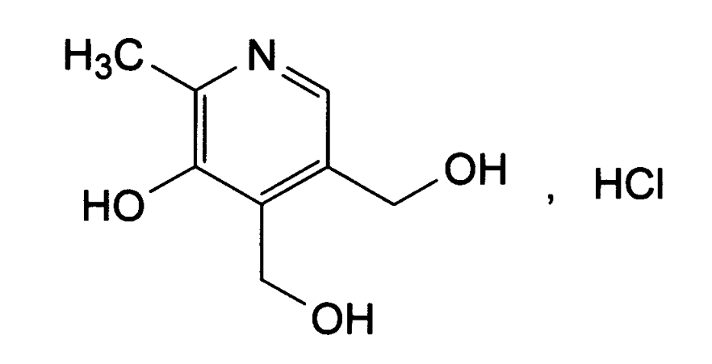
Fig[1]: Chemical Structure of pyridoxine hydrochloride

It is widely distributed in the plant and animal worlds, especially in yeast, liver, cereals and meat. In pharmaceutical formulations, vitamin B6 is usually found as the hydrochlo- dride . Pyridoxine hydrochloride is required for both mental and physical health , which has been used in the treatment of the nausea and vomiting of pregnancy and irradiation. The deficiency of pyridoxine hydrochloride has been suggested as the case of many types of illness and disease⁽ ¹⁻⁴⁾.Several methods for the determination of pyridoxine hydrochloride have been described in the literature, including spectrophotometric methods, most of these methods use either diazotized reagents or indirect spectrophotometric methods⁽⁵⁻⁹⁾, spectrofluorometric method⁽¹⁰⁾,voltammetric methods⁽¹¹⁻¹²⁾, partial least –squares regression methods⁽ ¹³⁻¹⁴⁾, non aqueose titration method⁽ ¹⁵⁾ and HPLC method⁽ ¹⁶⁾.The official BP described potantiometric titration for pure drug and UV spectrophotometric for tablets and injections⁽¹⁷⁾. The present work describes a new, simple direct, spectrophotometric method for the determination of pyridoxine hydrochloride in pure form ,pharmaceutical formulations and in industrial wastewater samples. The method is based on the reaction of drug with ferric ion at pH3 resulting in the formation of red complex which absorbs maximally at 465 nm.
Experimental
Apparatus
ShimadzuUV- 1700 pharmaspec (double beam) spectrophotometer with 1.0 cm quartz cells was used for absorption measurement, and Jenway3310 pH meter was used

Reagents
All chemical used were of analytical or pharmaceutical grade and pyridoxine hydrochloride standard material was provided from AL-hokamaa company for pharmaceutical industries (HPI) Mosul-Iraq.
Pyridoxine hydrochloride standard solution :0.01% (4.86x10⁻⁴M)
This solution was prepared by dissolve 0.01 gm of Pyridoxine hydrochloride in 100mL of distilled water in volumetric flask.
Ferric ammonium sulfate ;1%(0.02 M)
This solution was prepared by dissolve 1 gm of NH₄Fe(SO₄₎₂.12 H₂O in distilled water containing 3mL of concentrated H₂SO₄ and makeup to 100mL in volumetric flask.
Buffer solution (pH3)
This solution was prepared by mixing of 22.3mL of 0.1M HCL with 50mL of 0.1 M potassium hydrogen phthalate and dilute to 100mL by distilled water in a volumetric flask ^{(17).}
General procedure :
Different aliquots of standard pyridoxine hydrochloride solution equivalent 50-700 µg (0.5-7mL) were transferred into a series of 25mL volumetric flasks, 0.5ml of buffer solution pH3 , and 7mL of Ferric ammonium sulfate solution were added. The content was mixed and let stand for 5min with occasional shaking. The volume was diluted to the mark with distilled water and mixed well. The absorbance of each solution was measured at 465 nm against a reagent blank
Procedures for pharmaceutical preparations
Tablets
To minimize a possible variation in the composition of the tablets, the mixed content of 20 tablets, (containing 40mg of pyridoxine hydrochloride/tablet were provided from AL-Hokamaa company for pharmaceutical industries (HPI) Mosul-Iraq).).were weighed and grounded, then the powder equivalent to 100 mg of pyridoxine hydrochloride in about 70mL of distilled water was stirred well for 30 min and then filtered through whatman No. 42 filter paper and the filtrate solution was diluted to 1L by distilled water and 3mL of this solution was treated as described above under general procedure.

Injection
2ml vial containing 100mg of pyridoxine hydrochloride ( were provided from state company of drug industries and medical appliance (NDI) Ninavah- Iraq .) was transferred into 1L volumetric flask and diluted up to the mark with distilled water, 3ml of this solution was treated as described above under general procedure.
Procedure for industrial wastewater samples
To demonstrate the practical applicability of the proposed method, real industrial wastewater samples from al-hokamaa company for drug industries (HPI) Mosul-Iraq were analyzed by spiked with the concentrations ranging from 2-20 µg/ml of pyridoxine hydrochloride and aliquot of this solution was treated as described above under general procedure
Result and Discussion
Pyridoxine hydrochloride was found to react with Fe( III) at room temperature resulting in formation of red colored complex which absorbed at465nm Fig 2.The various experimental affecting the development and stability of the reaction product was optimized by changing each variable in turn while keeping all other variables constant.

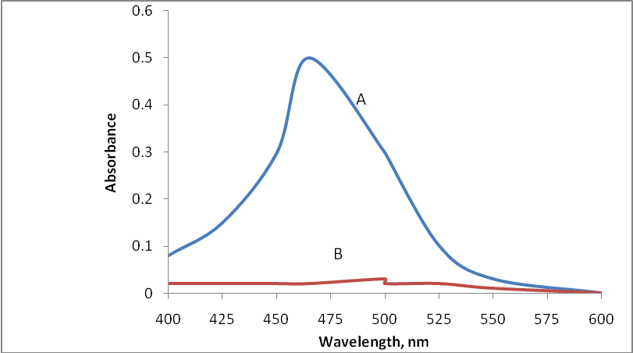
Fig(2):Absorption spectra of (A) - pyridoxine hydrochloride (16µg/ml) and its complex with Fe(III). (B) - Blank against water.

Effect of PH:
The effect of pH was investigated in the range 1-11. (by added various amounts of 0.01 M HCL or 0.01 M NaOH) to 16µg/ml Pyridoxine hydrochloride and 7mL of Ferric ammonium sulfate solution were added. The results indicated that the product remained
maximum and constant over the pH range 2.5-3.5,fig(3) . There for a 0.5 ml of pH₃ was selected for further study. .

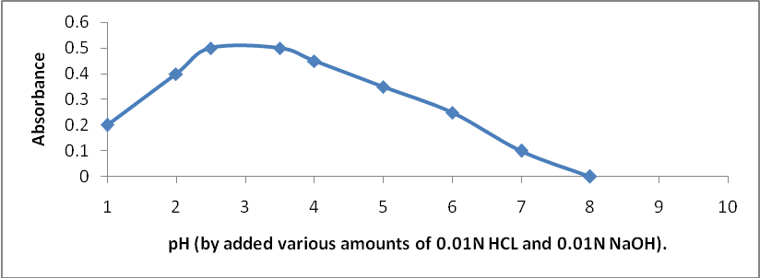

Fig(3):Effect of pH

Effect of Ferric ammonium sulfate solution:
The amount of Ferric ammonium sulfate solution (1%) for maximum color intensity was examined the maximum constant intensity was reached at 6 ml of reagent solution and remained constant up to 9ml ,fig(4). .However 7ml of the reagent solution was selected for the subsequent work.

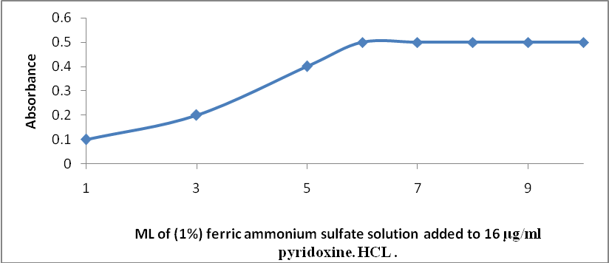

Fig(4):Effect of the amount of ferric ammonium sulfate solution.

Effect of temperature and time:
The results obtained indicated that complete color formation occurred immediately and not effected by temperature. Higher temperature causes turbid color, therefore, room temperature was selected as suitable temperature. The absorbance remained constant for 6 hours at least, and 5 min was selected as a suitable time.
Effect of order of addition
To test the effect of order of the addition of the reagents on the absorbance of the product, different order were tested. The selected order was sample solution, buffer solution pH3 followed by ferric ammonium sulfate solution which was gave high absorbance value.
Calibration graph
Employing the conditions described in the general procedure a linear calibration graph of pyridoxine hydrochloride was obtained fig(5), which shows that Beer’s law was obeyed over the concentration range 2-28 µg/ml with correlation coefficient of (R²= 0.997, intercept of 0.036 and slope of 0.026 .The conditional molar absorptivity of the product formed and sandell s sensitivity were found to be 0.534×10⁴ L/ mol .cm and 0.035µg/cm² respectively.

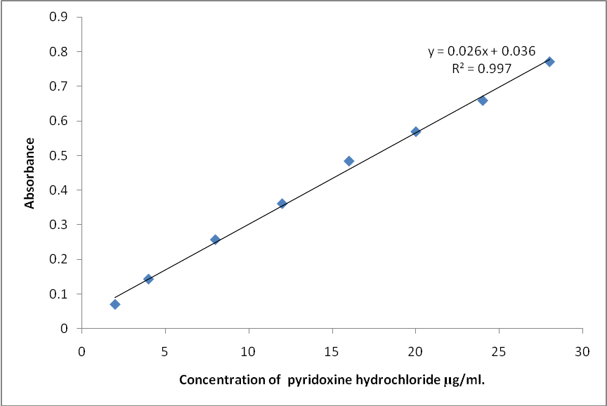

Fig. (5): Calibration graph of pyridoxine hydrochloride.

Accuracy and precision
The accuracy and precision of the method was established by analyzing the pure drug solution at three different levels. each determination being repeated ten times. The average recovery which is a measure of accuracy is 100 ± 0.95 revealing high accuracy of the method . The relative standard deviation (RSD) , which is an indicator of precision is less than 2% . The results are complied in Table[1]

Table [1]: Optical characteristics and statistical data for regression equation of the proposed method
Parameters | Value
λ max (nm)  Beer´s law limits (µg .ml⁻¹)  Molar absorpitivity (1.mol⁻¹.cm⁻¹)  Sandell s Sensitivity  Correlation coefficient (r² )  Regression equation (Y= a × + b )  Slope (a)  Intercept (b)  Recovery %  Relative standard deviation (%) | 465  2-28  0.534× 10⁴  0.035  0.997  0.026  0.036  100 ± 0.95  < 2.0

Apparent stability of the product
The conditional stability constant of the product can be estimated by using the following equation ⁽¹⁸⁾.
K=a-(ΔA/ε) /n^{n}(ΔA/ε)^{n+1} Where:
a= pyridoxine hydrochloride total concentration . (molar)
ΔA=Sample absorbance in reagent excess minus the sample absorbance at stiochiometric mount.
ε= Molar absorptivity at the measured wavelength.
And n=number of ligands.
The stability constant (means of three values) was found to be 6.0x106 l^{1/2}/mol^{1/2}.cm^{1/2}.indicating the product is very stable.

Stoichiometry of reaction

The stoicheiometry of the reaction between pyridoxine hydrochloride and Fe III was investigated using job's method of continuous variation and mole ratio methods of equimolar solution(4.86x10⁻⁴M), the result obtained show that 1:2 Fe(III) to drug at 465 nm fig(6) .

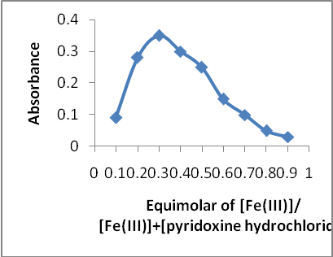
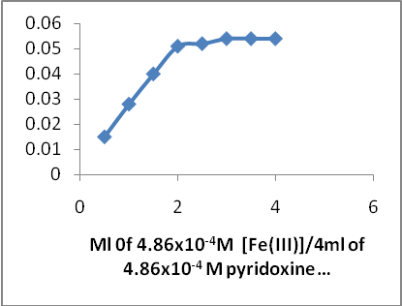

Fig(6) :Continuous variation and mole ratio plots for reaction of Fe(III) with pyridoxine hydrochloride

The suggested reaction and structure of the product might be written as:

Interferences Study
In order to assess the possible of the proposed method, the effect of substance that often accompany with pyridoxine hydrochloride in various pharmaceutical products were studied by adding different amount of substances to 300µg/25ml (12µg/ml) of pyridoxine hydrochloride . An attractive feature of the method is its relative freedom from inference by the usual diluents and expcipients in amount for in excess of their normal occurance in pharmaceutical preparations. The results are given in table (2).

Table (2): Determination of 300µg/25ml of pyridoxine hydrochloride in the presence of excipients and other substances.
Interfering substances | Amount added(mg) | Amount of pyridoxine hydrochloride found(µg) * |  | RSD %
Benzyl alcohol | 1 | 299 |  |  | 0.88
Chlorobutanol | 10 | 301 |  |  | 0.91
Lactose | 40 | 300.8 |  |  | 0.71
Microcrystalline cellulose | 20 | 300.6 |  |  | 0.64
Corn starch | 30 | 300.7 |  |  | 0.78
Magnesium stearate | 40 | 300.7 |  |  | 0.91
Hydroxylpropyl methyl cellulose | 40 | 298.8 |  |  | 0.93
*Average of six determinations.

Analytical application
The proposed method was satisfactorily applied to the determination of pyridoxine hydrochloride in its pharmaceutical formulations and wastewater samples . the results of the assay of the pharmaceutical formulations revels that there is close agreement between the results obtained by the proposed method and the lable claim. The results were also compared statistically by student t-test and by the variance ratio F-test with those obtained by Uv- spectrophotometric official BP method ^{[17]} at 95% confidence level. The calculated t- and F- values did not exceed the theoretical values indicating that there was no significant differences between the precision of the proposed and literature method as cited in table( 3) , And the results of wastewater samples table (4) show that the recovery values obtained were close to 100%.

Table(3): Determination of pyridoxine hydrochloride in pharmaceutical formulations
Pharmaceutical formulations | Lable amount mg | Found by proposed method * mg | official BP method ⁽ ¹⁷⁾ | t value | F value
Tablets | 40mg/tab | 39.92 | 39.95 | 1.14 | 1.02
Injections | 100mg/2ml | 100.08 | 100.1 | 1.95 | 1.06
*mean value of ten determinations
T values (n=10, at 95% confidence level tabulated value 2.262).
F values (n1-1 and n2-1 =9, at 95% confidence tabulated value 3.18).
Table(4): Determination of pyridoxine hydrochloride in wastewater samples
Wastewater samples | Added µg/ml | Found* µg/ml | Recovery %(n=10)
Industrial wastewater | 5.0  15.0  25.0 | 5.06  14.98  25.1 | 101.2  99.86  100.4
* mean value of ten determinations.

Conclusions
The proposed method was simple, accurate, sensitive and low economical cost. Furthermore, the proposed method doesn’t require elaboration of procedures, which are usually associated with chromatographic methods. The proposed method could be applied successfully for determination of of pyridoxine hydrochloride in pure form as well as in different dosage forms and in wastewater samples .

References
- The pharmaceutical codex, 11Edn,the pharmaceutical press. London. 1979,p .766- 767
- British National Formulary(BNF 58),Royal Pharmaceutical Society of Great Britan Publishing, 2009, p.324, 517, 547.
- Remington:The Science and practice of pharmacy,Mack publishing Company,19 th Edn , 1995, (2), p. 1127.
- Sean.C,Swetman;Martindale;The complet Drug References, 35 Edn ,Pharmaceutical press London,2007, ( 2), p.1815-1816.
- Asma.N;Spectrophotometric determination of vitamin B6 by coupling with dizotized p-nitroaniline; Jou.Raf.Sci,2010,22(4),49-59.
- Nirmalchander.V, and Balasubrama. N; Spectrophotometric determination of pyridoxine hydrochloride in pharmaceutical samples; Analyst, 1988, 113,1097-1099.
- Lioren. M , Liuis. R, Josep. R and Celia. M; Spectrophotometric determination of B6 vitamins by coupling with diazotized p-sulphanilic acid in micellar medium of N-cetylpyridinium chloride; Analytical Letters,1999, 32(1), 51-63.
- Kuchekar.B ;Spectrophotometric estimation of melatonin and pyridoxine hydrochloride in combined dosage forms; Indian Journal of pharmaceutical Science; 2002, 64(2), 158-160.
- Raeed. M and Azzm. A; Spectrophotometric assay of pyridoxine hydrochloride (vitamin B6)in pharmaceutical preparation and serum via Arsenazo III –Cerium III reaction; Raf.Jour.Sci, 2008, 19(2), 28-41.
- Hamid.A,Mohammed.H and Naseri. A; Simultaneous spectrofluorometric determination of piroxicam and pyridoxine using generalized rank annihilation method; Analytical Sciences, 2006, 22, 263-267.
- Habibi.B,Phezhhan.H. and Azar.M; Voltammetric determination of vitamin B6(pyridoxine) using multi wall carbon nano tube modified carbon-ceramic electrode; Journal of the Iranian chemical Society,2010,7,103-112.
- Teixeira.M, Aline.S, Moraes.C, Luiz.H and Eder.T;Determination of vitamin B6 (pyridoxine) in pharmaceutical preparations by cyclic voltammetry at a copper(II) hexacanoferrate(III) modified carbon paste electrod; J.Braz.Chem.Soc , 2003, 14(2), 316-321.
- Ghasemi. J and Vosough. M; Simultaneous spectrophotometric determination of folic acid, thiamine, riboflavin and pyridoxal using partial least – squares regression method; Spectroscopy Letters, 2002, 35(2), 153-169.
- Alba.L,Lope.L.Cerda.V and Amador. J; Simulaneous determination and classification of riboflavin, thiamine, nicotinamide and pyridoxine in pharmaceutical formulations by Uv –visible spectrophotometry and multivariate analysis ; J. Braz. Chem. Soc, 2006, 17(4), 715-722.
- Kar. A; Pharmaceutical drug analysis ; 2nd Edn , New ago international puplishers, New Delhi, India , 2005, p. 116.
- The United State Pharmacopeia Convection, Inc, 32-NF , 27, 2009, p. 3451-3452.
- British pharmacopeia , Her Majesty, Stationary Office, London, 2009, P. 3451,5107.
18-Nief. Rahman and Widad. Esa; Spectrophotometric determination of chlorocresol via nitrosation reaction –Application in pharmaceutical preparations (creams); Raf .Jour. Sci, 2009, 20(3), 66-73.

