Removal of copper (II) ion from aqueous solution using copolymer of acrylic acid and acrylamide

Jamal A. Abbas
Chemistry Dep. Faculty of science, Duhok University , Iraq
Email:jamal_aleas@yahoo.com

(NJC)

(Recevied on 29/4 /2012 ) (Accepted for publication 23/10/2012)

Abstract
Cross linked copolymers of acrylic acid(sodium acrylate) and acrylamide hydrogel was studied for capture of copper ion from aqueous solution .The batch experiment was conducted to evaluate the effect of system variables .The effect of the pH and contact time have been studied at room temperature .The optimal pH value of Cu(II)removal by polymer was 7.0 . The adsorption kinetic data was analyzed using pseudo-first order, pseudo-second order, and Elovich models. The adsorption kinetic was found to follow pseudo- second order rate model, due to the high correlation coefficient and agreement between the experimental and calculated value of q_{e}.
Keywords:Adsorption,Cu(II)kinetic,hydrogel
الخلاصة
استخدمنا في هذه الدراسة كوبوليمر متشابك من حامض الاكريليك (اكريلات الصوديوم) والاكريل امايد لسحب ايون النحاس الثنائي من محلوله المائي .اعتمدت طريقة الدفعة في تقييس مختلف المتغيرات، حيث تم دراسة تأثير الاس الحامضي pH وزمن التلامس عند درجة حرارة الغرفة، وكانت افضل النتائج لسحب ايون النحاس من قبل البوليمر عند الاس الحامضي 7 . كما تم دراسة حركية الامتزاز لمرتبة التفاعل من الدرجة الاولى ومرتبة التفاعل من الدرجة الثانية وموديل إيلوفيتش .
ومن خلال الدراسة وجد ان حركية الامتزاز تتبع مرتبة التفاعل من الدرجة الثانية وذلك من ملاحظة القيمة العالية لمعامل الارتباط R² والتوافق بين النتائج التجريبية والمحسوبة لـ q_{e}

Introduction
Hydrophilic gels that are usually referred to as hydrogels are networks of polymer chains that are sometimes found as colloidal gels in which water is the dispersion medium ⁽¹⁾.
Hydrogels have been defined as polymeric materials which exhibit the ability of swelling in water and retaining a significant fraction (>20%) of water within their structure, without dissolving in water ⁽²⁻⁴⁾. They possess also a degree of flexibility very similar to natural tissue due to their large water content.
The applications of hydrogels are grown extensively ⁽³⁻⁶⁾. They are currently used as scaffolds in tissue engineering where they may contain human cells in order to repair tissue. Hydrogels that are responsive to specific molecules, such as glucose or antigens can be used as biosensors as well as in drug delivery systems (DDS).
Special hydrogels as superabsorbent materials are widely employed in hygienic uses particularly disposable diapers and female napkins where they can capture secreted fluids, e.g., urine, blood, etc. Super absorbent polymer as hydrogels, relative to their own mass can absorb and retain extraordinary large amounts of water or aqueous solution⁽ ^{2,3)}. These ultrahigh absorbing materials can imbibe deionized water as high as 1,000-100,000% (10-1000 g/g) whereas the absorption capacity of common hydrogels is not more than 100% (1 g/g).
Hydrogels structures are heterogeneous in different orders in micro-morphology⁽⁸⁾. Many methods are available to prepare hydrogel materials. They are mainly made from water-soluble monomers by radical polymerization reactions. The most popular water-soluble monomers include acrylic acid, acrylamide and their derivatives. These monomers can be used to synthesize cross-linked homo polymers and copolymers consisting of different co-monomers by aqueous solution or other polymerization processes.
Because of the ionic groups on the macromolecular chains, polyelectrolyte has an electrostatic potential field around the macromolecular chains ⁽⁸⁾. Therefore, they can also attract certain cations or anions to form complexes. so it can be used to bind and capture metal ions from water. Heavy metal ions are harmful and toxic to human beings and the environment ^{(9,10)} . For example, copper ions can damage kidneys and the liver, causing anemia.
In this work, hydrogels based on acrylic acid (sodium acrylate) and acrylamide copolymers were studied for copper (II) ion removal from aqueous solution.
Chemical and apparatus used
- polymer (copolymer of acrylic and acryl amide ,white crystal. Free absorbency of distilled water: 350~450 g/g,) from hana king way chemical co, Ltd, China. All the chemical compounds used to prepare the reagent solutions, were of analytic reagent grade (Merck).
- Ion meter (D R 3597× EDT.with copper combined electrode, pH meter model 3505 (jenway) , Shakes water bath (Stuart) ,Fourier transform infrared (FTIR-84005, shmadzu ).

Experimental
Preparation of Cu(II)solution and analysis
A stock solution of Cu (II) 1000 mg/L was obtained by dissolving (2.683) g of CuCl₂ . 2H₂O in 1L of deionized water and the solution was used for further experimental solution preparation .The Cu (II) content in the adsorption solutions was determined by Ion meter using combined Copper electrode (DR.359T×EDT).
Effect of PH
Adsorption experiments were adjusted to pH 4,5,6,7 and 8 . The acidic and alkaline pH of the medium were maintained by adding the required amount of hydrochloric acid and sodium hydroxide solutions.
The adsorption was determined using 0.1g of polymer in to (50) ml of Cu(II) solution of 10 mg/L at temperature 25⁰C for 120 minute and 150 rpm agitating speed .
Contact time
The effect of period of contact between the polymer and copper chloride solution on the removal of the copper ions in a single cycle was determined by keeping particle size , initial concentration ,pH and temperature constant .
Kinetic studies
Kinetic studies were achieved at solution pH (7) by shaking 0.1g of the polymer in 50 ml of copper chloride solution 10 mg /L at 25^{O}C for 120 minute, then samples were collected from duplicated flask at different time intervals , filtered and the filtrate was analyzed for residual copper concentration .The amount of Cu(II) a adsorbed on to the polymer (q_{e} mg/g ) was calculated using the following equation:

$q_{e}=\frac{(C_{0}−C_{e})×V}{m}$ ……….............. (1)

Where C_{i} and C_{e} are the initial and equilibrium liquid – phase concentration (mg/ L) of Cu(II) respectively ,V is the volume of the solution (L) and m weight of the adsorbent used .
The Cu(II) percent removal R% was calculated using the following equation

$R\text{\%}=\frac{(C_{∘}−C_{e})}{C_{∘}}×\text{100}$ ............. (2)

Results and Discussion
It was found that the maximum removal of copper from aqueous solution using polymer as adsorbent occurred at pH 7 , and the required time for equilibrium was 120 minutes. So all batch adsorption experiments were done these conditions. The FTIR Spectrum of the polymer Figure (1) showed the presence of functional groups responsible for binding of metal ions. A strong band at 3434cm⁻¹ indicate the presence of hydroxyl groups ,a peak at 2920cm⁻¹ is due to the C-H stretching frequency and the peak at 1635cm⁻¹ is due to C=O stretching mode of the primary and secondary amide(NH₂CO),while a peak at 1384cm⁻¹ indicate presence of carboxylic acids⁽¹¹⁾ .
Effect of pH on the Cu(II) adsorption
pH is an important parameter influencing heavy metal adsorption from aqueous solution . Figure (2) shows the effect of pH on the adsorption of Cu(II) on to the polymer .It can be seen that at pH 7 the adsorption capacity q_{e} was maximum, due to the presence sufficient carboxylic group (-COOH) , while at lower pH value (pH< 7) the surface of the polymer become highly protonated and might decrease the dissociation of carboxylic group in the polymer which in turn lead to decrease the adsorption of Cu(II) ions ⁽¹²⁻¹³⁾ . At higher value of pH (pH > 7) the decreasing of Cu(II) ion adsorption may attributed to the competition between the Cu(II) ion and Na ion which came from the addition of NaOH as a base.
Effect of contact time
The influence of contact time on q_{e} is show in figure (3),it is clear that the rate of adsorption is rapid at the beginning of the reaction, about 96% of Cu (II) was removed from the solution in the first five minutes and thereafter the rate of adsorption of Cu(II) onto polymer was found to be slow which may be attributed to slow pore diffusion of the Cu(II) ion into the bulk of the adsorbent ⁽¹⁴⁾ .
Kinetic of adsorption
Kinetic of adsorption describes the solute uptake rate, which in turn governs the residence time of adsorption reaction.
Batch experiment were conducted to study the rate of Cu(II) (10 mg/L) adsorption by the polymer (0.1g) at pH 7 .
Pseudo- first order model
The pseudo first order model was described by lagergren ^{(15),}

$\frac{{\text{dq}}_{t}}{\text{dt}}=k_{1}(q_{e}−q_{t})$ ……………… (3)
The linear form is
$\text{log}(q_{e}−q_{t})=\text{log}q_{e}−(\frac{k_{1}}{2\text{.}\text{303}})t⋅⋅⋅⋅⋅\left(4\right)$

Where q_{e} and q_{t} are the amount of Cu adsorbed mg /g at equilibrium and at any time t respectively and k₁ (min⁻¹ ) is the equilibrium rate constant of pseudo first order adsorption .
The plot of log (q_{e}_q_{t}) vs. t should give linear relationship from which the value of k₁ , equilibrium adsorption q_{e} and correlation coefficient R² were calculated . The pseudo first order kinetic model for adsorption of Cu(II) on to the polymer is not applicable due to the low correlation coefficient value and big difference between experimental and calculated value table (1), Figure (4) .
Pseudo -second order model
The pseudo-second order model is represented by the following differential equation ⁽¹⁶⁾

$\frac{{\text{dq}}_{t}}{\text{dt}}=k_{2}(q_{e}−q_{t})^{2}$ …………………. (5)

Where k₂ is the equilibrium rate constant of pseudo- second order adsorption (g/ mg.min )
The linear form is :

$t/{q_{t}}=\frac{1}{k_{2}q_{e^{2}}}+\frac{1}{q_{e}}(t)⋅⋅⋅⋅⋅⋅\left(6\right)$
The initial adsorption rate , h (mg/ g.min ) is expressed by the following equation
$h=k_{2}q_{e^{2}}⋅⋅⋅⋅⋅⋅⋅⋅\left(7\right)$

The slope and intercept of plot t/q versus t were used to calculate the second order rate constant k₂ .The correlation coefficients was found ( R² =1) ,and the calculated q_{e} values agree very well with experimental data (table 1,figure 5 ). This model confirms that the adsorption of Cu(II) on the polymer follows the pseudo second order model .
Elovich kinetic equation
Elovich equation is a rate equation based on the adsorption capacity commonly expressed as the following equation ⁽¹⁷⁾

$\frac{{\text{dq}}_{t}}{\text{dt}}=α\text{exp}(−{βq}_{t})$……………………………(8)

Where α is the initial adsorption rate (mg/g min) and β is the desorption constant .(g/mg) related to the extent of surface coverage and the linear form is:

$q_{t}=\frac{1}{β}\text{ln}(\text{αβ})+\frac{1}{β}\text{ln}(t)⋅⋅⋅⋅⋅⋅\left(9\right)$

Plot of q_{t} vs ln t and the Elovich constants α and β were calculated from intercept and slope respectively. Table (1) and figure (6) demonstrate that the correlation coefficient has low value suggest that this model is not applicable to the adsorption of Cu(II) on the polymer .
Conclusion
This study suggest that the copolymer of acrylic acid acrylamide is an effective adsorbent for removal of Cu(II) ion from its aqueous solution. The maximum removal of copper ion was 99.3 % at pH 7.
The kinetics data were best modeled by a pseudo second order kinetic equation, which provides a higher correlation coefficient and calculated q_{e} results comparable with experimental q_{e} .

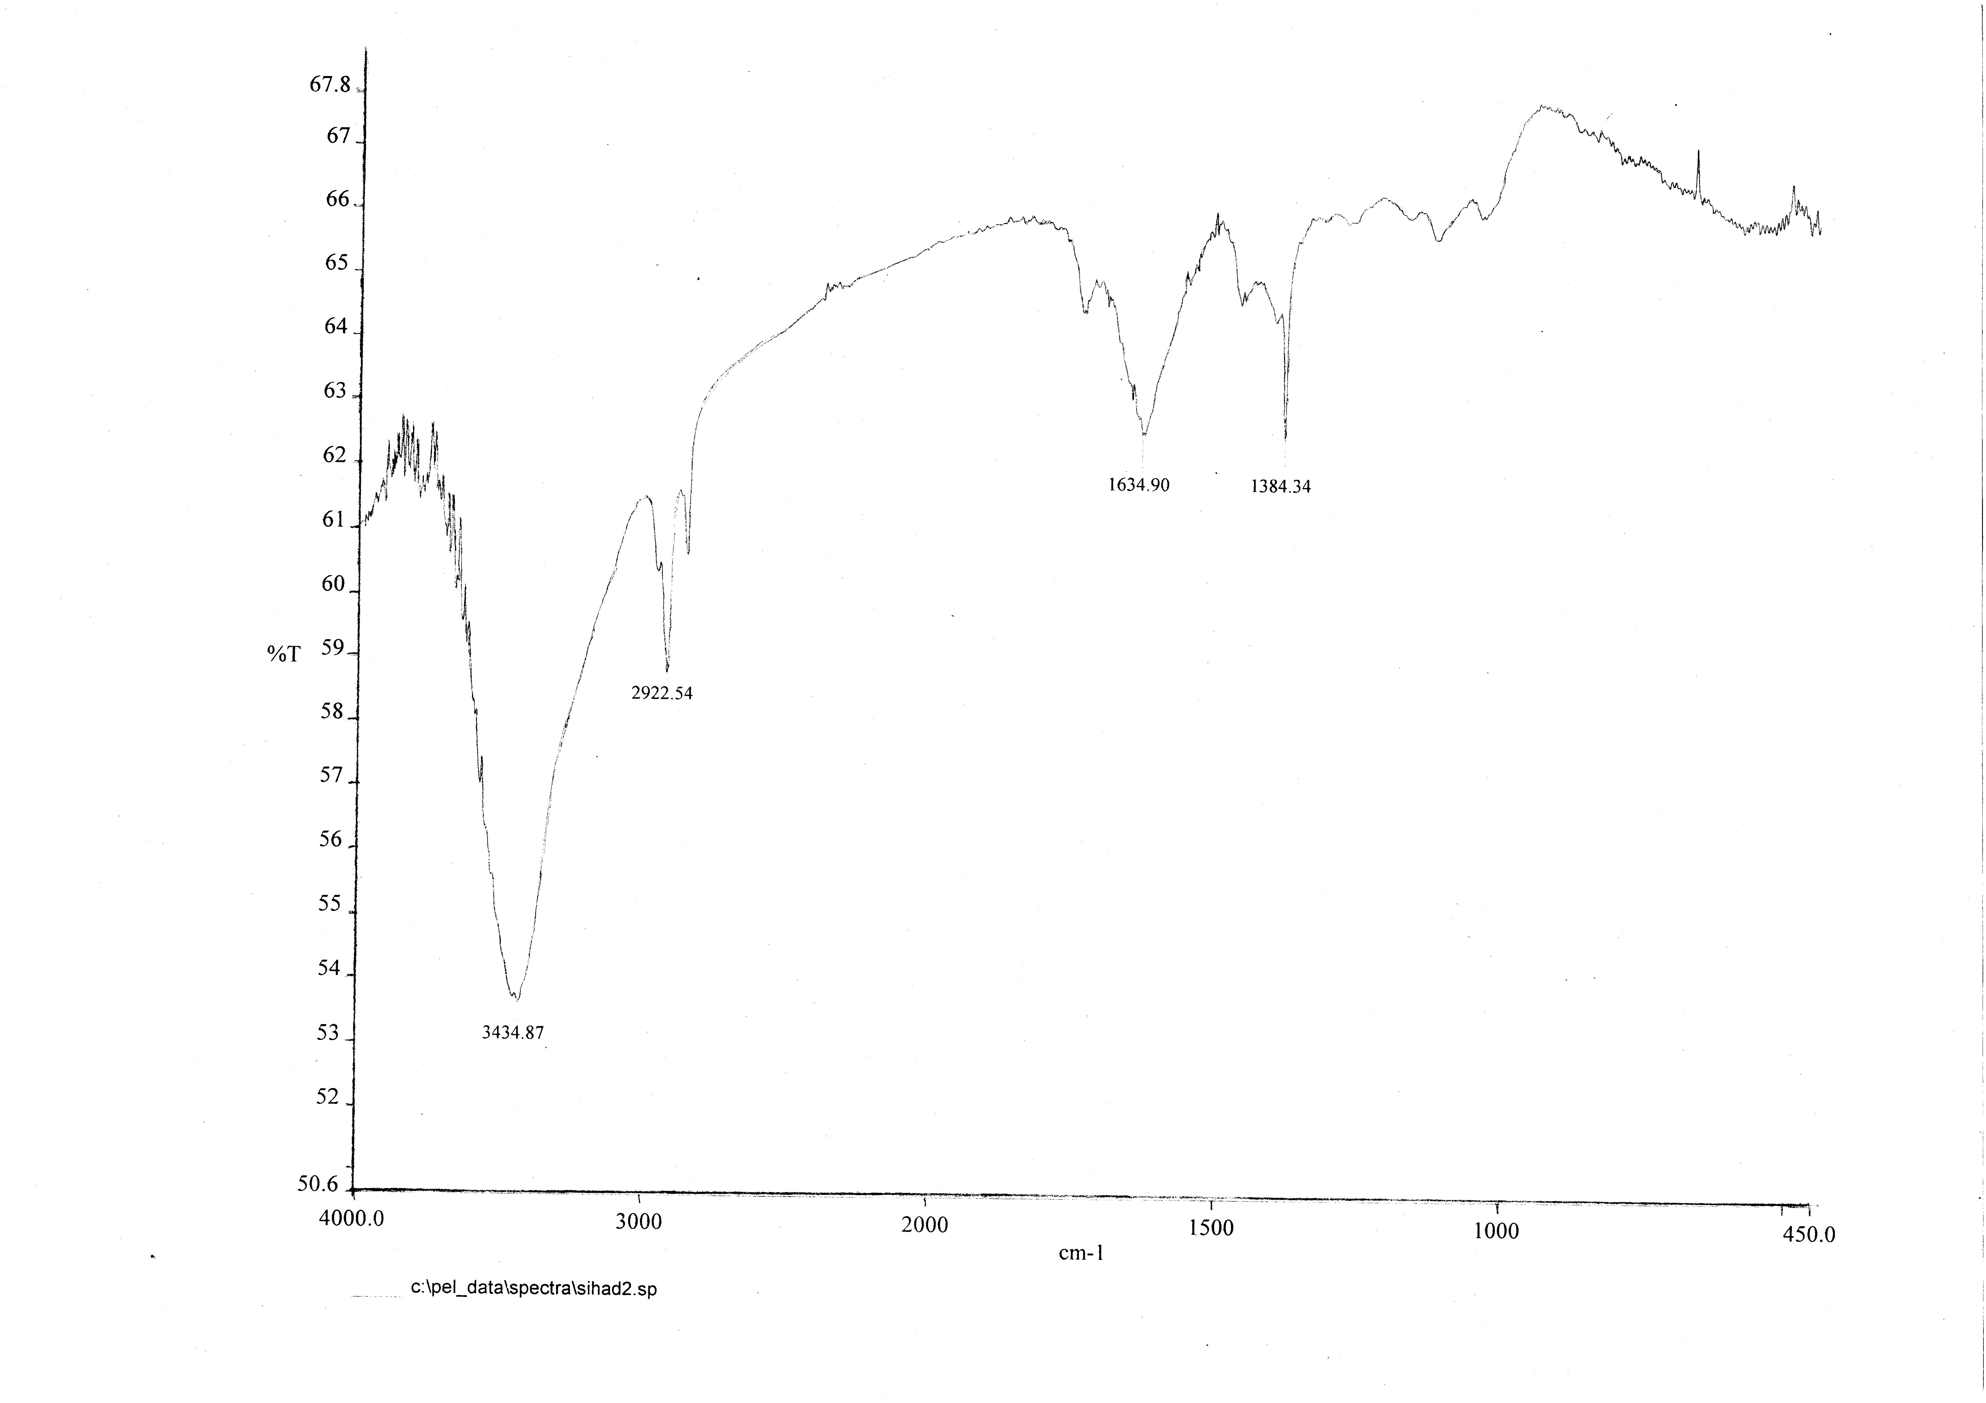

Figure (1): FTIR Spectrum of the polymer

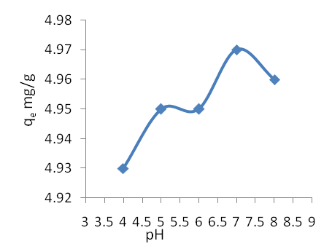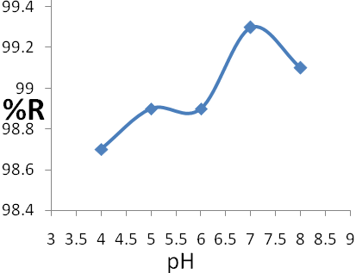
- (b)
Figure (2a,2b) Effect of pH on the adsorption of Cu(II) 10mg/L onto polymer 0.1g .

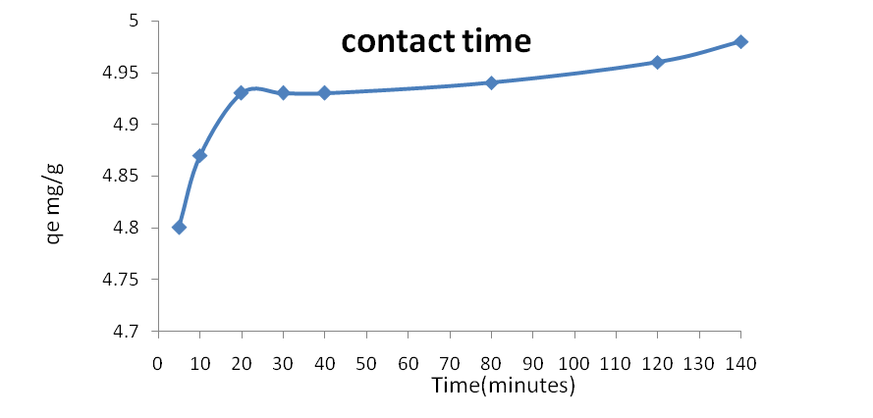
Figure (3) Effect of contact time on the amount of Cu(II) adsorbed at equilibrium ,q_{e}, using 0.1g( pH=7, temp =25^{O}C).
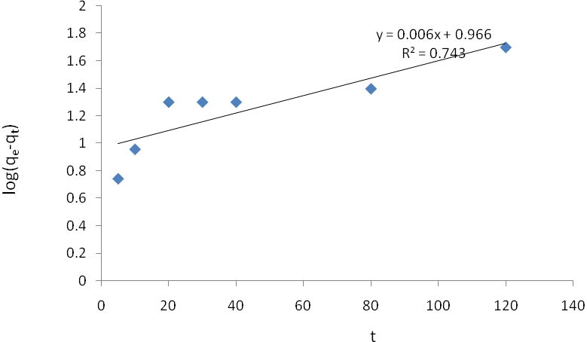
Figure (4) First order kinetic for adsorption of Cu(II) 10 mg/L on to polymer
0.1 g , pH 7.

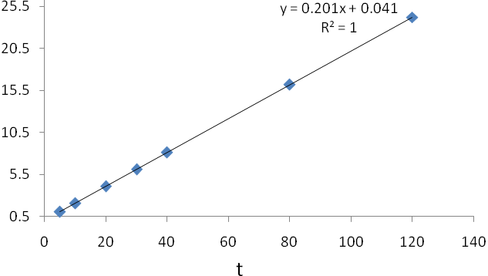
t/ q_{e}
Figure (5 ) Pseudo –second order kinetic for adsorption of Cu(II) 10 mg/L onto polymer 0.1 g at pH 7.

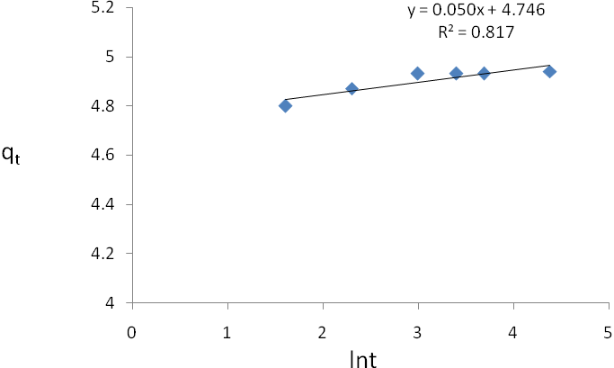
Figure (6) Elovich kinetic for the adsorption of Cu(II) 10mg/L on to polymer
0.1g at pH 7.

Table 1 : Comparison of the first- order, Second- order, and Elovich rate constants , calculated and experimental qe values for the adsorption of Cu 10mg/L, onto, polymer 0.1 g .
kinetic model | Parameter | The value
first- order kinetic model | q_{e}exp.(mg/g) | 4.98
first- order kinetic model | k₁(min.⁻¹) | 0.0138
first- order kinetic model | q_{e} calc. (mg/g) | 9.2469
first- order kinetic model | R² | 0.743
Second- order kinetic model | k₂ (g /mg . min) | 0.985
Second- order kinetic model | h (mg/g . min) | 24.3793
Second- order kinetic model | q_{e} calc.(mg/g) | 4.975
Second- order kinetic model | R² | 1
Elovich model | β (g /mg) | 20
Elovich model | α (mg /g .min) | 4.217
Elovich model | R² | 0.817

References
1. Kabiri, K., European Polymer Journal ,2003,39 (7), 1341–1348.
2. Buchholz FL, Graham AT, Modern Superabsorbent Polymer Technology , Wiley-VCH, New York, 1998,Ch 1-7.
3. Brannon-Peppas L, Harland RS, Absorbent Polymer Technology, Elsevier, Amsterdam , 1990, Ch 1- 4.
4. Andrade JD, Hydrogels for medical and related applications, ACS Symp. Series, American Chemical Society , Washington DC, 1976, 31, 1.
5. Po R, Water absorbent polymers: A patent survey, J Macromol. Sci-Rev Macromol Chem Phys, 1994, C34,607-662,.
6. Buchholz FL, Peppas NA, Superabsorbent Polymers Science and Technology, ACS Symposium Series, American Chemical society, Washington, DC, 1994, 573, Ch 2, 7, 8, 9.
7. Omidian H, Zohuriaan-Mehr MJ, Kabiri K, Shah K, Polymer chemistry attractiveness: Synthesis and swelling studies of gluttonous hydrogels in the
advanced academic laboratory, J Polym Mater, 2004,21, 281-292.
8. Osada. Y. and J.P. Gong, Soft and wet materials: polymer gels, Advanced
Materials, 1998, 10 (11), 827-837
9. Zhao, L., “Removal of heavy metals from waste water by adsorption using chitosan membrane”, Master Thesis, Department of Chemical Engineering, University of Waterloo,2004.
10- Shawket K. Jawad ,Senaa K. Ali and Safa M. Hameed , Iraqi National Journal of Chemistry , 2011,43
11-D.L.Pavia,G.M. Lampman, G.k.kriz Jr., Introduction to spectroscopy, Saunders Golden Sunburst series,1979.
12. Coskun , R., C. Soykan and M. Sacak, Separation and Purification Technology, 2006, 49,107–114.
13- Longzhe, C., W. Guiping and J. Tae-seop , Can. J. Chem. Eng., 2010, 88(1), 109 –115.
14.El-Nemr A,J Hazard Mater.,2009,161(1) ,132-141.

15. I. M. El-Naggar, E. I. Shabana and M. I. El-Dessouky, Advances in Chemical Engineering and Science, 2012, 2, 180-186
16. Sag, Y. and Y. Aktay, Biochemical Engineering Journal, 2002, 12, 143–153.
17. Ho, Y.S., D.A.J. Wase, and C.F. Forster, Environmental Technology, 1996, 17(1), 71-77.
18. Chien S H and Clayton W R , Soil Sci Soc Am J,1980, 44, 265-268.

