Preparation, Characterization of Acid Hydrazide Schiff Base Complexes of Nickel (II) and Their Biological Activity

Amira J. Al-Shaheen, Issam. J. Sallomi
Chemistry Depart./Edu.College, Mosul University
a.inorganic@yahoo.com
Sahba. A. Al-Sabaawi
Chemistry Depart./Sci.College, Mosul University

(NJC)

(Recevied on 3/4 /2012 ) (Accepted for publication 23/10/2012)

Abstract
The work reported in this research deals with the preparation,characterization and biological studiesofhomodinuclearNi(II)complexeswith three Schiff base
ligands. The ligands are: dibenzoinlidenemalonoyldihydrazide (BMDH₄),dibenzoinli-denesuccinyldihydrazide(BSDH₄)and dibenzoinlidenephthalolyldihydrazide(BPDH₄) which areobtained by the reaction ofmalonoyldihydrazide ,succinyldihydrazide and phthalolyldihydrazide with benzoin in mole ratio1: 2.The preparation of the complex-es was carried out in both neutral and basic media and have beencharacterizedphys-ico-chemically and they found to have the formulas [Ni₂(LH₄)₂]X₄ in neutral medium and [Ni₂L₂]in basic mediumrespectively.Octahededralstructure has beensuggested for all thehexacoordinatedcomplexes .Furthermore the complexeshave been found to be biologically active as demonstrated by antibacterial screening against four human pathogenic bacterial stains. It has been found that thecomplexes were more
effective agent than the ligands(where X=Cl⁻,NO₃⁻ ).
Key words:acid hydrazide, Schiff base complexes, nickel (II) complexes, antibacterial agents
الخلاصة
تم في هذا البحث تحضير وتشخيص عدد من معقدات النيكل(II)ثنائية النوى المتجانسة مع ثلاث ليكاندات وهي ثنائي بنزونيليدين مالونويل ثنائي هيدرازيد(BMDH₄) و ثنائي بنزونيليدين سكسنايل ثنائي هيدرازيد(BSDH₄) وثنائي بنزونيليدين فثالوليل ثنائي هيدرازيد(BPDH₄), تم الحصول عليها من التفاعل بين الهيدرازيدات الحامضية مع البنزوين بنسبة مولالية 1: 2. وتم تحضير المعقدات في كل من المحيطن المتعادل والقاعدي وشخصت هذه المعقدات باستخدام تقنيات مختلفة فيزياوية وكيميائية وطيفية.واستُنتج من هذاالدراسات ان معقدات الوسط المتعادل ايونية موجبة لها الصيغة العامة [Ni₂(LH₄)₂]X₄ في حين معقدات الوسط القاعدي ايونية متعادلة لها الصيغة العامة [Ni₂L₂] 0( حيث ان X=Cl⁻,NO₃⁻) واوضحت هذه الدراسات ان لهذه المعقدات سداسية التناسق بنية ثماني السطوح الاكثر احتمالا. كما شخصت الفعالية البكتيرية للمعقداتعلى اربع جراثيم مرضية كمضدات للبكتيريا الموجبة والسالبة لصبغة كرام والمعزولة من حالات مرضية وقداثبتالمعقدات ان لها فعالية كمضدات للبكتيريا اكثرمن اليكاندات.
الكلمات المفتاحية:معقدات قواعد شيف,الحوامض الهيدرازيدية , معقدات النيكل, مضادات البكتيريا

Introduction
The coordination chemistry of Schiff bases have gained importance over thela-st five decades because of their use as a model for biological system.In addition ,they are known to exhibit a wide variety of pharmacological properties such as antinflam-matory,antimalarial,antithelmentic activity, hypotensive actions, and antitumor and carcinostatic activity.⁽¹⁻³⁾Recently, considerable attention has been paid tochemistry of the metal complexes of Schiff bases containing oxygen, nitrogen and other donors because they offer many attractive properties such as displaying a double role ofele-ctron transport and light emission, higher thermal stability and easy sublimation⁽⁴⁻⁶⁾.Schiff bases derived from the reaction of the aldehydes or ketones with hydrazides are very interesting since they are present in keto-enol forms and can form different types of complexes ⁽⁷⁻¹¹⁾.In present work,newnickel complexes formed with Schiff base ligands derived from benzoin andmalonyldihydrazide(BMDH₄),succinyldihydr-azide (BSDH₄)andphthalolyldihydrazide (BPDH₄)have beensynthesized and characterized by different chemical, physical and spectral methods. Furthermore, the ligands and their complexes have been found to be biologically activedemonstrated by antibacterial screening against four human pathogenic bacterial stains.it has been found that the complexes were more effective agents than the ligands.
Experimental
1-Starting materials:
All the chemicals used were supplied fromFluka, BDH, Aldrich, Merck, Acid hydrazides,malonyl,succinyl andphthaloyldihydrazides were prepared by the condensation of the corresponding esters and hydrazine hydrate in 1:2 molar ratio according to the reported procedure⁽¹²⁾.
2- Analysis and physical measurements:
Nickel contents were determined by applying precipitation method after the decomposition of the complexes with concentrated nitric acid ⁽¹³⁾.Electronic spectra were recorded on Shimadzu UV-160 spectrophotometer for 10⁻³ M for complexes in DMF at 25°C using 1 cm quartz cell. Infrared absorption was recorded on a Perkin-Elmer 580 spectrophotometer as KBrPelletes in the range 400-4000 cm⁻¹. Molar conductance of the complexes was measured at room temperature for 10⁻³ M in DMF solution using conductivity bridge type LF-42.Magnetic susceptibility of thecomple-xeswas measured by Bruker-BM6.
3- Synthetic methods:
The Schiff base ligandswere prepared by the condensation ofbenzoin (0.02mole, 4.7g) and one of the following ,acid dihydrazide in(2:1) molar ratio in 20 ml ethanol. [malonyldihydrazide(MDH₂)(0.01mole,1.43g)orsuccinyldihydrazide(SDH₂) (0.01,1.5g) or phthaloyldihydrazide (PDH₂)(0.01 mole , 2.15g)] . The reaction mixture was heated under reflux for 3-9 hrs. After cooling, fine precipitate wasformed which was filtered off, washed with cold ethanol and dried.
B- Preparation of the complexes( 1:1 molar ratio ,nickel salts: ligand )
A general procedure has been used for the preparation ofthe complexes inneutral and basic medium .In neutral medium ,a solution of 0.5g of nickel chloride or nickel nitrate in 10 ml of ethanol has been added to the solution of one of acid dihydrazides [(BMDH₄ ,1.09g or0.89g) or (BSDH₄,1.12g or 0.91g) or (BPDH₄1.22g or 1.0g) . Anethanolic mixture containing 1:1 molar ratio ofnickel (II) salt and the ligand has been refluxed for about three hours. After cooling the separated complexes were filteredoff,recrystallized from hot water and dried.The alkaline medium complexeshave beenpreparedby applying the same above amountsexcept that the ligands were treated with 1M KOH solution . Complete precipitation of the complexes were achieved at pH 9-10. The mixtures were left to stand for 30 minutes, then filtered off,recrystallized from hot water and dried.
4- Biological activity:
The antibacterial activity of the ligandsand their complexes were selected forscreening by disc diffusion technique ⁽¹⁴⁾. The test disc was containing 20microgram of the compound. The activity was shown againsttheS.aureus,E.Coli,P.mirabilisand k.pneumoniae. The antibiotic Vancomycin andgentamycin were used as control drugs.
Results and Discussion
The reaction of thetwo nickel (II) salts with the ligands in both neutral and basic solution may be represented in the following two reactions: -
2NiX₂.nH₂O + 2LH₄⎯⎯⎯→ [Ni₂ (LH₄)₂]X₄ + 2nH₂O….. Type I
2NiX₂.nH₂O + 2LH₄ + 2KOH ⎯⎯⎯→ [Ni₂L₂]+2KX +(2n+2) H₂O+3H₂… Type II
Where X = Cl⁻, NO⁻₃; LH₄ = BMDH₄, BSDH₄, BPDH₄ and L are the tetrabasic anionic species were obtained from neutral and alkaline solutions, respectively . For all the complexes, the metal contents and the molar conductance values are in a good agreement with the given formulations Table (1). The solid complexes are colored, conductance in DMF indicate their ionicand non ionic nature ^{(15, 16)}.
The coordination sites of the ligands were inferred by infrared spectroscopy, which is considered a useful technique for probing the structure of Schiff base complexes. The infrared data of the main absorption bands of the ligands and the complexes are given in (Table 2). For Type I complexes, [Ni₂(LH₄)₂]X_{4,} the stretching and deformation vibrations of OH groups were shifted to lower frequency byabout 100 -120 and10 - 40 cm⁻¹, respectively. Compared to their positions in the free ligands spectrum indicating coordination of alcoholic hydroxyl groups through their oxygen atoms. In addition, the stretching vibration of C-O single bond split into two peaks due to (C-O _{H}^{M} ) which support the above suggested coordination of the hydroxyl groups without deprotonation^{(15).} The negative shift of about 10 -25 cm⁻¹ in the stretching frequency of carbonyl group suggests coordination through the carbonyl oxygen atom as observed in similar acid hyrazide andhydrazine complexes ⁽¹⁷⁾. The C=N stretching band shows negative shift of about 10 - 40 cm⁻¹, indicating the involvement of azomethine nitrogen atom in complex formulation^{(18,19)}while the NH remains almost unaffected compared to the free ligand spectrum.
In the infrared spectra of type II complexes, [Ni₂L₂] the absence of the bands due to OH- stretching and deformation vibrations was attributed to the coordination of the ligand through deprotonanon of the alcoholic hydroxyl groups⁽¹⁹⁾. The stretching band of theazomethine group was also shifted by about (10 - 40 cm⁻¹), suggesting coordination throughazomethine nitrogen similar to that which occurred in type I complexes.On the other hand,the absence of the stretching band due to NH and C=O mioety was attributed, as reported for similar cases ⁽²⁰⁾,to the presence of theenol tautomer. In these complexes, the new bands located at 1625 -1630 and 1550-1570 cm⁻¹ were assigned to the combined stretching vibration of [(O-C=N) + (C=N)] and the stretching vibration ofazinechromophore, respectively⁽²¹⁾.The presence of these bands is strong evidence for theenolization and deprotonation in alkaline solution.
In all complexes of both types, positive shift of about 10 - 30 cm⁻¹ was observed in the stretching vibration of N-N band, since the shift is less than 50 cm⁻¹ only one nitrogen atom isinvolved in bonding ⁽²²⁾. In addition to the above mentioned perturbation in infrared spectra, new bands around 470-480 and 430-440 cm⁻¹ were observed and tentatively assigned to M-N and M-O stretching modes,respectively ⁽²³⁾. The band located at 1380, 720 and 760 cm⁻¹ in nitrate complexes, were attributed to ionic nitrate groups, while the new band located at 575-600 cm⁻¹ in complexes might be due to the interaction of chloride ion with other atoms in the molecule and thus, suggesting uncoordinated chloride ion^{(24).} These observations are in accordance with the conductivity data and the given general formula for these complexes (Type I).
The electronic absorption spectra of the free ligands and their complexes were recorded at room temperature using DMF as the solvent .Free ligands exhibited an absorption peaks at 240, 235,265,402,415 and 425 nm respectively .which are assigned as intra –ligand charge –transfer bands ( Fig 3 ) .
In the electronic spectra, theoretically, three bands are expected to appear in the visible region for nickel(II)complexes.These bands are due to the allowed transitions
³A_{2g} (F) →³T_{2g}(F) v_{l}, ³A_{lg} (F) →³T_{2g} (F) v₂ and ³A_{2g} (F) →³T_{1g} (P) v₃.
For both types of complexes, these bands were observed in the visible region at positions (Table 1) characteristic for octahedral structure ⁽²⁵⁾In addition, high intensity bands were observed in the ultraviolet region of the spectra and assigned to C-T transitions which due to the partial electron density migration from the filled ligands π-orbital to the empty metal π-orbitals. The observedCTbands suggested the presence of some π-character in the coordination bonds between the metal ions and the ligand. All the complexes showed magnetic behavior corresponds to par-magnetism. The values of the magnetic moments (Table 1) are in good agreement with the high-spin octahedral structure⁽²⁶⁾ and in the range (2.99- 3.25)B .M, it wasfound that the effective magnetic moments obtained at room temperature ( Table 1) are in the range expected for high spinoctahedral .The antibacterial agents were known to attack the bacterial cell in a variety of ways such as killing or inhibiting the growth of bacteria by affecting special target sites like the synthesis of cell wall, protein and nucleic acid through their effects on the synthesis of ribonucleic acid which could be resulted from the inhibition action of bacterial DNAenzyme which caused the separation of supercoiling ordecantenation or unknotting of the DNA. Numerous experiments have been done to determine the antibacterial influence of the complexes (Table 3,4&Fig. 2). The chemical complexes had a good ability to attack the cell wall of the bacteria through the heavy metal ions whichpreferentially bind to SH (sulfhydryl group) of the cell enzyme more strongly,it is logical to assume that the complexes screened were involved in acompetitiveequilibria involving the SH group of the cell enzyme.

Conclusions
According to the above studies, it was concluded that all the ligands act as neutral hexadentate in neutral solution giving cationic complexes and coordinating through alcoholic oxygen, carbonyl oxygen andazomethine nitrogen atoms. In basic medium neutral complexes were obtained (Fig. 1) and thehexadentate action of the ligand was satisfied by coordination through both deprotonatedalcoholic oxygen,enolic oxygen and azomethine nitrogen atoms .In neutral medium (cationic complexes) ,the chloride ion joint to the nickel ion in ionic manner . In all cases the same complexes were obtained with respect to mole ratio(1: 1 or 2:2 ligand : metal) and an octahedral structure was suggested. Therefore, weconcluded the most of the complexes acquire a good antibacterial activity,this may be due to interaction of the metal ion more strongly than the donor atoms in the ligands andthese observations have been consistent with that observed by many authors ⁽²⁷⁾as shown in (Table 3 ) and Figure (2).

Table (1): Some physical and spectral data of the complexes
Complexes | Color | M.P^{º}C | Λ_{M} DMF Cm².Ohm⁻¹.mol⁻¹ | μ_{eff.}(B.M) | % Nianalysis, Calc. (obser) | Electronic Spectral Bands, Cm⁻¹
 |  |  |  |  |  | ν₁ | V₂ | v₃ | C.T
[Ni₂(BMDH₄)₂]Cl₄ | Olive | 282 | 341 | 3.11 | 9.07 (8.98) | 10101 | 14409 | 24154 | 27932
[Ni₂(BMD)₂] | Brown | 301 | 12 | 3.25 | 9.03 (8.57) | 10482 | 14005 | 24154 | 27855
[Ni₂(BMDH₄)₂] (NO₃₎₄ | Green | 274 | 311 | 3.21 | 8.39 (8.16) | 10266 | 13440 | 24449 | 26385
[Ni₂(BSDH₄)₂]CI₄ | Green | 224 | 302 | 3.25 | 8.88 (8.77) | 10373 | 16556 | 26041 | 30395
[Ni₂(BSD)₂] | Brown | 290 | 15 | 3.01 | 8.84 (8.57) | 10482 | 14005 | 25706 | 29069
[Ni₂(BSDH₄)₂](NO₃)₄ | brown | 222 | 335 | 3.09 | 8.22 (7.96) | 10482 | 15527 | 25380 | 29069
[Ni₂(BPDH₄)₂]Cl₄ | Green | 250 | 330 | 3.23 | 8.28 (7.96) | 10373 | 16077 | 24752 | 32154
[Ni₂(BPD)₂] | Green | 313 | 16 | 2.99 | 8.25 (7.75) | 10683 | 14104 | 25706 | 31055
[Ni₂(BPDH₄)₂](NO₃)₄ | Yellow | 204 | 344 | 3.21 | 7.71 (7.55) | 10482 | 14306 | 24449 | 30864
Table (2): Important IR spectral bands (cm⁻¹) of the free ligands and their complexes
Compound | ν_{OH} | ν _{NH} | ν_{C=0} | ν_{C=N} | δ_{OH} | ν_{C-O} | ν_{C=N-N=C}  _{azinechromophore} | ν_{N-N} | ν_{M-O} | ν_{M-N} | ν_{Cl}⁻  _{ionic} | νNO⁻₃  _{ionic}
BMDH₄ | 3400 | 3250 | 1685 | 1630 | 1255 | 1200 | - | 1035 | - | - | - | -
[Ni₂(BMDH₄)₂]Cl₄ | 3290 | 3250 | 1665 | 1610 | 1230 | 1170 | - | 1055 | 440 | 480 | 615 | -
[Ni₂(BMD)₂] | - | - | - | 1610 | - | 1175 | 1585 | 1045 | 440 | 475 | - | -
[Ni₂(BMDH₄)₂](NO₃)₄ | 3280 | 3250 | 1660 | 1590 | 1225 | 1180 | - | 1045 | 430 | 480 | - | 1380,720
BSDH₄ | 3410 | 3300 | 1695 | 1615 | 1275 | 1220 | - | 1030 | - | - | - | -
[Ni₂(BSDH₄)₂]Cl₄ | 3300 | 3295 | 1675 | 1605 | 1245 | 1190 | - | 1050 | 440 | 470 | 585 | -
[Ni₂(BSD)₂] | - | - | - | 1595 | - | 1195 | 1565 | 1045 | 430 | 480 | - | -
[Ni₂(BSDH₄)₂](NO₃)₄ | 3290 | 3300 | 1685 | 1590 | 1255 | 1190 | - | 1054 | 440 | 480 | - | 1380,720
BPDH₄ | 3500 | 3200 | 1675 | 1625 | 1275 | 1205 | - | 1020 | - | - | - | -
[Ni₂(BPDH₄)₂]Cl₄ | 3380 | 3200 | 1660 | 1585 | 1255 | 1175 | - | 1040 | 440 | 480 | 605 | -
[Ni₂(BPD)₂] | - | - | - | 1605 | - | 1180 | 1590 | 1050 | 435 | 480 | - | -
[Ni₂(BPDH₄)₂](NO₃)₄ | 3400 | 3200 | 1665 | 1605 | 1255 | 1175 | - | 1040 | 440 | 475 | - | 1380,720

Table (3): The antibacterial activities of the ligands and their complexes
Compound | Test organism
Compound | Gr⁺ | Gr⁻
Compound | s.aureus | E.coli | k.pneumoniae | P.mirabilis
BMDH₄ | 4 |  |  | 5
[Ni₂(BMDH₄)₂]Cl₄ | 12 | 16 | 8 | 16
[Ni₂(BMD)₂] | 12 | 13 | 5 | 7
[Ni₂(BMDH₄)₂](N0₃)₄ | 11 | 13 | 8 | 12
BSDH₄ | 4 | - | - | 3
[Ni₂(BSDH₄)₂]Cl₄ | 12 | 12 | 11 | 9
[Ni₂(BSD)₂] | 10 | 7 | 8 | 6
[Ni₂(BSDH₄)₂](N0₃)₄ | 12 | 11 | 10 | 9
BPDH₄ | 7 | 5 | 3 | 5
[Ni₂(BPDH₄)₂]Cl₄ | 11 | 5 | 5 | 9
[Ni₂(BPD)₂] | 4 | 6 | 5 | 8
[Ni₂(BPDH₄)₂](N0₃)₄ | 14 | 9 | 8 | 1
Cancomycin | 15 | - | - | -
Gentamicin | - | 17 | 14 | 17
The value is the inhibition zone diameter subtracted disc diameter.
S= sensitive, zone diameter nor more than 6mm less than control
MS= moderately sensitive, zone diameter of 6-12 mm less than control
R= resistant, zone diameter of 12 mm or less than control.

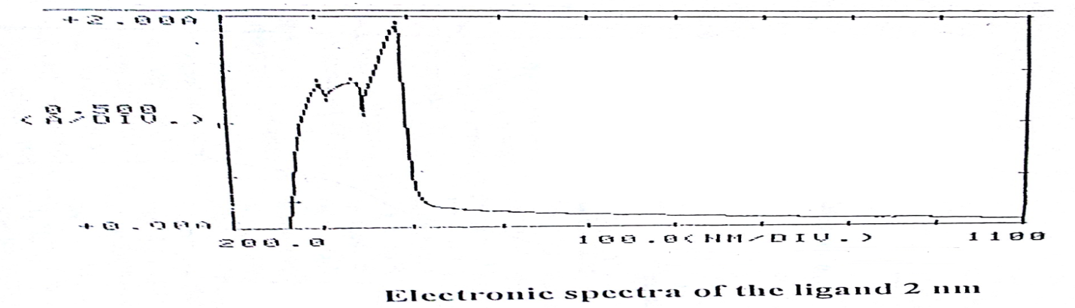

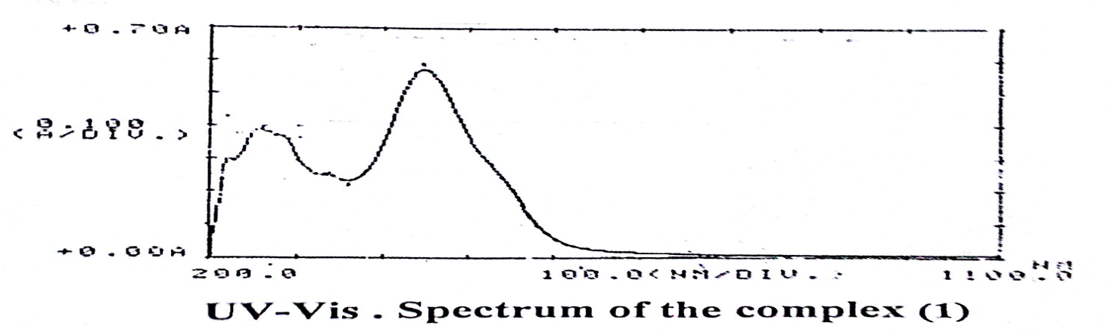

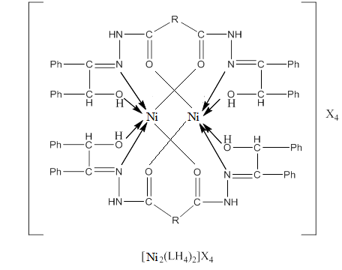
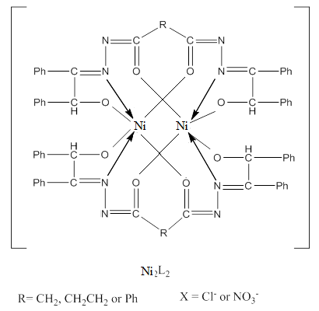
Fig. (1): The proposed structures of complexes

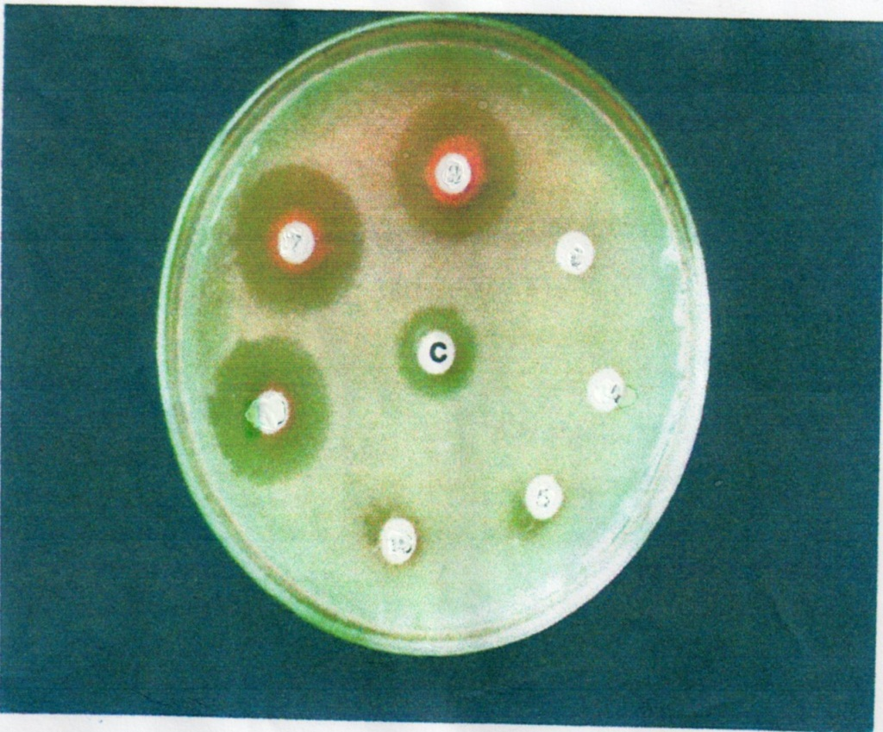
Effect of some complexes on S. Aureus

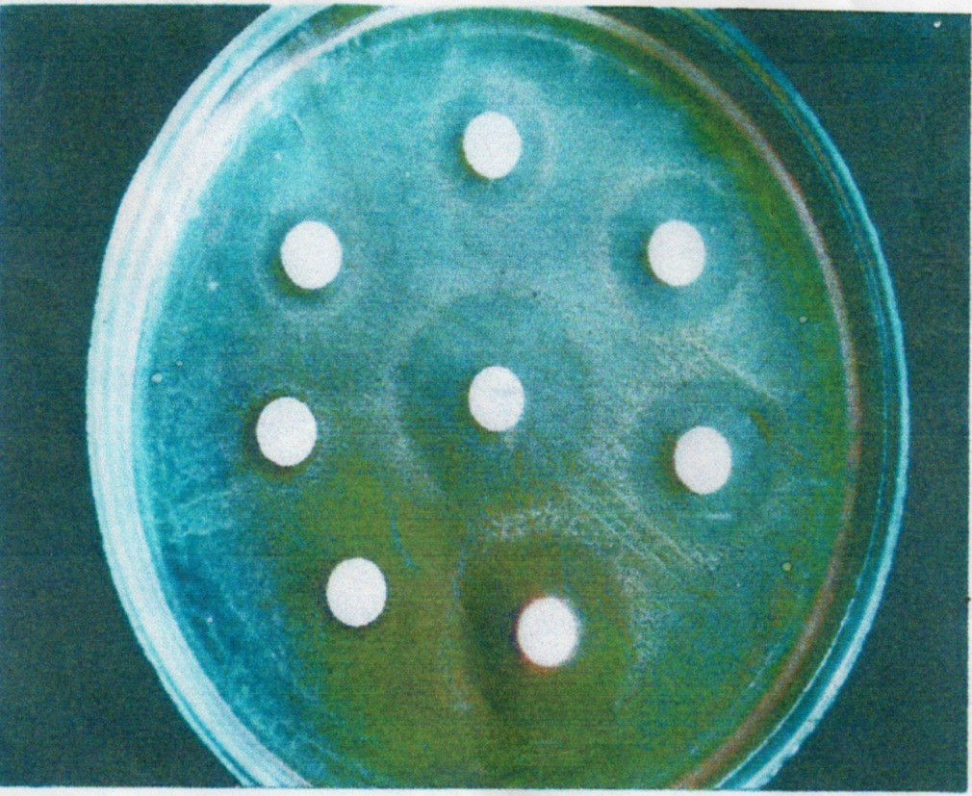

Fig (2): Antibacterial activity of different concentration
of complex [Ni₂(BSDH₄)₂](NO₃)₄ on E. Coli

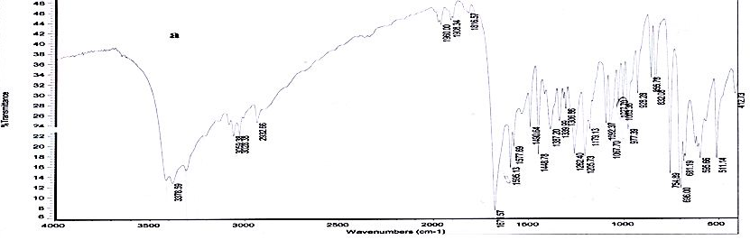

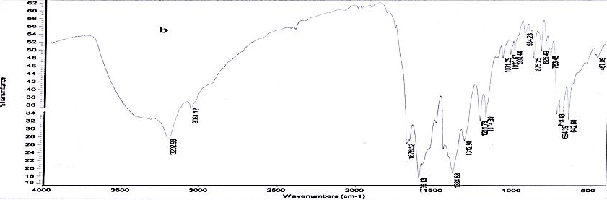

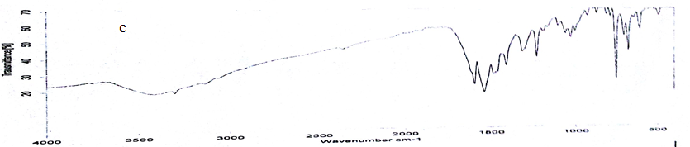
IR Spectra OF (a) BMDH₄, (b) [Ni₂(BMDH₄)₂](NO₃)₄and (c) [Ni₂(BPD)₂]

References
1. Maurya, M.R., D.C. Antony, S. Gopinathan and C.Gopinathan,.Bull. Chem. Soc.Jap., 1995,68 , 554.
2. Taylor, M. K.; Trotter, K. D.; Reglinski, J.;Berlouis, L.E.A.; Kennedy, A.R.; Spickett,C.M.; Sowden, R. J.,Inorg. Chim.Acta, 2008, 361(9-10), 2851.
3. Chira R Bhattacharjee, PankajGoswami, SankarNeogi andSaptarashiDhibar;
J. Sci. Tech., 2010, 5,1, 81.
4. Saydam, S.; Alkan, C.Polish J. Chem.,2001,75, 29.
5. Ciobanu, A.; Zalaru, F.; Albinescu, D.; Zalaru, C. Braz. ,J., 1999,7(8), 95.
6. Sone, K.; Fukuda, Y. InorganicThermochromism: InorganicChemistry
Concept", Springer, Heidelberg, Vol.10. 1987,30
7. Holm, R. H., Evere , J. R., andChakravorty, R. S., Inorganic Chemistry, 1966,7 ,83.
8. Mayer, P.; Potgieter, K. C.; Gerber T. I. A.,Polyhedron,2010, 29, 1423.
9. Feng, Y.; Wang, C; Zhao, Y.; Li, J.; Liao, D.; Yan, S.; Wang, Q. ,Inorg. Chim. Acta,2009 ,362(10),3563.
10. Zahid H. Chohan,Arif M., Akhtar A. and Claudiu T. Supuran Bioinorgchem.AndAppl. ArticleID 83131, 2007 , 1.
11. Hanna Wageih G., Moawaad Nona.Transition metal chemistry, 2001, 26(6), 644
12. Baker, W., C.N. Haksar and J.F.W. Mcomie, J. Chem. Soc., 1950, 170.
13. Vogel, A.I. ,"A Text Book of Quantitative Inorganic Chemistry", 3rd Ed.,
John Wiley,Vol. 2, 1972, 479, 529
14. Collins, C.H., P.M. Lyne and J.M. Grange, Microbiological Meth , Butterworths, London, 6th ed., 1989 ,75
15. Sallomi, I.J. and AJ. Shaheen, , Polyhedron , 1998, 17,1429 .
16.Chohan, Z. H.; Sherazi, S. K. A.Inorg. Met-Org.Chem., 1999,29,105.
17. Sallomi, I.J. and AJ. Al-Shaheen, Transition, Met.-Chem.,1994 ,19, 275.
18. Taylor, L.T. and R.D. Patron, Inorg.Chem .Acta .,1974, 8 ,19
19. Abd-Elzaher, M. M.,J. Chin. Chem. Soc., 2001,48,153 .
20. Stratton,W.J., M.F. Ren g and R.F. drug, Inorg. Chem.Acta, 1969 ,3, 97.
21. Manimekalai, A. and R. Mahendhiran , Indian J. Chem .,2002, 41A., ,2296
22.Por Zhang L, Lu X., Zhaug Q., Chen C. and Kang B., Trans. Metal Chem., 2005, 30(1), 76 .
23. Wilkinson G., Gillard R.D. and McCleverty J.A., Comprehensive Coordination Chemistry, Pergamon Press, Great Britain , 1987, 4th ed., 1184.
24. Nakamoto K., Infrared and Raman Spectra of Inorganic and Coordination Compound,1997 ,5th ed.,Part B, John Wiley and Sons , Inc.,
25. Shaheen,A. J.,National J. of Chem. 2010 ,37,111.
26. Pearly SebastianChittilappily and K.K. Mohammed Yusff,, J. Indian Chem. Soc., 2008 ,47A, 848.
27. Monica Tyagi, Sulekh Chandra and sunil KumarChaudhang, J.of Chem.and pharm. Resear., 2011, 3(1), 56.

